SUPPLEMENTAL Appendix

Isolation of Infectious SARS-CoV-2 from urine of a COVID-19 Patient

Running title: Infectious SARS-CoV-2 in patient’s urine

Jing Sun¹*, Airu Zhu¹*, Heying Li²*, Kui Zheng³*, Zhen Zhuang¹*, Zhao Chen¹*, Yongxia Shi³*, Zhaoyong Zhang¹*, Si-bei Chen¹*, Xuesong Liu¹*, Jun Dai³, Xiaobo Li³, Shuxiang Huang³, Xiaofang Huang¹, Ling Luo¹, Liyan Wen¹, Jianfen Zhuo¹, Yuming Li¹, Yanqun Wang¹, Lu Zhang¹, Yanjun Zhang¹, Fang Li¹, Liqiang Feng², Xinwen Chen², Nanshan Zhong¹, Zifeng Yang^{1#}, Jicheng Huang^{3#}, Jincun Zhao^{1,4#}, Yi-min Li^{1#}

¹State Key Laboratory of Respiratory Disease, National Clinical Research Center for Respiratory Disease, Guangzhou Institute of Respiratory Health, the First Affiliated Hospital of Guangzhou Medical University, Guangzhou, China 510182
²State Key Laboratory of Respiratory Disease, Guangzhou Institutes of Biomedicine and Health, Chinese Academy of Sciences, Guangzhou, China 510530
³Guangzhou Customs District Technology Center, Guangzhou, China 510700
⁴Institute of Infectious disease, Guangzhou Eighth People's Hospital of Guangzhou Medical University, Guangzhou, China 510182

*Contributed equally to this manuscript
#Corresponding authors: Dr. Jincun Zhao, zhaojincun@gird.cn
Dr. Yimin Li, dryiminli@vip.163.com
Dr. Jicheng Huang, jichenghuang@126.com
Dr. Zifeng Yang, jeffyah@163.com

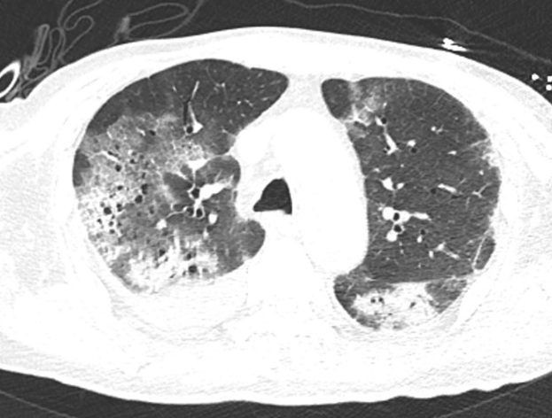

Figure S1. Chest CT scan of the SARS-CoV-2 infected patient

Table S1. Nucleotide and amino acid changes between original virus strain (Wuhan-Hu-1 NC_045512.2) and the virus isolated from the patient’s urine.

Genome nucleotide position | Protein | Nucleotides changes |  | Amino acides changes
 |  | NC_045512.2 | Urine SARS-CoV-2
6819 | ORF1ab | G | T | Ser>Ile
6996 | ORF1ab | T | C | Ile>Thr
14235 | ORF1ab | C | T | Thr>Ile
17373 | ORF1ab | C | T | Synonymous
29527 | N | G | A | Synonymous

