**Supporting Information**

For

**Benzophenone degradation by thermally activated persulfate:** **Kinetics, mechanisms and influence of water matrix anions**

Jie Ma*, Yuan Feng, Xin Yang, Yongxin Wu, Shuo Wang, Congchao Zhang, Quan Shi

State Key Laboratory of Heavy Oil Processing, Beijing Key Lab of Oil & Gas Pollution Control, China University of Petroleum-Beijing, Beijing 102249, China

*Corresponding author

Jie Ma (Email: rubpmj@sina.com)

**TextS1. Chemicals**

Sodium persulfate (Na2S2O8; ≥99%), sodium hydroxide (NaOH; ≥99.8%), potassium chloride (KCl; ≥99.5%), sodium bromide (NaBr; ≥99%), sodium sulfate anhydrous (Na2SO4; ≥99%), sodium carbonate anhydrous (Na2CO3; ≥99.8%), sodium bicarbonate (NaHCO3; ≥99.8%), potassium monohydrogen phosphate (K2HPO4; ≥99%) and potassium dihydrogen phosphate (KH2PO4; ≥99.5% ) were purchased from Aladdin Bio-Chem Technology Company (Shanghai, China). Potassium phosphate tribasic trihydrous (K3PO4·3H2O; ≥99%) was purchased from Tianjin Fuchen Chemical Reagents Factory (Tianjin, China). Sodium nitrate (NaNO3; ≥98%) and [sulfuric](http://cn.bing.com/dict/search?q=sulfuric&FORM=BDVSP6&mkt=zh-cn) [acid](http://cn.bing.com/dict/search?q=acid&FORM=BDVSP6&mkt=zh-cn) (H2SO4; 95%~98%) was purchased from Beijing Chemical Works (Beijing, China). Benzophenone (C13H10O; ≥99.5%) was purchased from Tianjin Yongda Chemical Regent Company (Tianjin, China). [Ascorbic](http://cn.bing.com/dict/search?q=ascorbic&FORM=BDVSP6&mkt=zh-cn) [acid](http://cn.bing.com/dict/search?q=acid&FORM=BDVSP6&mkt=zh-cn) (C6H8O6; ≥99.7%) and sodium phosphate (Na3PO4; ≥99%) were purchased from Tianjin Guangfu Fine Chemical Research Institute (Tianjin, China). HPLC grade acetonitrile (CH3CN; ≥99.9%) was purchased from Fisher Scientific. All solutions were prepared using ultrapure water (18.2 MΩ cm) from a bench ultrapure water system (Master-RUV, Hitech Instruments Co, China).

|  |  |  |  |  |  |  |  |  |
| --- | --- | --- | --- | --- | --- | --- | --- | --- |
| **Table S1.Experimental results including pseudo-first-order rate constant (k1), R2, BP removal efficiency, BP degradation half-life (t1/2), pHinitial and pHfinal** | | | | | | | | |
| **Setup** | **[BP]0** | **[PS] 0** | ***Kobs*** | **R2** | **BP removal efficiency** | **t1/2** | **pHinitial** | **pHfinal** |
| **Unit** | mM | mM | h-1 |  |  | h |  |  |
| **Varying [PS] 0** | 0.1 | 2 | 0.051 | 0.998 | 20.7% | 15.21 | 4.38 | 2.80 |
| **Varying [PS] 0** | 0.1 | 5 | 0.103 | 0.999 | 38.4% | 7.60 | 3.94 | 2.42 |
| **Varying [PS] 0** | 0.1 | 10 | 0.179 | 0.964 | 61.6% | 3.86 | 3.59 | 2.70 |
| **Varying [PS] 0** | 0.1 | 20 | 0.396 | 0.993 | 100.0% | 1.97 | 3.22 | 2.79 |
| **Varying [PS] 0** | 0.1 | 50 | 1.130 | 0.990 | 100.0% | 0.71 | 2.92 | 2.55 |
| **T=30**°C | 0.1 | 10 | 0.015 | 0.925 | 10.2% | 43.95 | 3.61 | 3.90 |
| **T=40**°C | 0.1 | 10 | 0.045 | 0.994 | 21.5% | 14.51 | 3.61 | 3.46 |
| **T=50**°C | 0.1 | 10 | 0.230 | 0.964 | 56.4% | 3.83 | 3.61 | 2.90 |
| **T=60**°C | 0.1 | 10 | 1.063 | 0.977 | 100.0% | 0.89 | 3.61 | 2.42 |
| **T=70**°C | 0.1 | 10 | 3.808 | 0.982 | 100.0% | 0.24 | 3.61 | 2.82 |
| **pHinitial=1.09** | 0.1 | 10 | 0.202 | 0.996 | 81.3% | 3.78 | 1.09 | 1.30 |
| **pHinitial=2.92** | 0.1 | 10 | 0.188 | 0.993 | 78.5% | 4.12 | 2.92 | 2.57 |
| **pHinitial=3.61** | 0.1 | 10 | 0.190 | 0.990 | 78.9% | 4.17 | 3.61 | 2.70 |
| **pHinitial=11.90** | 0.1 | 10 | 0.470 | 0.997 | 100.0% | 1.59 | 11.90 | 11.85 |
| **pHinitial=13.58** | 0.1 | 10 | 0.315 | 0.997 | 92.4% | 2.12 | 13.5 | 13.68 |
| **0.1 M Methanol** | 0.1 | 10 | -0.023 | 0.999 | 20.7% | 26.39 | 3.42 | 1.91 |
| **1 M Methanol** | 0.1 | 10 | -0.010 | 0.853 | 37.4% | 26.51 | 3.40 | 1.90 |
| **0.1 M TBA** | 0.1 | 10 | -0.026 | 0.998 | 56.4% | 17.64 | 3.40 | 2.62 |
| **1 M TBA** | 0.1 | 10 | -0.001 | 0.08 | 85.9% | 34.81 | 3.35 | 2.65 |

|  |  |  |  |  |  |  |  |  |
| --- | --- | --- | --- | --- | --- | --- | --- | --- |
| **Table S2. Experimental results in presence of anions** | | | | | | | | |
| **Setup** | **[BP]0** | **[PS] 0** | ***k1*** | **R2** | **BP removal efficiency** | **t1/2** | **pHinitial** | **pHfinal** |
| **Unit** | mM | mM | h-1 |  |  | h |  |  |
| **1 mM SO42-** | 0.1 | 10 | 0.478 | 1.000 | 100.0% | 1.74 | - | 2.82 |
| **10 mM SO42-** | 0.1 | 10 | 0.479 | 0.998 | 100.0% | 1.63 | - | 3.04 |
| **100 mM SO42-** | 0.1 | 10 | 0.408 | 0.997 | 100.0% | 1.86 | - | 3.39 |
| **1 mM NO3-** | 0.1 | 10 | 0.433 | 0.997 | 100.0% | 1.68 | - | 3.03 |
| **10 mM NO3-** | 0.1 | 10 | 0.512 | 0.996 | 100.0% | 1.59 | - | 2.93 |
| **100 mM NO3-** | 0.1 | 10 | 0.444 | 0.970 | 100.0% | 1.85 | - | 2.95 |
| **1 mM Cl-** | 0.1 | 10 | 0.888 | 0.992 | 100.0% | 1.14 | - | 2.8 |
| **10 mM Cl-** | 0.1 | 10 | 0.762 | 0.996 | 100.0% | 1.42 | - | 2.78 |
| **100 mM Cl-** | 0.1 | 10 | 0.196 | 0.999 | 84.9% | 3.40 | - | 2.97 |
| **1 mM Br-** | 0.1 | 10 | 0.047 | 0.992 | 30.3% | 10.60 | - | 3.26 |
| **10 mM Br-** | 0.1 | 10 | 0.046 | 0.998 | 27.7% | 13.98 | - | 3.37 |
| **100 mM Br-** | 0.1 | 10 | 0.043 | 0.996 | 27.1% | 11.95 | - | 3.52 |



Figure S2. Pseudo-first-order kinetic model fitting of BP degradation by TAP under different conditions: a) PS concentrations, b) BP concentrations, c) temperatures, and d) solution pH.

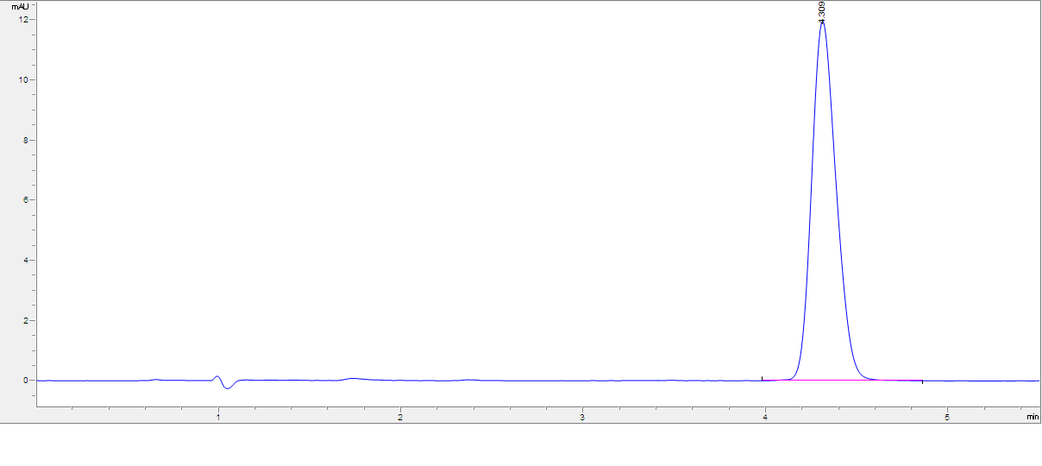

**BP**

Figure S1. The chromatograms of the HPLC analysis of BP

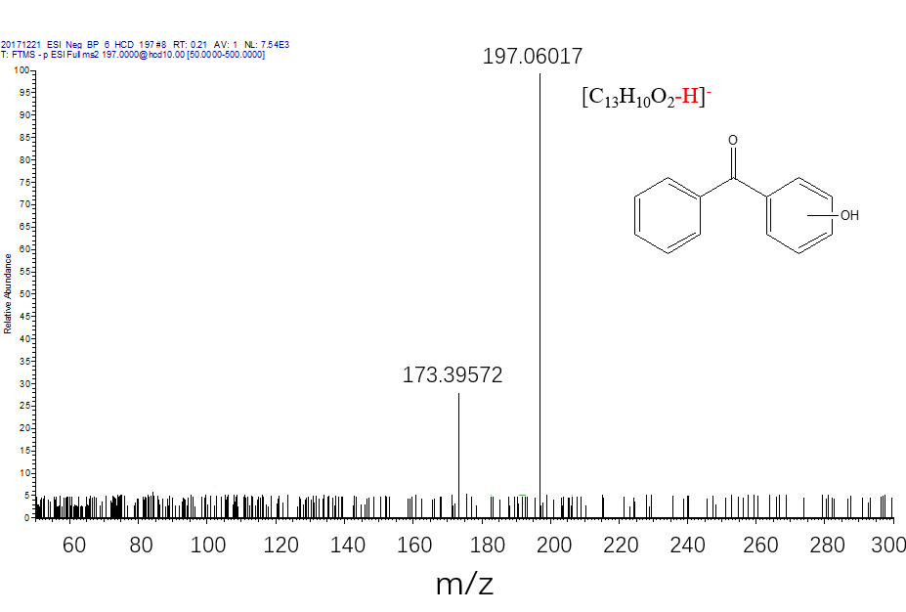

Figure S3. The mass spectrum of the intermediate P1.

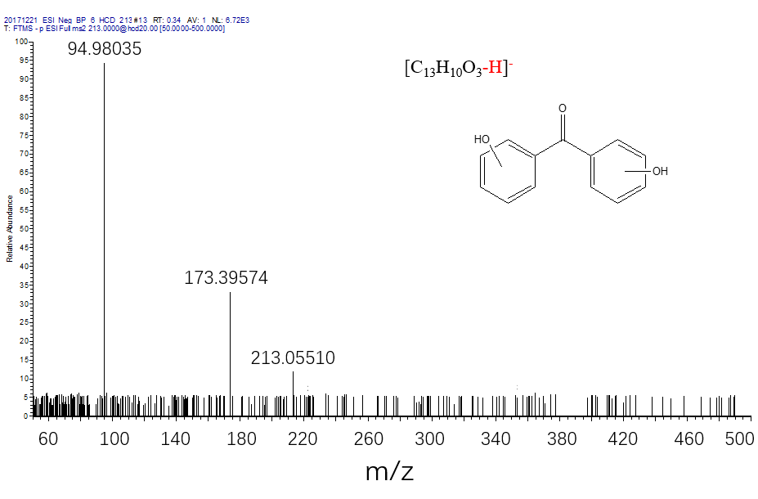

Figure S4. The mass spectrum of the intermediate P2.

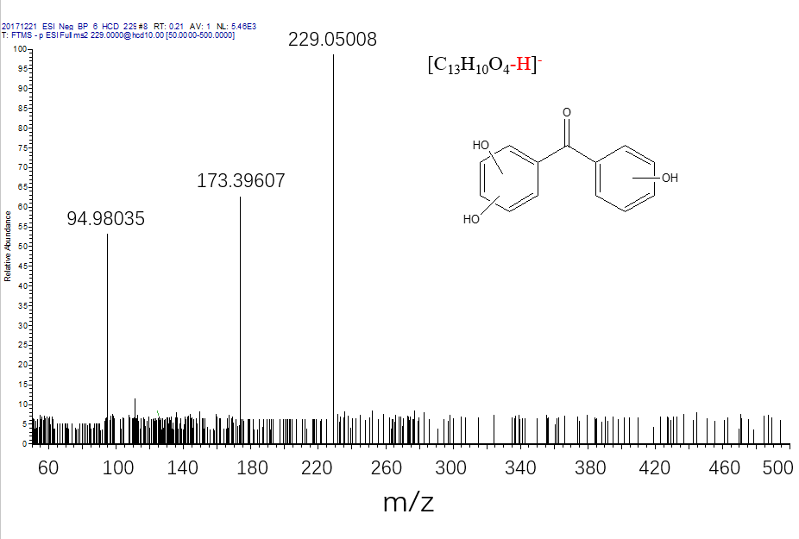

Figure S5. The mass spectrum of the intermediate P3.

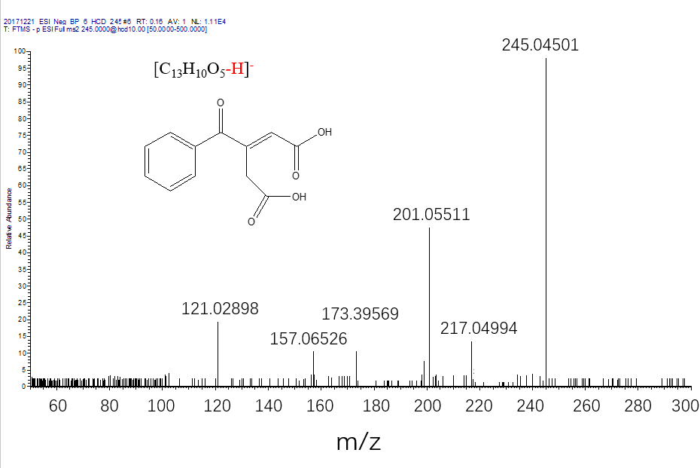

Figure S6. The mass spectrum of the intermediate P4.

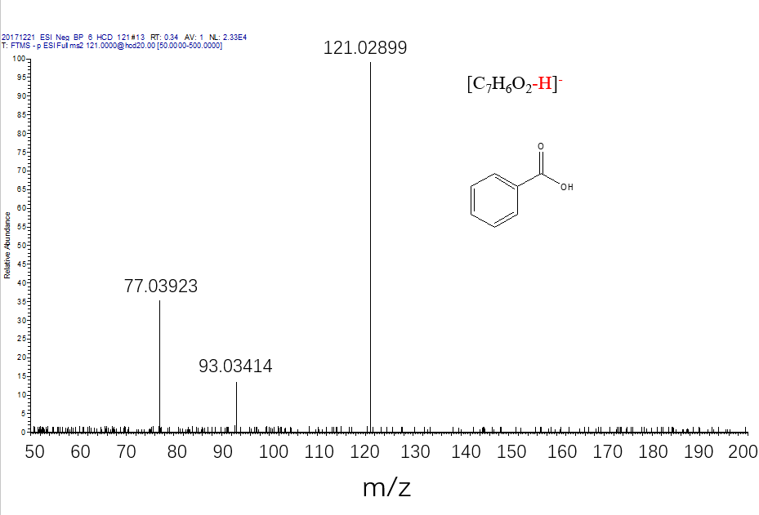

Figure S7. The mass spectrum of the intermediate P5.

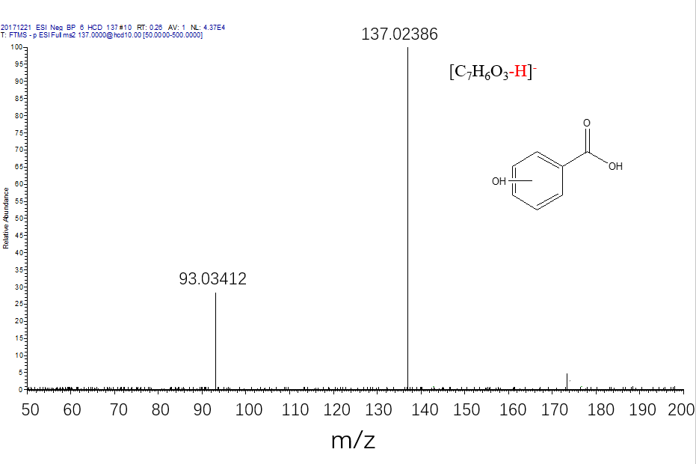

Figure S8. The mass spectrum of the intermediate P6.