Appendix
Appendix A Survey Questions
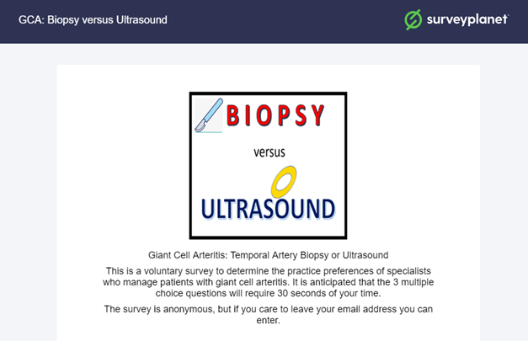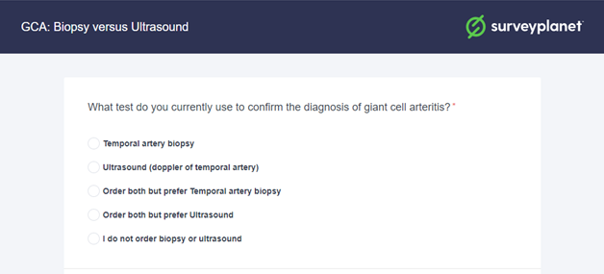
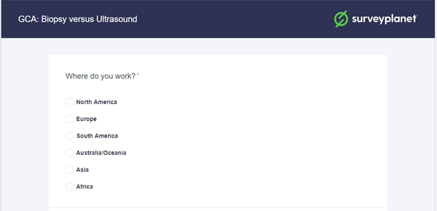

Appendix B: Estimation of Survey Response Rate
Calculations
NANOS members: 627 American + 55 Canadian = 682
ASOPRS members: 669 American + 28 Canadian = 697
Overlaps in NANOS & ASOPRS estimated at 5%: (682+697)*.95 = 1,310

Ont-Eye internet line ophthalmologists: 463-16-14 = 433
2018 communication with website moderator: 16 NANOS members overlap in Ont-Eye;
14 ASOPRS overlaps in Ont-Eye

EUNOS member: 244 - 4 NA = 240 recipients
Ontario rheumatologists: 270 according to College of Physicans and Surgeons website
Best denominator estimate =2,253
406 (NA + Europe&Israel) respondents/2253 = 18.0% response rate overall
Abbreviations
NANOS = North American Neuro-Ophthalmology Society
ASOPRS = American Society of Ophthalmic Plastic & Reconstructive Surgery
Ont-Eye = Eye Physicians and Surgeons of Ontario
EUNOS = European Neuro-ophthalmology Society
NA = North American
CPSO = College of Physicians and Surgeons of Ontario

Appendix C: Calculation of Survey 95% Confidence Intervals
Calculation of survey 95% confidence intervals was done using the online tool: https://www.surveysystem.com/sscalc.htm
Result | Sample Size Calculator
303/335 O&N NA +Europe (90.5% prefer TABx). Total estimated 1,983 O&N NA+Europe
95% CI is +/-2.9%
A total of 303 O&N in NA & Europe preferred TABx. 88.4% used TABx exclusively
95% CI is +/-3.32%

253 North American O&N / total 1743 O&N in North America with 95.58% choosing TABx
95% CI is +/-2.31%

82 European O&N / total 240 O&N in Europe with 74.39% choosing TABx  95% CI is +/-7.7 % | 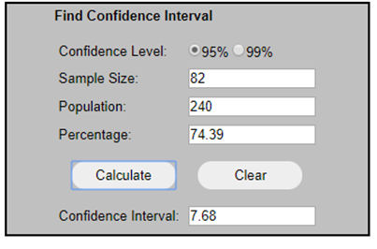
24.39 +/-7.56 % of op& neuro in Europe prefer US

64/71 rheumatologists in survey (90.14% prefer TABx). There are 270 provincially registered rheum
95%CI is +/- 6.0%

Appendix D: Statistical Tests for Regional Differences in O&N Preference for TABx
Chi Square Test
 | Region
 | Europe | North America | Total
Neither | 1 | 9 | 10
TABx | 61 | 242 | 303
US | 20 | 2 | 22
Total | 82 | 253 | 335

Pearson Chi² = 56.7492 Pr = < 0.001

Conventional 2 Sample Tests of Proportions
Although the test is not adjusted for survey weighting, given the 21% difference and survey confidence intervals, there would be no change in the inference.

Two-sample test of proportions x: Number of obs = 253
y: Number of obs = 82
 | Mean | Std. Err. | z | P>|z| | [95% Conf. Interval]
x | .9565217 | .012821 |  |  | .931393 | .9816505
y | .7439024 | .0482007 |  |  | .6494307 | .8383742
diff | .2126193 | .0498768 |  |  | .1148626 | .310376
 | under Ho: | .0373514 | 5.69 | 0.000

diff = prop(x) - prop(y) z = 5.6924
Ho: diff = 0
Ha: diff < 0 Ha: diff != 0 Ha: diff > 0
Pr(Z < z) = 1.0000 Pr(|Z| > |z|) = 0.0000 Pr(Z > z) = 0.0000

Appendix E: Statistical Tests for Specialty Differences in Preference for TABx
tab confirmtestcategory specialtycat

| SpecialtyCAT
ConfirmTestCATEGORY | Neurology Ophthal.. Rheumat.. | Total
----------------------+---------------------------------+----------
Neither | 0 10 3 | 13
Temporal artery bio.. | 34 269 64 | 367
Ultrasound (doppler.. | 3 19 4 | 26
----------------------+---------------------------------+----------
Total | 37 298 71 | 406

. prtesti 37 34 298 269, count

Two-sample test of proportions x: Number of obs = 37
y: Number of obs = 298
------------------------------------------------------------------------------
| Mean Std. Err. z P>|z| [95% Conf. Interval]
-------------+----------------------------------------------------------------
x | .9189189 .0448743 .8309669 1.006871
y | .9026846 .0171692 .8690335 .9363356
-------------+----------------------------------------------------------------
diff | .0162344 .0480467 -.0779354 .1104041
| under Ho: .0512348 0.32 0.751
------------------------------------------------------------------------------
diff = prop(x) - prop(y) z = 0.3169
Ho: diff = 0

Ha: diff < 0 Ha: diff != 0 Ha: diff > 0
Pr(Z < z) = 0.6243 Pr(|Z| > |z|) = 0.7513 Pr(Z > z) = 0.3757

. prtesti 71 64 298 269, count

Two-sample test of proportions x: Number of obs = 71
y: Number of obs = 298
------------------------------------------------------------------------------
| Mean Std. Err. z P>|z| [95% Conf. Interval]
-------------+----------------------------------------------------------------
x | .9014085 .0353795 .8320659 .970751
y | .9026846 .0171692 .8690335 .9363356
-------------+----------------------------------------------------------------
diff | -.0012761 .0393254 -.0783526 .0758003
| under Ho: .0391853 -0.03 0.974
------------------------------------------------------------------------------
diff = prop(x) - prop(y) z = -0.0326
Ho: diff = 0

Ha: diff < 0 Ha: diff != 0 Ha: diff > 0
Pr(Z < z) = 0.4870 Pr(|Z| > |z|) = 0.9740 Pr(Z > z) = 0.5130

. prtesti 71 64 37 34, count

Two-sample test of proportions x: Number of obs = 71
y: Number of obs = 37
------------------------------------------------------------------------------
| Mean Std. Err. z P>|z| [95% Conf. Interval]
-------------+----------------------------------------------------------------
x | .9014085 .0353795 .8320659 .970751
y | .9189189 .0448743 .8309669 1.006871
-------------+----------------------------------------------------------------
diff | -.0175105 .0571438 -.1295102 .0944892
| under Ho: .0587721 -0.30 0.766
------------------------------------------------------------------------------
diff = prop(x) - prop(y) z = -0.2979
Ho: diff = 0

Ha: diff < 0 Ha: diff != 0 Ha: diff > 0
Pr(Z < z) = 0.3829 Pr(|Z| > |z|) = 0.7658 Pr(Z > z) = 0.6171

