Supplementary Information

**Synthesis of 1,4,5-trisubstituted 1,2,3-triazoles through a one-pot three component reaction of boronic acids, sodium azide and active methylene compounds under ball-milling conditions**

Rahman Hosseinzadeh1*, Fatemeh Fathalipour1, Mahmood Tajbakhsh1, Mohammad Mavvaji1, Mona Pooryousef1

1Department of Organic Chemistry,Faculty of Chemistry,University of Mazandaran, Babolsar, Iran.

* Corresponding author. Tel.: +0-98-1135302350; fax: +0-98-1135302350

Email address: [r.hosseinzadeh@umz.ac.ir](mailto:r.hosseinzadeh@umz.ac.ir)





**Figure S1-** **a)** 1H-NMR spectrum of Ethyl 5-methyl-1-phenyl-1H-1,2,3-triazole-4-carboxylate (**1**)



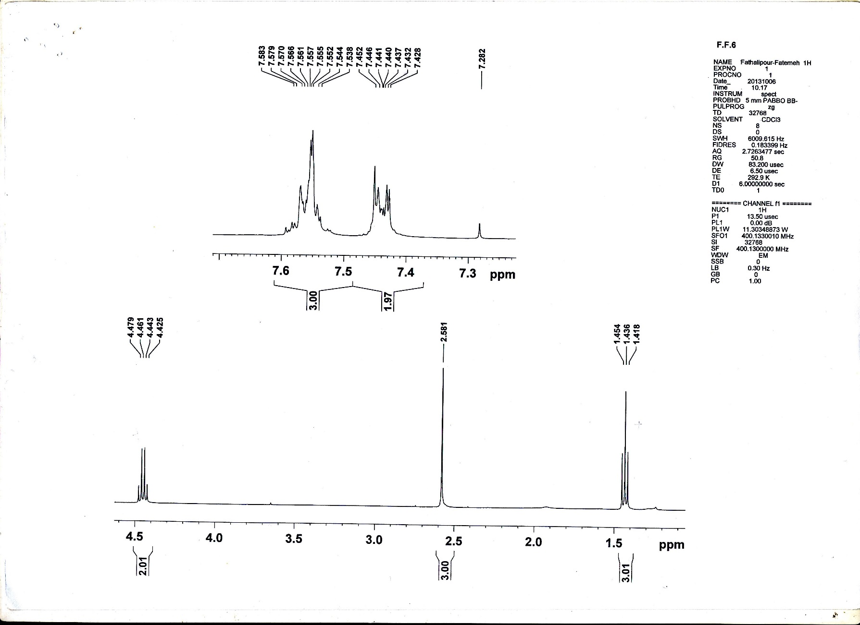

**Figure S1-** **b)** Expanded 1H-NMR spectrum of Ethyl 5-methyl-1-phenyl-1H-1,2,3-triazole-4-carboxylate (**1**)



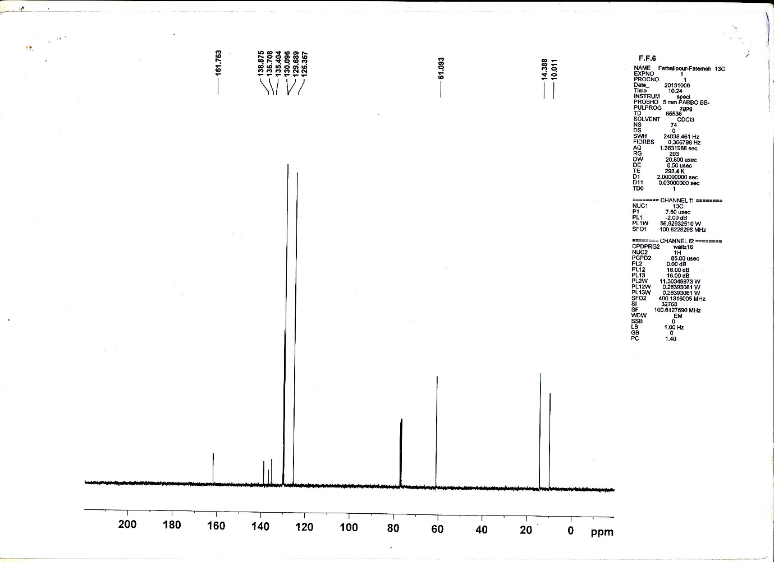

**Figure S1-****c)** 13C-NMR spectrum of Ethyl 5-methyl-1-phenyl-1H-1,2,3-triazole-4-carboxylate (**1**)

:



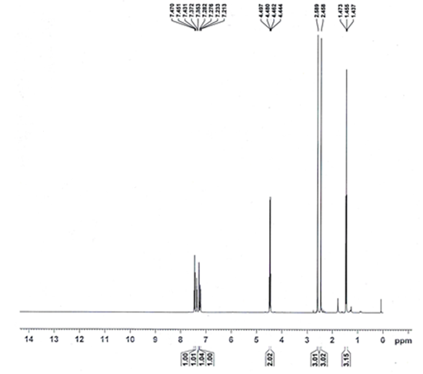

**Figure S2-** **a)** 1H-NMR spectrum of Ethyl 5-methyl-1-(m-tolyl)-1H-1,2,3-triazole-4-carboxylate (**2**)



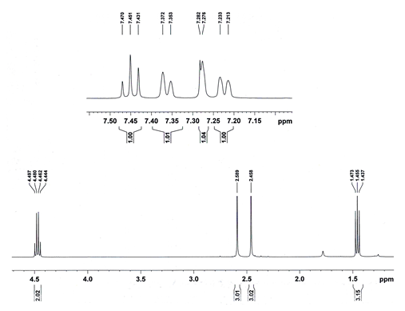

**Figure S2-** **b)** Expanded 1H-NMR spectrum of Ethyl 5-methyl-1-(m-tolyl)-1H-1,2,3-triazole-4-carboxylate (**2**)



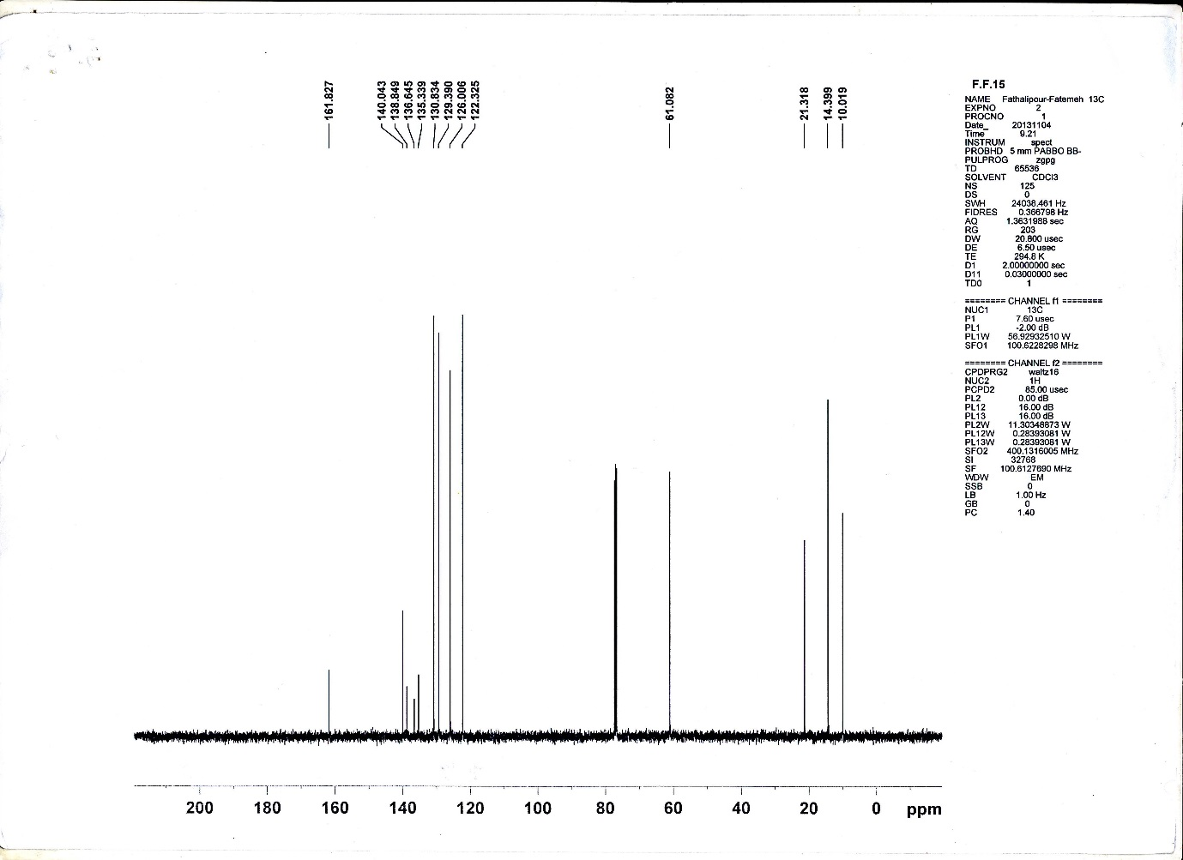

**Figure S2-** **c)** 13C-NMR spectrum of Ethyl 5-methyl-1-(m-tolyl)-1H-1,2,3-triazole-4-carboxylate (**2**)



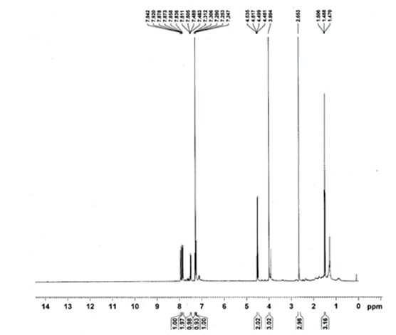

**Figure S3-** **a)** 1H-NMR spectrum of Ethyl 1-(6-methoxynaphthalen-2-yl)-5-methyl-1H-1,2,3-triazole-4-carboxylate (**3**)



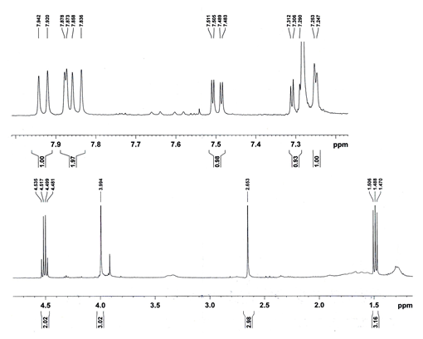

**Figure S3-** **b)** Expanded 1H-NMR spectrum of Ethyl 1-(6-methoxynaphthalen-2-yl)-5-methyl-1H-1,2,3-triazole-4-carboxylate (**3**)



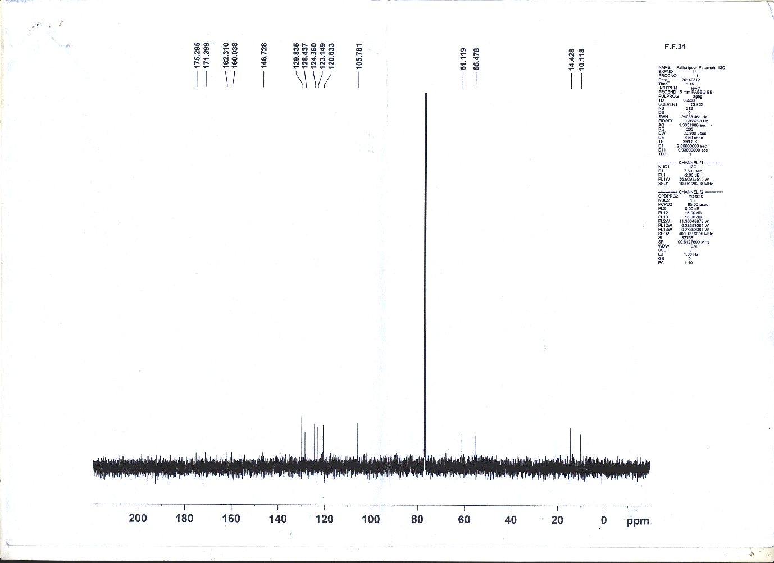

**Figure S3-** **c)** 13C-NMR spectrum of Ethyl 1-(6-methoxynaphthalen-2-yl)-5-methyl-1H-1,2,3-triazole-4-carboxylate (**3**)



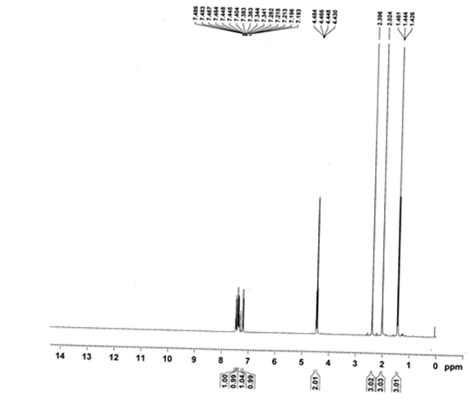

**Figure S4-** **a)** 1H-NMR spectrum of Ethyl 5-methyl-1-(o-tolyl)-1H-1,2,3-triazole-4-carboxylate (**4**)



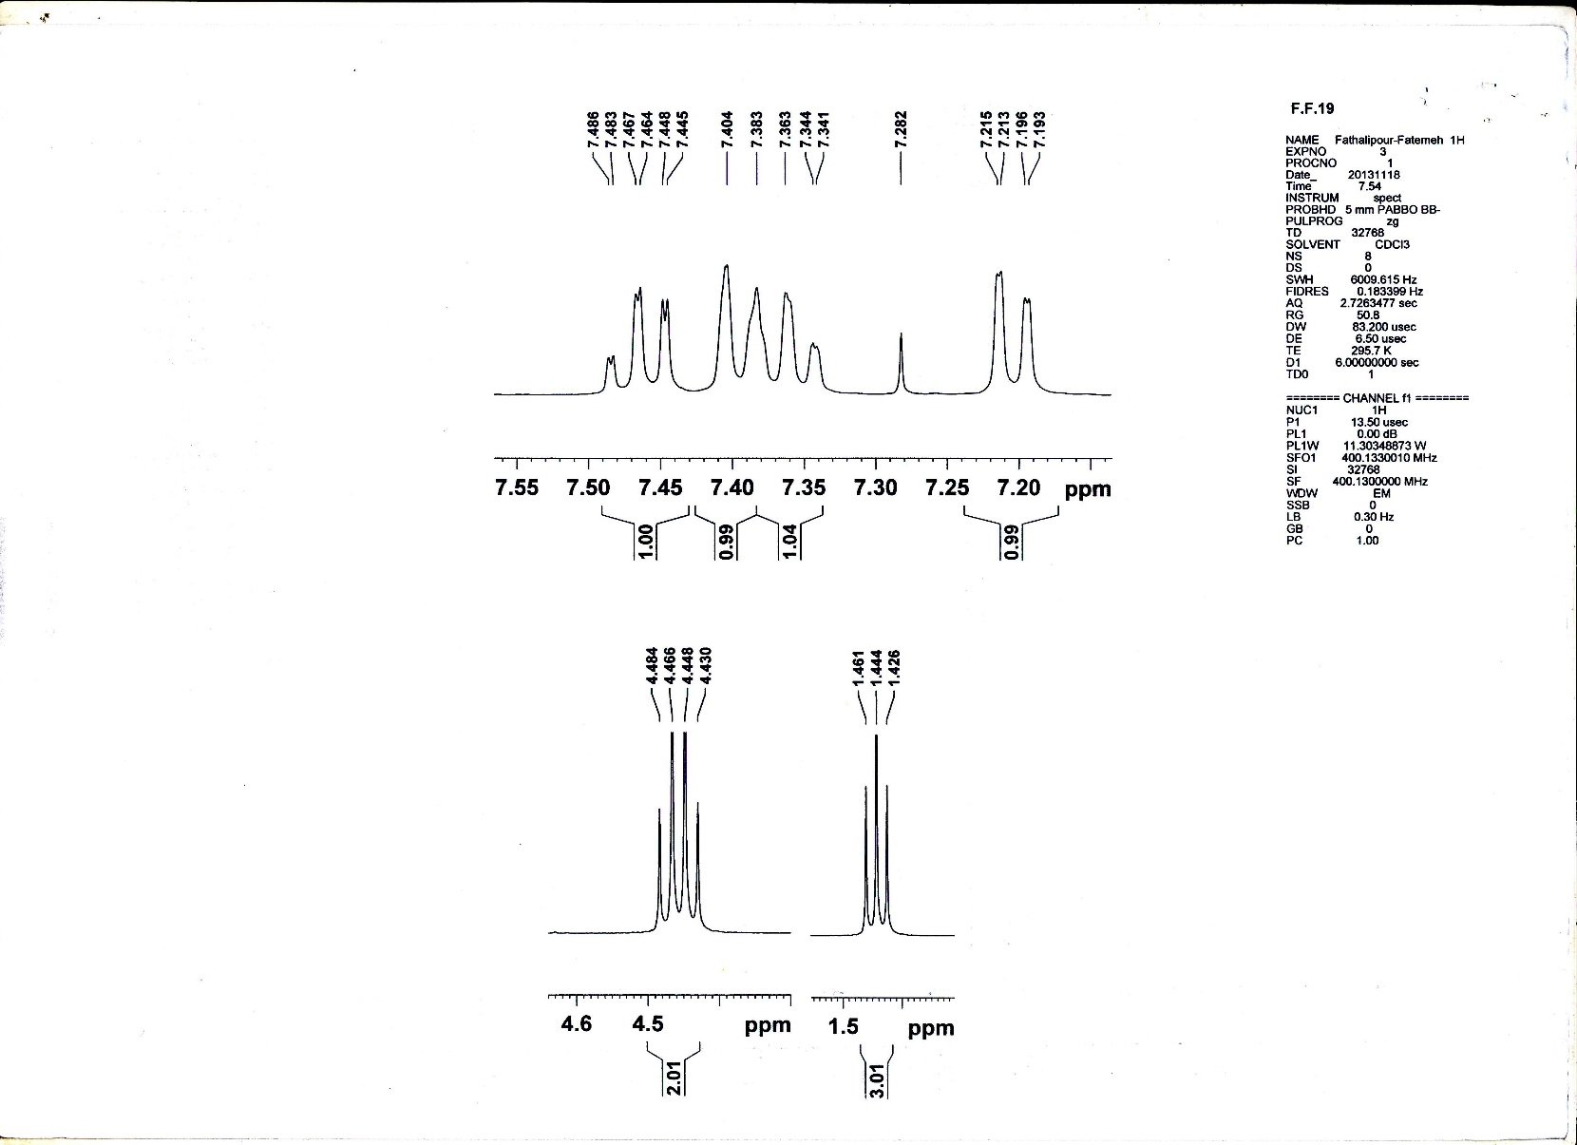

**Figure S4-** **b)** Expanded 1H-NMR spectrum of Ethyl 5-methyl-1-(o-tolyl)-1H-1,2,3-triazole-4-carboxylate (**4**)



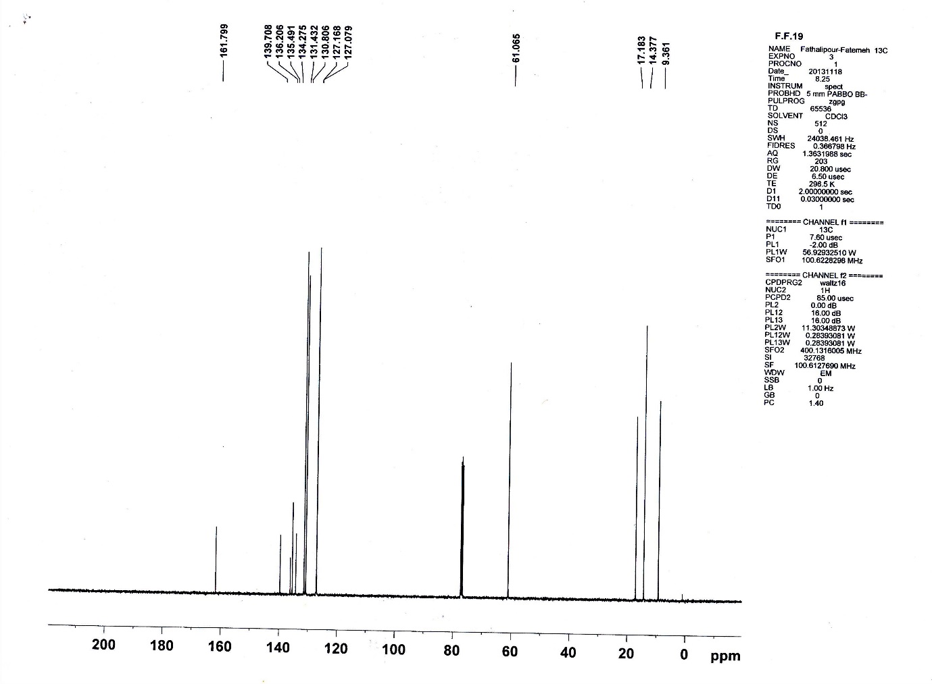

**Figure S4-** **c)** 13C-NMR spectrum of Ethyl 5-methyl-1-(o-tolyl)-1H-1,2,3-triazole-4-carboxylate (**4**)



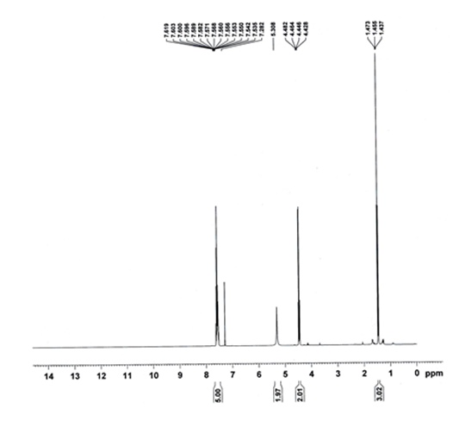

**Figure S5-** **a)** 1H-NMR spectrum of Ethyl 5-amino-1-phenyl-1H-1,2,3-triazole-4-carboxylate (**5**)



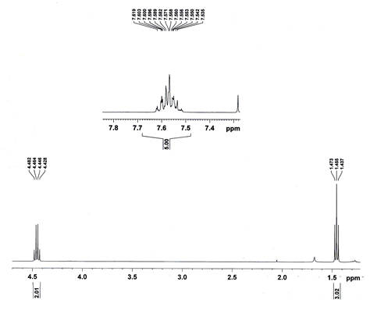

**Figure S5-** **b)** Expanded 1H-NMR spectrum of Ethyl 5-amino-1-phenyl-1H-1,2,3-triazole-4-carboxylate (**5**)



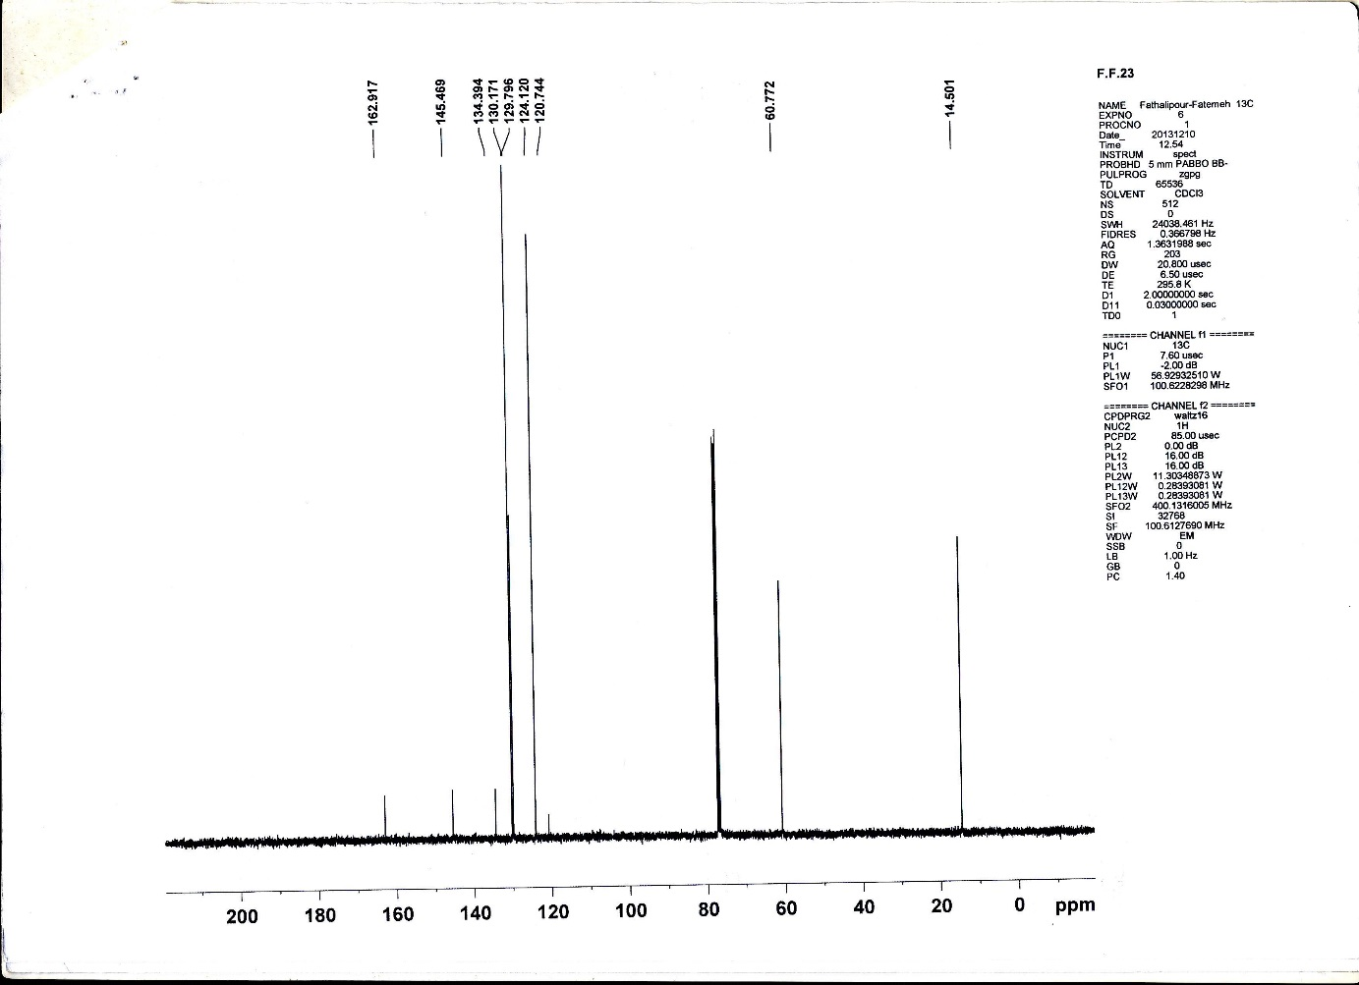

**Figure S5-** **c)** 13C-NMR spectrum of Ethyl 5-amino-1-phenyl-1H-1,2,3-triazole-4-carboxylate (**5**)



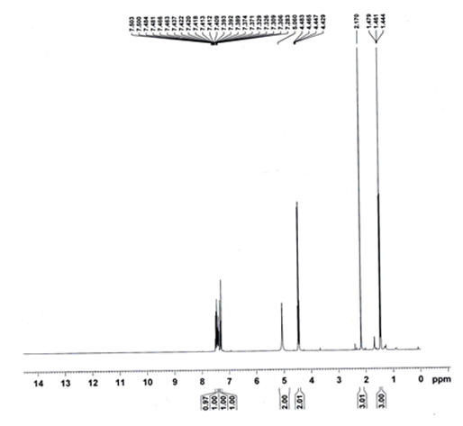

**Figure S6-** **a)** 1H-NMR spectrum of Ethyl 5-amino-1-(o-tolyl)-1H-1,2,3-triazole-4-carboxylate (**6**)



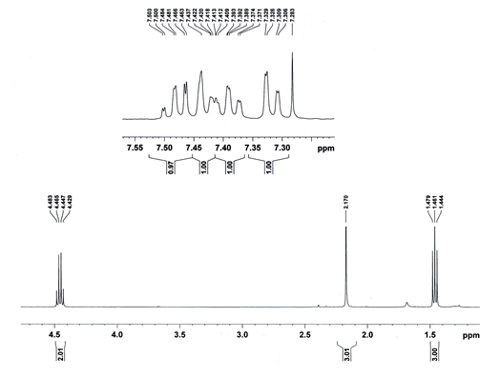

**Figure S6-** **b)** Expanded 1H-NMR spectrum of Ethyl 5-amino-1-(o-tolyl)-1H-1,2,3-triazole-4-carboxylate (**6**)



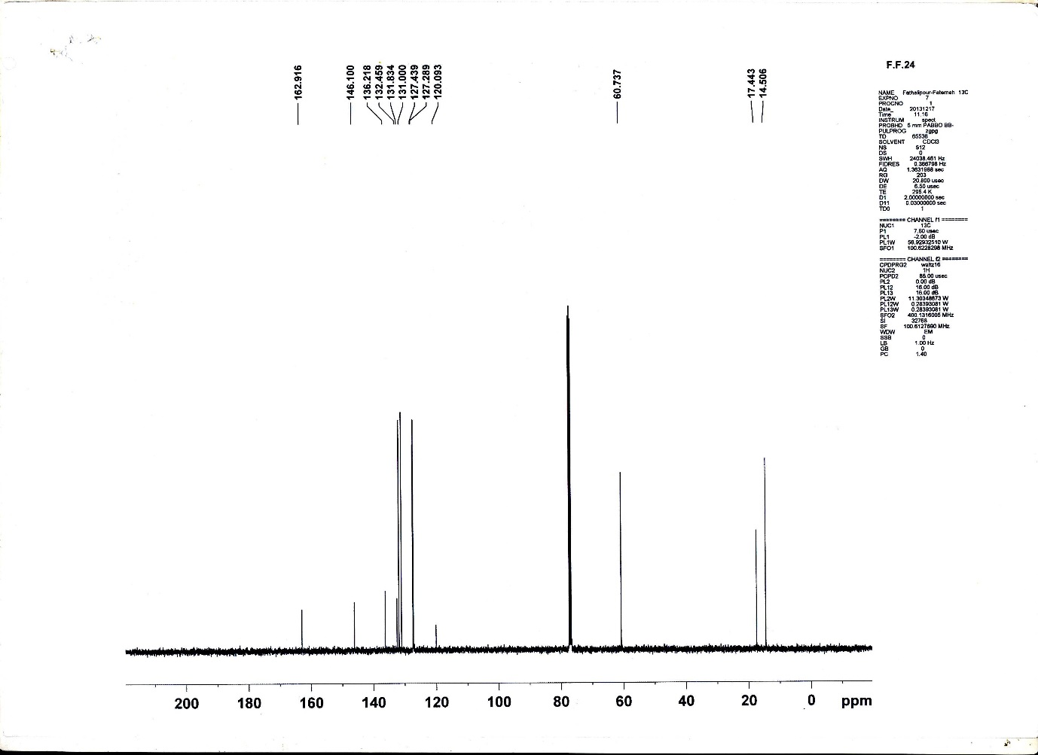

**Figure S6-** **c)** 13C-NMR spectrum of Ethyl 5-amino-1-(o-tolyl)-1H-1,2,3-triazole-4-carboxylate (**6**)



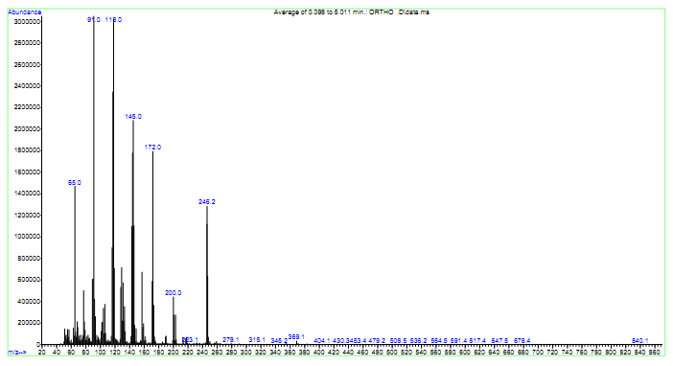

**Figure S6-** **d)** Mass spectrum of Ethyl 5-amino-1-(o-tolyl)-1H-1,2,3-triazole-4-carboxylate (**6**)



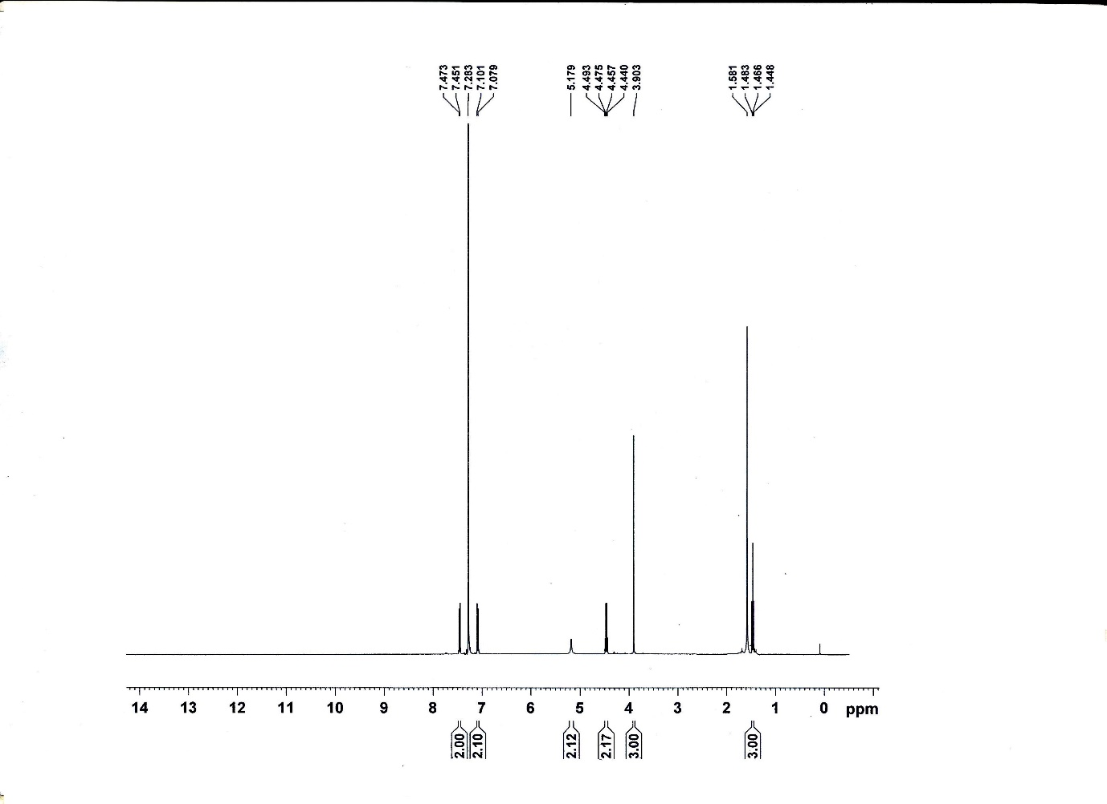

**Figure S7-** **a)** 1H-NMR spectrum of Ethyl 5-amino-1-(4-methoxyphenyl)-1H-1,2,3-triazole-4-carboxylate (**7**)



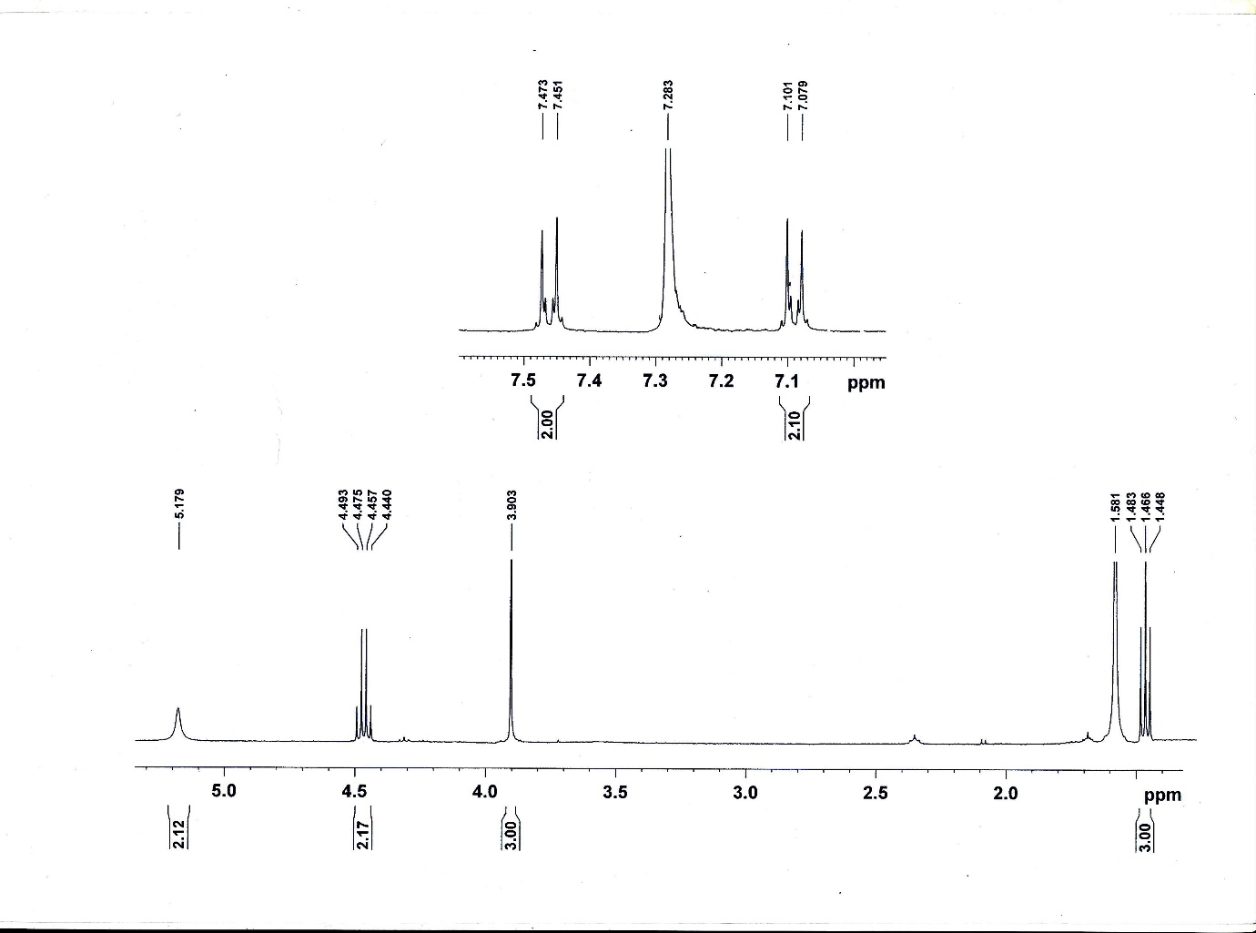

**Figure S7-** **b)** Expanded 1H-NMR spectrum of Ethyl 5-amino-1-(4-methoxyphenyl)-1H-1,2,3-triazole-4-carboxylate (**7**)



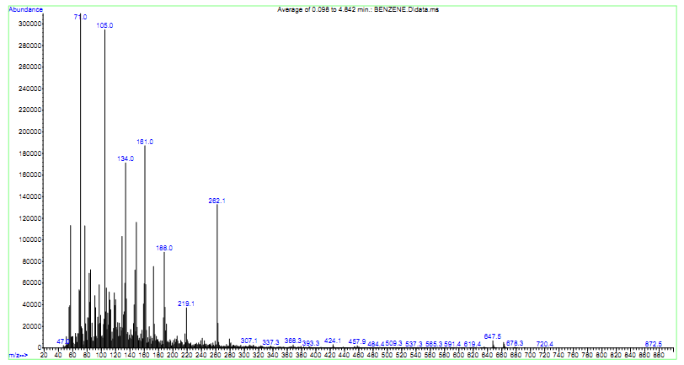

**Figure S7-** **c)** Mass spectrum of Ethyl 5-amino-1-(4-methoxyphenyl)-1H-1,2,3-triazole-4-carboxylate (**7**)



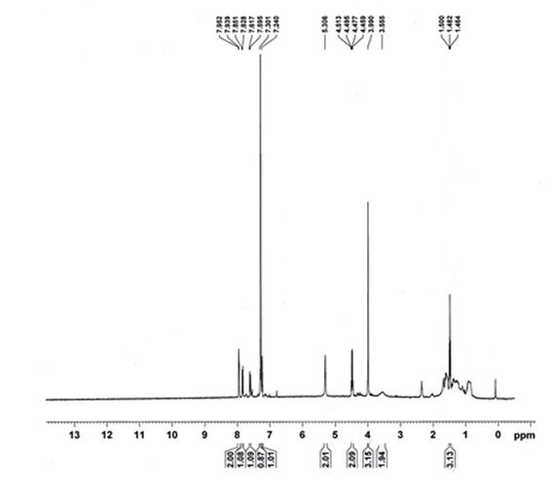

**Figure S8-** **a)** 1H-NMR spectrum of Ethyl 5-amino-1-(6-methoxynaphthalen-2-yl)-1H-1,2,3-triazole-4-carboxylate (**8**)



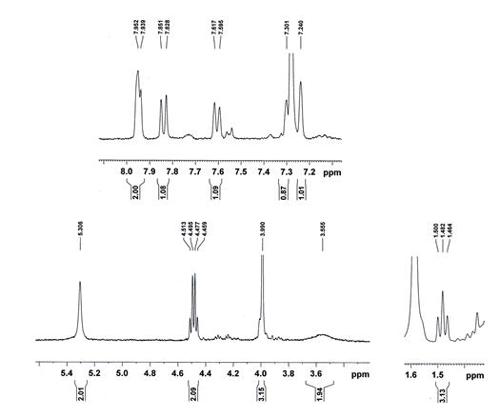

**Figure S8-** **b)** Expanded 1H-NMR spectrum of Ethyl 5-amino-1-(6-methoxynaphthalen-2-yl)-1H-1,2,3-triazole-4-carboxylate (**8**)



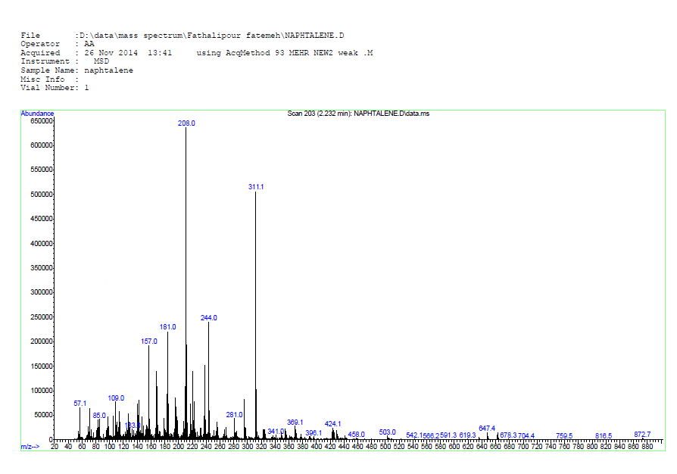

**Figure S8-** **c)** Mass spectrum of Ethyl 5-amino-1-(6-methoxynaphthalen-2-yl)-1H-1,2,3-triazole-4-carboxylate (**8**)



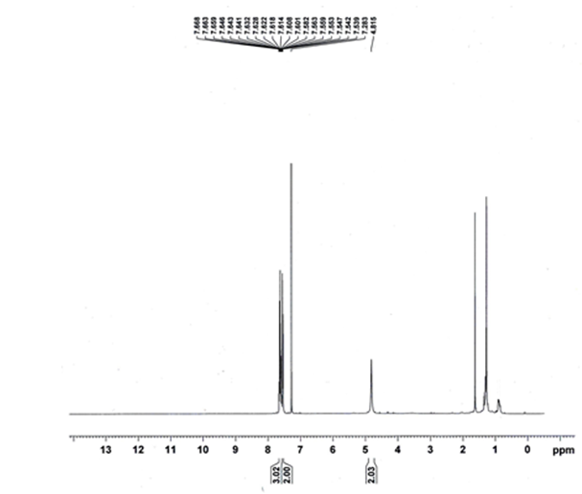

**Figure S9-** **a)** 1H-NMR spectrum of 5-Amino-1-phenyl-1H-1,2,3-triazole-4-carbonitrile (**9**)



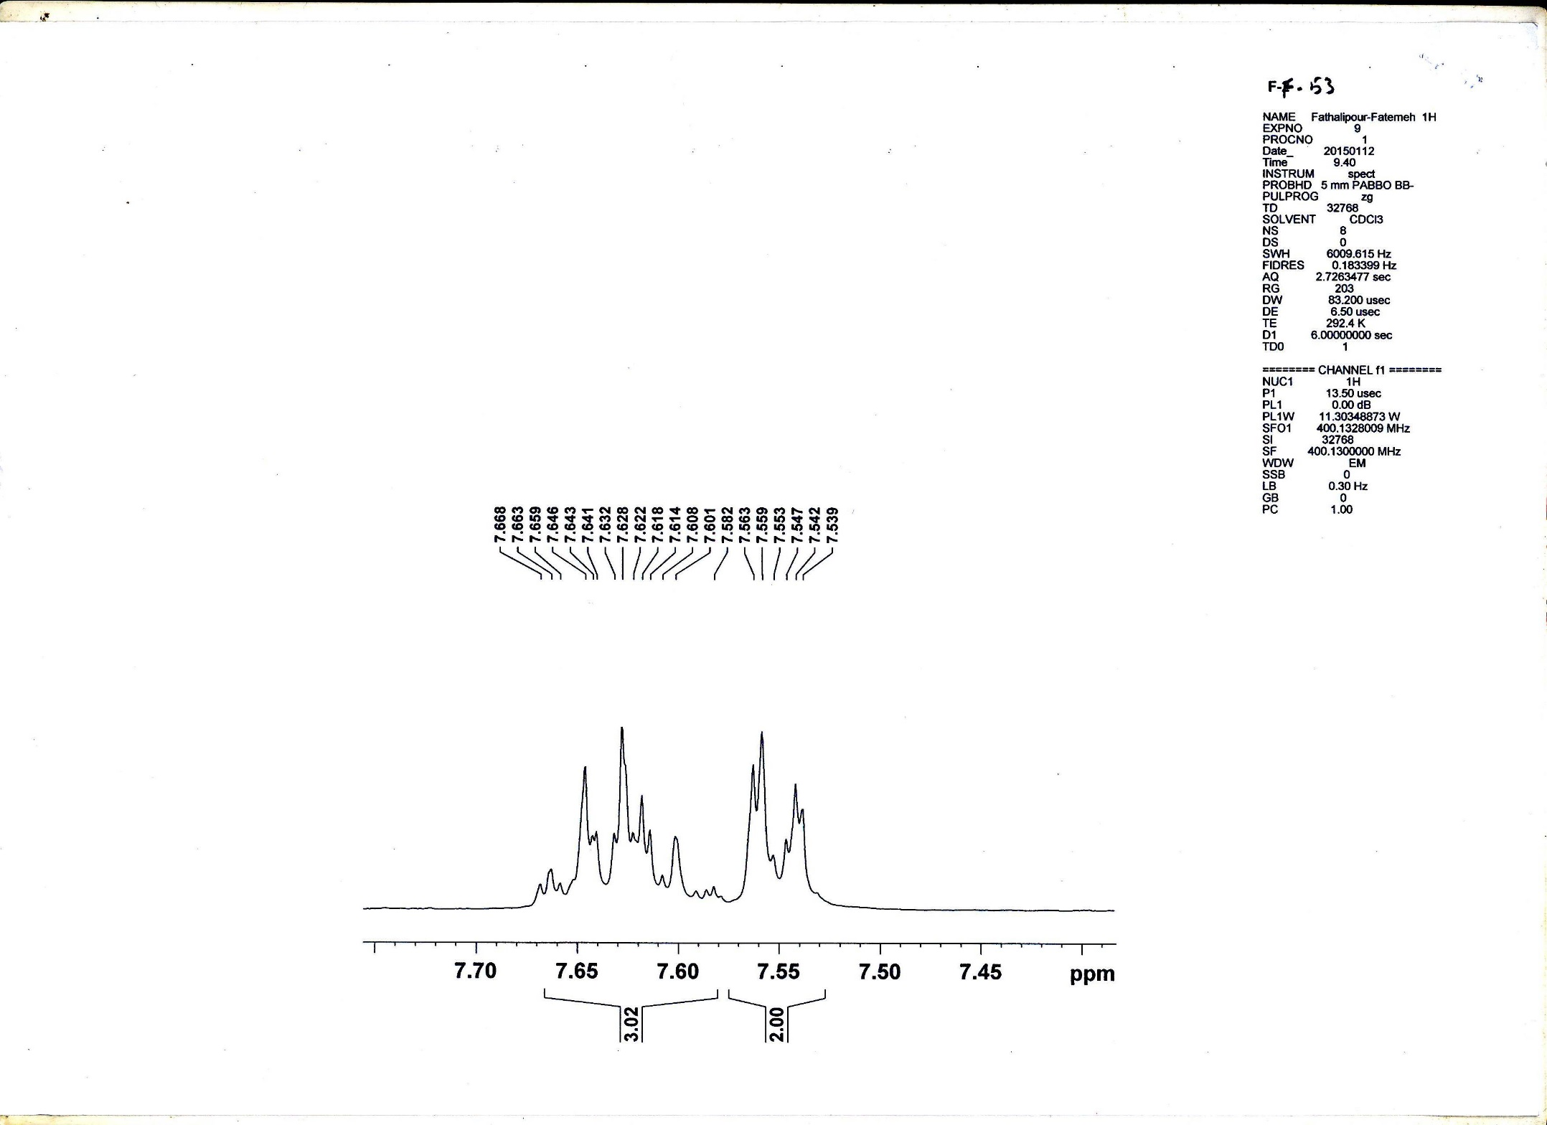

**Figure S9-** **b)** Expanded 1H-NMR spectrum of 5-Amino-1-phenyl-1H-1,2,3-triazole-4-carbonitrile (**9**)



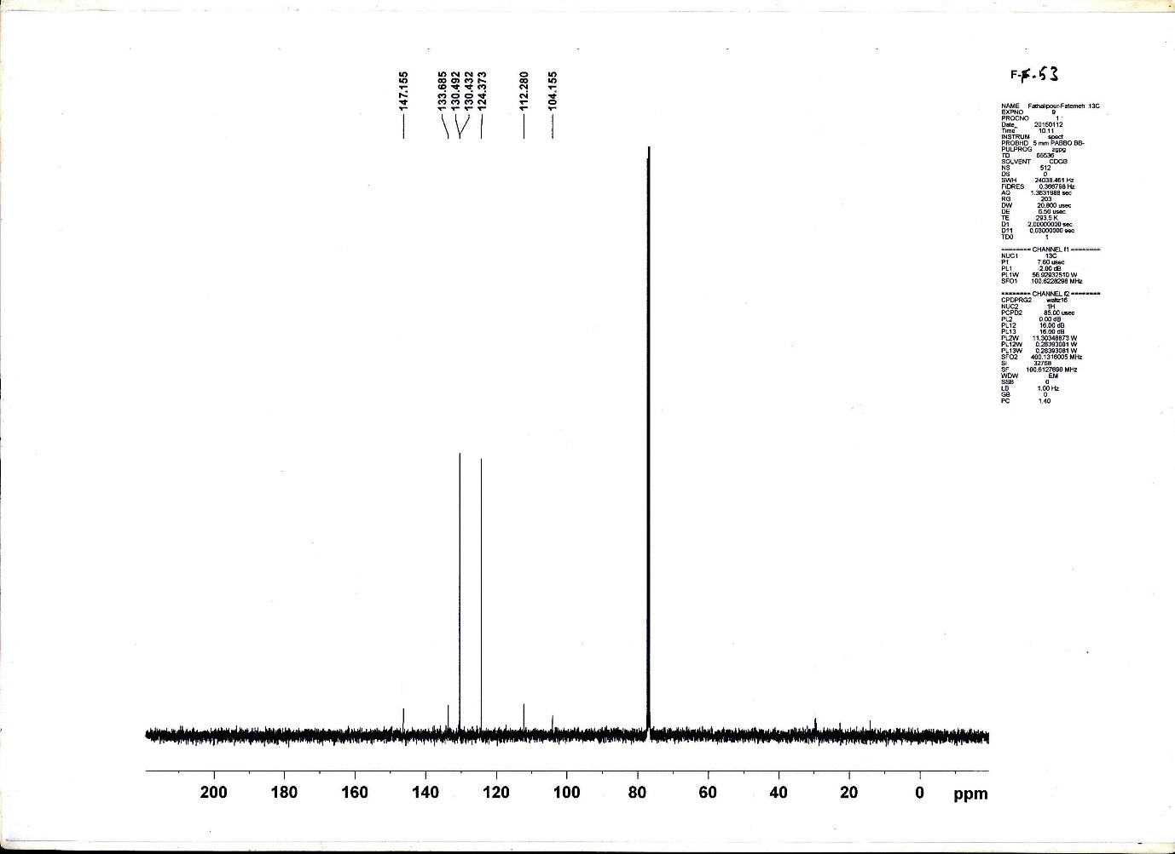

**Figure S9-** **c)** 13C-NMR spectrum of 5-Amino-1-phenyl-1H-1,2,3-triazole-4-carbonitrile (**9**)



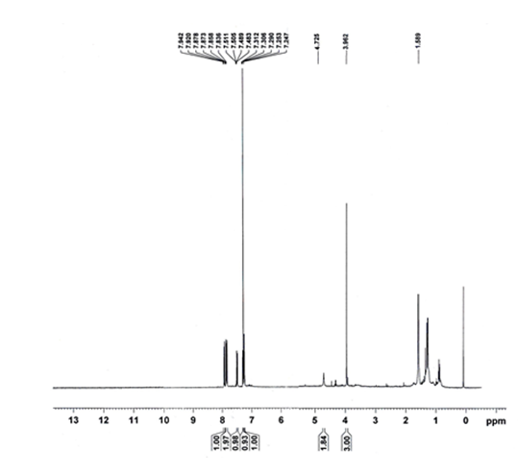

**Figure S10-** **a)** 1H-NMR spectrum of 5-Amino-1-(6-methoxynaphthalen-2-yl)-1H-1,2,3-triazole-4-carbonitrile (**10**)



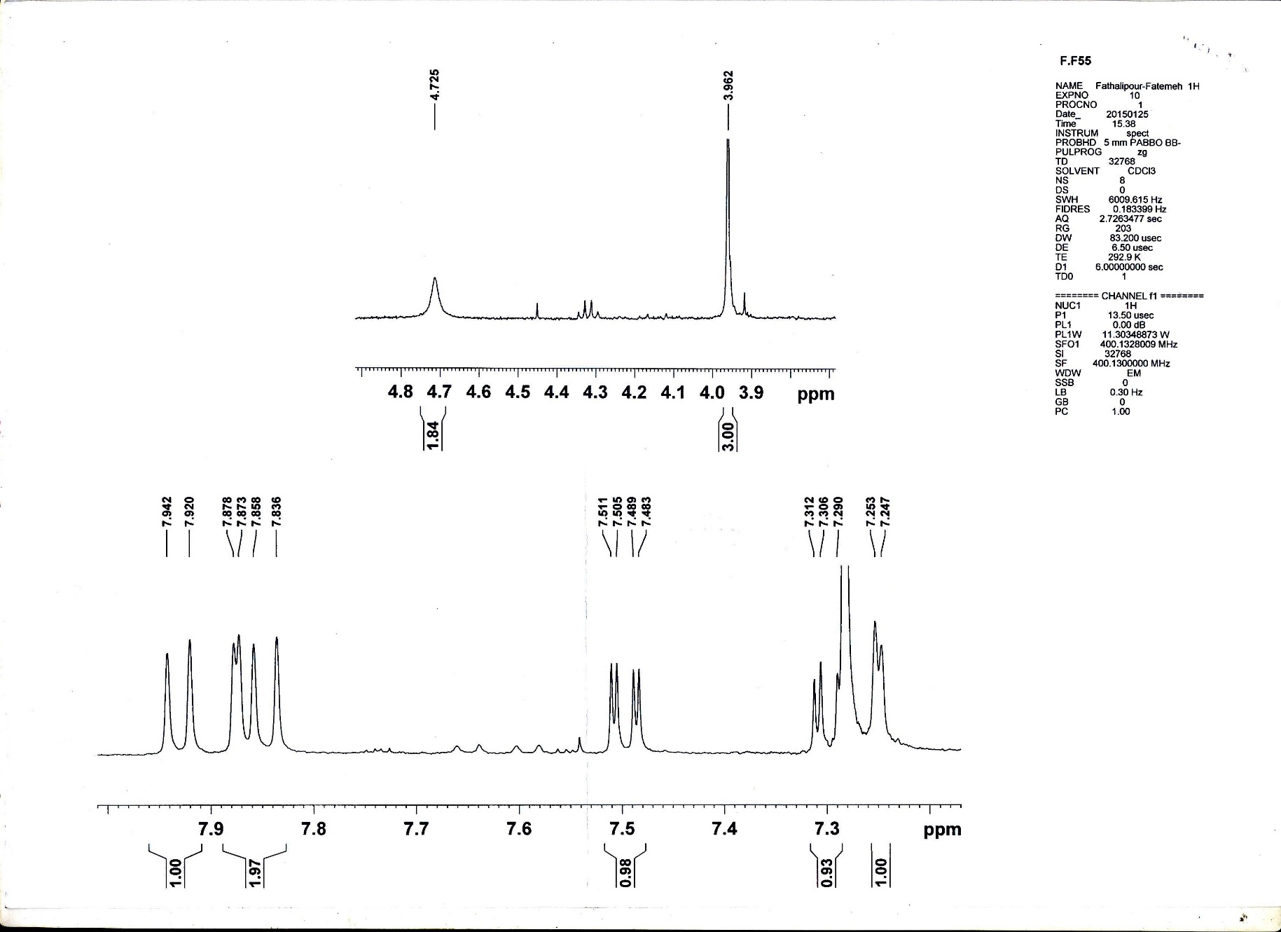

**Figure S10-** **b)** Expanded 1H-NMR spectrum of 5-Amino-1-(6-methoxynaphthalen-2-yl)-1H-1,2,3-triazole-4-carbonitrile (**10**)