Electronic Supplementary Information

Magnetic retrieval of a switchable hydrophilicity solvent: Fast homogeneous liquid–liquid microextraction for the determination of benzophenone‐type UV filters in environmental waters

Hasan Çabuk*, Onur Kavaracı

Zonguldak Bülent Ecevit University, Faculty of Arts and Sciences, Department of Chemistry, 67100, Zonguldak, TURKEY

Corresponding author: Dr. Hasan Çabuk,
Zonguldak Bülent Ecevit University, Faculty of Arts and Sciences, Department of Chemistry, 67100, Zonguldak, TURKEY
Tel.: 00 90 372 291 1920
Fax: 00 90 372 257 41 81
E-mail: cabukhasan@hotmail.com

Figure S1. Effect of magnetic retrieval time. 6M HCl, 200 µL; DEHPA, 40 µL; Fe₃O₄ NPs, 40 mg; elution solvent and its volume, acetonitrile and 400 µL; elution time, 2 min; spike level, 125 µg L⁻¹.

Figure S2. FT-IR spectra of Fe₃O₄-DEHPA complex after elution of analytes with acetonitrile.

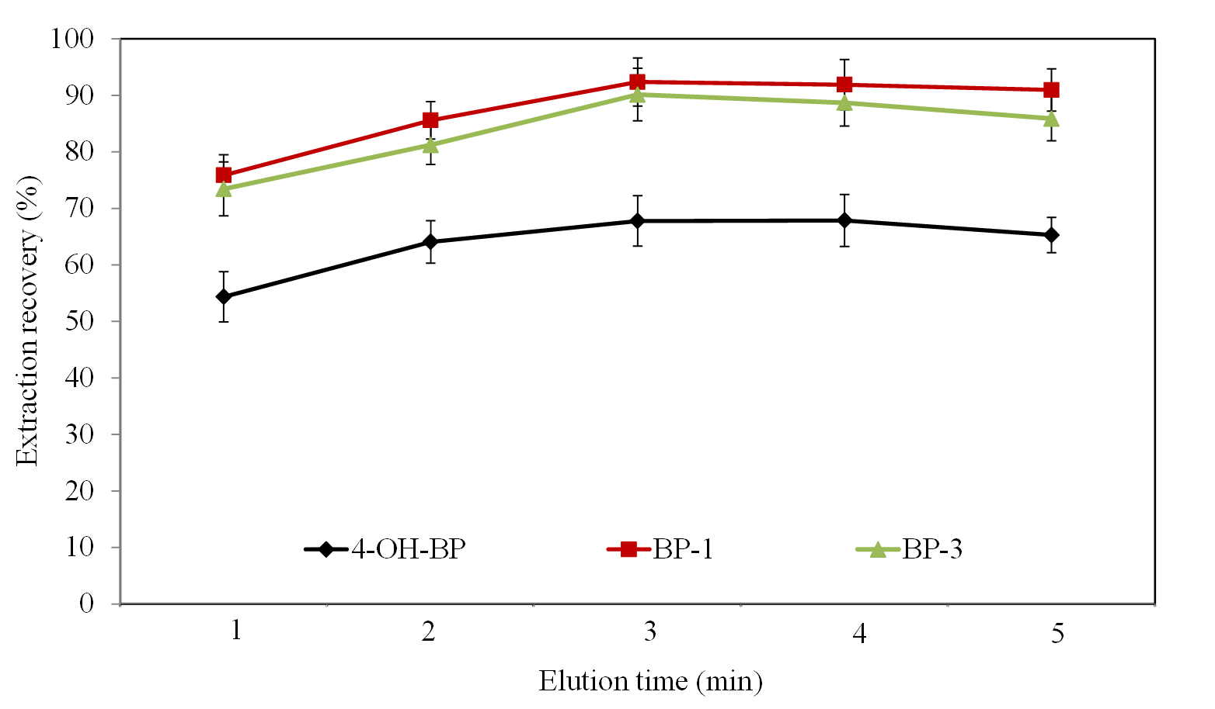
Figure S3. Effect of elution time. 6M HCl, 200 µL; DEHPA, 40 µL; Fe₃O₄ NPs, 40 mg; magnetic retrieval time, 3 min; elution solvent and its volume, acetonitrile and 300 µL; spike level, 125 µg L⁻¹.

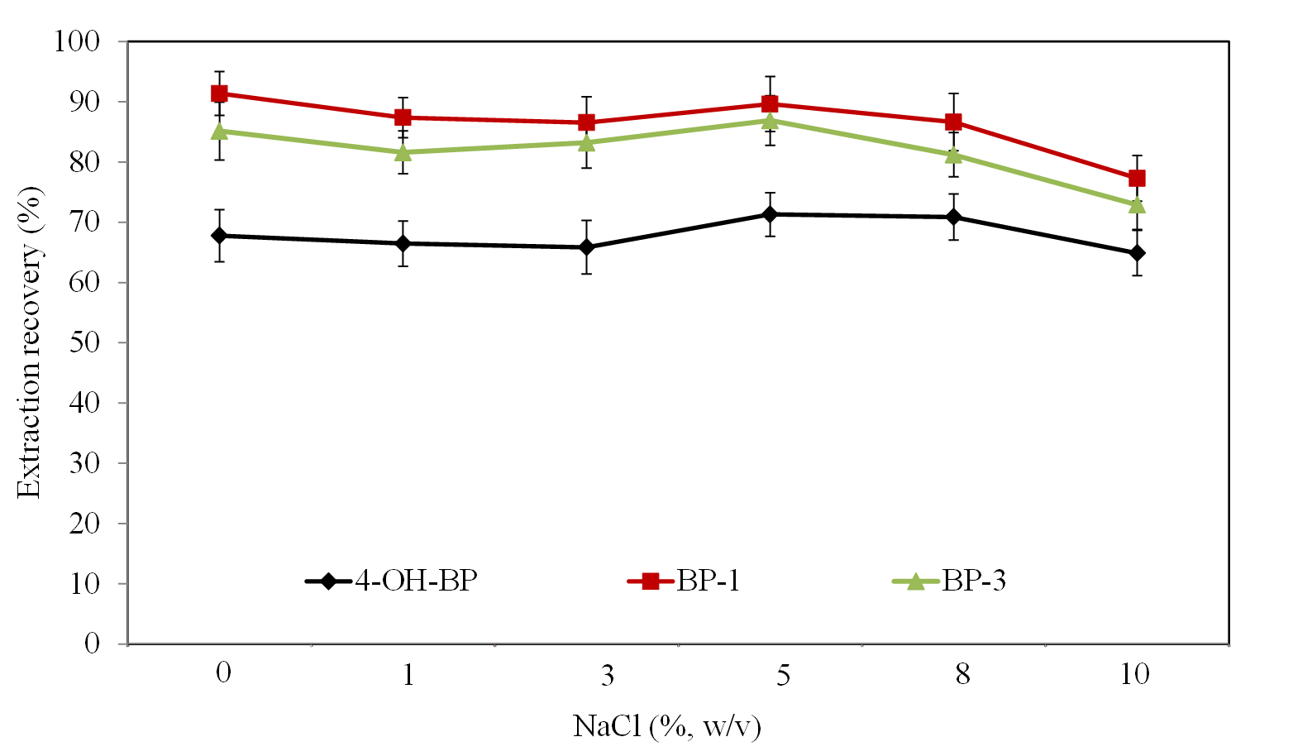
Figure S4. Effect of ionic strength. 6M HCl, 200 µL; DEHPA, 40 µL; Fe₃O₄ NPs, 40 mg; magnetic retrieval time, 3 min; elution solvent and its volume, acetonitrile and 300 µL; elution time, 3 min; spike level, 125 µg L⁻¹.

