Ultrasound assisted eco-friendly synthesis of 3-cinnamoyl coumarins using N,N'-(1,2-phenylene)bis(2-aminobenzamide) dichloro cobalt immobilized on mesoporous Al-SBA-15 as a new and recyclable catalyst

Zeinab Akbarzadeh and Javad Safaei-Ghomi*
Department of Organic Chemistry, Faculty of Chemistry, University of Kashan, Kashan, 87317, I.R. Iran

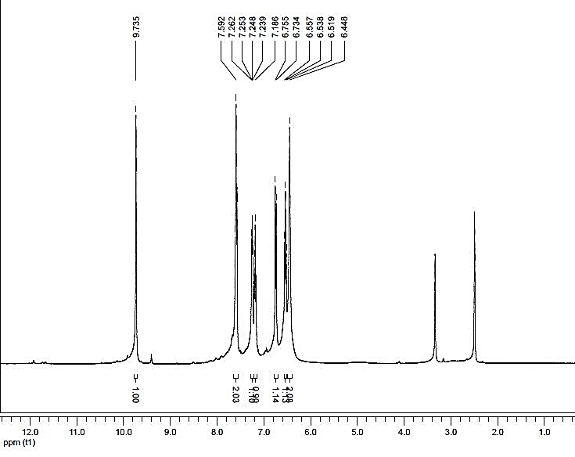
Fig. S1. ¹HNMR of N,N'-(1,2-phenylene)bis(2-aminobenzamide) ligand in DMSO-d₆
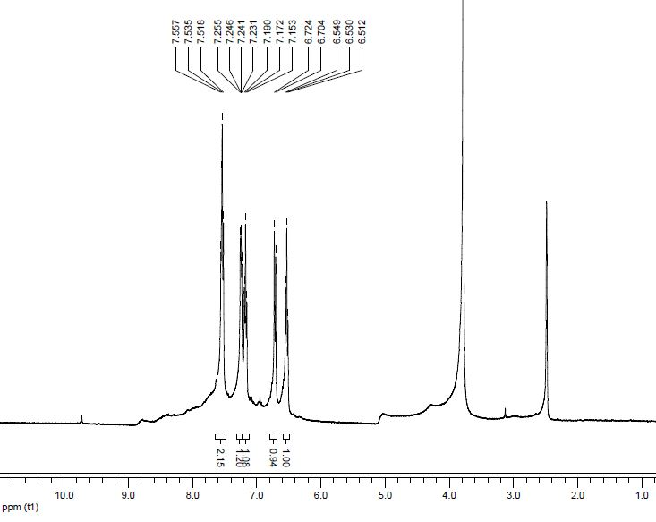
Fig.S2. ¹HNMR (Exchange with D₂O) of N,N'-(1,2-phenylene)bis(2-aminobenzamide) in DMSO-d₆

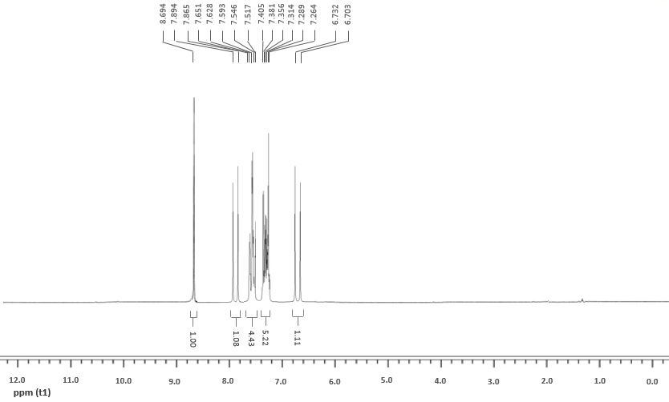
Fig.S3. ¹H NMR – Compound 4a

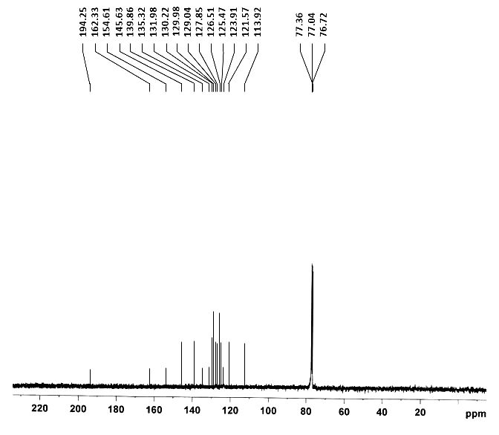
Fig.S4. ¹³C NMR – Compound 4a

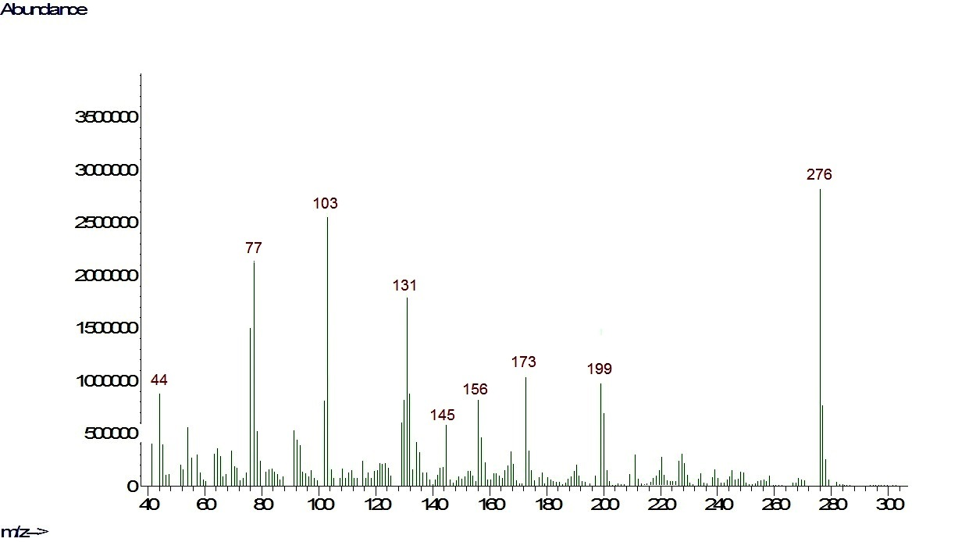 Fig.S5. MS – Compound 4a

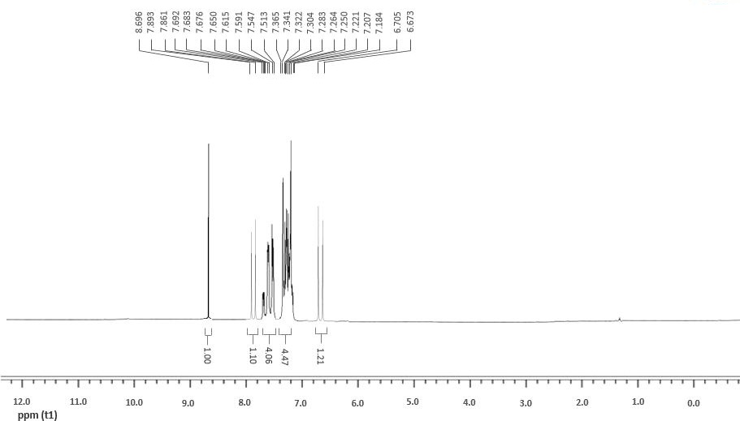
Fig.S6. ¹H NMR – Compound 4b

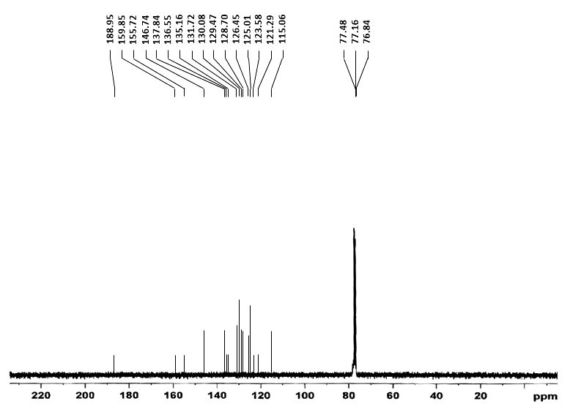
Fig.S7. ¹³C NMR – Compound 4b

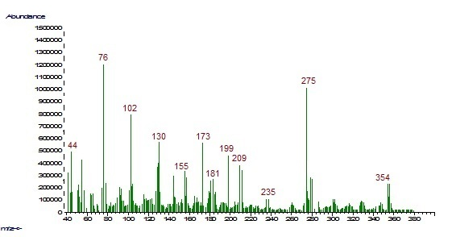
Fig.S8. MS – Compound 4b

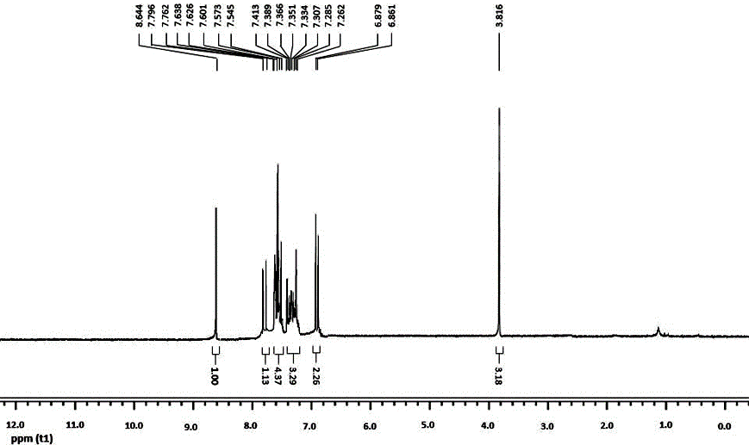
Fig.S9. ¹H NMR – Compound 4c

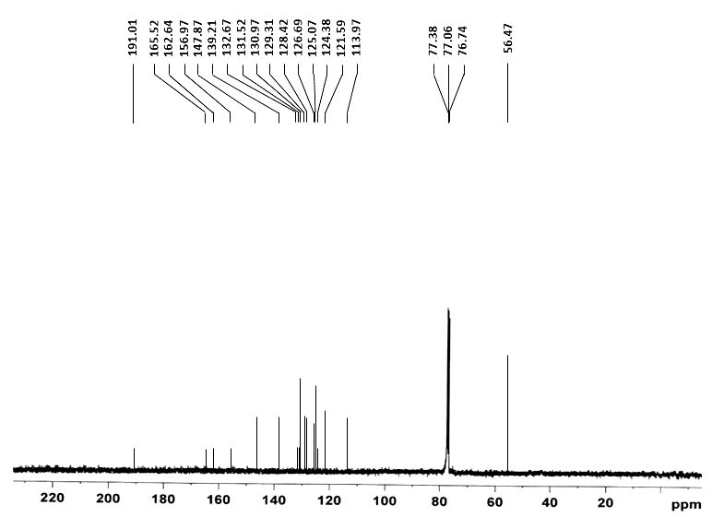
Fig.S10. ¹³C NMR – Compound 4c

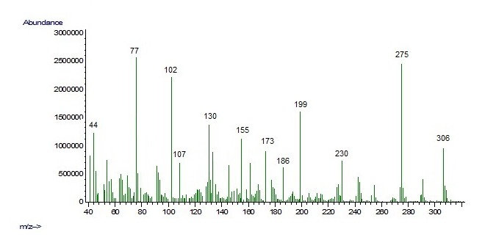
Fig.S11. MS – Compound 4c

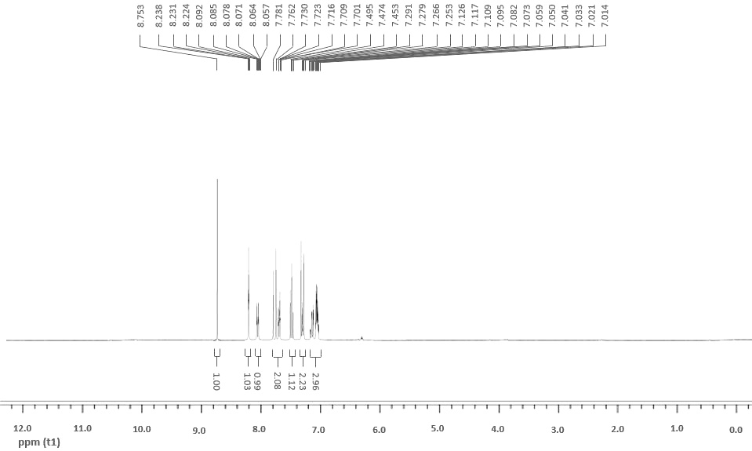
Fig.S12. ¹H NMR – Compound 4d

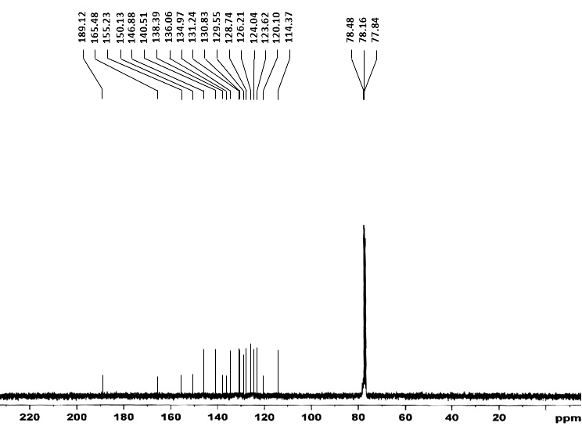
Fig.S13. ¹³C NMR – Compound 4d

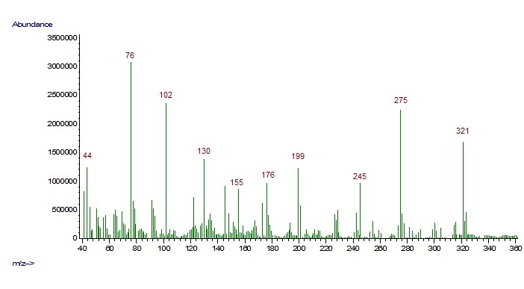
Fig.S14. MS – Compound 4d

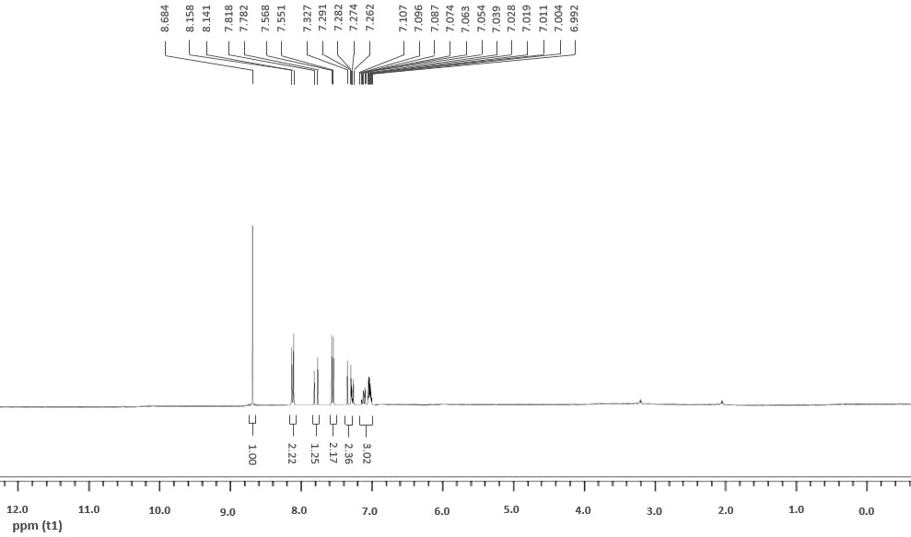
Fig.S15. ¹H NMR – Compound 4e

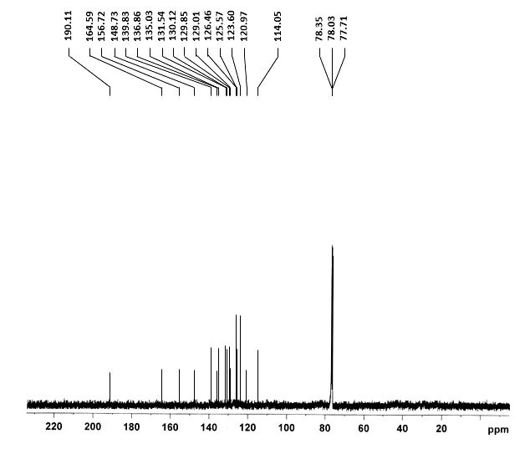
Fig.S16. ¹³C NMR – Compound 4e

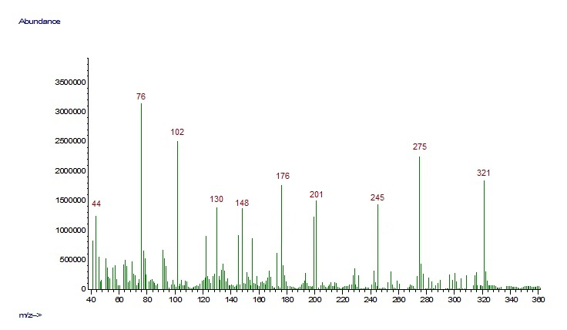
Fig.S17. MS – Compound 4e

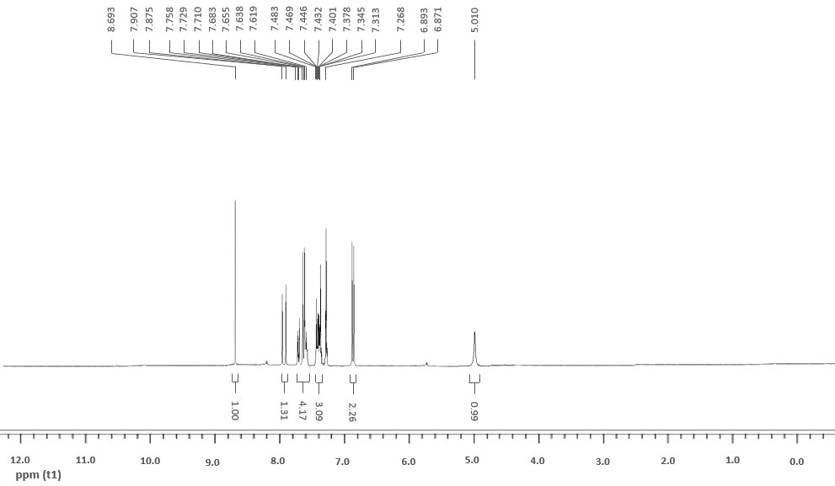
Fig.S18. ¹H NMR – Compound 4f

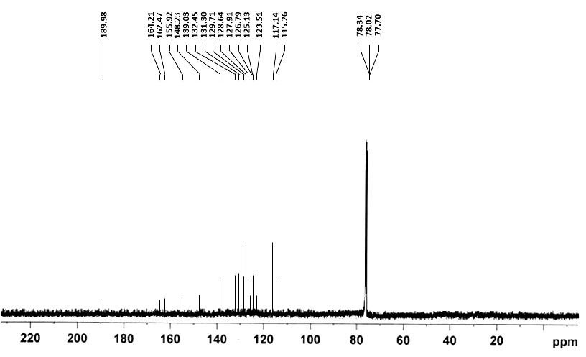
Fig.S19. ¹³C NMR – Compound 4f

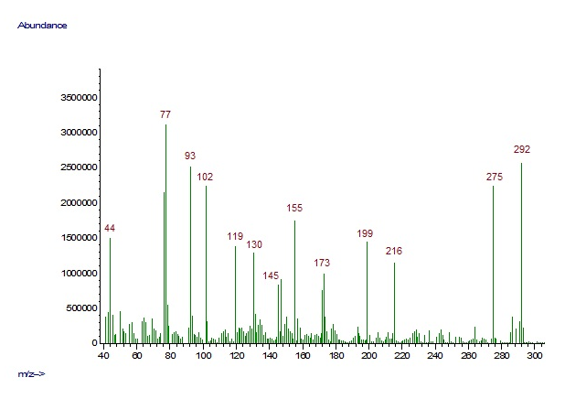
Fig.S20. MS – Compound 4f

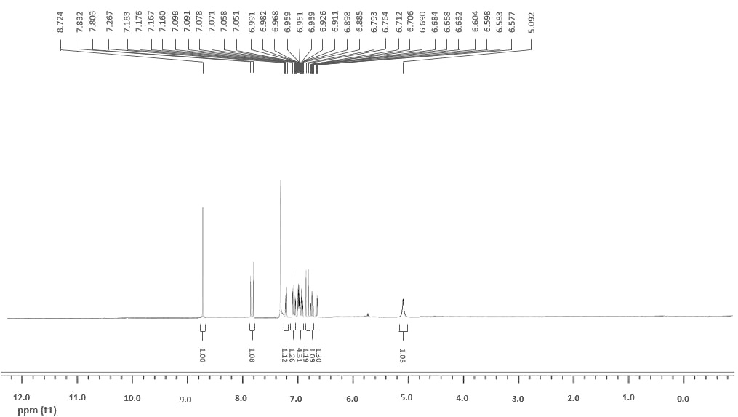
Fig.S21. ¹H NMR – Compound 4g

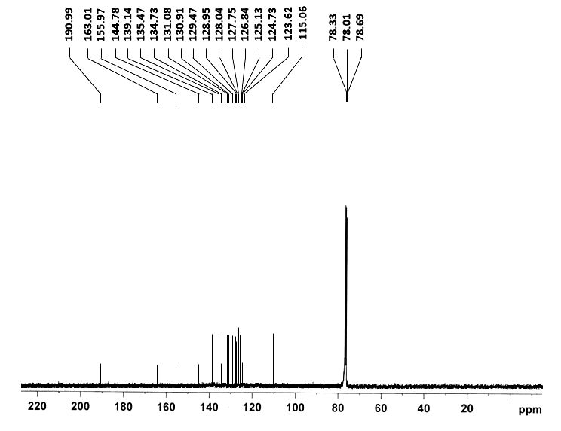
Fig.S22. ¹³C NMR – Compound 4g

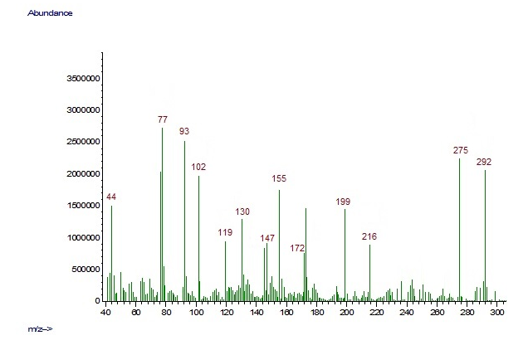
Fig.S23. MS – Compound 4g

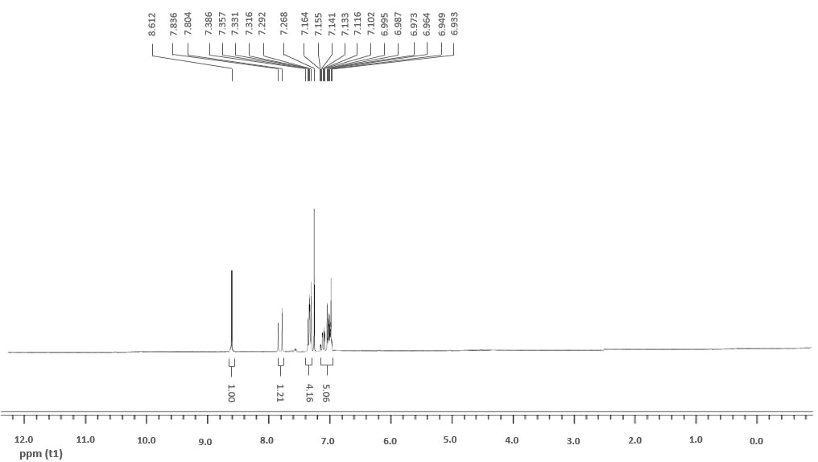

Fig.S24. ¹H NMR – Compound 4h

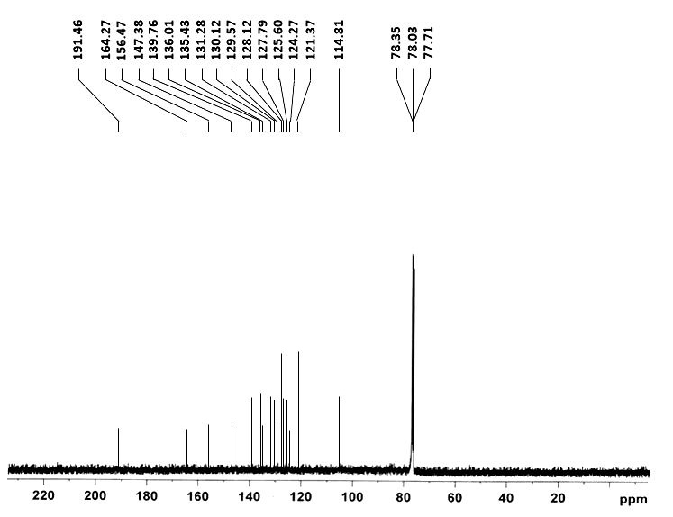
Fig.S25. ¹³C NMR – Compound 4h

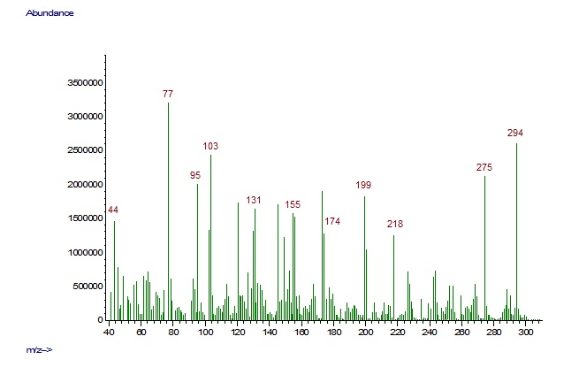
Fig.S26. MS – Compound 4h

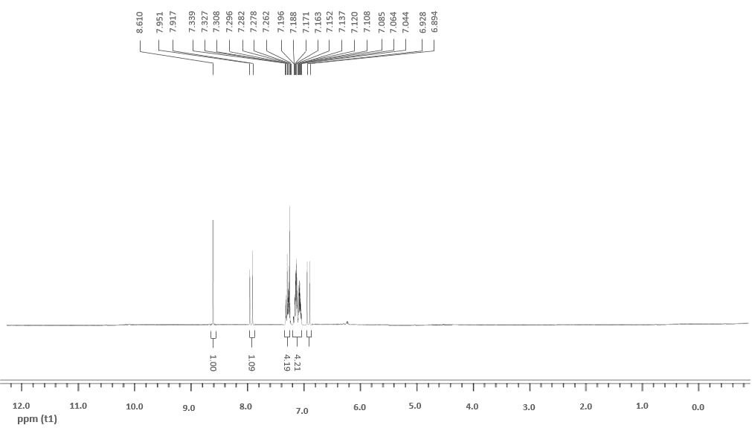
Fig.S27. ¹H NMR – Compound 4i

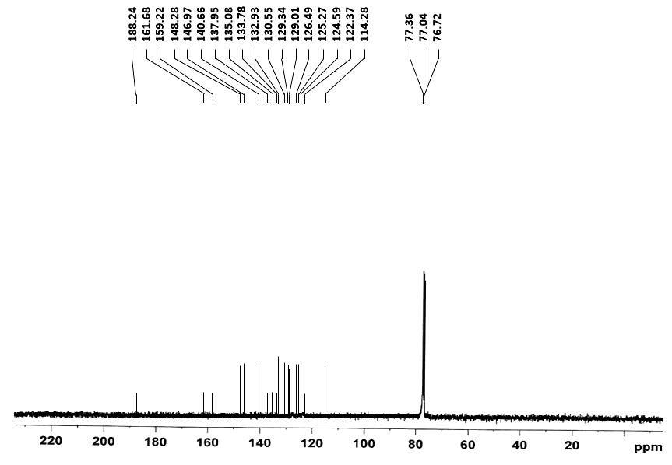
Fig.S28. ¹³C NMR – Compound 4i

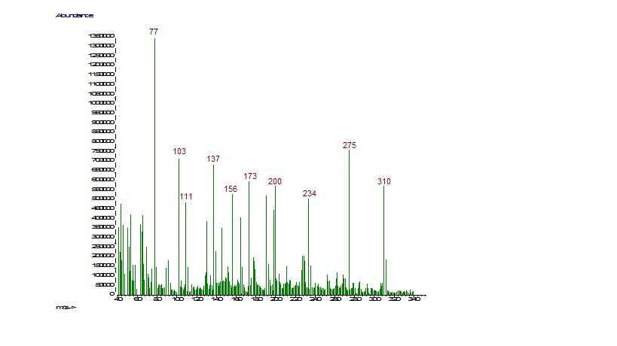
Fig.S29. MS – Compound 4i

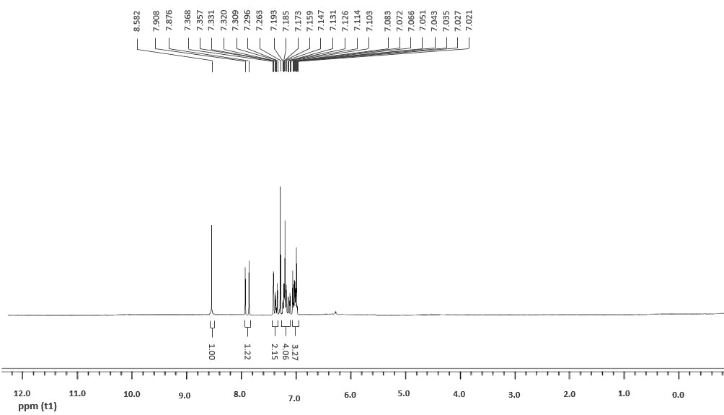
Fig.S30. ¹H NMR – Compound 4j

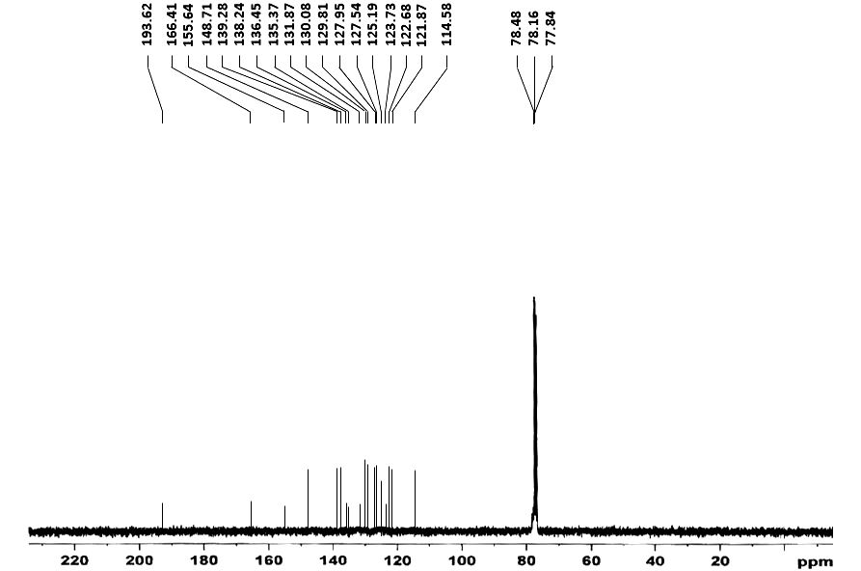
Fig.S31. ¹³C NMR – Compound 4j

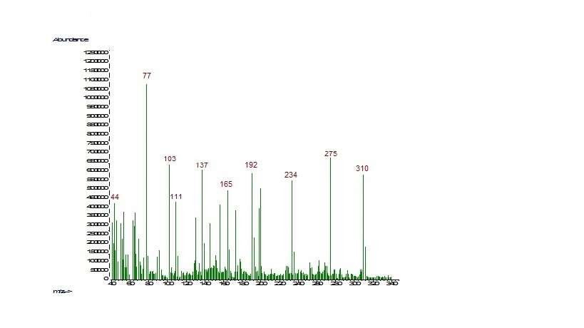
Fig.S32. MS – Compound 4j

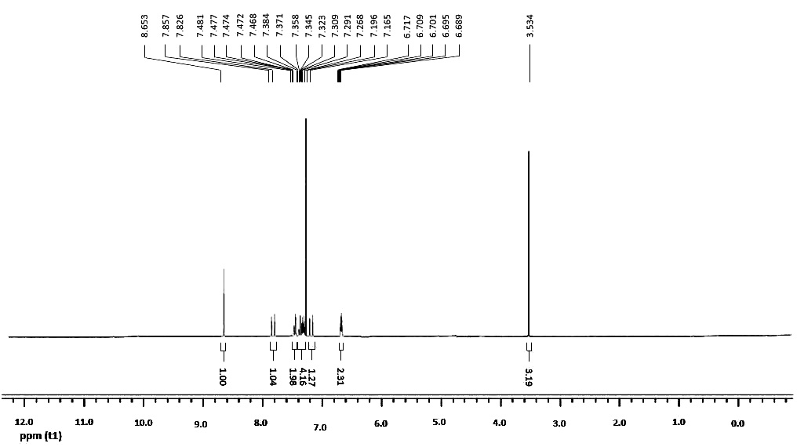
Fig.S33. ¹H NMR – Compound 4k

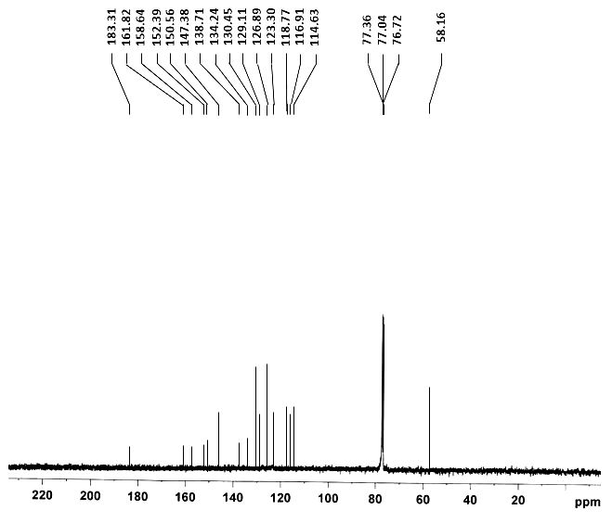
Fig.S34. ¹³C NMR – Compound 4k

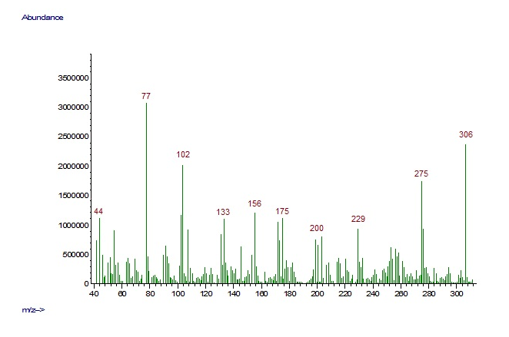
Fig.S35. MS – Compound 4k

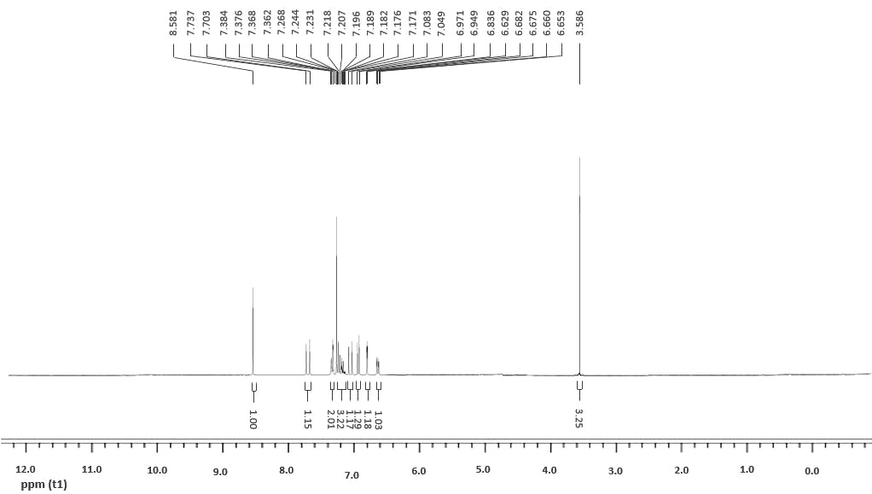
Fig.S36. ¹H NMR – Compound 4l
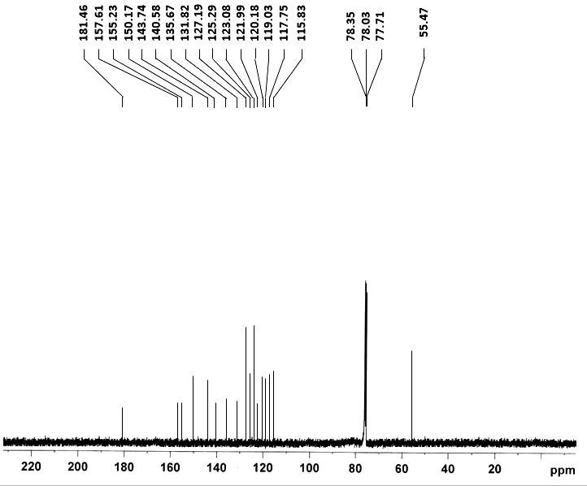
Fig.S37. ¹³C NMR – Compound 4l

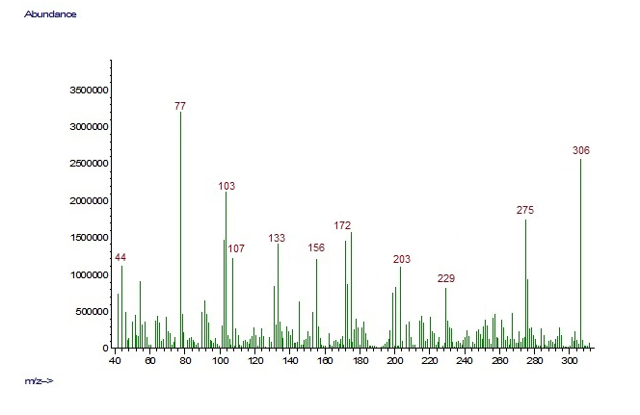
Fig.S38. MS – Compound 4l

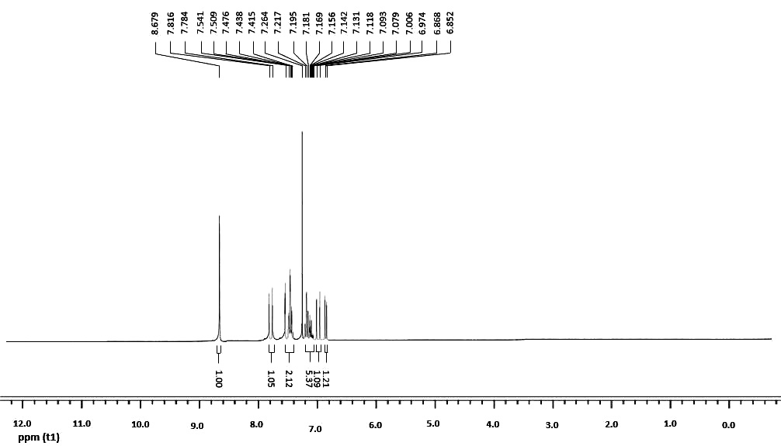
Fig.S39. ¹H NMR – Compound 4m

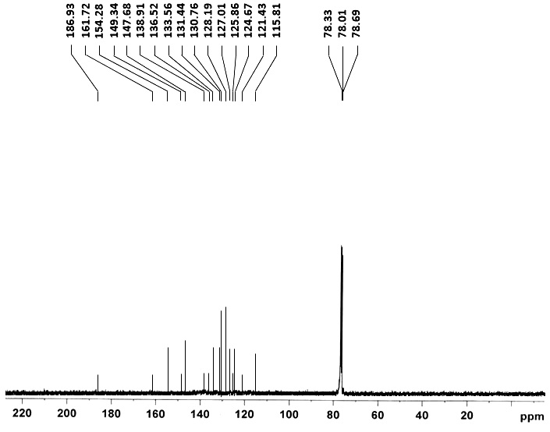
Fig.S40. ¹³C NMR – Compound 4m

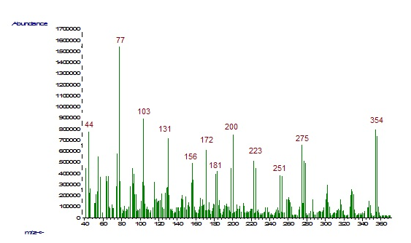
Fig.S41. MS – Compound 4m

