Supplementary Data
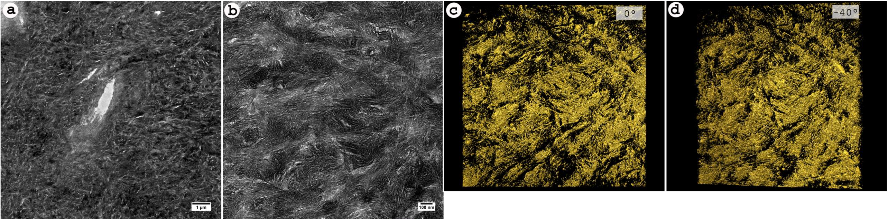
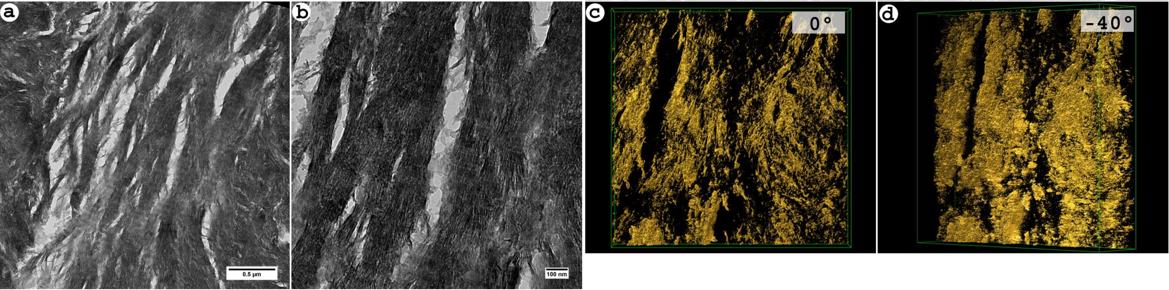
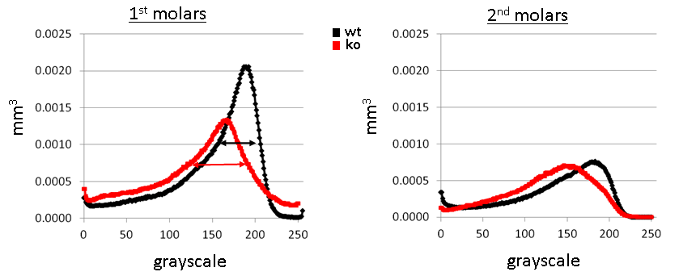
Supplementary Figure 2. Low (a) and high (b) magnification images of mineralized dentin from DSPP KO mice, showing the disordered nature of the mineral and the 3D tomographic reconstructions of the area in (b) at 0 (c) and -40 (d) degrees.
Supplementary Figure 1. Low (a) and high (b) magnification images of mineralized dentin from WT mice, showing the ordered nature of the mineral and the 3D tomographic reconstructions of the area in (b) at 0 (c) and -40 (d) degrees.
Supplementary Figure 3: Line graphs showing average mineral density distributions in the mineralized dentin volumes of 10 day WT (black) and DSPP KO (red) for 1st (left panel) and 2nd (right panel) molars. Double-headed arrows show that the width at half height of the Wt is narrower than that of the KO.

