**HYDROXY- AND METHOXY-SUBSTITUED INORGANIC RECEPTOR DESIGN:**

**DUAL SELECTIVITIES for Ag+ and CN- IN AQUEOUS MEDIUM**

Aslıhan YILMAZ OBALI*

Department of Chemistry, Science Faculty, Selcuk University, Turkey

[*aslihanyilmaz84@gmail.com](mailto:*aslihanyilmaz84@gmail.com)



**T%**

**Fig. S1.** FT-IR spectrum of **1** (bottom,blue color) and **Ru1** (top, red color).



**T%**

**Fig. S2.** FT-IR spectrum of **2** (top, blue color) and **Ru2** (bottom, red color).

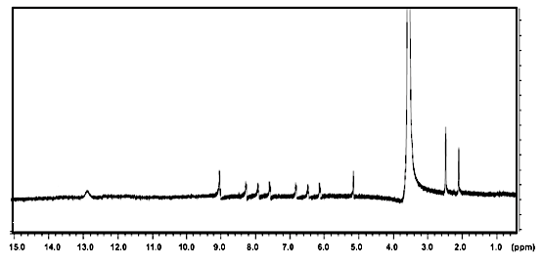

**Fig.S3.** 1H-NMR spectrum of **1**.

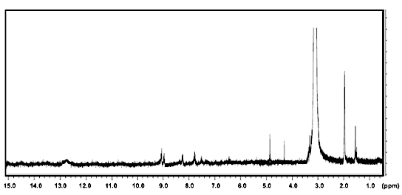

**Fig.S4.** 1H-NMR spectrum of **2**.

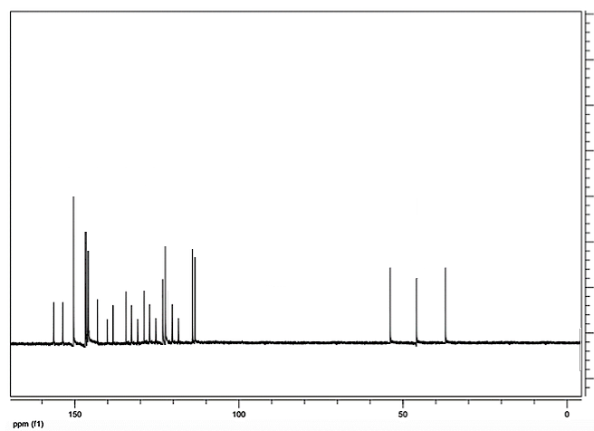

**Fig.S5.** 13C-NMR spectrum of **1**.

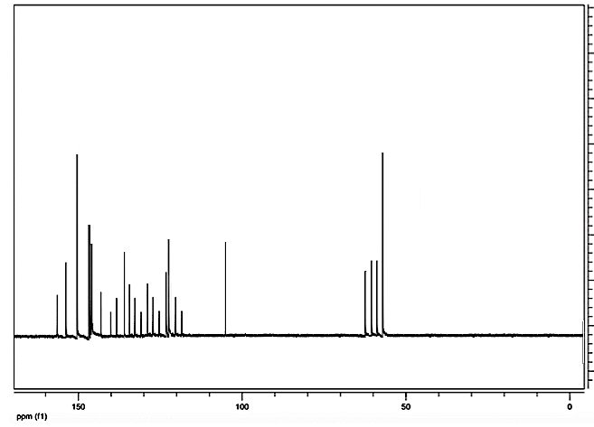

**Fig.S6.** 13C-NMR spectrum of **2**.

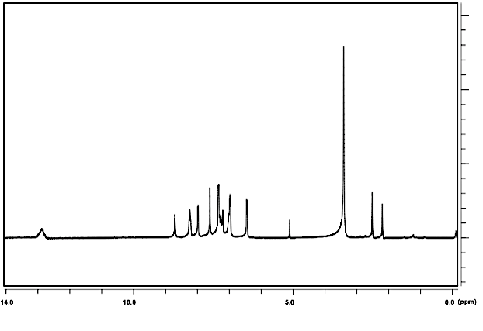

**Fig.S7.** 1H-NMR spectrum of **Ru1.**

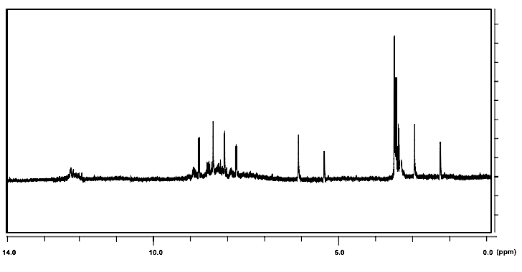

**Fig.S8.** 1H-NMR spectrum of **Ru2.**



**Fig.S9.** HRMS of **Ru1.**



**Fig.S10.** HRMS of **Ru1.**