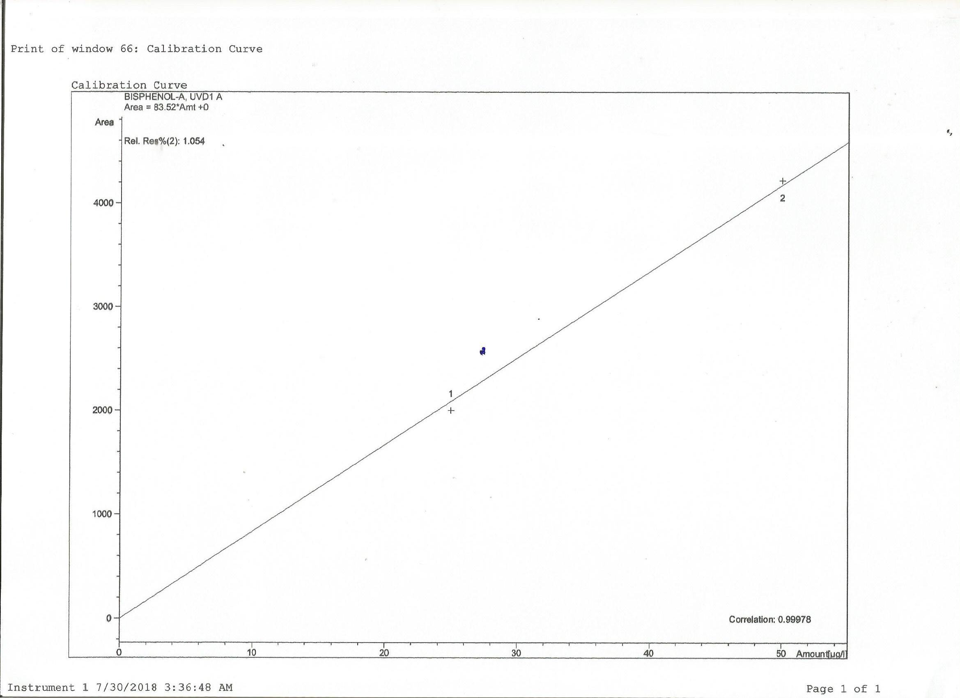
Suppl. 1: Calibration curve of the BPA standard with correlation coefficient

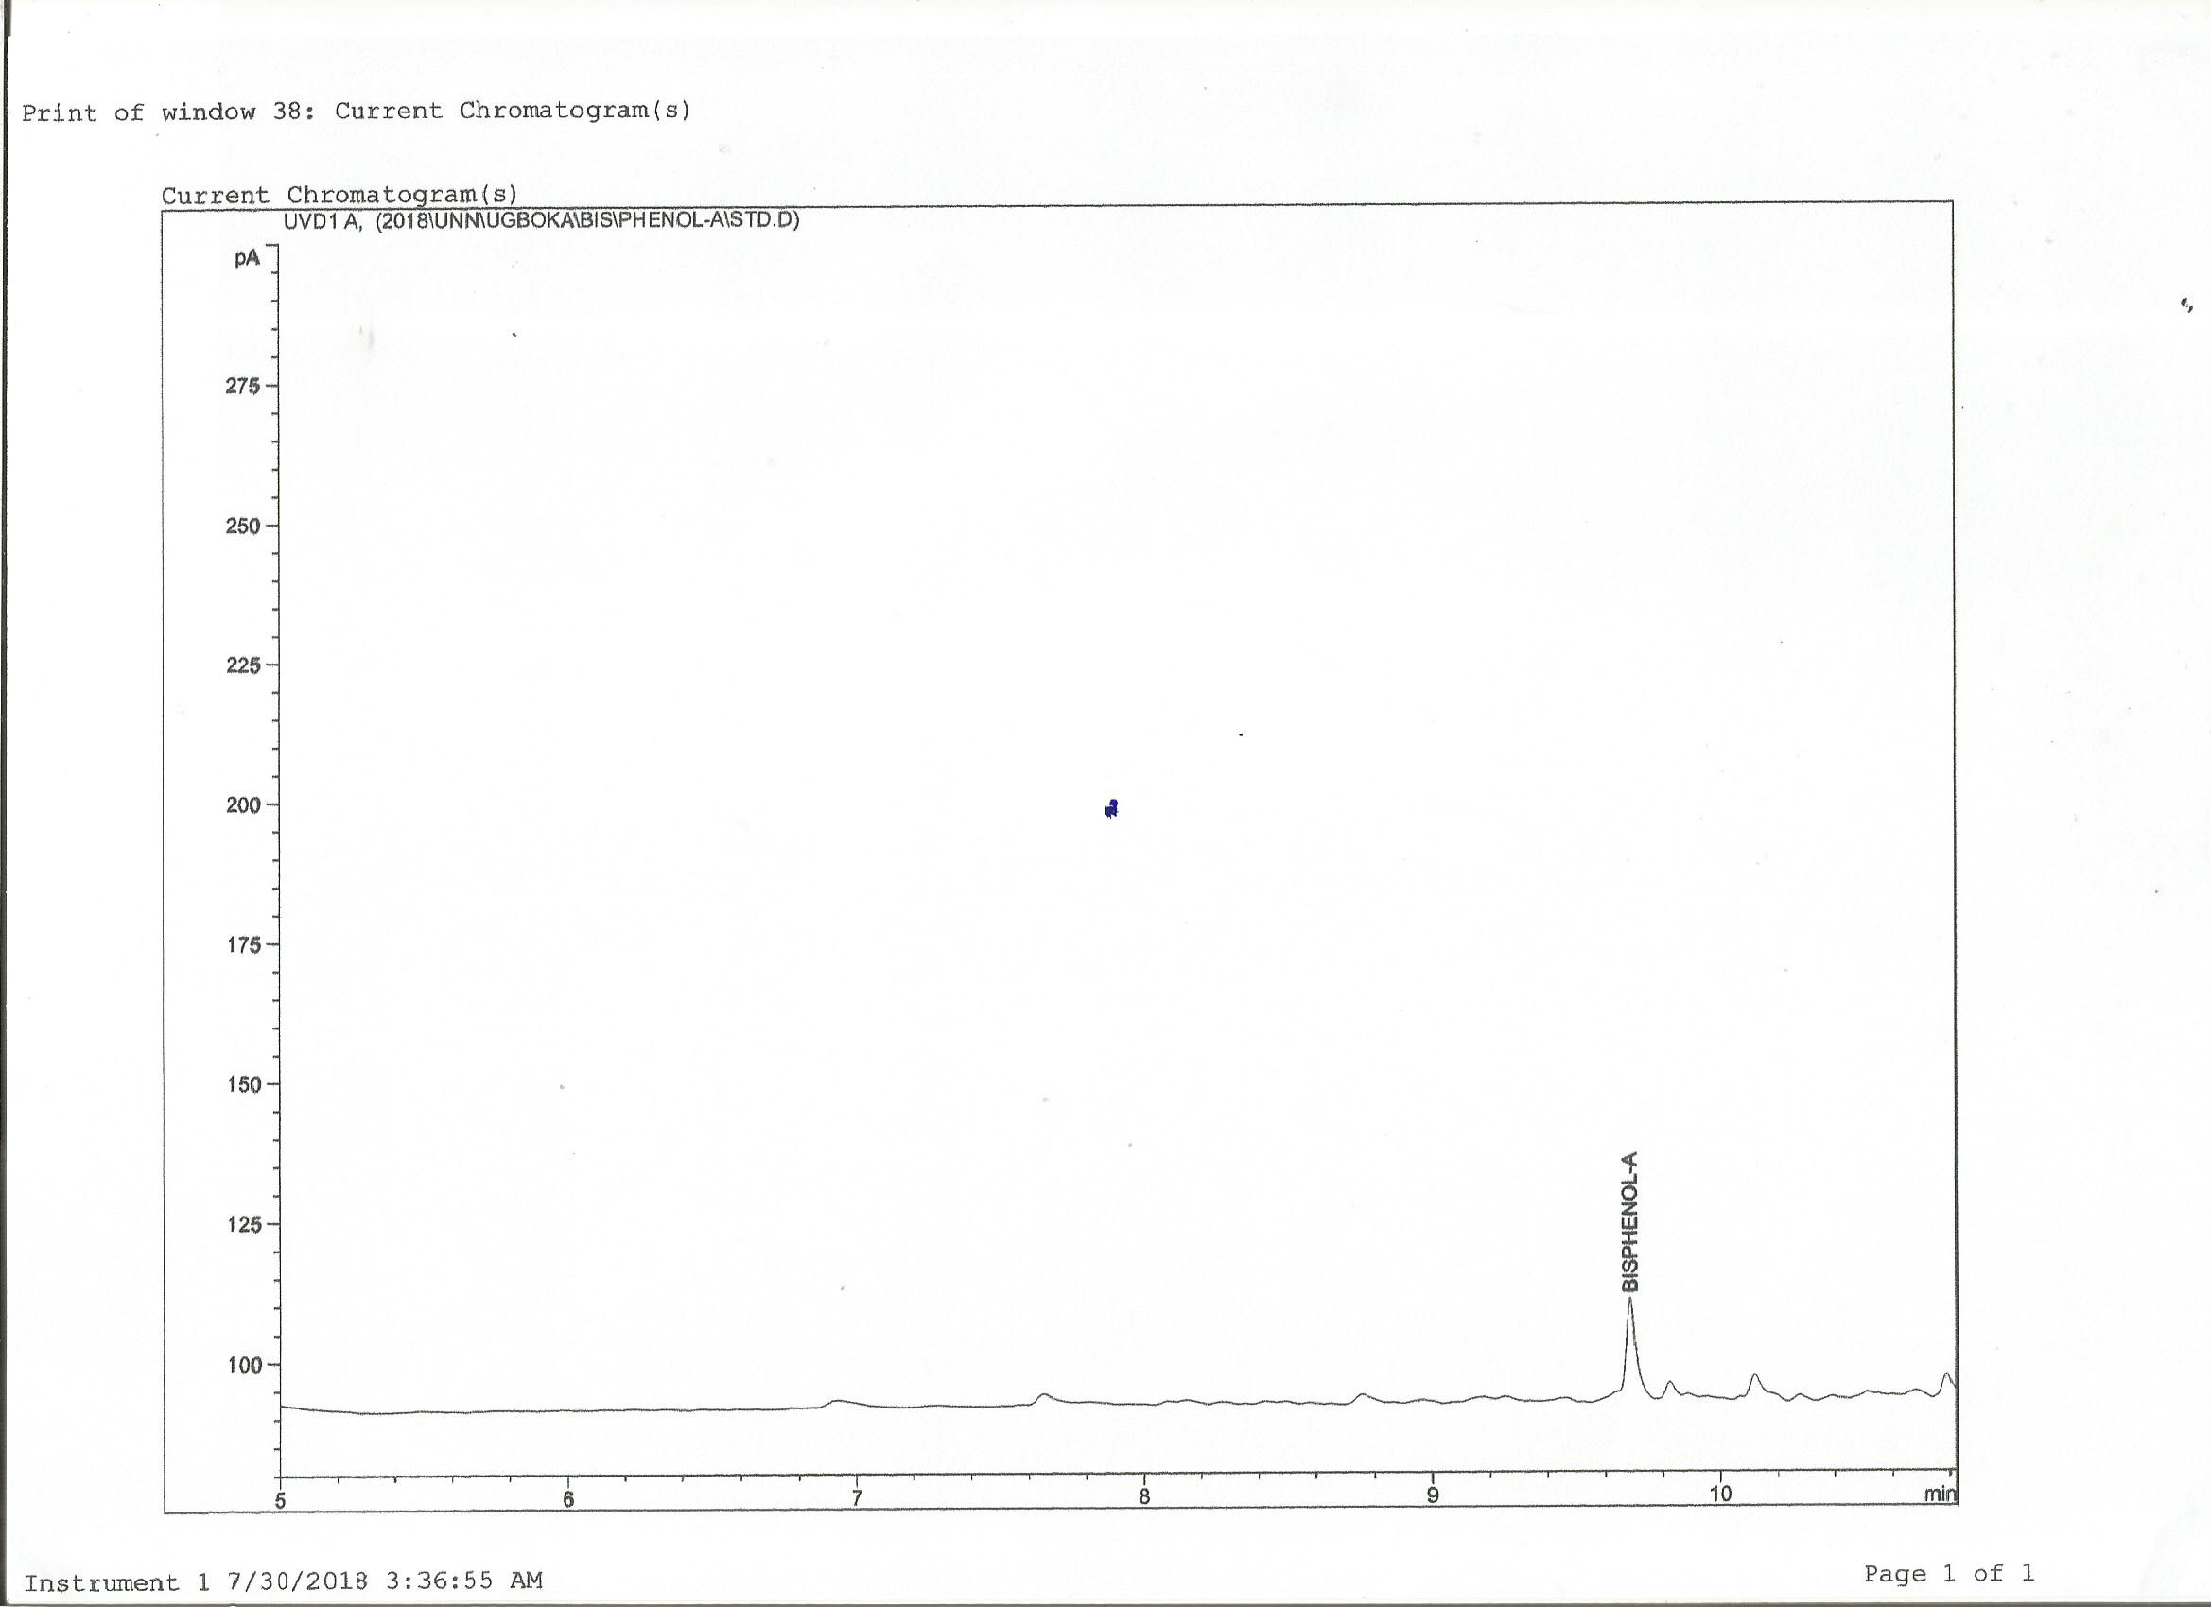
Suppl. 2: BPA standard chromatogram

Suppl. 3a: Chromatogram of BPA from PC bottled water sample exposed to sunlight for 30 days

Suppl. 3b: Chromatogram of BPA from PC bottled water sample exposed to sunlight for 60 days

