Supplementary Information for
DUAL-CAVITY SPECTROMETER FOR MONITORING BROADBAND LIGHT EXTINCTION BY ATMOSPHERIC AEROSOLS
Aiswarya Saseendran¹, Susan Mathai², Shreya Joshi^{1,2}, Anoop Pakkattil¹, Tyler Capek², Gregory Kinney², Claudio Mazzoleni^{2*}, and Ravi Varma^{1*}
¹ National Institute of Technology Calicut, Calicut, Kerala, India.
² Michigan Technological University, Physics Department and Atmospheric Sciences Program, Houghton, Michigan, USA.

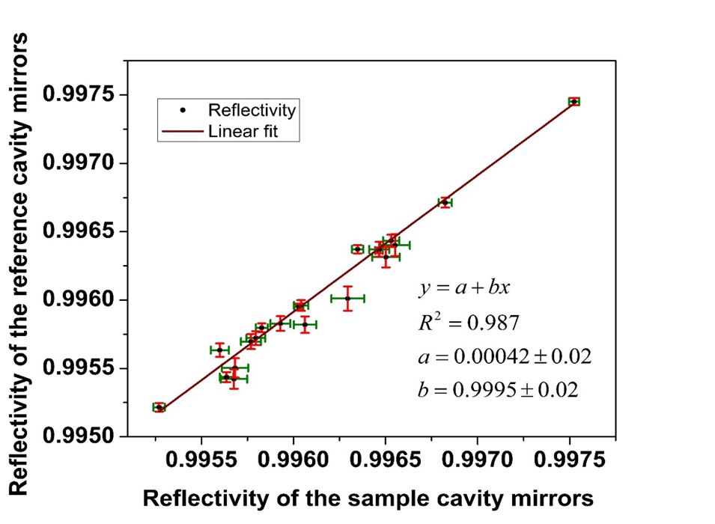

Figure S1. Linearity between the reflectivity values calculated for both cavities and plotted against each other. The error bars indicate one standard deviation (vertical and horizontal) of the values over all the points in each 5 nm bin.

Fig. S2(a)
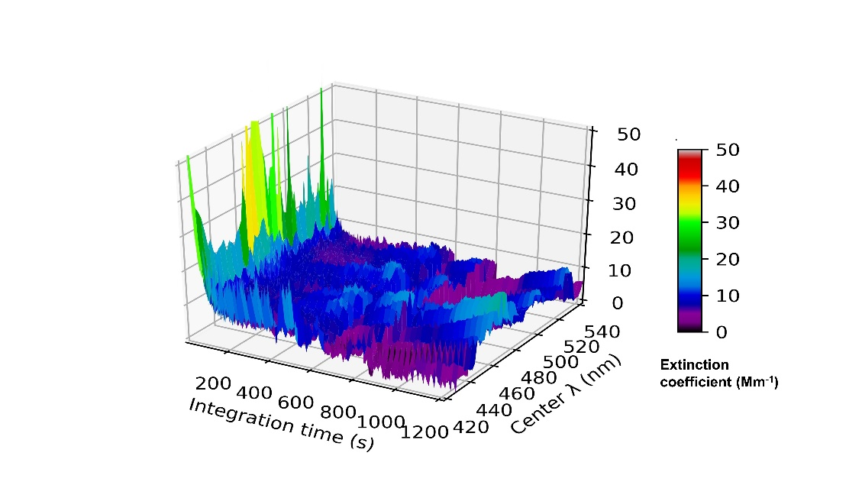

Fig. S2(b)

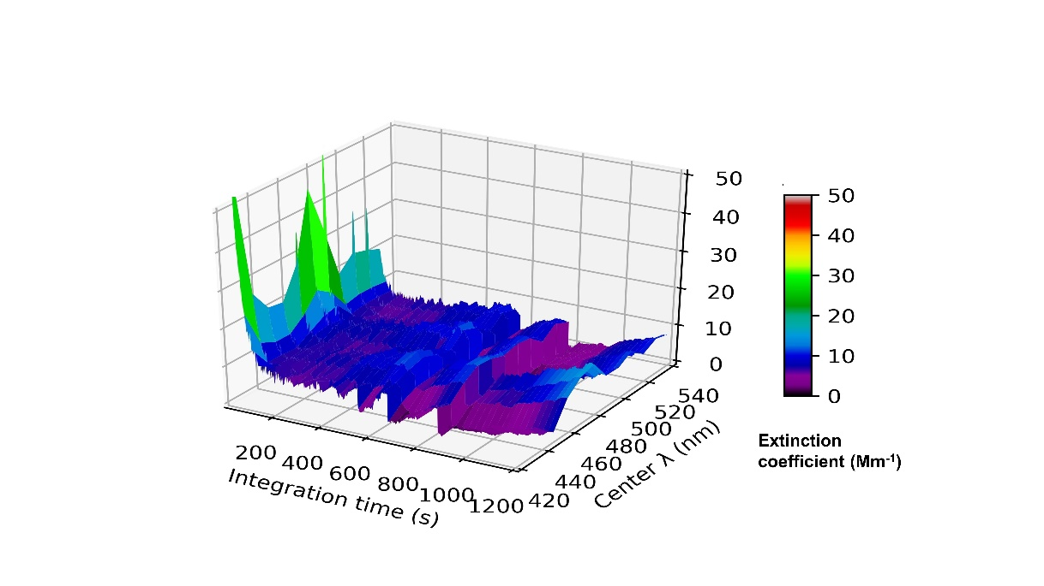

Fig. S2(c)
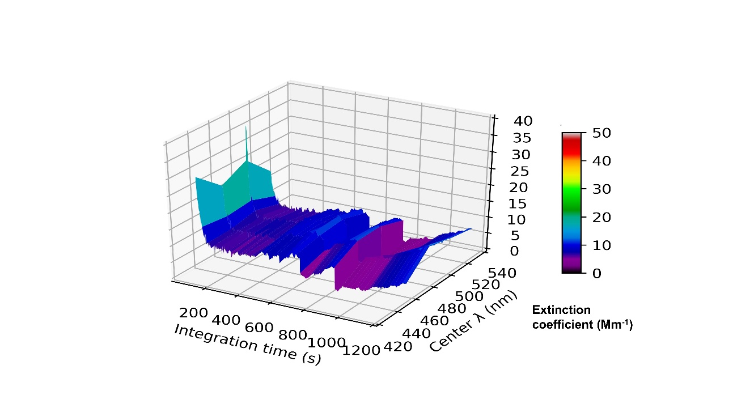
Figure S2. Allan deviation plot for a wavelength bin size of a) 2 nm, b) 10 nm, c) 25 nm.

