Supplementary data

Figure 1. HPLC chromatogram of standards for Fast Red E decolorization.

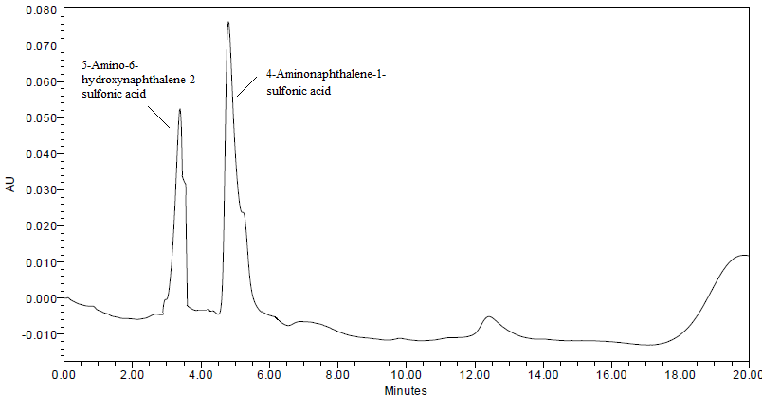
Figure 1

