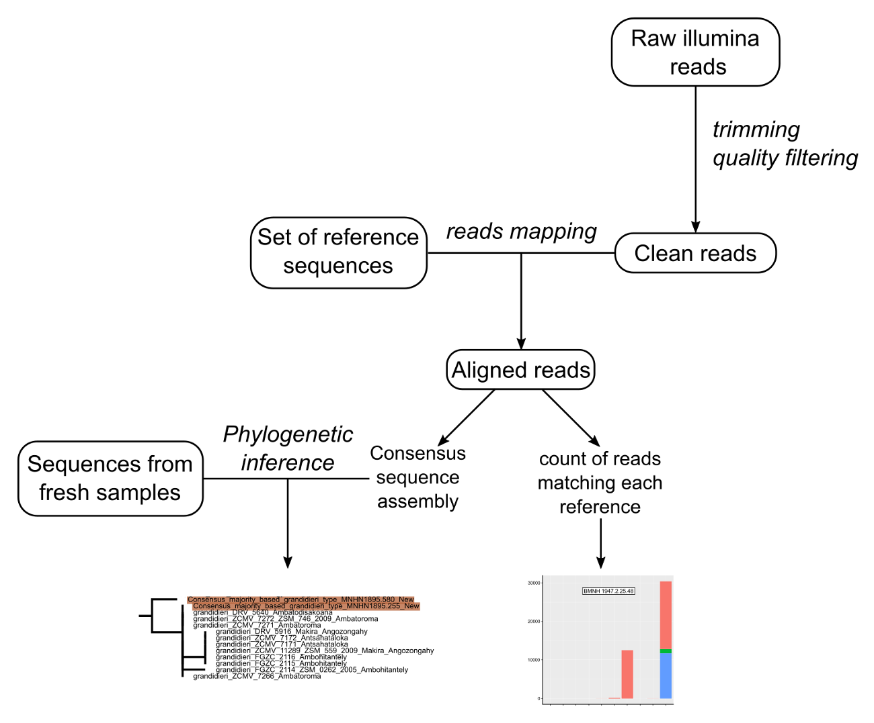
Figure S1. Graphical summary of the bioinformatic pipeline used to assign museum specimens to a lineage based on illumina reads.

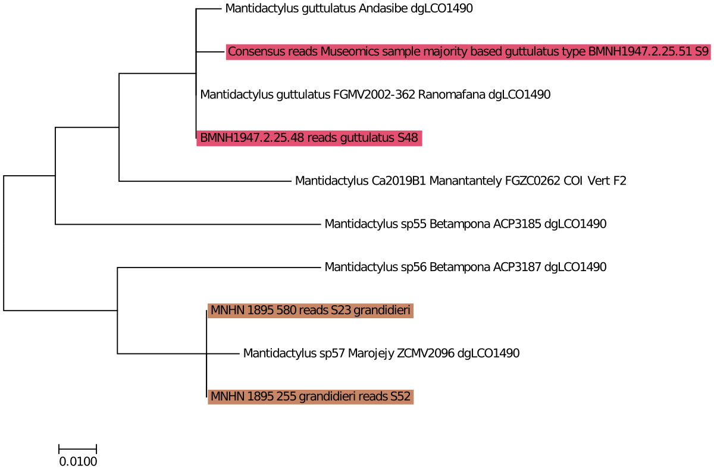

Figure S2. Tree based on cytochrome oxidase subunit 1 (cox1) sequences, including consensus sequences of four historical type specimens (in red: Mantidactylus (M.) guttulatus; in light brown: M. (M.) grandidieri).

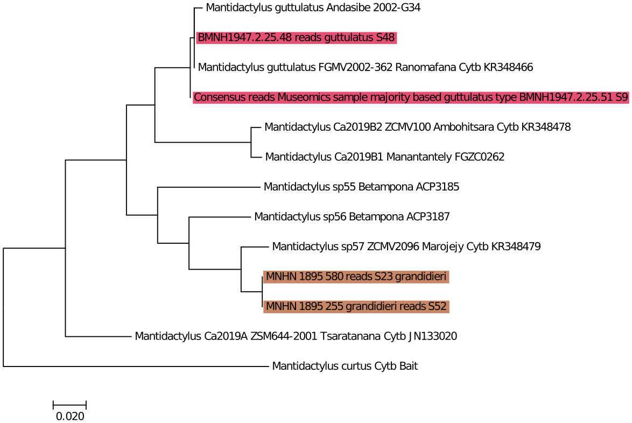

Figure S3. Tree based on cytochome b (cob) sequences, including consensus sequences of four historical type specimens (in red: Mantidactylus (M.) guttulatus; in light brown: M. (M.) grandidieri).

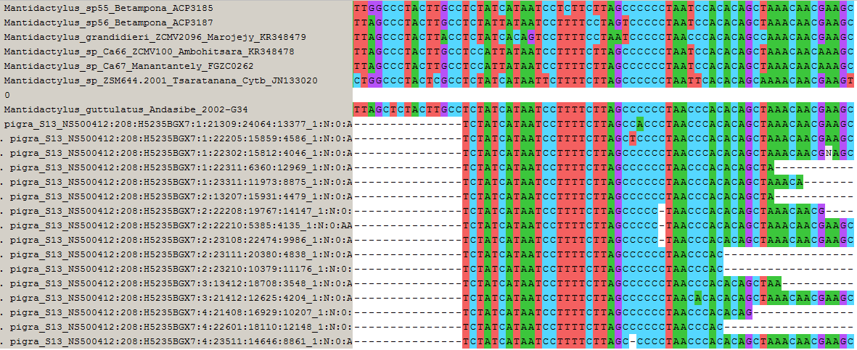

Figure S4. Alignment of 16 reads derived from bait capture of the holotype of Rana pigra (MNHN 1899.410) that matched the terminal part of the cytochrome b fragment analysed. These reads best match the sequence of the lineage considered to be Mantidactylus (M.) guttulatus.

