Supplementary Materials Section

Table S1:
Chemical composition of phenolic and flavonoid compounds of Centaurea cyanus extract

Phenolic compounds | Chlorogenic acid
 | p-coumaric acid
 | Caffeic acid
 | Syringic acid
Flavonoids | Taxifolin-O-dihexoside
 | Eriodictyol-O-hexoside
 | Apigenin-O-hexoside-O-glucuronide
 | Kaempferol-O-dihexoside
 | Apigenin-7-O-glucuronide-4-O-(6-Omalonylglucoside)
 | Apigenin-O-glucuronide-O-(malonylhexoside) isomer 1
 | Apigenin-O-glucuronide-O-(malonylhexoside) isomer 2
 | Apigenin-7-O-glucoside
 | Quercetin-3-O-(6-acetyl)glucoside
 | Kaempferol-3-O-glucoside
 | Apigenin-O-glucuronide
 | Kaempferol-O-acetylhexoside
 | Apigenin-O-acetylhexoside

Experimental design and statistical analysis
The Response surface methodology (RSM) and Central composite design (CCD) are a technique to reduce the number of experiments and achieve the optimal conditions. Five level-four variable CCD [30 experiments (including 6 runs at the central point)] was designed. The design variables were initial concentration of MB in the solution (A), pH (B), adsorbent dosage (C), and time (D) (shown in Table S2). Adsorption percentage of MB (R%) was considered as a response. Three levels of +α, 0, and -α were considered for high, medium, and low P-values, respectively. Two levels of +1 and -1 were studied as auxiliary levels for fitting the model. The order of the tests is randomly chosen to avoid a systematic error. Table S3 shows the CCD design matrix and the related results of the experiments.
The statistical software package, Design-Expert 7.1 (Stat- Ease, Inc., Minneapolis, MN, USA) was utilized for the regression analysis of the experimental data and optimization of the variables by plotting the response surface graphs. The analysis of variance (ANOVA) was performed to confirm the significance and adequacy of the regression model. The response process can be modeled by a quadratic equation as:
(1) | Y$=β_{0}+\sum_{i=0}^{4}{β_{i}x_{i}}+\sum_{i=0}^{4}{β_{ii}x_{i}^{2}}+\sum_{i=1}^{4}{\sum_{j=1}^{4}{β_{ij}x_{i}x_{j}}}$
where${ β}_{0}$,$β_{i}$, $β_{ii}$, and $β_{ij}$ are the regression coefficients for the intercept, linear, quadratic and cross product terms, respectively. $x_{i}$and $x_{j}$ are the independent variables.
Table S2:
Variables and test design levels for each agent for adsorption of MB ions
Independent variables | Unit | Symbol | Levels
 |  |  | $$-α$$ | -1 | 0 | +1 | $$+α$$
Initial concentration | mg.L⁻¹ | A | 10 | 32.5 | 55 mg.L⁻¹ | 77.5 | 100
pH | - | B | 3 | 5 | 7 | 9 | 11
Absorber dosage | g/20 mL | C | 0.02 | 0.065 | 0.11 | 0.155 | 0.2
Time | min. | D | 5 | 33.75 | 62.5 | 91.25 | 120

Table S3:
Experimental factors, levels and responses for MB dye removal according to the
CCD design
Run | Factors |  |  |  | MB dye removal (%)
 | A (mg.L⁻¹) | B | C (g/20 mL) | D (min)
1 | 55 | 3 | 0.11 | 62.5 | 65.36
2 | 55 | 7 | 0.11 | 62.5 | 37.2
3 | 77.5 | 9 | 0.065 | 91.25 | 99.07
4 | 55 | 7 | 0.11 | 62.5 | 37.2
5 | 32.5 | 9 | 0.065 | 33.75 | 58.03
6 | 55 | 7 | 0.11 | 62.5 | 37.2
7 | 77.5 | 9 | 0.065 | 33.75 | 90.8
8 | 77.5 | 5 | 0.155 | 91.25 | 92.7
9 | 100 | 7 | 0.11 | 62.5 | 69.38
10 | 77.5 | 5 | 0.065 | 91.25 | 65.74
11 | 32.5 | 5 | 0.155 | 33.75 | 67.02
12 | 77.5 | 9 | 0.155 | 33.75 | 95.63
13 | 55 | 7 | 0.11 | 120 | 82.7
14 | 55 | 7 | 0.02 | 62.5 | 73.4
15 | 55 | 7 | 0.2 | 62.5 | 89.3
16 | 55 | 7 | 0.11 | 62.5 | 37.2
17 | 55 | 7 | 0.11 | 5.00 | 48.11
18 | 55 | 7 | 0.11 | 62.50 | 37.2
19 | 32.5 | 9 | 0.065 | 91.25 | 89.02
20 | 32.5 | 5 | 0.155 | 91.25 | 96.43
21 | 77.5 | 5 | 0.065 | 33.75 | 47.75
22 | 32.5 | 5 | 0.065 | 91.25 | 62.36
23 | 32.5 | 9 | 0.155 | 91.25 | 84.37
24 | 55 | 11 | 0.11 | 62.50 | 96.77
25 | 77.5 | 9 | 0.155 | 91.25 | 98.21
26 | 10 | 7 | 0.11 | 62.50 | 91.7
27 | 77.5 | 5 | 0.155 | 33.75 | 68.6
28 | 32.5 | 5 | 0.065 | 33.75 | 49.5
29 | 32.5 | 9 | 0.155 | 33.75 | 72.16
30 | 55 | 7 | 0.11 | 62.50 | 37.2

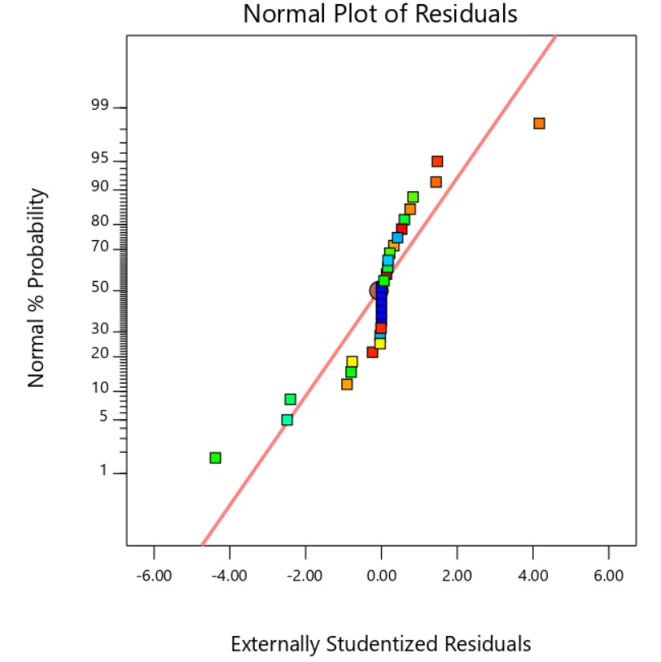
Fig. S1. Normal probability vs. internally studentized residuals values for MB removal
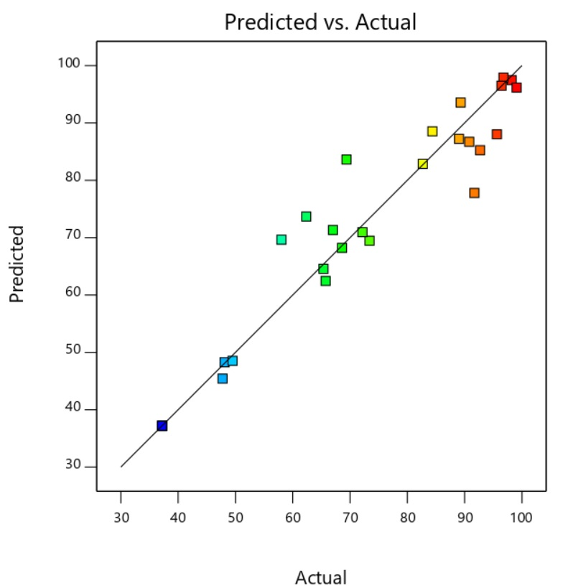
Fig. S2. Predicted vs. actual values for MB removal

a) | b)
c)
Fig. S3. Adsorption isothermal curves for dye adsorption onto IONPs : Langmuir (a), Freundlich (b), and (c) Temkin (pH:5, adsorbent dosage: 3.6g.L⁻¹)

Fig. S4. Pseudo-first-order (a) and pseudo-second-order (b) plots for the dye adsorption onto IONPs (pH:5, adsorbent dosage: 3.6 g.L⁻¹)

