Supplementary data
Text SM-1
X-ray diffraction patterns of the samples were done by an X' Pert Pro (PerkinElmer, Netherland) diffractometer, with Cu K$α$ radiation (λ =1.54060 Å), Generator settings = 40 kV, 40 mA and the 2θ range from 10 to 80°. The average dimension (D) of particles was calculated based on the diffraction of peak broadening using the Debye–Scherer's formula (Eq. S1).

d = $k$λ/βcosθ (S1)
Where λ is the X-ray wavelength of the Cu Kα radiation (0.15418 nm), $β$ is the peak width of the diffraction peak profile at half the maximum height at the 2θ value which results from the small crystallite size (radians), and K is a coefficient related to crystalline shape which is normally equal to 0.9. [1, 2]. The morphological features and surface characteristics of F-TiO₂ were investigated using a Field Emission Scanning Electron Microscopy (FESEM) unit (MIRA3, TE-SCAN, Czechoslovakia). Energy-dispersive X-ray spectroscopy (EDS) were observed from (MIRA3, TE-SCAN, Czechoslovakia). The transmission electron micrograph (TEM), were done using a Philips CM30 (Netherland). Fourier-transform infrared spectroscopy (FTIR), is another characterization technique was obtained using (Spectrum Tow PerkinElmer, USA). The BET and BJH isotherm models for determine the specific surface area, volume and size of pores carried out using a Belsorp mini II (Japan) at 77 K. The samples were degassed in a vacuum at 120 °C for 17 h before N2 adsorption/desorption analysis. UV-Vis diffuse reflectance spectra (DRS) were recorded on a TU-1901 UV-Vis spectrophotometer (Beijing purkinje general instrument Co., Ltd., China).
Text SM-2
The LC-MS/MS system (Quartro Micro API micromass Waters 2695) was equipped with a T3- C18 chromatography column (2.1 × 100 mm) which operated in the positive ion mode [M+H] and temperature of 300 ºC. For the chromatographic separation, the sample (25 µL) was injected at flow rate of 1.0 mL min-1 on a gradient mode. Nitrogen (grade 5) was used as the nebulizer and desolvation gas at a flow rate of 200 L/h. The applied jet stream conditions were as follow: capillary voltage = 4500 V, fragment or cone voltage = 35 V, extractor = 3 V, gas temperature = 300 °C, and nebulizer pressure = 50 psi. A spectra system UV 6000 LP photodiode array UV detector scanning from 200 to 700 nm applied to acquire the spectra of SMX and its intermediates. The separation of intermediates was conducted by Water (30% with 0.1% Formic Acid) and Acetonitrile (70% with 0.1% Formic Acid) as the mobile phase at a flow rate of 0.25 mL min with temperature of 30 °C and at a total analysis time of 10 min. To carry out a mobile phase, a gradient mode was used. Firstly, during the first 2 min, 100 % of Formic acid was kept; from 2 to 47 min, acetonitrile was linearly increased from 0 % to 60 %, while Formic acid was steadily decreased to 40 % then held for 5 min; then from 52 to 55 min, the mobile phase turned to the initial composition and until the end of the run.

Table S1. Coded values of independent variables used for experimental design
 |  | Coded level
Variable |  | -0.5 | -1 | 0 | 0.5 | 1
 |  |  | values
pH | X₁ | 4 | 5.5 | 7 | 8.5 | 10
Dose Catalyst (g L⁻¹) | X₂ | 0.1 | 0.2 | 0.3 | 0.4 | 0.5
Time (min) | x₃ | 10 | 30 | 50 | 70 | 90
TCAA.Conc (mg L⁻¹) | x₄ | 1 | 3 | 5 | 7 | 9

The Independent variables were adjusted over five levels as -1, -0.5, 0, 0.5 and 1, respectively at the determined ranges based on a set of preliminary experiments. The experimental design was carried out using R software for Windows (version 3.0.3:6 March 2014).

Table S2. Band gap values for the pure TiO2 and F(1, 2, 4 and 8% Wt) doped TiO2
Sample | Apparent band gap energy(eV)
TiO₂ | 3.2
F-Tio₂ – 1% WT | 2.6
F-Tio₂ – 2% WT | 2.7
F-Tio₂ – 4% WT | 2.4
F-Tio₂ – 8% WT | 2.7

Table S3. Pore size, pore volume and BET specific surface area of the F-TiO₂ sample
Sample | Adsorption Pore  Size(mean diameter) (nm) | Adsorption Pore  Volume (cm³ g⁻¹) | BET Specific  Surface Area (m² g⁻¹)
F-TiO₂ | 23.660 | 0.1738 | 29.385

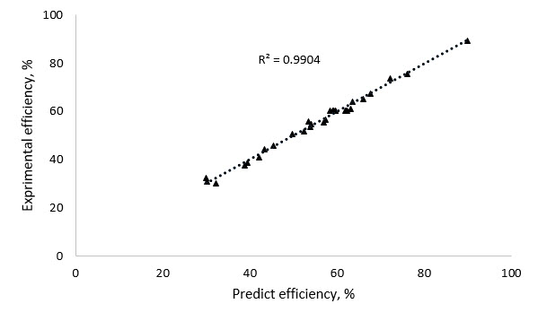
Fig. S1. Correlation of actual and predicted degradation efficiency for TCAA

Table S4. CCD experimental design for TCAA removal by F doped TiO₂

Run | Independent factors |  |  |  | Experimental | Predicted
 | pH | Cata.  dose | Time | TCAA Conc. | Removal (%) | Removal (%) | Lwr | Upr
1 | 7 | 0.3 | 50 | 5 | 61.9 | 60.46 | 56.39 | 64.52
2 | 5.5 | 0.2 | 30 | 3 | 45.44 | 45.7 | 40.92 | 50.48
3 | 8.5 | 0.4 | 70 | 7 | 57.07 | 55.48 | 50.7 | 60.26
4 | 7 | 0.3 | 50 | 5 | 62.26 | 60.46 | 56.39 | 64.52
5 | 8.5 | 0.2 | 70 | 3 | 67.63 | 67.45 | 62.67 | 72.23
6 | 5.5 | 0.2 | 70 | 3 | 63.63 | 64.16 | 59.38 | 68.94
7 | 7 | 0.3 | 50 | 5 | 62.17 | 60.46 | 56.39 | 64.52
8 | 5.5 | 0.2 | 30 | 7 | 32.23 | 30.24 | 25.46 | 35.02
9 | 8.5 | 0.4 | 70 | 3 | 72.18 | 73.76 | 68.98 | 78.54
10 | 7 | 0.3 | 50 | 5 | 59.17 | 60.46 | 56.39 | 64.52
11 | 8.5 | 0.2 | 30 | 3 | 52.37 | 51.57 | 46.79 | 56.35
12 | 8.5 | 0.2 | 30 | 7 | 39.48 | 38.79 | 34.01 | 43.57
13 | 8.5 | 0.4 | 30 | 3 | 63.18 | 61.15 | 56.37 | 65.93
14 | 5.5 | 0.4 | 30 | 3 | 59.73 | 60.32 | 55.54 | 65.1
15 | 5.5 | 0.4 | 70 | 7 | 54.15 | 54.54 | 49.76 | 59.32
16 | 8.5 | 0.4 | 30 | 7 | 42.04 | 41.1 | 36.32 | 45.88
17 | 7 | 0.3 | 50 | 5 | 59.14 | 60.46 | 56.39 | 64.52
18 | 7 | 0.3 | 50 | 5 | 59.64 | 60.46 | 56.39 | 64.52
19 | 8.5 | 0.2 | 70 | 7 | 57.44 | 56.44 | 51.66 | 61.22
20 | 5.5 | 0.4 | 30 | 7 | 38.74 | 37.59 | 32.81 | 42.37
21 | 7 | 0.3 | 50 | 5 | 58.94 | 60.46 | 56.39 | 64.52
22 | 5.5 | 0.4 | 70 | 3 | 76.15 | 75.51 | 70.73 | 80.29
23 | 5.5 | 0.2 | 70 | 7 | 49.77 | 50.47 | 45.69 | 55.25
24 | 7 | 0.5 | 50 | 5 | 43.44 | 44.45 | 39.67 | 49.23
25 | 7 | 0.3 | 50 | 9 | 53.5 | 55.75 | 50.97 | 60.53
26 | 7 | 0.1 | 50 | 5 | 30.08 | 30.79 | 26.0 | 35.57
27 | 7 | 0.3 | 90 | 5 | 66.04 | 65.26 | 60.48 | 70.04
28 | 4 | 0.3 | 50 | 5 | 53.81 | 53.58 | 48.8 | 58.36
29 | 10 | 0.3 | 50 | 5 | 58.45 | 60.39 | 55.61 | 65.17
30 | 7 | 0.3 | 10 | 5 | 29.92 | 32.42 | 27.63 | 37.2
31 | 7 | 0.3 | 50 | 1 | 90.04 | 89.5 | 84.7 | 94.28

Table S5. Regression analysis for the reduced quadratic model
Model term | Coefficient estimate | Std. error | t-Value | p-Value
Intercept | 60.46 | 0.716 | 84.328 | < 2.2e-16
$$X_{1}$$ | 3.40 | 0.774 | 4.393 | 0.0003
$$X_{2}$$ | 6.83 | 0.774 | 8.820 | 3.815e-08
$$X_{3}$$ | 16.42 | 0.774 | 21.204 | 1.097e-14
$$X_{4}$$ | -16.00 | 0.774 | -21.787 | 6.680e-15
$$X_{1}:X_{2}$$ | -5.03 | 1.896 | -2.655 | 0.0156
$$X_{2}:X_{3}$$ | -3.27 | 1.896 | -1.725 | 0.1007
$X_{2}:X_{4}$ | -7.27 | 1.896 | -3.833 | 0.0011
$$X_{1}^{2}$$ | -3.46 | 1.418 | -2.444 | 0.0244
$$X_{2}^{2}$$ | -22.83 | 1.418 | -16.096 | 1.582e-12
$$X_{3}^{2}$$  $$X_{4}^{2}$$ | -11.61  12.17 | 1.418  1.418 | -8.188 8.578 | 1.184e-07 5.858e-08

Pareto analysis using the Eq. S2 was employed to assess the importance of the role (P_{i}) of the selected factors (factor i) on the created response.
$P_{i}= \left(\frac{β_{i}^{2}}{\sum{β_{i}^{2}}}\right)$ (S2)
As indicated in Fig. S2, the following sequence was gained for the terms containing singular factors X₄ (TCAA Conc; 18.74%) > X₃ (Time; 17.75%) > X₂ (Catalyst dosage; 3.1%) > X₁ (pH; 0.76%), which approves that TCAA concentration and Time play the most important role among these terms. The quadratic terms have the sequence of X₂² (34.35%) > X₄² (9.75%) > X₃² (8.89%)> X₁² (0.79%), while the interaction terms were the X₂X₄ (3.48%) > X₁X₂ (1.68%) > X₂X₃ (0.71%). The results obtained from the Pareto method can be well certified by the F-values.
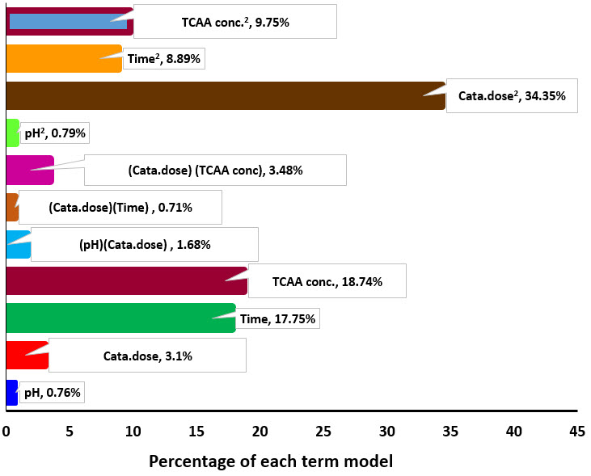
Fig. S2. Pareto plot for studying the importance of each variable to the F-TiO₂ response in the degradation of TCAA.

In Fig. S3 the effect of interaction of variables are studied. The effect of catalyst dose and pH on the degradation efficiency at reaction time of 50 minutes and TCAA initial concentration of 5 mg /l is presented in Fig S3-(a). The percentage of TCAA degradation was changed by varying the pH and catalyst dose. As can be understood from the Figure, the highest degradation efficiency is 60% due to the catalyst dose and pH interference, which is achieved at a catalyst dose of 0.34 gl⁻¹ mg and pH of approximately 8. The effect of the simultaneous interference of these two parameters is also seen in Fig. S4-(a).
The interaction between the two parameters of time and catalyst dose at pH of 7 and TCAA initial concentration of 5 mg/l is shown in Fig. S3-(b) and Fig. S4-(b). As it is understood from these two figures, the maximum interaction of these two parameters is 80%, which is obtained within a time interval of 70-80 minutes and range of 0.3-0.4 gl⁻¹ of catalyst dose. on the other hand, in higher and lesser than this quantities, degradation efficiency decreases.
In figures S3-(c) and S4-(c) interaction of TCAA initial concentration and catalyst dose is shown at pH of 7 and reaction time of 50 minutes. As shown in these Figures, the highest process efficiency is obtained at chlorine concentration of 1 mg/l and catalyst dose range between 0.3 and 0.4 gl⁻.
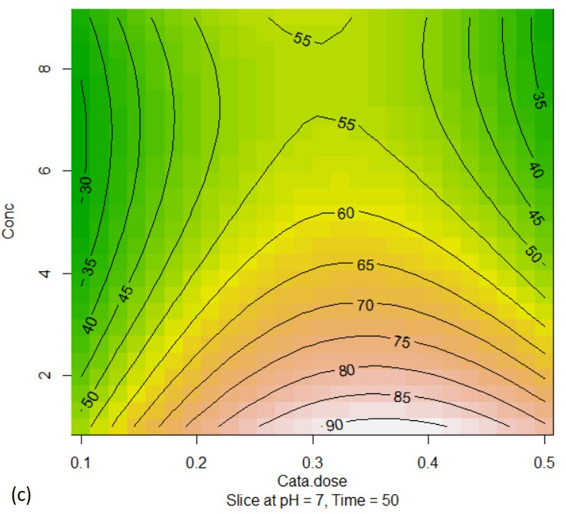
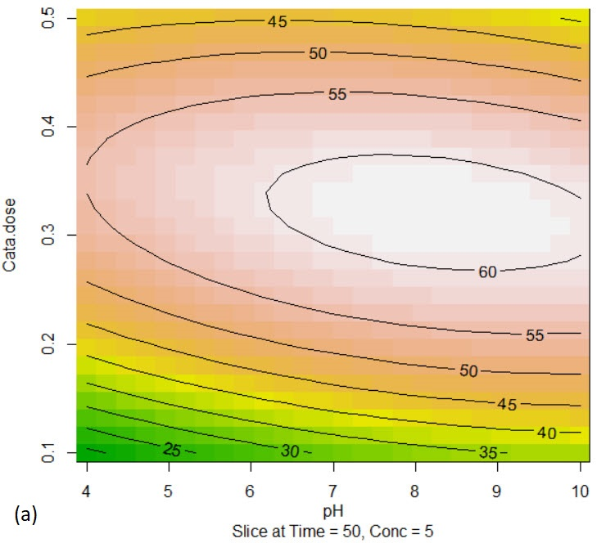
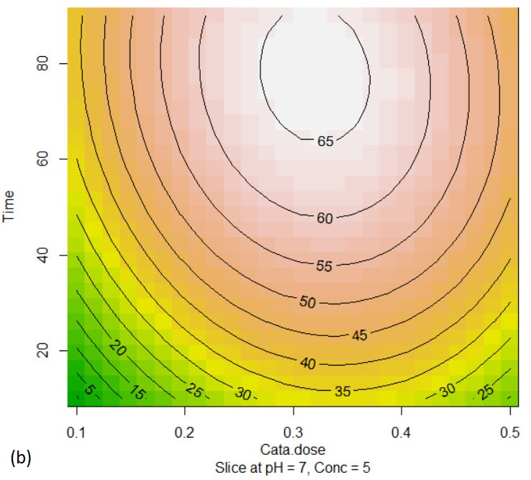

Fig. S3 Contour plot of (a) TCAA initial concentration and pH, (b) time and catalyst dose, (c) TCAA initial concentration and catalyst dose

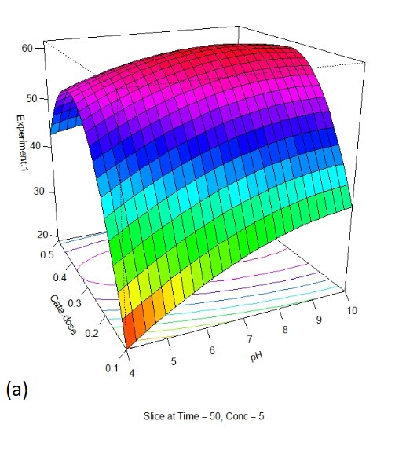
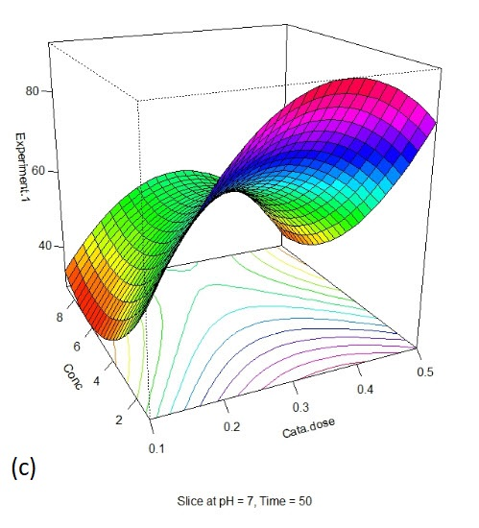
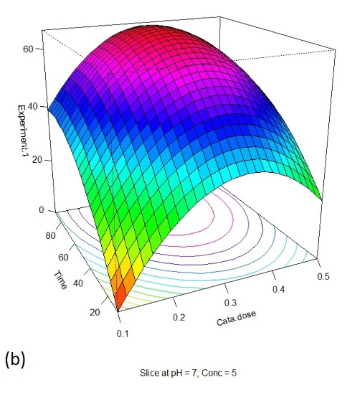

Fig. S4 prespective plot of (a) TCAA initial concentration and pH, (b) time and catalyst dose, (c) TCAA initial concentration and catalyst dose

TCAA concentration (mg L⁻¹) | Degradation-PFO
 | R² | k_{obs}(min⁻¹) | r_{obs} (mg/l.min)
1 | 0.9821 | 0.0428 | 0.0428
3 | 0.9816 | 0.0186 | 0.0558
5 | 0.981 | 0.0127 | 0.0635
7 | 0.98 | 0.0103 | 0.0721
9 | 0.9777 | 0.0102 | 0.0918

Table S6. Kinetics of reduction of TCAA in F-TiO₂ process for different TCAA concentrations

References | Removal rate  (reaction time) | Reaction conditions | Process
This work | >97% (76 min) | [TCAA]₀ = 1 mg L⁻¹,  [ MeOH ]₀ = 12% v/v, F-TiO₂ =0.3gr l⁻ , 11 W 254 nm Hg  lamp, pH = 7.9, N₂ saturation | MeOH/UV/TiO₂
[3] | 50% (6 d) | [TCAA] 0 = 2.0 mg L⁻¹ ; 400 W greenhouse sunlight lamps;  15 °C; TiO₂ =0.4g L⁻¹ | UV/TiO₂
[25] | 42.27% (3 h) | [TCAA] 0 = 1 mg L⁻¹ ;  [H 2 O 2 ]0 = 70 mg L⁻¹ ;1048 µW cm⁻² at 254 nm | UV/ H₂O₂
[4] | 16% (20 min) | [TCAA] 0 = 50 mM;  [H 2 O 2 ] 0 = 1.0 mM; 25 °C;  6.27 mW cm⁻² at 254 nm; no  pH adjustment | UV/ H₂O₂
[25] | 15% (120 min) | [TCAA] 0 = 0.5 mg L⁻¹ ; H2O2  dosage 141.5 mg L⁻¹ ;  183 µW cm⁻² ; O3 dosage  5 mg L⁻¹ | UV/O₃ /H₂O₂
[5] | 74% (30 min) | [TCAA] 0 = 5 mg L⁻¹ ; Pd content 0.534 wt% | Pd/Fe coated PAA/  PVDF  membrane  reduction
[6] | 80.5% (120 min) | [DO] 0 = 0.75 mg L⁻¹ ;  [TCAA] 0 = 5 mM; pH 7.0;  specific surface area  1.50 m² g⁻¹ | Iron particles  reduction
[7] | 97.1% (8 h) | [TCAA] 0 = 6.12 µM;  10 mg L⁻¹ zinc; 150 rpm;  25 ± 0.2 °C | Zinc reduction
[8] | 98%( 600 min) | 20.7 W cm⁻² ;  [TCAA] 0 = 5 mM; power  120 mA, 13.4 V; 0.01M  electrolyte | Sonoelectrolysis
[4] | 97% (20 min) | [TCAA] 0 = 50 mM;  [sulfite] 0 = 1 mM, pH 9.2;  25 °C; 6.27 mW cm⁻² at  254 nm; N₂ saturation | Sulfite/UV
Table S7 - Comparison of TCAA removal efficiency for different chemical technologies

Table S8. LC/MS data of possible products formed during the TCAA degradation at [M-H]-
mode
m/z [M-H]⁻ fragments | Observations | Structure
62[M-H] | Acetic acid (C₂H₄O₂)
93[M+Na-2H] | Hydroxyacetic acid (C₂H₄O₃)
46 [M-H] | Formic acid (CH₂O_{۲})

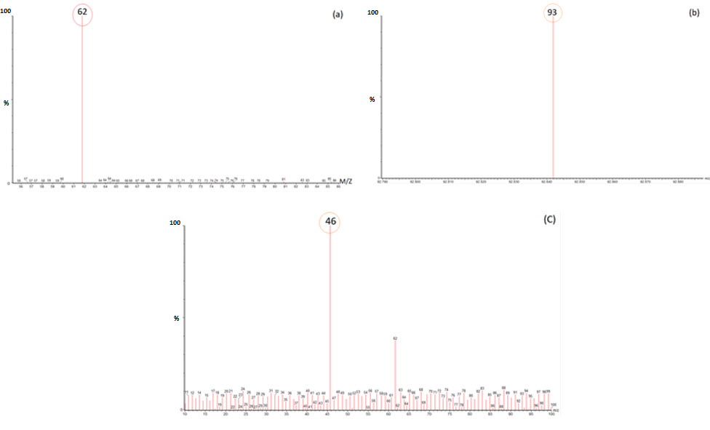
Fig. S5. LC/MS chromatograms (a,b) and LC/MS/MS chromatograms of the TCAA solution treated using MeOH/UV/F-TiO₂ process (c).

References
[1] Wu, D. and L. Wang. Applied surface science, 2013. 271: 357-361.
[2] Umadevi, M., M. Sangari, R. Parimaladevi, A. Sivanantham, and J. Mayandi. Journal of Fluorine Chemistry, 2013. 156: 209-213.

