Spectra of target compounds 8a-8j
Spectra of compound 8a
¹H NMR spectrum
Figure S16
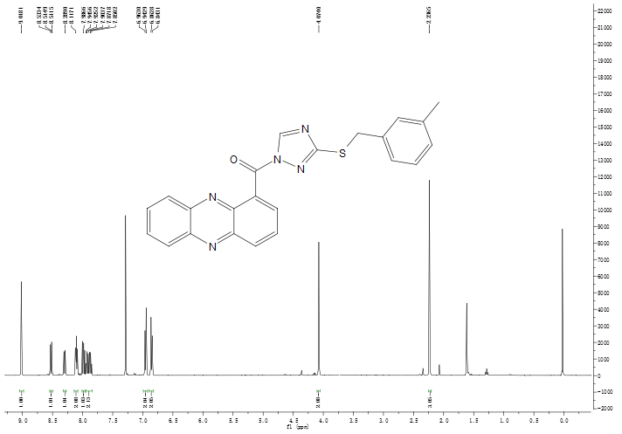
¹³C NMR spectrum
Figure S16
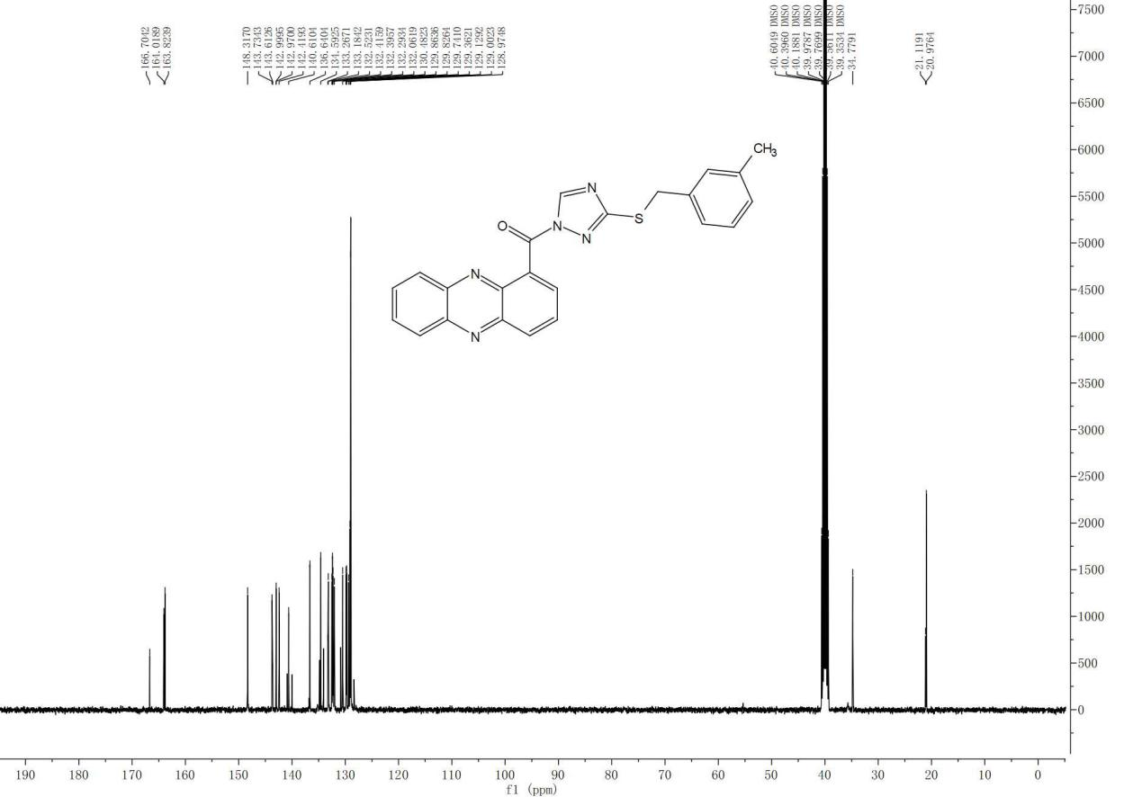
HRMS Spectrum
Figure S16
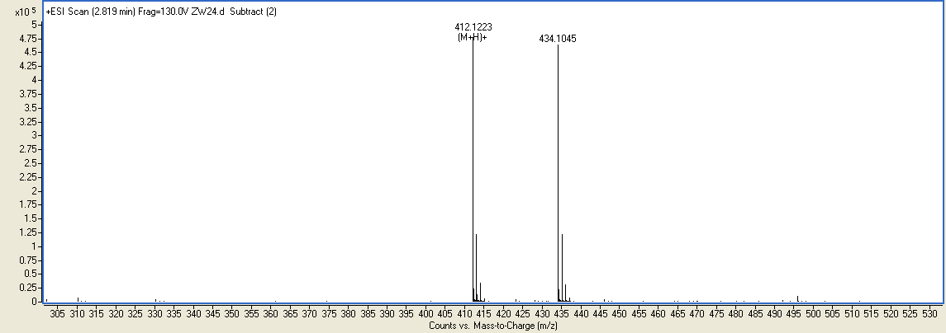
Spectra of compound 8b
¹H NMR spectrum
Figure S17
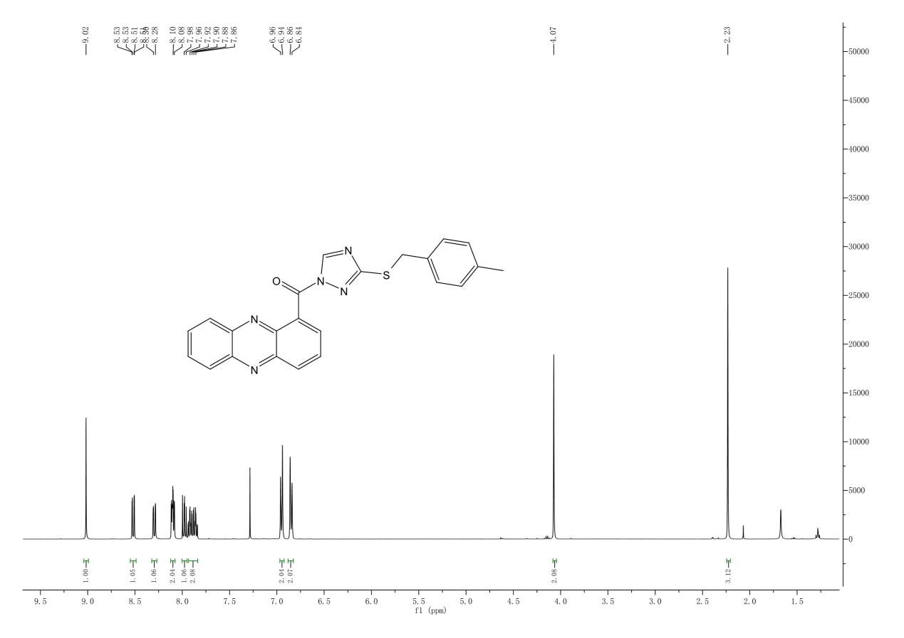
¹³C NMR spectrum
Figure S17
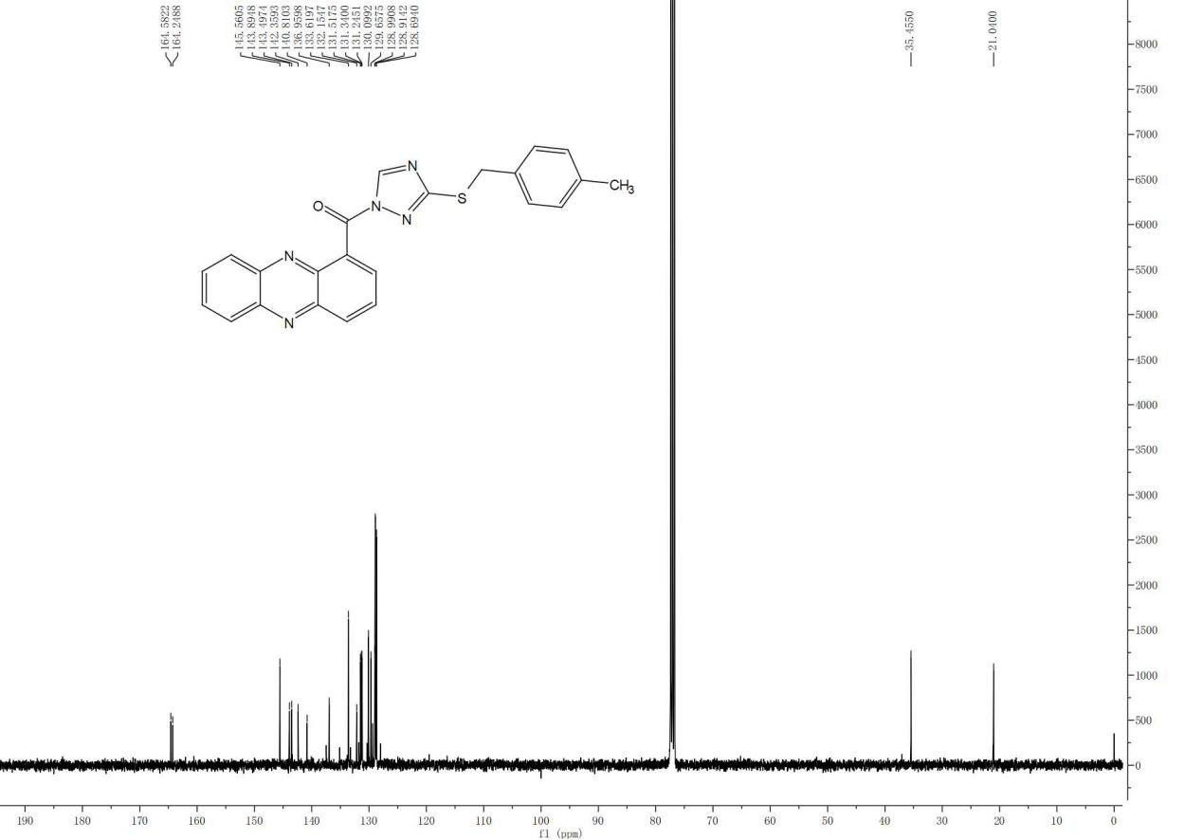
HRMS Spectrum
Figure S17
Spectra of compound 8c
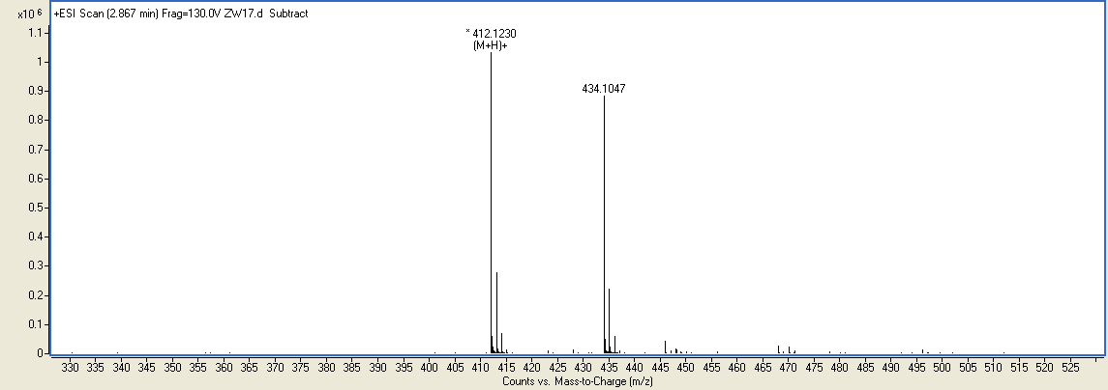
¹H NMR spectrum
Figure S18
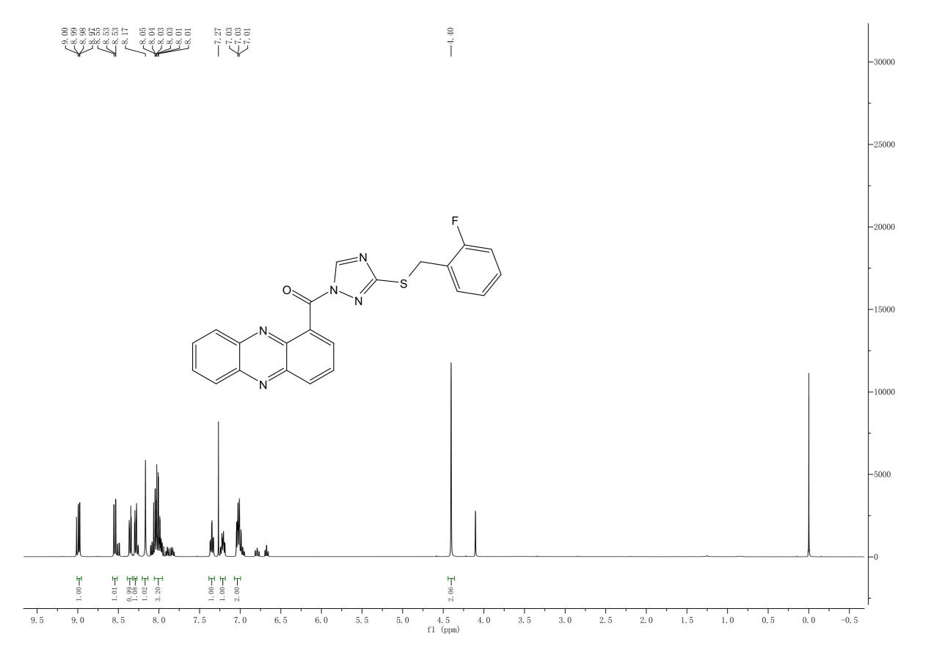

¹³C NMR spectrum
Figure S18
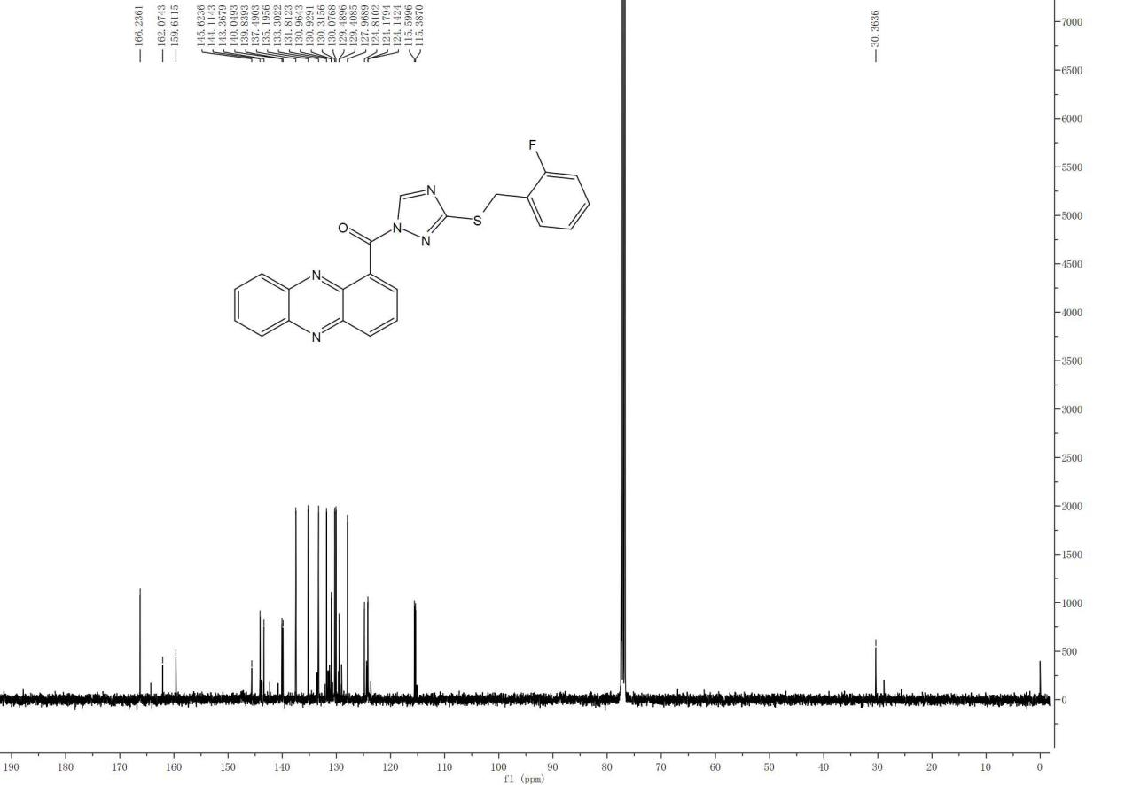
HRMS Spectrum
Figure S18
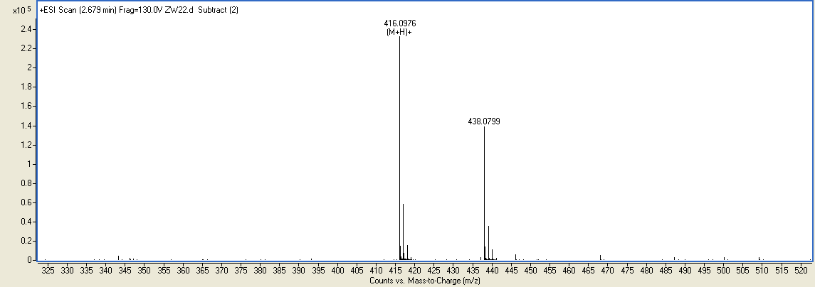
Spectra of compound 8d
¹H-NMR spectrum
Figure S19
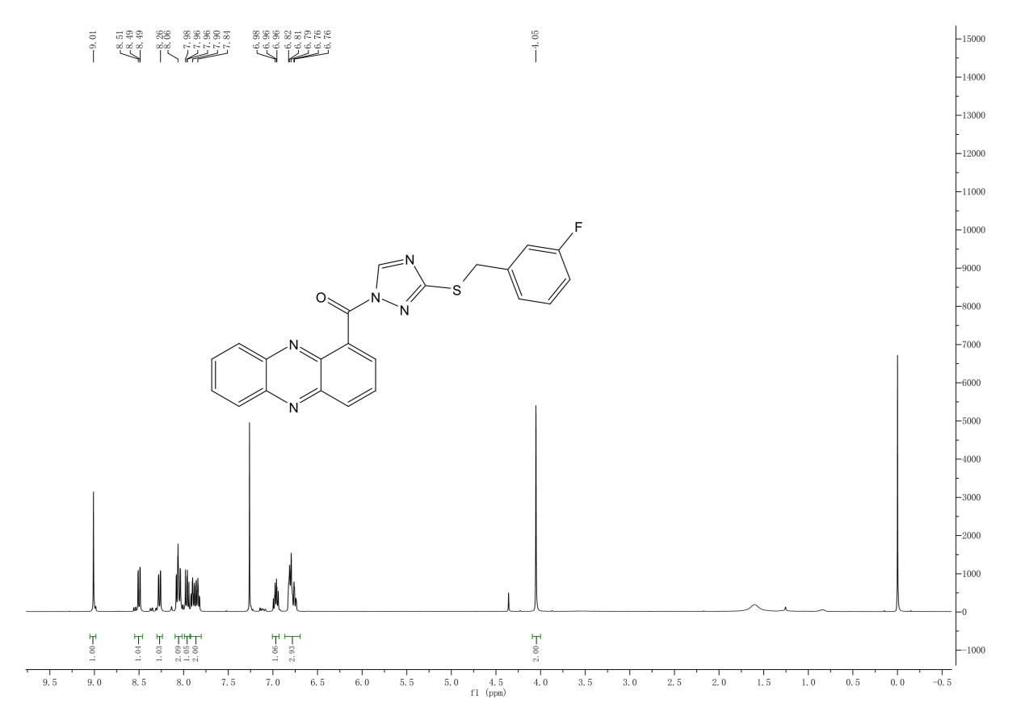
¹³C NMR spectrum
Figure S19
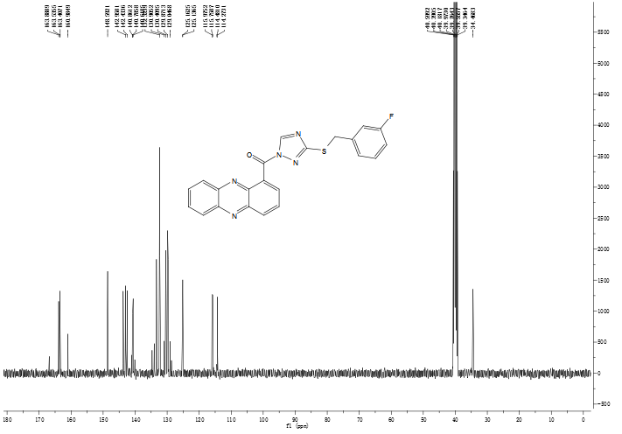
HRMS Spectrum
Figure S19
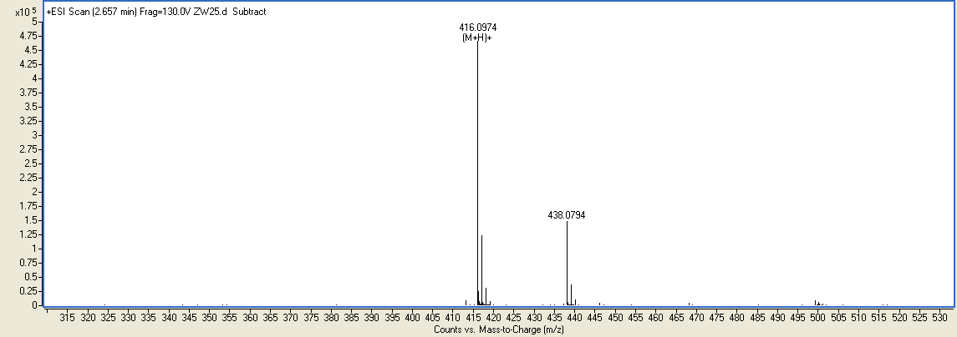
Spectra of compound 8e
¹H NMR spectrum
Figure S20
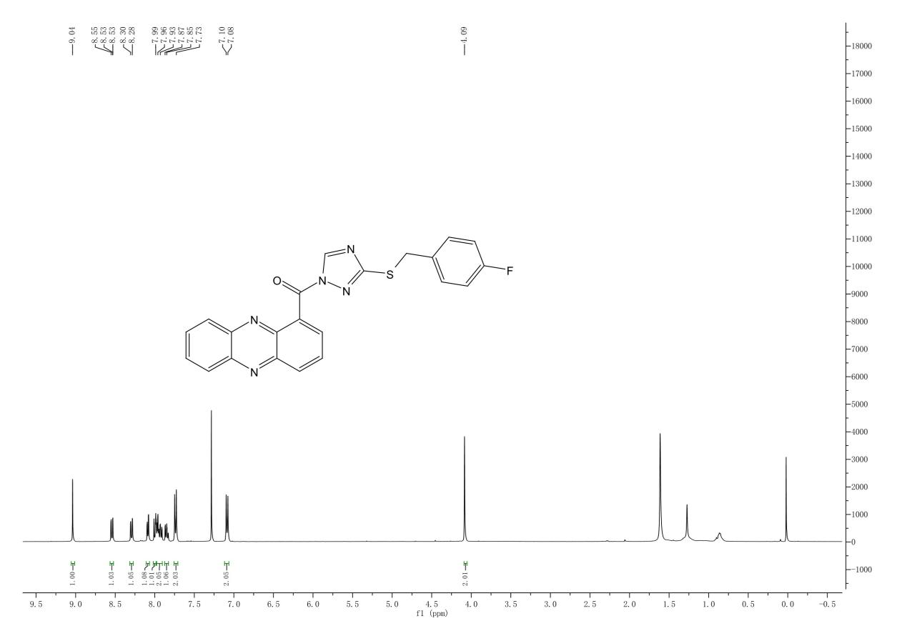
¹³C NMR spectrum
Figure S20
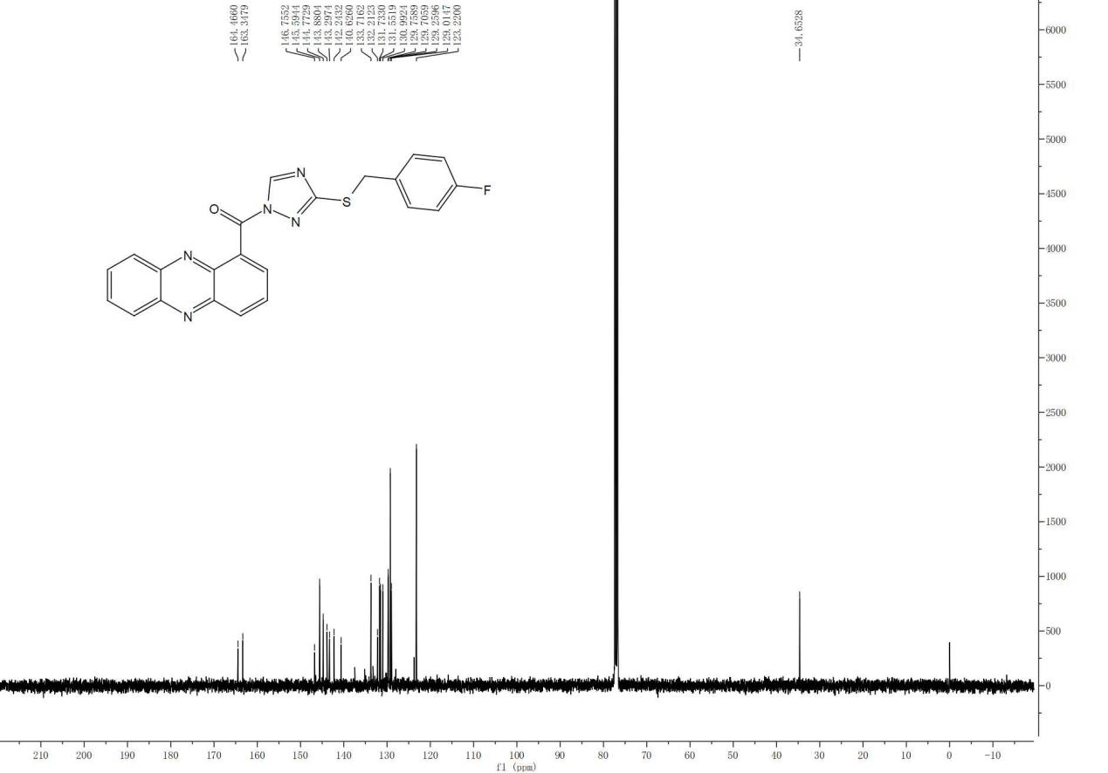
HRMS Spectrum
Figure S20
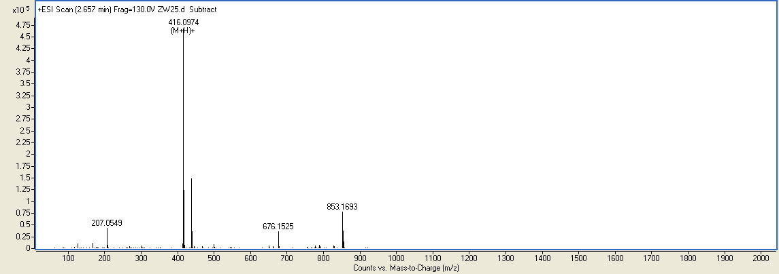Spectra of compound 8f
¹H NMR spectrum
Figure S21
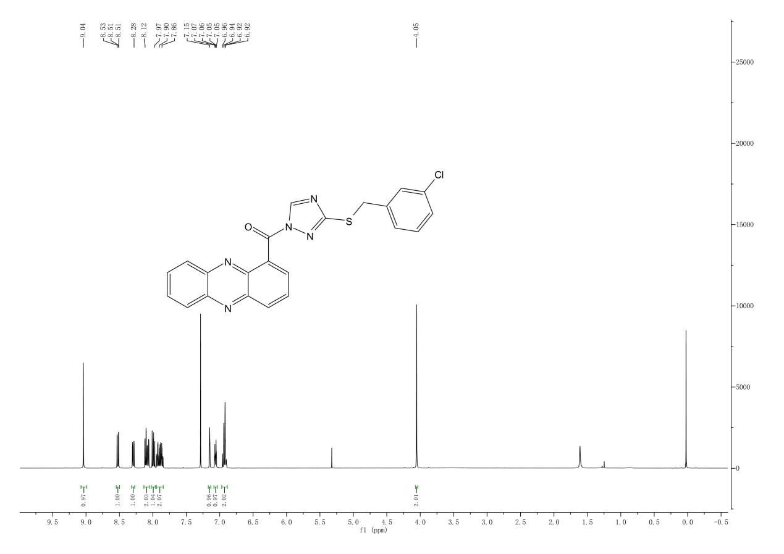
¹³C NMR spectrum
Figure S21
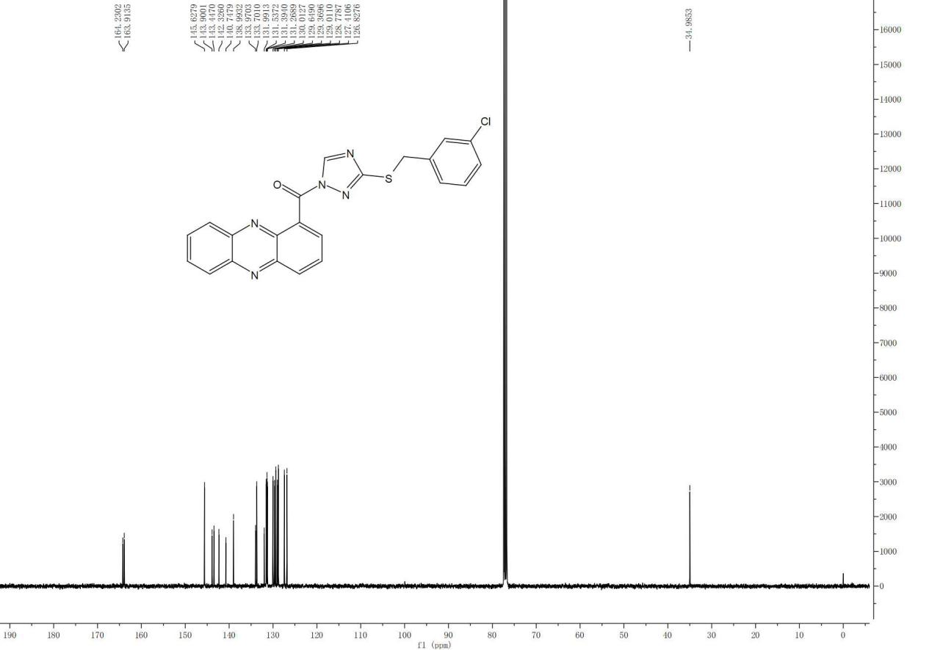
HRMS Spectrum
Figure S21
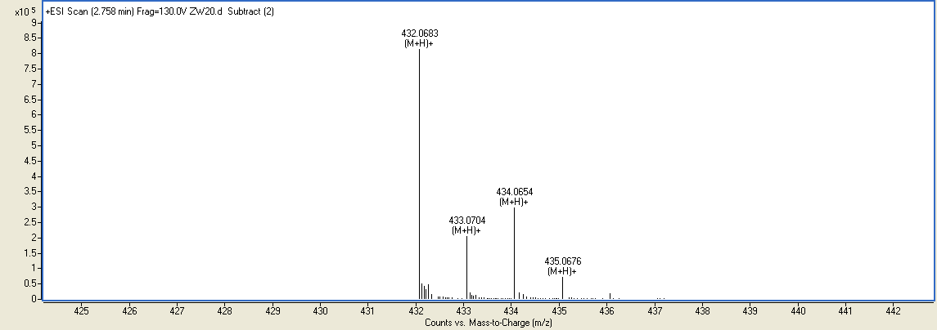
Spectra of compound 8g
¹H NMR spectrum
Figure S22
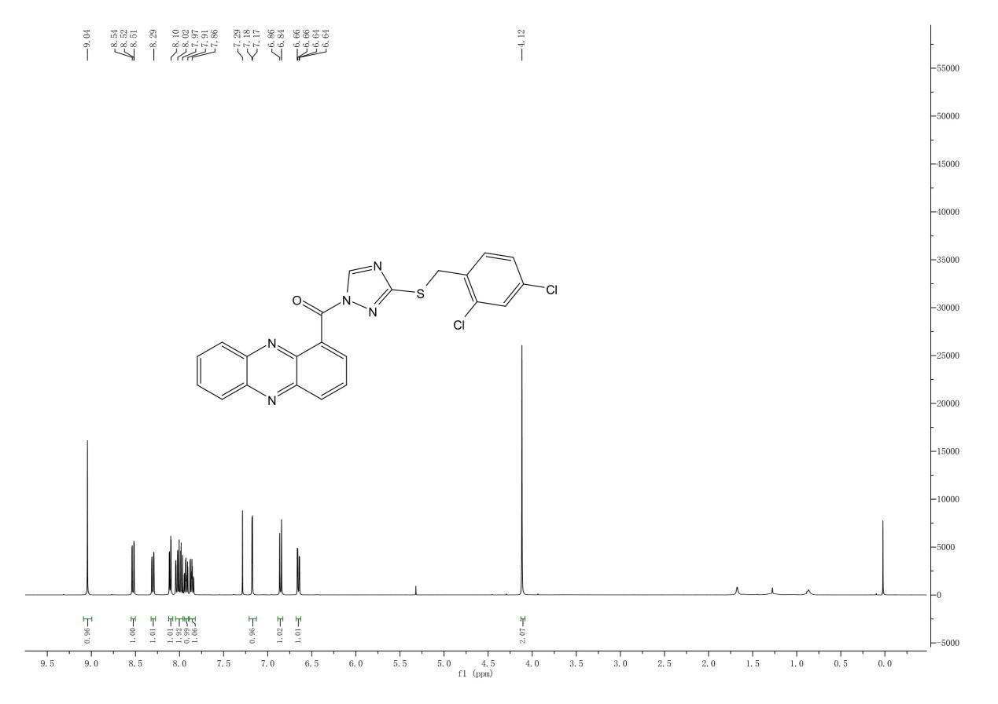
¹³C NMR spectrum
Figure S22
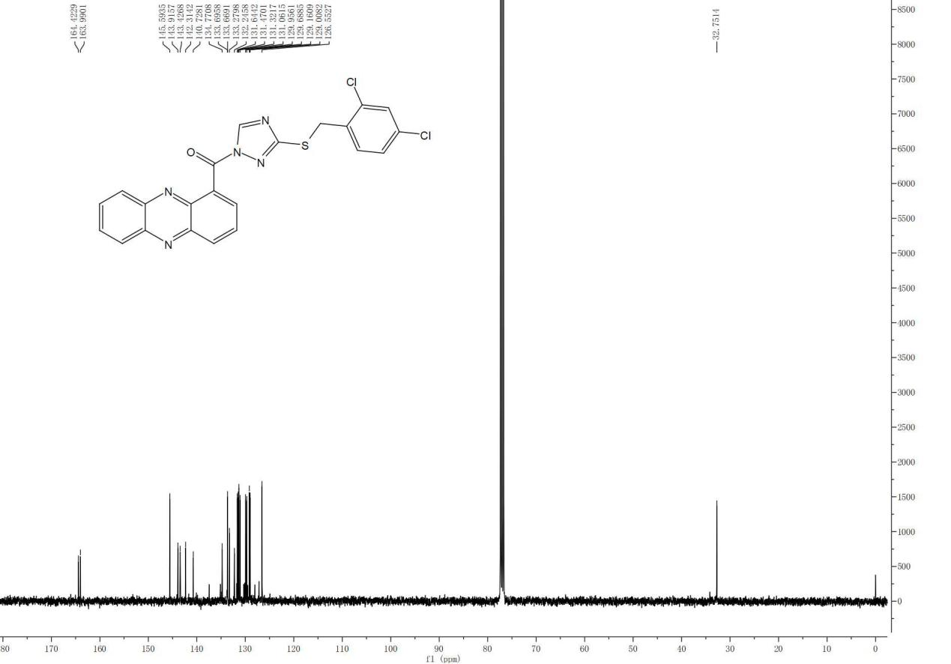
HRMS Spectrum
Figure S22
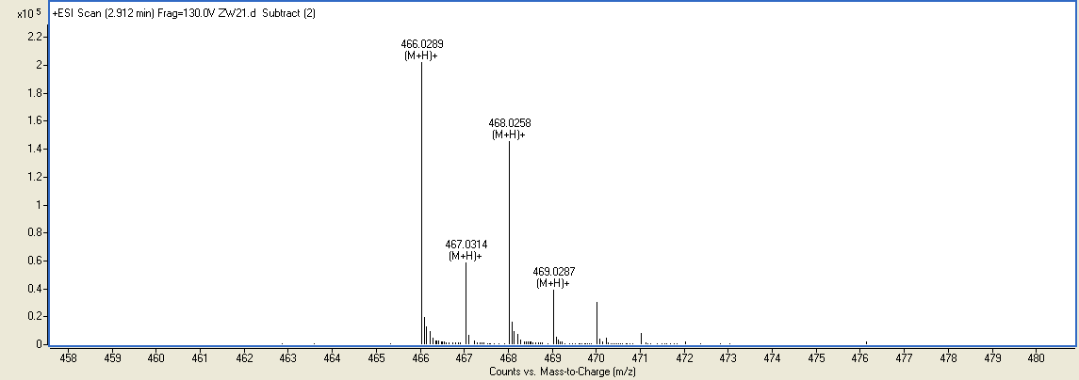
Spectra of compound 8h
¹H NMR spectrum
Figure S23
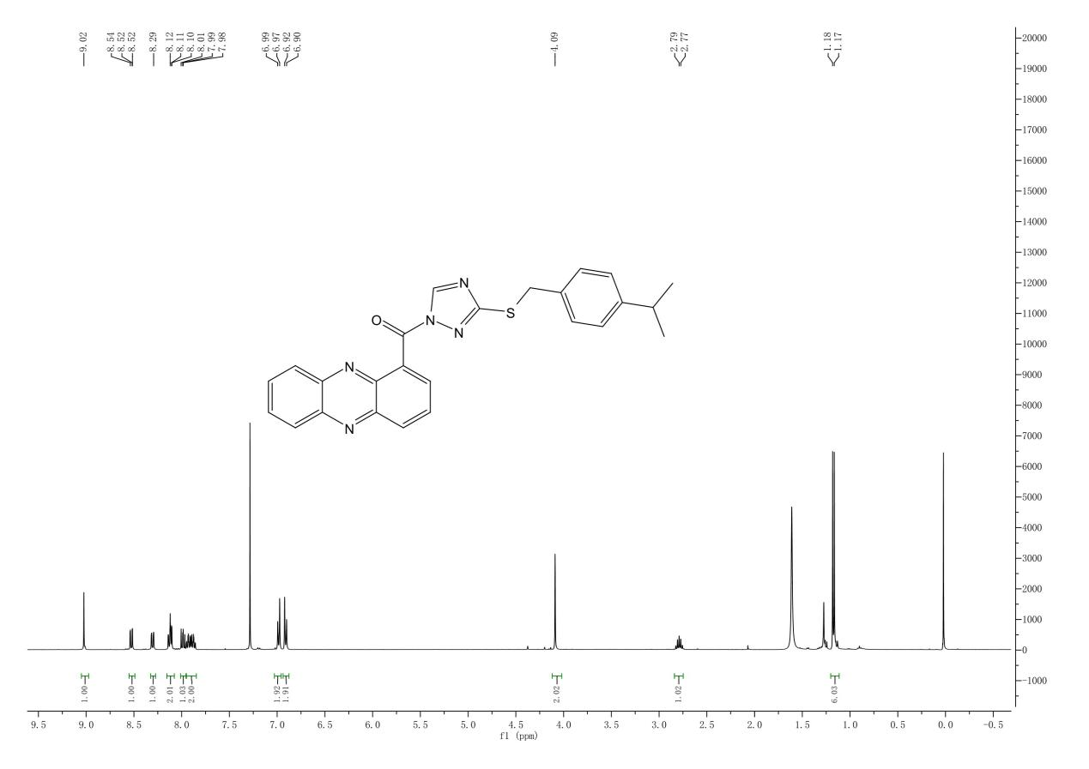
¹³C NMR spectrum
Figure S23
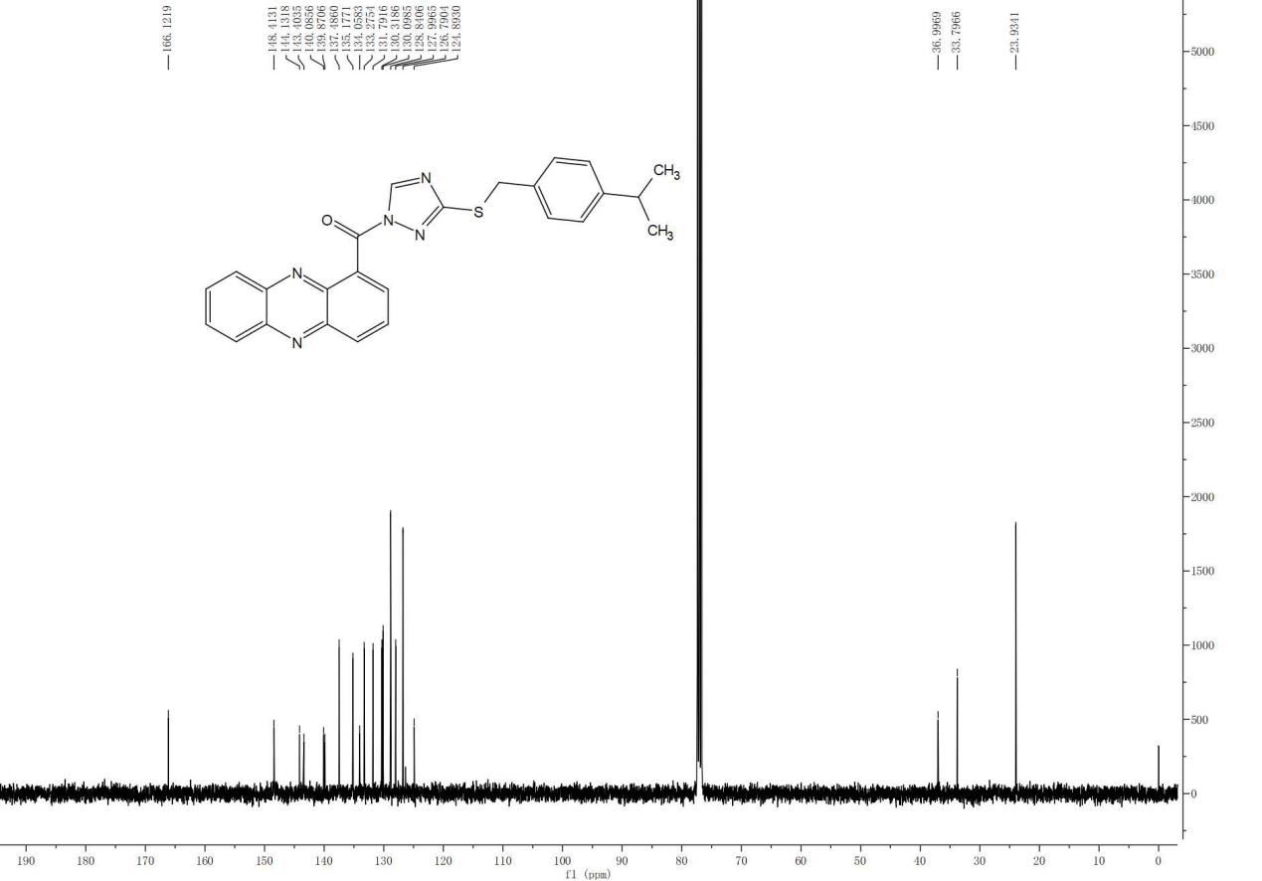
HRMS Spectrum
Figure S23
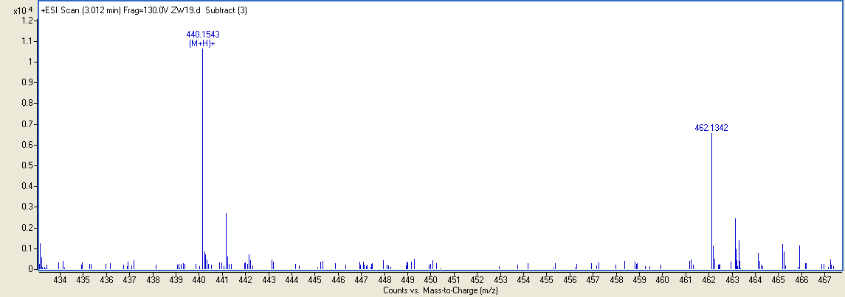
Spectra of compound 8i
¹H NMR spectrum
Figure S24
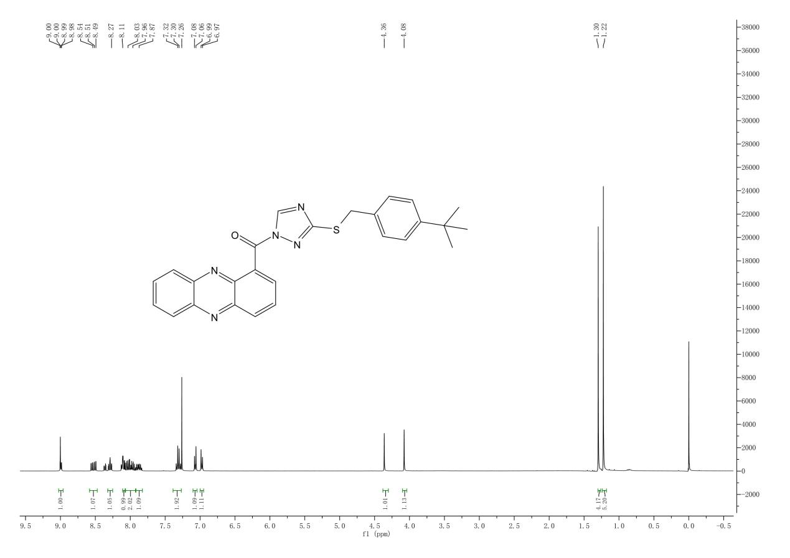
¹³C NMR spectrum
Figure S24
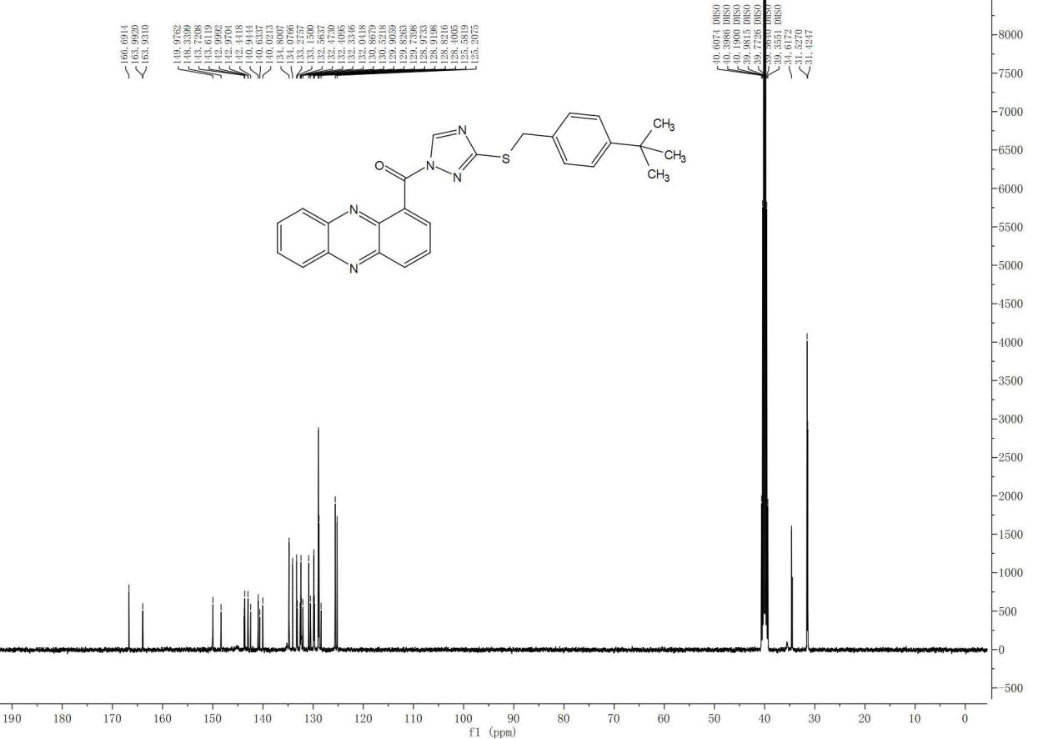
HRMS Spectrum
Figure S24
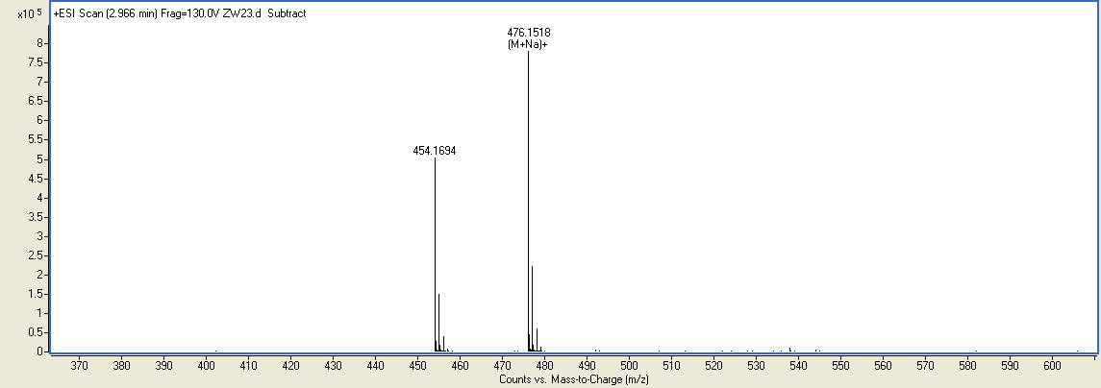
Spectra of compound 8j
¹H NMR spectrum
Figure S25
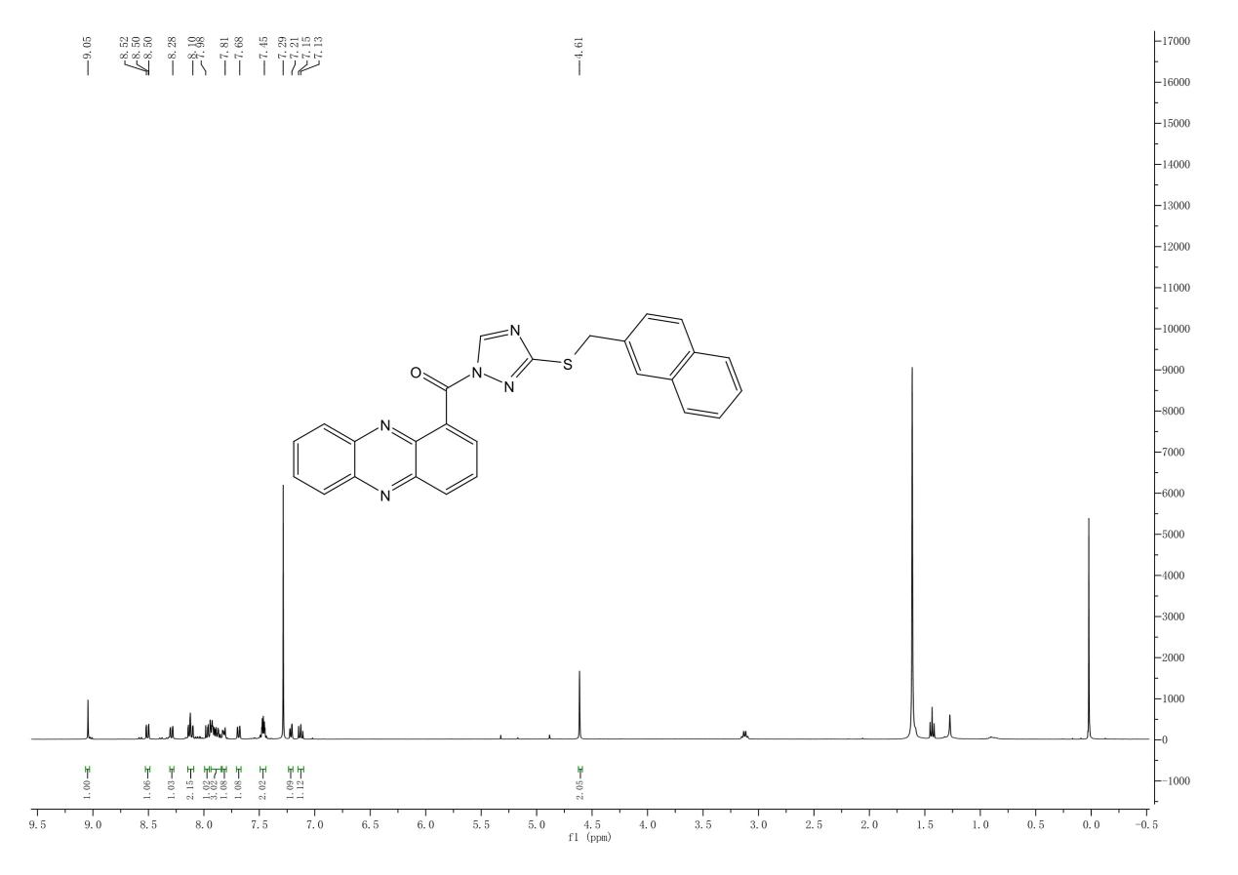
¹³C NMR spectrum
Figure S25
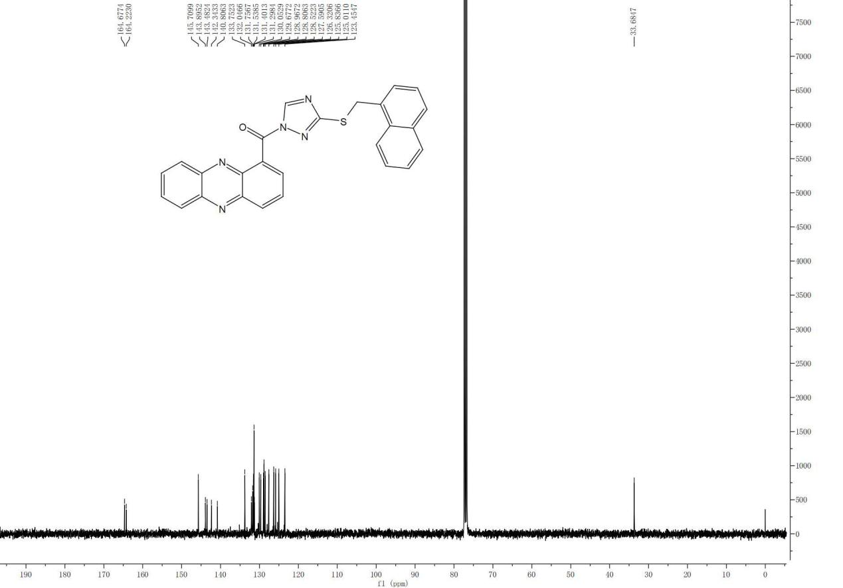
HRMS Spectrum
Figure S25


