Colorimetric paper bioassay by horseradish peroxidase for the detection of catechol and resorcinol in aqueous samples
Ajinkya Dabhade ¹, Sivaraman Jayaraman ², Balasubramanian Paramasivan ^{1,} *

¹ Agricultural and Environmental Biotechnology Lab, Department of Biotechnology and Medical Engineering, National Institute of Technology Rourkela, India – 769008
² Medical Electronics and Instrumentation Lab, Department of Biotechnology and Medical Engineering, National Institute of Technology Rourkela, India – 769008

*Corresponding author e-mail: biobala@nitrkl.ac.in; (+91) 661 2462297
21.04.2020

Supplementary Data

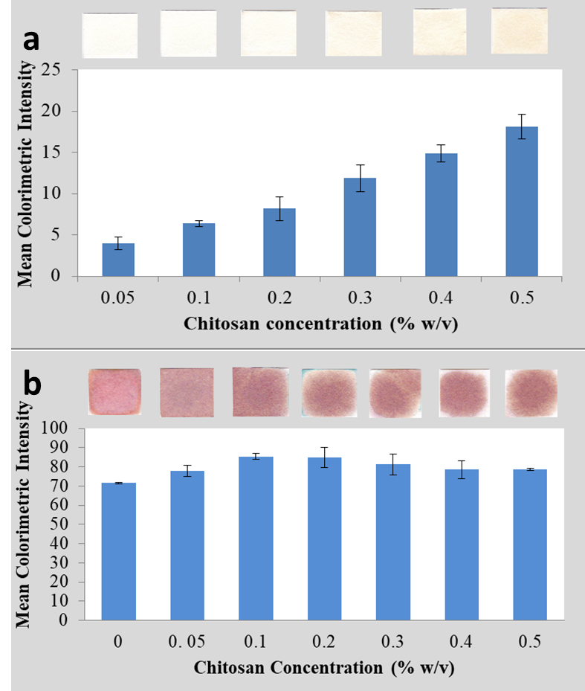
S. Fig. 1: a) Background intensity of chitosan modified Whatman #1 paper with immobilized HRP before catechol dispensation and b) Determination of optimum chitosan concentration

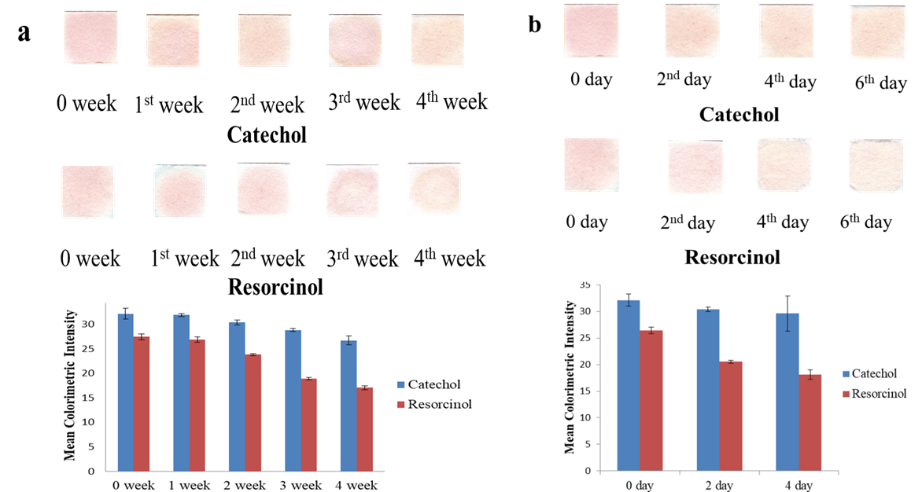
S. Fig. 2: Shelf life of biosensor a) at 4○C and b) at room temperature

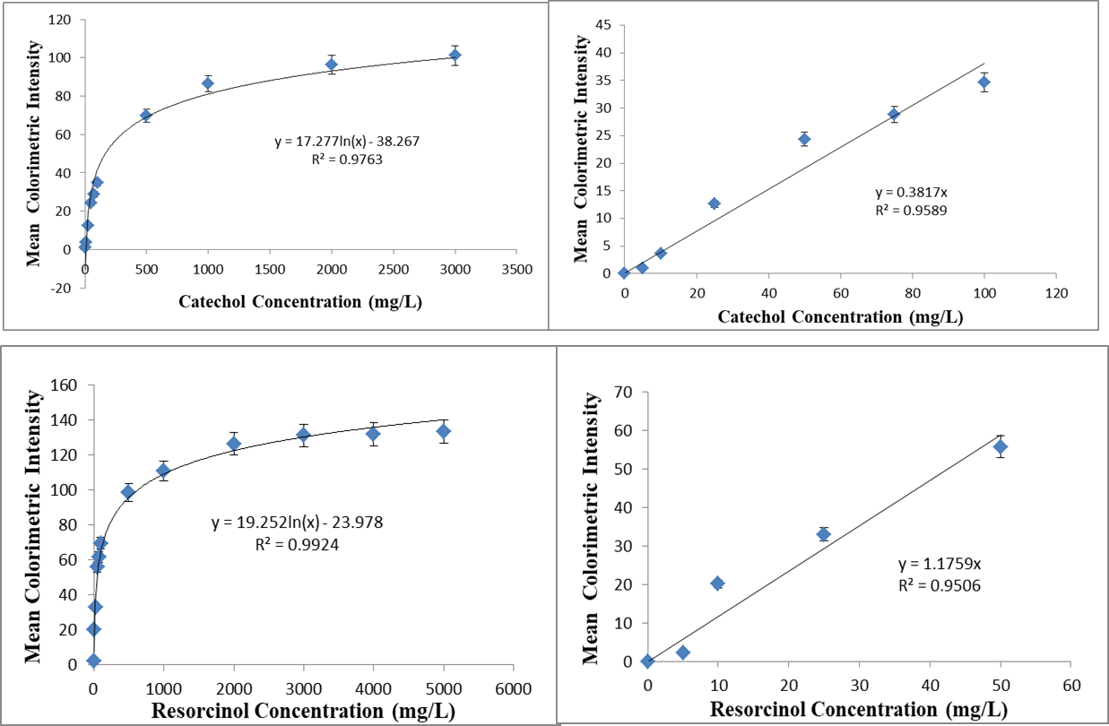
S. Fig. 3: Calibration curve for catechol and resorcinol detection using HRP as immobilized enzyme on paper

