Effect of formal CH/P exchange on Tandem Cope rearrangement and [2+2] cycloaddition of cis-1,2-diethynylcyclopropane and its mono-hetero analogues
Nivedita Sharma and R.K. Bansal
Department of Chemistry, The IIS University, Jaipur, Rajasthan, India.
E-mail: bansal56@gmail.com
Supplemental Materials
Cartesian coordinates of the optimized geometries
B3LYP/6-31+G(d)
1Aa
6 -1.521504000 0.378643000 -0.113493000
6 -2.172675000 1.374432000 0.109185000
6 -0.772166000 -0.815434000 -0.396593000
6 -0.000049000 -1.529567000 0.692687000
6 0.772131000 -0.815400000 -0.396641000
6 1.521545000 0.378595000 -0.113544000
6 2.172692000 1.374398000 0.109211000
1 2.734704000 2.258868000 0.310445000
1 1.209993000 -1.451628000 -1.163626000
1 -1.209999000 -1.451618000 -1.163639000
1 0.000007000 -1.072568000 1.677146000
1 -0.000004000 -2.616089000 0.684513000
1 -2.734551000 2.259039000 0.310295000
TS1Aa
6 0.349817000 1.390791000 -0.121399000
6 1.547603000 1.070939000 0.063773000
6 -0.933280000 0.904481000 -0.335262000
6 -1.614893000 0.000097000 0.658147000
6 -0.933168000 -0.904753000 -0.334810000
6 0.349989000 -1.390926000 -0.120863000
6 1.547872000 -1.070651000 0.063295000
1 2.518768000 -1.365818000 0.415183000
1 -1.511671000 -1.245018000 -1.189109000
1 -1.511482000 1.244265000 -1.189951000
1 -1.193409000 0.000412000 1.660788000
1 -2.703963000 0.000074000 0.649175000
1 2.518117000 1.366218000 0.416628000
IntAa
6 -1.517882000 0.764452000 0.045480000
6 -1.519072000 -0.763176000 0.045311000
6 -0.364876000 -1.366491000 -0.168650000
6 0.944828000 -1.161903000 -0.252754000
6 0.946496000 1.161363000 -0.252636000
6 -0.363092000 1.366816000 -0.168817000
6 1.525852000 -0.001049000 0.579147000
1 -2.388708000 1.226771000 0.502834000
1 1.545056000 1.546441000 -1.077003000
1 1.542378000 -1.547412000 -1.077681000
1 1.161072000 -0.000584000 1.607629000
1 2.617777000 -0.001605000 0.579550000
1 -2.391103000 -1.223676000 0.502183000
TS2Aa
6 1.681635000 -0.667185000 0.268985000
6 1.681565000 0.667333000 -0.268917000
6 0.365279000 1.014836000 -0.116620000
6 -0.903837000 1.202355000 0.195486000
6 -1.843529000 -0.000105000 0.000128000
6 -0.903668000 -1.202423000 -0.195613000
6 0.365322000 -1.014833000 0.116659000
1 -2.507282000 -0.102576000 0.873494000
1 -2.507958000 0.102274000 -0.872730000
1 -1.269197000 2.097859000 0.697085000
1 -1.268603000 -2.097371000 -0.698493000
1 2.448210000 -1.180561000 0.845410000
1 2.448223000 1.180517000 -0.845421000
PrAa
6 -0.307306000 0.737102000 -0.000101000
6 -0.307238000 -0.736786000 -0.000128000
6 0.945904000 -1.214117000 0.000060000
6 1.890592000 -0.000028000 -0.000007000
6 0.945906000 1.214038000 0.000032000
6 -1.795139000 -0.686282000 0.000025000
6 -1.795431000 0.686119000 0.000030000
1 2.554169000 0.000119000 0.879528000
1 2.554190000 0.000094000 -0.879527000
1 1.297263000 -2.240859000 0.000158000
1 1.297509000 2.240731000 0.000130000
1 -2.583702000 1.431450000 0.000157000
1 -2.583157000 -1.431813000 0.000087000
1Ab
6 -1.537314000 0.368801000 -0.093853000
6 -0.757560000 -0.812853000 -0.360450000
6 0.757570000 -0.813015000 -0.360110000
6 1.537430000 0.368505000 -0.093112000
6 2.216933000 1.351096000 0.094061000
6 -2.216719000 1.351242000 0.094388000
7 -0.000265000 -1.416385000 0.752501000
1 2.801645000 2.225728000 0.273658000
1 1.206415000 -1.492921000 -1.085049000
1 -1.206207000 -1.492778000 -1.085488000
1 -0.000406000 -2.433615000 0.669204000
1 -2.801624000 2.225628000 0.274625000
TS1Ab
6 0.341039000 -1.395196000 0.100924000
6 -0.931721000 -0.842898000 0.310222000
7 -1.520544000 -0.000087000 -0.722349000
6 -0.931880000 0.842843000 0.310230000
6 0.340881000 1.395218000 0.101082000
6 1.532227000 1.025963000 -0.054613000
6 1.532370000 -1.025810000 -0.054503000
1 2.514364000 1.323888000 -0.375082000
1 -1.572164000 1.230451000 1.100857000
1 -1.571904000 -1.230484000 1.100939000
1 -2.538702000 -0.000247000 -0.675950000
1 2.514707000 -1.323719000 -0.374370000
IntAb
6 1.510761000 0.753678000 -0.032059000
6 1.510754000 -0.753571000 -0.032044000
6 0.356696000 -1.379456000 0.152003000
6 -0.955355000 -1.125001000 0.200004000
7 -1.431615000 0.000010000 -0.566315000
6 -0.955452000 1.125016000 0.200028000
6 0.356592000 1.379331000 0.151987000
1 2.386459000 1.221396000 -0.477721000
1 -1.633489000 1.596542000 0.912891000
1 -1.633585000 -1.596753000 0.912526000
1 -2.428634000 -0.000052000 -0.745399000
1 2.386577000 -1.221189000 -0.477609000
TS2Ab
6 1.665779000 0.668156000 -0.250650000
6 1.676393000 -0.664030000 0.255829000
6 0.340348000 -1.000773000 0.149097000
6 -0.925567000 -1.156026000 -0.205308000
7 -1.783737000 0.006503000 -0.098965000
6 -0.939837000 1.139746000 0.199880000
6 0.337971000 1.024439000 -0.110175000
1 -2.586664000 -0.079539000 0.523118000
1 -1.344508000 -2.028114000 -0.699624000
1 -1.415764000 1.999571000 0.663816000
1 2.438823000 1.198244000 -0.801712000
1 2.463751000 -1.204762000 0.775121000
PrAb
6 -1.799198000 0.680034000 -0.023457000
6 -0.288511000 0.720072000 0.085832000
6 -0.288337000 -0.720065000 0.085279000
6 -1.799402000 -0.679968000 -0.023292000
6 0.992265000 -1.154480000 -0.004741000
7 1.808339000 0.000053000 -0.096041000
6 0.992237000 1.154298000 -0.005394000
1 2.750737000 0.000354000 0.275358000
1 1.444325000 2.136162000 -0.053290000
1 1.444021000 -2.136383000 -0.054405000
1 -2.576005000 -1.433096000 -0.090500000
1 -2.575766000 1.433251000 -0.090244000
1Ac
6 -1.526005000 0.348029000 -0.098568000
6 -2.219449000 1.323710000 0.071575000
6 -0.746700000 -0.838490000 -0.347291000
8 -0.000031000 -1.401271000 0.745767000
6 0.746628000 -0.838519000 -0.347183000
6 1.525978000 0.348009000 -0.098464000
6 2.219575000 1.323612000 0.071497000
1 2.817211000 2.192458000 0.238151000
1 1.231707000 -1.586410000 -0.975954000
1 -1.231640000 -1.586450000 -0.976064000
1 -2.817189000 2.192470000 0.238333000
TS1Ac
6 -0.318757000 -1.392677000 -0.115362000
6 0.949965000 -0.809617000 -0.307130000
8 1.507933000 0.000001000 0.731480000
6 0.949972000 0.809573000 -0.307198000
6 -0.318697000 1.392694000 -0.115330000
6 -1.502468000 0.986223000 0.039143000
6 -1.502512000 -0.986187000 0.039148000
1 -2.486424000 1.288624000 0.354162000
1 1.682222000 1.251072000 -0.979940000
1 1.682193000 -1.251172000 -0.979861000
1 -2.486470000 -1.288578000 0.354167000
IntAc
6 1.488282000 0.753253000 -0.017359000
6 1.488475000 -0.752903000 -0.017263000
6 0.331598000 -1.372596000 0.174158000
6 -0.968408000 -1.086038000 0.192721000
8 -1.432578000 -0.000243000 -0.608888000
6 -0.968733000 1.086030000 0.192738000
6 0.331206000 1.372541000 0.174221000
1 2.355491000 1.215593000 -0.483365000
1 -1.732996000 1.534492000 0.820987000
1 -1.732373000 -1.534830000 0.821145000
1 2.355975000 -1.215030000 -0.482965000
TS2Ac
6 -1.652072000 -0.662943000 -0.255092000
6 -1.652116000 0.662976000 0.254887000
6 -0.319510000 1.018135000 0.141373000
6 0.944197000 1.113694000 -0.216180000
8 1.787785000 -0.000039000 -0.000382000
6 0.944247000 -1.113651000 0.216306000
6 -0.319634000 -1.018272000 -0.140818000
1 1.455362000 1.937282000 -0.699816000
1 1.455353000 -1.936666000 0.700992000
1 -2.441568000 -1.205828000 -0.767861000
1 -2.442104000 1.205890000 0.766881000
PrAc
6 -1.783318000 -0.680628000 -0.000013000
6 -0.275146000 -0.724069000 -0.000149000
6 -0.275155000 0.723893000 -0.000191000
6 -1.783355000 0.680635000 0.000135000
6 1.006039000 1.126245000 -0.000035000
8 1.836147000 0.000063000 0.000101000
6 1.006179000 -1.126180000 0.000032000
1 1.530167000 -2.070157000 0.000150000
1 1.529887000 2.070290000 -0.000002000
1 -2.560371000 1.435668000 0.000306000
1 -2.560328000 -1.435682000 0.000063000
1Ad
1 -2.751734000 2.439308000 -0.645832000
6 -0.753668000 -0.404366000 0.660882000
16 -0.000158000 -1.632603000 -0.504786000
6 0.753653000 -0.404302000 0.661157000
6 1.507164000 0.699877000 0.135476000
6 2.177486000 1.621253000 -0.270858000
1 2.752087000 2.438564000 -0.646250000
6 -1.506956000 0.700200000 0.135518000
6 -2.177242000 1.621537000 -0.270849000
1 -1.205163000 -0.880591000 1.530206000
1 1.204708000 -0.880820000 1.530488000
TS1Ad
6 0.678254000 -1.388936000 0.168298000
6 -0.527187000 -0.831497000 0.624767000
16 -1.684587000 0.000007000 -0.529662000
6 -0.527138000 0.831619000 0.624636000
6 0.678343000 1.388904000 0.168077000
6 1.806802000 0.986661000 -0.225008000
6 1.806631000 -0.986786000 -0.225150000
1 2.726650000 1.291696000 -0.692329000
1 -0.996788000 1.224864000 1.523014000
1 -0.996921000 -1.224622000 1.523154000
1 2.726223000 -1.291844000 -0.692964000
IntAd
6 1.775790000 0.743902000 -0.149307000
6 1.775588000 -0.745163000 -0.148597000
6 0.660572000 -1.360682000 0.223162000
6 -0.634439000 -1.314876000 0.454187000
16 -1.529188000 -0.000031000 -0.468326000
6 -0.633186000 1.315860000 0.453733000
6 0.661916000 1.361004000 0.223608000
1 2.571496000 1.230171000 -0.707579000
1 -1.156766000 1.782948000 1.282256000
1 -1.156598000 -1.781073000 1.284181000
1 2.571431000 -1.231815000 -0.706361000
TS2Ad
6 -2.002920000 0.660191000 0.273731000
6 -2.003119000 -0.659995000 -0.273752000
6 0.561863000 -1.299202000 0.185313000
16 1.823593000 -0.000111000 -0.000019000
6 0.562071000 1.299199000 -0.185313000
6 -0.676757000 1.005704000 0.141263000
6 -0.676988000 -1.005673000 -0.141440000
1 0.898690000 -2.214868000 0.664631000
1 0.899241000 2.215220000 -0.663727000
1 -2.779896000 1.177182000 0.831655000
1 -2.780426000 -1.177098000 -0.831077000
PrAd
6 -2.125829000 0.680454000 0.000140000
6 -0.615767000 0.723509000 -0.000465000
6 -0.615854000 -0.723116000 -0.000589000
6 -2.125451000 -0.680647000 0.000271000
6 0.606310000 -1.285902000 -0.000016000
16 1.849324000 -0.000099000 0.000165000
6 0.606441000 1.286040000 -0.000055000
1 0.921407000 2.322075000 0.000287000
1 0.920908000 -2.322044000 0.000103000
1 -2.904966000 -1.433416000 0.000671000
1 -2.905637000 1.432947000 0.000580000
1Ae
6 1.502663000 0.722501000 0.146943000
6 2.150525000 1.656787000 -0.268965000
6 0.760564000 -0.395394000 0.657901000
15 -0.002152000 -1.628136000 -0.572118000
6 -0.761467000 -0.393588000 0.658170000
6 -1.500892000 0.726038000 0.147038000
6 -2.146304000 1.661976000 -0.268990000
1 -2.701470000 2.494641000 -0.639469000
1 -1.205103000 -0.855704000 1.538336000
1 1.203237000 -0.858906000 1.537820000
1 -0.002557000 -2.716083000 0.351808000
1 2.707639000 2.488179000 -0.639306000
TS1Ae
6 0.700058000 -1.390626000 0.176031000
6 1.836402000 -1.020801000 -0.217228000
6 -0.521936000 -0.871296000 0.609376000
15 -1.665633000 0.000019000 -0.587067000
6 -0.521884000 0.871316000 0.609362000
6 0.700159000 1.390575000 0.176081000
6 1.836500000 1.020773000 -0.217209000
1 2.750855000 1.324389000 -0.693951000
1 -0.948854000 1.221681000 1.545667000
1 -0.948843000 -1.221621000 1.545724000
1 -2.795389000 0.000096000 0.283687000
1 2.750929000 -1.324468000 -0.693606000
IntAe
6 1.793393000 0.754088000 -0.152726000
6 1.794536000 -0.752961000 -0.152116000
6 0.684976000 -1.367180000 0.224189000
6 -0.608509000 -1.333374000 0.462968000
15 -1.521126000 -0.000681000 -0.535601000
6 -0.609838000 1.333559000 0.462681000
6 0.683725000 1.367323000 0.224852000
1 2.593223000 1.234008000 -0.710071000
1 -1.067056000 1.739409000 1.363232000
1 -1.064335000 -1.738489000 1.364586000
1 -2.670573000 -0.001153000 0.304935000
1 2.595937000 -1.232287000 -0.707751000
TS2Ae
6 -2.011313000 -0.665996000 -0.267279000
6 -2.014651000 0.660839000 0.286224000
6 -0.697996000 1.002229000 0.133999000
6 0.538980000 1.336436000 -0.181297000
15 1.843445000 -0.000710000 -0.091944000
6 0.549901000 -1.330853000 0.172079000
6 -0.694864000 -1.015453000 -0.113573000
1 2.252131000 0.087601000 1.280485000
1 0.790151000 2.264459000 -0.694290000
1 0.847311000 -2.277893000 0.623325000
1 -2.773937000 -1.164308000 -0.862264000
1 -2.787660000 1.177579000 0.850991000
PrAe
6 2.122550000 -0.684416000 -0.010078000
6 0.630576000 -0.737089000 0.036784000
6 -0.572693000 -1.331168000 0.027366000
15 -1.867107000 -0.000023000 -0.117976000
6 -0.572761000 1.331477000 0.027953000
6 0.630017000 0.736675000 0.036414000
6 2.122363000 0.684462000 -0.009899000
1 -2.372161000 -0.000786000 1.221404000
1 -0.799240000 -2.392110000 -0.008217000
1 -0.798135000 2.392608000 -0.008095000
1 2.907280000 1.431959000 -0.044420000
1 2.908546000 -1.430966000 -0.042271000

1Ba
6 1.457307000 -0.571647000 -0.375002000
6 0.984825000 -1.509480000 0.709827000
6 0.021025000 -1.162688000 -0.411925000
6 -1.131202000 -0.343610000 -0.171450000
15 -2.382960000 0.541073000 0.076507000
6 1.684969000 0.821948000 -0.108532000
6 1.899063000 1.995086000 0.098961000
1 2.072347000 3.030237000 0.292193000
1 2.118449000 -1.003475000 -1.124201000
1 -0.113810000 -1.928827000 -1.174824000
1 0.777864000 -1.075428000 1.682819000
1 1.393630000 -2.516247000 0.725134000
TS1Ba
6 1.570610000 0.629901000 -0.302872000
6 1.820315000 -0.514303000 0.643709000
6 0.878464000 -1.191053000 -0.320819000
6 -0.481313000 -1.162653000 -0.155368000
15 -1.876937000 -0.443651000 0.066996000
6 0.520987000 1.499192000 -0.120305000
6 -0.681039000 1.800665000 0.034387000
1 -1.411991000 2.501292000 0.390917000
1 2.215738000 0.725085000 -1.171789000
1 1.319699000 -1.664011000 -1.196054000
1 1.423299000 -0.375954000 1.648069000
1 2.839168000 -0.902144000 0.651530000
IntBa
6 1.596599000 0.686312000 -0.285194000
6 1.806535000 -0.510831000 0.618718000
6 0.861017000 -1.251763000 -0.305625000
6 -0.479820000 -1.180992000 -0.152278000
15 -1.854989000 -0.389871000 0.067263000
6 0.514460000 1.488588000 -0.124283000
6 -0.726024000 1.697097000 0.027238000
1 -1.400704000 2.430600000 0.435001000
1 2.225598000 0.771300000 -1.168158000
1 1.294899000 -1.688471000 -1.204776000
1 1.421697000 -0.378808000 1.629630000
1 2.826279000 -0.898835000 0.627993000
TS2Ba
6 -1.213272000 1.137587000 0.402335000
15 -1.795578000 -0.455625000 -0.251708000
6 -0.174088000 -0.953658000 0.018057000
6 1.084404000 -1.246463000 0.292474000
6 2.143269000 -0.196699000 -0.059410000
6 1.366601000 1.105287000 -0.280492000
6 0.104009000 1.124259000 0.109783000
1 2.894169000 -0.120126000 0.742324000
1 2.700191000 -0.456136000 -0.973379000
1 1.369519000 -2.131645000 0.861412000
1 1.811842000 1.915073000 -0.856463000
1 -1.707584000 1.805331000 1.105245000
PrBa
6 1.563796000 0.894950000 -0.244261000
6 1.802925000 -0.372094000 0.587772000
6 0.931785000 -1.290976000 -0.276877000
6 -0.392134000 -1.247565000 -0.155065000
15 -1.763482000 -0.380398000 0.064647000
6 0.365351000 1.469586000 -0.155255000
6 -0.922394000 1.404268000 0.004777000
1 -1.565021000 2.130174000 0.496593000
1 2.238024000 1.099084000 -1.073472000
1 1.400491000 -1.714188000 -1.166371000
1 1.430253000 -0.285332000 1.609286000
1 2.852502000 -0.672785000 0.597711000
1Bb
6 -1.149450000 -0.315643000 -0.145405000
15 -2.394245000 0.582426000 0.067950000
6 0.001254000 -1.149535000 -0.373960000
7 0.902171000 -1.428417000 0.766268000
6 1.425890000 -0.613799000 -0.342500000
6 1.730512000 0.770378000 -0.090469000
6 2.015828000 1.932209000 0.085850000
1 2.251475000 2.959311000 0.255705000
1 2.098226000 -1.102189000 -1.048889000
1 -0.155622000 -1.953827000 -1.094961000
1 1.260193000 -2.382430000 0.703929000
TS1Bb
6 0.429754000 -1.202850000 0.130775000
15 1.819336000 -0.456176000 -0.060107000
6 -0.936069000 -1.113788000 0.289899000
7 -1.738488000 -0.420735000 -0.698031000
6 -1.518516000 0.631345000 0.274441000
6 -0.461977000 1.500377000 0.099949000
6 0.775416000 1.684172000 -0.020814000
1 1.517825000 2.383400000 -0.364307000
1 -2.224393000 0.762618000 1.092713000
1 -1.440775000 -1.611729000 1.118677000
1 -2.704923000 -0.742042000 -0.704772000
IntBb
6 0.354733000 -1.259365000 0.141156000
15 1.736620000 -0.406067000 -0.063500000
6 -0.979060000 -1.243279000 0.232724000
7 -1.715773000 -0.319286000 -0.606251000
6 -1.527564000 0.871347000 0.201546000
6 -0.338825000 1.478473000 0.121096000
6 0.955320000 1.389911000 0.020753000
1 1.628188000 2.116092000 -0.429783000
1 -2.249086000 1.099557000 0.986320000
1 -1.512224000 -1.739777000 1.047460000
1 -2.693393000 -0.572388000 -0.711381000
TS2Bb
6 -1.188832000 1.139902000 0.382214000
6 0.135163000 1.131362000 0.097003000
6 1.397130000 1.033082000 -0.291082000
7 2.078661000 -0.176732000 0.047680000
6 1.111108000 -1.212462000 0.275746000
6 -0.155695000 -0.942752000 -0.010888000
15 -1.796032000 -0.450480000 -0.236676000
1 2.884207000 -0.402463000 -0.530051000
1 1.455181000 -2.093523000 0.812237000
1 1.942766000 1.780100000 -0.859732000
1 -1.685551000 1.815426000 1.075959000
PrBb
6 1.303128000 1.124995000 -0.002580000
6 -0.120710000 0.760671000 0.040242000
6 -1.455489000 1.073989000 -0.002469000
7 -2.139650000 -0.139133000 -0.047879000
6 -1.225736000 -1.210007000 0.001697000
6 0.018453000 -0.666236000 0.046853000
15 1.919840000 -0.478310000 -0.013477000
1 -3.133234000 -0.233469000 0.102569000
1 -1.589550000 -2.228786000 -0.016139000
1 -1.995849000 2.010977000 -0.024784000
1 1.780720000 2.099383000 -0.026787000
1Bc
6 1.406967000 -0.669166000 -0.330094000
8 0.864271000 -1.430687000 0.758480000
6 -0.007948000 -1.164039000 -0.358024000
6 -1.140630000 -0.298906000 -0.145002000
15 -2.377622000 0.611306000 0.055242000
6 1.745759000 0.711209000 -0.095878000
6 2.075223000 1.863599000 0.063255000
1 2.351480000 2.882846000 0.220726000
1 2.121196000 -1.224049000 -0.940289000
1 -0.198738000 -2.039089000 -0.982450000
TS1Bc
6 -0.394052000 -1.228533000 -0.139074000
15 -1.761868000 -0.420744000 0.050204000
6 0.964757000 -1.096180000 -0.275606000
8 1.722293000 -0.396861000 0.700711000
6 1.512691000 0.627205000 -0.260562000
6 0.447152000 1.480389000 -0.119416000
6 -0.815029000 1.562857000 -0.001352000
1 -1.534350000 2.273203000 0.379198000
1 2.329088000 0.783480000 -0.960165000
1 1.561822000 -1.645067000 -1.001722000
IntBc
6 0.378014000 -1.251372000 0.143282000
6 -0.953411000 -1.226580000 0.227317000
8 -1.698803000 -0.371964000 -0.632259000
6 -1.564773000 0.782989000 0.193101000
6 -0.411972000 1.455545000 0.145537000
6 0.882639000 1.409324000 0.029955000
15 1.735780000 -0.360826000 -0.050548000
1 1.522885000 2.140821000 -0.458239000
1 -2.396527000 0.968887000 0.865591000
1 -1.555625000 -1.741051000 0.973794000
TS2Bc
6 -1.174040000 1.140907000 0.390742000
6 0.153432000 1.124359000 0.123056000
6 1.394729000 0.999052000 -0.310012000
8 2.077607000 -0.198782000 -0.049513000
6 1.125237000 -1.174385000 0.292434000
6 -0.143568000 -0.961727000 -0.001918000
15 -1.773345000 -0.447366000 -0.237737000
1 1.556955000 -2.005931000 0.837680000
1 1.969909000 1.703003000 -0.898286000
1 -1.682296000 1.834439000 1.056947000
PrBc
6 -1.287799000 1.128911000 0.000123000
6 0.133737000 0.764524000 -0.000368000
6 1.460677000 1.041776000 0.000164000
8 2.169382000 -0.146380000 0.000008000
6 1.232011000 -1.186146000 0.000271000
6 -0.010314000 -0.673508000 -0.000422000
15 -1.899669000 -0.476547000 0.000064000
1 1.666708000 -2.174657000 0.000062000
1 2.065938000 1.936272000 -0.000022000
1 -1.762544000 2.104295000 0.000332000
1Bd
6 1.235079000 -0.309391000 0.268307000
15 2.627096000 0.209582000 -0.176626000
6 -0.036169000 -0.801211000 0.716836000
16 -1.275709000 -1.385836000 -0.541159000
6 -1.289072000 0.041241000 0.635008000
6 -1.260791000 1.384251000 0.126407000
6 -1.274986000 2.527934000 -0.267298000
1 -1.270605000 3.536126000 -0.618014000
1 -1.980066000 -0.106817000 1.463819000
1 0.011201000 -1.456597000 1.586551000

TS1Bd
6 0.610434000 -1.187358000 0.273889000
15 2.026222000 -0.611632000 -0.166778000
6 -0.695293000 -0.956095000 0.625599000
16 -1.898321000 -0.278504000 -0.551294000
6 -1.087545000 0.897105000 0.558813000
6 0.036210000 1.588890000 0.172407000
6 1.253318000 1.593085000 -0.146194000
1 2.024216000 2.184956000 -0.608411000
1 -1.629908000 1.153227000 1.464502000
1 -1.117253000 -1.321404000 1.559201000
IntBd
6 0.560169000 -1.228489000 0.278660000
15 1.962382000 -0.480737000 -0.160271000
6 -0.731645000 -1.325422000 0.511835000
16 -1.798416000 -0.225804000 -0.503925000
6 -1.188257000 1.212528000 0.434393000
6 0.074782000 1.531972000 0.218446000
6 1.336708000 1.317359000 -0.048430000
1 1.994852000 2.003202000 -0.576626000
1 -1.777539000 1.546261000 1.283174000
1 -1.188920000 -1.773233000 1.390900000
TS2Bd
6 -1.566599000 1.102068000 0.419461000
6 -0.243107000 1.140130000 0.139472000
6 1.007357000 1.263801000 -0.260883000
16 2.128393000 -0.132210000 -0.040133000
6 0.775242000 -1.287696000 0.288986000
6 -0.456285000 -0.924866000 -0.004639000
15 -2.101143000 -0.487476000 -0.264840000
1 1.054693000 -2.195477000 0.818985000
1 1.402780000 2.111468000 -0.814073000
1 -2.094264000 1.750892000 1.115436000
PrBd
6 -1.657718000 1.111318000 -0.000005000
6 -0.222234000 0.789175000 0.002190000
6 1.056549000 1.251571000 -0.000168000
16 2.186500000 -0.105601000 -0.000945000
6 0.849130000 -1.291242000 0.000181000
6 -0.333459000 -0.649141000 0.003513000
15 -2.233899000 -0.504878000 -0.001214000
1 1.088735000 -2.347461000 0.000631000
1 1.438369000 2.265156000 -0.000452000
1 -2.156221000 2.075003000 -0.001100000
1Be
6 1.220683000 -0.386889000 0.277433000
6 -0.079940000 -0.797957000 0.712930000
6 -1.279703000 0.142604000 0.636194000
6 -1.137828000 1.481996000 0.138498000
6 -1.040848000 2.618757000 -0.266096000
15 2.637207000 0.060386000 -0.175845000
15 -1.371529000 -1.288960000 -0.604868000
1 -0.941812000 3.618393000 -0.626565000
1 -1.961698000 0.051623000 1.480125000
1 -0.078083000 -1.443670000 1.590901000
1 -2.097775000 -2.148797000 0.272471000
TS1Be
6 0.652324000 -1.159450000 0.281214000
6 -0.666902000 -0.998668000 0.614051000
15 -1.880810000 -0.300802000 -0.603916000
6 -1.112637000 0.923807000 0.549908000
6 0.014696000 1.620036000 0.177729000
6 1.213936000 1.728983000 -0.150828000
15 2.085772000 -0.650056000 -0.162951000
1 1.997069000 2.307176000 -0.602380000
1 -1.595873000 1.133233000 1.500336000
1 -1.043426000 -1.325605000 1.581214000
1 -3.040711000 -0.540179000 0.191391000
IntBe
6 0.589631000 -1.234246000 0.277282000
6 -0.701332000 -1.327436000 0.516444000
15 -1.800223000 -0.225494000 -0.561811000
6 -1.173978000 1.236687000 0.441925000
6 0.091253000 1.545812000 0.222880000
6 1.345007000 1.326062000 -0.064965000
15 1.991704000 -0.489313000 -0.157068000
1 1.998744000 2.003331000 -0.609371000
1 -1.700566000 1.538938000 1.344798000
1 -1.098613000 -1.687069000 1.466076000
1 -2.975263000 -0.414367000 0.220279000
TS2Be
6 1.583156000 1.102410000 -0.411883000
6 0.263394000 1.146618000 -0.118938000
6 -0.993569000 1.299852000 0.247611000
15 -2.162983000 -0.121813000 -0.046327000
6 -0.751614000 -1.318907000 -0.298530000
6 0.469936000 -0.918729000 -0.000863000
15 2.111204000 -0.491439000 0.271395000
1 -2.457024000 -0.365805000 1.334993000
1 -0.946450000 -2.232333000 -0.861255000
1 -1.351935000 2.187868000 0.768122000
1 2.104272000 1.741581000 -1.122256000
PrBe
6 1.666734000 1.115683000 -0.004172000
6 0.235359000 0.813824000 0.038221000
6 -1.026548000 1.302849000 0.033458000
15 -2.204350000 -0.111665000 -0.124673000
6 -0.807687000 -1.328650000 0.037497000
6 0.350630000 -0.651882000 0.043400000
15 2.225598000 -0.513325000 -0.014100000
1 -2.728537000 -0.151182000 1.205205000
1 -0.949447000 -2.404749000 0.013004000
1 -1.326949000 2.345580000 0.002217000
1 2.175290000 2.074252000 -0.029259000
1Ca
6 1.527507000 0.084027000 -0.162236000
15 2.337473000 -1.219857000 0.070837000
6 0.782672000 1.286637000 -0.390398000
6 0.001404000 1.954021000 0.721892000
6 -0.782455000 1.286960000 -0.389222000
6 -1.527588000 0.084945000 -0.159729000
15 -2.338288000 -1.219041000 0.070239000
1 -1.206925000 1.954005000 -1.139004000
1 1.206242000 1.953087000 -1.141244000
1 0.002021000 1.456530000 1.686641000
1 0.001651000 3.040313000 0.755635000
TS1Ca
6 0.188655000 -1.456482000 -0.149025000
15 -1.381585000 -1.497008000 0.054802000
6 1.469825000 -1.010456000 -0.301605000
6 2.085406000 -0.002486000 0.636735000
6 1.472737000 1.007304000 -0.301642000
6 0.192630000 1.456623000 -0.150106000
15 -1.377841000 1.499878000 0.055308000
1 2.053081000 1.292828000 -1.177291000
1 2.048581000 -1.296985000 -1.177964000
1 1.658277000 -0.002061000 1.638865000
1 3.175941000 -0.003851000 0.658600000
IntCa
15 1.441171000 1.006188000 -0.497943000
6 -0.152968000 1.180009000 -0.010650000
6 -1.415855000 1.198490000 0.373920000
6 -2.341457000 0.031109000 0.021227000
6 -1.453550000 -1.160190000 -0.347928000
6 -0.183941000 -1.175432000 0.013999000
15 1.422948000 -1.044365000 0.471917000
1 -3.006885000 0.254832000 -0.825665000
1 -2.996980000 -0.175170000 0.880171000
1 -1.835869000 -1.891299000 -1.060200000
1 -1.765899000 1.939458000 1.092552000
TS2Ca
15 -1.449605000 1.059145000 0.362390000
6 0.179255000 1.071893000 -0.108356000
6 1.451820000 1.130484000 -0.463054000
6 2.368996000 -0.000517000 0.000092000
6 1.450970000 -1.130571000 0.463446000
6 0.179094000 -1.071670000 0.107137000
15 -1.449958000 -1.058920000 -0.362212000
1 3.031303000 0.313515000 0.821580000
1 3.030508000 -0.315259000 -0.821791000
1 1.824305000 -1.883081000 1.157632000
1 1.826519000 1.883748000 -1.155682000
PrCa
6 0.198583000 -1.453659000 -0.154946000
15 -1.389434000 -1.297455000 0.051719000
15 -1.386641000 1.299456000 0.052171000
6 0.201401000 1.453631000 -0.155489000
6 1.491195000 1.103799000 -0.272562000
6 2.067044000 -0.001535000 0.602914000
6 1.488988000 -1.106101000 -0.271921000
1 2.071684000 1.401784000 -1.145278000
1 2.068479000 -1.405091000 -1.145002000
1 1.659244000 -0.000805000 1.614392000
1 3.158443000 -0.002727000 0.629562000
1Cb
6 1.542037000 0.086328000 -0.137939000
6 0.765090000 1.277262000 -0.354952000
6 -0.765662000 1.277146000 -0.355534000
6 -1.542336000 0.085854000 -0.139182000
15 -2.381470000 -1.201114000 0.062874000
15 2.382325000 -1.200283000 0.062548000
7 -0.000964000 1.833996000 0.776278000
1 -1.203673000 1.984423000 -1.062458000
1 1.203821000 1.984635000 -1.061320000
1 -0.001004000 2.854380000 0.734145000
TS1Cb
6 0.206469000 1.452581000 0.122289000
6 1.483341000 1.013113000 0.250747000
7 1.979376000 -0.000070000 -0.656669000
6 1.483238000 -1.013227000 0.250716000
6 0.206321000 -1.452610000 0.122310000
15 -1.378018000 -1.370182000 -0.045124000
15 -1.377872000 1.370292000 -0.045124000
1 2.105521000 -1.316769000 1.094529000
1 2.105631000 1.316578000 1.094584000
1 2.995339000 -0.000122000 -0.715082000
Int Cb
6 1.271072000 1.321790000 -0.324413000
6 0.000185000 1.129012000 0.039709000
15 -1.560643000 0.731149000 0.473676000
15 -1.196103000 -1.308687000 -0.476743000
6 0.397055000 -1.183147000 -0.004158000
6 1.656116000 -0.909346000 0.347278000
7 2.230560000 0.310357000 -0.062380000
1 3.144714000 0.557206000 0.301519000
1 1.589498000 2.144316000 -0.959812000
1 2.244340000 -1.541464000 1.007536000
TS2Cb
6 1.475752000 1.096325000 -0.437087000
6 0.188477000 1.060646000 -0.098813000
15 -1.447537000 1.063640000 0.346272000
15 -1.428425000 -1.071382000 -0.349297000
6 0.197100000 -1.068407000 0.133642000
6 1.489949000 -1.075672000 0.443848000
7 2.277338000 -0.021716000 -0.078958000
1 3.189304000 0.141486000 0.335561000
1 1.925988000 1.843270000 -1.085706000
1 1.975114000 -1.793981000 1.098688000
PrCb
6 -1.580362000 1.142271000 -0.000042000
6 -0.278585000 0.713358000 0.000234000
15 1.546569000 1.051533000 0.000072000
15 1.547206000 -1.051322000 -0.000221000
6 -0.278744000 -0.713544000 0.000437000
6 -1.580403000 -1.142514000 0.000235000
7 -2.378081000 -0.000067000 -0.000534000
1 -3.387224000 0.000070000 0.000641000
1 -2.032061000 2.125515000 -0.000366000
1 -2.032208000 -2.125699000 0.000511000
1Cc
6 1.533934000 0.096223000 -0.137498000
6 0.752783000 1.288782000 -0.340493000
6 -0.753116000 1.288565000 -0.341605000
6 -1.533948000 0.095624000 -0.139441000
15 -2.400262000 -1.174094000 0.050561000
15 2.400941000 -1.173482000 0.050023000
8 -0.001092000 1.809567000 0.768369000
1 -1.226268000 2.060773000 -0.951810000
1 1.226907000 2.061176000 -0.949694000
TS1Cc
IntCc
6 0.162163000 -1.366555000 0.225254000
6 1.380080000 -1.005066000 0.634038000
8 2.090233000 -0.000044000 0.000006000
6 1.380136000 1.005016000 -0.634039000
6 0.162226000 1.366552000 -0.225281000
15 -1.303166000 1.150283000 0.449604000
15 -1.303236000 -1.150234000 -0.449598000
1 1.933319000 1.420635000 -1.468957000
1 1.933216000 -1.420700000 1.468980000
TS2Cc
6 0.208730000 -1.074091000 0.107263000
6 1.482942000 -1.040692000 0.465460000
8 2.291657000 -0.000738000 0.000505000
6 1.484199000 1.039945000 -0.465738000
6 0.209871000 1.073937000 -0.108166000
15 -1.420825000 1.070935000 0.346162000
15 -1.422314000 -1.070069000 -0.345905000
1 2.000597000 1.707214000 -1.145622000
1 1.998793000 -1.708892000 1.144821000
PrCc
6 0.290336000 -0.719955000 -0.000772000
6 1.585285000 -1.114497000 -0.000200000
8 2.407737000 0.000117000 0.000162000
6 1.585078000 1.114594000 0.000315000
6 0.290141000 0.719980000 -0.000039000
15 -1.532642000 1.052863000 -0.000146000
15 -1.532423000 -1.052985000 0.000309000
1 2.104355000 2.061906000 0.000363000
1 2.104684000 -2.061743000 0.000081000
1Cd
6 -1.516443000 -0.226043000 0.257635000
6 -0.758337000 0.912531000 0.690805000
6 0.758310000 0.912143000 0.691107000
6 1.516140000 -0.226882000 0.258535000
15 2.355113000 -1.457718000 -0.172370000
15 -2.355679000 -1.457046000 -0.172229000
16 0.000654000 2.035241000 -0.578754000
1 1.202676000 1.463205000 1.520524000
1 -1.202671000 1.463910000 1.520026000
TS1Cd
15 -1.645053000 -1.450318000 -0.131913000
15 -1.645775000 1.449814000 -0.131741000
6 -0.109766000 1.451418000 0.255079000
6 1.142073000 1.013742000 0.574579000
16 2.105838000 0.000275000 -0.562879000
6 1.142615000 -1.013489000 0.574896000
6 -0.109177000 -1.451280000 0.255301000
1 1.637492000 -1.295932000 1.501145000
1 1.637059000 1.296757000 1.500592000
IntCd
6 0.084072000 -1.449614000 0.257952000
6 -1.207820000 -1.269398000 0.486987000
16 -2.034341000 0.000092000 -0.522733000
6 -1.207756000 1.269325000 0.486963000
6 0.084285000 1.449334000 0.258589000
15 1.650239000 1.203356000 -0.110541000
15 1.650252000 -1.203315000 -0.110344000
1 -1.737435000 1.625896000 1.366932000
1 -1.737162000 -1.625870000 1.367142000
TS2Cd
15 -1.755427000 -1.049505000 -0.390356000
6 -0.126681000 -1.060392000 0.082940000
6 1.129775000 -1.229969000 0.456967000
16 2.354452000 0.000212000 0.000008000
6 1.129254000 1.229722000 -0.457285000
6 -0.126986000 1.060241000 -0.082564000
15 -1.755425000 1.049446000 0.390353000
1 1.479191000 2.028138000 -1.107302000
1 1.480192000 -2.028272000 1.106862000
PrCd
6 0.036013000 0.718465000 0.000292000
6 0.036104000 -0.718538000 0.000299000
6 -1.205160000 -1.267719000 0.000039000
16 -2.436368000 -0.000069000 -0.000133000
6 -1.205088000 1.267890000 0.000101000
15 1.867900000 -1.049199000 -0.000057000
15 1.867735000 1.049217000 -0.000096000
1 -1.511748000 2.306990000 0.000056000
1 -1.512119000 -2.306741000 -0.000020000
1Ce
6 -1.511608000 -0.242034000 0.268262000
15 -2.326658000 -1.487972000 -0.173251000
6 -0.765972000 0.904854000 0.690525000
15 -0.000853000 2.038614000 -0.637619000
6 0.765691000 0.905496000 0.690114000
6 1.511832000 -0.240660000 0.266435000
15 2.327574000 -1.486951000 -0.172865000
1 1.202673000 1.441053000 1.532949000
1 -1.202402000 1.441253000 1.533126000
1 -0.000882000 3.196396000 0.197925000
TS1Ce
15 -1.661208000 -1.521724000 -0.136497000
15 -1.660681000 1.522071000 -0.136615000
6 -0.133617000 1.460747000 0.265414000
6 1.121065000 1.013874000 0.580633000
6 1.120845000 -1.014368000 0.580257000
6 -0.134040000 -1.460708000 0.265142000
15 2.102306000 -0.000095000 -0.618329000
1 1.570464000 -1.264953000 1.539146000
1 1.570800000 1.264397000 1.539486000
1 3.306961000 -0.000495000 0.144305000
IntCe
6 0.111632000 -1.463112000 0.262616000
15 1.673833000 -1.221976000 -0.113551000
15 1.665828000 1.226993000 -0.117319000
6 0.105184000 1.463196000 0.267966000
6 -1.186663000 1.276630000 0.494326000
15 -2.042758000 -0.003029000 -0.578096000
6 -1.180207000 -1.279986000 0.491757000
1 -1.654055000 1.572899000 1.433180000
1 -1.643467000 -1.576447000 1.432578000
1 -3.255713000 -0.006644000 0.168753000
TS2Ce
15 1.765336000 1.045571000 -0.390651000
6 0.137432000 1.062938000 0.099389000
6 -1.113889000 1.256273000 0.469396000
6 -1.107288000 -1.272704000 -0.453470000
6 0.141010000 -1.055663000 -0.075879000
15 1.772763000 -1.043353000 0.391892000
15 -2.387039000 0.027958000 -0.096534000
1 -2.816819000 -0.390189000 1.204382000
1 -1.373891000 -2.093206000 -1.119729000
1 -1.418777000 2.085680000 1.108128000
PrCe
15 -1.871087000 -1.052066000 -0.011267000
6 -0.048668000 -0.733950000 0.046439000
6 -0.049035000 0.731573000 0.046450000
15 -1.869806000 1.052943000 -0.011028000
6 1.170350000 1.312493000 0.042207000
15 2.458403000 0.000609000 -0.130721000
6 1.171069000 -1.313747000 0.042463000
1 3.000886000 0.000677000 1.190680000
1 1.386439000 2.376317000 0.019539000
1 1.387737000 -2.377488000 0.019653000

wB97XD/6-31+G*(d)
1Aa
6 -1.500635000 0.377947000 -0.117656000
6 -2.125597000 1.385315000 0.108017000
6 -0.766420000 -0.828656000 -0.396973000
6 -0.000061000 -1.528331000 0.698402000
6 0.766299000 -0.828677000 -0.396980000
6 1.500535000 0.377921000 -0.117688000
6 2.125824000 1.385099000 0.107928000
1 2.670594000 2.280359000 0.310680000
1 1.215172000 -1.466465000 -1.154002000
1 -1.215303000 -1.466400000 -1.154026000
1 -0.000041000 -1.058378000 1.676142000
1 -0.000078000 -2.613714000 0.700587000
1 -2.670002000 2.280898000 0.310317000
TS1Aa
6 -0.350491000 -1.380336000 -0.123570000
6 -1.539045000 -1.039284000 0.066133000
6 0.928579000 -0.880672000 -0.341684000
6 1.610342000 -0.000001000 0.667545000
6 0.928582000 0.880669000 -0.341686000
6 -0.350488000 1.380337000 -0.123572000
6 -1.539041000 1.039287000 0.066134000
1 -2.512705000 1.328208000 0.416411000
1 1.511879000 1.230073000 -1.187895000
1 1.511874000 -1.230078000 -1.187893000
1 1.173362000 0.000000000 1.662558000
1 2.697680000 -0.000002000 0.664619000
1 -2.512713000 -1.328204000 0.416399000
IntAa
6 -1.516877000 0.763653000 0.042785000
6 -1.517417000 -0.763046000 0.042612000
6 -0.360533000 -1.353908000 -0.165508000
6 0.944916000 -1.155702000 -0.254133000
6 0.945587000 1.155372000 -0.254111000
6 -0.359810000 1.354030000 -0.165700000
6 1.520503000 -0.000362000 0.581965000
1 -2.380673000 1.230405000 0.505893000
1 1.535342000 1.529017000 -1.088226000
1 1.534269000 -1.529322000 -1.088547000
1 1.143321000 -0.000267000 1.605411000
1 2.611224000 -0.000669000 0.592791000
1 -2.381698000 -1.229383000 0.505218000
TS2Aa
6 -1.671672000 -0.662416000 -0.282276000
6 -1.671546000 0.662524000 0.282351000
6 -0.364061000 1.009290000 0.120779000
6 0.898772000 1.196600000 -0.204081000
6 1.835336000 -0.000106000 0.000013000
6 0.898580000 -1.196641000 0.204139000
6 -0.364159000 -1.009226000 -0.121021000
1 2.494877000 -0.109693000 -0.872801000
1 2.494934000 0.109381000 0.872796000
1 1.251623000 2.085871000 -0.721093000
1 1.251187000 -2.085866000 0.721396000
1 -2.430217000 -1.161104000 -0.878288000
1 -2.429903000 1.161258000 0.878563000
PrAa
6 0.303712000 -0.734605000 -0.000083000
6 0.303704000 0.734517000 -0.000094000
6 -0.943706000 1.210681000 0.000082000
6 -1.884555000 0.000022000 -0.000051000
6 -0.943741000 -1.210666000 0.000068000
6 1.791956000 0.681654000 0.000008000
6 1.792010000 -0.681625000 0.000010000
1 -2.543774000 0.000012000 0.880189000
1 -2.543675000 0.000025000 -0.880367000
1 -1.294336000 2.236654000 0.000174000
1 -1.294469000 -2.236608000 0.000173000
1 2.580024000 -1.425962000 0.000105000
1 2.579948000 1.426014000 0.000080000
1Ab
6 -1.518069000 0.368316000 -0.094815000
6 -0.753052000 -0.826304000 -0.358259000
6 0.753030000 -0.826311000 -0.358259000
6 1.518054000 0.368305000 -0.094814000
6 2.172698000 1.363238000 0.092404000
6 -2.172688000 1.363266000 0.092401000
7 -0.000014000 -1.417005000 0.750479000
1 2.740805000 2.249194000 0.271583000
1 1.211558000 -1.505202000 -1.075774000
1 -1.211584000 -1.505192000 -1.075775000
1 -0.000019000 -2.432227000 0.683029000
1 -2.740500000 2.249400000 0.271633000
TS1Ab
6 -0.341283000 -1.384269000 -0.100590000
6 0.931298000 -0.837267000 -0.309017000
7 1.514409000 -0.000006000 0.720059000
6 0.931307000 0.837261000 -0.309017000
6 -0.341271000 1.384273000 -0.100602000
6 -1.527153000 1.011238000 0.053780000
6 -1.527166000 -1.011227000 0.053770000
1 -2.511850000 1.300414000 0.373966000
1 1.569375000 1.224974000 -1.100157000
1 1.569355000 -1.224984000 -1.100163000
1 2.529731000 -0.000011000 0.682064000
1 -2.511871000 -1.300399000 0.373934000
IntAb
6 1.511258000 -0.755894000 0.028214000
6 1.511195000 0.755979000 0.028118000
6 0.352916000 1.363297000 -0.146971000
6 -0.954178000 1.116190000 -0.201623000
7 -1.430016000 -0.000080000 0.573969000
6 -0.954064000 -1.116202000 -0.201748000
6 0.353027000 -1.363282000 -0.146941000
1 2.379199000 -1.225622000 0.482807000
1 -1.620285000 -1.569118000 -0.935407000
1 -1.620497000 1.569128000 -0.935175000
1 -2.428357000 -0.000140000 0.733046000
1 2.379120000 1.225789000 0.482655000
TS2Ab
6 -1.655693000 -0.664218000 -0.261856000
6 -1.665355000 0.660353000 0.271860000
6 -0.339368000 0.994441000 0.149664000
6 0.920000000 1.148650000 -0.217006000
7 1.776006000 -0.007094000 -0.094584000
6 0.934911000 -1.132818000 0.206013000
6 -0.336749000 -1.018146000 -0.117758000
1 2.563939000 0.087657000 0.539642000
1 1.325738000 2.012911000 -0.732059000
1 1.396977000 -1.988619000 0.687370000
1 -2.421712000 -1.177886000 -0.834649000
1 -2.443452000 1.186027000 0.816278000
PrAb
6 1.796595000 -0.676086000 -0.023005000
6 0.285547000 -0.716672000 0.082390000
6 0.285549000 0.716724000 0.082460000
6 1.796563000 0.676093000 -0.023293000
6 -0.991641000 1.149445000 -0.005453000
7 -1.798038000 -0.000015000 -0.085259000
6 -0.991601000 -1.149474000 -0.005524000
1 -2.757875000 -0.000029000 0.226196000
1 -1.443952000 -2.130387000 -0.051169000
1 -1.444048000 2.130352000 -0.050701000
1 2.573029000 1.428467000 -0.086712000
1 2.573044000 -1.428484000 -0.086256000
1Ac
6 -1.505503000 0.347340000 -0.099274000
6 -2.171330000 1.337884000 0.068976000
6 -0.741977000 -0.854217000 -0.342192000
8 -0.000021000 -1.401765000 0.741533000
6 0.741963000 -0.854221000 -0.342176000
6 1.505479000 0.347336000 -0.099245000
6 2.171385000 1.337835000 0.068954000
1 2.750082000 2.220347000 0.232441000
1 1.237158000 -1.599187000 -0.963698000
1 -1.237162000 -1.599177000 -0.963730000
1 -2.750007000 2.220409000 0.232460000
TS1Ac
6 -0.318536000 -1.381021000 -0.112928000
6 0.951123000 -0.808143000 -0.300800000
8 1.499776000 0.000005000 0.723782000
6 0.951119000 0.808145000 -0.300800000
6 -0.318542000 1.381019000 -0.112923000
6 -1.498268000 0.974523000 0.035695000
6 -1.498262000 -0.974528000 0.035699000
1 -2.483414000 1.270311000 0.352748000
1 1.678397000 1.246193000 -0.979713000
1 1.678408000 -1.246190000 -0.979708000
1 -2.483403000 -1.270318000 0.352763000
IntAc
6 -1.488357000 0.755493000 0.012173000
6 -1.488585000 -0.755222000 0.012253000
6 -0.328137000 -1.358210000 -0.167261000
6 0.967992000 -1.075388000 -0.191032000
8 1.429448000 -0.000201000 0.607427000
6 0.968304000 1.075267000 -0.190861000
6 -0.327794000 1.358277000 -0.167348000
1 -2.349212000 1.219209000 0.485298000
1 1.721587000 1.512956000 -0.838632000
1 1.721077000 -1.513146000 -0.838990000
1 -2.349568000 -1.218710000 0.485364000
TS2Ac
6 -1.641138000 -0.659537000 -0.268121000
6 -1.641131000 0.659563000 0.268137000
6 -0.317729000 1.010940000 0.145846000
6 0.940172000 1.102611000 -0.226164000
8 1.774458000 -0.000001000 0.000004000
6 0.940164000 -1.102596000 0.226167000
6 -0.317741000 -1.010992000 -0.145872000
1 1.438298000 1.920004000 -0.730692000
1 1.438296000 -1.919982000 0.730702000
1 -2.423926000 -1.187697000 -0.802663000
1 -2.423907000 1.187750000 0.802666000
PrAc
6 -1.779567000 -0.676784000 -0.000003000
6 -0.272086000 -0.721167000 -0.000132000
6 -0.272087000 0.721160000 -0.000141000
6 -1.779563000 0.676786000 0.000086000
6 1.005982000 1.118698000 0.000004000
8 1.825169000 0.000000000 0.000036000
6 1.005987000 -1.118694000 0.000054000
1 1.529370000 -2.062322000 0.000151000
1 1.529367000 2.062325000 0.000050000
1 -2.556040000 1.431220000 0.000225000
1 -2.556044000 -1.431218000 0.000069000
1Ad
1 -2.687831000 2.466250000 -0.634218000
6 -0.751316000 -0.426638000 0.656754000
16 -0.000412000 -1.622280000 -0.510172000
6 0.750975000 -0.426942000 0.656755000
6 1.488648000 0.696184000 0.139673000
6 2.132663000 1.632198000 -0.264000000
1 2.689708000 2.464475000 -0.634122000
6 -1.488594000 0.696746000 0.139660000
6 -2.131504000 1.633485000 -0.264108000
1 -1.209654000 -0.901970000 1.521349000
1 1.209142000 -0.902473000 1.521335000
TS1Ad
6 -0.673949000 1.378389000 0.166858000
6 0.537649000 0.837647000 0.614603000
16 1.667673000 -0.000004000 -0.527520000
6 0.537643000 -0.837644000 0.614604000
6 -0.673952000 -1.378385000 0.166849000
6 -1.800109000 -0.976644000 -0.217227000
6 -1.800100000 0.976647000 -0.217237000
1 -2.721863000 -1.274069000 -0.685265000
1 0.998907000 -1.222089000 1.520095000
1 0.998922000 1.222096000 1.520087000
1 -2.721840000 1.274072000 -0.685302000
IntAd
6 1.772446000 0.747111000 -0.144934000
6 1.772897000 -0.746679000 -0.144810000
6 0.654770000 -1.347150000 0.219467000
6 -0.636841000 -1.298875000 0.454514000
16 -1.519471000 -0.000266000 -0.470826000
6 -0.637415000 1.298847000 0.454346000
6 0.654282000 1.347289000 0.219710000
1 2.560217000 1.235213000 -0.709889000
1 -1.145812000 1.747890000 1.301065000
1 -1.144851000 -1.747621000 1.301623000
1 2.561151000 -1.234484000 -0.709334000
TS2Ad
6 -1.989525000 0.654706000 0.287965000
6 -1.989525000 -0.654707000 -0.287965000
6 0.561428000 -1.289729000 0.192956000
16 1.810061000 0.000000000 0.000000000
6 0.561427000 1.289729000 -0.192956000
6 -0.672757000 0.999812000 0.145534000
6 -0.672757000 -0.999812000 -0.145533000
1 0.883148000 -2.200797000 0.687805000
1 0.883147000 2.200796000 -0.687807000
1 -2.758506000 1.156073000 0.867295000
1 -2.758505000 -1.156073000 -0.867296000
PrAd
6 -2.119030000 0.676704000 0.000193000
6 -0.610506000 0.721078000 -0.000352000
6 -0.610504000 -0.721062000 -0.000363000
6 -2.119019000 -0.676711000 0.000129000
6 0.608526000 -1.279132000 -0.000075000
16 1.837921000 -0.000003000 0.000166000
6 0.608532000 1.279133000 -0.000131000
1 0.920788000 2.315380000 -0.000008000
1 0.920758000 -2.315387000 0.000021000
1 -2.898135000 -1.428705000 0.000392000
1 -2.898142000 1.428703000 0.000529000
1Ae
6 1.481512000 0.725627000 0.151194000
6 2.098242000 1.676603000 -0.262842000
6 0.760535000 -0.413114000 0.654894000
15 0.006458000 -1.614897000 -0.576156000
6 -0.757260000 -0.419053000 0.654723000
6 -1.486978000 0.714018000 0.150854000
6 -2.111691000 1.659973000 -0.262681000
1 -2.653824000 2.502645000 -0.630704000
1 -1.204405000 -0.880258000 1.532142000
1 1.211089000 -0.870800000 1.532407000
1 0.010169000 -2.715661000 0.322898000
1 2.633946000 2.523206000 -0.631263000
TS1Ae
6 -0.696124000 1.380254000 0.175322000
6 -1.827931000 1.006721000 -0.212922000
6 0.528863000 0.869213000 0.604277000
15 1.650188000 0.000003000 -0.585531000
6 0.528868000 -0.869214000 0.604277000
6 -0.696119000 -1.380257000 0.175328000
6 -1.827922000 -1.006725000 -0.212929000
1 -2.746336000 -1.301037000 -0.687416000
1 0.948365000 -1.215176000 1.544749000
1 0.948353000 1.215178000 1.544751000
1 2.785337000 0.000004000 0.268163000
1 -2.746349000 1.301034000 -0.687401000
Int1Ae
6 1.788552000 0.754676000 -0.149200000
6 1.789120000 -0.754187000 -0.148994000
6 0.675797000 -1.354380000 0.219917000
6 -0.614304000 -1.319092000 0.464583000
15 -1.505717000 -0.000318000 -0.536544000
6 -0.614968000 1.319090000 0.464439000
6 0.675203000 1.354565000 0.220145000
1 2.585151000 1.239116000 -0.704546000
1 -1.055570000 1.705706000 1.380321000
1 -1.054343000 -1.705182000 1.380961000
1 -2.672232000 -0.000574000 0.269768000
1 2.586346000 -1.238328000 -0.703679000
TS2Ae
6 1.788552000 0.754676000 -0.149200000
6 1.789120000 -0.754187000 -0.148994000
6 0.675797000 -1.354380000 0.219917000
6 -0.614304000 -1.319092000 0.464583000
15 -1.505717000 -0.000318000 -0.536544000
6 -0.614968000 1.319090000 0.464439000
6 0.675203000 1.354565000 0.220145000
1 2.585151000 1.239116000 -0.704546000
1 -1.055570000 1.705706000 1.380321000
1 -1.054343000 -1.705182000 1.380961000
1 -2.672232000 -0.000574000 0.269768000
1 2.586346000 -1.238328000 -0.703679000
PrAe
6 2.116584000 -0.680104000 -0.007849000
6 0.624724000 -0.734874000 0.033332000
6 -0.573360000 -1.326520000 0.022338000
15 -1.858787000 0.000011000 -0.113798000
6 -0.573371000 1.326527000 0.022562000
6 0.624687000 0.734816000 0.033238000
6 2.116542000 0.680135000 -0.007994000
1 -2.342913000 -0.000135000 1.225854000
1 -0.796776000 -2.387340000 -0.010049000
1 -0.796677000 2.387364000 -0.009995000
1 2.901624000 1.426488000 -0.036546000
1 2.901719000 -1.426425000 -0.036051000
1Ba
6 1.464045000 -0.548181000 -0.376165000
6 1.020741000 -1.485499000 0.715117000
6 0.059800000 -1.177930000 -0.412204000
6 -1.106654000 -0.373373000 -0.173957000
15 -2.351829000 0.500103000 0.075852000
6 1.628856000 0.857180000 -0.113348000
6 1.773266000 2.036297000 0.098801000
1 1.895107000 3.079337000 0.290596000
1 2.149863000 -0.955328000 -1.114602000
1 -0.064105000 -1.952574000 -1.165738000
1 0.796127000 -1.046269000 1.681383000
1 1.460122000 -2.477674000 0.741113000
TS1Ba
6 1.507613000 0.656452000 -0.317649000
6 1.835559000 -0.435336000 0.661205000
6 0.935023000 -1.110238000 -0.332859000
6 -0.427064000 -1.185993000 -0.155517000
15 -1.816915000 -0.475213000 0.068462000
6 0.432817000 1.494695000 -0.125340000
6 -0.791884000 1.684413000 0.039175000
1 -1.543959000 2.361468000 0.402037000
1 2.159579000 0.793330000 -1.174524000
1 1.402553000 -1.571596000 -1.199010000
1 1.412339000 -0.309127000 1.655060000
1 2.870821000 -0.769834000 0.675417000
IntBa
6 1.563618000 0.888295000 -0.248527000
6 1.798050000 -0.374427000 0.588059000
6 0.925155000 -1.279889000 -0.277154000
6 -0.392898000 -1.236816000 -0.142023000
15 -1.759692000 -0.370039000 0.058493000
6 0.367229000 1.452492000 -0.157376000
6 -0.918656000 1.381544000 0.012237000
1 -1.538079000 2.113872000 0.523444000
1 2.235540000 1.092504000 -1.077849000
1 1.377833000 -1.682770000 -1.182634000
1 1.419853000 -0.281657000 1.606500000
1 2.845245000 -0.678555000 0.601850000
TS2Ba
6 -1.210099000 1.124000000 0.412938000
15 -1.783189000 -0.450879000 -0.256474000
6 -0.174090000 -0.948194000 0.013482000
6 1.078774000 -1.238894000 0.298893000
6 2.133839000 -0.194811000 -0.059048000
6 1.357605000 1.100508000 -0.287858000
6 0.102077000 1.117674000 0.111416000
1 2.879024000 -0.109965000 0.744080000
1 2.687865000 -0.460692000 -0.970171000
1 1.355055000 -2.120104000 0.874403000
1 1.793681000 1.909981000 -0.867744000
1 -1.696432000 1.782256000 1.127605000
PrBa
6 -1.318283000 1.123854000 0.000107000
15 -1.889308000 -0.486006000 0.000002000
6 -0.042834000 -0.670233000 -0.000141000
6 1.158045000 -1.256381000 0.000064000
6 2.216490000 -0.153383000 0.000040000
6 1.405234000 1.136500000 -0.000043000
6 0.107631000 0.791854000 -0.000134000
1 2.871846000 -0.221977000 0.880372000
1 2.872006000 -0.222050000 -0.880165000
1 1.403511000 -2.312784000 0.000158000
1 1.849759000 2.125412000 0.000033000
1 -1.815203000 2.088233000 0.000217000
1Bb
6 -1.128140000 -0.344452000 -0.147396000
15 -2.361506000 0.549787000 0.067379000
6 0.034809000 -1.168027000 -0.372572000
7 0.930462000 -1.412692000 0.763887000
6 1.433419000 -0.596235000 -0.339743000
6 1.678708000 0.803040000 -0.091496000
6 1.897204000 1.975681000 0.083624000
1 2.080331000 3.013945000 0.252247000
1 2.130173000 -1.060038000 -1.036570000
1 -0.111772000 -1.977927000 -1.086870000
1 1.314632000 -2.353994000 0.718791000
TS1Bb
6 0.396150000 -1.212360000 0.126738000
15 1.779428000 -0.470314000 -0.059611000
6 -0.966060000 -1.062689000 0.294988000
7 -1.745277000 -0.374346000 -0.704374000
6 -1.480080000 0.647301000 0.281822000
6 -0.404858000 1.491857000 0.102166000
6 0.840956000 1.601833000 -0.024661000
1 1.596082000 2.287361000 -0.371403000
1 -2.185530000 0.808555000 1.093932000
1 -1.483018000 -1.551949000 1.120178000
1 -2.718663000 -0.664484000 -0.704245000
IntBb
6 0.359327000 -1.244546000 0.121541000
15 1.738022000 -0.393286000 -0.055145000
6 -0.968211000 -1.234467000 0.231731000
7 -1.714470000 -0.326385000 -0.603569000
6 -1.531283000 0.861294000 0.203694000
6 -0.346208000 1.461697000 0.124178000
6 0.946180000 1.371362000 0.012282000
1 1.594601000 2.103163000 -0.463513000
1 -2.253565000 1.088576000 0.986165000
1 -1.480012000 -1.714193000 1.068327000
1 -2.688890000 -0.585608000 -0.699376000
TS2Bb
6 -1.187488000 1.128997000 0.391205000
6 0.132015000 1.126115000 0.101191000
6 1.386547000 1.028668000 -0.296780000
7 2.069016000 -0.173523000 0.045151000
6 1.106100000 -1.203322000 0.284689000
6 -0.156089000 -0.938686000 -0.010491000
15 -1.781165000 -0.448128000 -0.243105000
1 2.859969000 -0.405957000 -0.544400000
1 1.443691000 -2.079248000 0.830298000
1 1.921944000 1.776741000 -0.870944000
1 -1.677748000 1.794414000 1.096675000
PrBb
6 1.314857000 1.113913000 -0.000149000
6 -0.119008000 0.758853000 0.000123000
6 -1.446687000 1.073883000 0.000005000
7 -2.127630000 -0.134619000 0.000339000
6 -1.226077000 -1.201621000 -0.000489000
6 0.018371000 -0.662540000 0.000381000
15 1.903431000 -0.479958000 0.000018000
1 -3.129690000 -0.228622000 -0.000243000
1 -1.592201000 -2.218909000 -0.000490000
1 -1.985801000 2.010858000 -0.000710000
1 1.800906000 2.083454000 -0.000419000
1Bc
6 -1.119512000 -0.326362000 -0.145023000
15 -2.343177000 0.583122000 0.053843000
6 0.024186000 -1.184843000 -0.353051000
8 0.891417000 -1.416923000 0.753862000
6 1.415028000 -0.655705000 -0.325324000
6 1.695230000 0.741909000 -0.096626000
6 1.958119000 1.907722000 0.060795000
1 2.181037000 2.940732000 0.215068000
1 2.153435000 -1.184008000 -0.927293000
1 -0.156464000 -2.064504000 -0.970929000
TS1Bc
6 -0.378486000 -1.225902000 -0.125894000
15 -1.742031000 -0.421541000 0.045447000
6 0.974645000 -1.071178000 -0.271736000
8 1.724672000 -0.376478000 0.694280000
6 1.497439000 0.636891000 -0.260237000
6 0.420412000 1.467645000 -0.118945000
6 -0.843426000 1.511224000 0.002603000
1 -1.558527000 2.220748000 0.394511000
1 2.302826000 0.803866000 -0.969273000
1 1.565298000 -1.601755000 -1.015932000
IntBc
6 -0.395082000 -1.233068000 -0.109525000
15 -1.745352000 -0.337234000 0.036301000
6 0.931154000 -1.211841000 -0.224350000
8 1.698947000 -0.393400000 0.623117000
6 1.579091000 0.759819000 -0.195567000
6 0.433297000 1.433129000 -0.150415000
6 -0.858196000 1.392343000 -0.014141000
1 -1.461210000 2.128021000 0.513361000
1 2.412943000 0.940588000 -0.865518000
1 1.495381000 -1.705189000 -1.013305000
TS2Bc
6 -1.172296000 1.130534000 0.398492000
6 0.150345000 1.118779000 0.125545000
6 1.384382000 0.990885000 -0.317358000
8 2.062604000 -0.195464000 -0.048933000
6 1.122409000 -1.161903000 0.298726000
6 -0.143246000 -0.956397000 -0.004173000
15 -1.758097000 -0.445795000 -0.242010000
1 1.546593000 -1.989349000 0.853623000
1 1.949790000 1.693386000 -0.914586000
1 -1.675331000 1.815202000 1.075188000
PrBc
6 -1.297553000 1.118104000 0.000109000
6 0.133057000 0.764171000 -0.000340000
6 1.453109000 1.038478000 0.000023000
8 2.153970000 -0.143157000 0.000121000
6 1.231476000 -1.175244000 0.000112000
6 -0.010228000 -0.669503000 -0.000419000
15 -1.882280000 -0.477936000 0.000084000
1 1.665331000 -2.163516000 0.000289000
1 2.057479000 1.932695000 0.000232000
1 -1.779528000 2.089076000 0.000337000
1Bd
6 1.207141000 -0.367305000 0.270659000
15 2.594736000 0.129316000 -0.172547000
6 -0.085293000 -0.825519000 0.709679000
16 -1.327210000 -1.322394000 -0.546933000
6 -1.289250000 0.075861000 0.632235000
6 -1.171641000 1.420916000 0.132979000
6 -1.096423000 2.559095000 -0.257852000
1 -1.018606000 3.561844000 -0.616435000
1 -1.993423000 -0.035976000 1.454097000
1 -0.060853000 -1.485581000 1.575265000
TS1Bd
6 0.594636000 -1.192928000 0.268854000
15 1.996450000 -0.600555000 -0.165183000
6 -0.706250000 -0.931412000 0.622359000
16 -1.891567000 -0.256645000 -0.549576000
6 -1.066914000 0.890213000 0.559555000
6 0.064199000 1.566792000 0.173144000
6 1.280025000 1.522535000 -0.147351000
1 2.049332000 2.114337000 -0.614786000
1 -1.600799000 1.158072000 1.466284000
1 -1.124382000 -1.288970000 1.560104000
IntBd
6 0.562822000 -1.214841000 0.266075000
15 1.962601000 -0.472280000 -0.153617000
6 -0.725201000 -1.302111000 0.511771000
16 -1.792415000 -0.233428000 -0.502237000
6 -1.192647000 1.195222000 0.433812000
6 0.065444000 1.517123000 0.215080000
6 1.325000000 1.307525000 -0.053754000
1 1.961408000 1.997904000 -0.601066000
1 -1.774876000 1.524616000 1.287777000
1 -1.159428000 -1.720976000 1.415430000
TS2Bd
6 -1.562263000 1.088663000 0.429786000
6 -0.243757000 1.133326000 0.142878000
6 0.999577000 1.255550000 -0.267351000
16 2.113177000 -0.129379000 -0.040434000
6 0.775658000 -1.276831000 0.295005000
6 -0.453559000 -0.921580000 -0.006089000
15 -2.083249000 -0.483585000 -0.270753000
1 1.044788000 -2.182449000 0.831162000
1 1.382437000 2.103956000 -0.825548000
1 -2.083244000 1.727560000 1.137254000
PrBd
6 -1.664879000 1.100392000 -0.000308000
6 -0.220006000 0.789272000 0.001512000
6 1.051482000 1.248706000 -0.000011000
16 2.170344000 -0.103730000 -0.000423000
6 0.851580000 -1.281486000 -0.000111000
6 -0.331204000 -0.645756000 0.001812000
15 -2.213021000 -0.506045000 -0.000515000
1 1.087754000 -2.337971000 -0.000595000
1 1.431272000 2.262348000 -0.000982000
1 -2.171056000 2.059202000 -0.001289000
1Be
6 1.207141000 -0.367305000 0.270659000
15 2.594736000 0.129316000 -0.172547000
6 -0.085293000 -0.825519000 0.709679000
16 -1.327210000 -1.322394000 -0.546933000
6 -1.289250000 0.075861000 0.632235000
6 -1.171641000 1.420916000 0.132979000
6 -1.096423000 2.559095000 -0.257852000
1 -1.018606000 3.561844000 -0.616435000
1 -1.993423000 -0.035976000 1.454097000
1 -0.060853000 -1.485581000 1.575265000
TS!Be
6 0.594636000 -1.192928000 0.268854000
15 1.996450000 -0.600555000 -0.165183000
6 -0.706250000 -0.931412000 0.622359000
16 -1.891567000 -0.256645000 -0.549576000
6 -1.066914000 0.890213000 0.559555000
6 0.064199000 1.566792000 0.173144000
6 1.280025000 1.522535000 -0.147351000
1 2.049332000 2.114337000 -0.614786000
1 -1.600799000 1.158072000 1.466284000
1 -1.124382000 -1.288970000 1.560104000
IntBe
6 0.562822000 -1.214841000 0.266075000
15 1.962601000 -0.472280000 -0.153617000
6 -0.725201000 -1.302111000 0.511771000
16 -1.792415000 -0.233428000 -0.502237000
6 -1.192647000 1.195222000 0.433812000
6 0.065444000 1.517123000 0.215080000
6 1.325000000 1.307525000 -0.053754000
1 1.961408000 1.997904000 -0.601066000
1 -1.774876000 1.524616000 1.287777000
1 -1.159428000 -1.720976000 1.415430000
TS2Be
6 -1.562263000 1.088663000 0.429786000
6 -0.243757000 1.133326000 0.142878000
6 0.999577000 1.255550000 -0.267351000
16 2.113177000 -0.129379000 -0.040434000
6 0.775658000 -1.276831000 0.295005000
6 -0.453559000 -0.921580000 -0.006089000
15 -2.083249000 -0.483585000 -0.270753000
1 1.044788000 -2.182449000 0.831162000
1 1.382437000 2.103956000 -0.825548000
1 -2.083244000 1.727560000 1.137254000
PrBe
6 -1.664879000 1.100392000 -0.000308000
6 -0.220006000 0.789272000 0.001512000
6 1.051482000 1.248706000 -0.000011000
16 2.170344000 -0.103730000 -0.000423000
6 0.851580000 -1.281486000 -0.000111000
6 -0.331204000 -0.645756000 0.001812000
15 -2.213021000 -0.506045000 -0.000515000
1 1.087754000 -2.337971000 -0.000595000
1 1.431272000 2.262348000 -0.000982000
1 -2.171056000 2.059202000 -0.001289000
1Ca
6 1.501343000 0.086790000 -0.165094000
15 2.268877000 -1.228856000 0.070260000
6 0.773687000 1.304255000 -0.391295000
6 0.000053000 1.956721000 0.728245000
6 -0.773475000 1.304210000 -0.391347000
6 -1.501035000 0.086708000 -0.165109000
15 -2.269119000 -1.228613000 0.070242000
1 -1.212993000 1.971435000 -1.129576000
1 1.213172000 1.971483000 -1.129539000
1 -0.000014000 1.445753000 1.685433000
1 0.000021000 3.041264000 0.773742000
TS1Ca
6 0.188655000 -1.456482000 -0.149025000
15 -1.381585000 -1.497008000 0.054802000
6 1.469825000 -1.010456000 -0.301605000
6 2.085406000 -0.002486000 0.636735000
6 1.472737000 1.007304000 -0.301642000
6 0.192630000 1.456623000 -0.150106000
15 -1.377841000 1.499878000 0.055308000
1 2.053081000 1.292828000 -1.177291000
1 2.048581000 -1.296985000 -1.177964000
1 1.658277000 -0.002061000 1.638865000
1 3.175941000 -0.003851000 0.658600000
IntCa
6 0.198224000 -1.426646000 -0.149906000
15 -1.380969000 -1.188409000 0.051161000
6 1.484125000 -1.102834000 -0.273224000
6 2.059255000 0.000035000 0.602509000
6 1.484094000 1.102836000 -0.273290000
6 0.198194000 1.426640000 -0.149947000
15 -1.380988000 1.188394000 0.051196000
1 2.047873000 1.391395000 -1.161698000
1 2.047940000 -1.391459000 -1.161588000
1 1.638716000 0.000057000 1.611131000
1 3.151485000 0.000052000 0.639950000
TS2Ca
15 -1.441748000 1.038716000 0.368186000
6 0.177580000 1.067852000 -0.104385000
6 1.443164000 1.124345000 -0.467112000
6 2.358608000 0.000001000 0.000003000
6 1.443165000 -1.124348000 0.467108000
6 0.177580000 -1.067853000 0.104383000
15 -1.441750000 -1.038715000 -0.368185000
1 3.015777000 0.319960000 0.820270000
1 3.015793000 -0.319953000 -0.820253000
1 1.810162000 -1.878169000 1.160216000
1 1.810160000 1.878162000 -1.160225000
PrCa
6 0.198583000 -1.453659000 -0.154946000
15 -1.389434000 -1.297455000 0.051719000
15 -1.386641000 1.299456000 0.052171000
6 0.201401000 1.453631000 -0.155489000
6 1.491195000 1.103799000 -0.272562000
6 2.067044000 -0.001535000 0.602914000
6 1.488988000 -1.106101000 -0.271921000
1 2.071684000 1.401784000 -1.145278000
1 2.068479000 -1.405091000 -1.145002000
1 1.659244000 -0.000805000 1.614392000
1 3.158443000 -0.002727000 0.629562000
1Cb
6 1.516513000 0.088958000 -0.140831000
6 0.758714000 1.297102000 -0.353963000
6 -0.758667000 1.297105000 -0.353947000
6 -1.516459000 0.088961000 -0.140787000
15 -2.311452000 -1.212548000 0.062096000
15 2.311388000 -1.212613000 0.062110000
7 0.000040000 1.840195000 0.775068000
1 -1.210643000 2.002769000 -1.050803000
1 1.210671000 2.002771000 -1.050827000
1 0.000053000 2.857751000 0.750237000
TS1Cb
6 -1.517041000 0.084856000 0.151729000
6 -0.758553000 1.294571000 0.353680000
7 0.000551000 1.824866000 -0.780937000
6 0.758522000 1.294131000 0.354385000
6 1.516642000 0.084501000 0.151865000
15 2.325755000 -1.206058000 -0.064068000
15 -2.325856000 -1.205953000 -0.064033000
1 1.210478000 2.007116000 1.043772000
1 -1.211542000 2.007977000 1.041937000
1 0.001293000 2.842652000 -0.767574000
IntCb
6 1.375642000 1.057943000 -0.608332000
6 0.140590000 1.397973000 -0.197873000
15 -1.308783000 1.130447000 0.455546000
15 -1.308801000 -1.130437000 -0.455544000
6 0.140572000 -1.397963000 0.197875000
6 1.375639000 -1.057962000 0.608320000
7 2.031891000 -0.000016000 -0.000005000
1 3.043896000 0.000009000 0.000039000
1 1.900998000 1.548096000 -1.423225000
1 1.900956000 -1.548092000 1.423253000
TS2Cb
6 1.455940000 1.095014000 -0.443341000
6 0.180067000 1.058204000 -0.082783000
15 -1.450664000 1.036760000 0.349331000
15 -1.409221000 -1.055931000 -0.355358000
6 0.204821000 -1.071652000 0.131897000
6 1.491620000 -1.061545000 0.447321000
7 2.266897000 -0.009793000 -0.081685000
1 3.169313000 0.168590000 0.339861000
1 1.888399000 1.842537000 -1.100621000
1 1.977596000 -1.775141000 1.104399000
PrCb
6 -1.575633000 1.138426000 0.000136000
6 -0.279134000 0.712220000 0.000376000
15 1.541702000 1.032500000 -0.000031000
15 1.541728000 -1.032490000 -0.000179000
6 -0.279142000 -0.712251000 0.000401000
6 -1.575647000 -1.138431000 0.000337000
7 -2.366558000 0.000006000 -0.000628000
1 -3.373647000 0.000008000 -0.000268000
1 -2.027255000 2.120725000 -0.000029000
1 -2.027297000 -2.120717000 0.000354000
1Cc
6 1.507680000 0.099874000 -0.137796000
6 0.746614000 1.311183000 -0.336603000
6 -0.746633000 1.311181000 -0.336626000
6 -1.507696000 0.099866000 -0.137845000
15 -2.326721000 -1.188042000 0.048875000
15 2.326748000 -1.188016000 0.048860000
8 -0.000024000 1.819030000 0.763060000
1 -1.234538000 2.078004000 -0.938665000
1 1.234534000 2.078011000 -0.938625000
TS1Cc

IntCc
6 0.161846000 -1.352676000 0.211914000
6 1.373653000 -0.996630000 0.628594000
8 2.082709000 -0.000014000 0.000003000
6 1.373674000 0.996614000 -0.628594000
6 0.161867000 1.352673000 -0.211927000
15 -1.297136000 1.101110000 0.457522000
15 -1.297160000 -1.101093000 -0.457519000
1 1.913274000 1.412686000 -1.470846000
1 1.913238000 -1.412709000 1.470852000
TS2Cc
6 -0.208613000 -1.072941000 -0.101976000
6 -1.476268000 -1.030462000 -0.468213000
8 -2.276555000 0.000001000 0.000001000
6 -1.476266000 1.030463000 0.468213000
6 -0.208611000 1.072942000 0.101975000
15 1.413390000 1.049822000 -0.349718000
15 1.413387000 -1.049823000 0.349718000
1 -1.985327000 1.696893000 1.152569000
1 -1.985329000 -1.696890000 -1.152571000
PrCc
6 -0.290522000 0.718380000 -0.000271000
6 -1.581427000 1.107795000 0.000240000
8 -2.393030000 0.000000000 0.000242000
6 -1.581428000 -1.107793000 -0.000318000
6 -0.290523000 -0.718378000 -0.000324000
15 1.526955000 -1.033835000 0.000245000
15 1.526960000 1.033833000 -0.000112000
1 -2.100544000 -2.054304000 -0.000341000
1 -2.100545000 2.054305000 0.000440000
1Cd
6 -1.493078000 -0.221110000 0.258486000
6 -0.754945000 0.939424000 0.683486000
6 0.754912000 0.939392000 0.683516000
6 1.493010000 -0.221177000 0.258553000
15 2.286344000 -1.469243000 -0.167441000
15 -2.286331000 -1.469252000 -0.167435000
16 0.000028000 2.030469000 -0.581255000
1 1.208177000 1.485349000 1.509507000
1 -1.208221000 1.485396000 1.509461000
TS1Cd
15 1.638513000 1.345831000 -0.131021000
15 1.638482000 -1.345849000 -0.131039000
6 0.109398000 -1.434153000 0.253931000
6 -1.140554000 -1.001367000 0.572437000
16 -2.095261000 0.000011000 -0.561749000
6 -1.140535000 1.001383000 0.572425000
6 0.109417000 1.434151000 0.253896000
1 -1.628534000 1.284046000 1.501381000
1 -1.628577000 -1.284029000 1.501381000
IntCd
6 -0.084853000 1.432417000 0.257680000
6 1.201815000 1.244020000 0.489820000
16 2.026543000 0.000276000 -0.525249000
6 1.202335000 -1.243831000 0.489856000
6 -0.084358000 -1.432429000 0.258007000
15 -1.641994000 -1.180359000 -0.111265000
15 -1.642567000 1.179986000 -0.111053000
1 1.717490000 -1.585385000 1.383180000
1 1.716594000 1.585500000 1.383391000
TS2Cd
15 -1.744535000 1.027056000 0.396655000
6 -0.126262000 1.059251000 -0.078557000
6 1.124539000 1.221196000 -0.459466000
16 2.339138000 0.000001000 0.000000000
6 1.124540000 -1.221196000 0.459465000
6 -0.126261000 -1.059252000 0.078557000
15 -1.744534000 -1.027056000 -0.396656000
1 1.465256000 -2.020565000 1.111053000
1 1.465254000 2.020564000 -1.111054000
PrCd

6 0.033072000 0.717283000 0.000206000
6 0.033070000 -0.717297000 0.000207000
6 -1.204246000 -1.262053000 0.000406000
16 -2.420408000 0.000003000 -0.000340000
6 -1.204237000 1.262053000 0.000405000
15 1.859952000 -1.030837000 -0.000102000
15 1.859948000 1.030839000 -0.000101000
1 -1.508949000 2.301026000 0.000569000
1 -1.508964000 -2.301025000 0.000571000
1Ce
6 -1.490195000 -0.235275000 0.268248000
15 -2.262553000 -1.495459000 -0.168750000
6 -0.762974000 0.930944000 0.684586000
15 0.000552000 2.027716000 -0.639731000
6 0.763119000 0.930587000 0.684861000
6 1.489862000 -0.235989000 0.268702000
15 2.262044000 -1.496110000 -0.168813000
1 1.207486000 1.459429000 1.526224000
1 -1.207356000 1.460023000 1.525792000
1 0.000360000 3.196730000 0.169015000
TS1Ce
15 -1.655359000 -1.390688000 -0.136175000
15 -1.655692000 1.390495000 -0.135988000
6 -0.132228000 1.440345000 0.264518000
6 1.120780000 1.000691000 0.580176000
6 1.120972000 -1.000546000 0.580310000
6 -0.132044000 -1.440344000 0.264909000
15 2.091863000 0.000102000 -0.618122000
1 1.563043000 -1.250969000 1.541792000
1 1.562648000 1.251232000 1.541718000
1 3.297249000 0.000229000 0.131301000
IntCe
6 0.107891000 -1.445937000 0.264857000
15 1.660906000 -1.191468000 -0.114698000
15 1.655680000 1.194794000 -0.116940000
6 0.103487000 1.445818000 0.268088000
6 -1.184059000 1.259483000 0.498415000
15 -2.021522000 -0.002227000 -0.581690000
6 -1.179487000 -1.261256000 0.497497000
1 -1.636551000 1.542341000 1.447418000
1 -1.628652000 -1.542897000 1.448453000
1 -3.247758000 -0.004571000 0.130912000
TS2Ce
15 -1.754993000 -1.023389000 -0.396404000
6 -0.137304000 -1.061844000 0.093268000
6 1.109569000 -1.251350000 0.465829000
6 1.100039000 1.260070000 -0.467444000
6 -0.141076000 1.052894000 -0.076401000
15 -1.760394000 1.022662000 0.401666000
15 2.374059000 -0.025693000 -0.089619000
1 2.771966000 0.403611000 1.209957000
1 1.355919000 2.078527000 -1.137743000
1 1.404680000 -2.084463000 1.101617000
PrCe
15 1.863465000 1.033561000 -0.009063000
6 0.045323000 0.732549000 0.039281000
6 0.045330000 -0.732447000 0.039289000
15 1.863401000 -1.033588000 -0.009091000
6 -1.167958000 -1.309258000 0.037661000
15 -2.446766000 -0.000016000 -0.125893000
6 -1.168006000 1.309267000 0.037614000
1 -2.965085000 0.000000000 1.197947000
1 -1.382190000 -2.372754000 0.019860000
1 -1.382361000 2.372741000 0.019824000

Active Space Orbitals obtained at the CASSCF(8,8)/6-31+G(d)//B3LYP/6-31+G(d) level
_{IntAa (Restricted mode)}
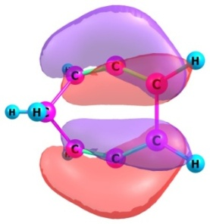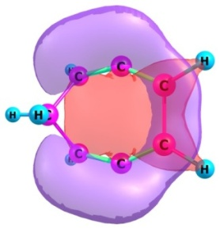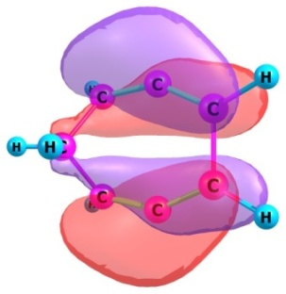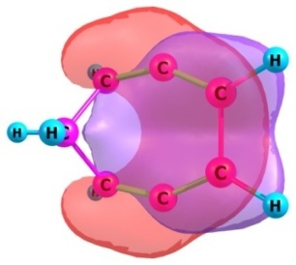
24, HOMO 23, HOMO-1 22, HOMO-2 21, HOMO-3
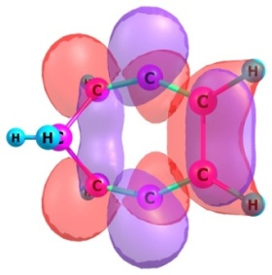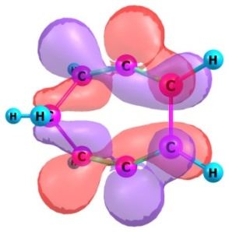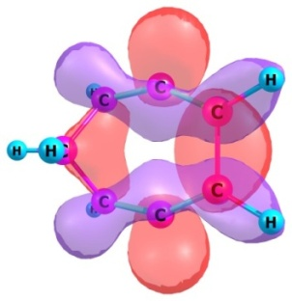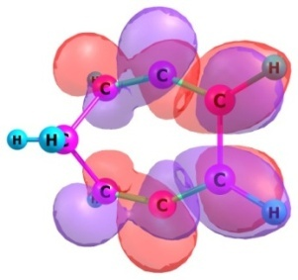
25, LUMO 26, LUMO+1 27, LUMO+2 28, LUMO+3
_{IntAa (unrestricted mode)}
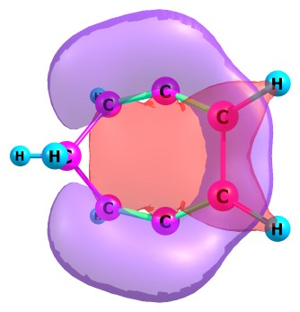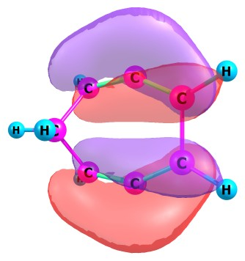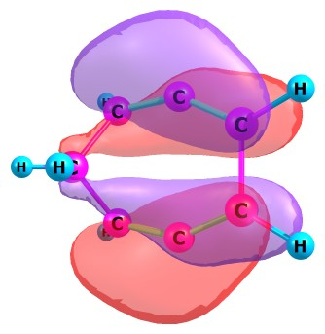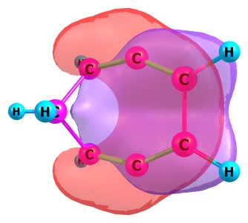
24, HOMO 23, HOMO-1 22, HOMO-2 21, HOMO-3
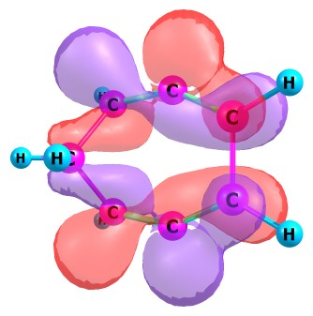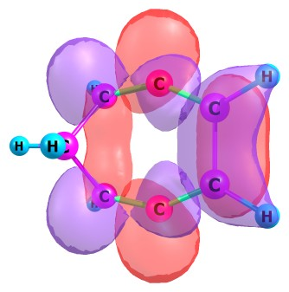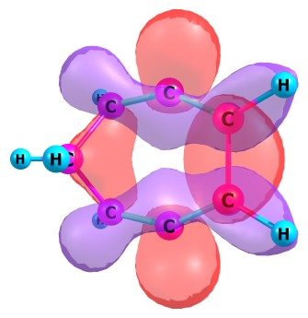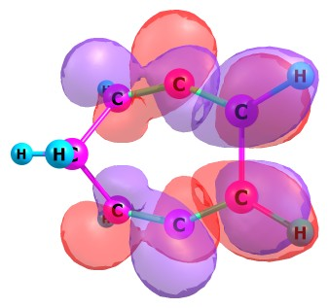
25, LUMO 26, LUMO+1 27, LUMO+2 28, LUMO+3
_{TS2Aa (restricted mode)}
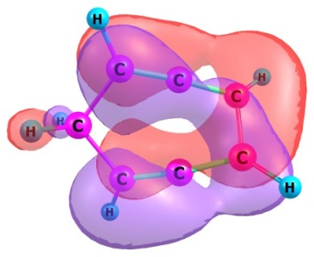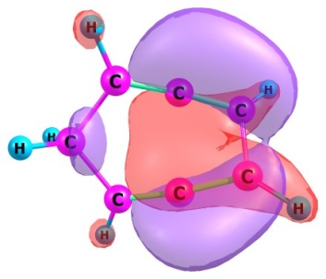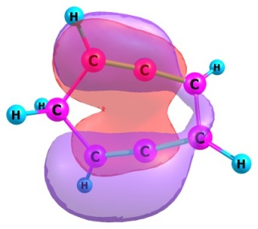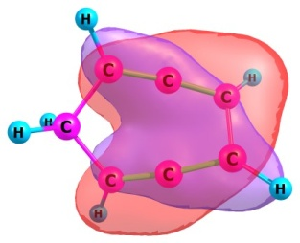
24, HOMO 23, HOMO-1 22, HOMO-2 21, HOMO-3
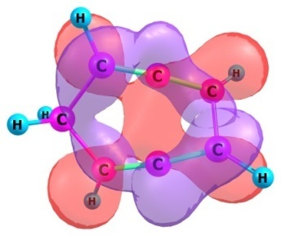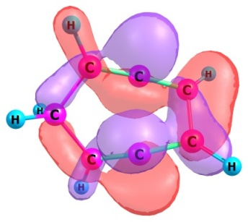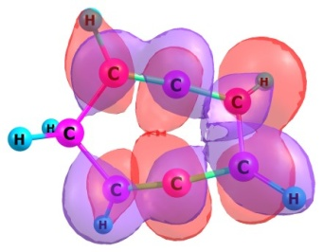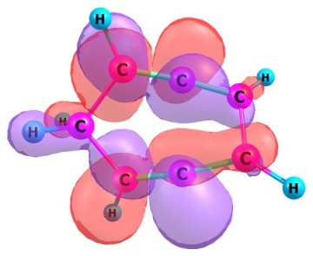
25, LUMO 26, LUMO+1 27, LUMO+2 28, LUMO+3

_{TS2Aa (unrestricted mode)}
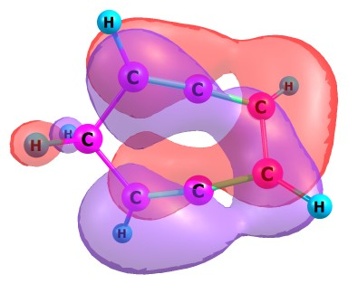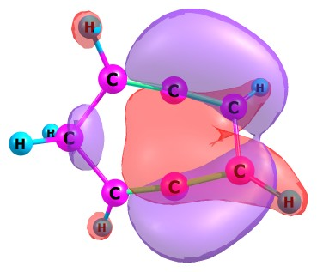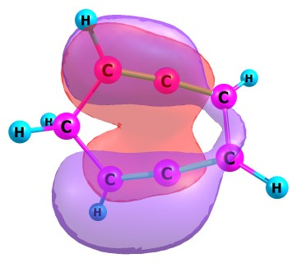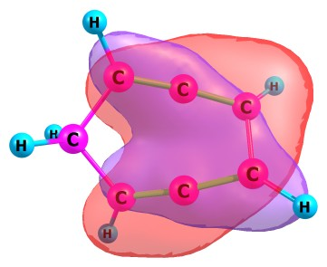
24, HOMO 23, HOMO-1 22, HOMO-2 21, HOMO-3
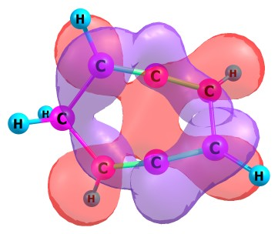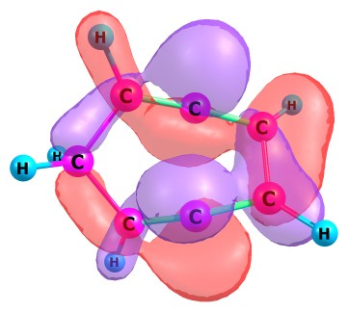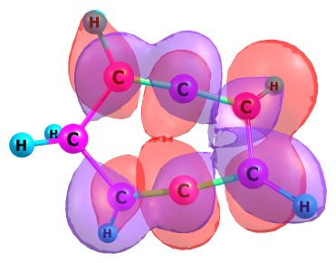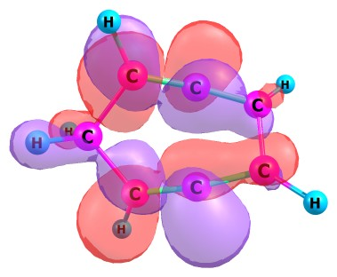
25, LUMO 26, LUMO+1 27, LUMO+2 28, LUMO+3

_{IntAb (restricted mode)}
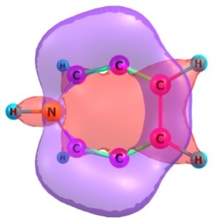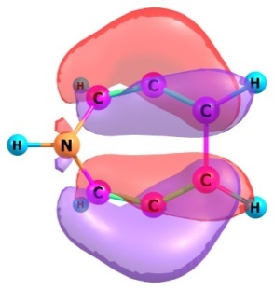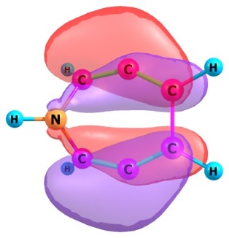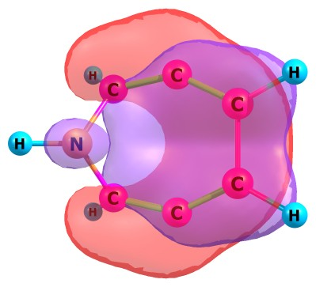
24, HOMO 23, HOMO-1 22, HOMO-2 21, HOMO-3
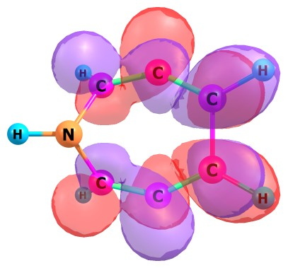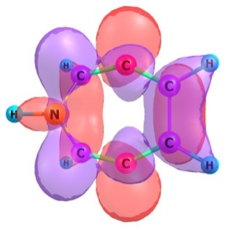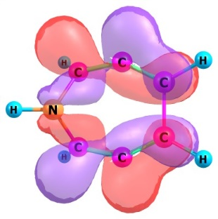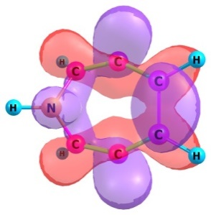
25, LUMO 26, LUMO+1 27, LUMO+2 28, LUMO+3
_{IntAb (unrestricted mode)}
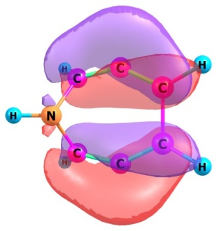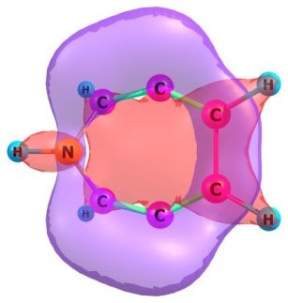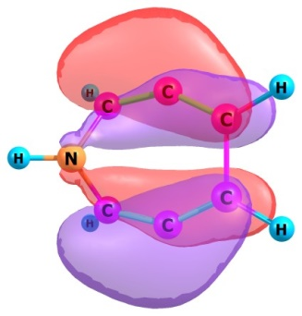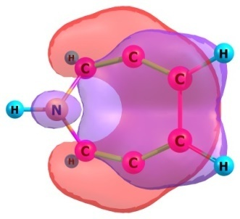
24, HOMO 23, HOMO-1 22, HOMO-2 21, HOMO-3
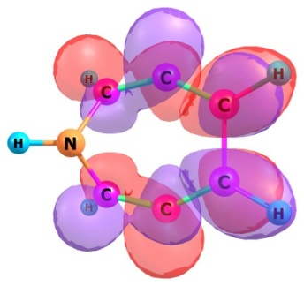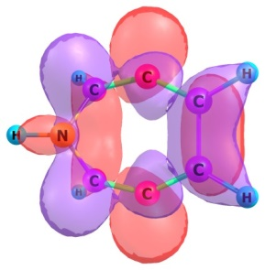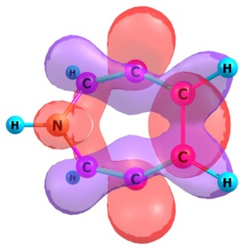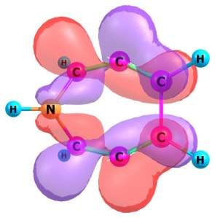
25, LUMO 26, LUMO+1 27, LUMO+2 28, LUMO+3

_{TS2Ab (restricted mode)}
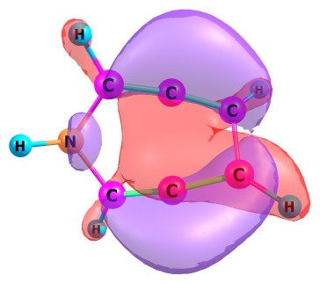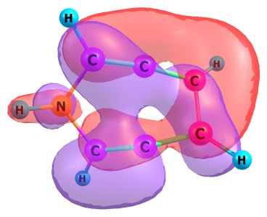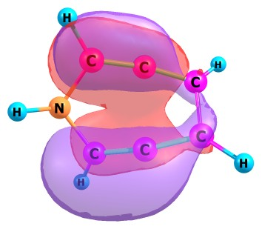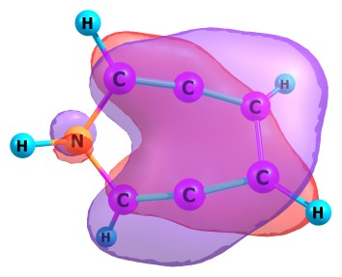
24, HOMO 23, HOMO-1 22, HOMO-2 21, HOMO-3
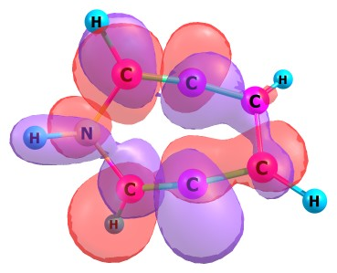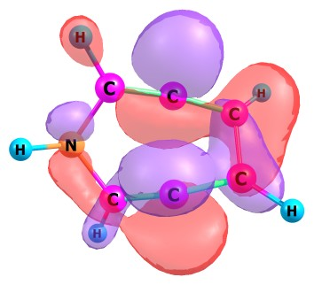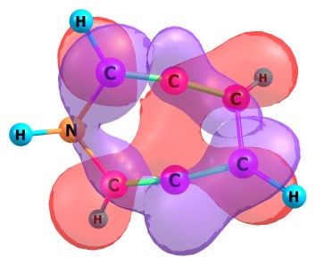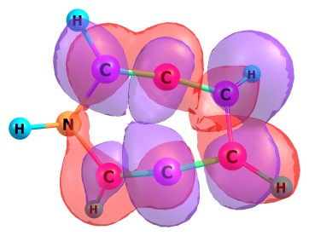
25, LUMO 26, LUMO+1 27, LUMO+2 28, LUMO+3

_{TSAb (unrestricted mode)}
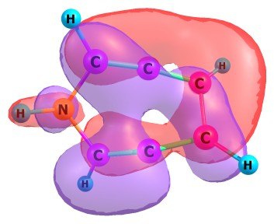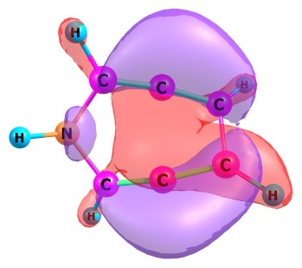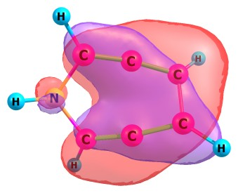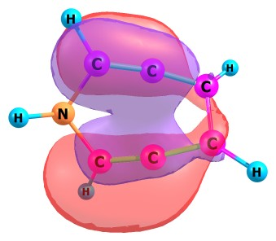
24, HOMO 23, HOMO-1 22, HOMO-2 21, HOMO-3
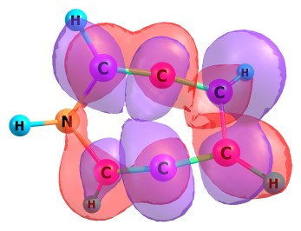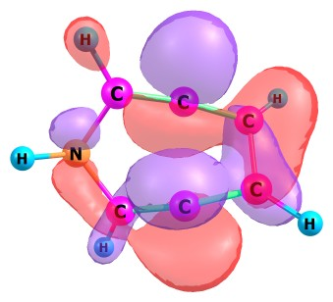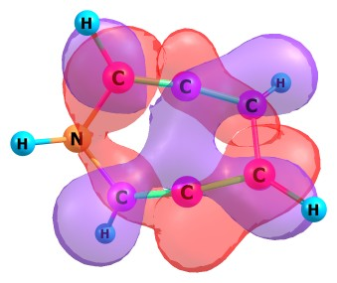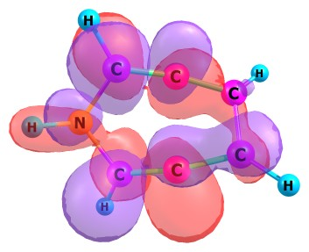
25, LUMO 26, LUMO+1 27, LUMO+2 28, LUMO+3

_{IntAc (restricted mode)}
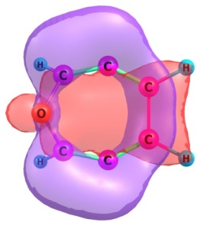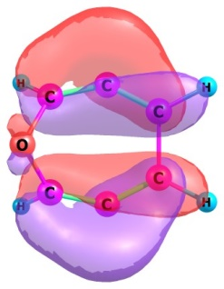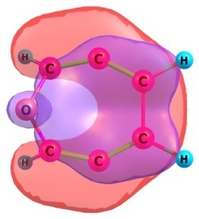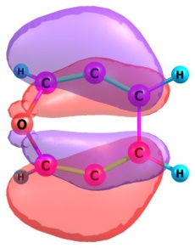
24, HOMO 23, HOMO-1 22, HOMO-2 21, HOMO-3
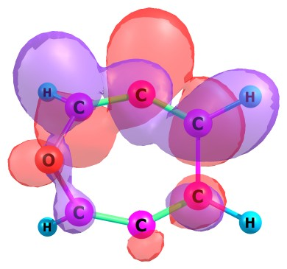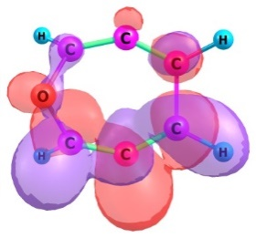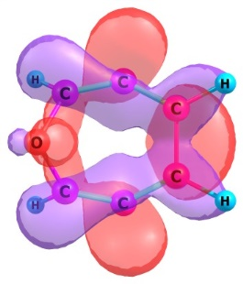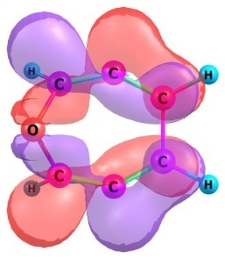
25, LUMO 26, LUMO+1 27, LUMO+2 28, LUMO+3
_{IntAc (unrestricted mode)}
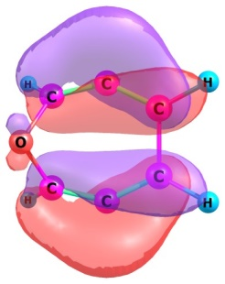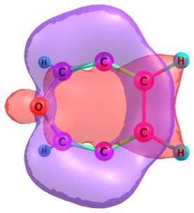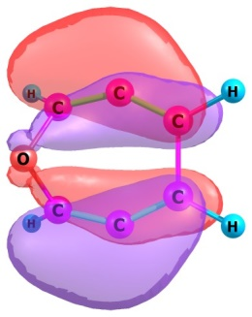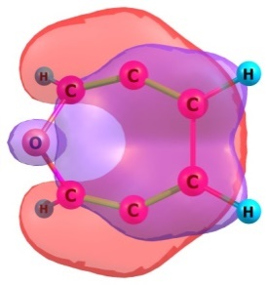
24, HOMO 23, HOMO-1 22, HOMO-2 21, HOMO-3
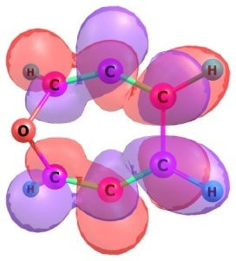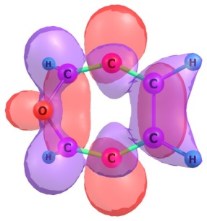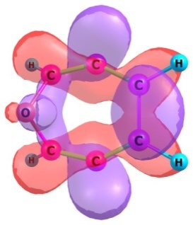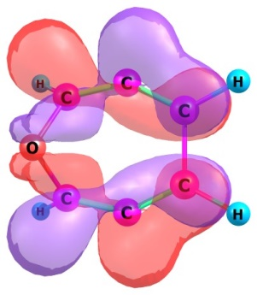
25, LUMO 26, LUMO+1 27, LUMO+2 28, LUMO+3

_{TS2Ac (restricted mode)}
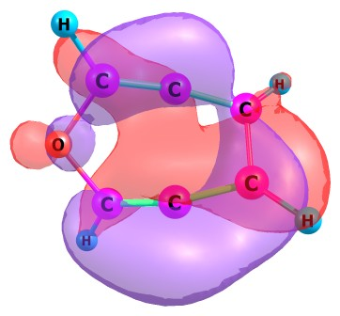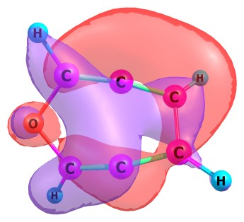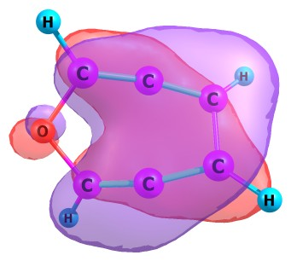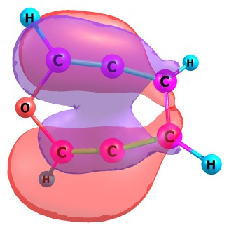
24, HOMO 23, HOMO-1 22, HOMO-2 21, HOMO-3
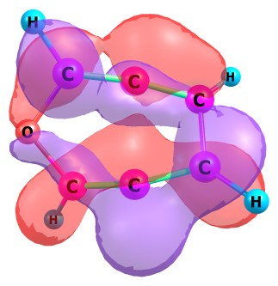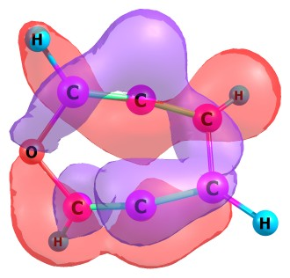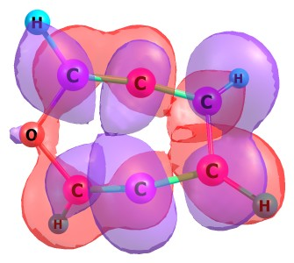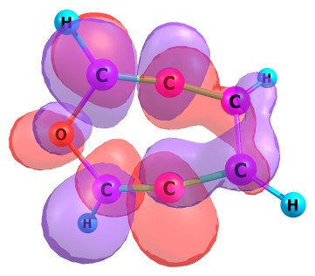
25, LUMO 26, LUMO+1 27, LUMO+2 28, LUMO+3
_{TSAc (unrestricted mode)}
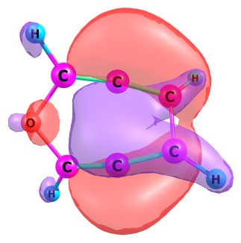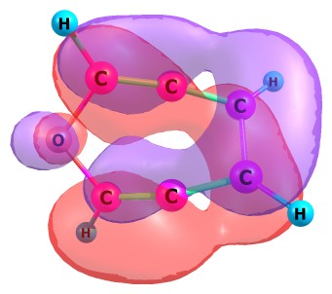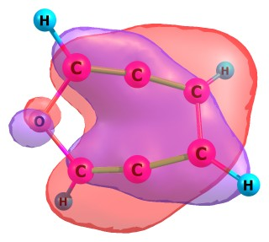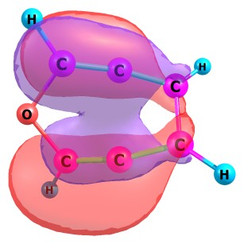
24, HOMO 23, HOMO-1 22, HOMO-2 21, HOMO-3
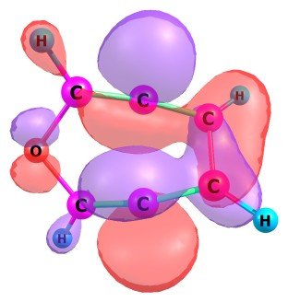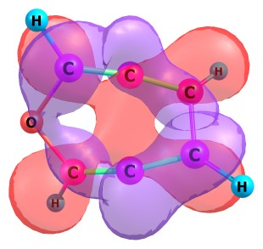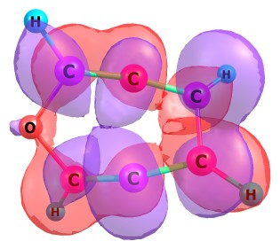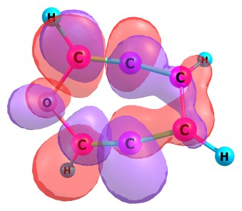
25, LUMO 26, LUMO+1 27, LUMO+2 28, LUMO+3
_{IntAd (restricted mode)}
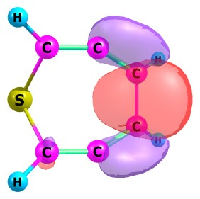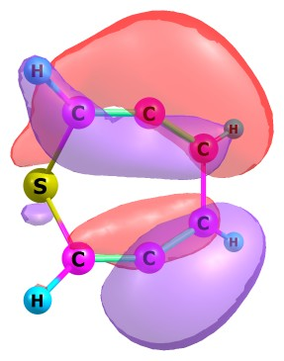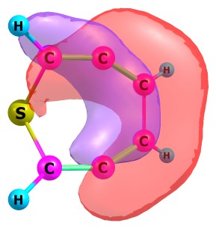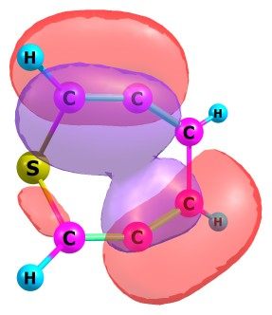
28, HOMO 27, HOMO-1 26, HOMO-2 25, HOMO-3
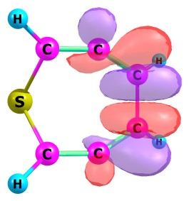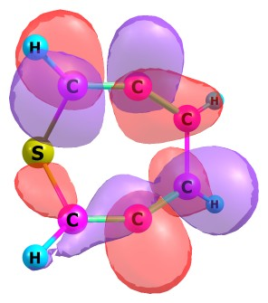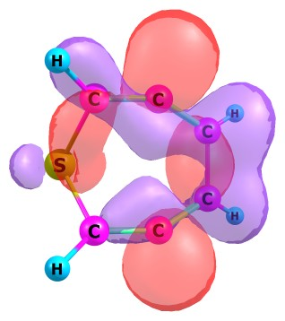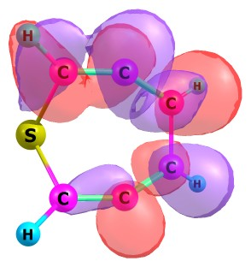
29, LUMO 30, LUMO+1 31, LUMO+2 32, LUMO+3
_{IntAd (unrestricted mode)}
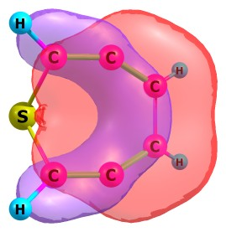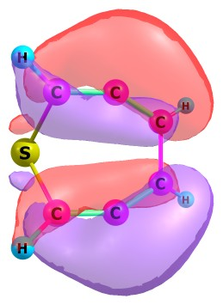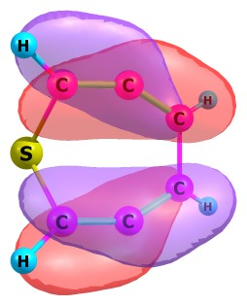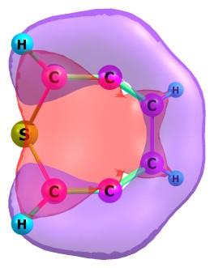
28, HOMO 27, HOMO-1 26, HOMO-2 25, HOMO-3
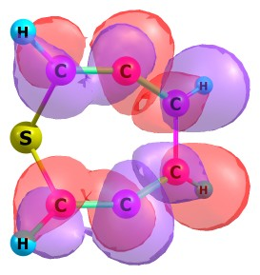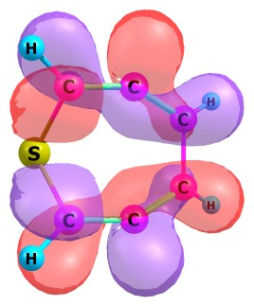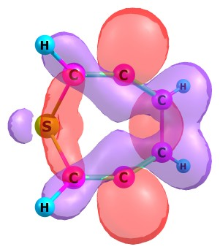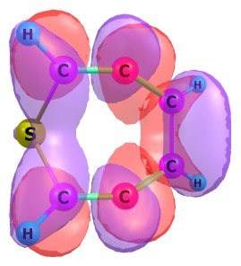
29, LUMO 30, LUMO+1 31, LUMO+2 32, LUMO+3

_{TS2Ad (restricted mode)}
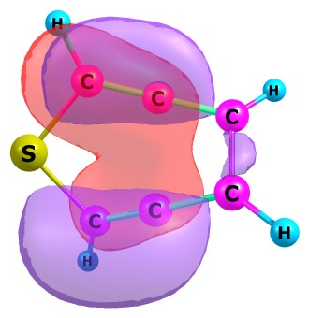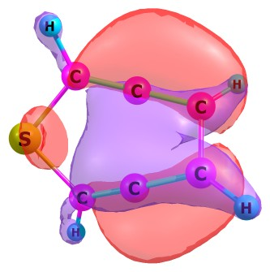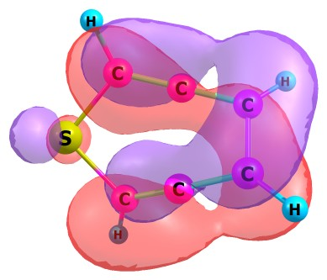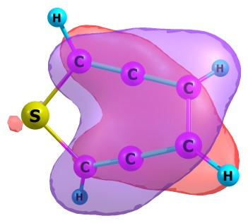
28, HOMO 27, HOMO-1 26, HOMO-2 25, HOMO-3
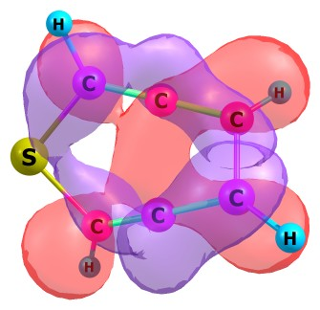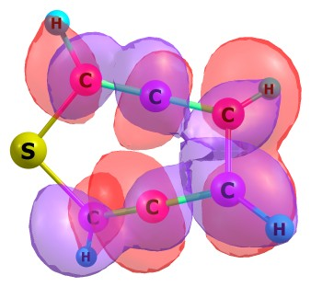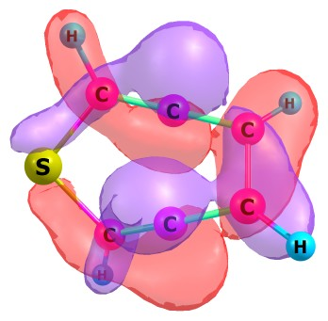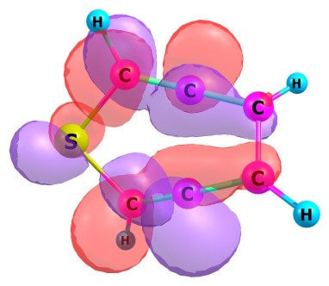
29, LUMO 30, LUMO+1 31, LUMO+2 32, LUMO+3
_{TS2Ad (unrestricted mode)}
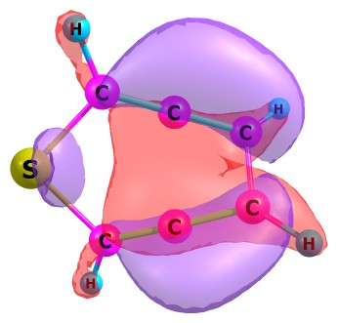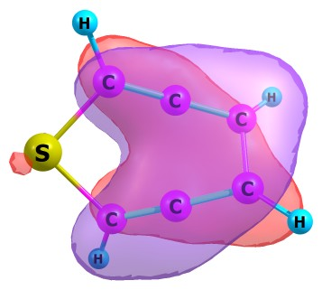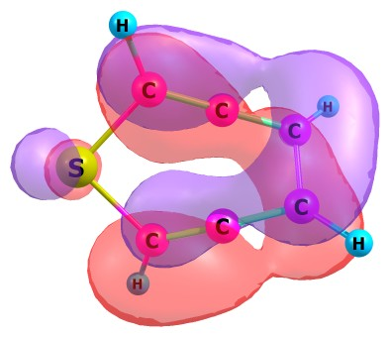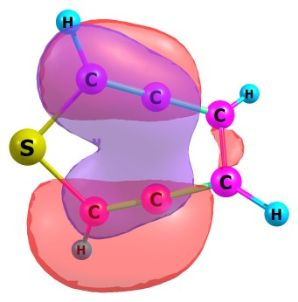
28, HOMO 27, HOMO-1 26, HOMO-2 25, HOMO-3
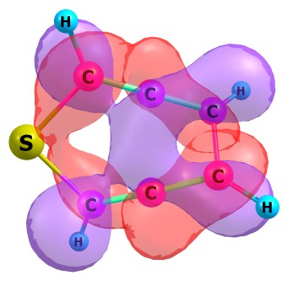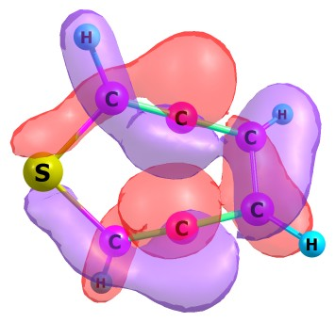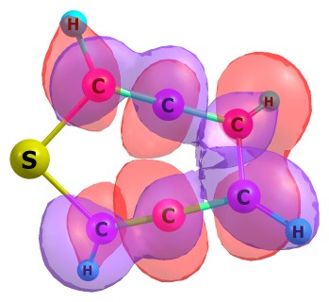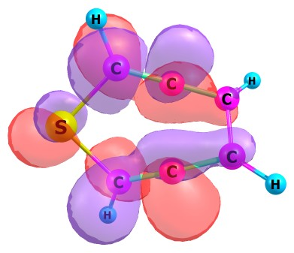
29, LUMO 30, LUMO+1 31, LUMO+2 32, LUMO+3

_{IntAe (restricted mode)}
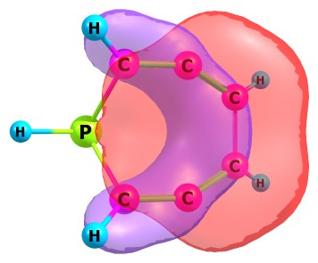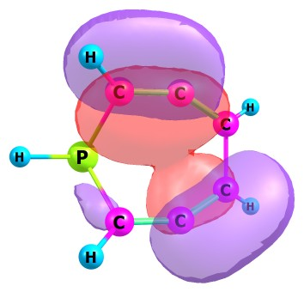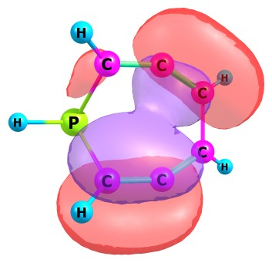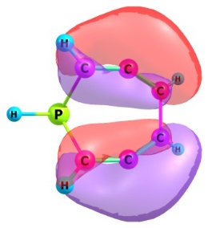
28, HOMO 27, HOMO-1 26, HOMO-2 25, HOMO-3
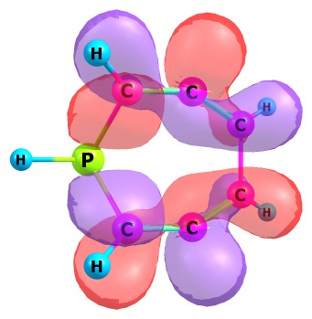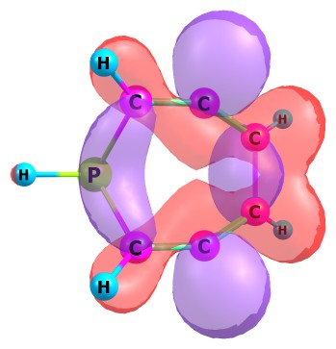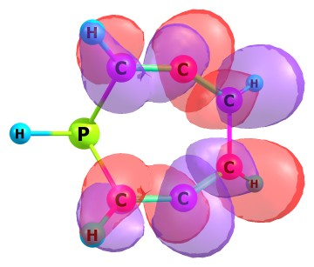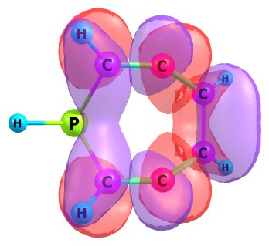
29, LUMO 30, LUMO+1 31, LUMO+2 32, LUMO+3
_{IntAe (unrestricted mode)}
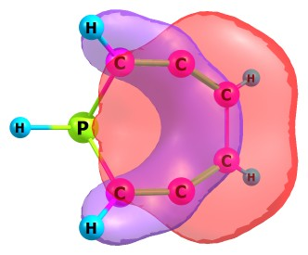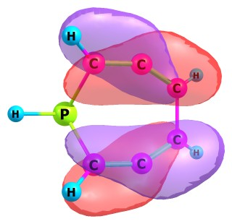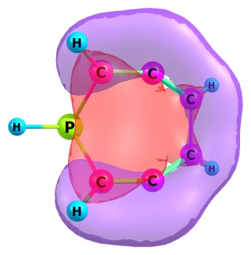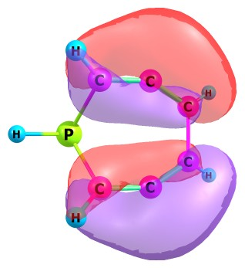
28, HOMO 27, HOMO-1 26, HOMO-2 25, HOMO-3
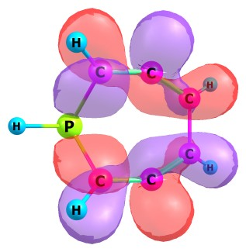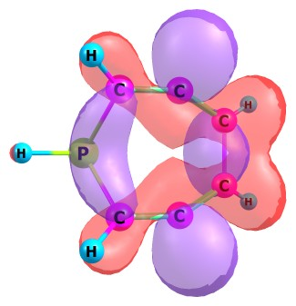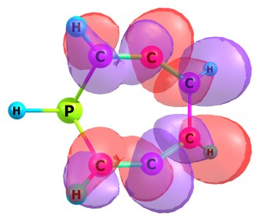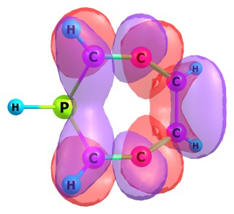
29, LUMO 30, LUMO+1 31, LUMO+2 32, LUMO+3

_{TS2Ae (restricted mode)}
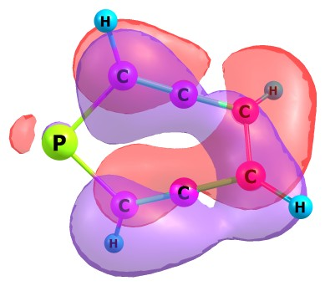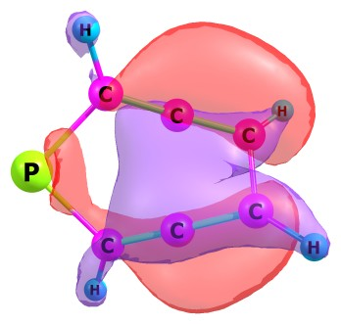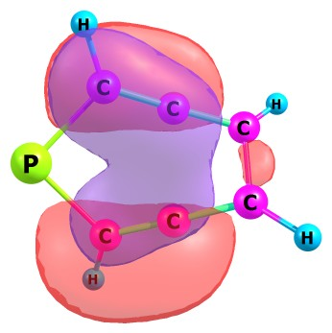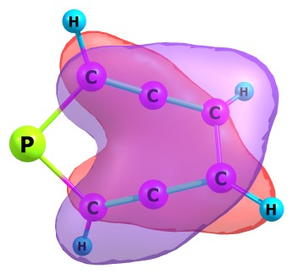
28, HOMO 27, HOMO-1 26, HOMO-2 25, HOMO-3
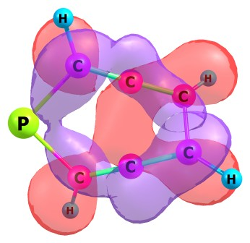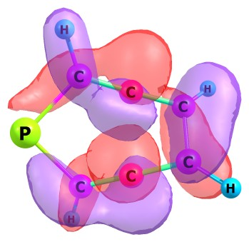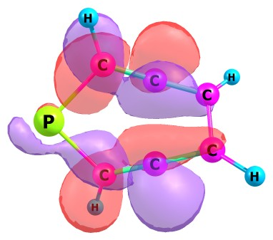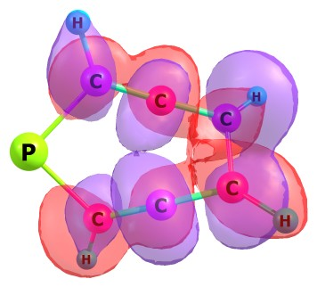
29, LUMO 30, LUMO+1 31, LUMO+2 32, LUMO+3
_{TS2Ae (unrestricted mode)}
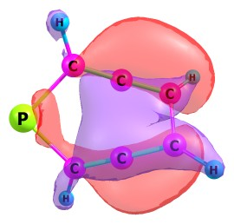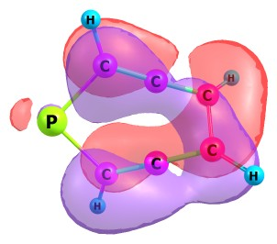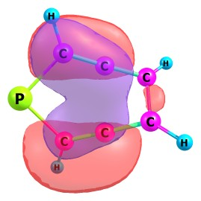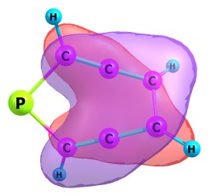
28, HOMO 27, HOMO-1 26, HOMO-2 25, HOMO-3
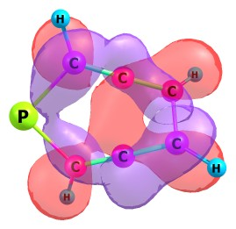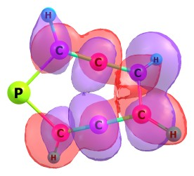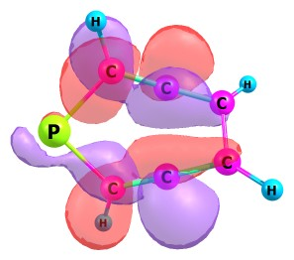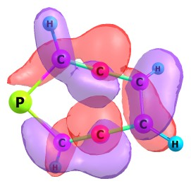
29, LUMO 30, LUMO+1 31, LUMO+2 32, LUMO+3
_{IntBa (restricted mode)}
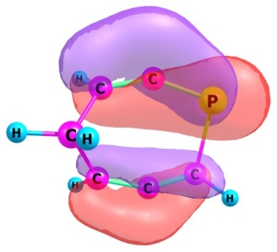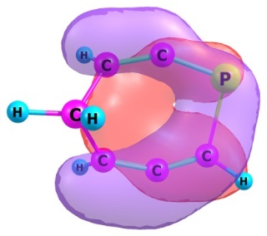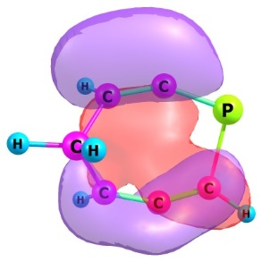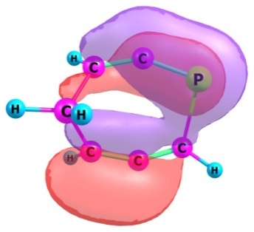
28, HOMO 27, HOMO-1 26, HOMO-2 25, HOMO-3
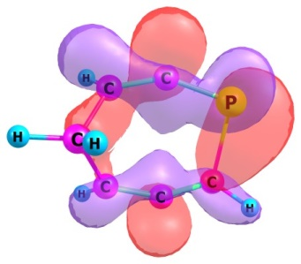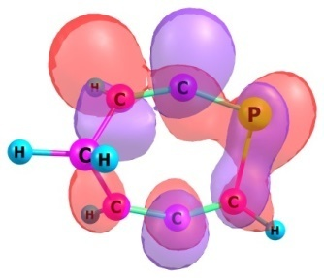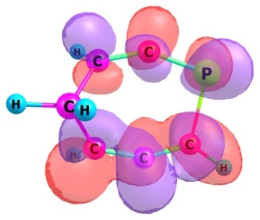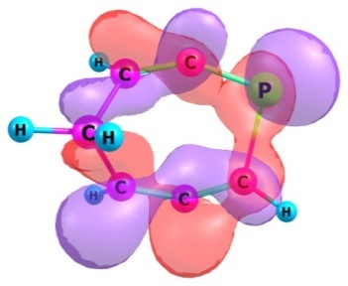
29, LUMO 30, LUMO+1 31, LUMO+2 32, LUMO+3
_{IntBa (unrestricted mode)}
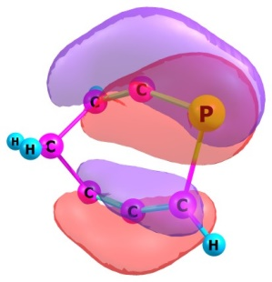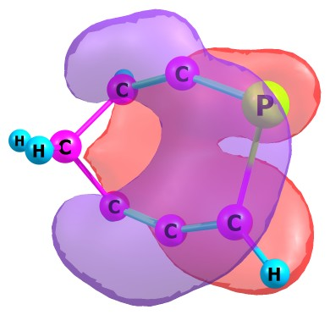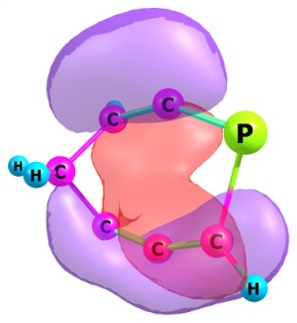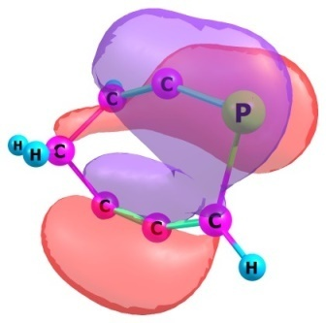
28, HOMO 27, HOMO-1 26, HOMO-2 25, HOMO-3
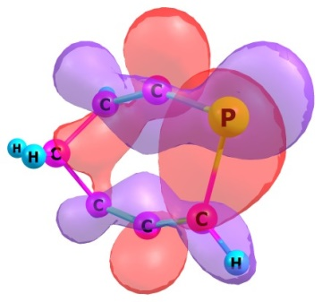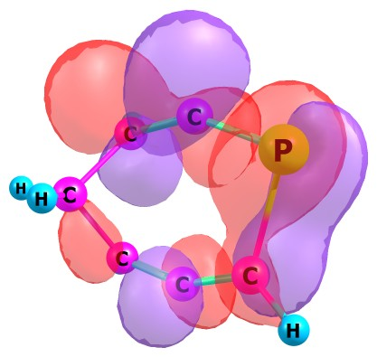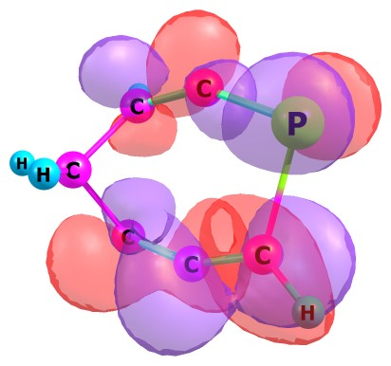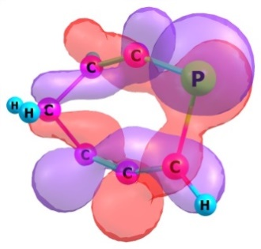
29, LUMO 30, LUMO+1 31, LUMO+2 32, LUMO+3

_{TS2Ba (restricted mode)}
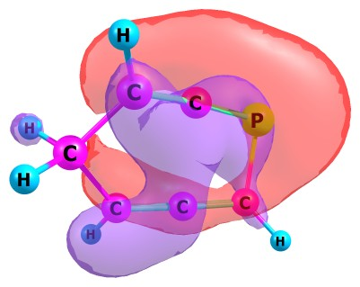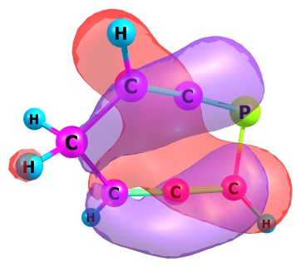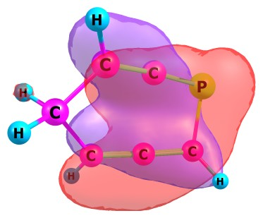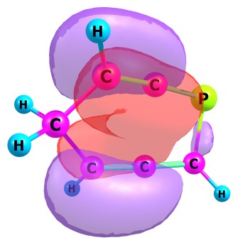
28, HOMO 27, HOMO-1 26, HOMO-2 25, HOMO-3
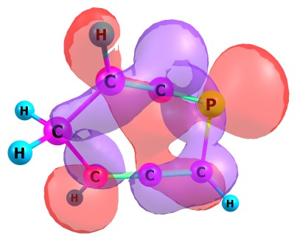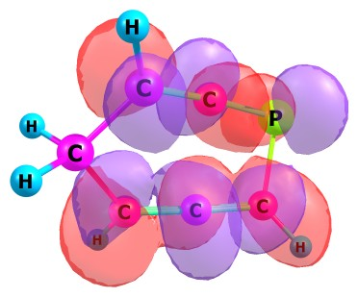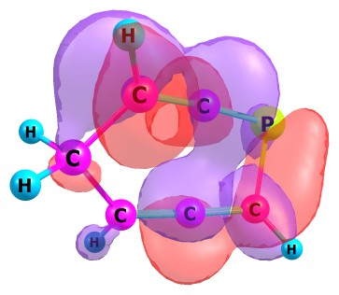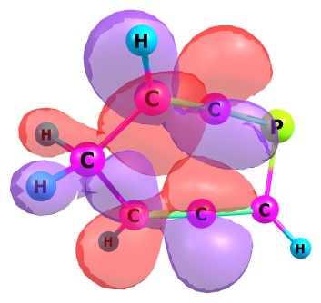
29, LUMO 30, LUMO+1 31, LUMO+2 32, LUMO+3
_{TS2Ba (unrestricted mode)}
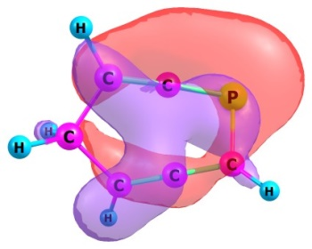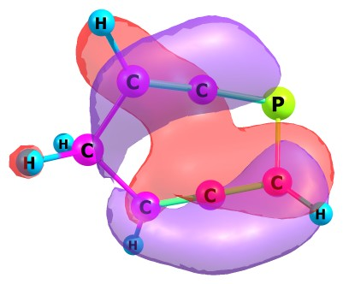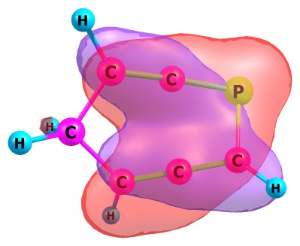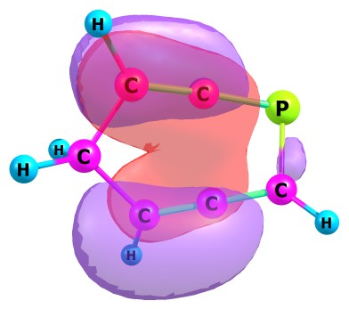
28, HOMO 27, HOMO-1 26, HOMO-2 25, HOMO-3
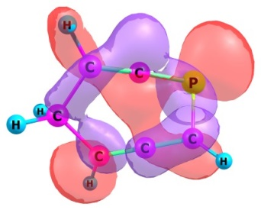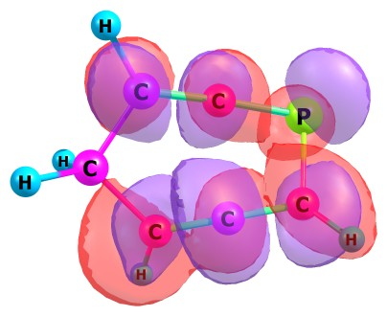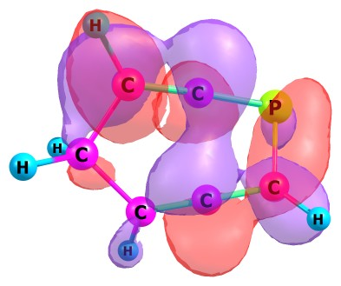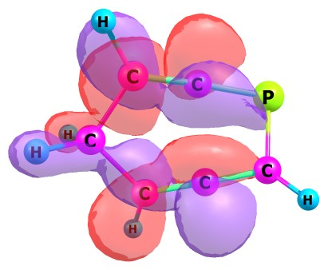
29, LUMO 30, LUMO+1 31, LUMO+2 32, LUMO+3

_{IntBb (restricted mode)}
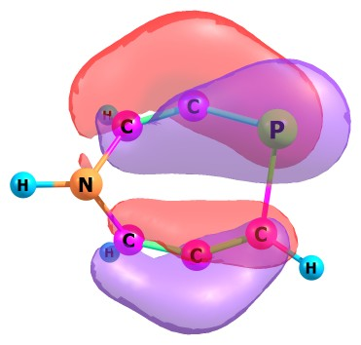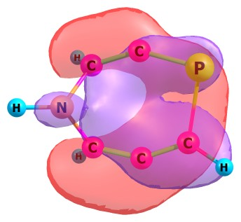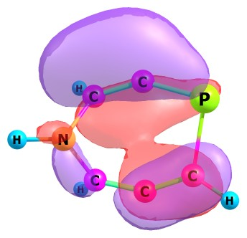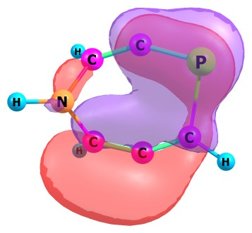
28, HOMO 27, HOMO-1 26, HOMO-2 25, HOMO-3
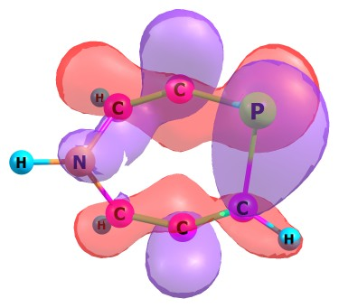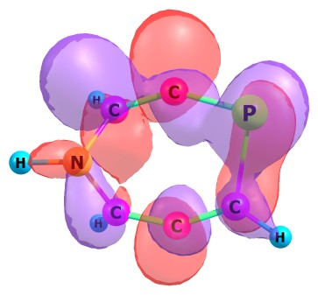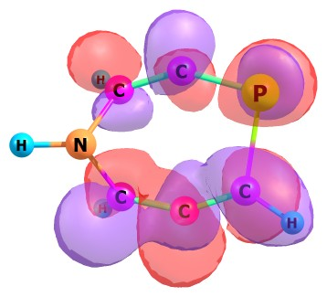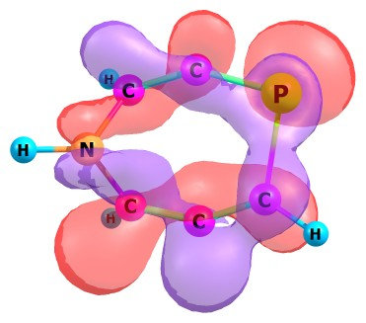
29, LUMO 30, LUMO+1 31, LUMO+2 32, LUMO+3
_{IntBb (unrestricted mode)}
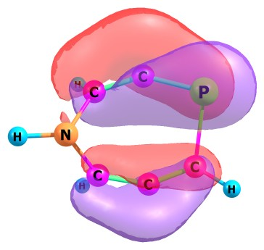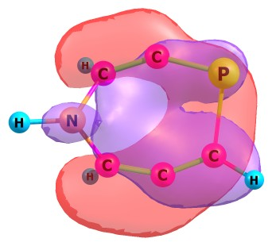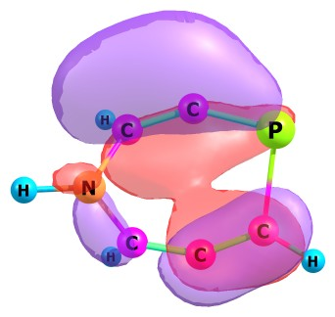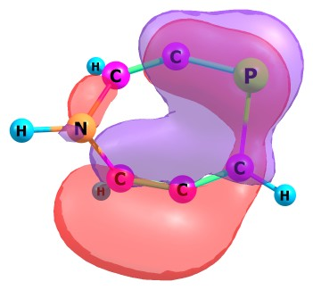
28, HOMO 27, HOMO-1 26, HOMO-2 25, HOMO-3
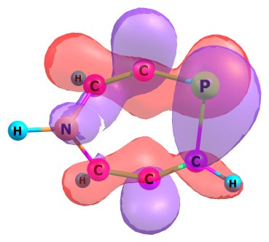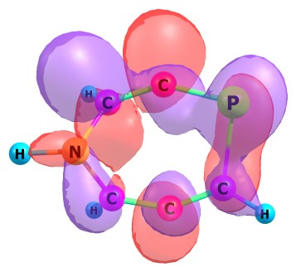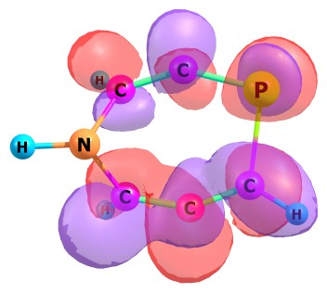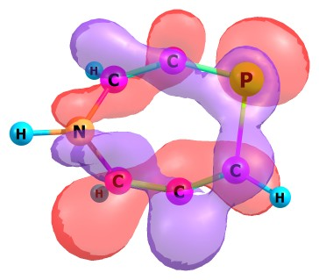
29, LUMO 30, LUMO+1 31, LUMO+2 32, LUMO+3

_{TS2Bb (restricted mode)}
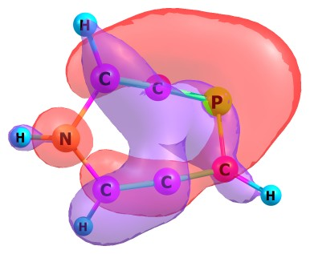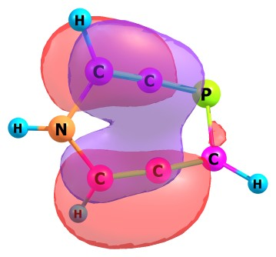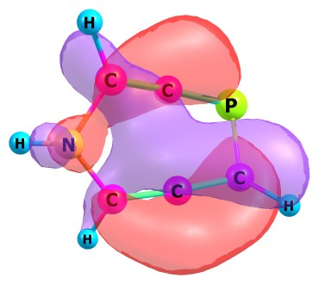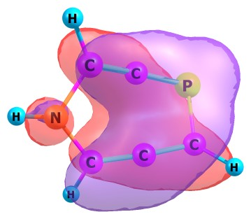
28, HOMO 27, HOMO-1 26, HOMO-2 25, HOMO-3
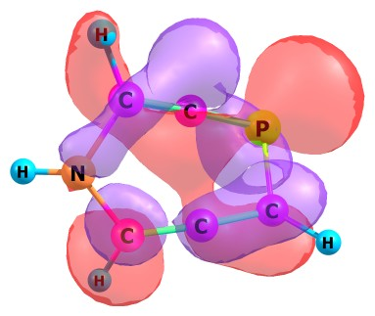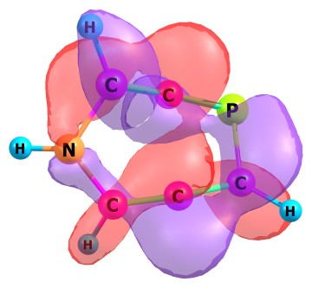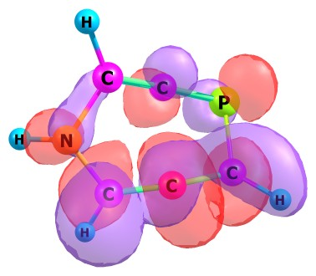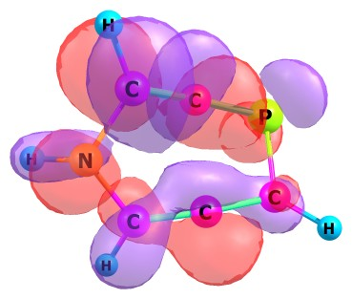
29, LUMO 30, LUMO+1 31, LUMO+2 32, LUMO+3
_{TS2Bb (unrestricted mode)}
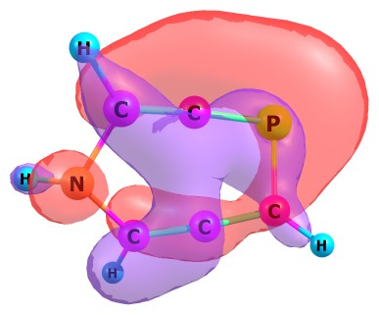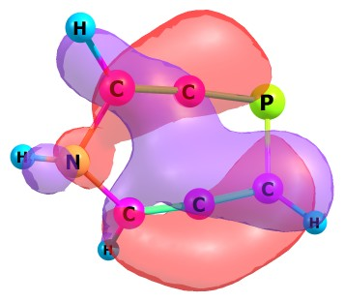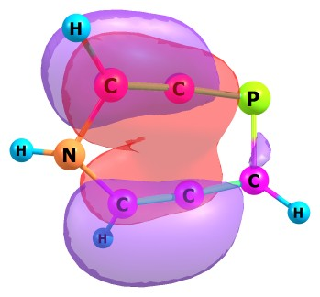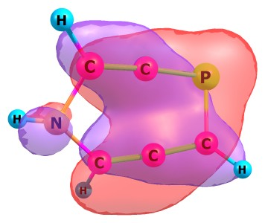
28, HOMO 27, HOMO-1 26, HOMO-2 25, HOMO-3
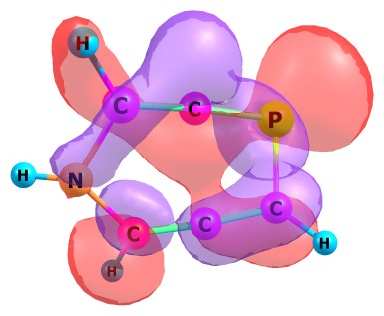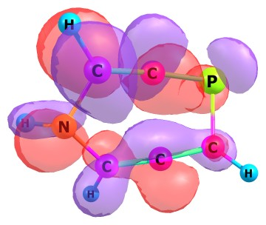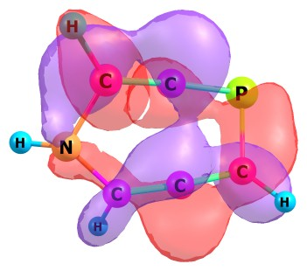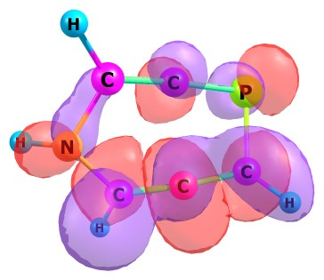
29, LUMO 30, LUMO+1 31, LUMO+2 32, LUMO+3

_{IntBc (restricted mode)}
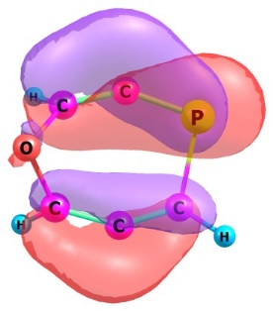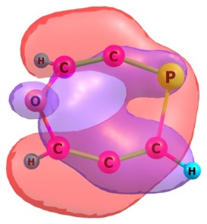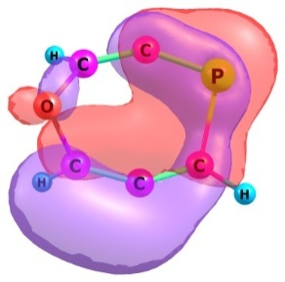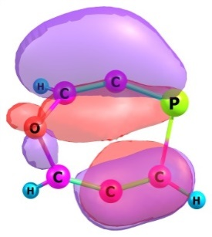
28, HOMO 27, HOMO-1 26, HOMO-2 25, HOMO-3
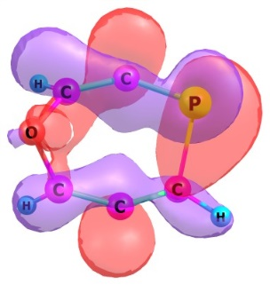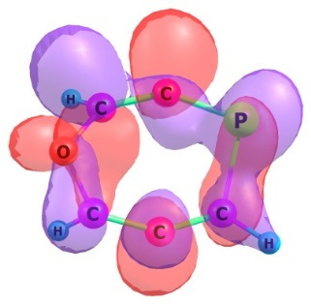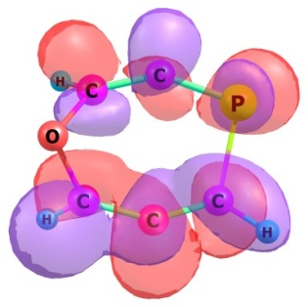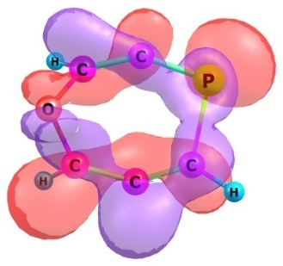
29, LUMO 30, LUMO+1 31, LUMO+2 32, LUMO+3
_{IntBc (unrestricted mode)}
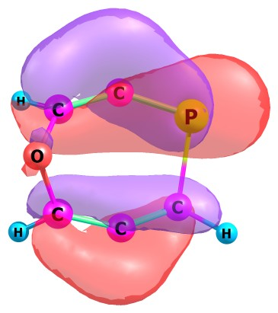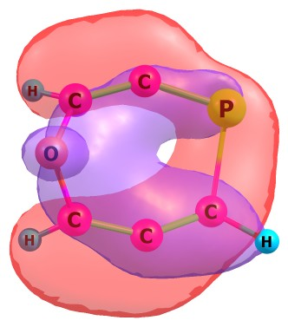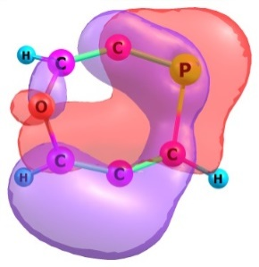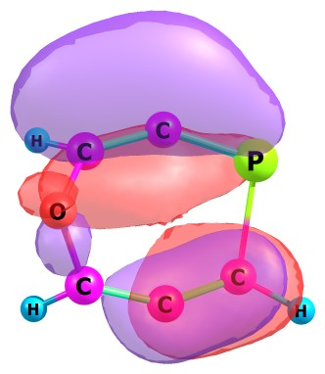
28, HOMO 27, HOMO-1 26, HOMO-2 25, HOMO-3
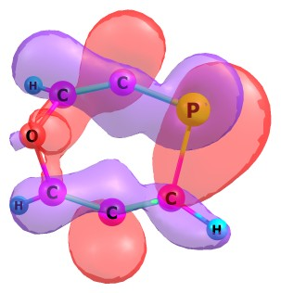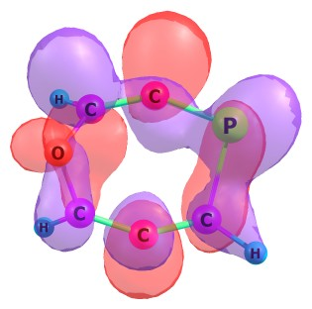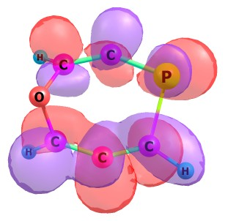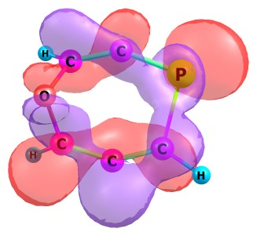
29, LUMO 30, LUMO+1 31, LUMO+2 32, LUMO+3

_{TS2Bc (restricted mode)}
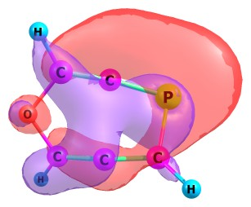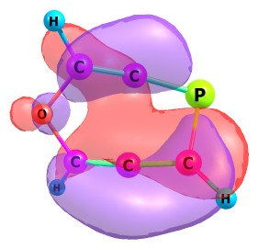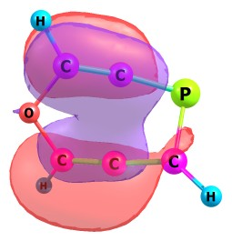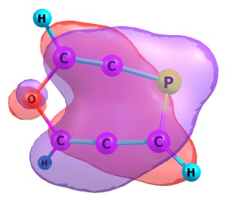
28, HOMO 27, HOMO-1 26, HOMO-2 25, HOMO-3
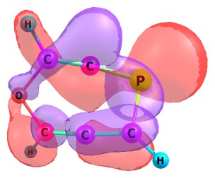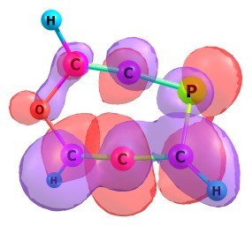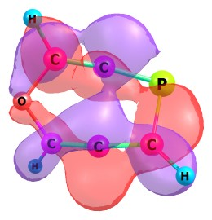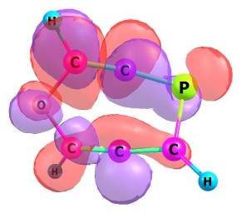
29, LUMO 30, LUMO+1 31, LUMO+2 32, LUMO+3
_{TS2Bc (unrestricted mode)}
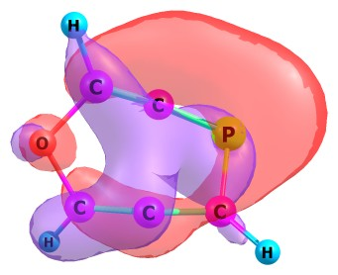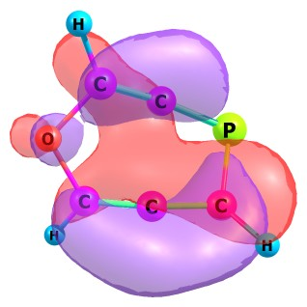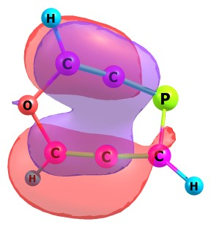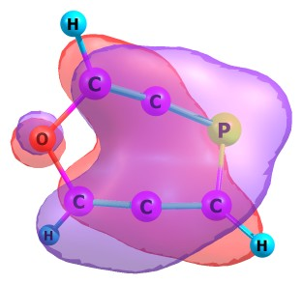
28, HOMO 27, HOMO-1 26, HOMO-2 25, HOMO-3
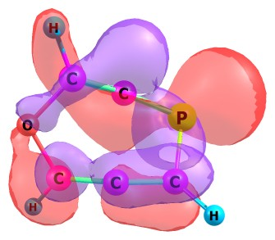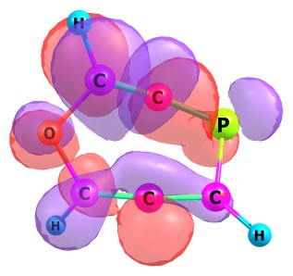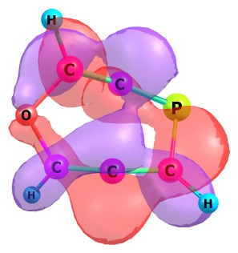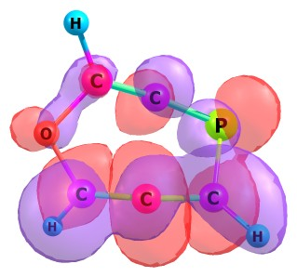
29, LUMO 30, LUMO+1 31, LUMO+2 32, LUMO+3
_{IntBd (restricted mode)}
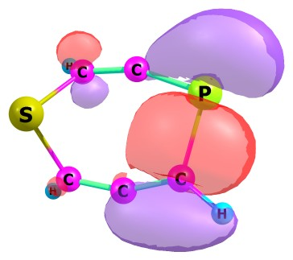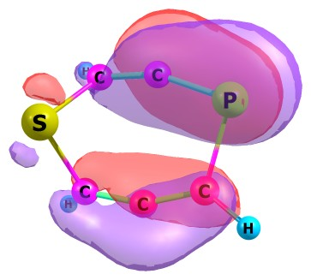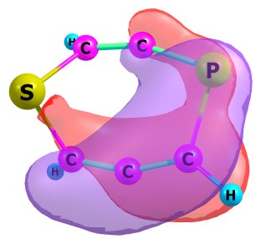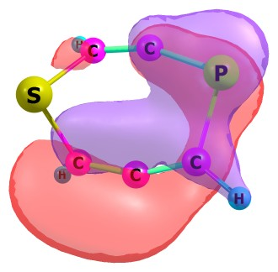
32, HOMO 31, HOMO-1 30, HOMO-2 29, HOMO-3
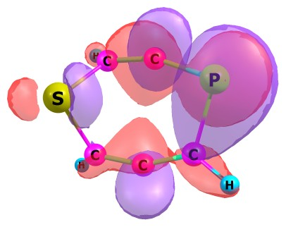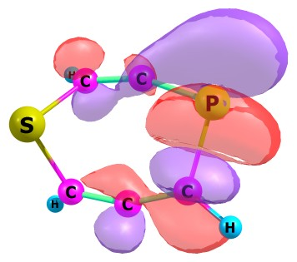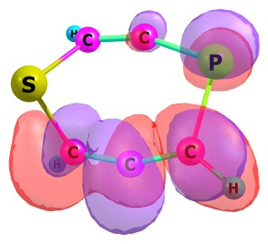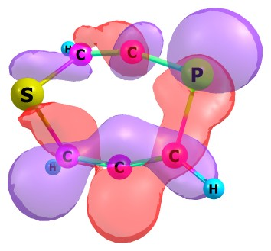
33, LUMO 34, LUMO+1 35, LUMO+2 36, LUMO+3
_{IntBd (unrestricted mode)}
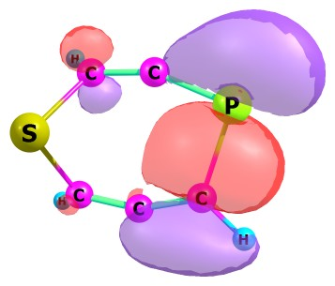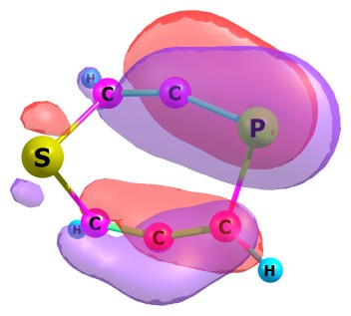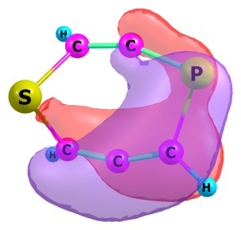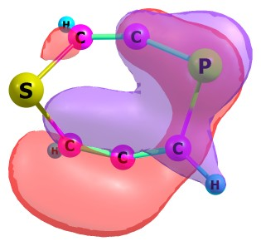
32, HOMO 31, HOMO-1 30, HOMO-2 29, HOMO-3
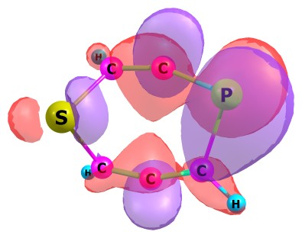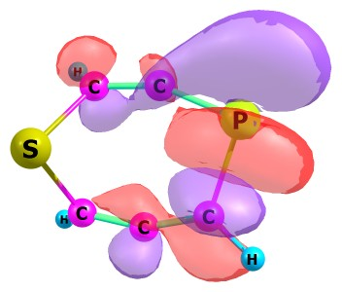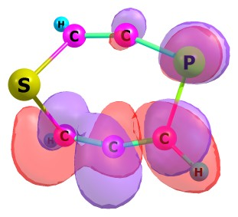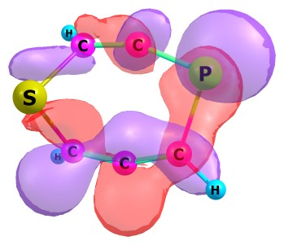
33, LUMO 34, LUMO+1 35, LUMO+2 36, LUMO+3

_{TS2Bd (restricted mode)}
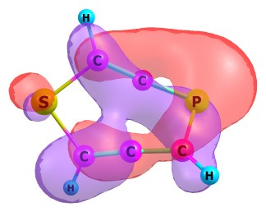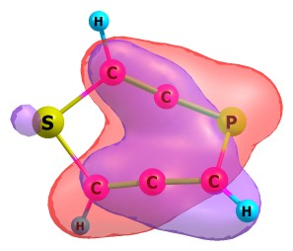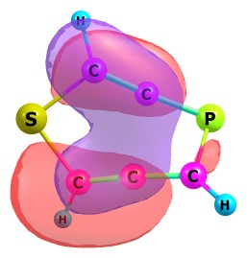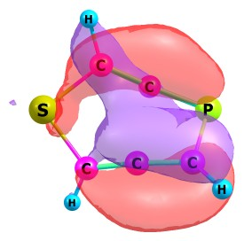
32, HOMO 31, HOMO-1 30, HOMO-2 29, HOMO-3
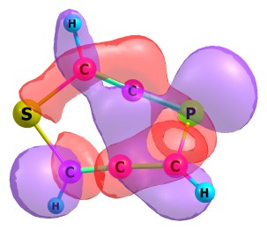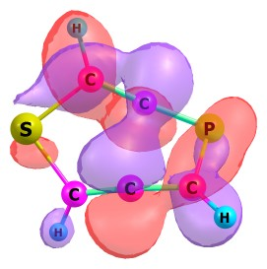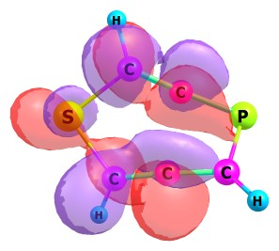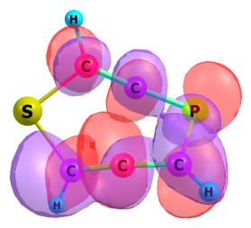
33, LUMO 34, LUMO+1 35, LUMO+2 36, LUMO+3

_{TS2Bd (unrestricted mode)}
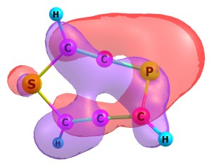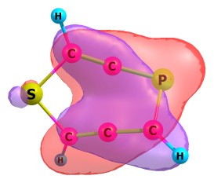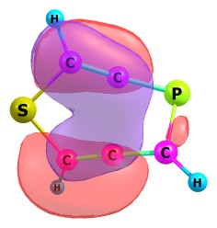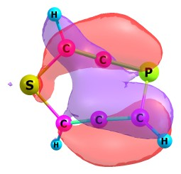
32, HOMO 31, HOMO-1 30, HOMO-2 29, HOMO-3
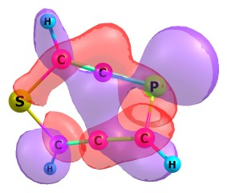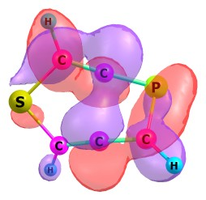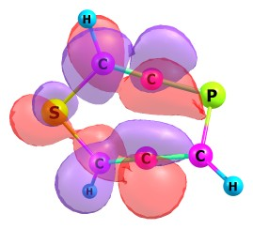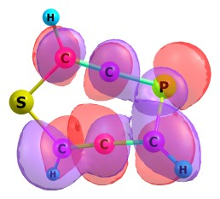
33, LUMO 34, LUMO+1 35, LUMO+2 36, LUMO+3
_{IntBe (restricted mode)}
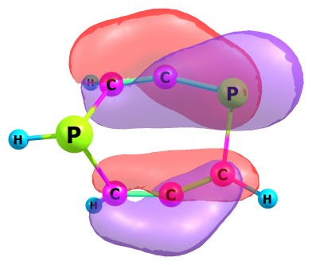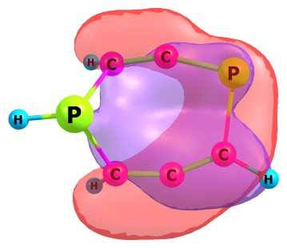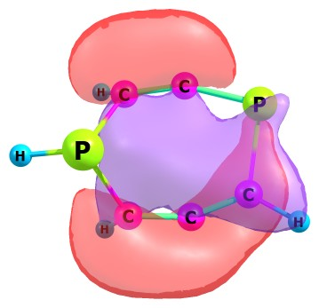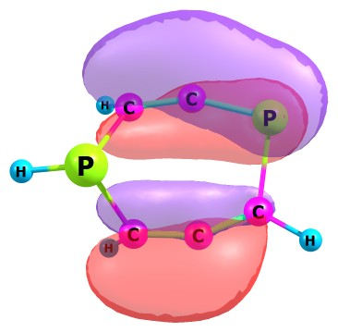
32, HOMO 31, HOMO-1 30, HOMO-2 29, HOMO-3
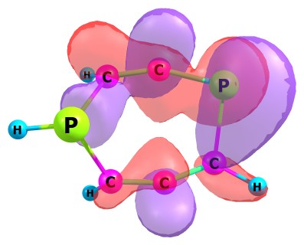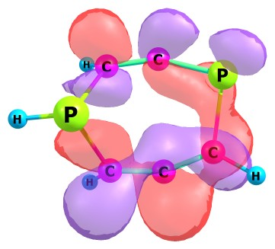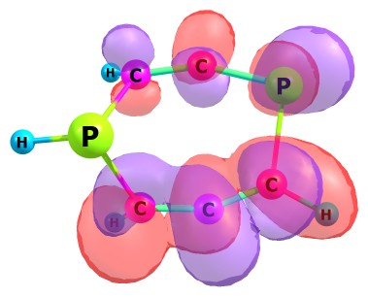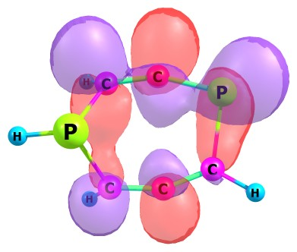
33, LUMO 34, LUMO+1 35, LUMO+2 36, LUMO+3
_{IntBe (unrestricted mode)}
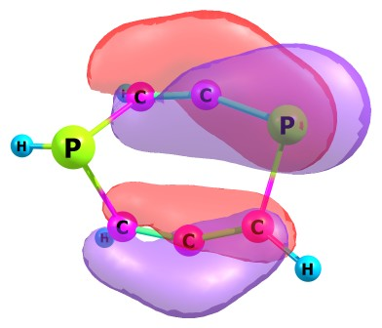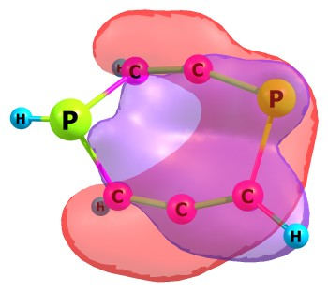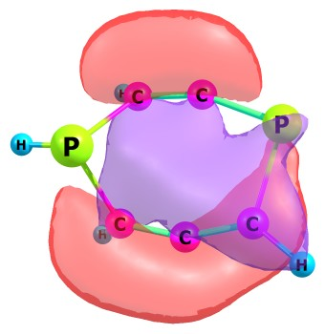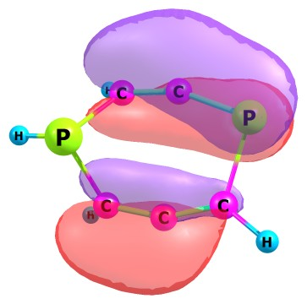
32, HOMO 31, HOMO-1 30, HOMO-2 29, HOMO-3
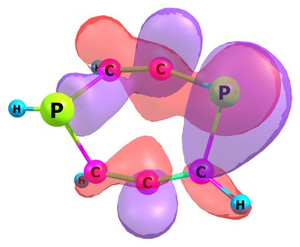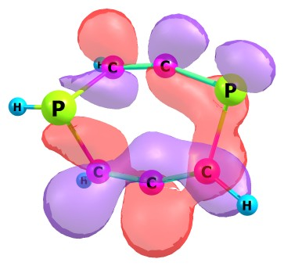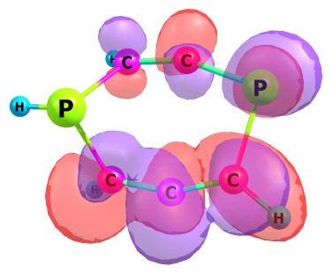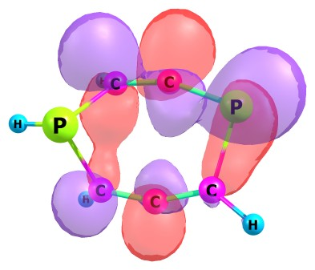
33, LUMO 34, LUMO+1 35, LUMO+2 36, LUMO+3

_{TS2Be (restricted mode)}
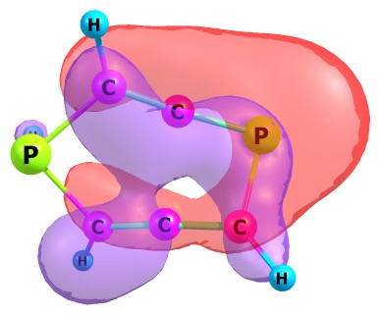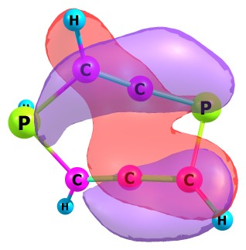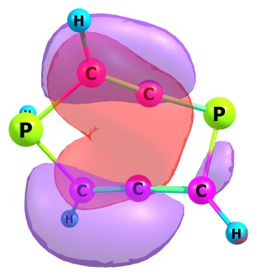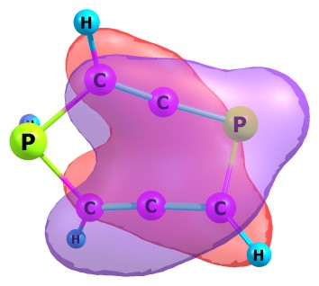
32, HOMO 31, HOMO-1 30, HOMO-2 29, HOMO-3
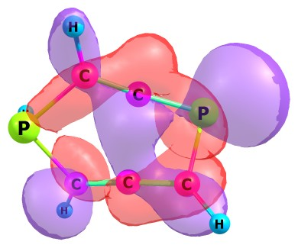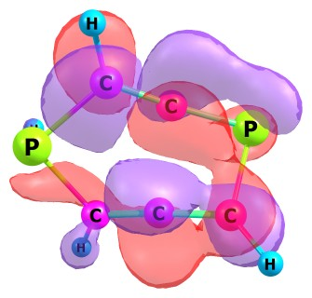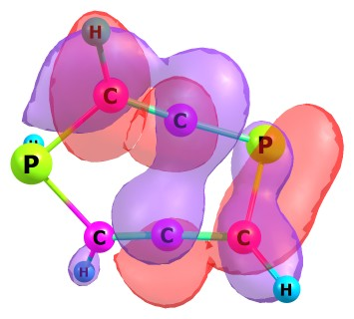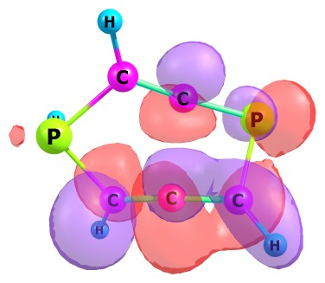
33, LUMO 34, LUMO+1 35, LUMO+2 36, LUMO+3
_{TS2Be (unrestricted mode)}
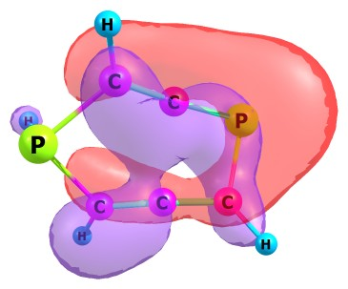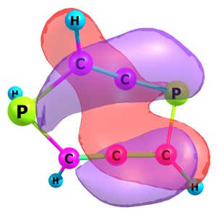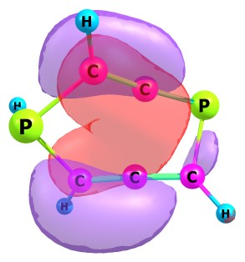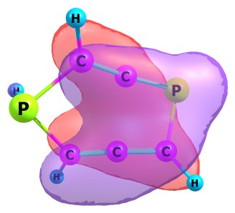
32, HOMO 31, HOMO-1 30, HOMO-2 29, HOMO-3
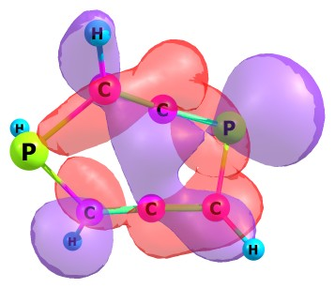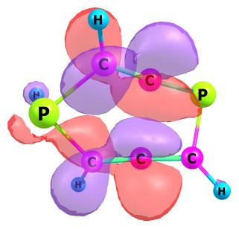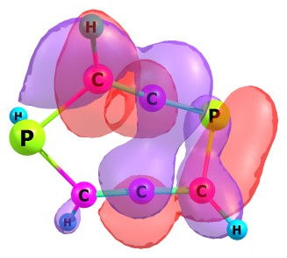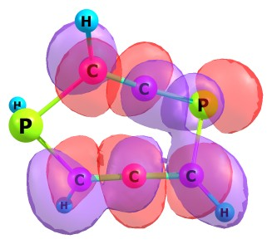
33, LUMO 34, LUMO+1 35, LUMO+2 36, LUMO+3

_{IntCa (restricted mode)}
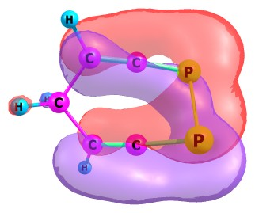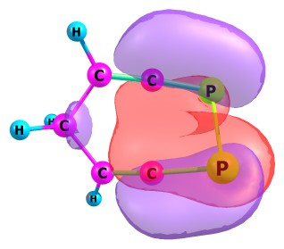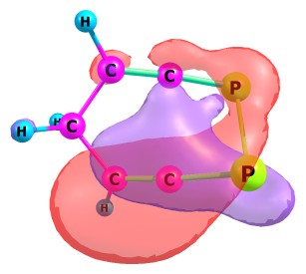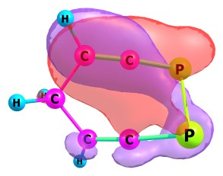
32, HOMO 31, HOMO-1 30, HOMO-2 29, HOMO-3
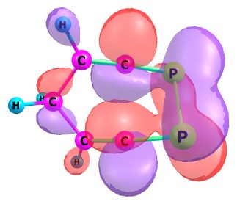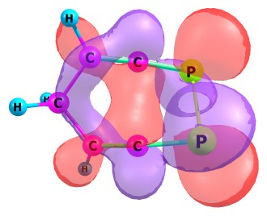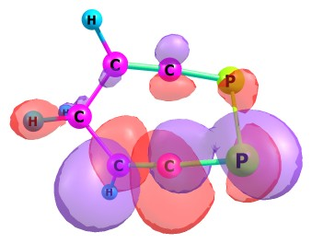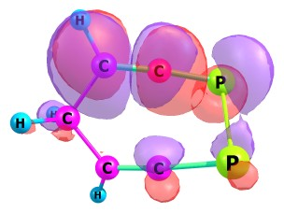
33, LUMO 34, LUMO+1 35, LUMO+2 36, LUMO+3
_{IntCa (unrestricted mode)}
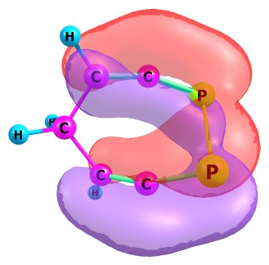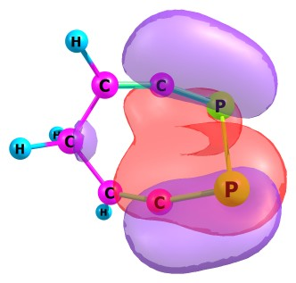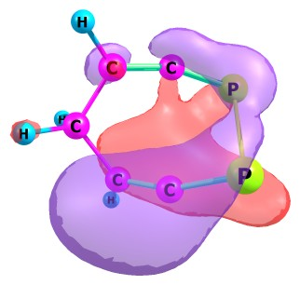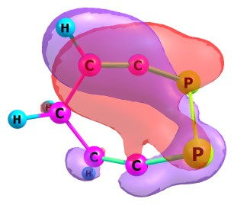
32, HOMO 31, HOMO-1 30, HOMO-2 29, HOMO-3
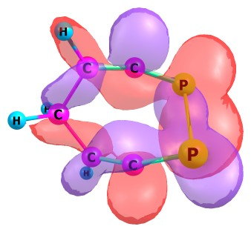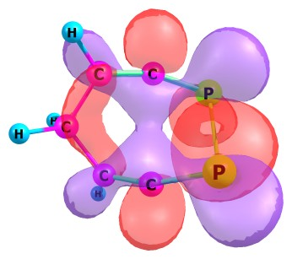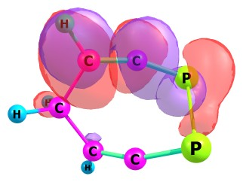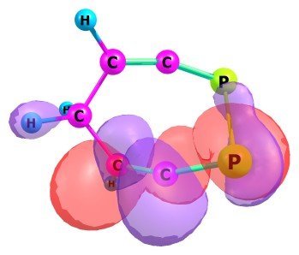
33, LUMO 34, LUMO+1 35, LUMO+2 36, LUMO+3

_{TS2Ca (restricted mode)}
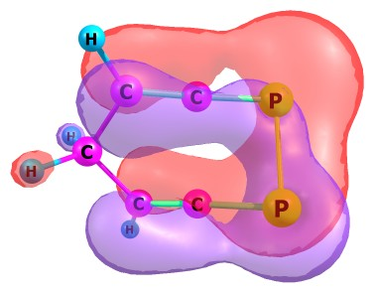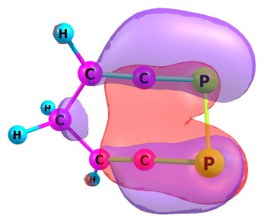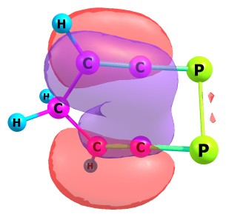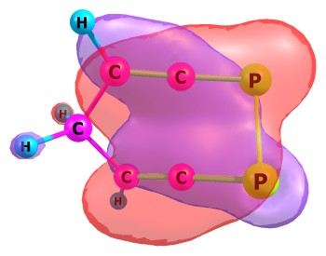
32, HOMO 31, HOMO-1 30, HOMO-2 29, HOMO-3
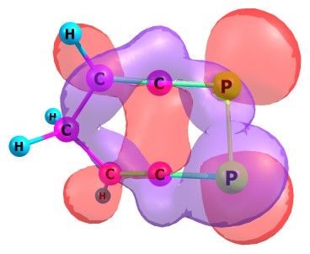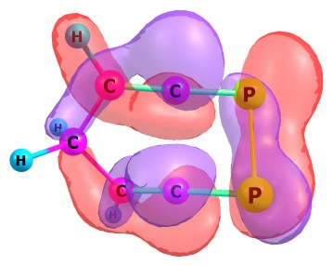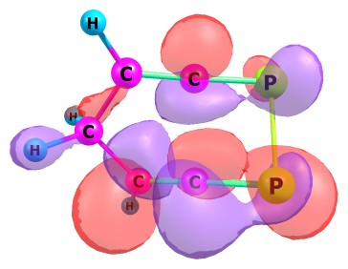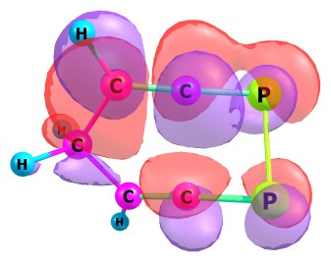
33, LUMO 34, LUMO+1 35, LUMO+2 36, LUMO+3
_{TS2Ca (unrestricted mode)}
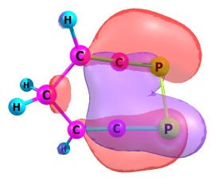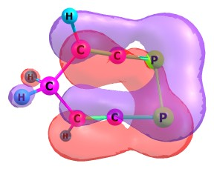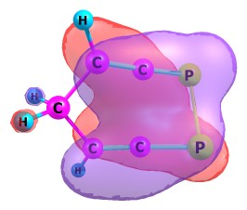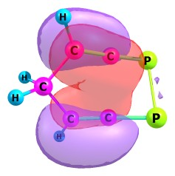
32, HOMO 31, HOMO-1 30, HOMO-2 29, HOMO-3
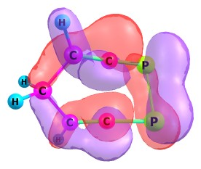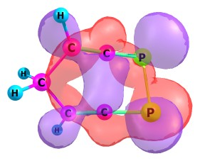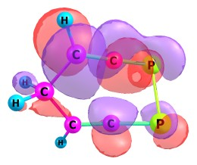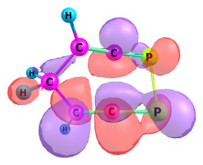
33, LUMO 34, LUMO+1 35, LUMO+2 36, LUMO+3

_{IntCb (restricted mode)}
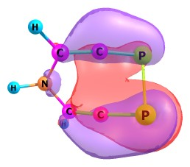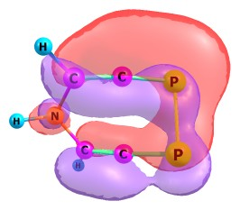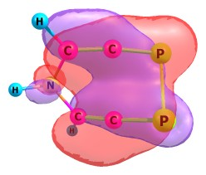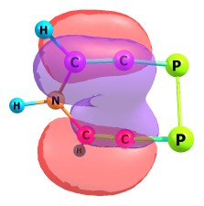
32, HOMO 31, HOMO-1 30, HOMO-2 29, HOMO-3
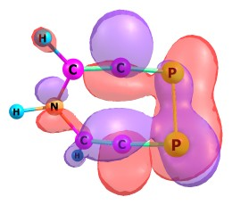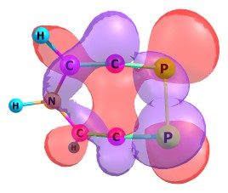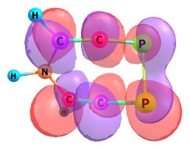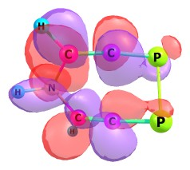
33, LUMO 34, LUMO+1 35, LUMO+2 36, LUMO+3
_{IntCb (unrestricted mode)}
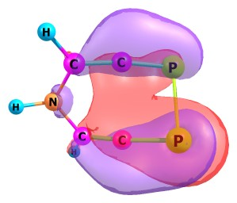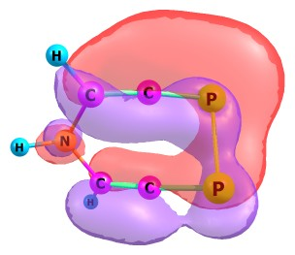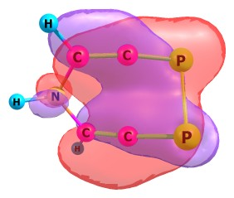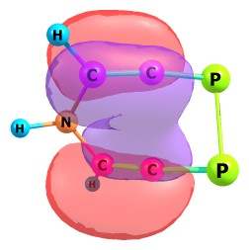
32, HOMO 31, HOMO-1 30, HOMO-2 29, HOMO-3
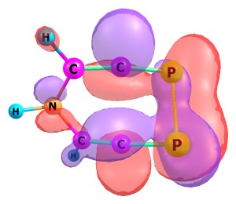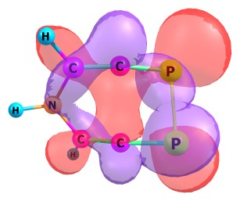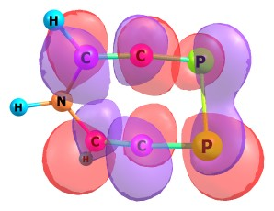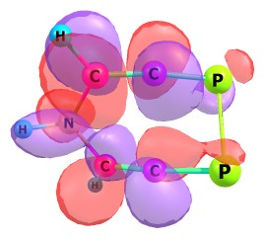
33, LUMO 34, LUMO+1 35, LUMO+2 36, LUMO+3

_{TS2Cb (restricted mode)}
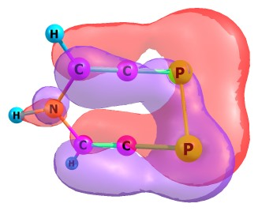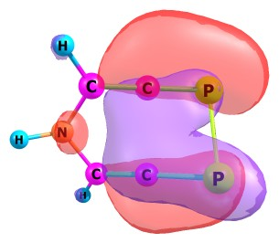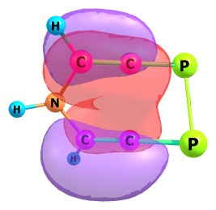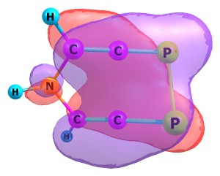
32, HOMO 31, HOMO-1 30, HOMO-2 29, HOMO-3
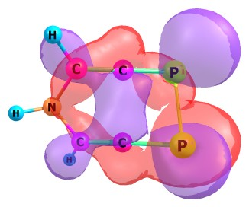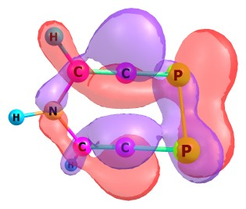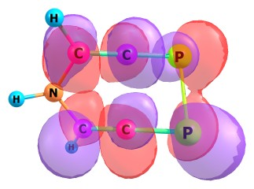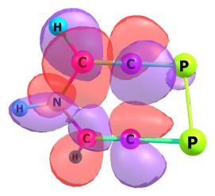
33, LUMO 34, LUMO+1 35, LUMO+2 36, LUMO+3
_{TS2Cb (unrestricted mode)}
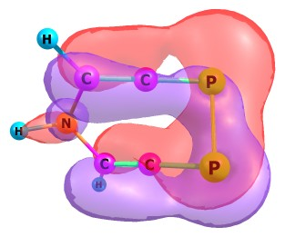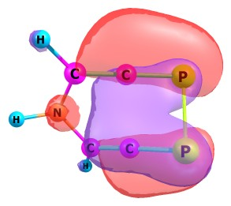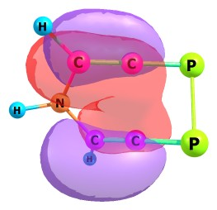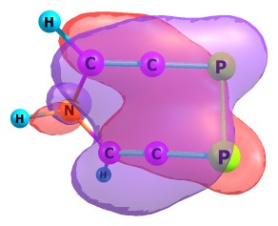
32, HOMO 31, HOMO-1 30, HOMO-2 29, HOMO-3
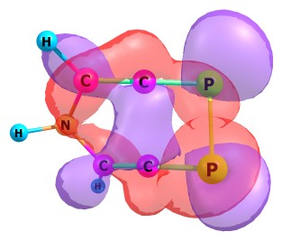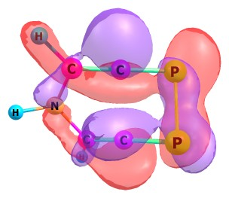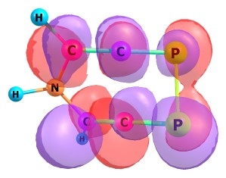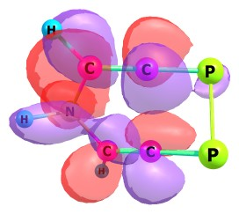
33, LUMO 34, LUMO+1 35, LUMO+2 36, LUMO+3

_{IntCc (restricted mode)}
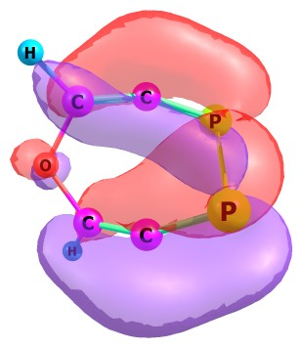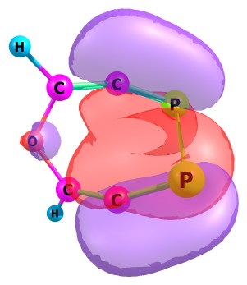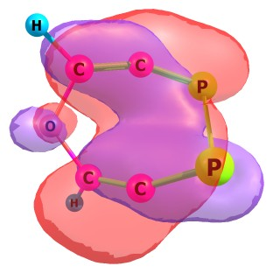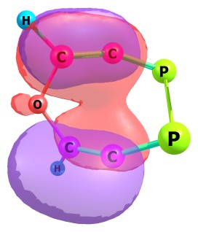
32, HOMO 31, HOMO-1 30, HOMO-2 29, HOMO-3
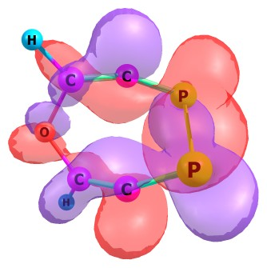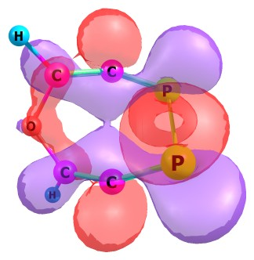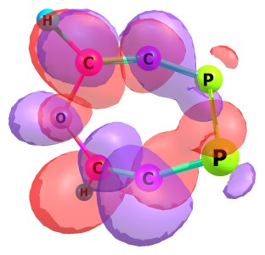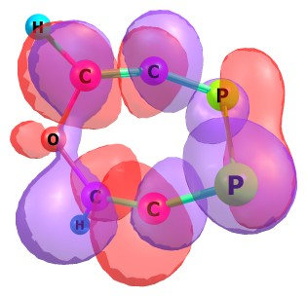
33, LUMO 34, LUMO+1 35, LUMO+2 36, LUMO+3
_{IntCc (unrestricted mode)}
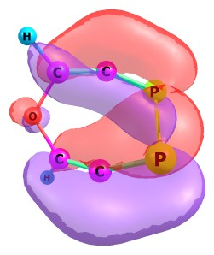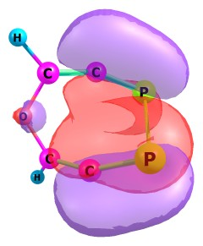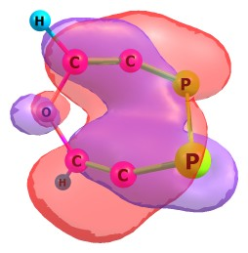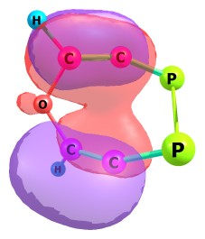
32, HOMO 31, HOMO-1 30, HOMO-2 29, HOMO-3
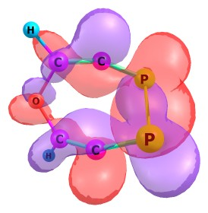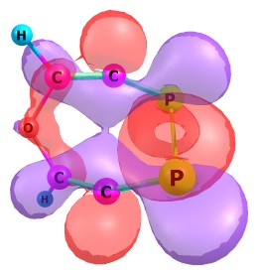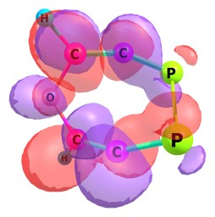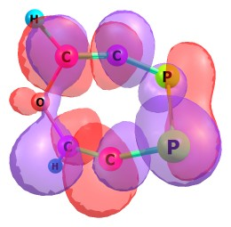
33, LUMO 34, LUMO+1 35, LUMO+2 36, LUMO+3

_{TS2Cc (restricted mode)}
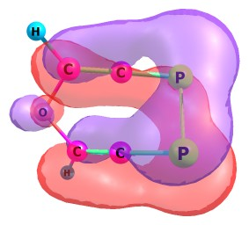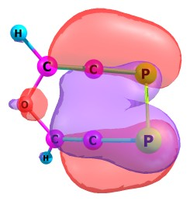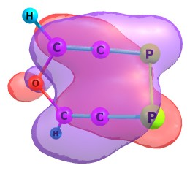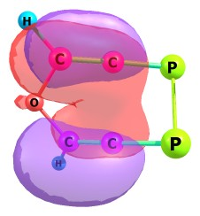
32, HOMO 31, HOMO-1 30, HOMO-2 29, HOMO-3
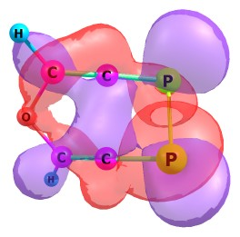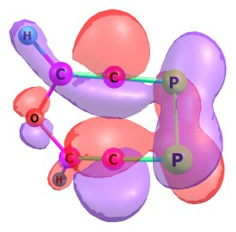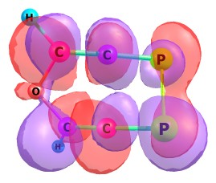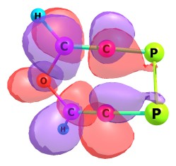
33, LUMO 34, LUMO+1 35, LUMO+2 36, LUMO+3
_{TS2Cc (unrestricted mode)}
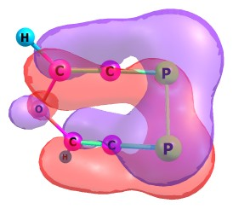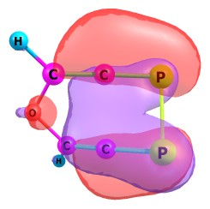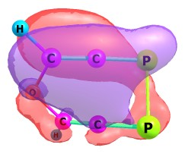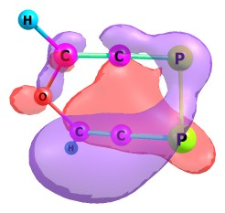
32, HOMO 31, HOMO-1 30, HOMO-2 29, HOMO-3
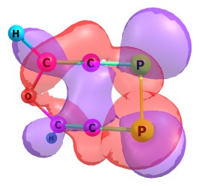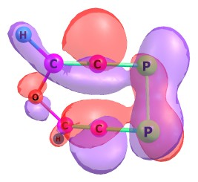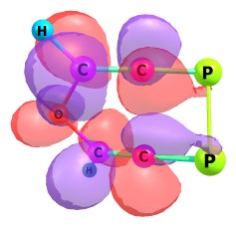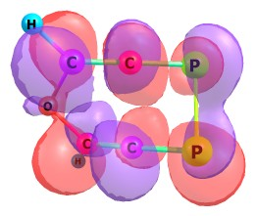
33, LUMO 34, LUMO+1 35, LUMO+2 36, LUMO+3

_{IntCd (restricted mode)}
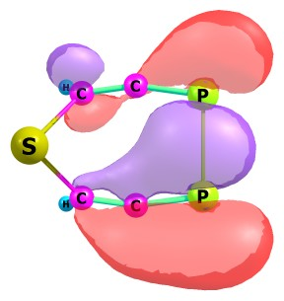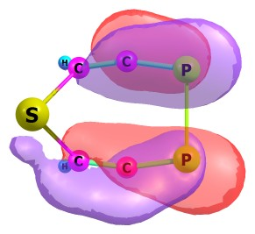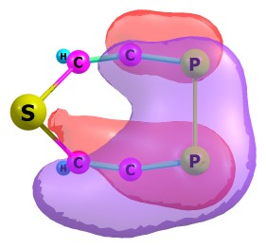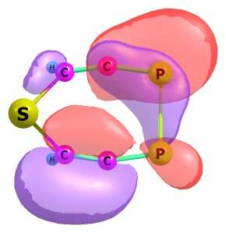
36, HOMO 35, HOMO-1 34, HOMO-2 33, HOMO-3
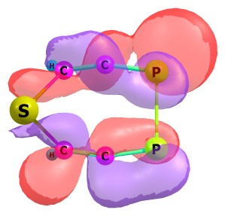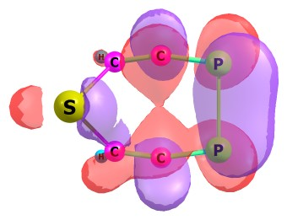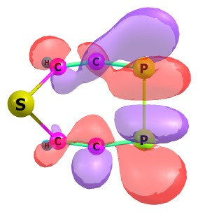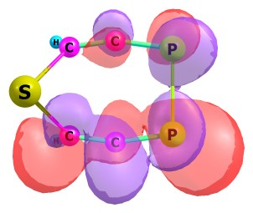
37,LUMO 38, LUMO+1 3 39, LUMO+2 40, LUMO+3
_{IntCd (unrestricted mode)}
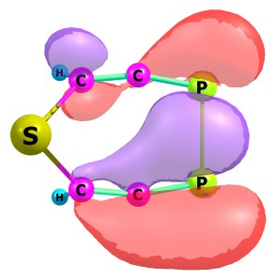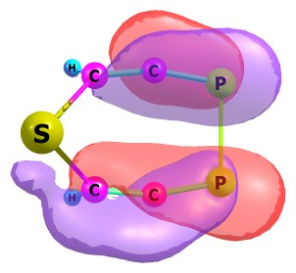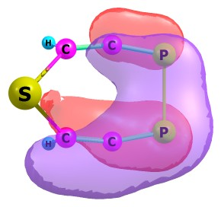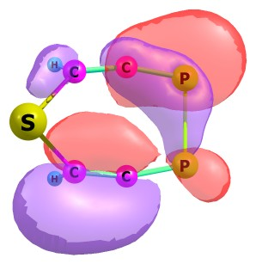
36, HOMO 35, HOMO-1 34, HOMO-2 33, HOMO-3
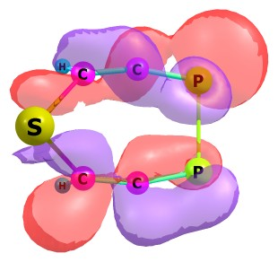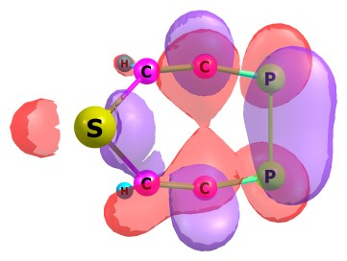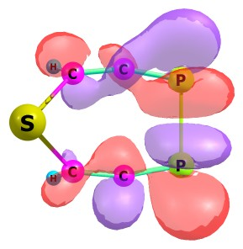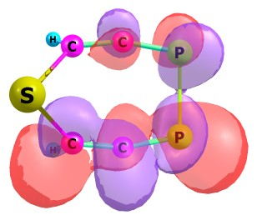
37, LUMO 38, LUMO+1 39, LUMO+2 40, LUMO+3
_{TS2Cd (restricted mode)}
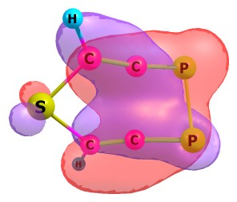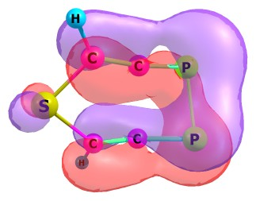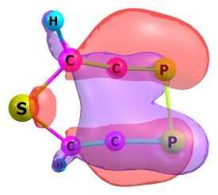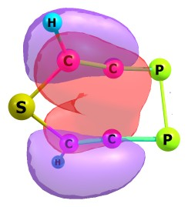
36, HOMO 35, HOMO-1 34, HOMO-2 33, HOMO-3
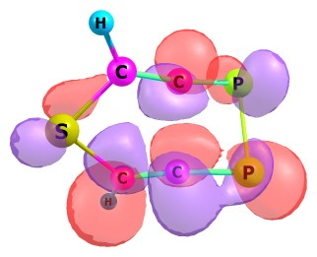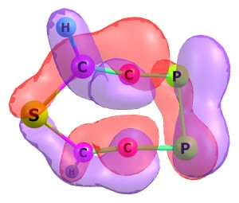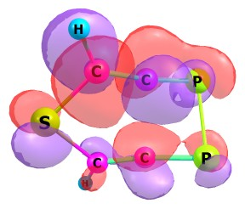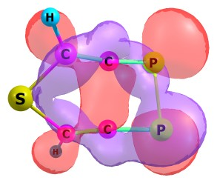
37, LUMO 38, LUMO+1 39, LUMO+2 40, LUMO+3
_{TS2Cd (unrestricted mode)}
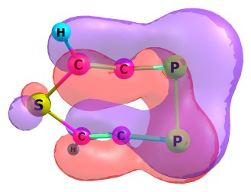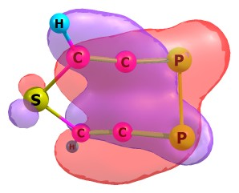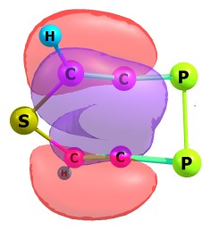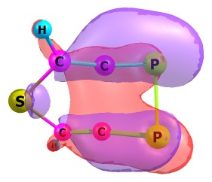
36, HOMO 35, HOMO-1 34, HOMO-2 33, HOMO-3
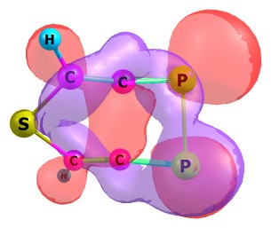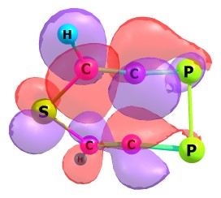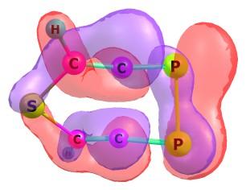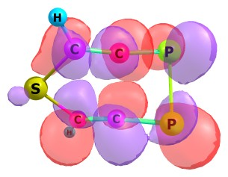
37, LUMO 38, LUMO+1 39, LUMO+2 40, LUMO+3

_{IntCe (restricted mode)}
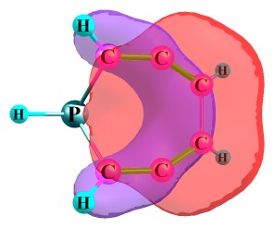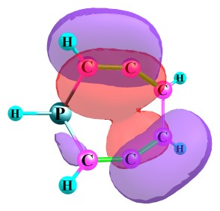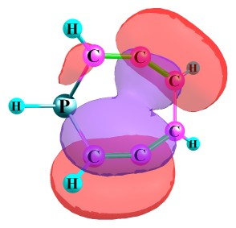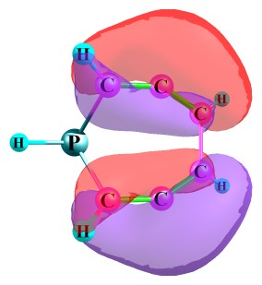
28, HOMO 27, HOMO-1 26, HOMO-2 25, HOMO-3
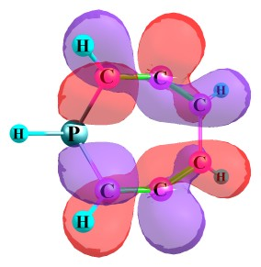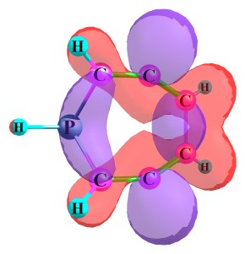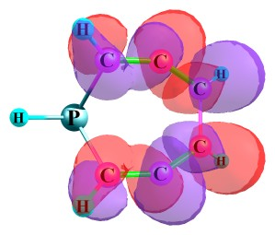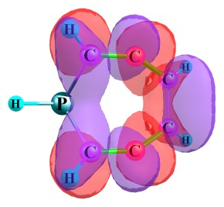
29, LUMO 30, LUMO+1 31, LUMO+2 32, LUMO+3
_{IntCe (unrestricted mode)}
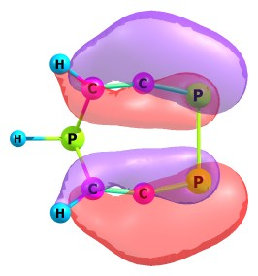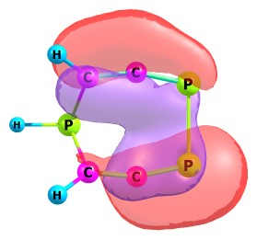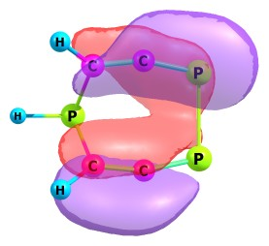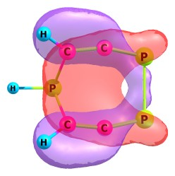
36, HOMO 35, HOMO-1 34, HOMO-2 33, HOMO-3
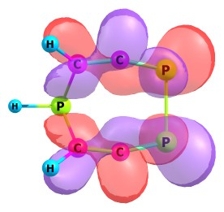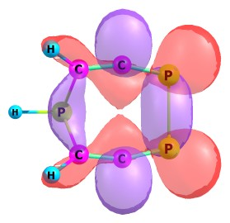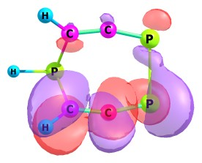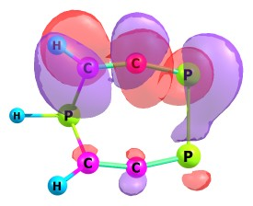
37, LUMO 38, LUMO+1 39, LUMO+2 40, LUMO+3
_{TS2Ce (restricted mode)}
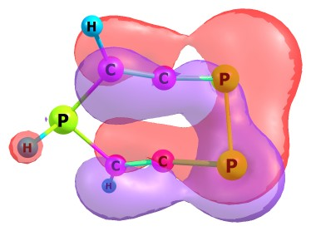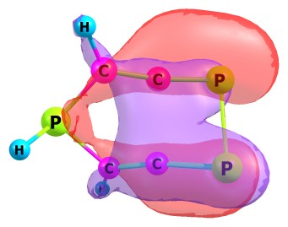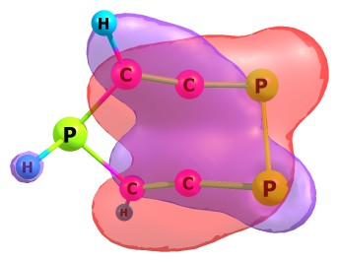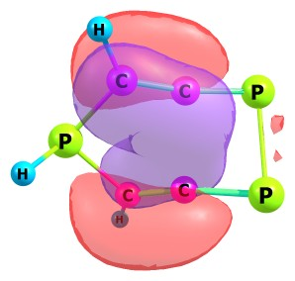
36, HOMO 35, HOMO-1 34, HOMO-2 33, HOMO-3
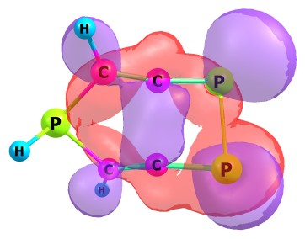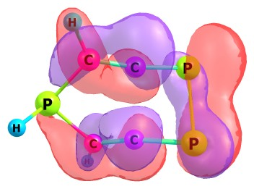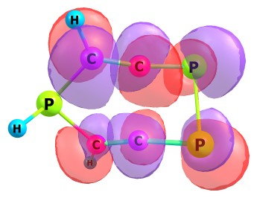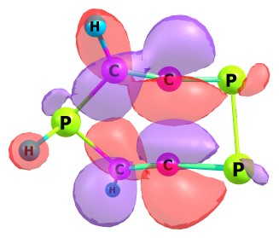
37, LUMO 38, LUMO+1 39, LUMO+2 40, LUMO+3
_{TS2Ce (unrestricted mode)}
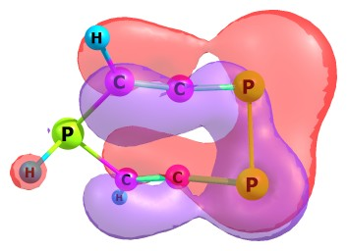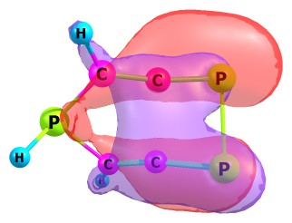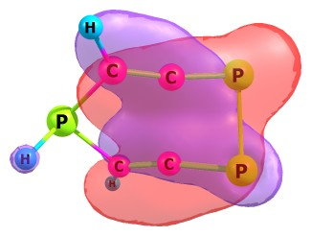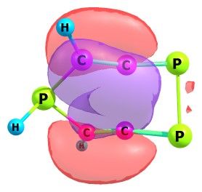
36, HOMO 35, HOMO-1 34, HOMO-2 33, HOMO-3
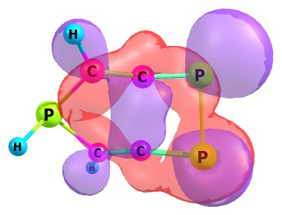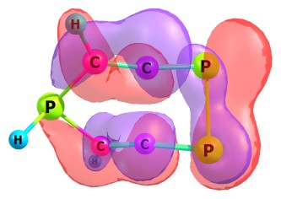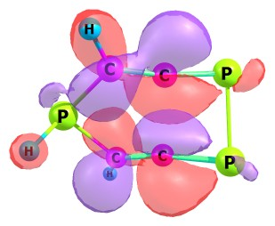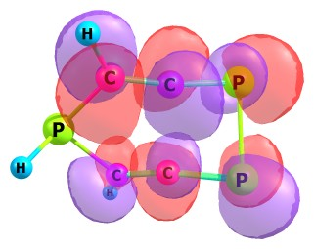
37, LUMO 38, LUMO+1 39, LUMO+2 40, LUMO+3

