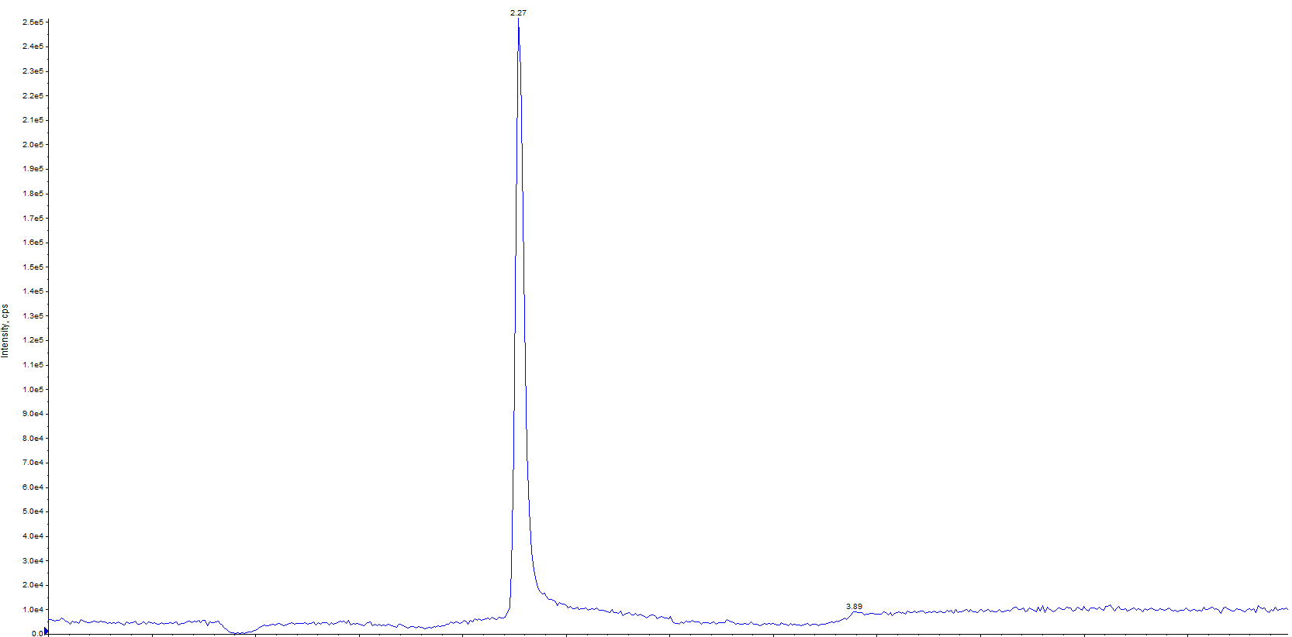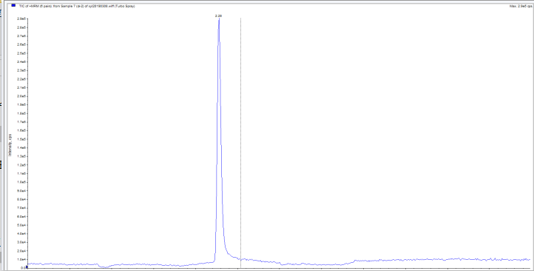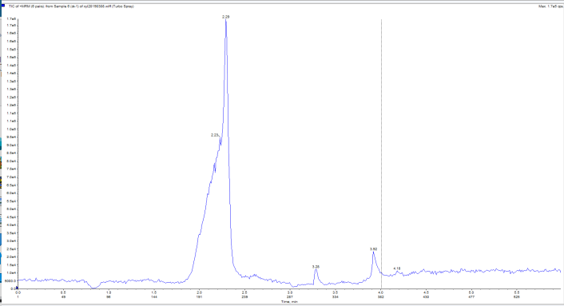

c

b

a

Fig. S1 The chromatogram of optimization of mobile phase (a: mixture of 50% MeOH and water solution; b: ACN, and MeOH; c: 0.05% formic acid water+CAN



Fig. S2 Final residue results of 7 d and 14 d in different matrix