Supporting Information
Phenylboronic Ester-Modified Anionic Micelles for ROS-Stimuli Response in HeLa Cell
Qi Y. Wang^{1⊥}, Yi S. Xu^{1⊥}, Nan X. Zhang¹, Zhi P. Dong¹, Bo N. Zhao¹, Lin C. Liu², Tao Lu*¹, Yue Wang*¹
¹ Key Laboratory of Biomedical Functional Materials, School of Sciences, China Pharmaceutical University, Nanjing 211198, Jiangsu Province, China.
2 Department of Rheumatology, Zhongda Hospital, School of Medicine, Southeast University, Nanjing, Jiangsu, China.

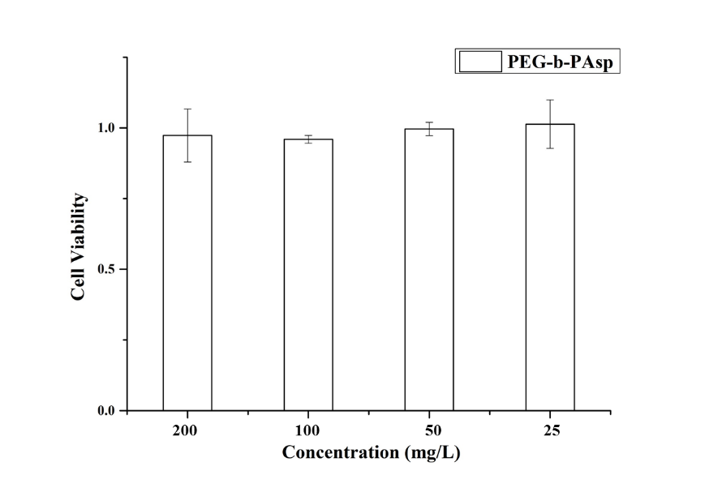
Figure S1. Cell inhibition of PEG-b-PAsp on L-O2 at different concentrations
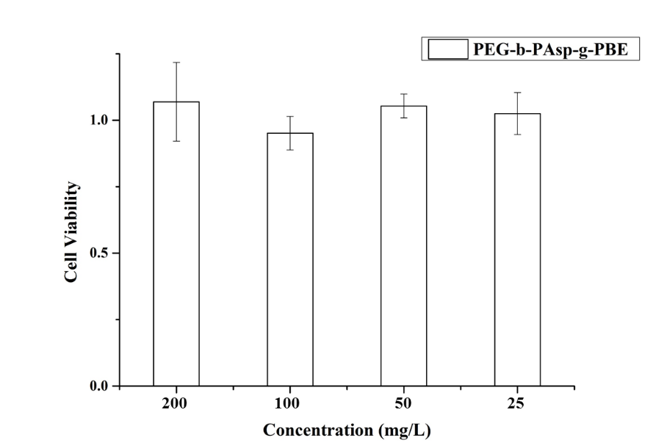
Figure S2. Cell inhibition of PEG-b-PAsp-g-PBE on L-O2 cells at different concentrations
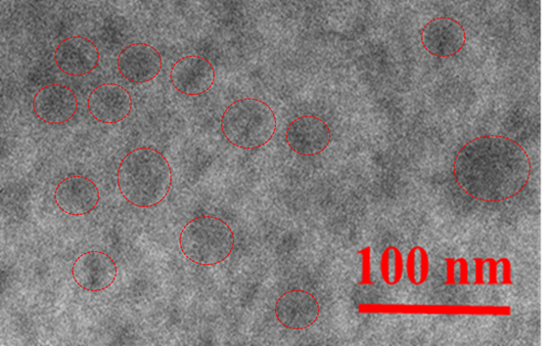
Figure S3.TEM image of the PEG₄₅-b-PAsp₇₂-g-PBE₄₁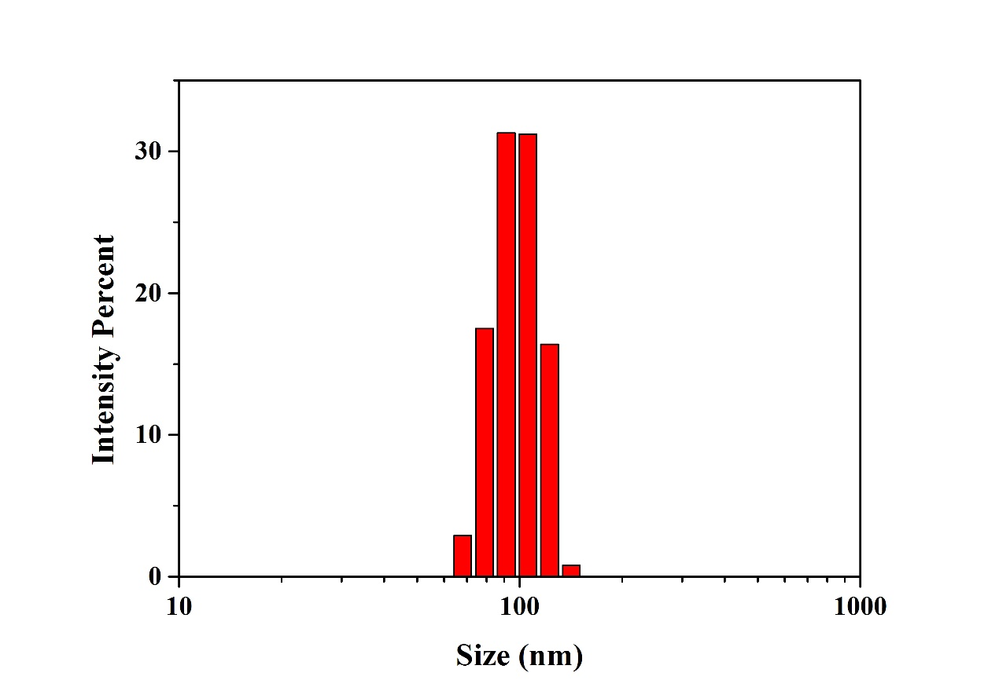
Figure S4. Size distribution of the PEG₄₅-b-PAsp₇₂ in PBS 7.4

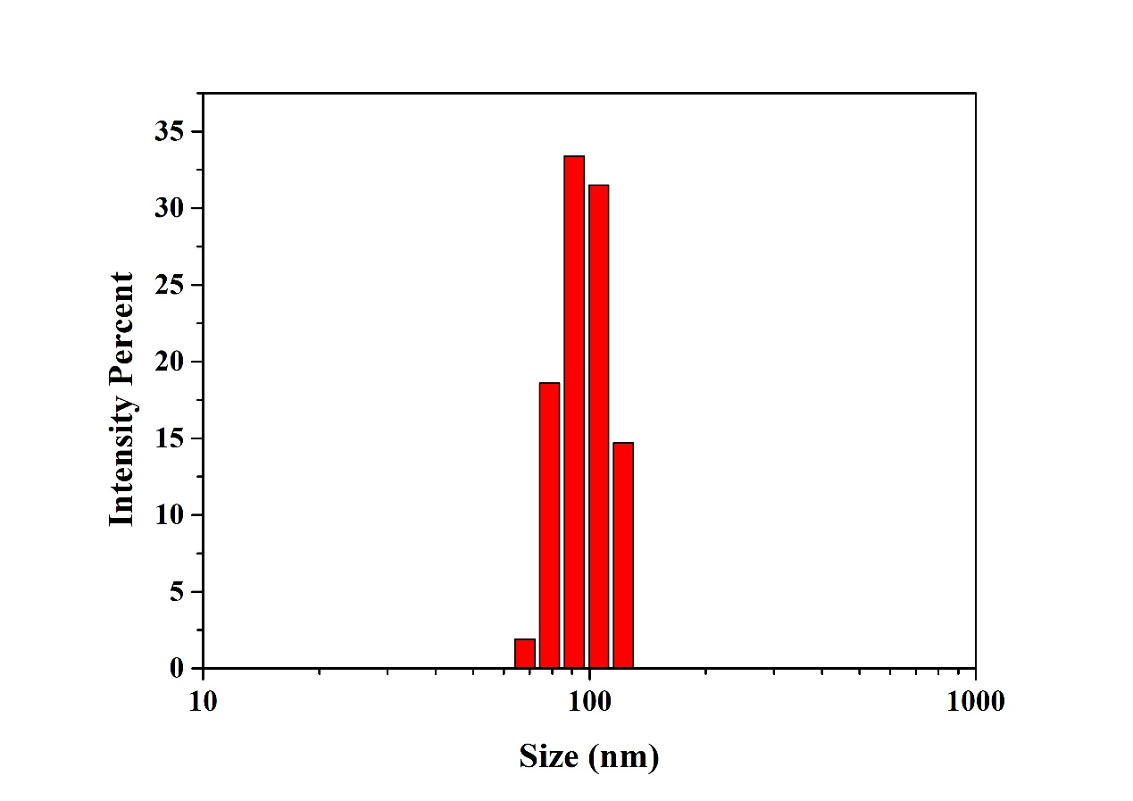
Figure S5. Size distribution of the PEG₄₅-b-PAsp₇₂-g-PBE₄₁ in PBS 7.4

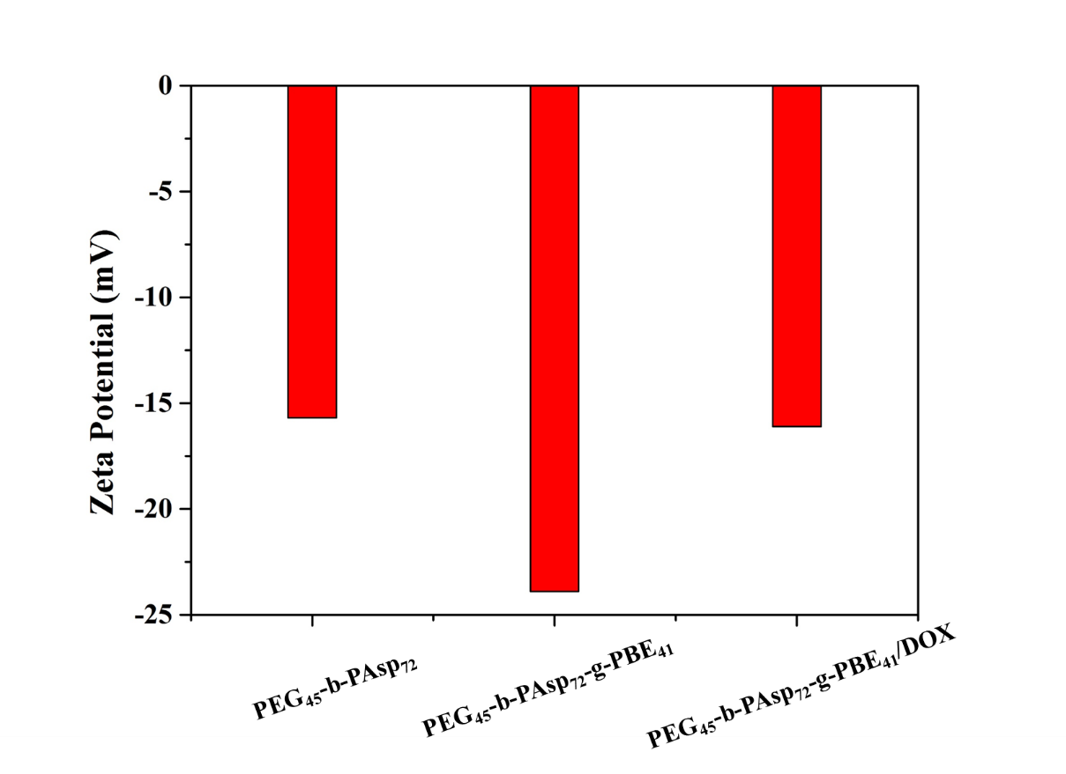
Figure S6. Zeta potential of polymeric micelles
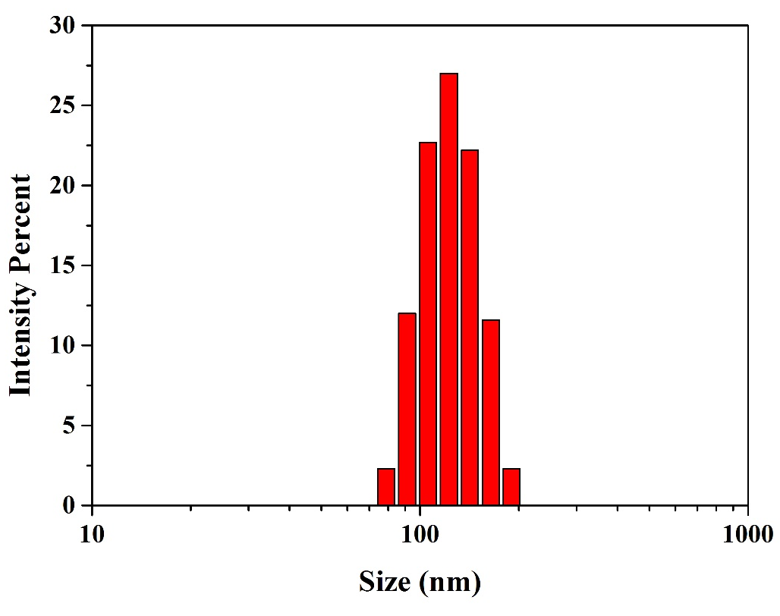
Figure S7. Size distribution of the PEG₄₅-b-PAsp₇₂-g-PBE₄₁/DOX in PBS 7.4

