Interaction of 1-acylamino-2,2-dichloro-ethenyltriphenylphosphonium chlorides with alkanolamines

O.V. Golovchenkoª, E.R. Abdurakhmanovaª, S.O. Vladimirov ^{b}, M.Y. Brusnakovª, T.O. Krupoder^{c}, E.B. Rusanov^{d}, R. N.Vydzhakª, V.S. Brovarets^{a*}

ªV. P. Kukhar Institute of Bioorganic Chemistry and Petrochemistry of the National Academy of Sciences of Ukraine, 1 Murmanska str., 02094, Kyiv-94, Ukraine;

^{b}Taras Shevchenko National University of Kyiv, 64 Volodymyrska str., Kyiv, Ukraine;

^{c}Nizhyn Mykola Gogol State University, 2 Grafska str., 16600, Nizhyn, Chernihivska Oblast, Ukraine;

^{d}Institute of Organic Chemistry of the National Academy of Sciences of Ukraine,
5 Murmanska str., 02660, Kyiv, Ukraine.
Email: brovarets@bpci.kiev.ua

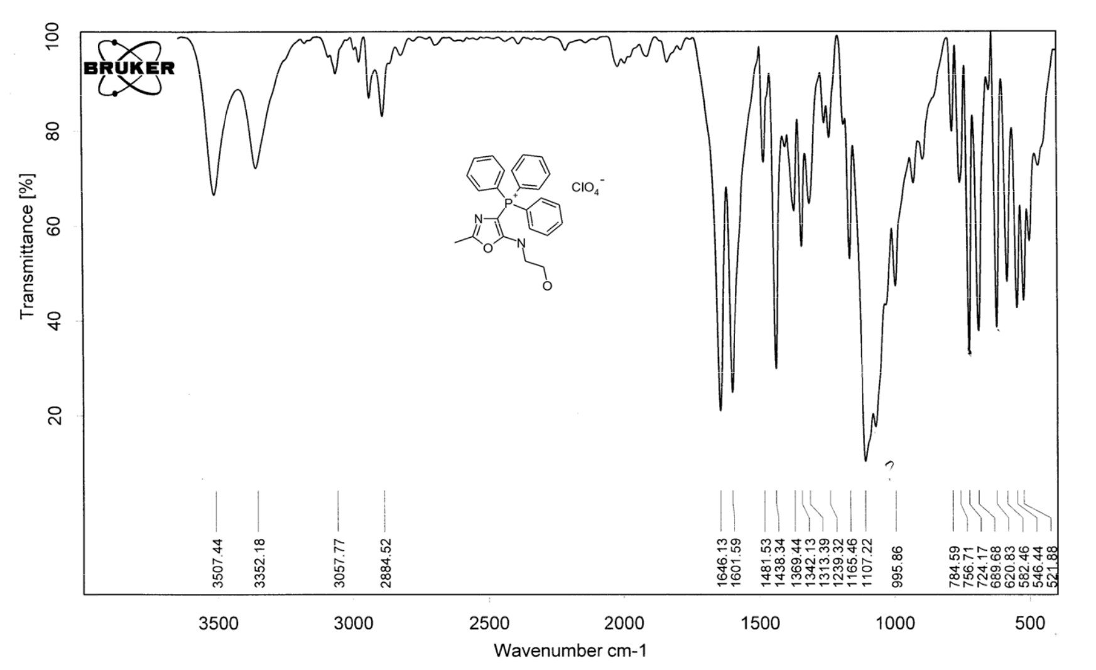

Figure S 1. IR (KBr) spectra of [5-(2-Hydroxyethyl)amino-2-methyl-4-oxazolyl]triphenylphosphonium perchlorate (3a).

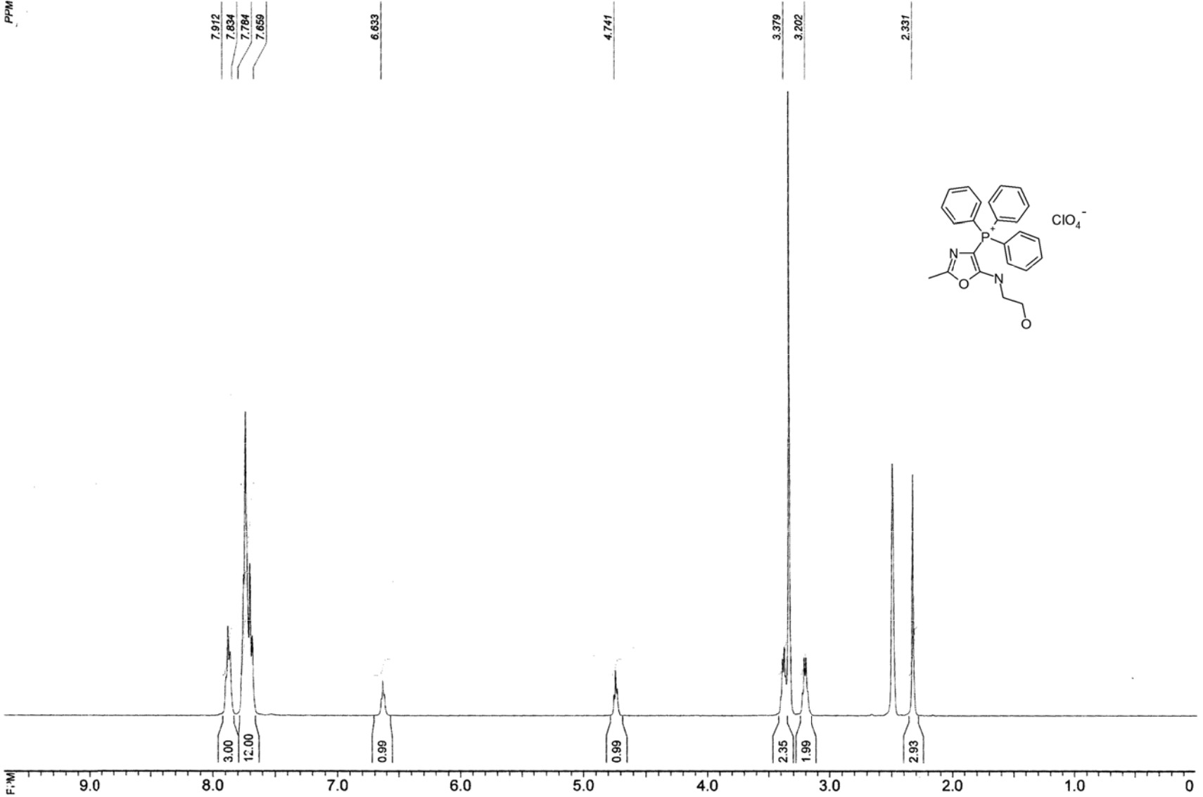

Figure S 2. ¹H NMR spectra of [5-( 2-Hydroxyethyl )amino-2-methyl-4-oxazolyl]triphenylphosphonium perchlorate (3a).

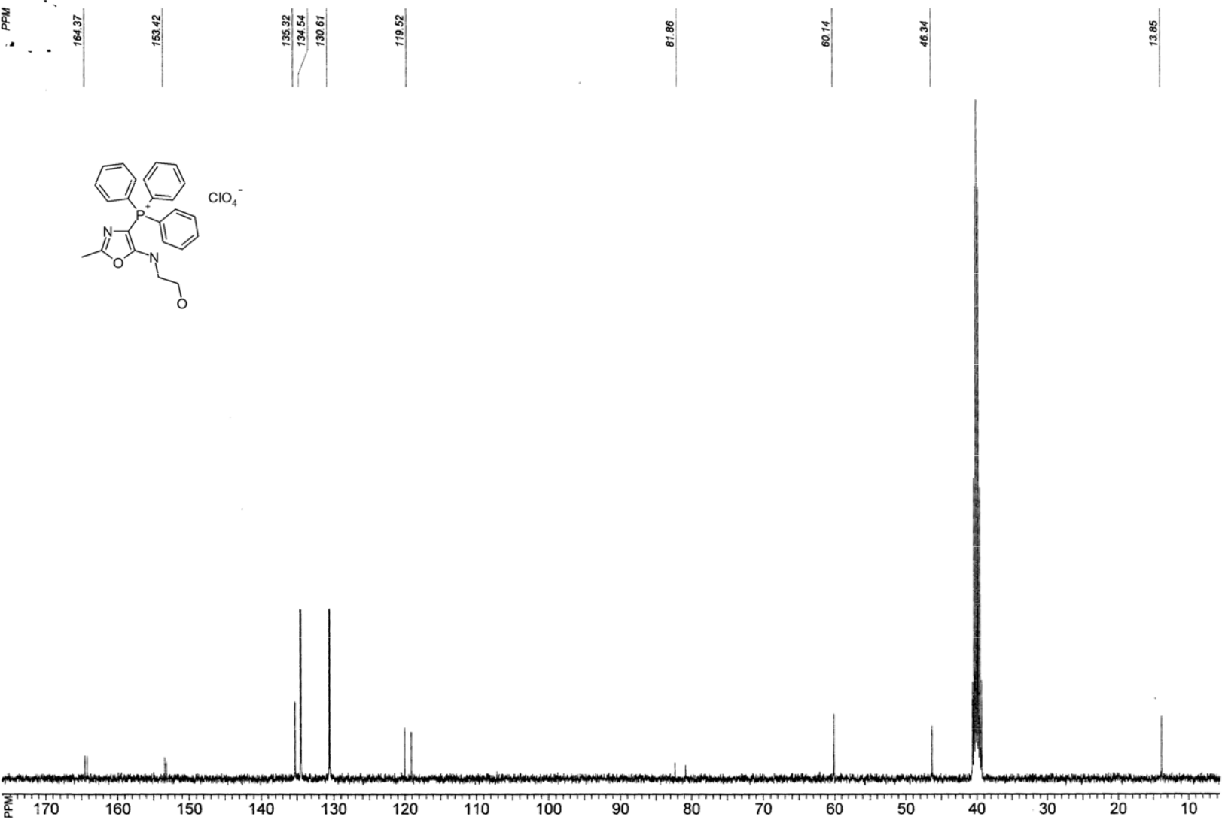

Figure S 3. ¹³C NMR spectra of [5-( 2-Hydroxyethy l)amino-2-metyyl-4-oxazolyl]triphenylphosphonium perchlorate (3a).

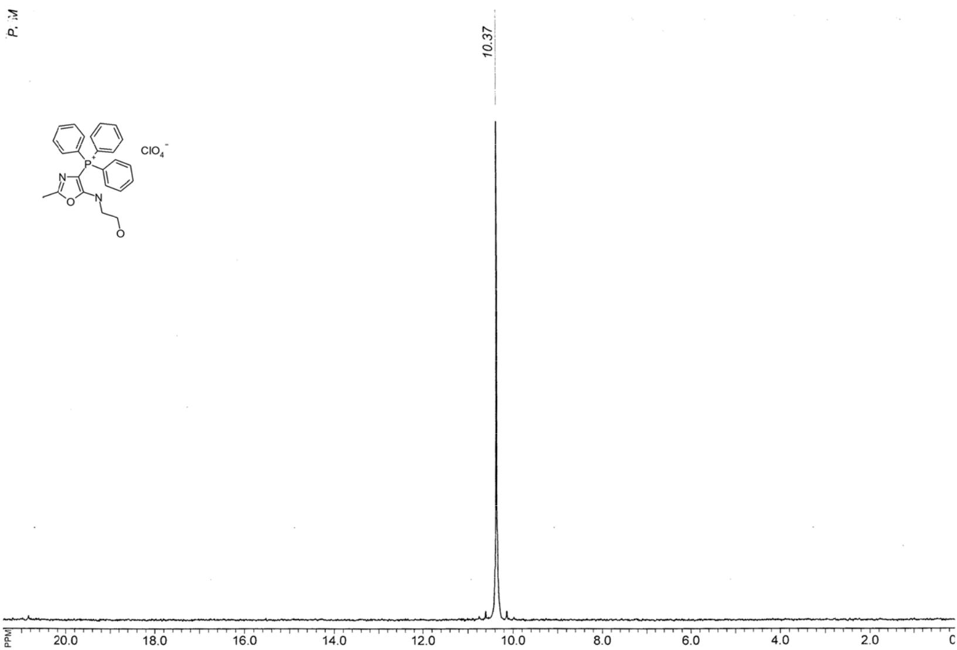

Figure S 4. ³¹P NMR spectra of [5-(2-Hydroxyethyl)amino-2-methyl-4-oxazolyl]triphenylphosphonium perchlorate (3a).

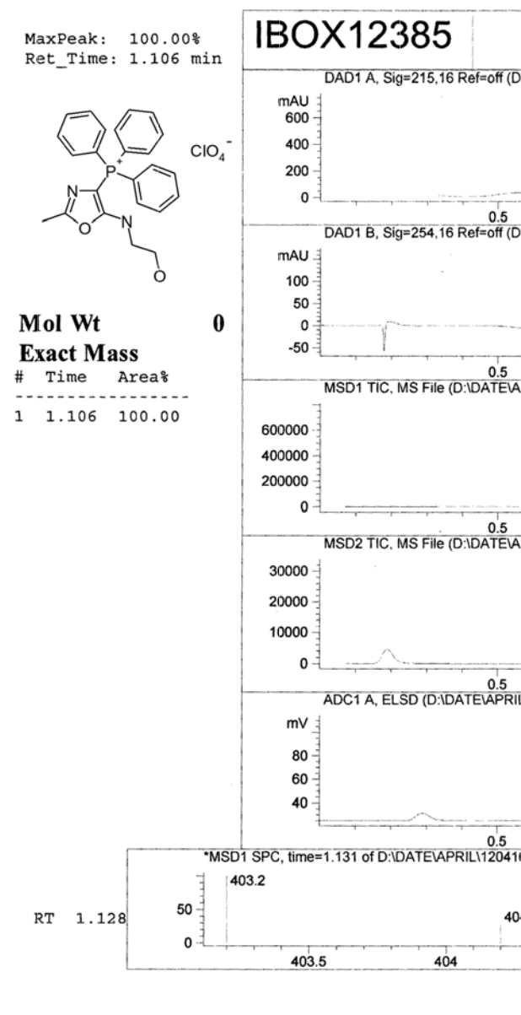

Figure S 5. LC MS spectra of [5-(2-Hydroxyethyl)oxazolyl]triphenylphosphonium perchlorate (3a).

amino-2-meethyl-4-
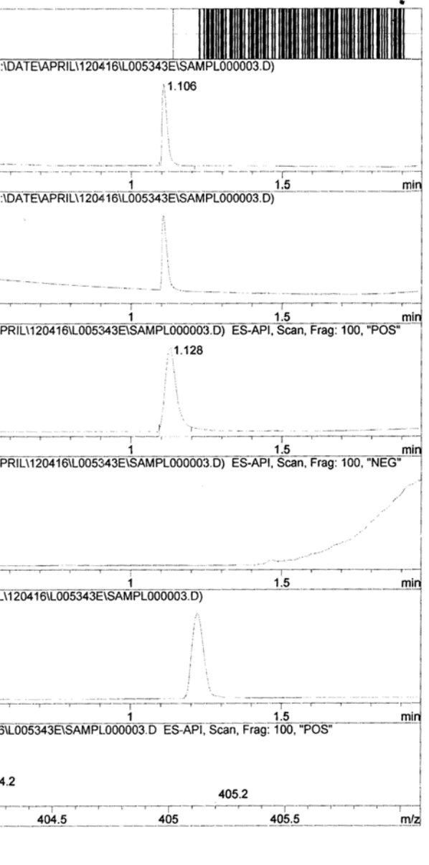

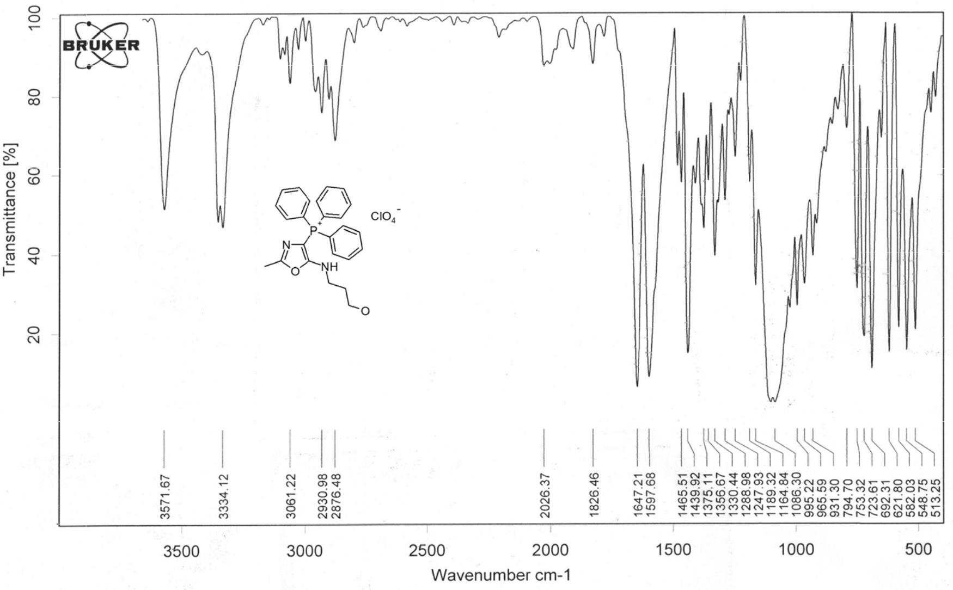

Figure S 6. IR (KBr) spectra of [5-(2-Hydroxyprop yl)amino-2-methyl-4-oxazolyl]triphenylphosphnium perchlorate (3b).

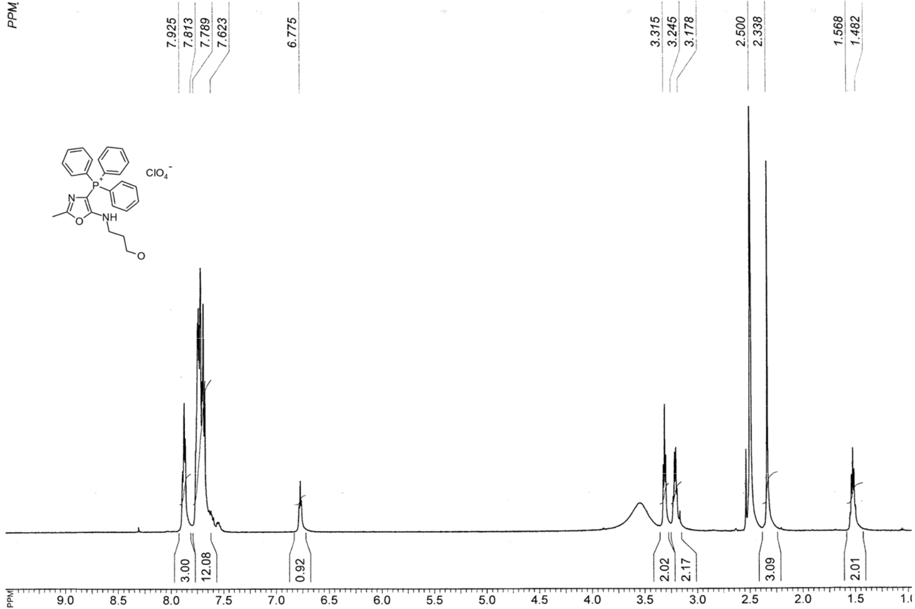

Figure S 7. ¹H NMR spectrum of [5-(2-Hydroxypropyl)amino-2-methyl-4-oxazolyl]triphenylphosphonium perchlorate (3b).

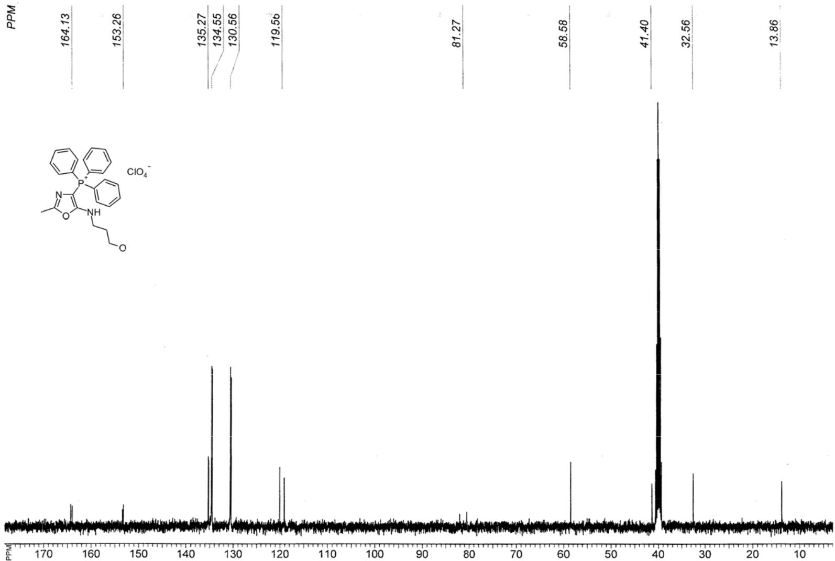

Figure S 8. ¹³C NMR spectra of [5-( 2-Hydroxypropyl)amino-2-methyl-4-oxazolyl]triphenylphosphonium perchlorate (3b).

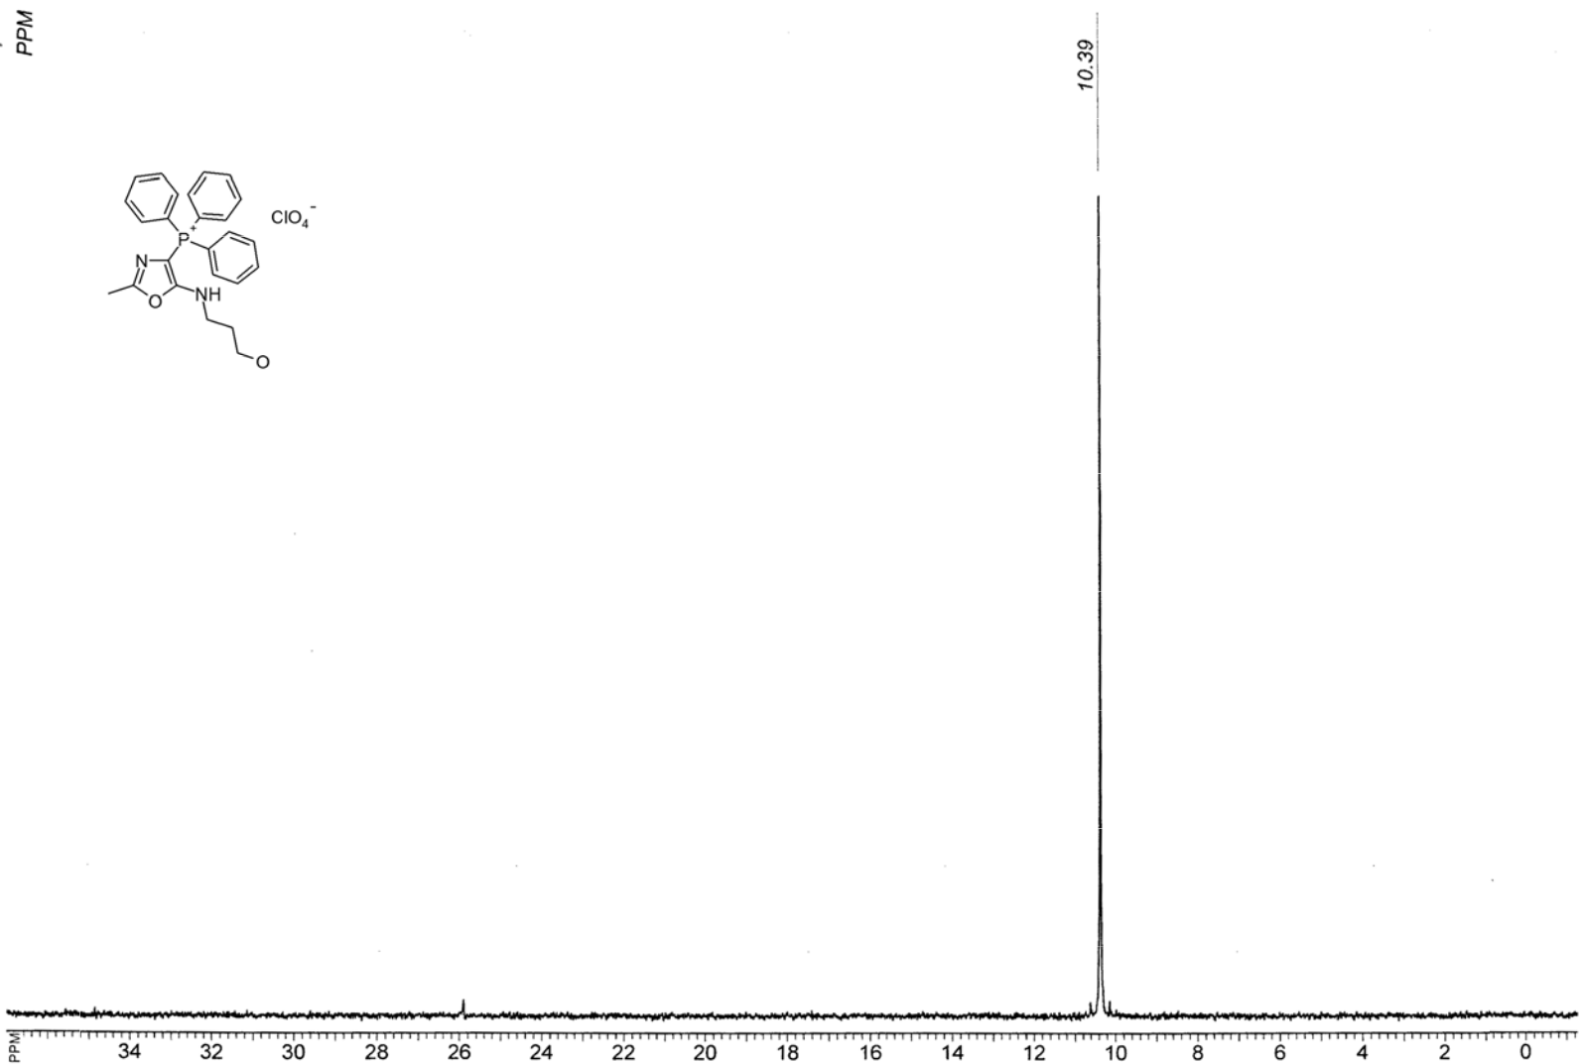

Figure S 9. ³¹P NMR spectra of [5-(2-Hydroxypropyl)amino-2-methyl-4-oxazolyl]triphenylphosphonium perchlorate (3b).

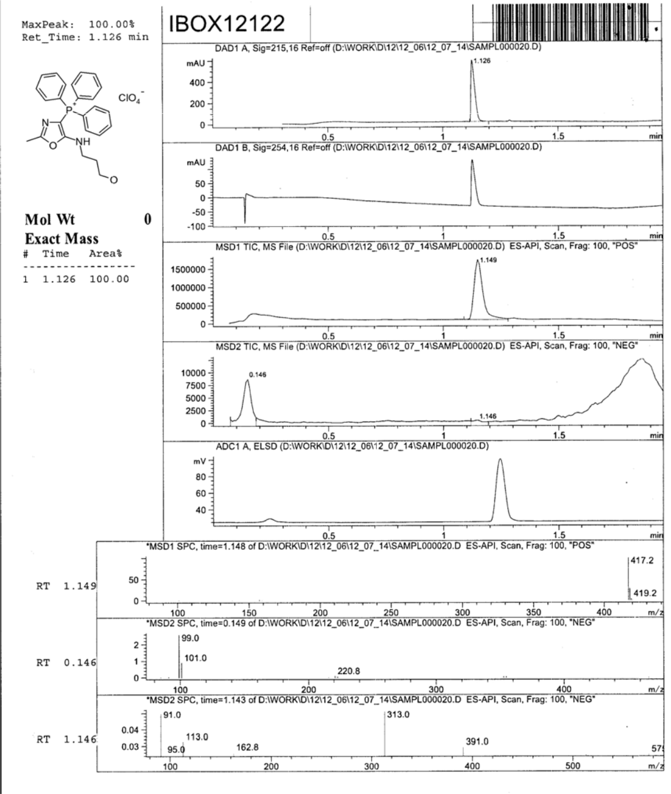

Figure S 10. LCMS spectra of [5-(2-Hydroxypropyl)amino-2-methyl-4-oxazolyl]triphenylphosphonium perchlorate (3b).

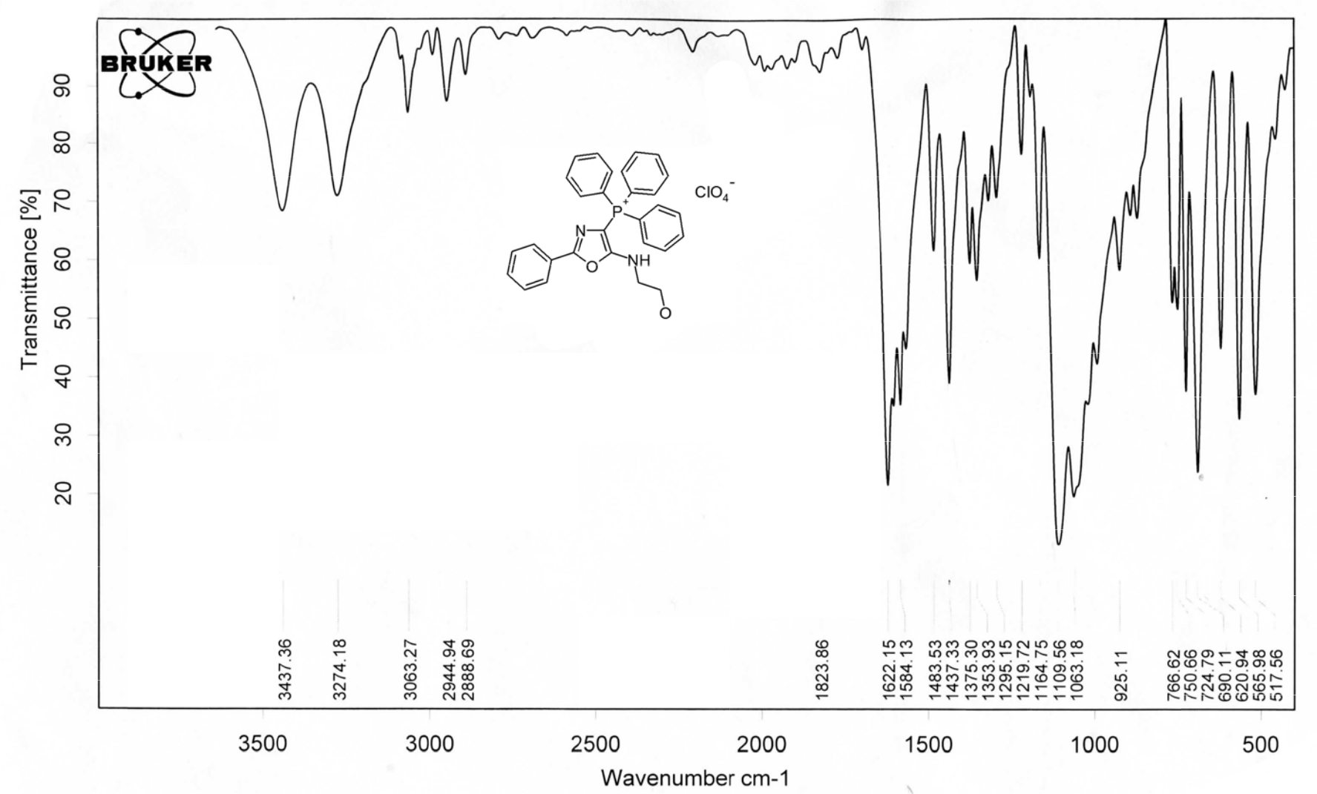

Figure S 11. IR spe trum of [5-(2-H ydroxyethyl)amino-2-phenyl-4 -oxazolyl]triphenylphosphonium perchlorate (3c).

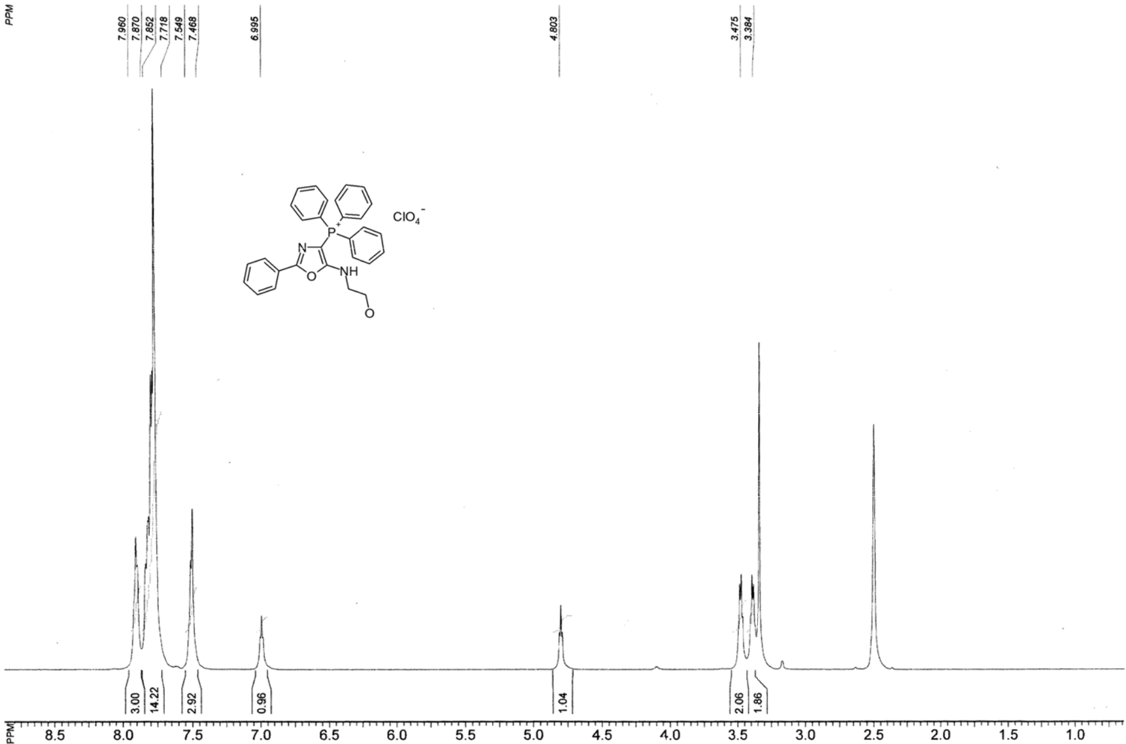

Figure S 12. ¹H NMR spectrum of [5-(2-Hydroxyethyl)amino-2-phenyl-4-oxazolyl]triphenylphosphonium perchlorate (3c).

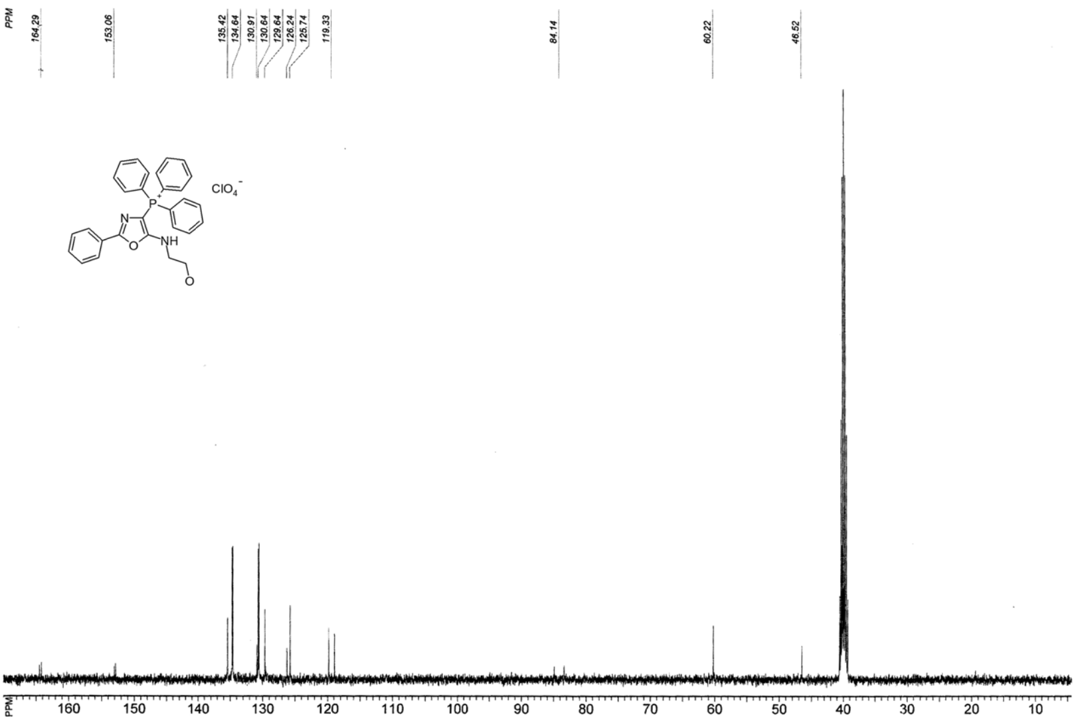

Figure S 13. ¹³C NMR spectrum of [5-(2-Hydroxyethyl)amino-2-phenyl-4-oxazoly ]triphenylphosphonium perchlorate (3c).

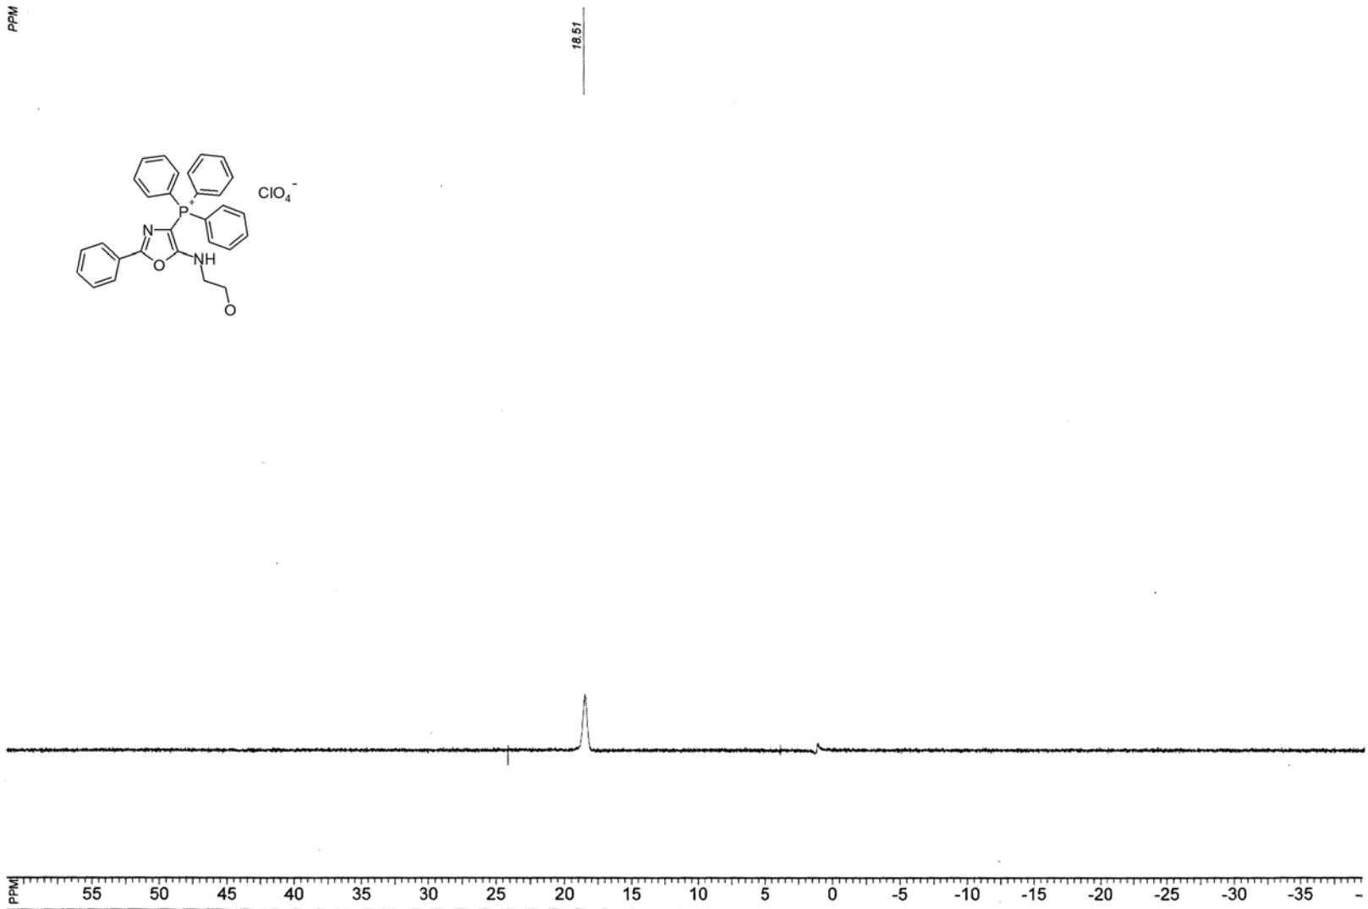

Figure S 14. ³¹P NMR spectrum of 5-(2-Hydroxyethyl)amino-2-phenyl-4-oxazolyl]triphenylphosphonium perchlorate (3c).

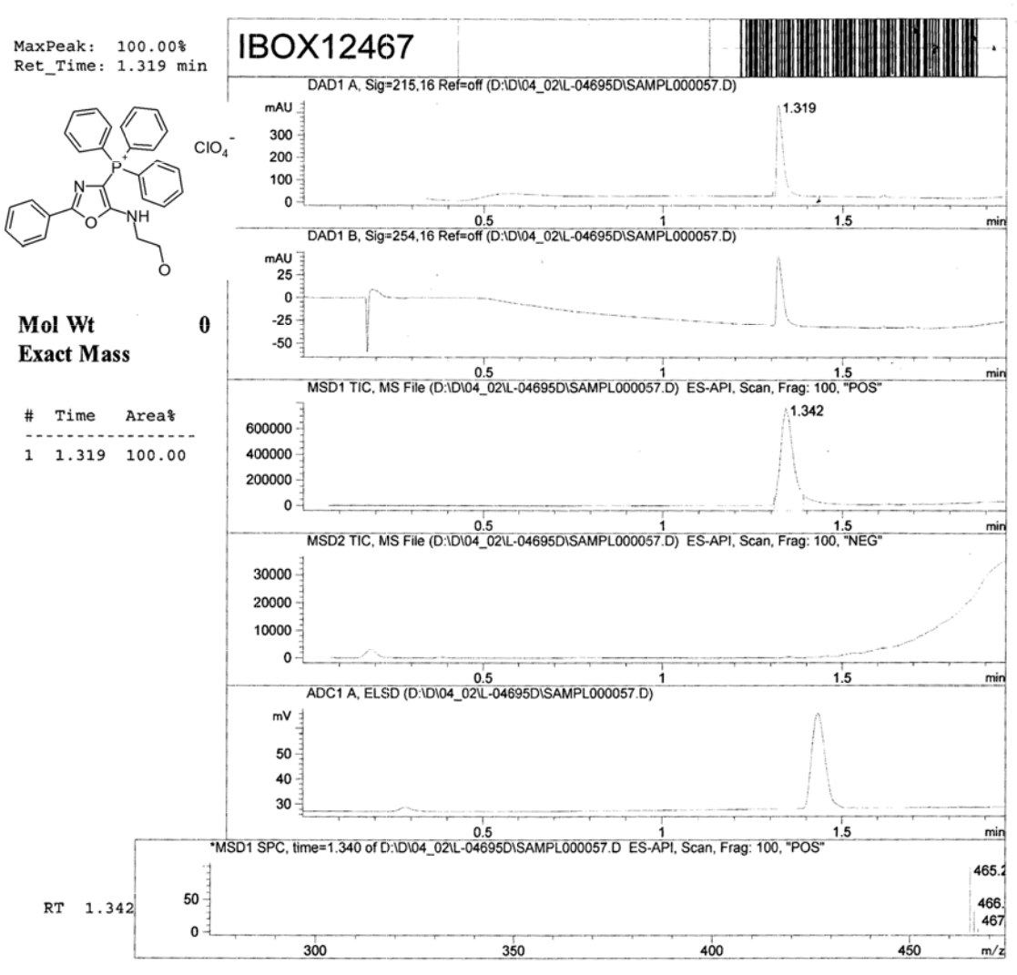

Figure S 15. LCMS analysi s report of [5-(2-Hydroxyethyl)amino-2-phenyl-4-oxazolyl]triphenylphosphonium perchlorate (3c).

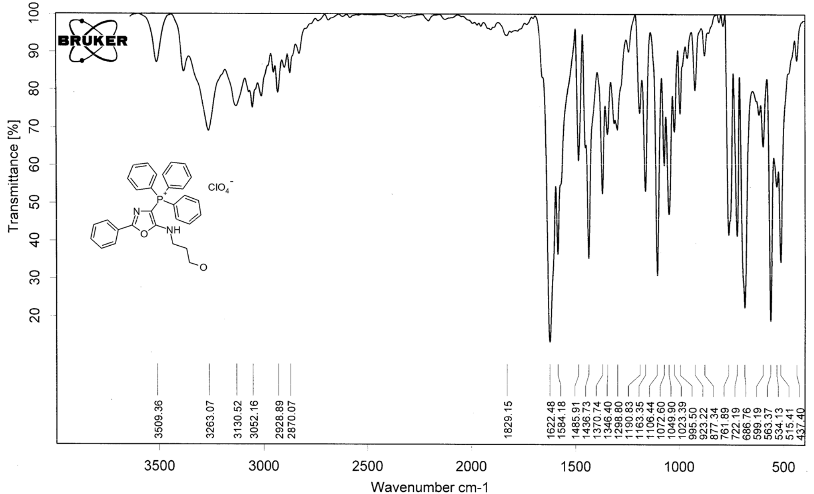

Figure S 16. IR spectrum of [5-(2- ydroxypropyl) amino-2-phenyl -4-oxazolyl]triphenylphosphonium perchlorate 3d).

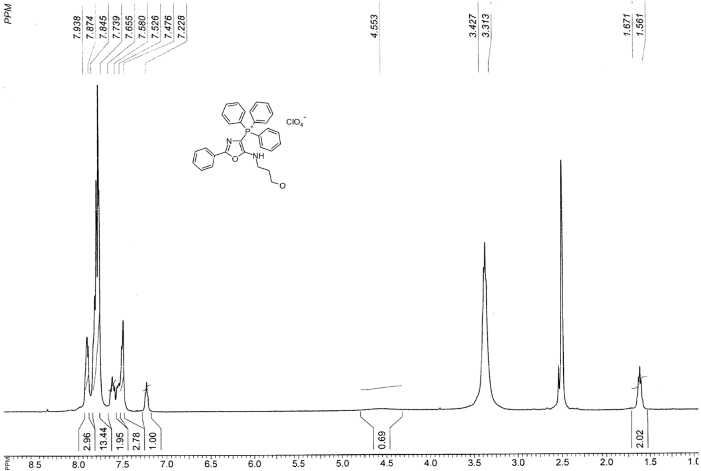

Figure S 17. ¹H NMR spectrum of [5-(2-Hydroxypropyl)amino-2-phenyl-4-oxazolyl]triphenylphosphonium perchlorate (3d).

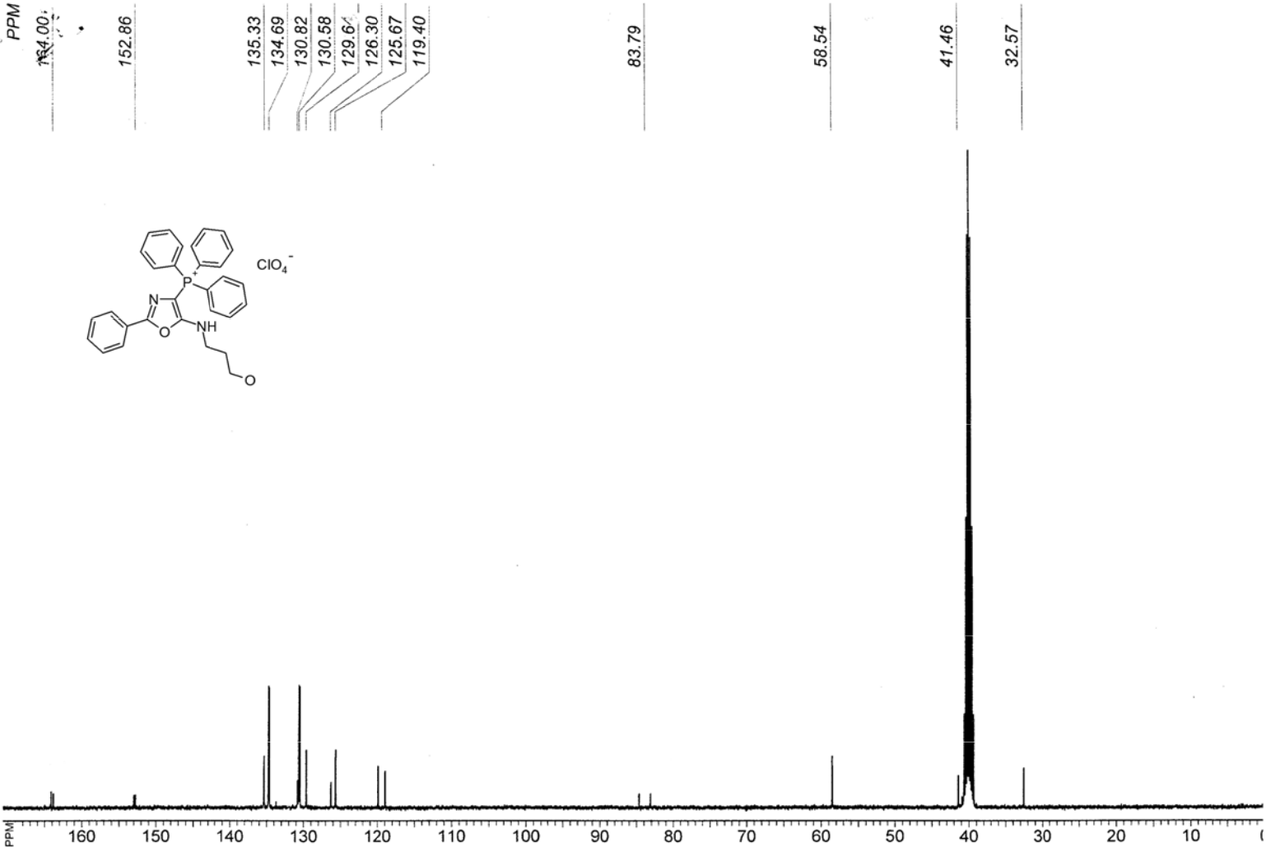

Figure S 18. ¹³C NMR spectrum of [5-(2-Hydroxypropyl)amino-2- phenyl-4-oxazolyl]triphenylphosphonium perchlorate (3d).

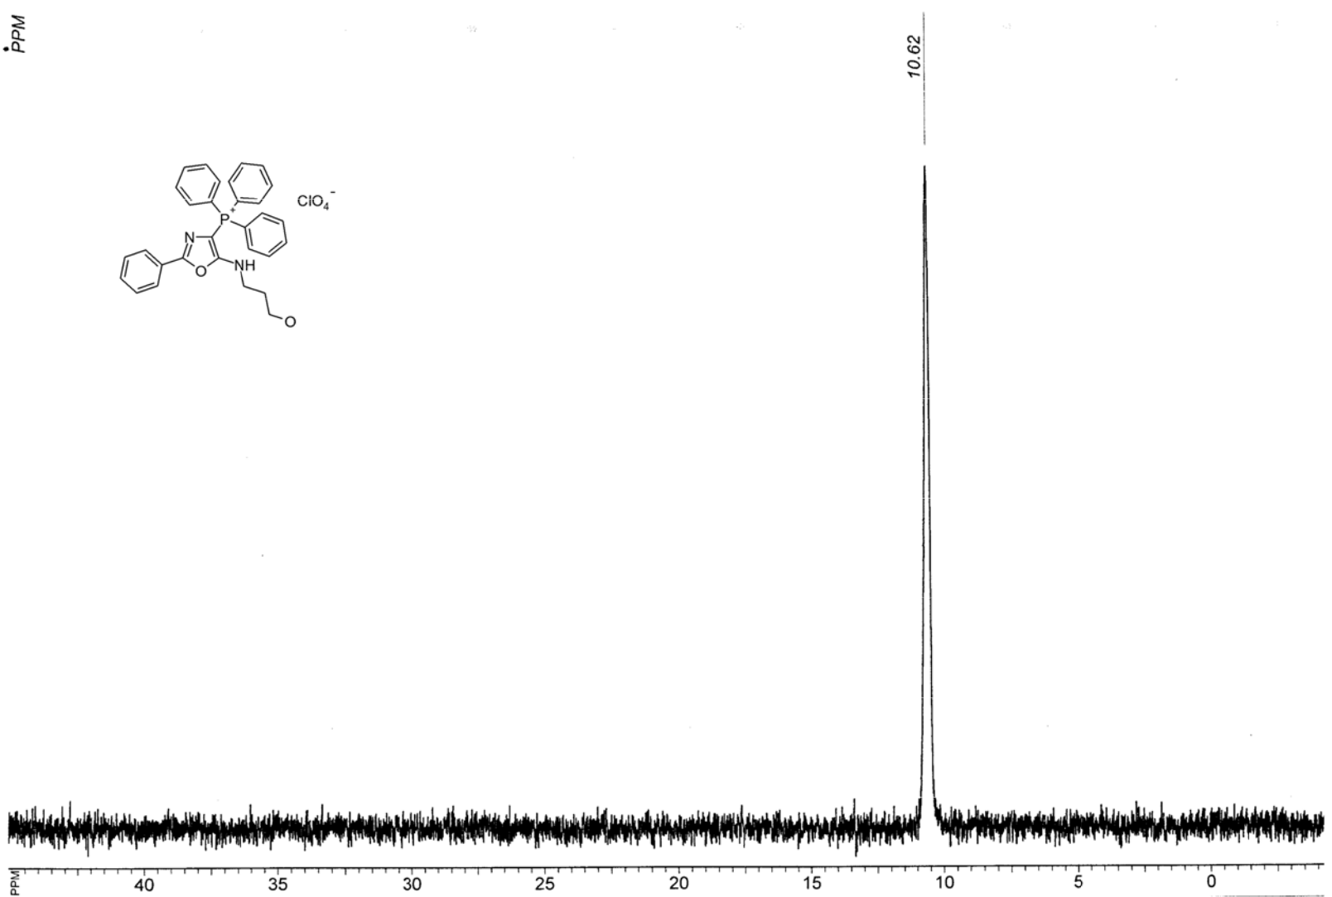

Figure S 19. ³¹P NMR spectrum of 5-(2-Hydroxyp ropyl)amino-2-phenyl-4-oxazolyl]triphenylphosphonium perchlorate (3d).

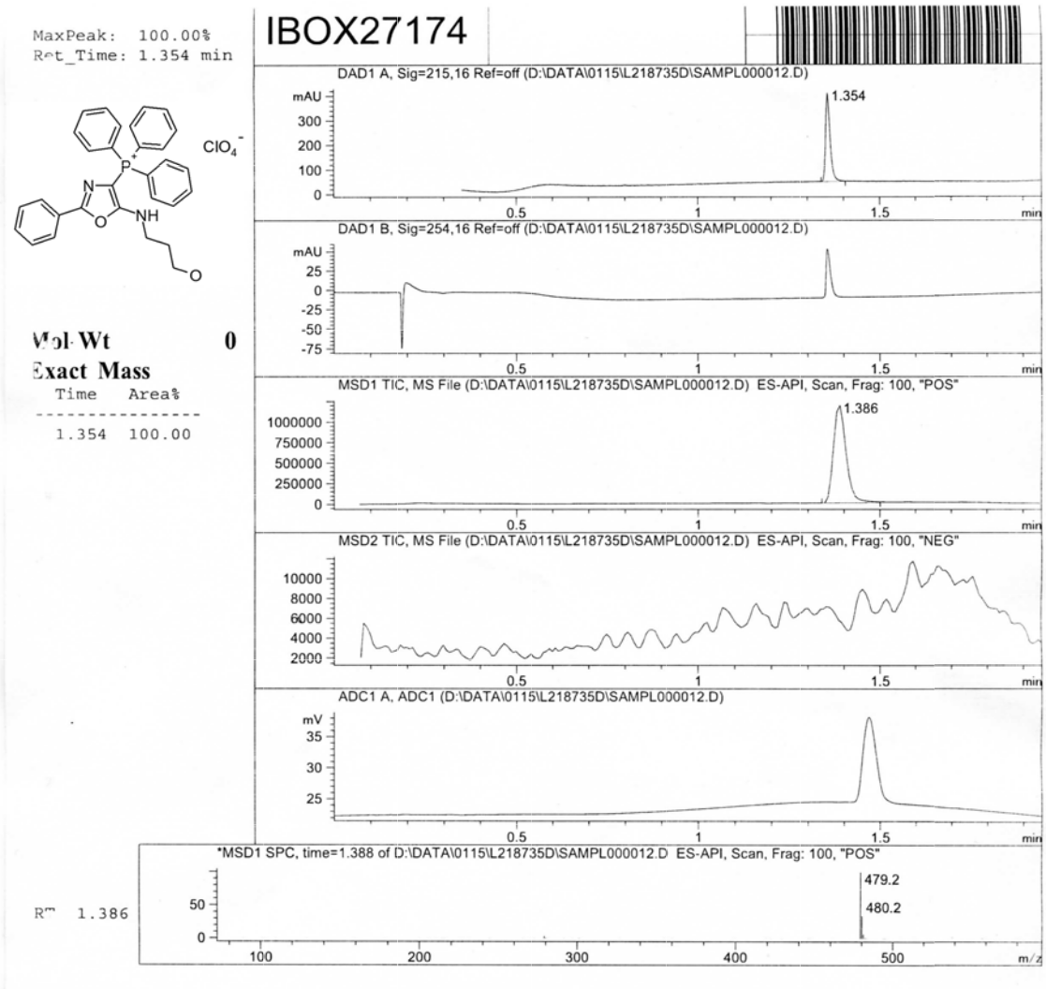

Figure S 20. LCMS analysis report of [5-(2-Hydroxypropyl) amino-2-phenyl-4-oxazolyl]triphenylphosphonium perchlorate (3d).

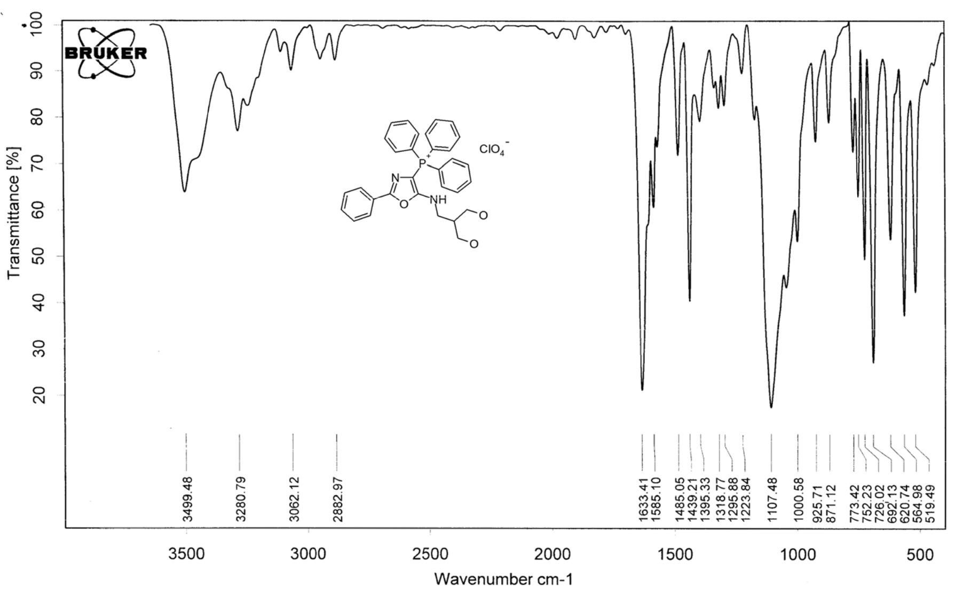

Figure S 21. IR (KBr) spectrum of [5-(2,3-Dihydro xypropyl)amino-2-phenyl-4-oxazolyl]triphenylphosphonium perchlorate (3e).

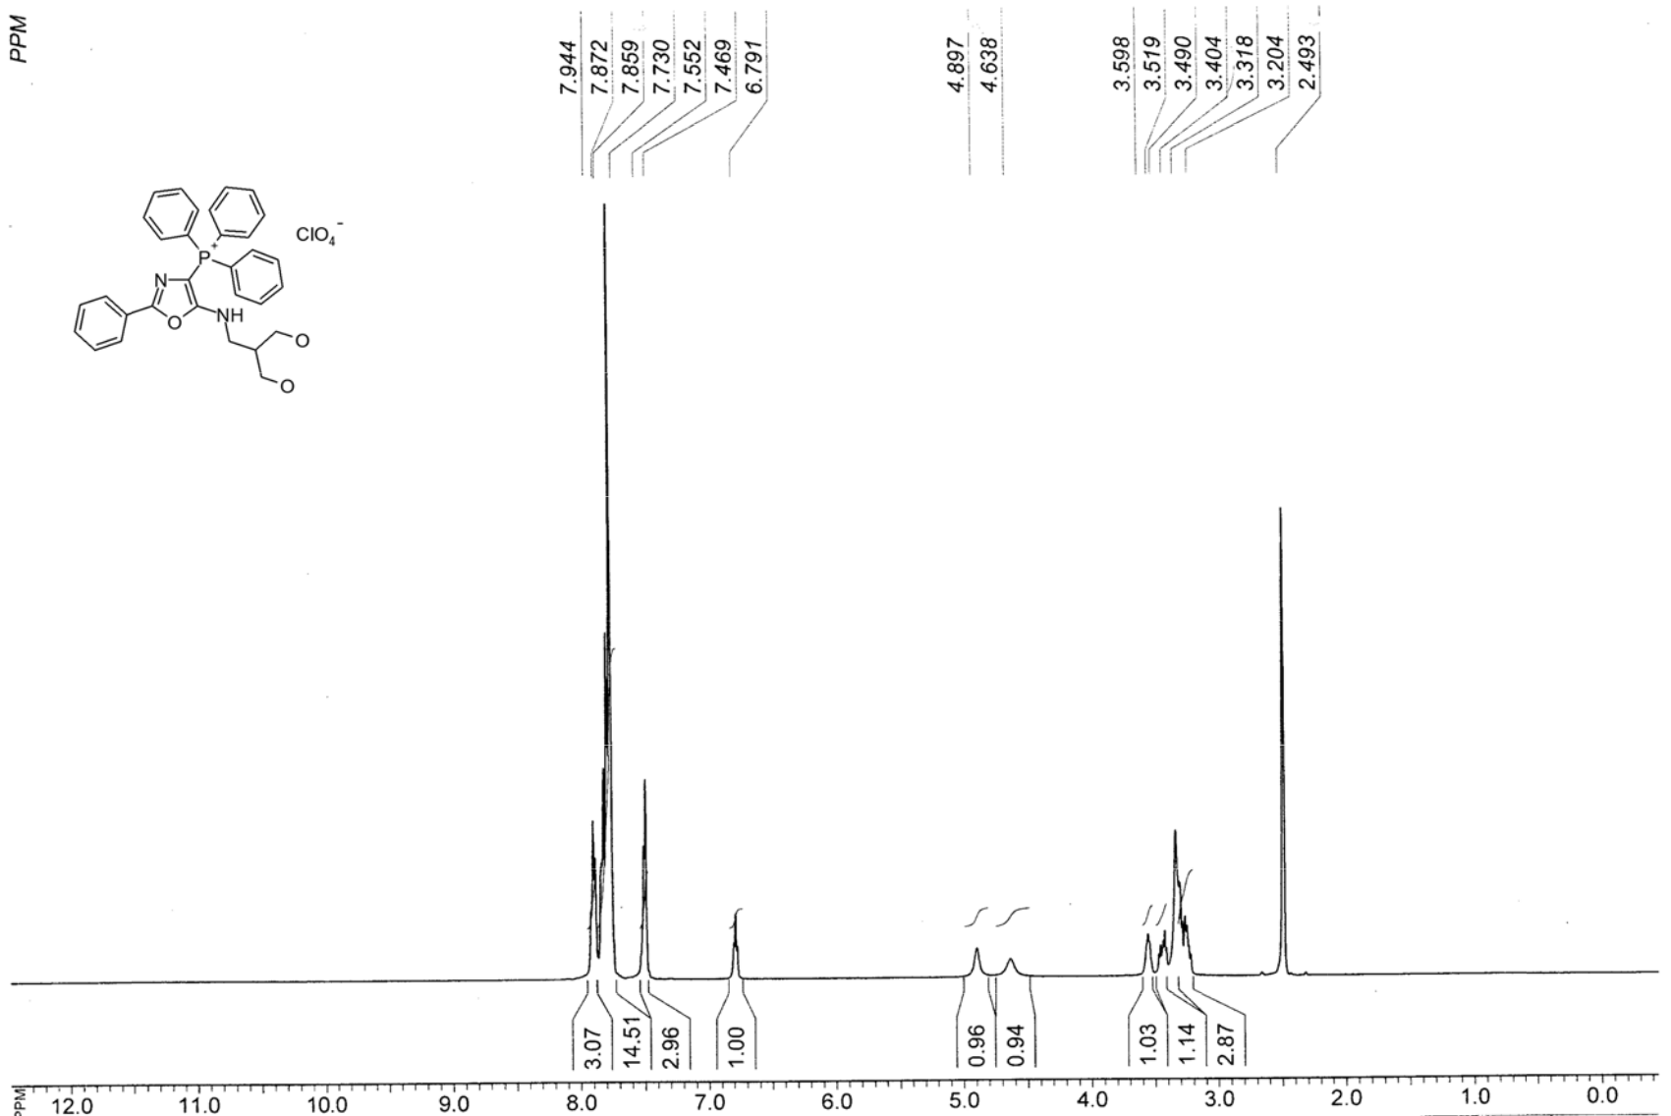

Figure S 22. ¹H NMR spectrum of [5-(2,3-Dihydro ypropyl)amino -2-phenyl-4-oxazolyl]triphenylphosphonium pe rchlorate (3e).

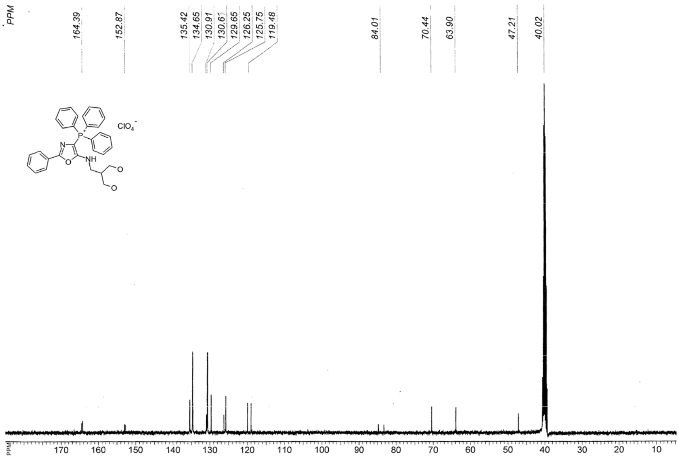

Figure S 23. ¹³C NMR spectrum of [5-(2,3-Dihydroxypropyl)amino -2-phenyl-4-oxazolyl]triphenyl phosphonium perchlorate (3e).

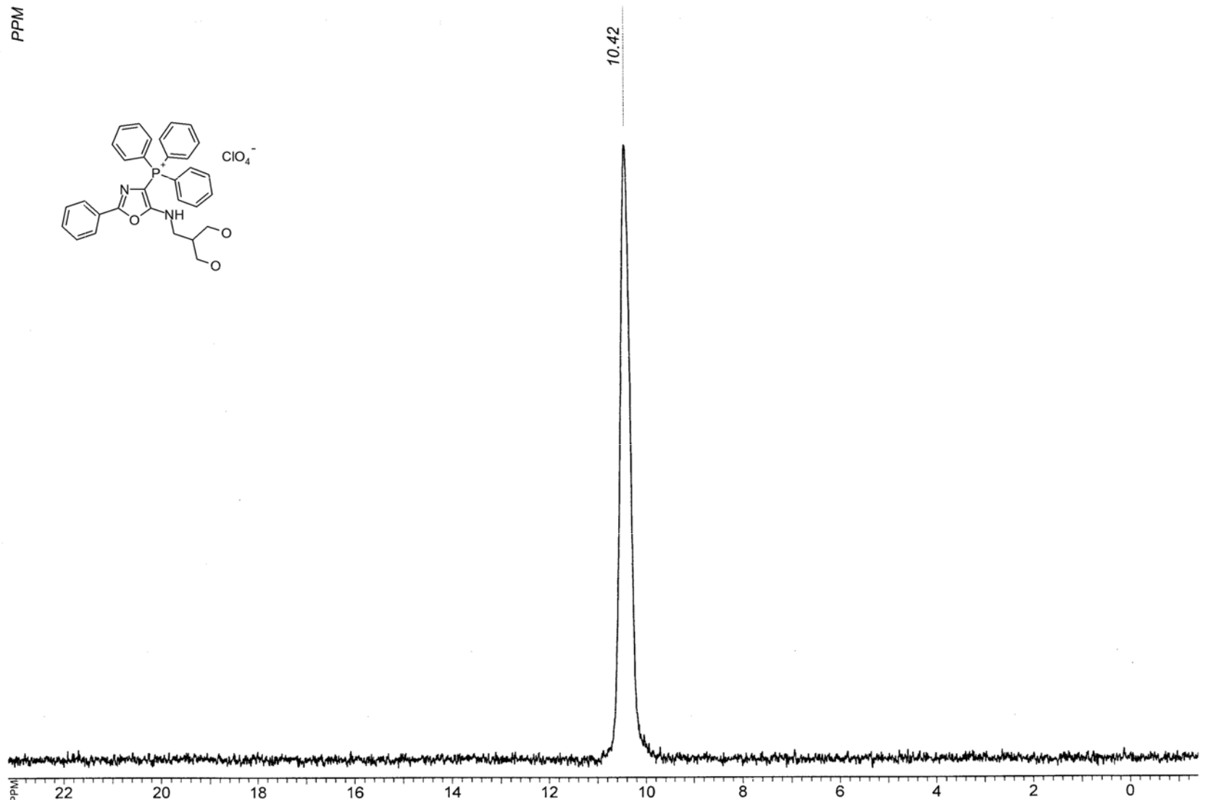

Figure S 24. ³¹P NMR spectrum of 5-(2,3-Dihydroxypropyl)amino-2-phenyl-4-oxazolyl]triphenylphosphonium perchlorate (3e).

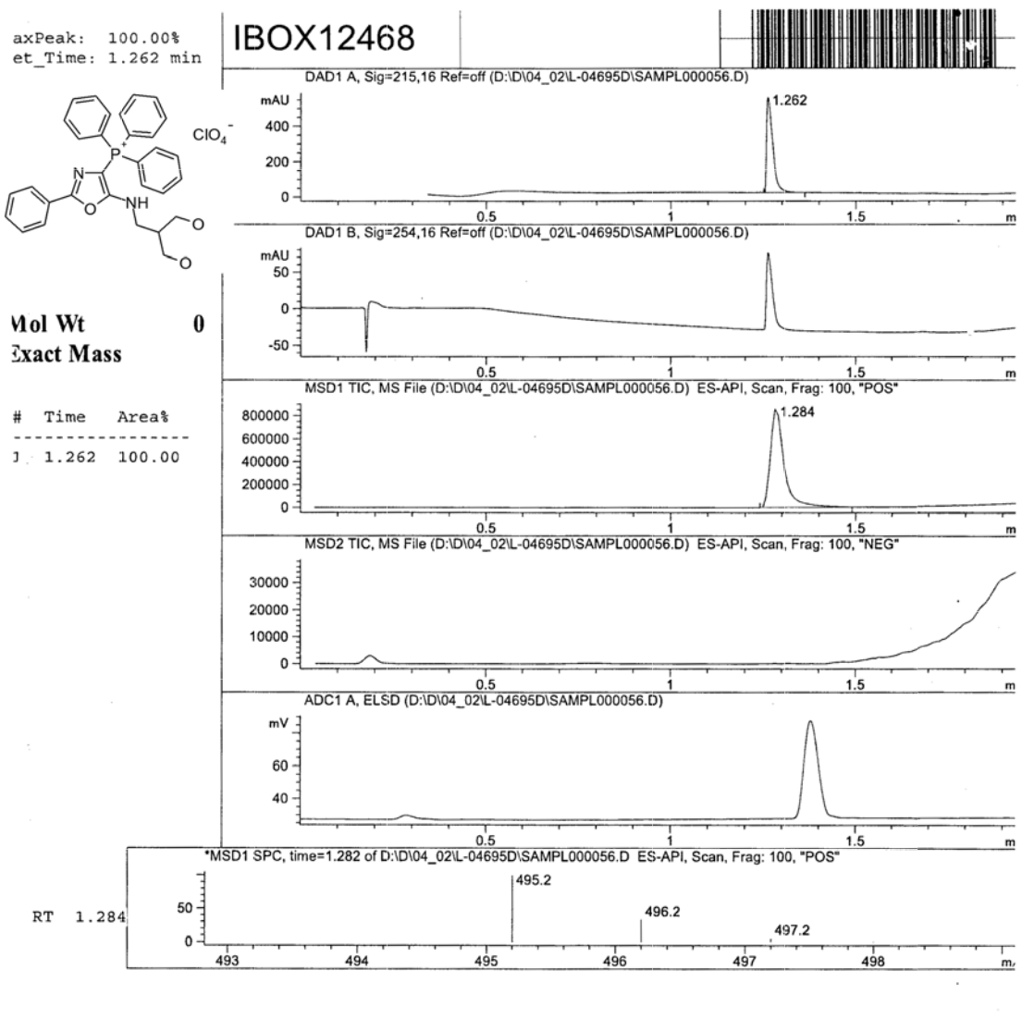

Figure S 25. LCMS analysi s report of [5-(2,3-Dihydroxypropyl)amino- 2-phenyl-4 oxazolyl]triphe ylphosphonium perchlorate (3e).

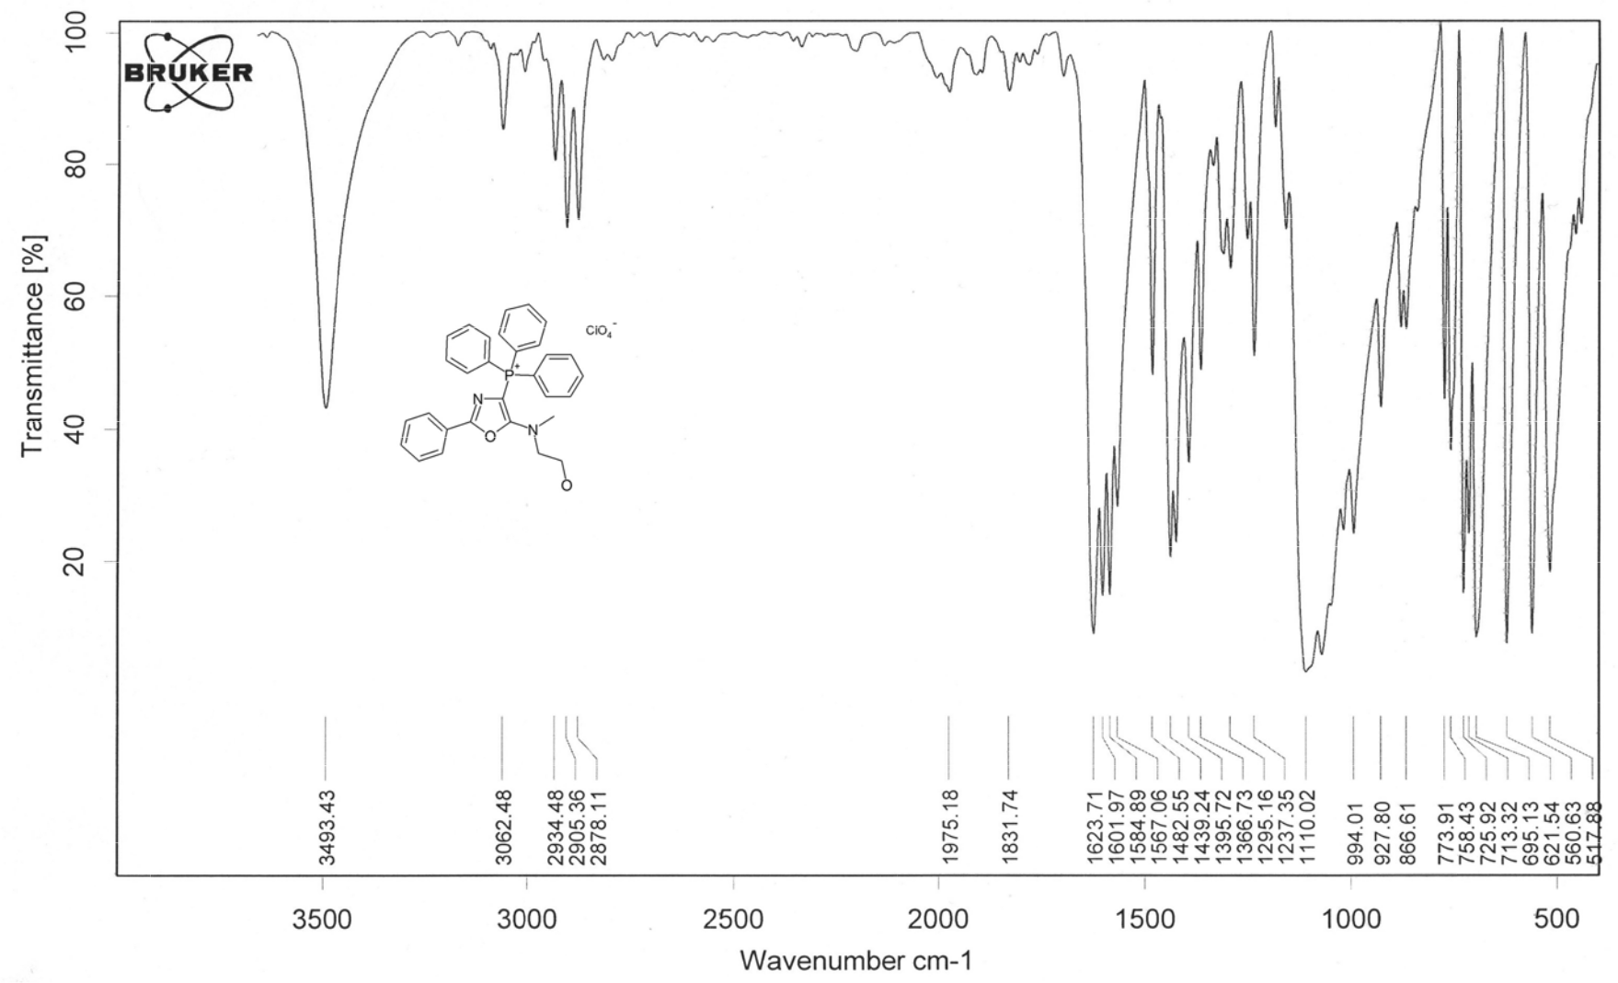

Figure S 26. IR (KB r) spectrum of [5-(2-Hydroxyethyl)methylamino-2-phenyl-4-oxazolyl]triphenylphosphonium perchlorate (3f).

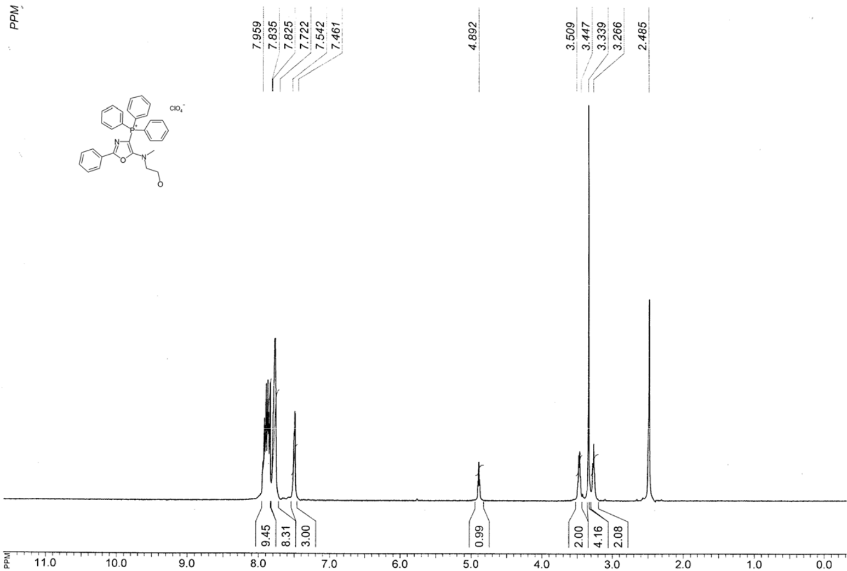

Figure S 27. ¹H NMR spectrum of [5-(2-Hydroxyethyl)methylamino-2-phenyl-4-o azolyl]triphenylphosphonium perchlorate (3f).

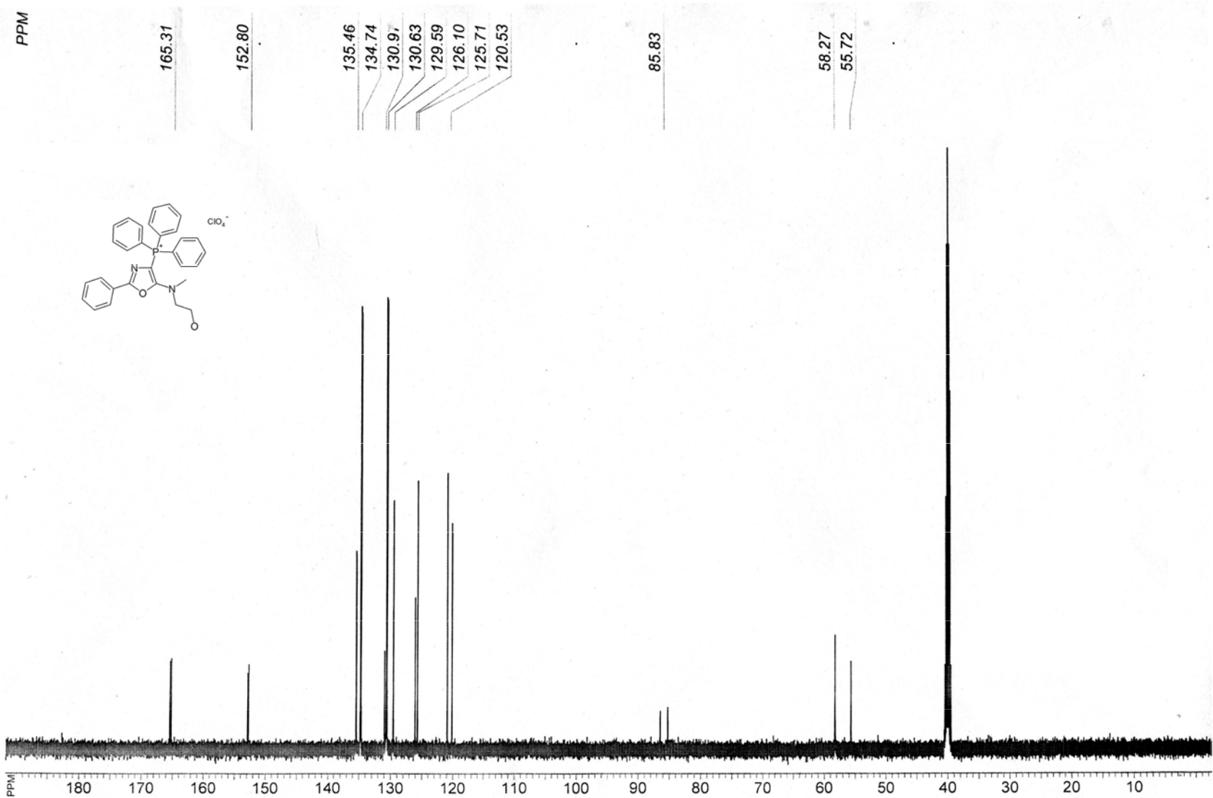

Figure S 28. ¹³C NMR spectrum of [5-(2-Hydroxyethyl)methylami no-2-phenyl-4-oxazolyl]triphenylphosphonium perchlorate (3f).

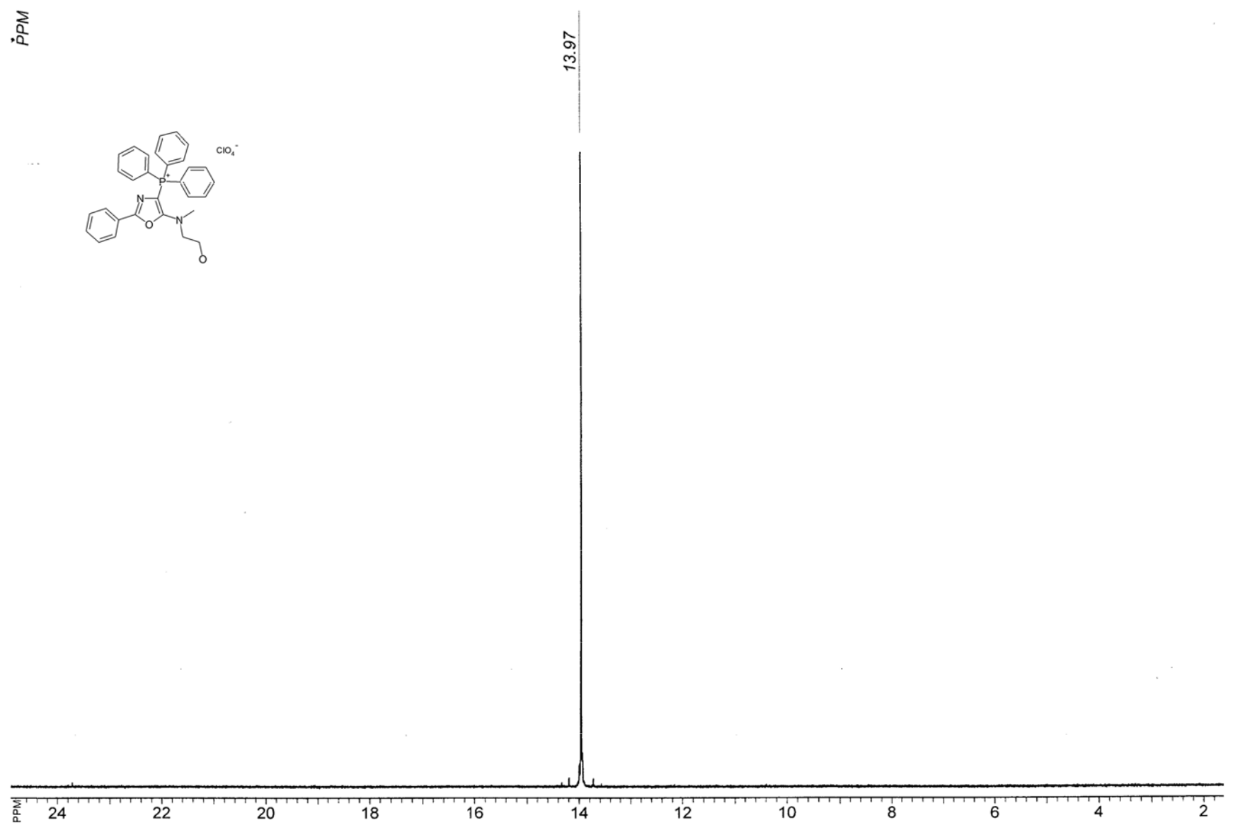

Figure S 29. ³¹P NMR spectrum of 5-(2-Hydroxyethyl)methylamin o-2-phenyl-4-o xazolyl]triphenylphosphonium perchlorate (3f).

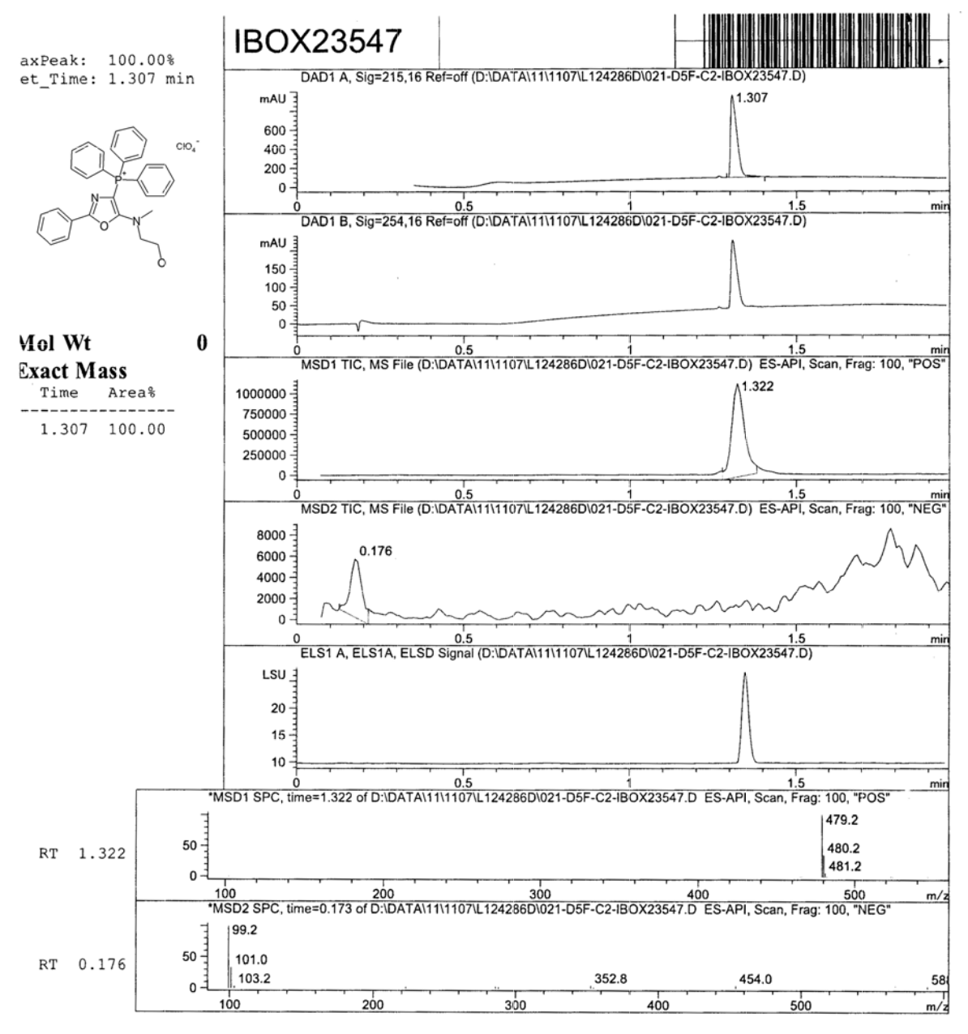

Figure S 30. LCMS analysi s report of [5-(2-Hydroxyethyl)methylamino-2-phenyl- 4-oxazolyl]tripheylphosphonium perchlorate (3f).

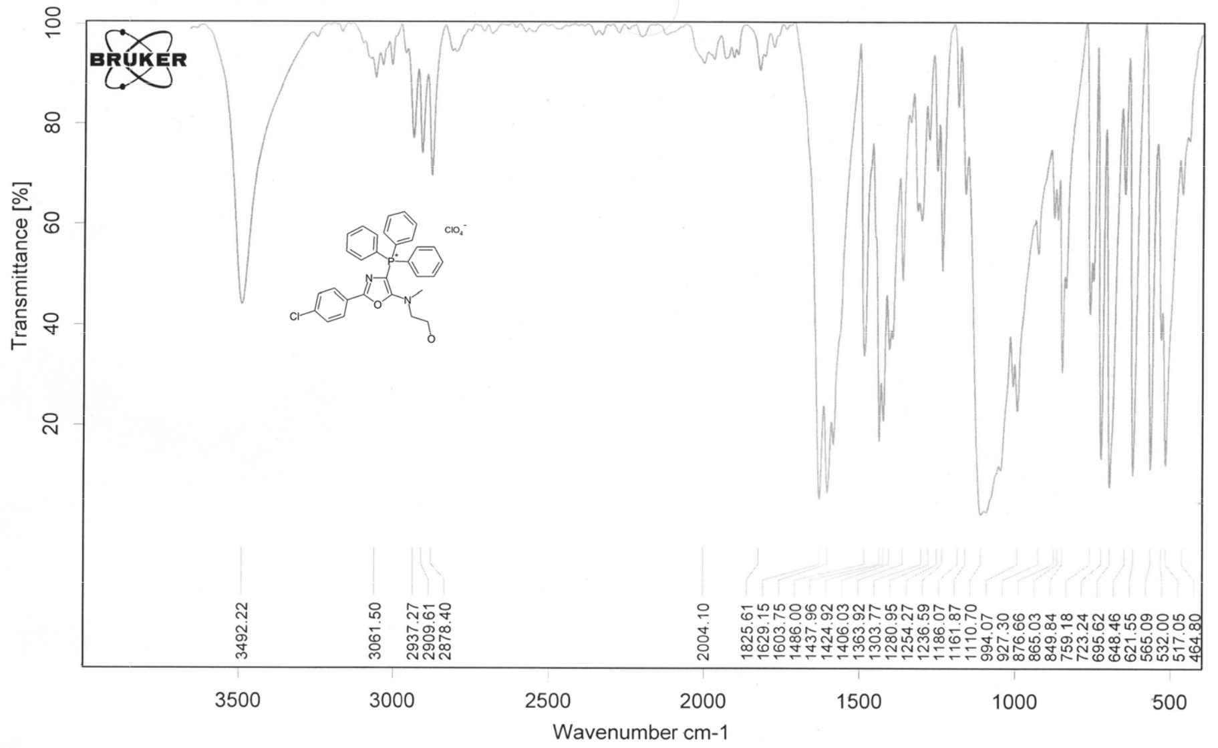

Figure S 31. IR (KB r) spectrum of [2-(4-Chlorophenyl)-5-(2-hydro xyethyl)methylamino-4-oxazoly l]triphenylphosphonium perchlorate (3h).

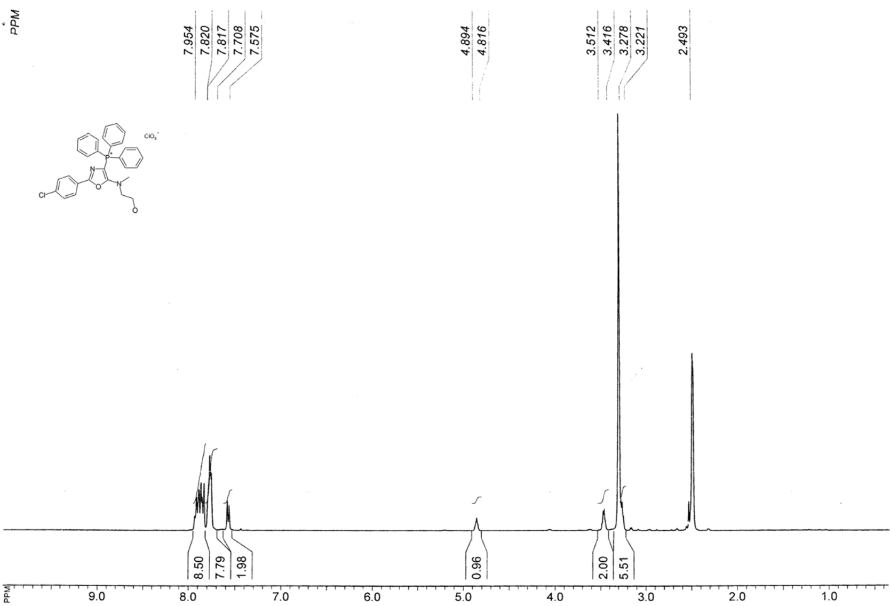

Figure S 32. ¹H NMR spectrum of [2-(4-Chlorophe nyl)-5-(2-hydro xyethyl)methylamino-4-oxazolyl]triphenylphosphonium perchl orate (3h).

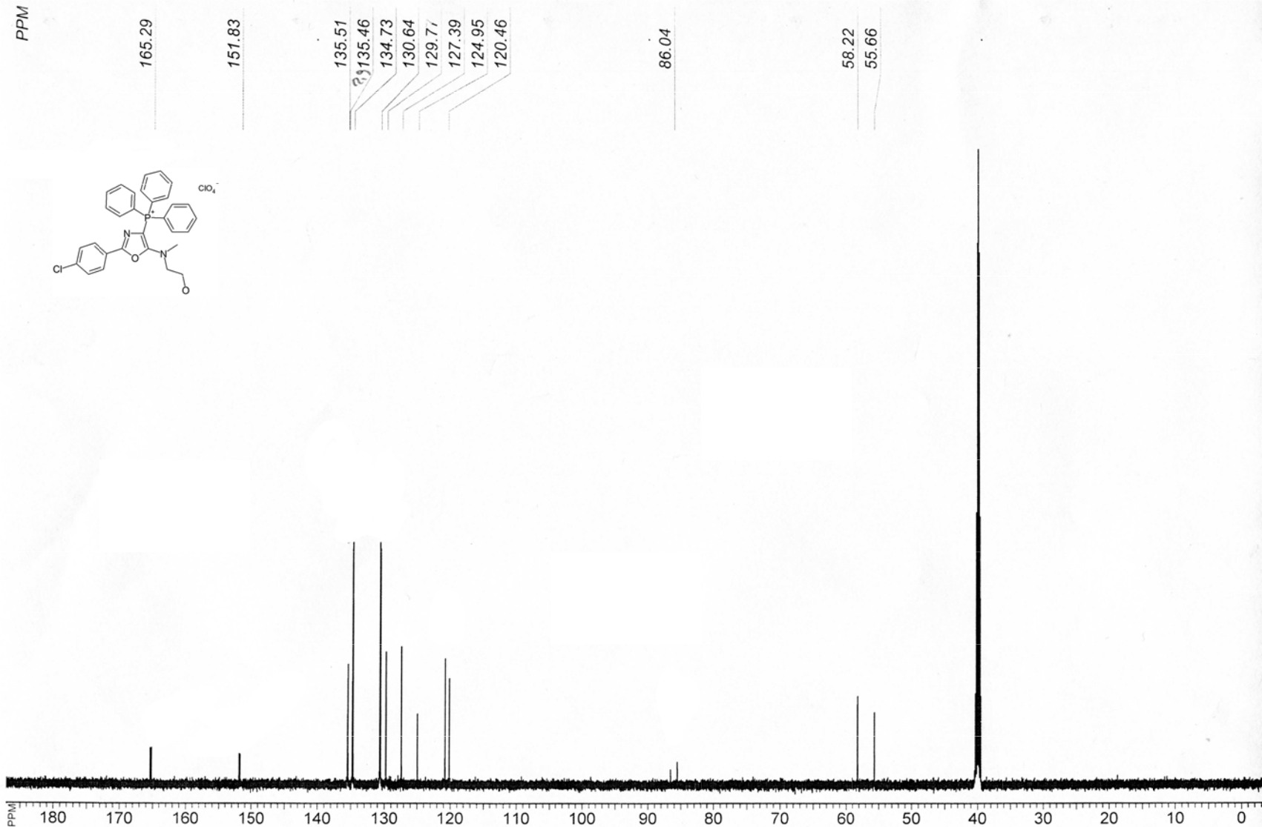

Figure S 33. ¹³C NMR spectrum of [2-(4-Chlorophe nyl)-5-(2-hydro xyethyl)methyl amino-4-oxazol yl]triphenylphosphonium perchlorate (3h).

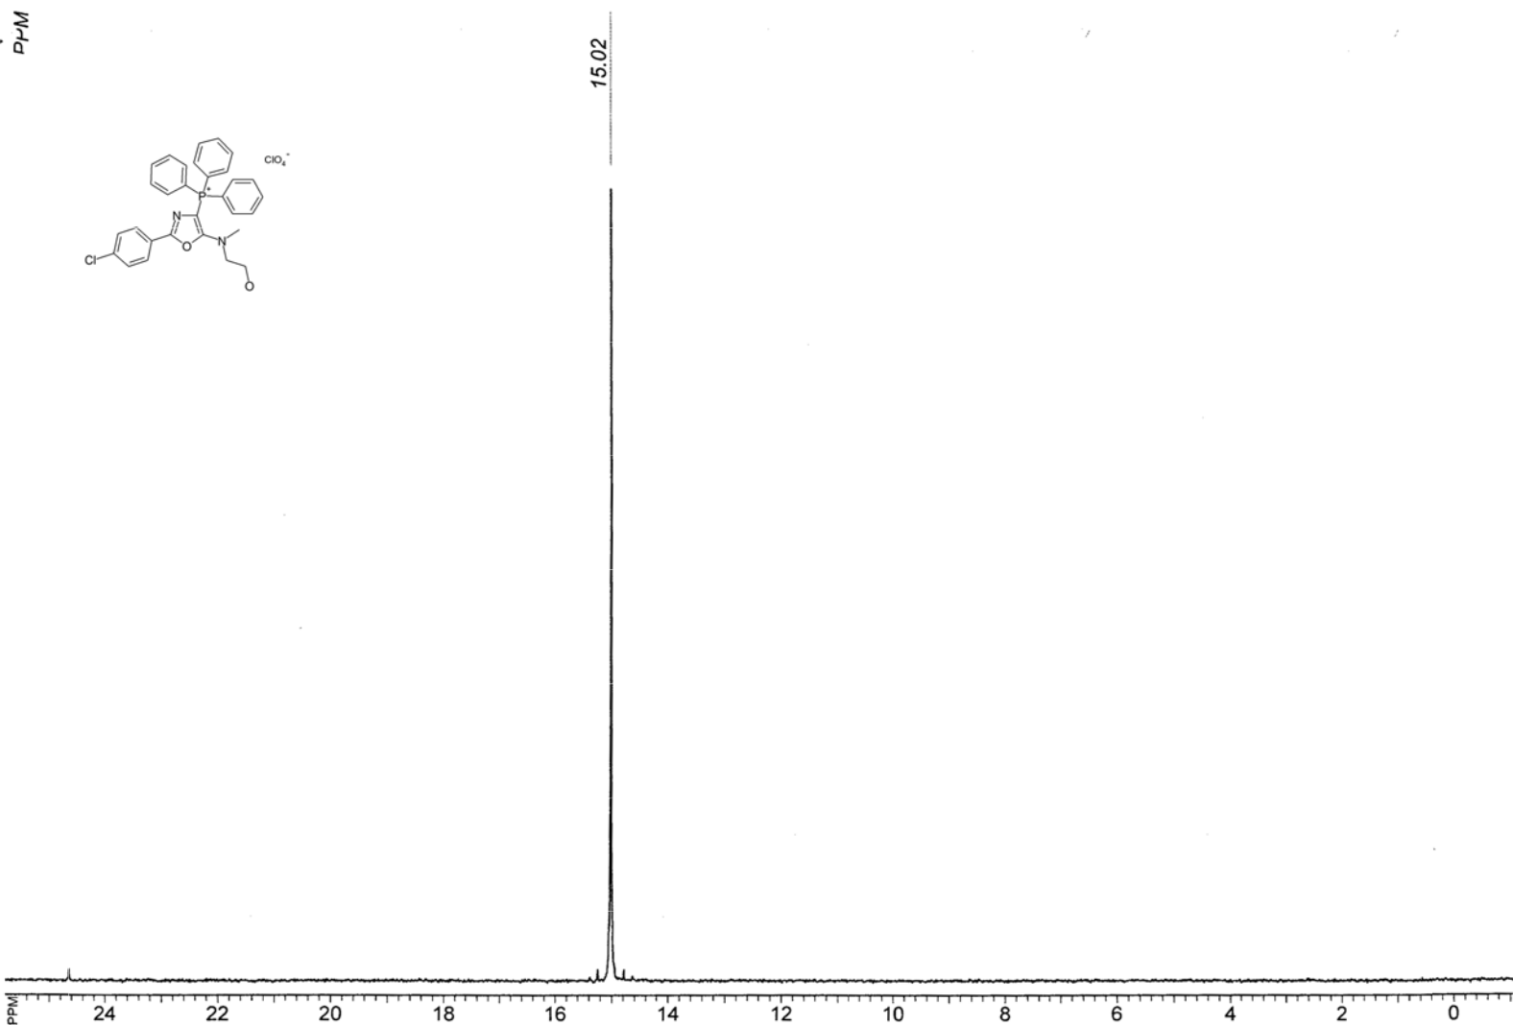

Figure S 34. ³¹P NMR spectrum of 2-(4-Chlorophenyl)-5-(2-hydroxyethyl)methyl mino-4-oxazol l]triphenylphosphonium perchlorate (3h).

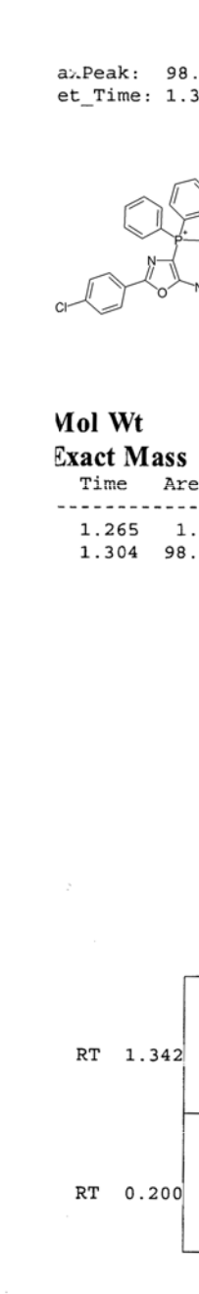

Figure S 35. LC oxazolyl]triphe нydroxyethyl)m

-MS analy is report of [2-(4 -Chlo rophenyl)- 5-(2-hydrox yethyl)methylamino-4 - ylphosphonium perchlorate [2-(4-chlorophe yl) -5-[(2-ethylamino ]-4-oxazol yl]triphenyl-phosphonium perchlorate (3h).
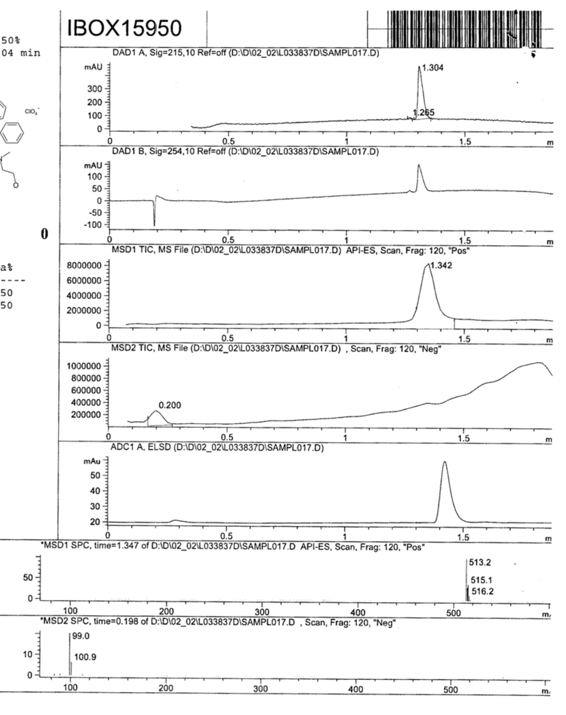

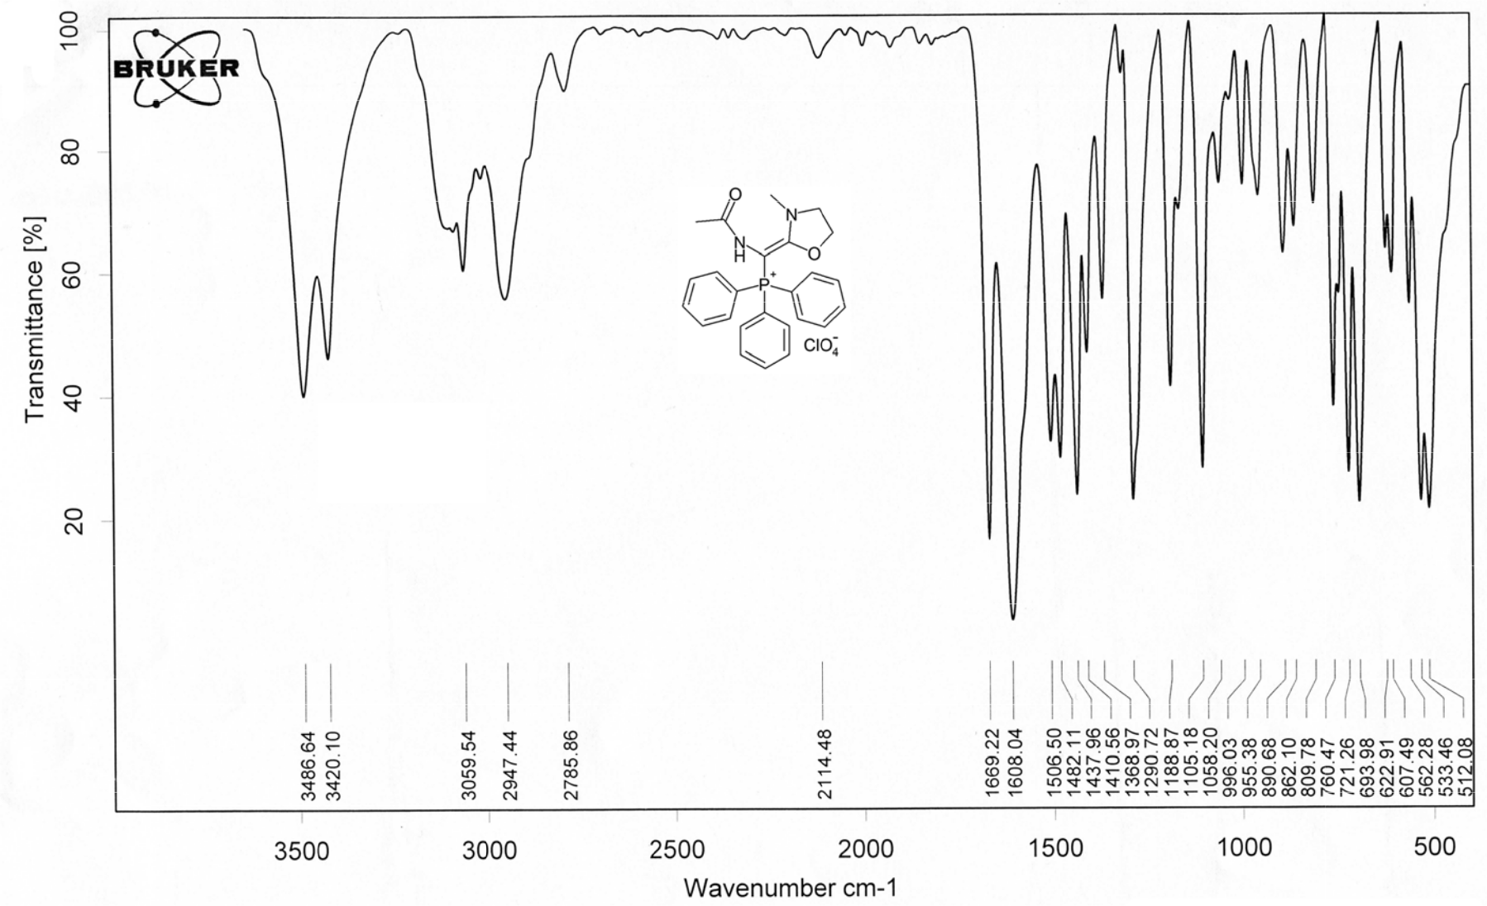

Figure S 36. IR (KBr) spectr um of [Acetyla mino-(3-methyl 1,3-oxazolidin-2-ylidene)methy l]triphenylphosphonium perchlorate (5a).

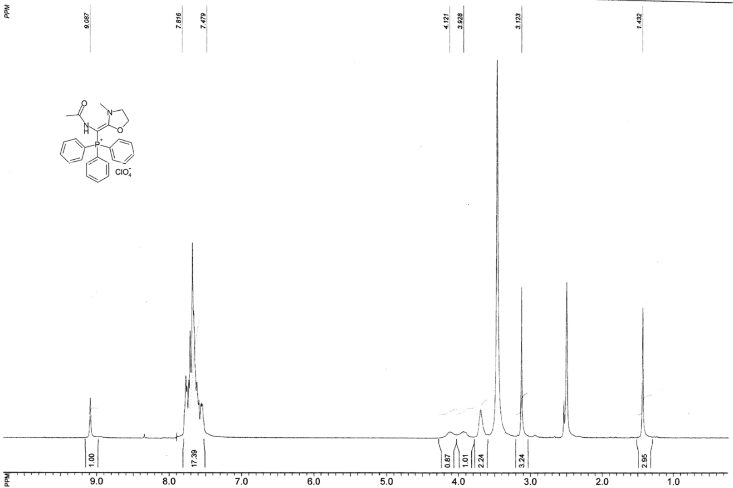

Figure S 37. ¹H NMR spectrum of [Acetylamino-(3-methyl-1,3-oxa zolidin-2-ylide e)methyl]triphenylphosphonium perchlorate (5a).

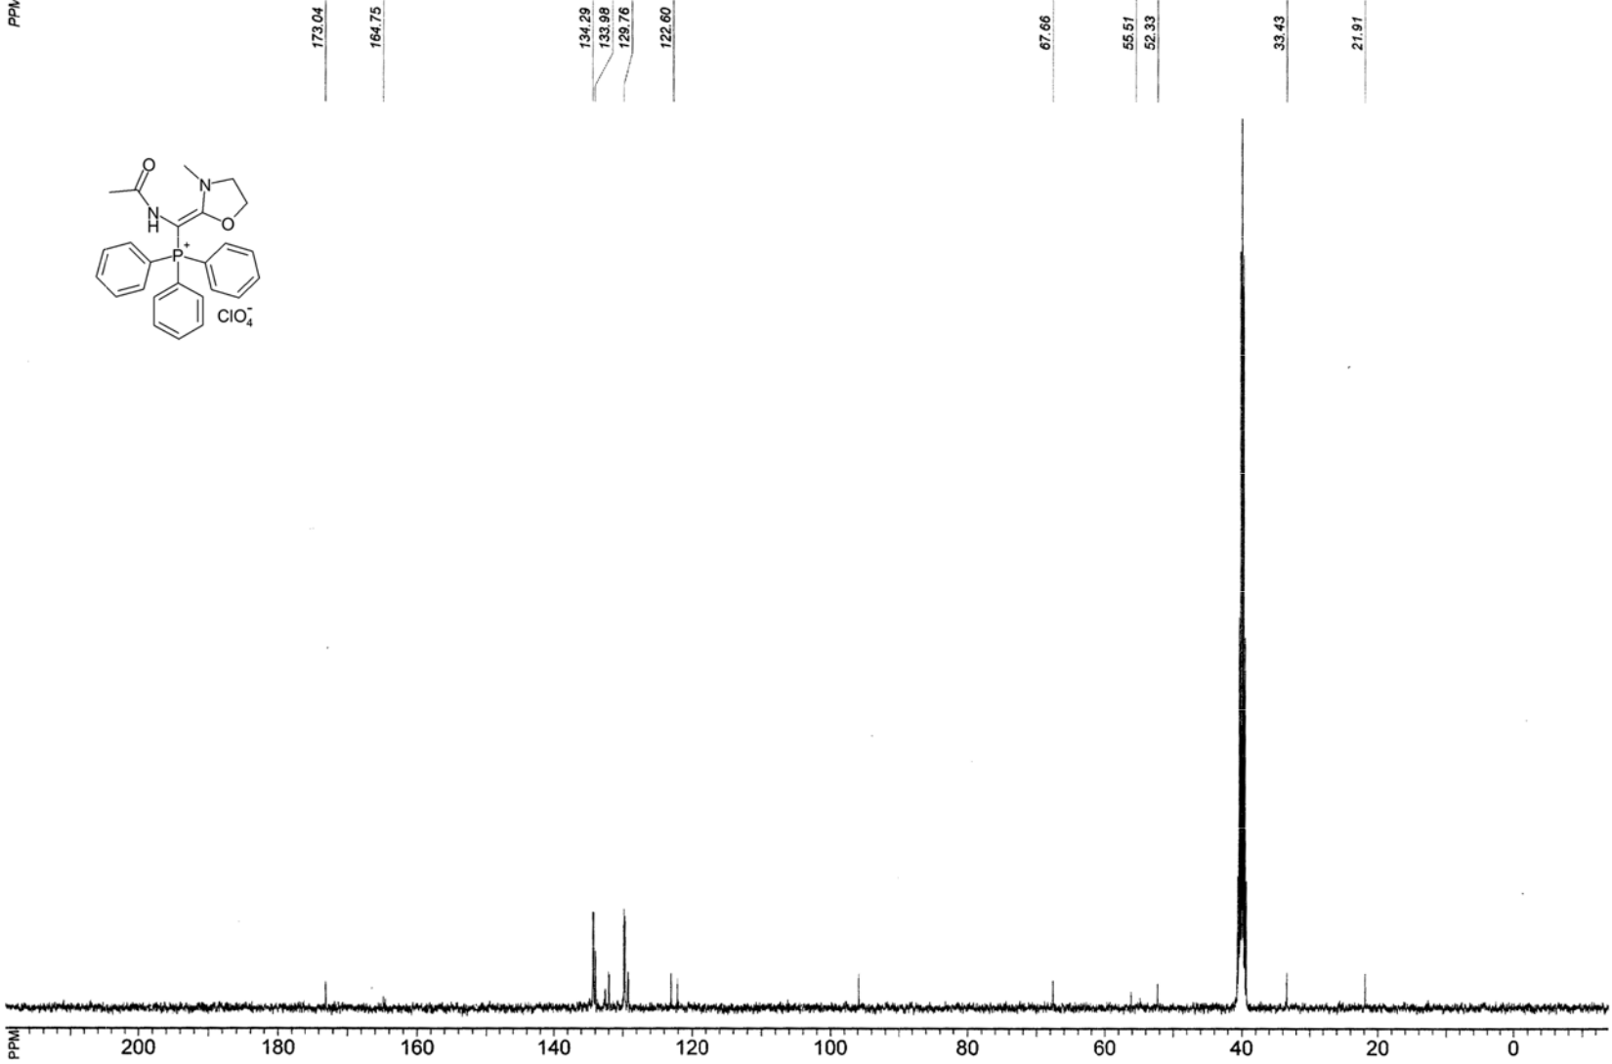

Figure S 38. ¹³C NMR spectrum of [Acetylamino-( 3-methyl-1,3-oxazolidin-2-ylidene)methyl]triphenylphosphonium perchlorate ( a).

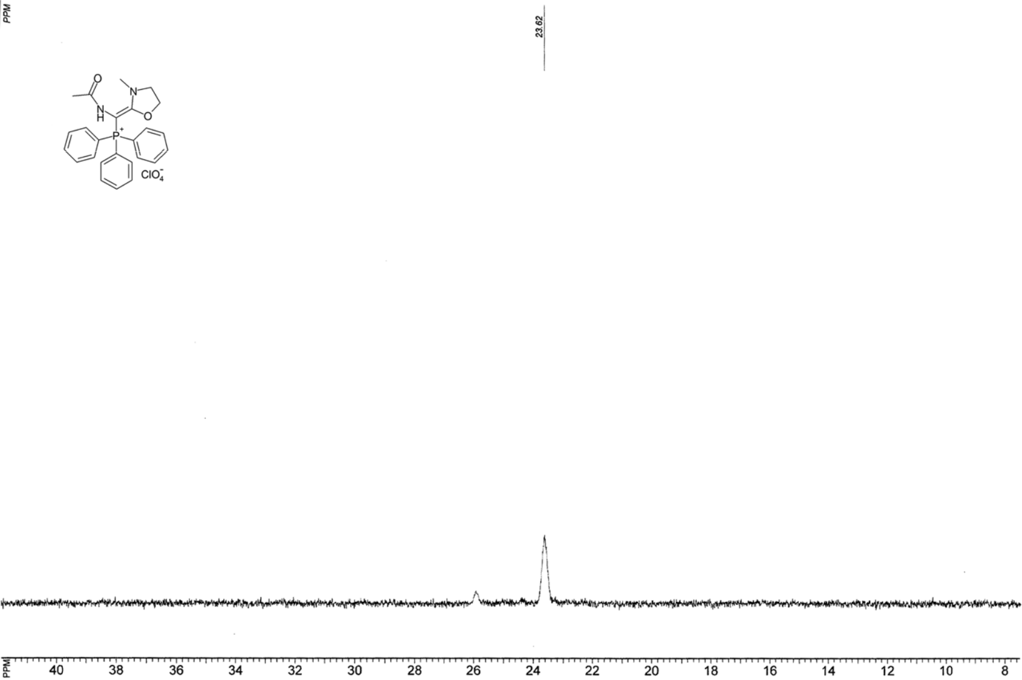

Figure S 39. ³¹P NMR spectrum of Acetylamino-(3 -methyl-1,3-ox azolidin-2-ylidene)methyl]triphenylphosphonium perchlorate (5 a).

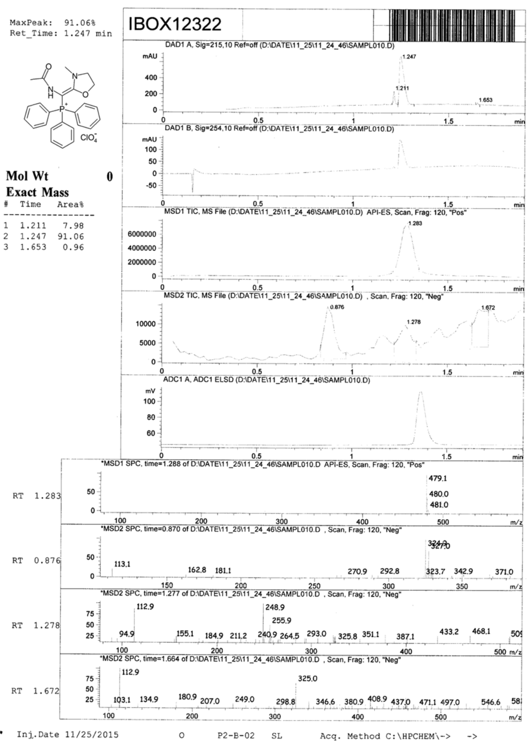

Figure S 40. LC-MS analysis report of [Acetyl amino-(3- methyl-1,3-oxazolidin-2 - yl dene)meth yl]triphenyl phosphoni m perchlorate (5a).

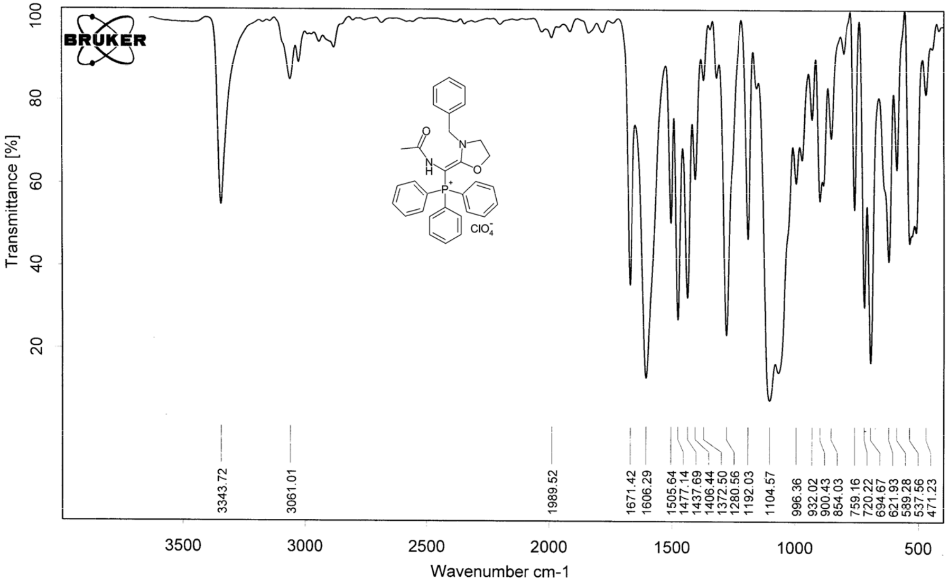

Figure S 41. IR (KBr) spectr um of [Acetyla mino-(3-benzyl-1,3-oxazolidin- 2-ylidene)methyl]triphenylphos phonium perchlorate (5b).

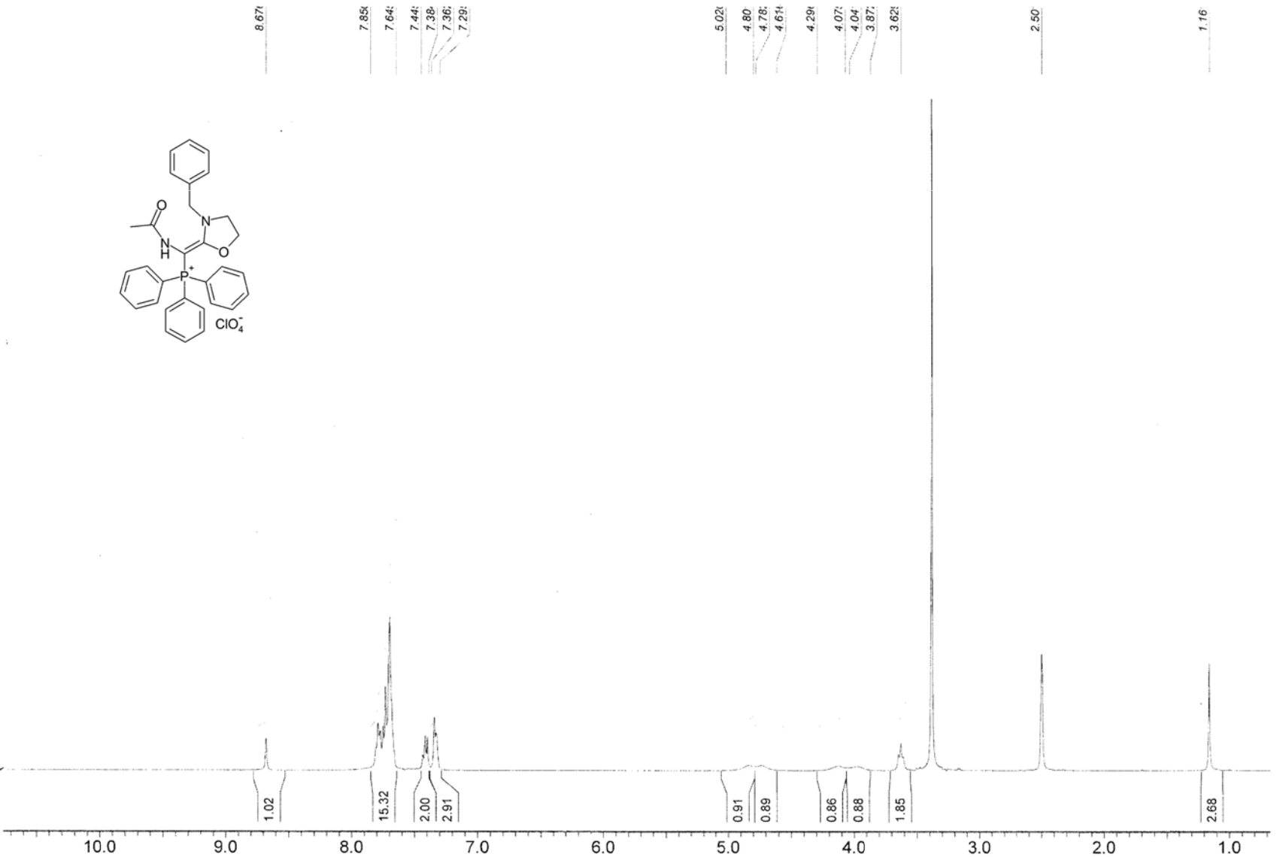

Figure S 42. ¹H NMR spectrum of [Acetyla mino-(3-benzyl-1,3-oxazolidin- -ylidene)methyl]triphenylphos phonium perchl rate (5b).

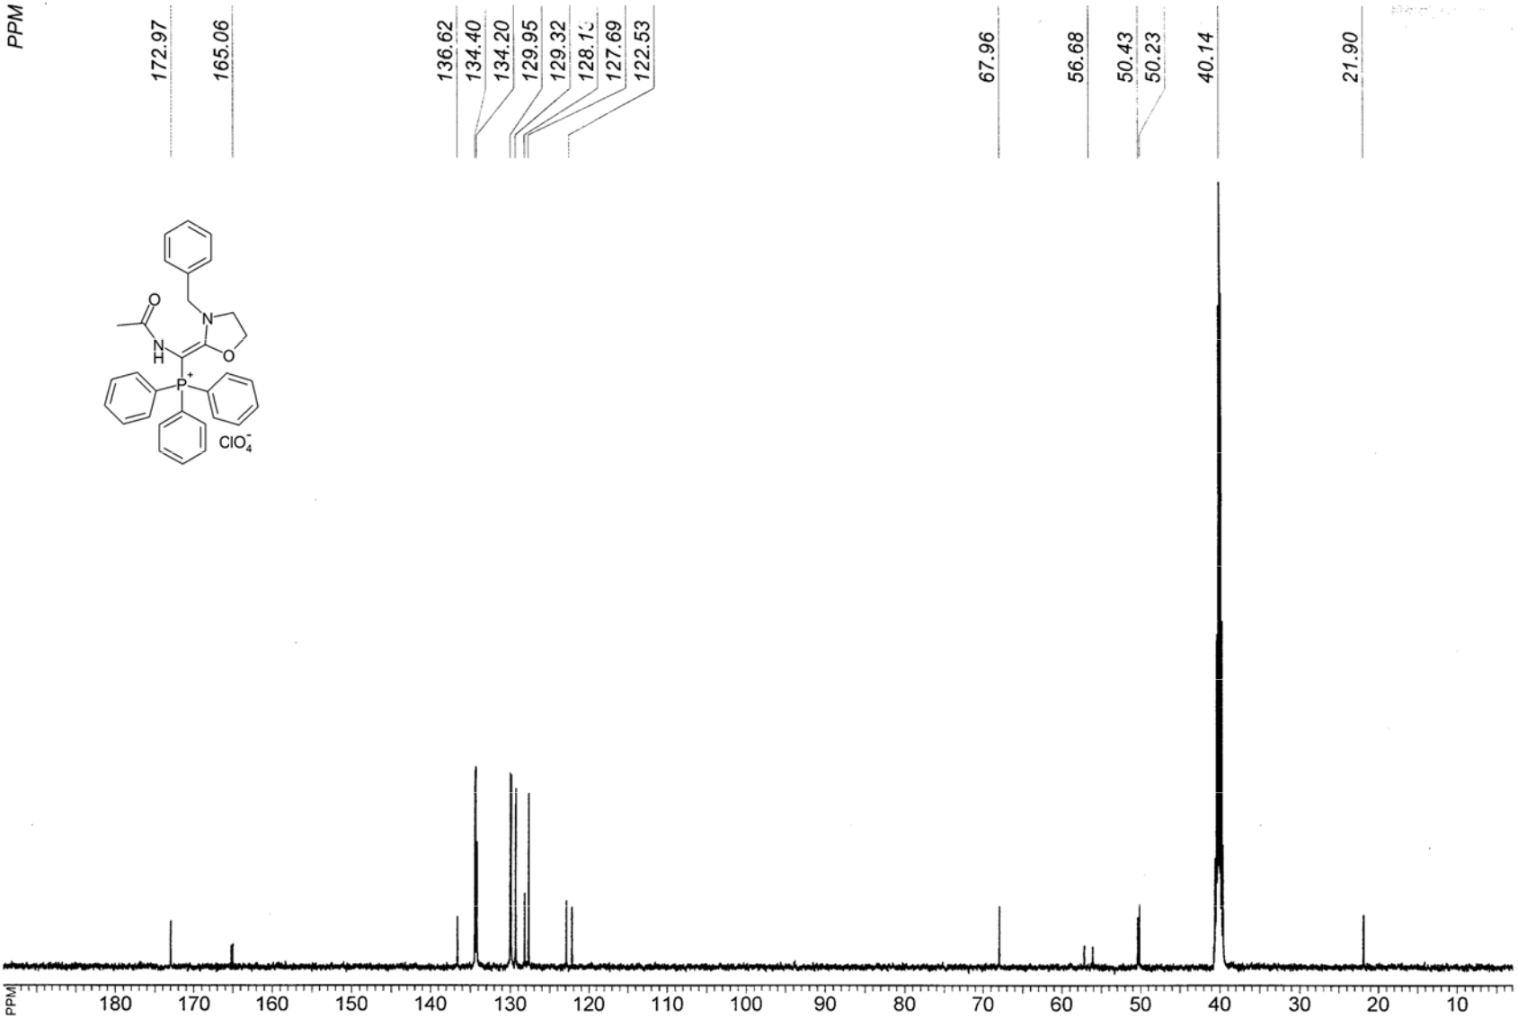

Figure S 43. ¹³C NMR spectrum of [Acetylamino-( 3-benzyl-1,3-ox azolidin-2-ylidene)methyl]triph enylphosphoniu m perchlorate (5 b).

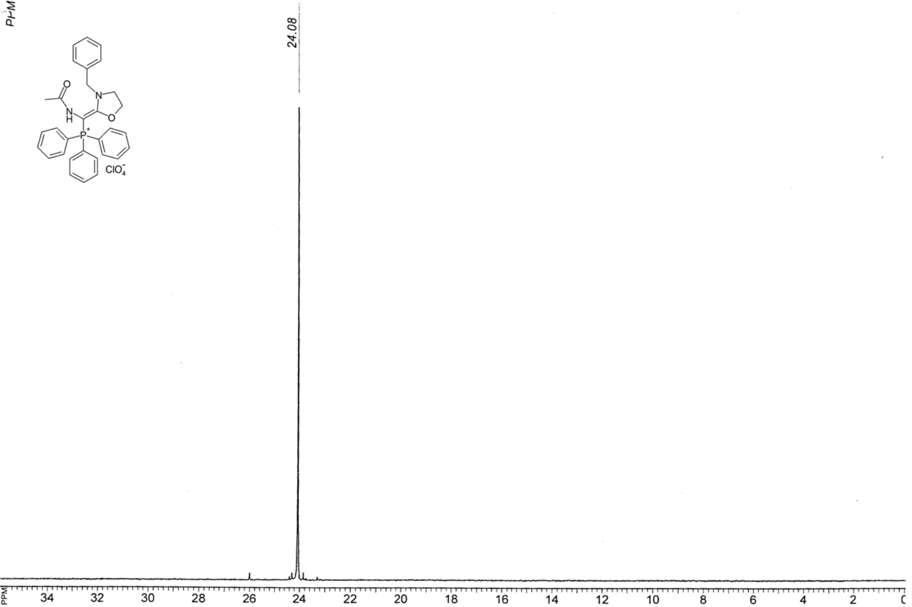

Figure S 44. ³¹P NMR spectrum of Acetylamino-(3 -benzyl-1,3-oxa zolidin-2-ylide e)methyl]triphe nylphosphoniu m perchlorate (5b).

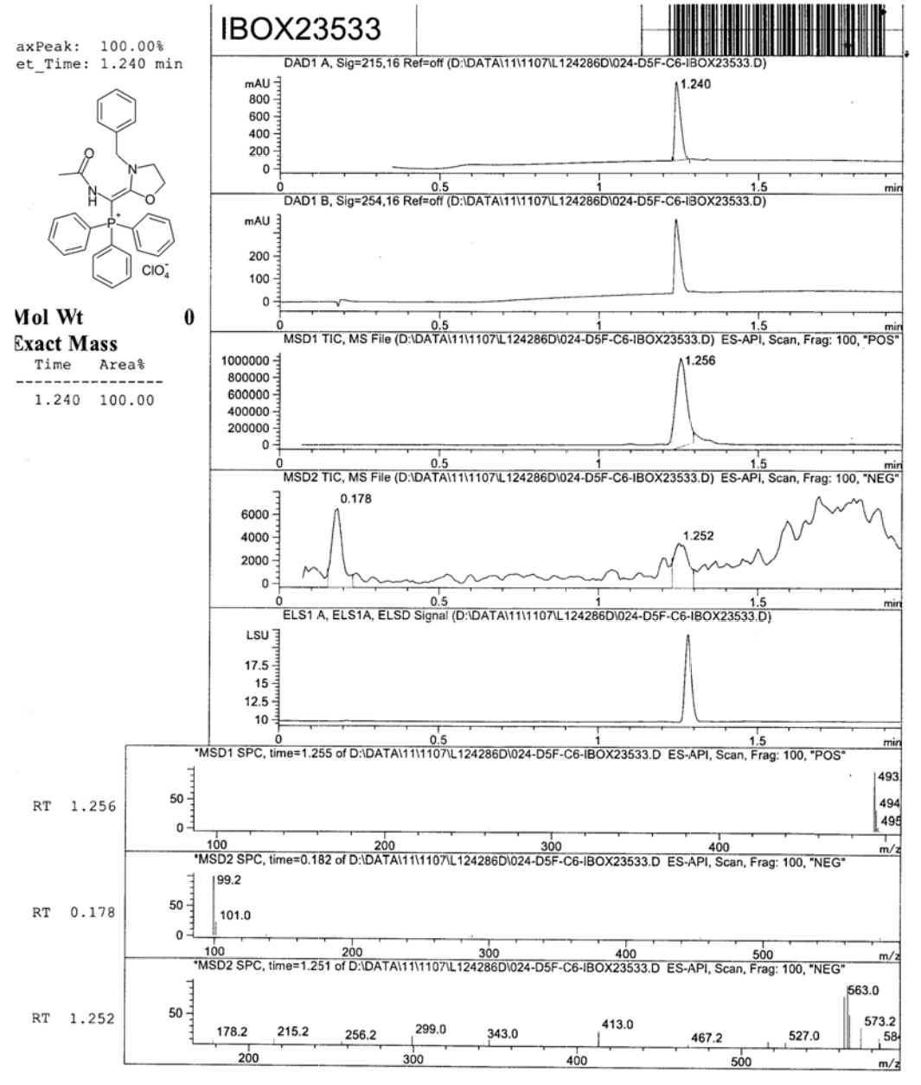

Figur e S45. LC-MS analysis report of [Acetylamino-(3-benzyl -1,3-oxazolidin-2-ylidene)methyl]triphenylphosphoniu perchlorate (5b).

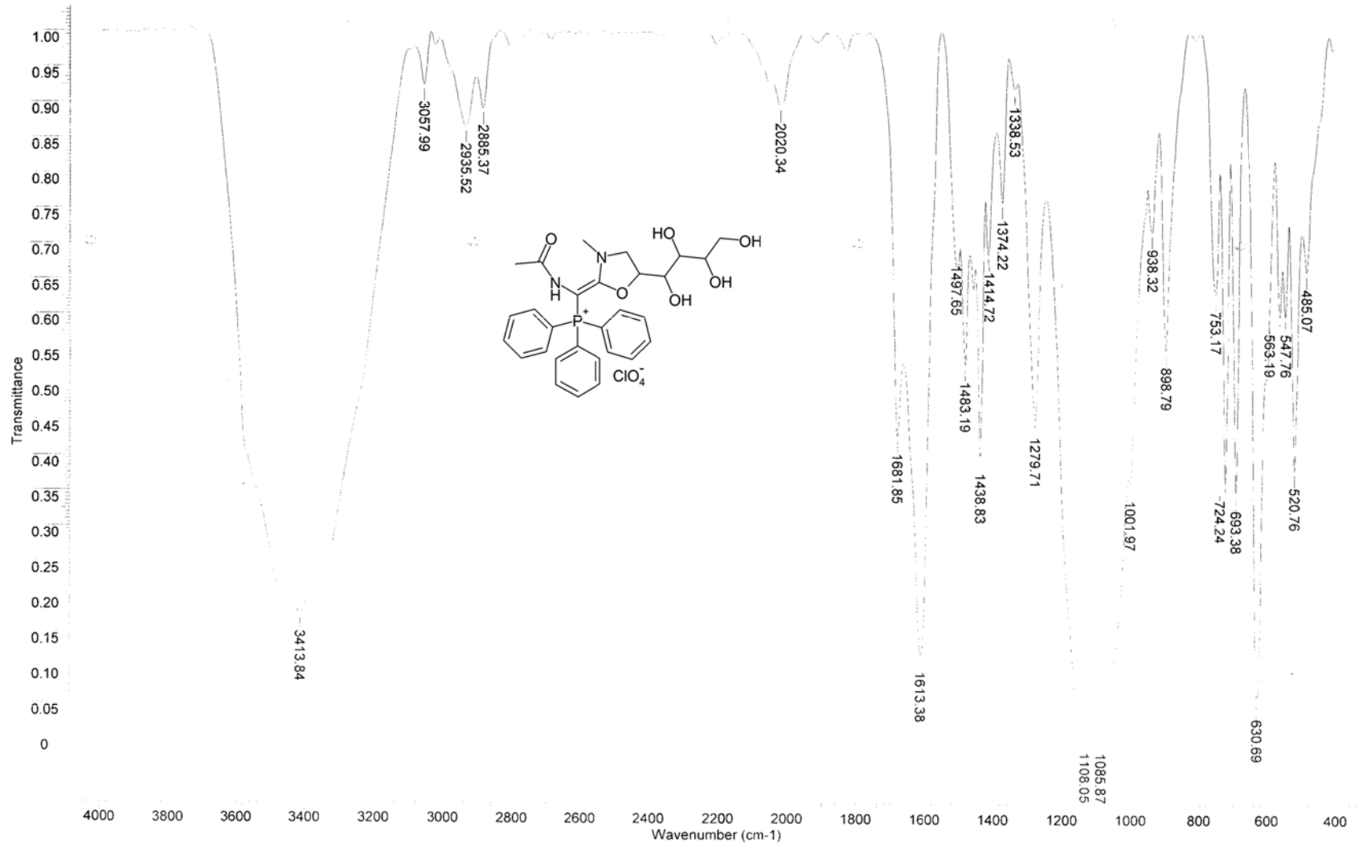

Figure S 46. IR (KBr) spectr um of {Acetylamino-[3-methyl-5-((1S,2R,3S)-1,2,3,4-tetrahydroxybutyl)-1,3-o xazolidin-2-ylidene]met hyl}triphenylph osphonium perchlorate (5c).

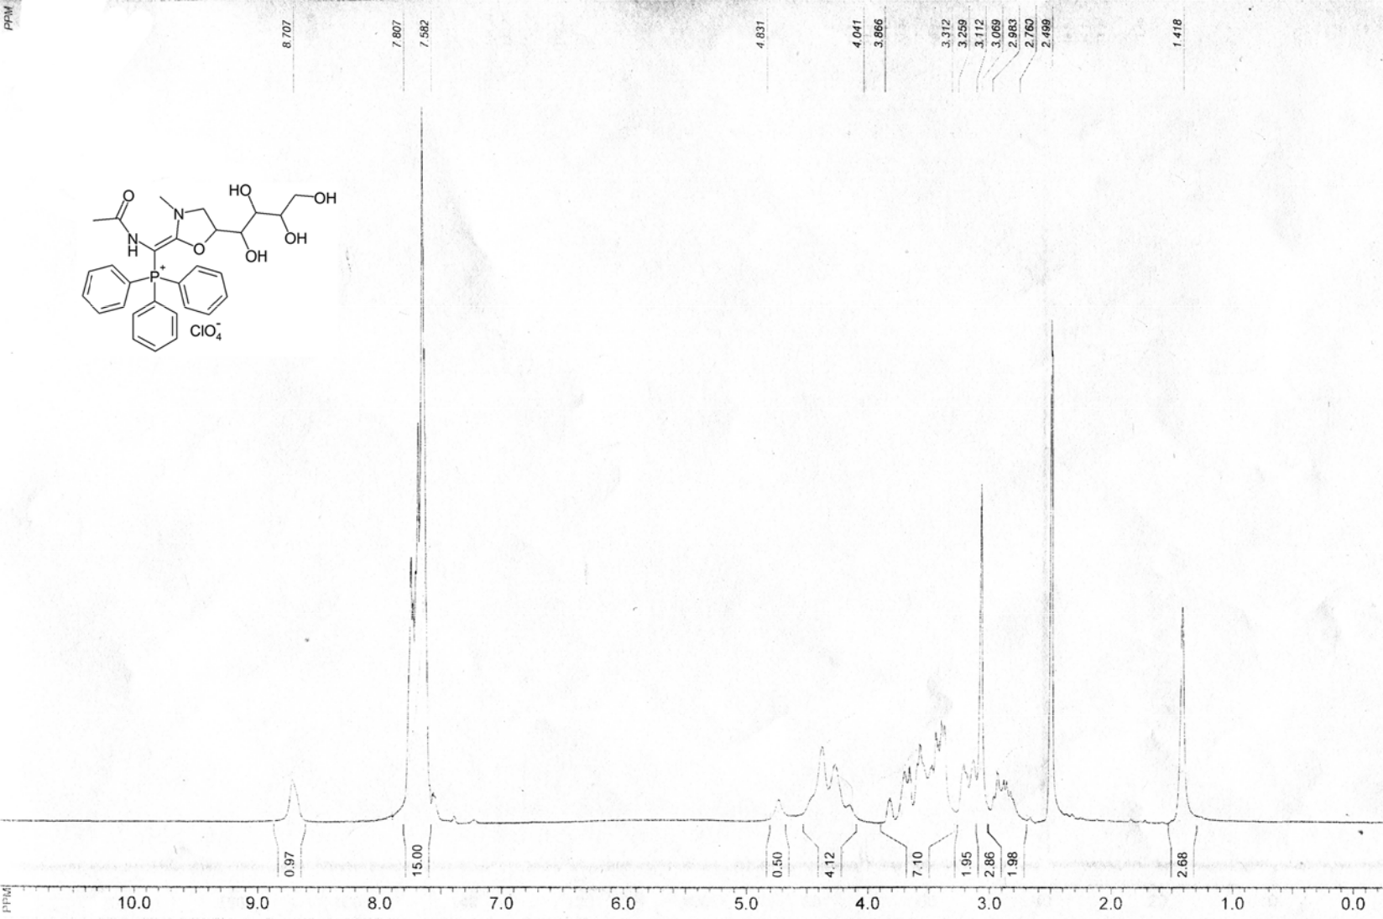

Figure S 47. ¹H NMR spectrum of { Acetylamino-[3 -methyl-5-((1S,2R,3S)-1,2,3,4-tetrahydroxybutyl)-1,3-oxazolid in-2-ylidene]methyl}triphenylphosphonium perchlorate (5c).

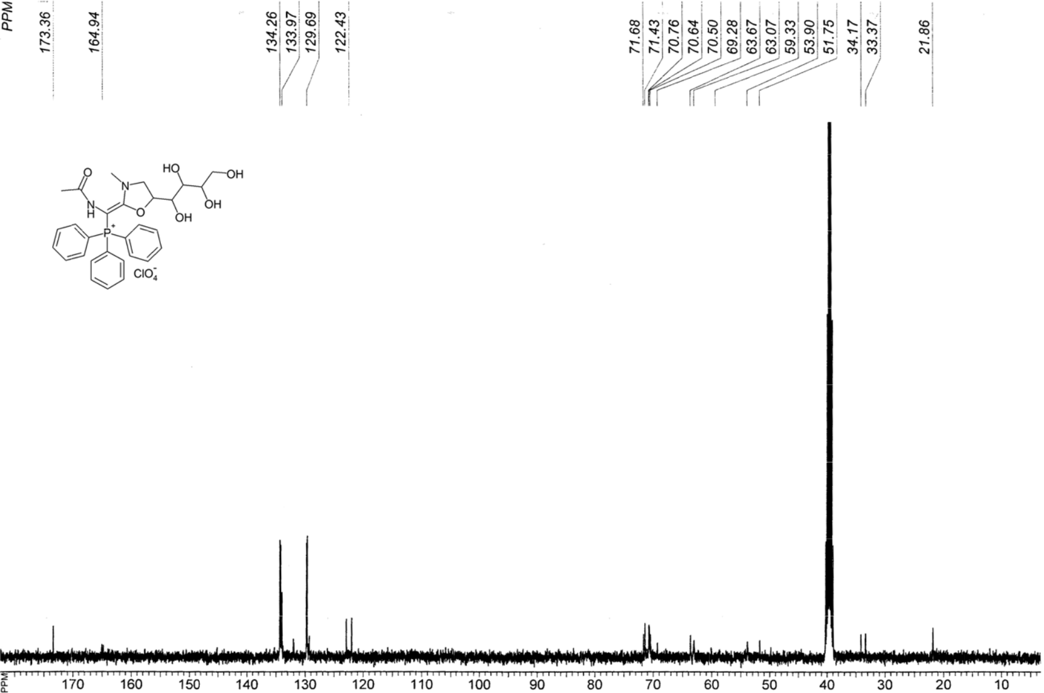

Figure S 48. ¹³C NMR spectrum of {Acetylamino-[3-methyl-5-((1S ,2R,3S)-1,2,3,4-tetrahydroxybutyl)-1,3-oxazoli din-2-ylidene]methyl}triphenylphosphonium perchlorate (5c).

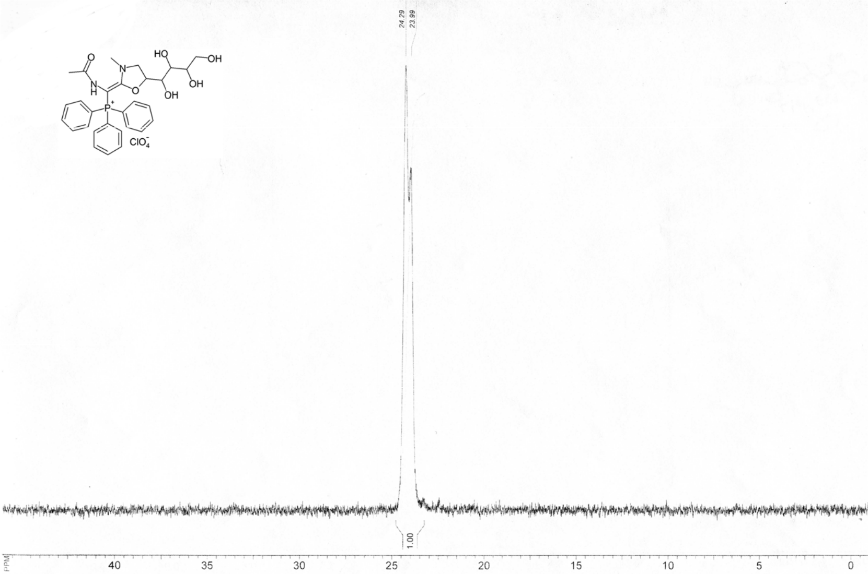

Figure S 49. ³¹P NMR spectrum of {Acetylamino-[ 3-methyl-5-((1S,2R,3S)-1,2,3,4-tetrahydroxybu yl)-1,3-oxazoli in-2-ylidene]methyl}triphenylphosphonium perchlorate (5c).

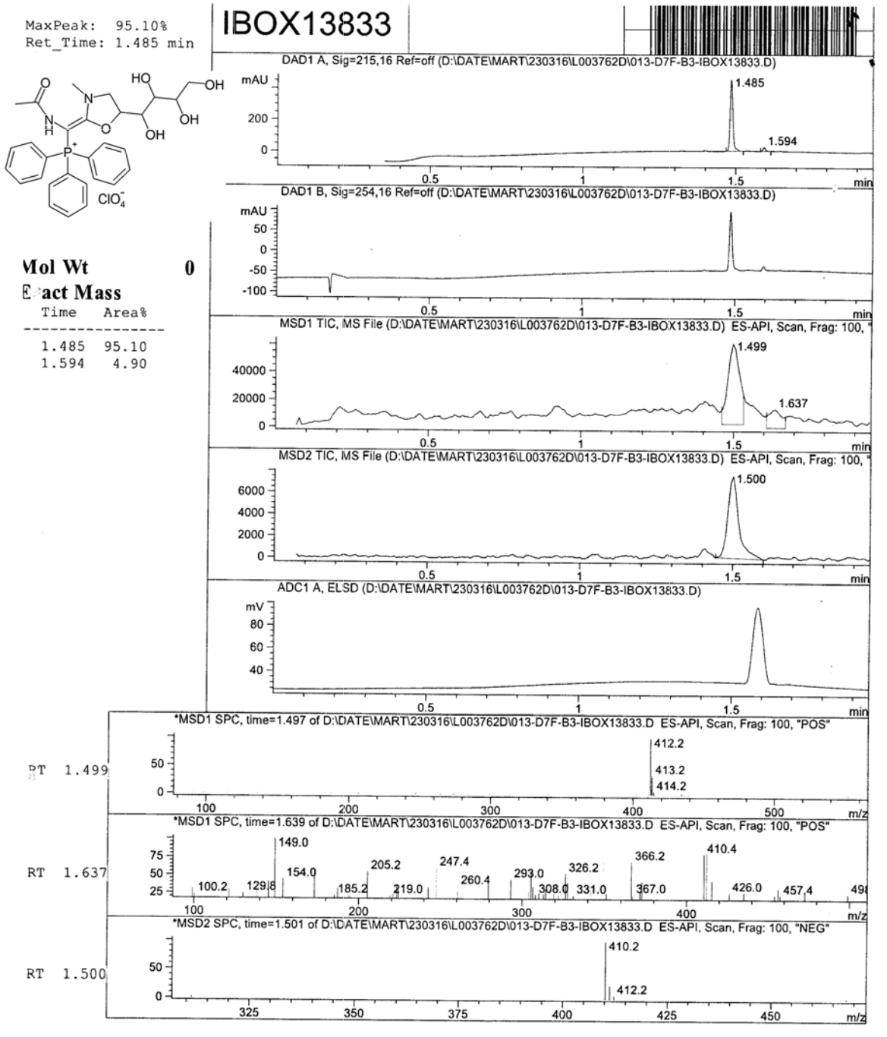

Figure S 50. LC-MS analy is report { Acetylamino-[3-methyl-5-((1S,2R,3S)-1,2,3, 4-

tetrahydroxybutyl)-1,3-oxazolidin-2-ylidene]met hyl}triphenylphosphon ium perchlorate (5c).

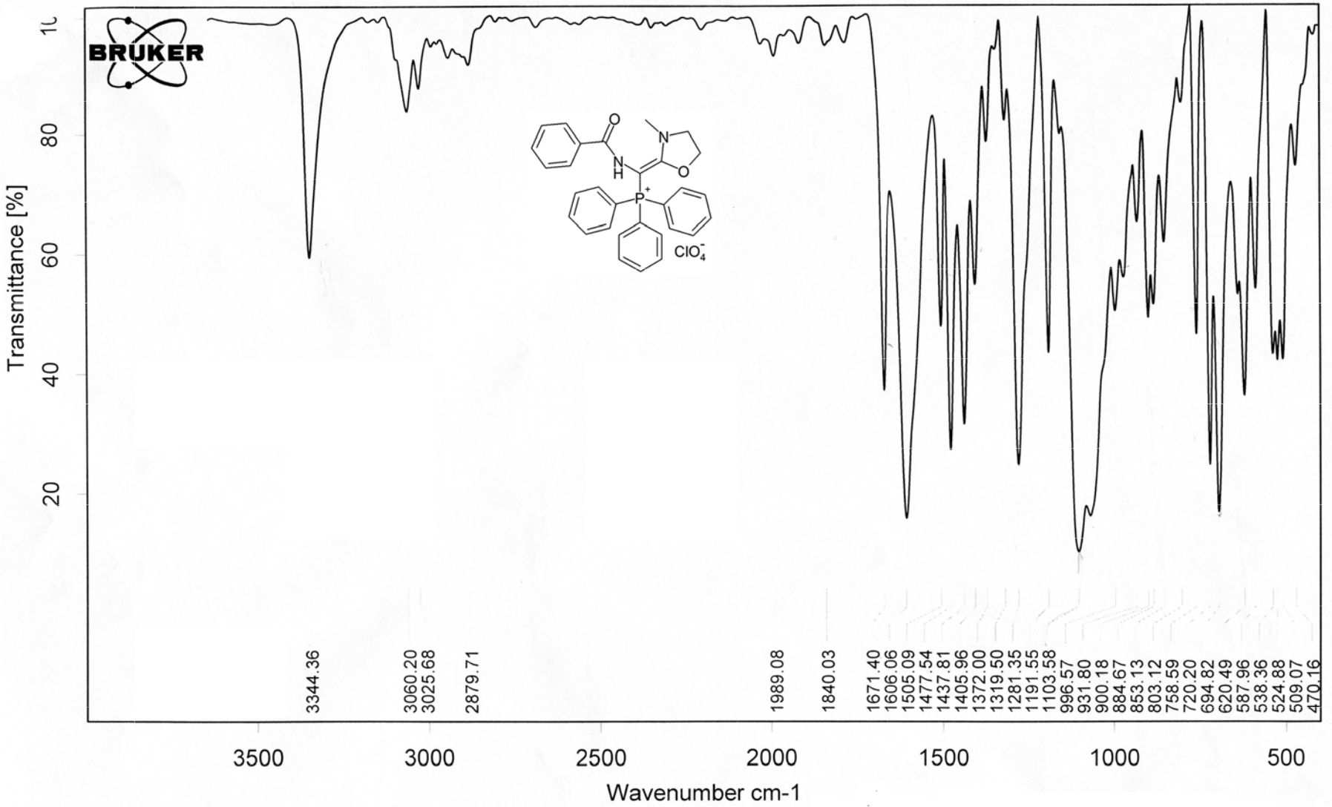

Figure S 51. IR (KBr) spectr um of [Benzoylamino-(3-meth l-1,3-oxazolidi -2-ylidene)met hyl]triphenylph sphonium perc hlorate (5d).

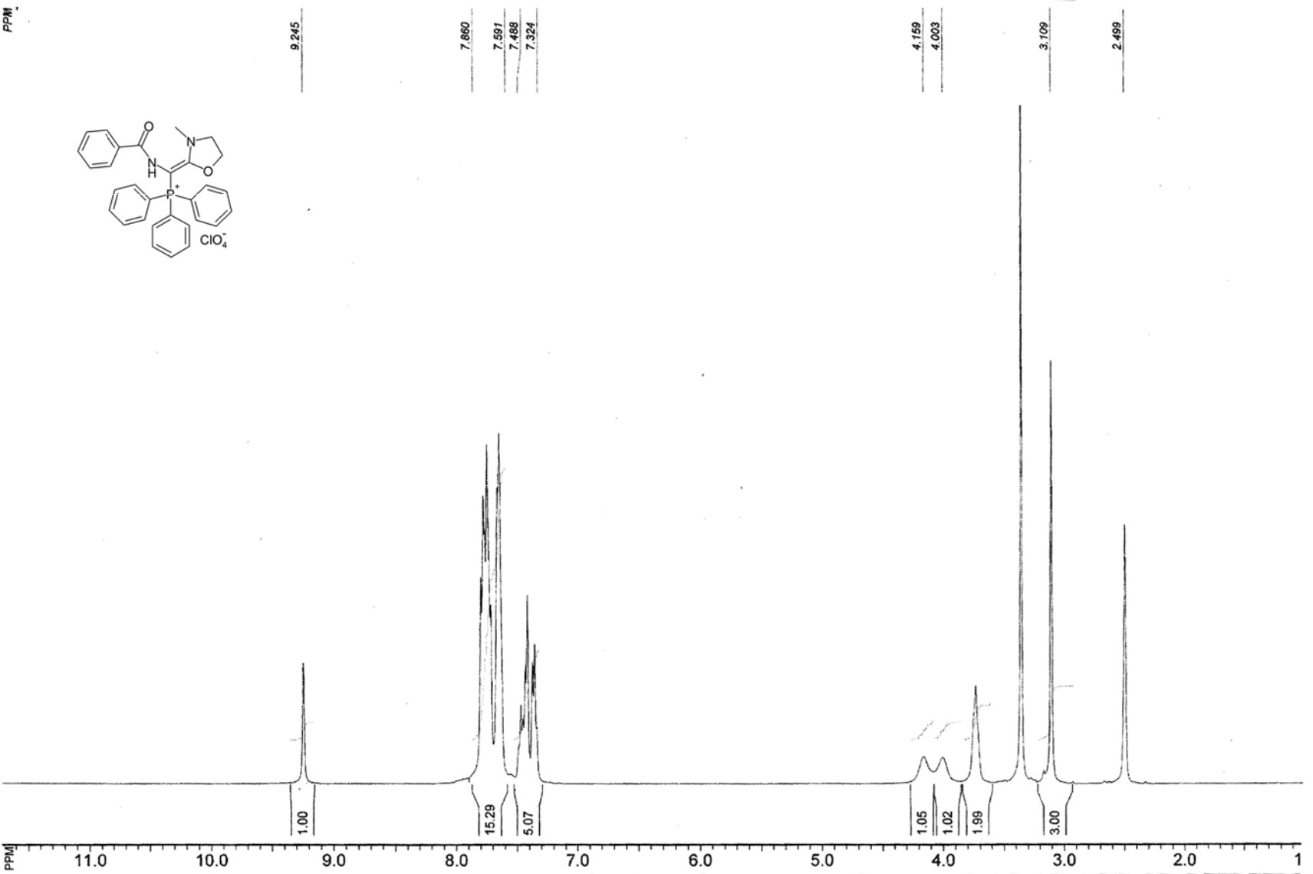

Figure S 52. ¹H NMR spectrum of [Benzoylamino- 3-methyl-1,3-o xazolidin-2-ylidene)methyl]trip henylphosphoni um perchlorate ( 5d).

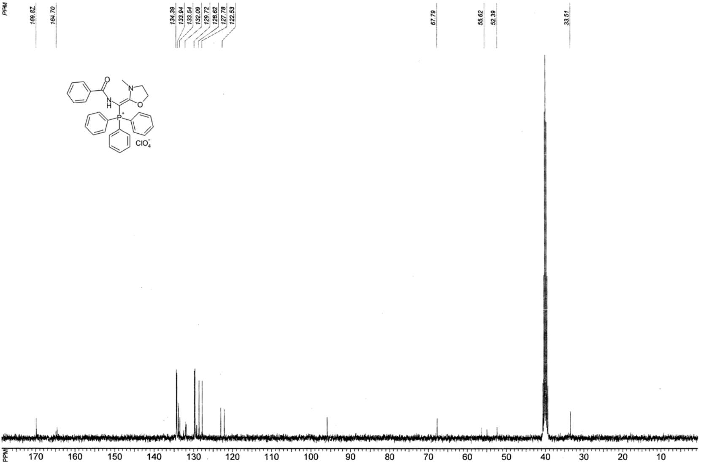

Figure S 53. ¹³C NMR spectrum of [Benzoylamino- (3-methyl-1,3-o xazolidin-2-yli ene)methyl]triphenylphosphon um perchlorate (5d).

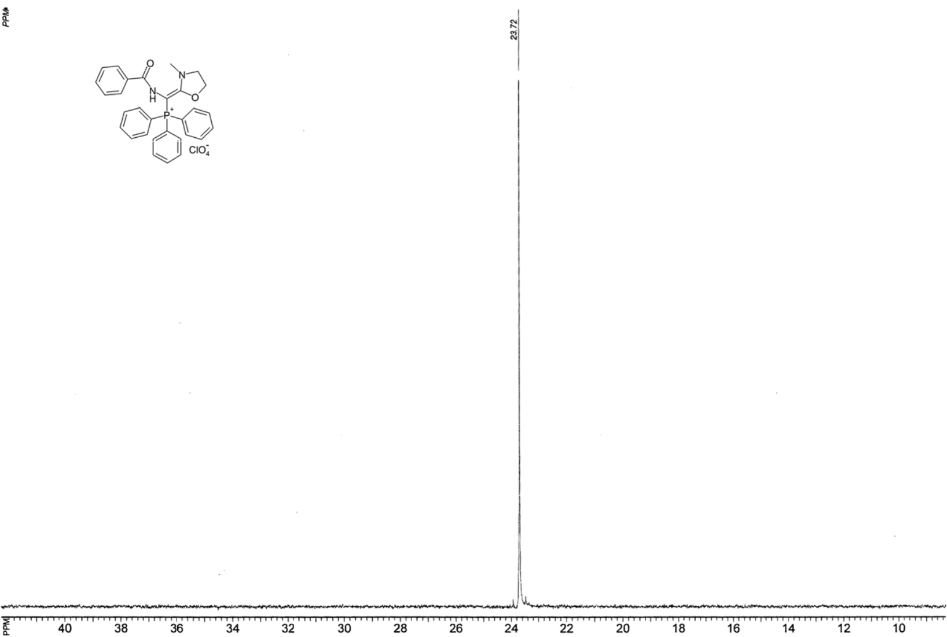

Figure S 54. ³¹P NMR spectrum of Benzoylamino-(3-methyl-1,3-oxazolidin-2-ylid ene)methyl]triphenylphosphonium perchlorate (5d).

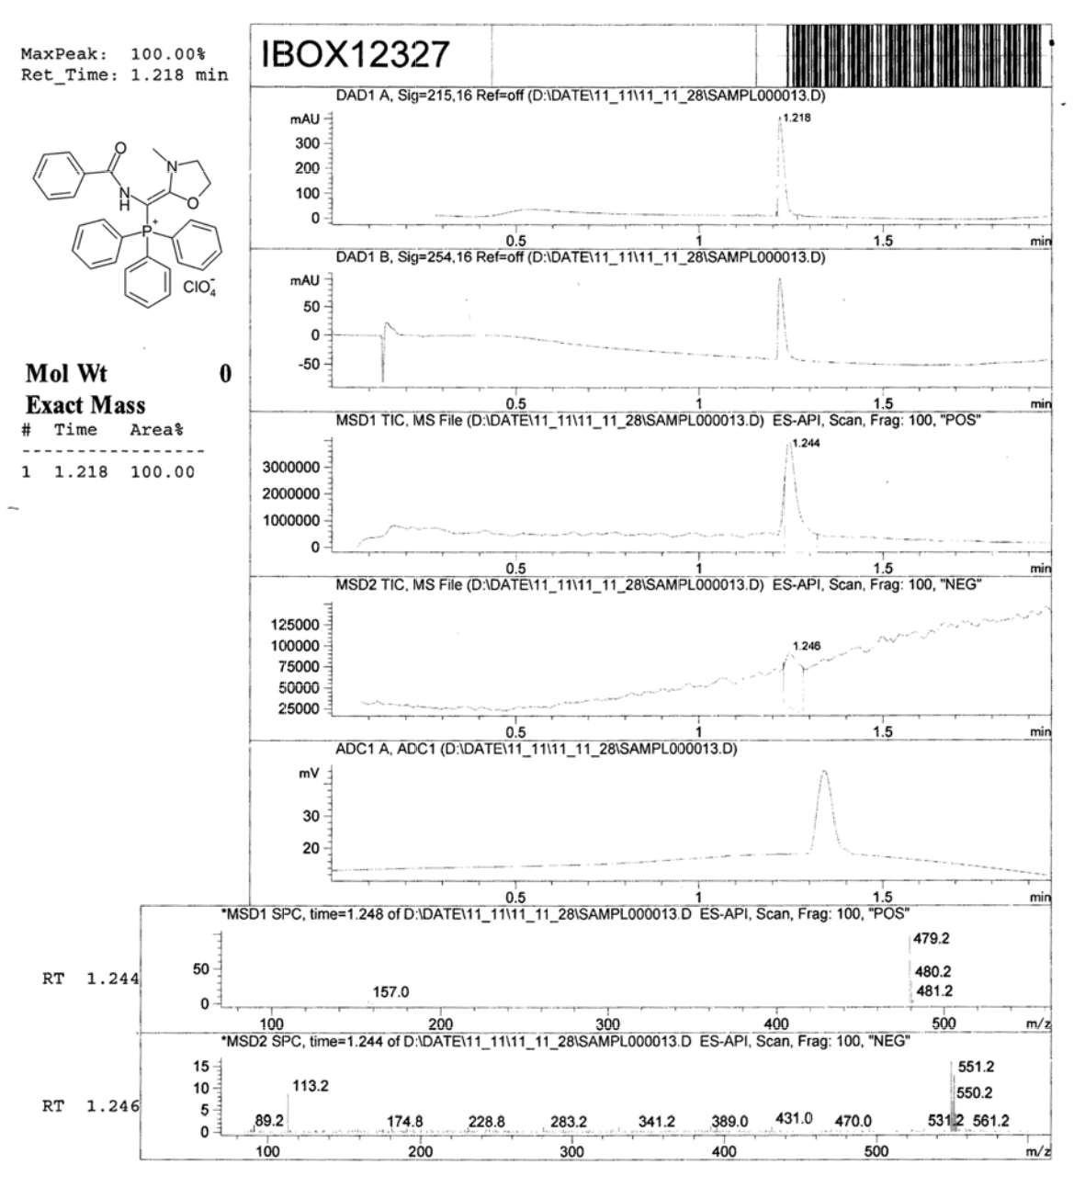

Figure S 55. LC-MS analy is report [B enzoylamino-(3-methyl-1,3-oxazolidin-2-ylide ne)methyl]triphenylph osphonium perchlorate (5d).

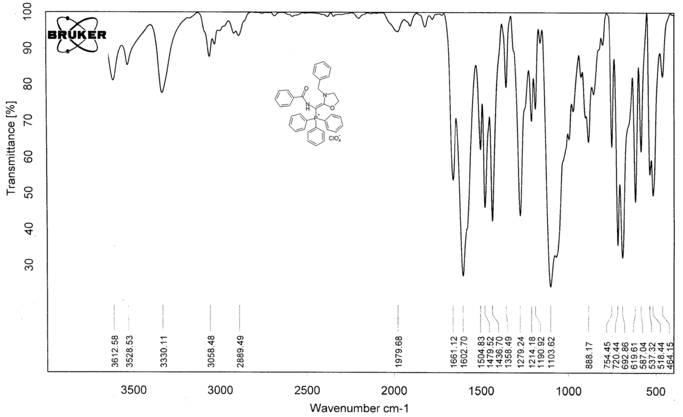

Figure S 56. IR (KBr) spectr um of [Benzoylamino-(3-benzy l-1,3-oxazolidin -2-ylidene)met yl]triphenylpho sphonium perch lorate (5e).

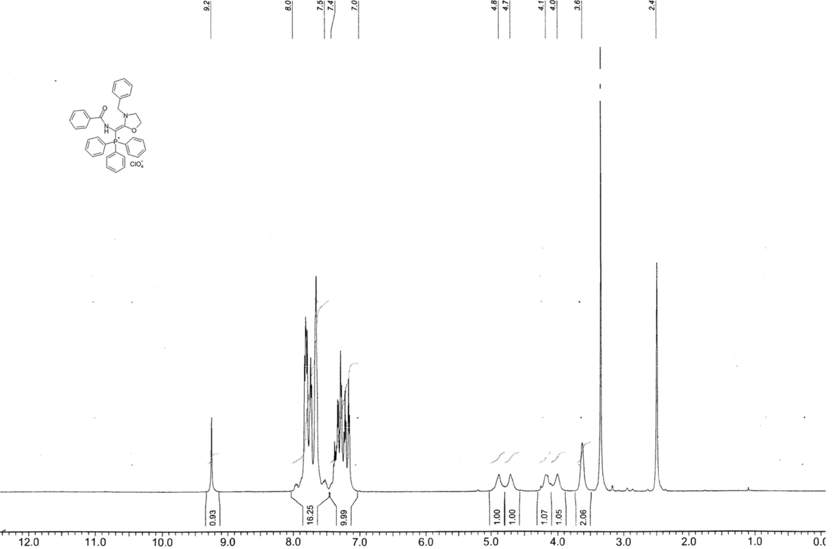

Figure S 57. ¹H NMR spectrum of [Benzoylamino- 3-benzyl-1,3-o azolidin-2-ylid ene)methyl]triph enylphosphoni m perchlorate (5e).

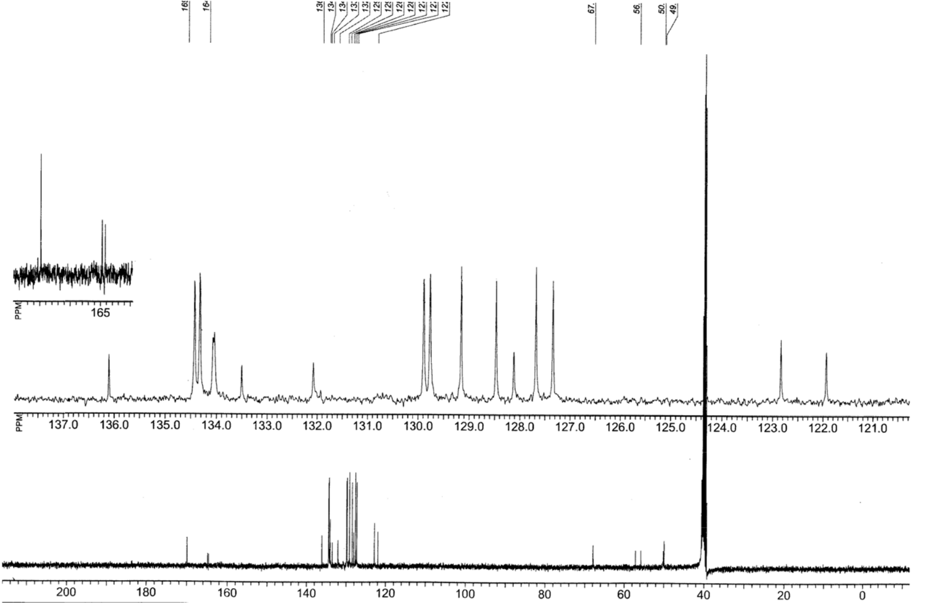

Figure S 58. ¹³C NMR spectrum of [Benzoylamino- (3-benzyl-1,3-oxazolidin-2-ylid ene)methyl]triphenylphosphonium perchlorate (5e).

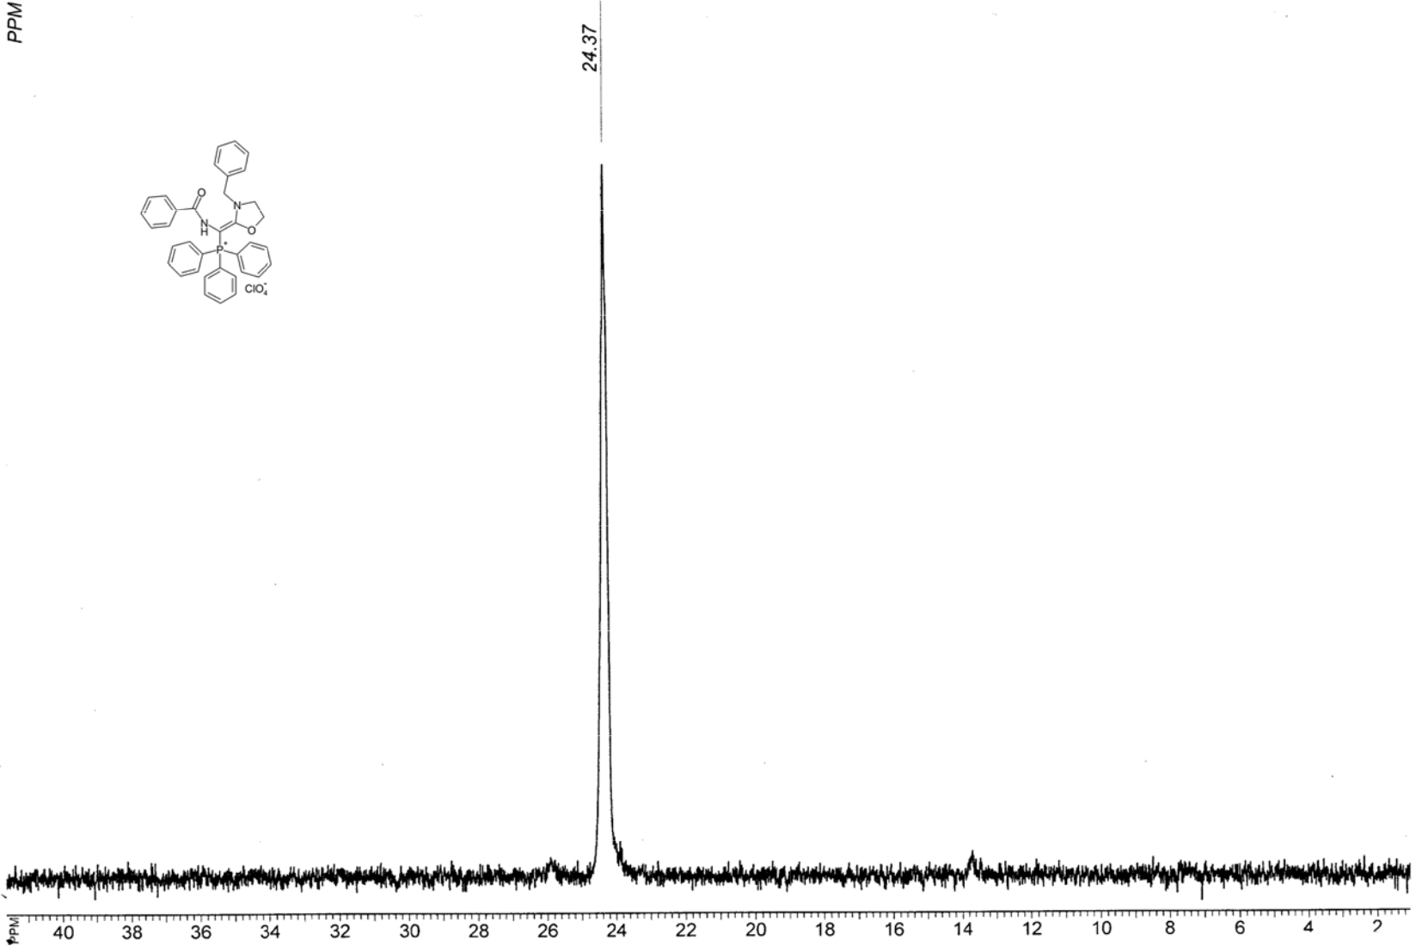

Figure S 59. ³¹P NMR spectrum of Benzoylamino-(3-benzyl-1,3-oxazolidin-2-ylidene)methyl]trip henylphosphonium perchlorate (5e).

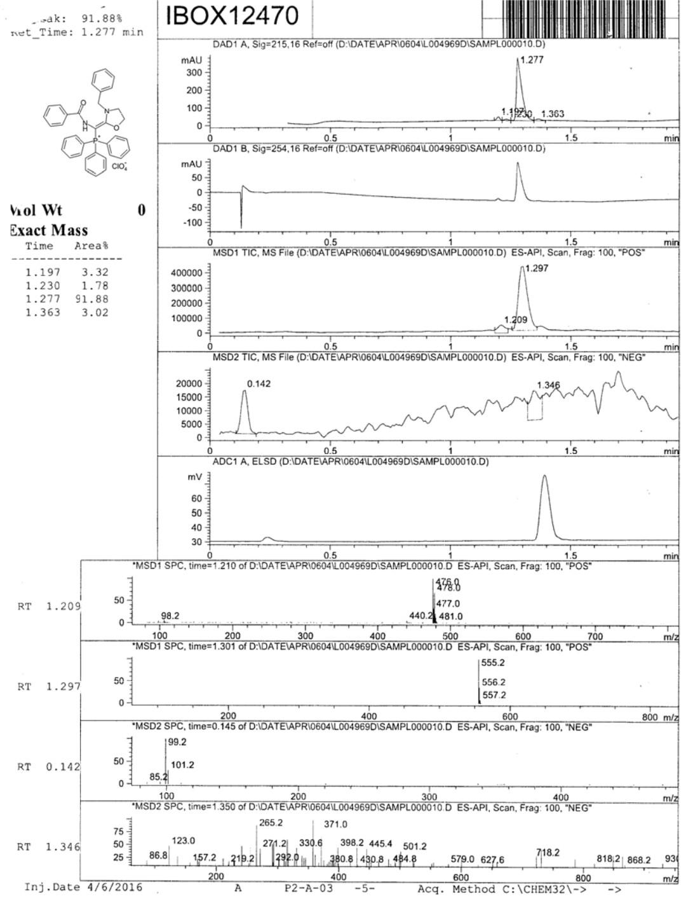

Figure S 60. LC-MS analy is report of [Benzoylamino-(3-benzyl-1,3-ox azolidin-2-ylide ne)methyl]triphenylph osphonium perchlorate (5e).

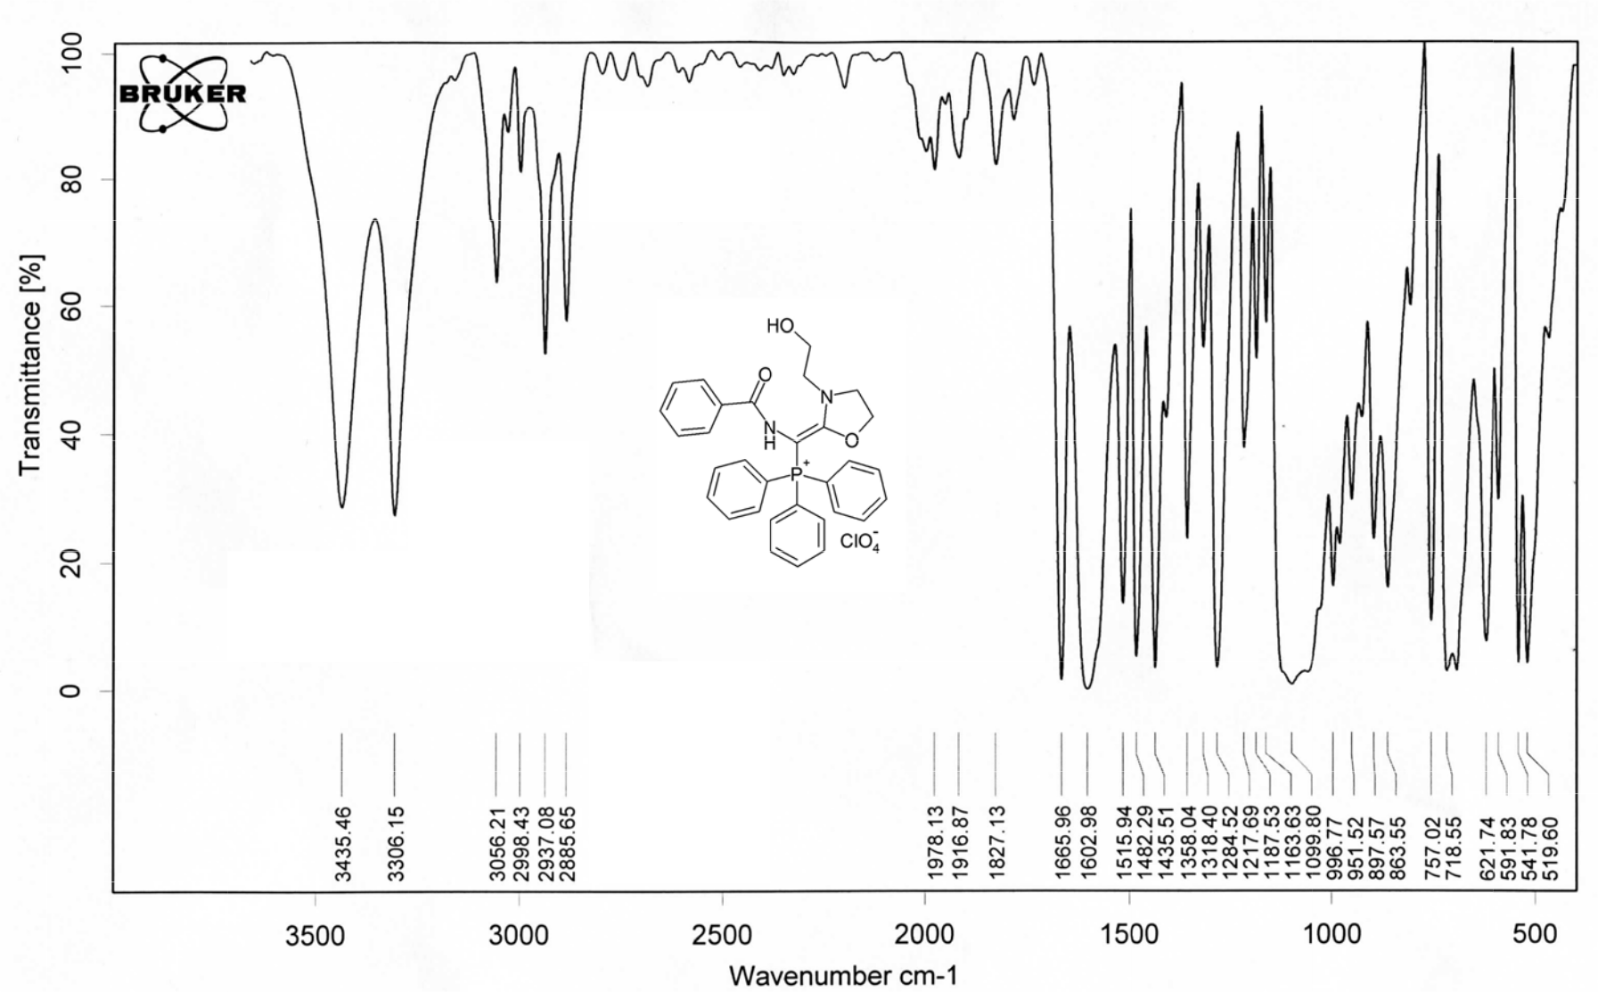

Figure S 61. IR (KBr) spectr um of {Benzoylamino-[3-(2-hydroxyethyl)-1,3-oxazolidin-2-ylidene]methyl}tr iphenylphospho nium perchlora te

(5f).

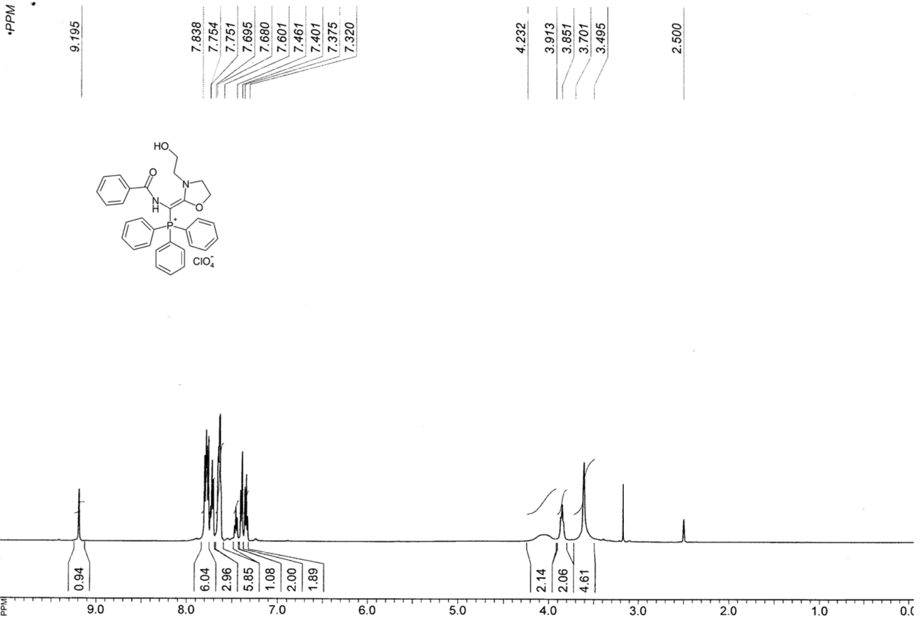

Figure S 62. ¹H NMR spectrum of { Benzoylamino-[3-(2-hydroxyethyl)-1,3-oxazol din-2-ylidene]m ethyl}triphenylphosphonium perchlorate (5f).

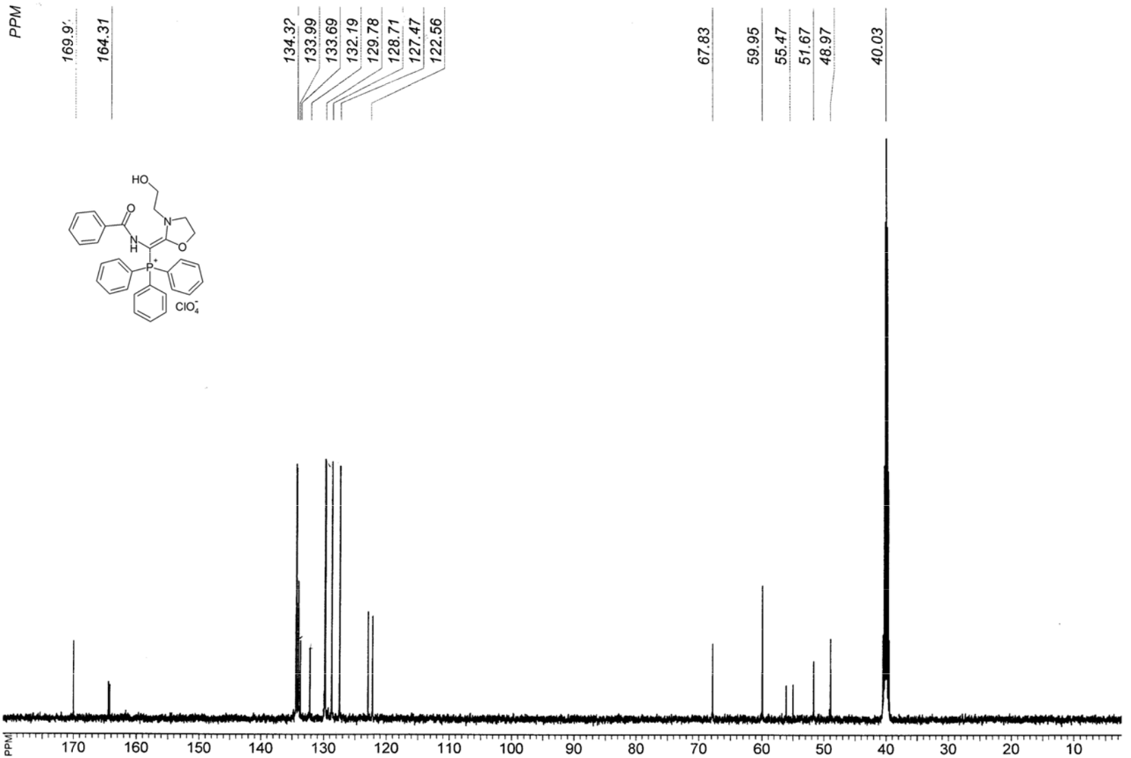

Figure S 63. ¹³C NMR spectrum of {Benzoylamino-[3-(2-hydroxyethyl)-1,3-oxazo idin-2-ylidene] methyl}triphenylphosphonium p erchlorate (5f).

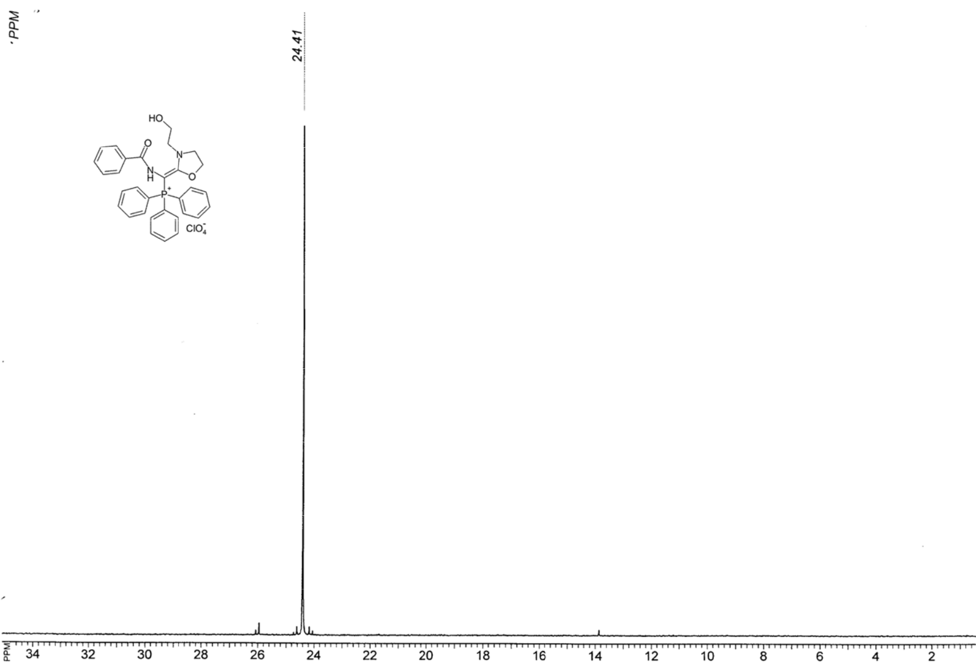

Figure S 64. ³¹P NMR spectrum of {Benzoylamino [3-(2-hydroxyethyl)-1,3-oxazolidin-2-ylidene] methyl}triphenylphosphonium perchlorate (5f).

Figu ylide

re S 65. LC-MS analy is report of ne]methyl} triphenylp hosphonium
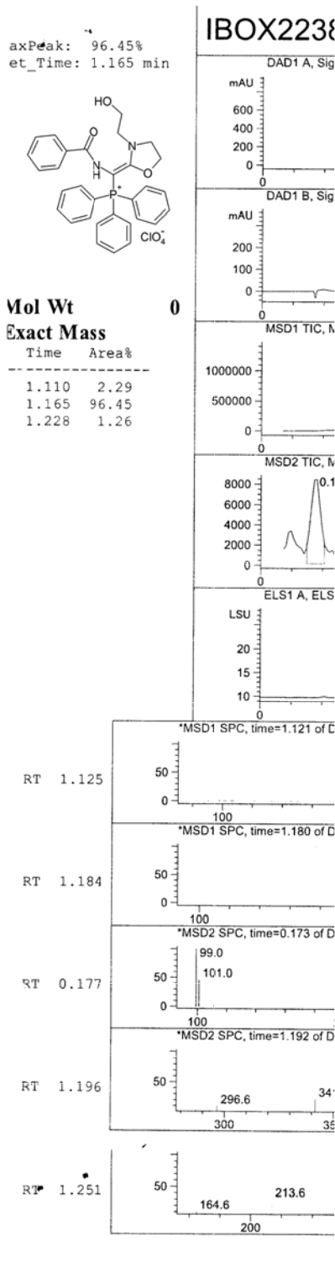

{Benzoyla perchlorat

mino-[3-(2-hydroxyet hyl)-1,3-oxazolidin-ee (5f).
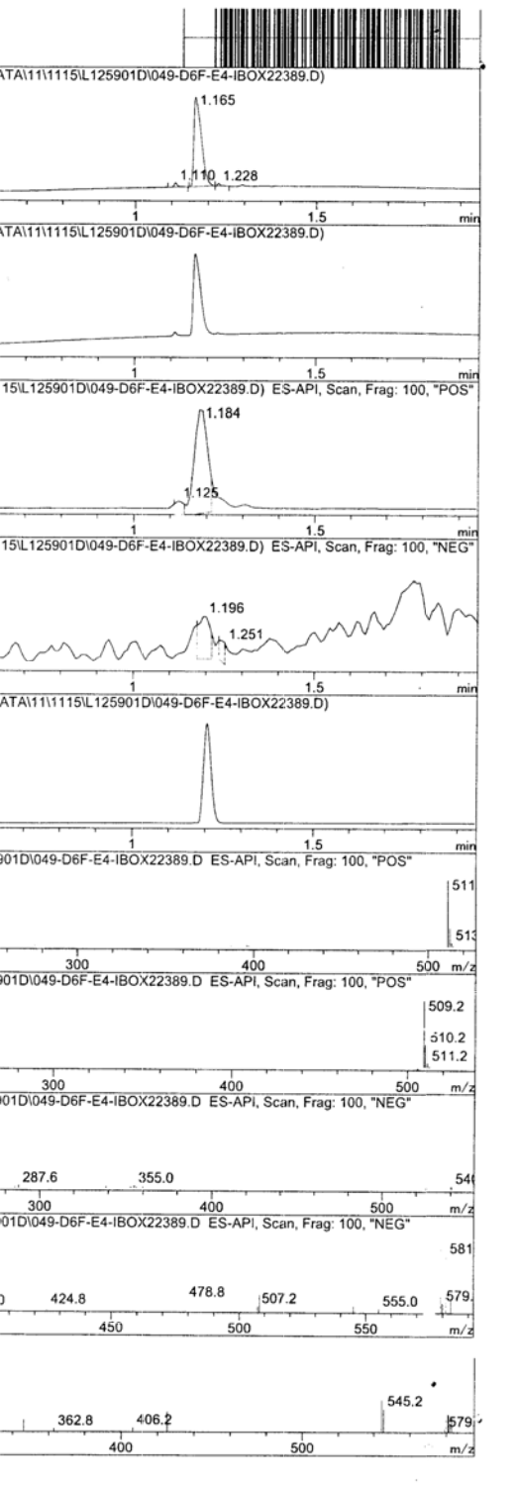

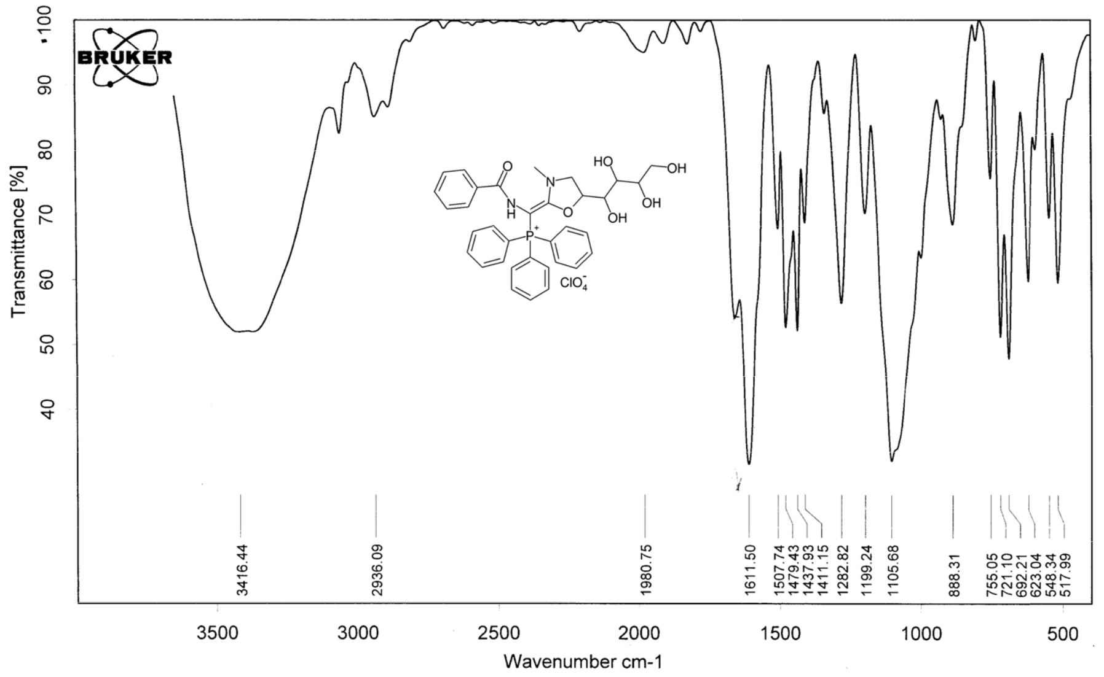

Figure S 66. IR (KBr) spectr um of {Benzoylamino-[3-meth yl-5-((1S,2R,3S)-1,2,3,4-tetrahydroxybutyl)-1,3-oxazolidin-2-ylidene]met hyl}triphenylph osphonium perchlorate (5g).

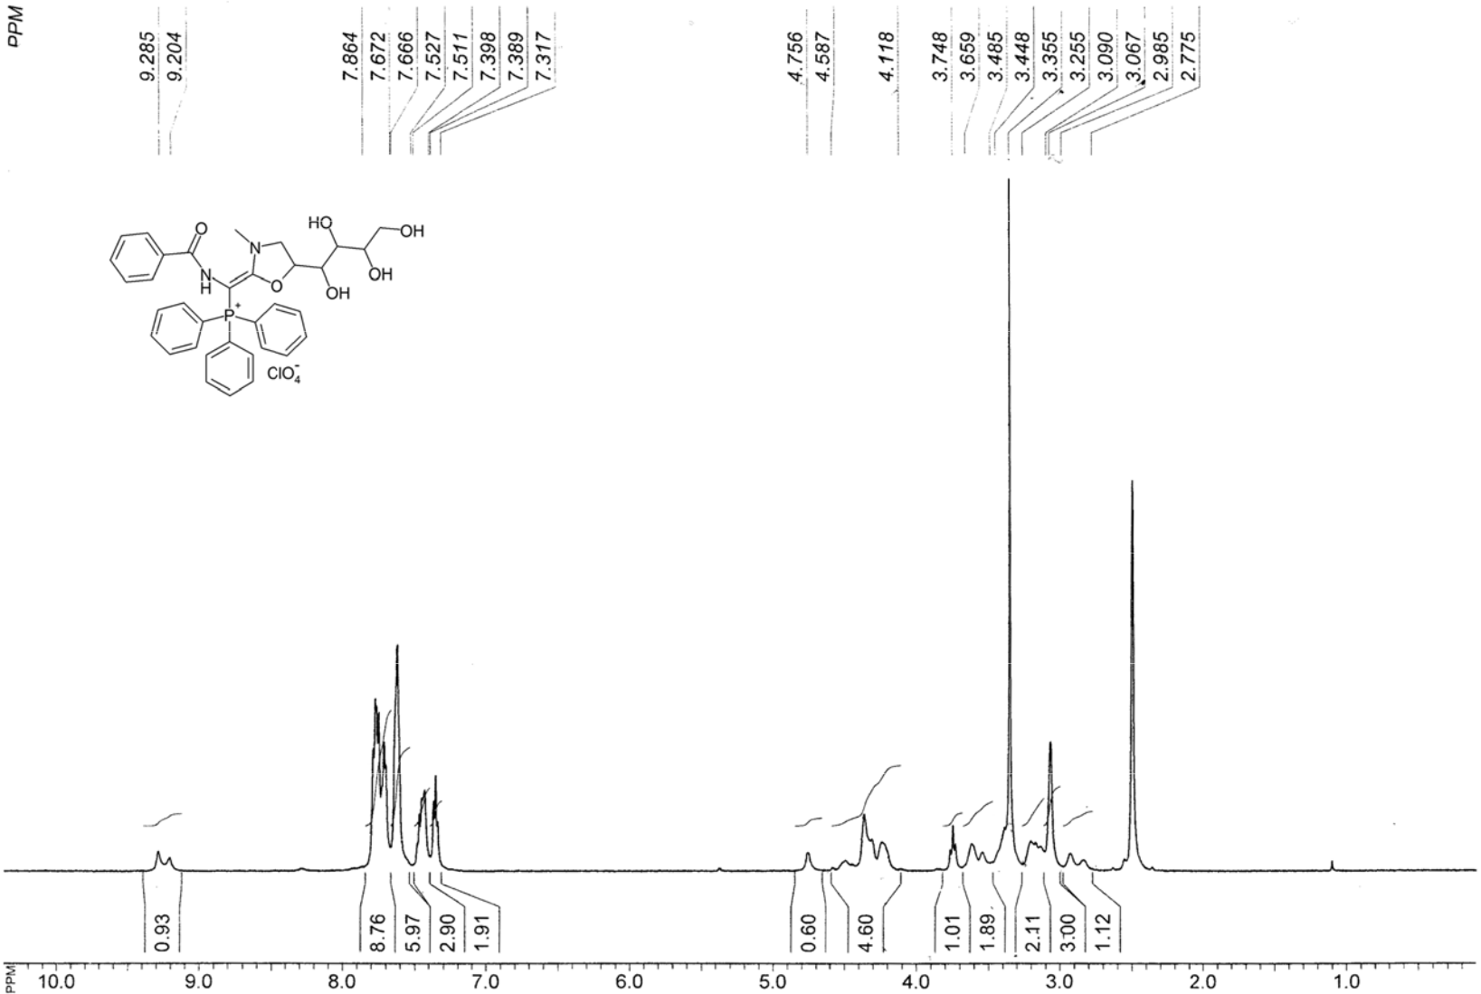

Figure S 67. ¹H NMR spectrum of { Benzoylamino-[3-methyl-5-((1S,2R,3S)-1,2,3, -tetrahydroxyb utyl)-1,3-oxazolidin-2-ylidene]methyl}triphenylphosphonium perchlorate (5g).

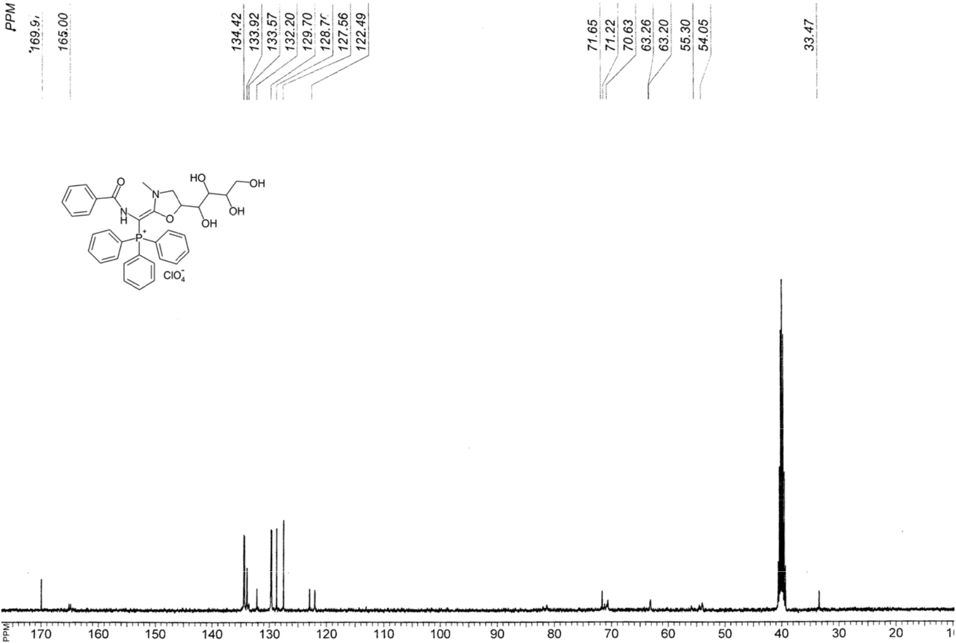

Figure S 68. ¹³C NMR spectrum of {Benzoylamino-[3-methyl-5-((1 S,2R,3S)-1,2,3,4-tetrahydroxyb utyl)-1,3-oxazolidin-2-ylidene]methyl}triphenylphosphonium perchlorate (5g).

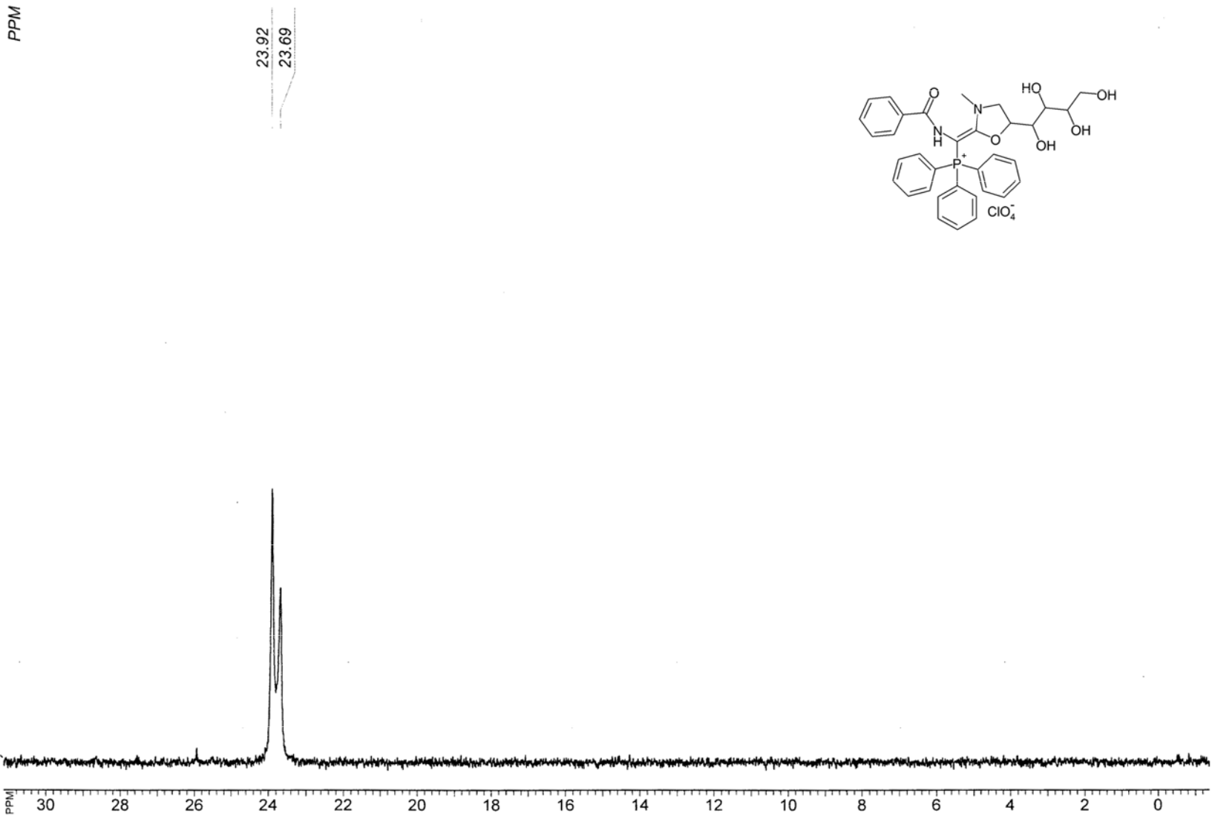

Figure S 69. ³¹P NMR spectrum of {Benzoylamino [3-methyl-5-((1S,2R,3S)-1,2,3,4-tetrahydroxybutyl)-1,3-oxazo lidin-2-ylidene]methyl}triphenylphosphonium perchlorate (5g).

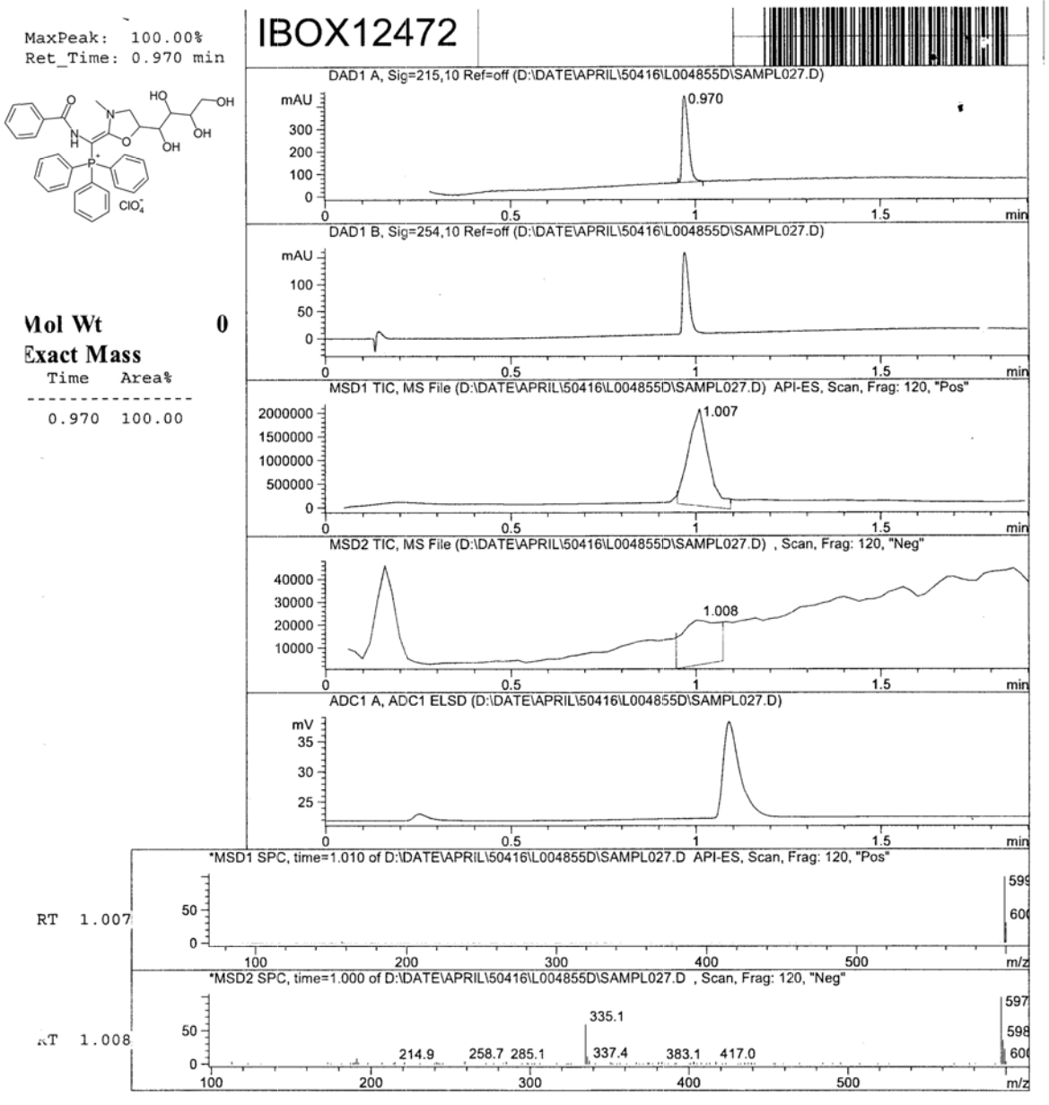

Figure S 70. LC-MS analy is report of {Benzoyla mino-[3-methyl-5-((1 S,2R,3S)-1,2,3,4-tetrahydroxybutyl)-1,3-oxazolidin-2-ylidene]met hyl}triphenylphosphon ium perchlorate (5g).

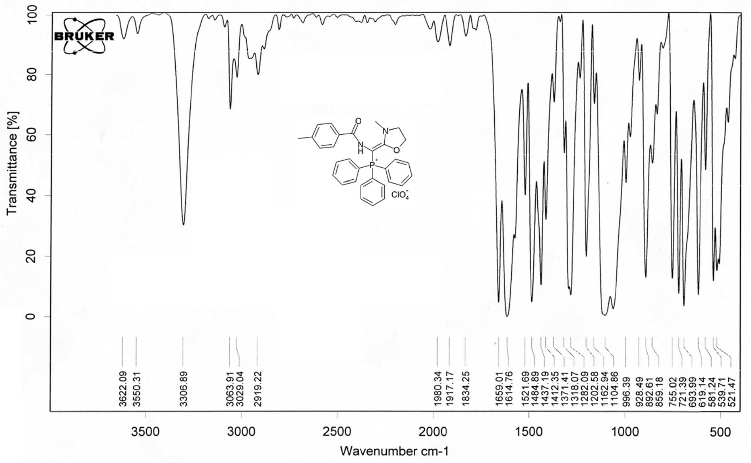

Figure S 71. IR (KBr) spectrum of {(4-Meth ylbenzoyl)amino-[3-methyl-1,3-oxazolidin-2-ylidene]methyl}triphenylphosph onium perchlorate

(5h).

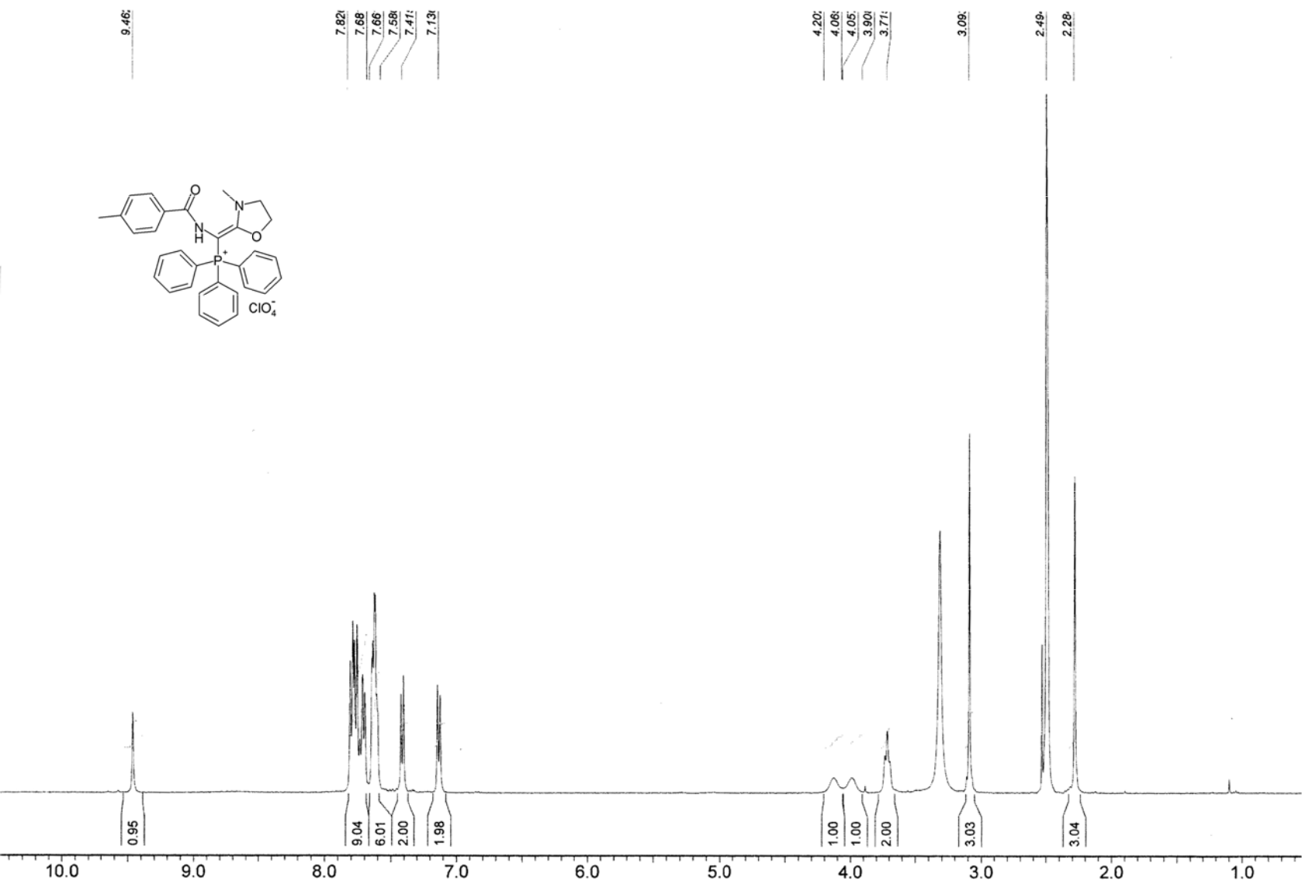

Figure S 72. ¹H NMR spectrum of { (4-Methylbenz yl)amino-[3-m ethyl-1,3-oxazolidin-2-ylidene] methyl}triphenylphosphonium perchlorate (5h).

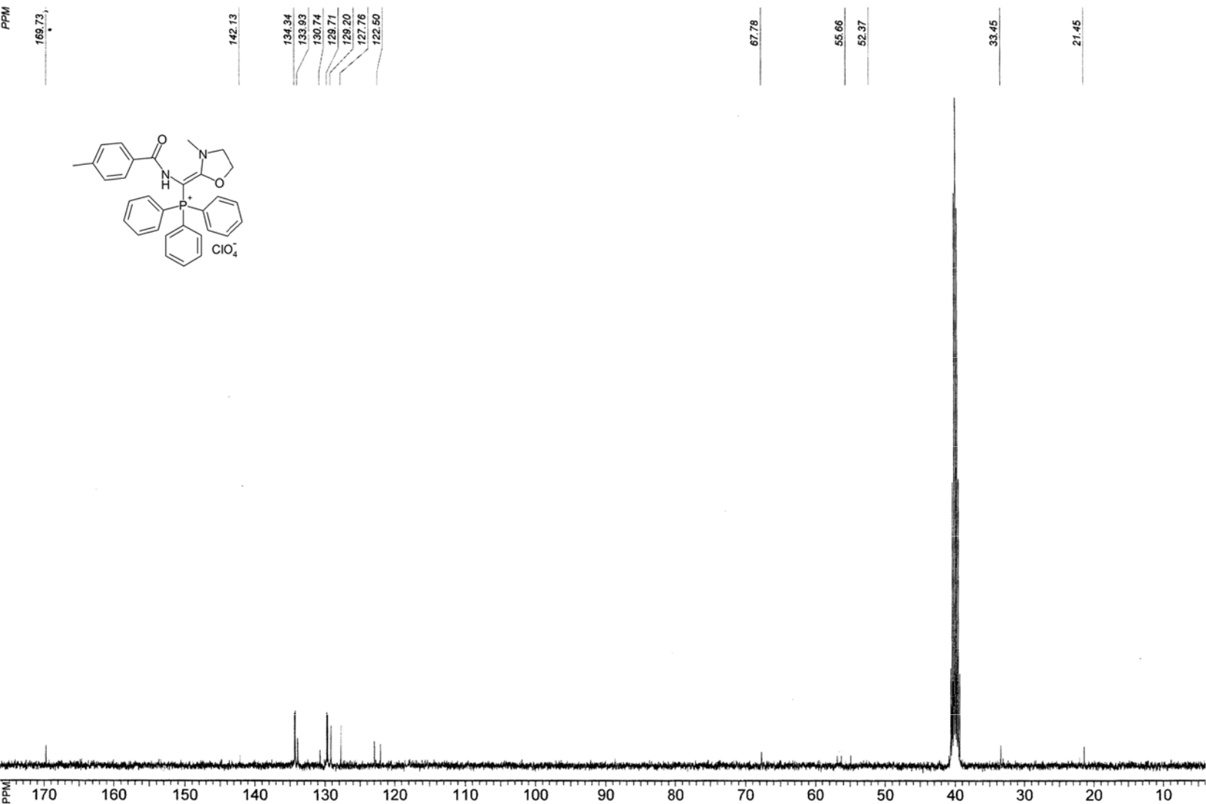

Figure S 73. ¹³C NMR spectrum of {(4-Methylbenzoyl)amino-[3-methyl-1,3-oxazolidin-2-ylidene]methyl}tripheny lphosphonium perchlorate (5h).

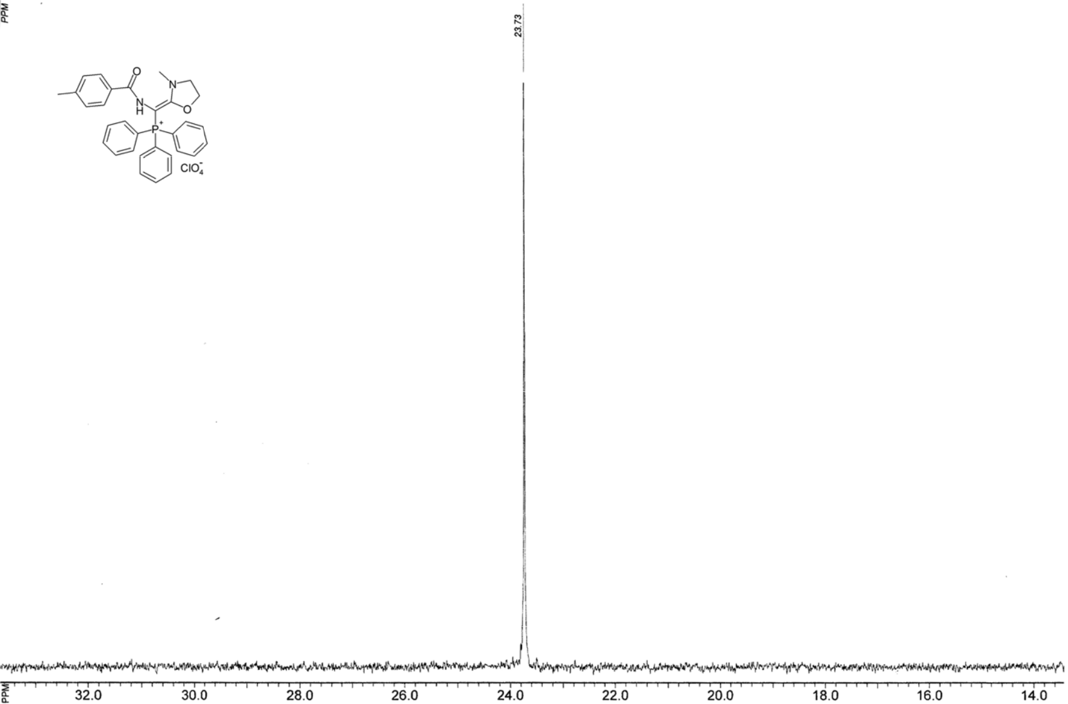

Figure S 74. ³¹P NMR spectrum of {(4-Methylbenzoyl)amino-[3-methyl-1,3-oxazolidin-2-ylidene] methyl}tripheny lphosphonium erchlorate (5h)

Figu ylide

re S 75. LC-MS analy is report of ne]methyl} triphenylp hosphonium
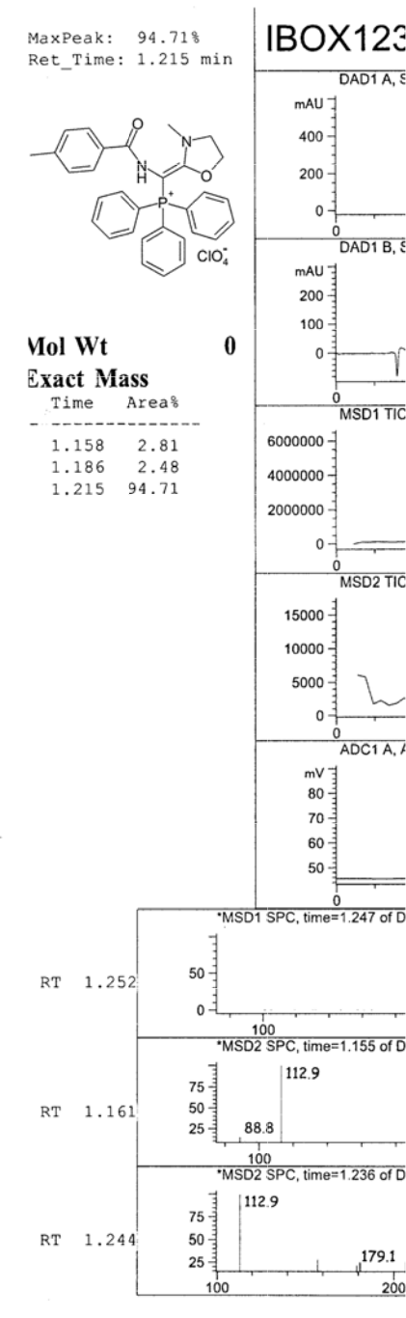

{(4-Methy lbenzoyl)a mino-[3-me thyl-1,3-ox azolidin-2-perchlorate (5h).
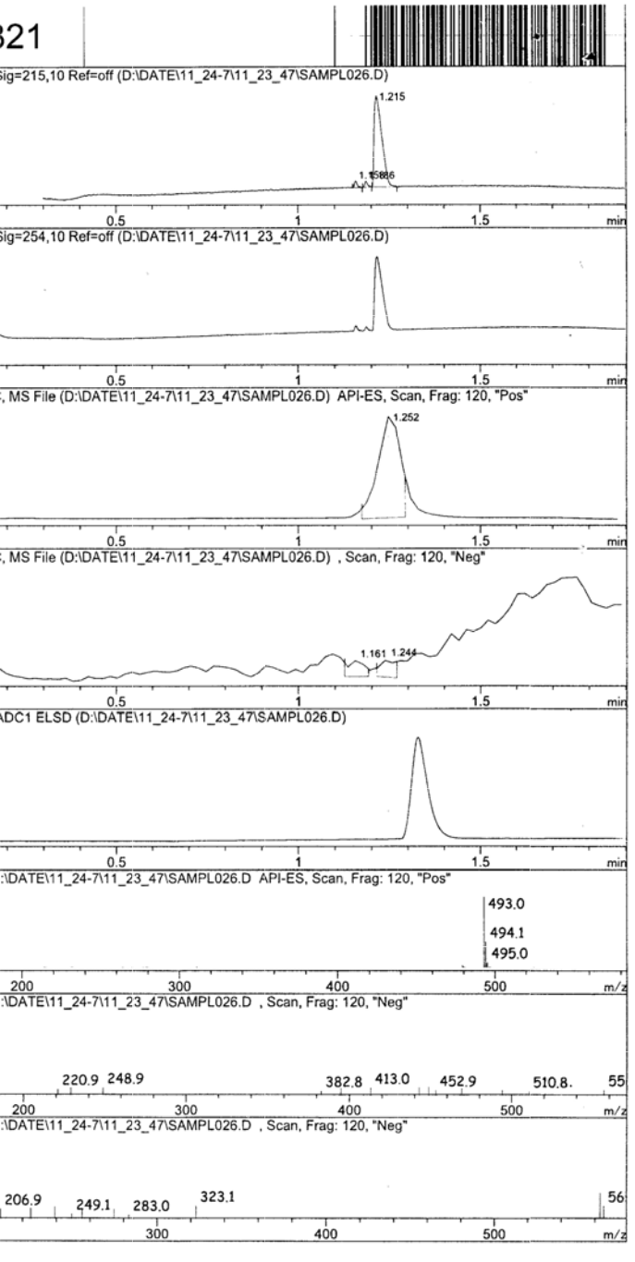

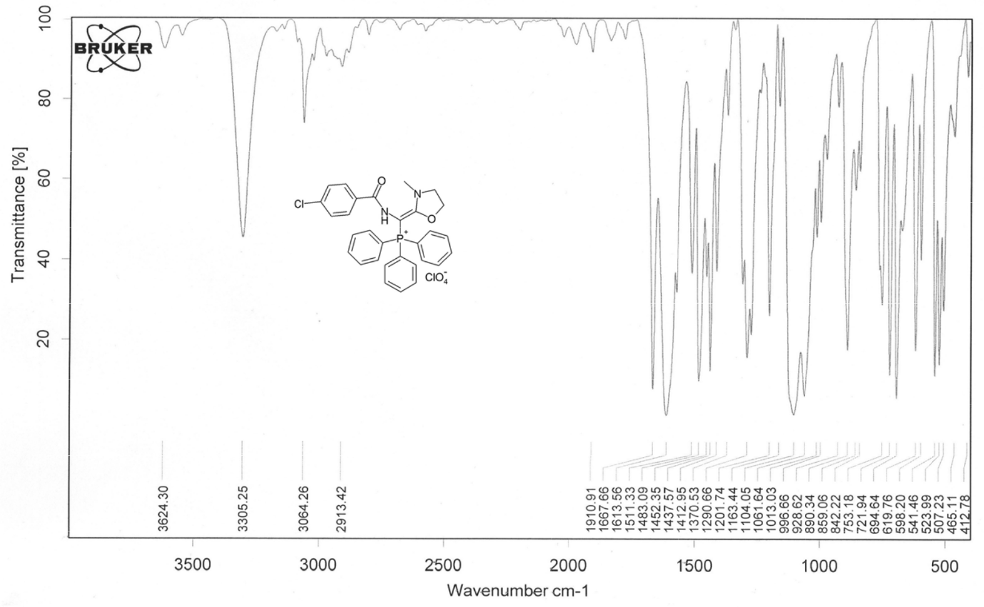

Figure S 76. IR (KBr) spectr um of {(4-Chlorobenzoyl)amino-[3-methyl-1,3-oxazolidin-2-y idene]methyl}t iphenylphospho nium perchlorate (5i).

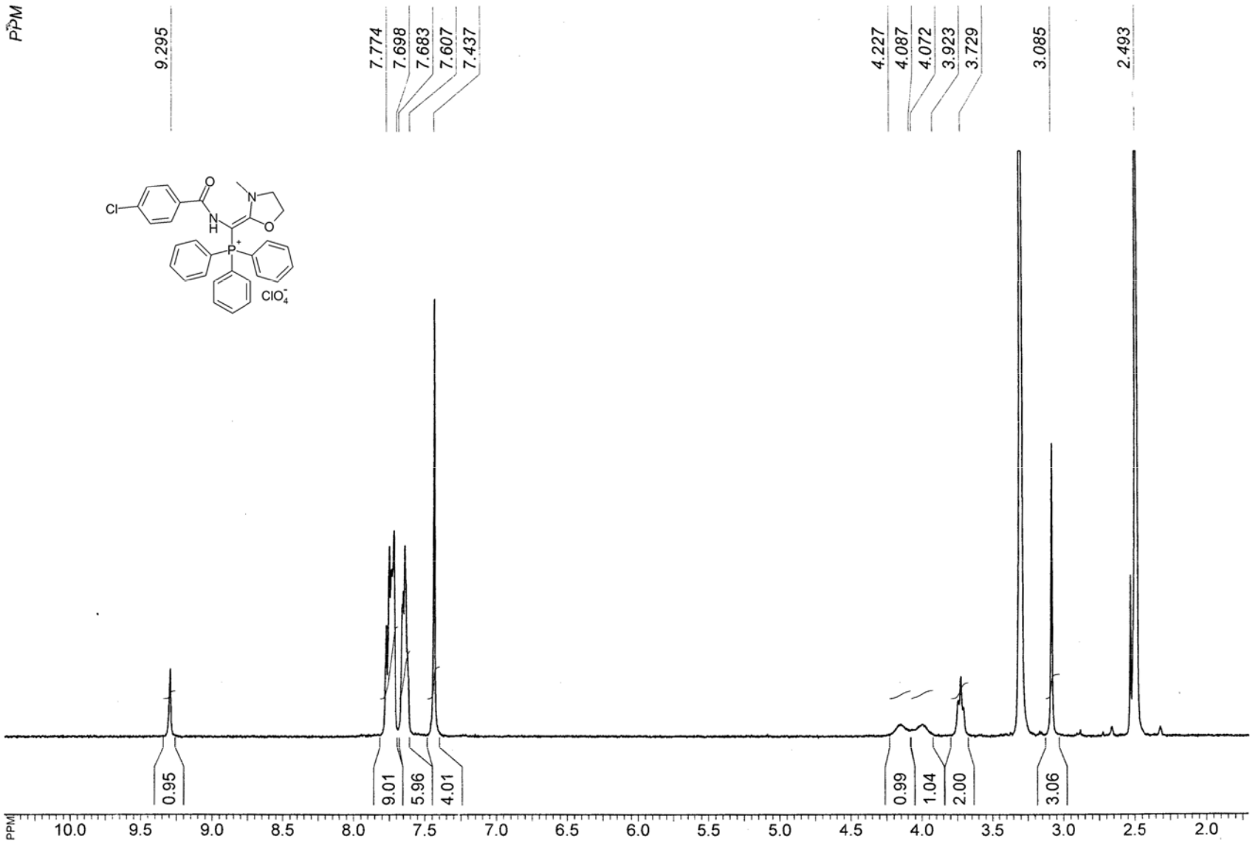

Figure S 77. ¹H NMR spectrum of { (4-Chlorobenzo yl)amino-[3-me thyl-1,3-oxazolidin-2-ylidene] ethyl}triphenylphosphonium perchlorate (5i).

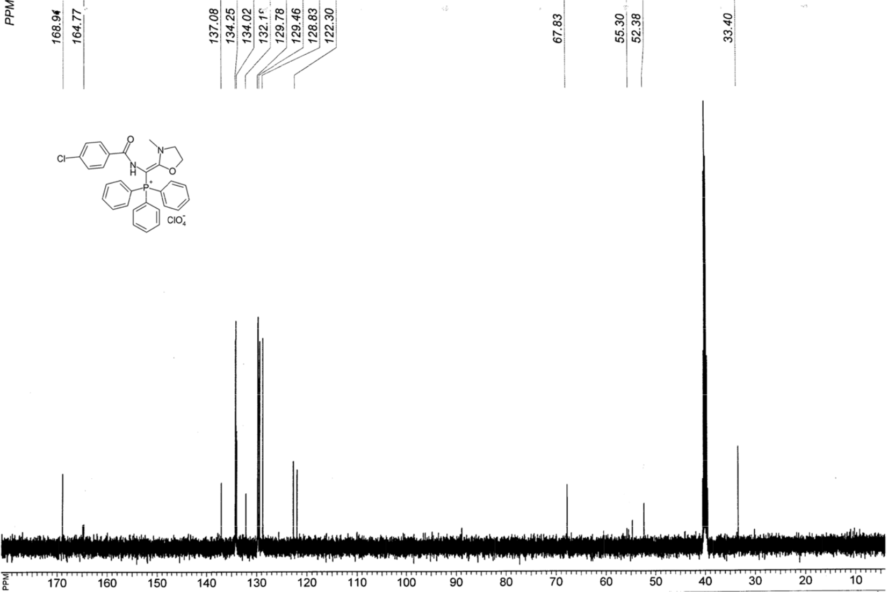

Figure S 78. ¹³C NMR spectrum of {(4-Chlorobenzoyl)amino-[3-methyl-1,3-oxazolidin-2-ylidene] methyl}tripheny lphosphonium erchlorate (5i).

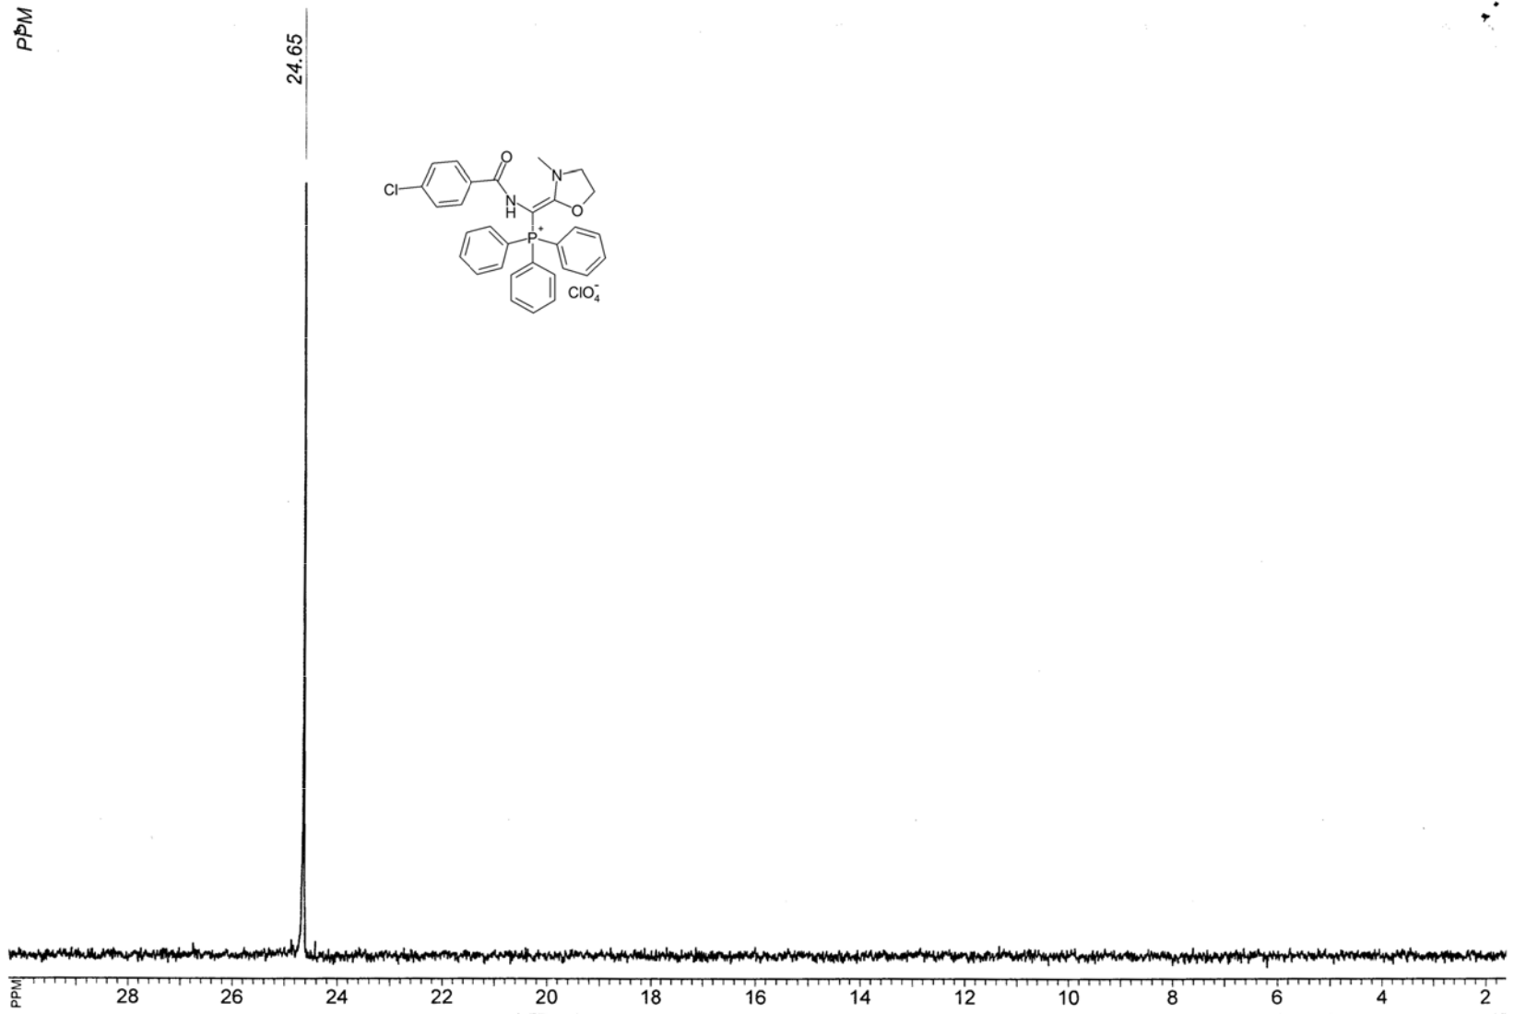

Figure S 79. ³¹P NMR spectrum of {(4-Chlorobenz oyl)amino-[3-m ethyl-1,3-oxazo idin-2-ylidene] methyl}triphenylphosphonium p erchlorate (5i).

Figu ylide

re S 80. LC-MS analy is report of {(4-Chlor obenzoyl)a mino-[3-methyl-1,3-oxazolidin-2-ne]methyl} triphenylp hosphonium perchlorat e (5i).
