Supplementary Data
Stir bar sorptive extraction combined with deep eutectic solvent–based dispersive liquid–liquid microextraction; Application in simultaneous derivatization and extraction of acidic pesticides

Mohammad Reza Afshar Mogaddam^{1,2} , Mir Ali Farajzadeh^{3,4}, Ali Mohebbi^{3,*}, Mahboob Nemati ^{1,2,**}
¹ Food and Drug Safety Research Center, Tabriz University of Medical Sciences, Tabriz, Iran
²Pharmaceutical Analysis Research Center, Tabriz University of Medical Sciences, Tabriz, Iran
³ Department of Analytical Chemistry, Faculty of Chemistry, University of Tabriz, Tabriz, Iran
⁴ Engineering Faculty, Near East University, 99138 Nicosia, North Cyprus, Mersin 10, Turkey

*First Corresponding author: Professor M. Nemati
Tel.: +98 41 31773336
Fax: +98 41 31773333
E–mail address: nematim@tbzmed.ac.ir

*Second Corresponding author: Dr. A. Mohebbi
Tel.: +98 41 33393084
Fax: +98 41 33340194
E–mail address: alimohebi03@gmail.com

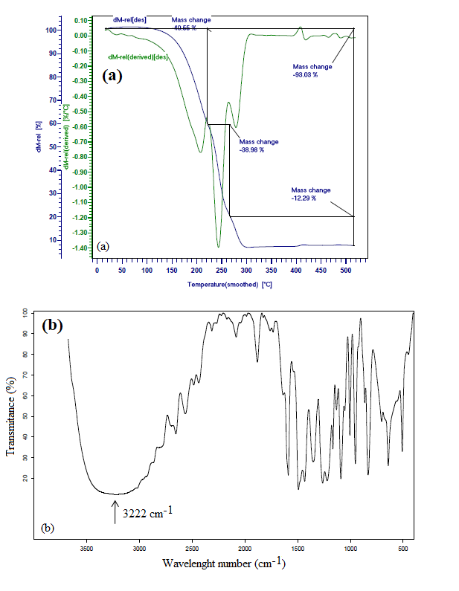
Fig. S1. (a) TGA thermogram and (b) FTIR spectrum of ChCl: p-chlorophenol DES.

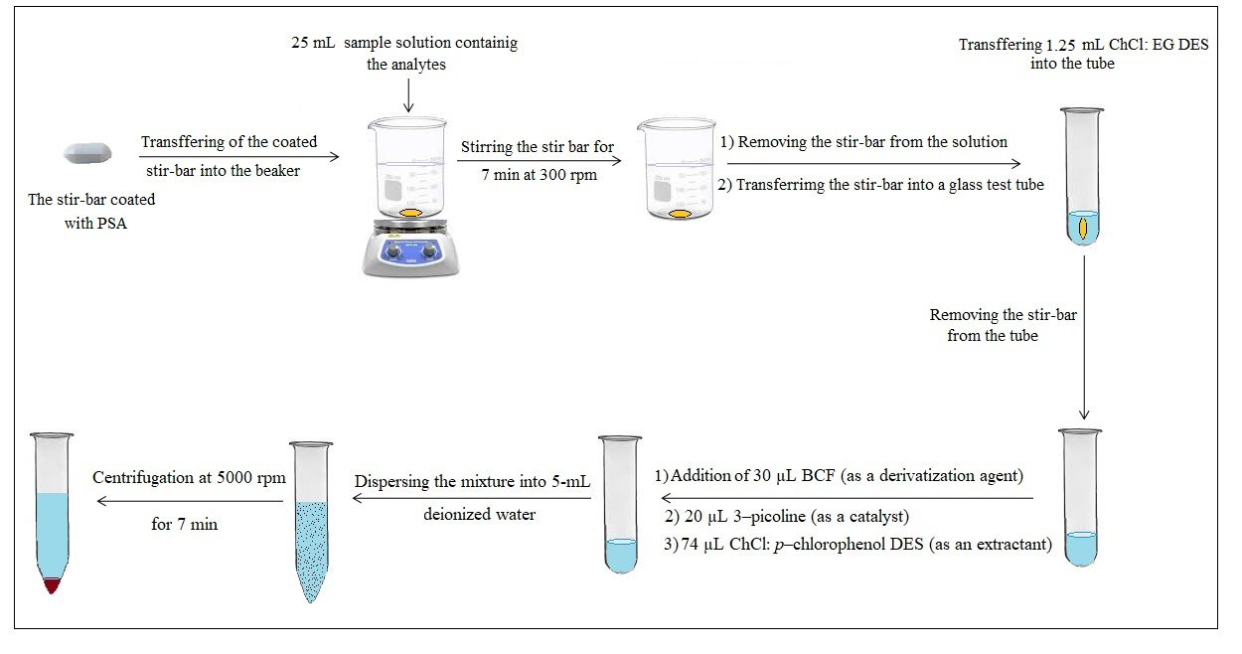
Fig. S2. Scheme of the developed method.

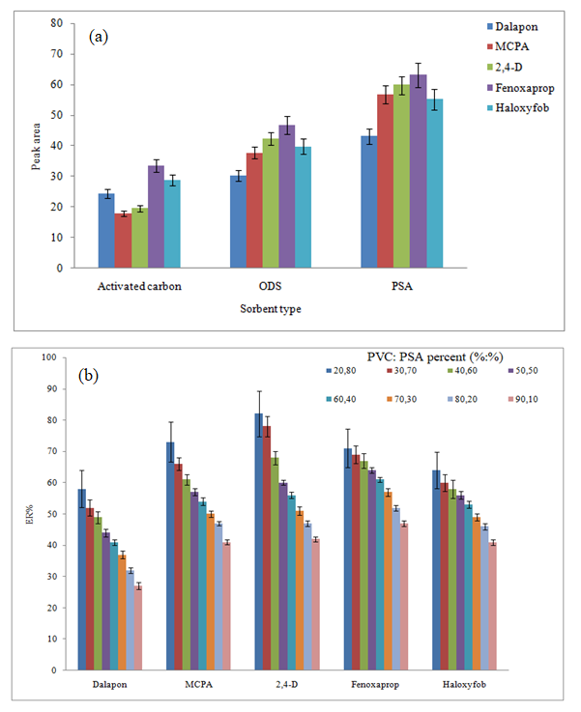
Fig. S3. Selection of the type and composition of the sorbent.
(a) Extraction conditions: SBSE step: volume of aqueous sample, 25 mL deionized water spiked with 5 ng mL^{–1} of each pesticide adjusted at pH=3; stirring rate, 500 rpm; stirring time 10 min; and elution/disperser solvent (volume), DES prepared from ChCl: EG (1.0 mL).
Simultaneous derivatization and DES–DLLME step: aqueous phase, 5.0 mL deionized water; derivatization agent (volume), BCF (40 µL); catalyst (volume), 3–picoline (25 µL); extraction solvent (volume), DES prepared from ChCl: p–chlorophenol (74 µL); and centrifugation rate and time, 5000 rpm and 5 min. The error bars indicate the standard deviations of three repeated determinations.
(b) Extraction conditions: the same as those used in Fig. 1a, except PSA: PVC was used for coating the stir bar.
Fig. S4. Study of stirring rate.
Conditions: the same as those used in Fig. 3S, except PSA: PVC (80:20%, w/w) was used as the coated sorbent.

Fig. S5. Study of derivatization agent volume.
Conditions: as the same as those used in Fig. S4, except DES prepared from ChCl: EG (1.25 mL) was used as elution/disperser solvent.

Fig. S6. Study of catalyst volume.
Conditions: the same as those used in Fig. S5, except 30 µL of BCF was used.

Optimization of centrifuging rate and time
Centrifugation is an ordinary procedure used to rapid separation of the extraction solvent droplets from the solution. The rate and time of centrifugation were studied within the ranges of 2000–6000 rpm and 3–10 min, respectively. The data revealed that ERs of the analytes increased by enhancing centrifugation rate and time up to 5000 rpm and 7 min, respectively, and then remained constant. So, 5000 rpm and 7 min were chosen as the optimum values of centrifugation rate and time, respectively.

Table S1. Physicochemical properties and structures of the selected herbicides.
Analyte | Structure | log P at 20 ⁰C | pK_{a} | Solubility in water at 20 ⁰C (g L⁻¹) | Melting point (⁰C)
Haloxyfop |  | 4.3 | 2.9 | 0.58 | 56-58
Fenoxaprop |  | 1.8 | 3.2 | 0.61 | -
Fluazifop |  | 3.2 | 3.2 | 0.04 | Decomposes

