Structural, Hirshfeld surface and in vitro cytotoxicity evaluation of five new N-aryl-N'-alkoxycarbonyl thiocarbamide derivatives
Sunil K. Pandey ª, Seema Pratap ^{a*}, Sunil K. Rai ^{b}, Gaetano Marverti ^{c}
ª Department of Chemistry (M.M.V), Banaras Hindu University, Varanasi−221005, UP, India
^{b}Organic Chemistry Division, CSIR-National Chemical Laboratory (NCL), Pune-411008, Maharashtra, India
^{c}Department of Biomedical, Metabolic and Neural Sciences, University of Modena and Reggio Emilia, 41125 Modena, Italy

Email: drseemapratap@gmail.com

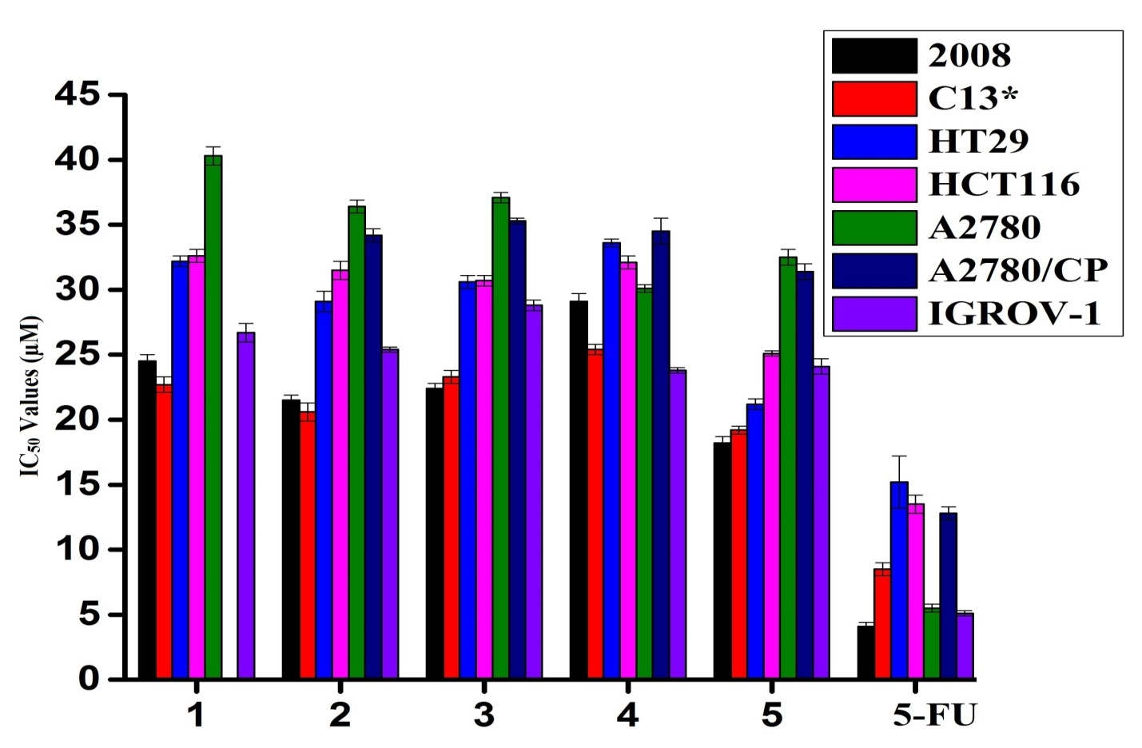

Figure S 1. Comparative in vitro cytotoxicity of compounds 1−5 for a panel of seven human cancer cell lines; Cervical (2008 and C13*), Colorectal (HT29 and HCT116) and Ovarian carcinoma (A2780, A2780/CP and IGROV-1

Table S1 : Decomposed fingerprint plots for various interactions in compounds 2 and 5.

Compound 2 |  |  | Compound 5
Interactions | Decomposed fingerprint plots |  | Interactions |  | Decomposed fingerprint plots
C⋯C | 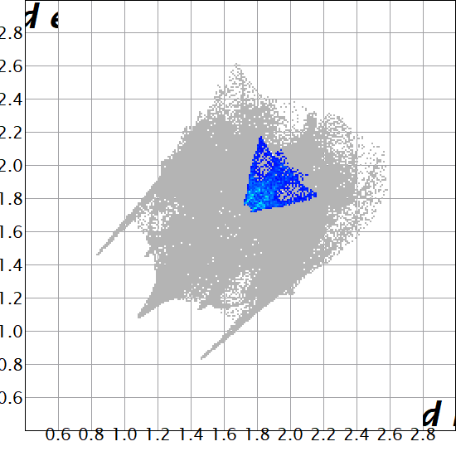 |  | C⋯C |  | 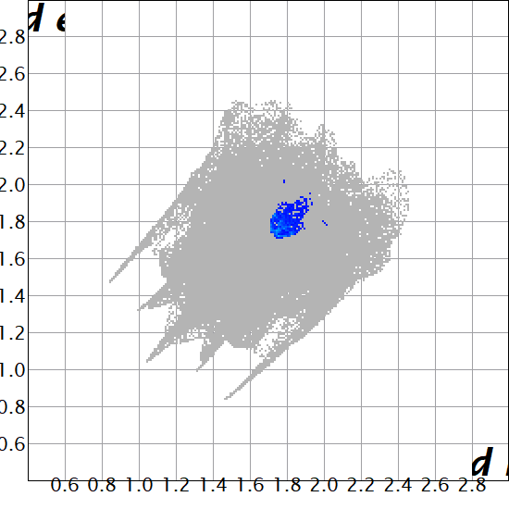
H⋯H | 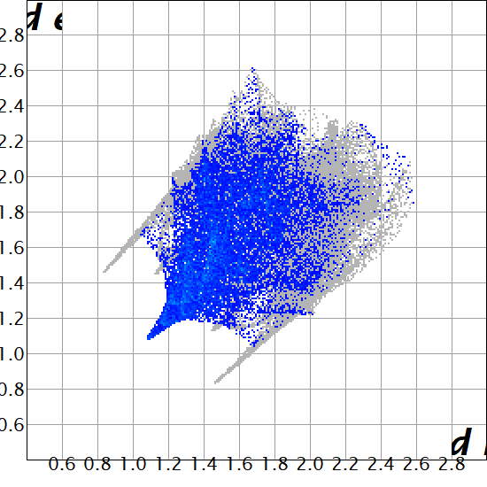 |  | H⋯H |  | 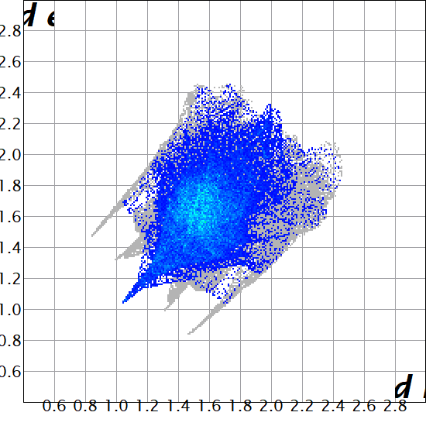
C⋯H | 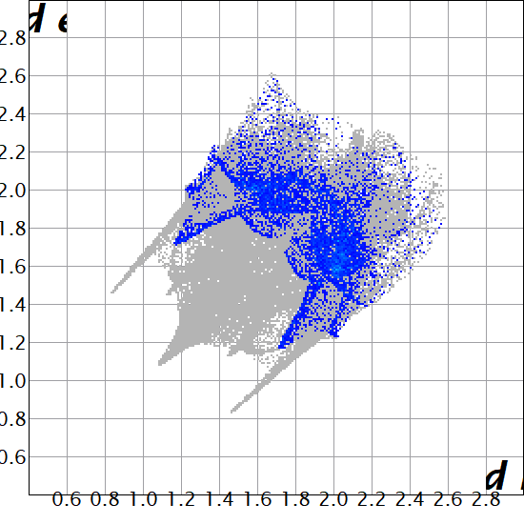 |  | C⋯H |  | 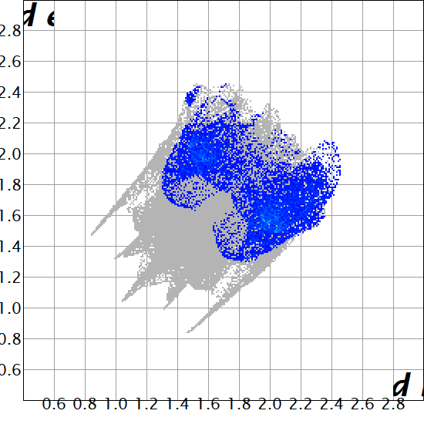
O⋯H | 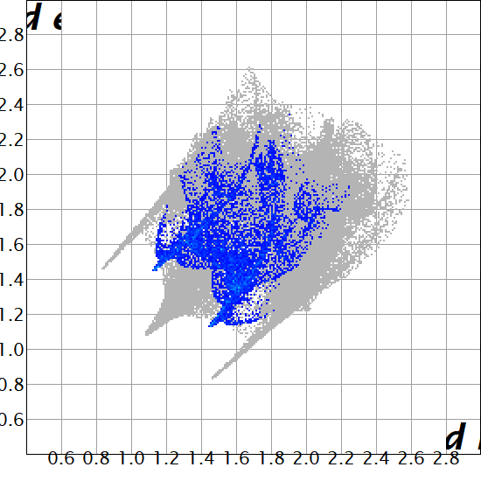 |  | O⋯H |  | 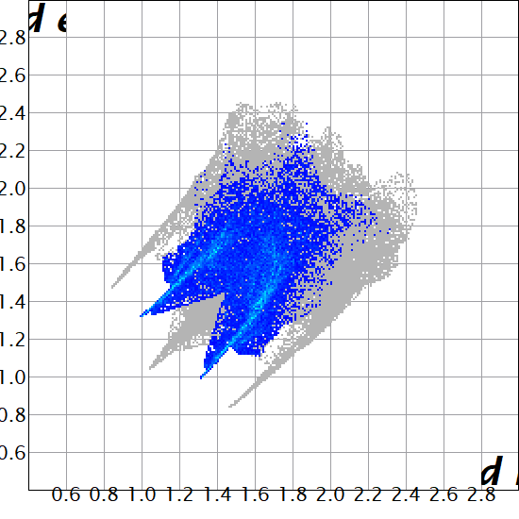
S⋯H | 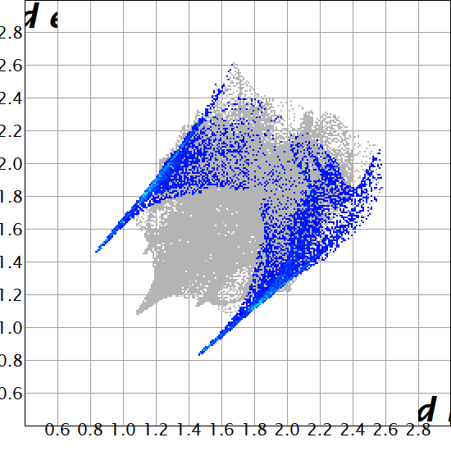 |  | N⋯H |  | 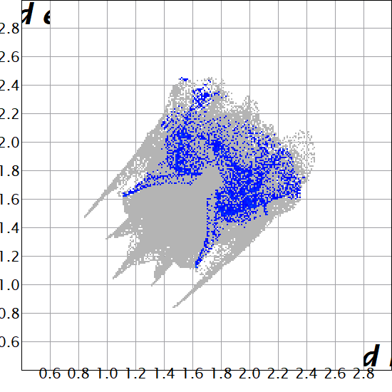
C⋯Cl | 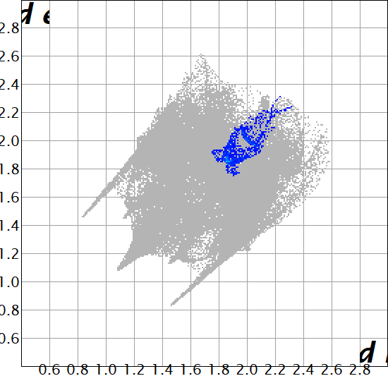 |  | S⋯H |  | 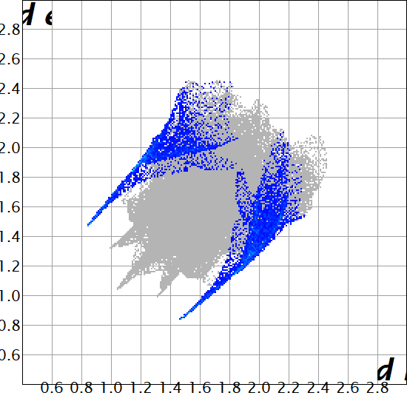
Cl⋯ Cl | 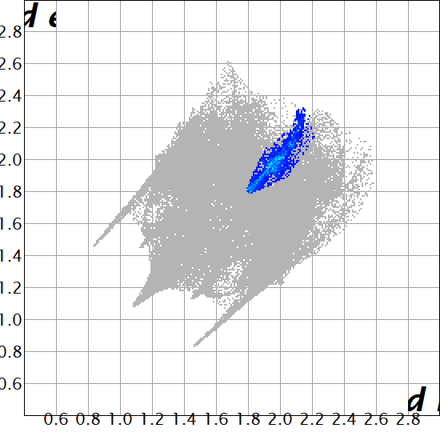 |  |  | C⋯O | 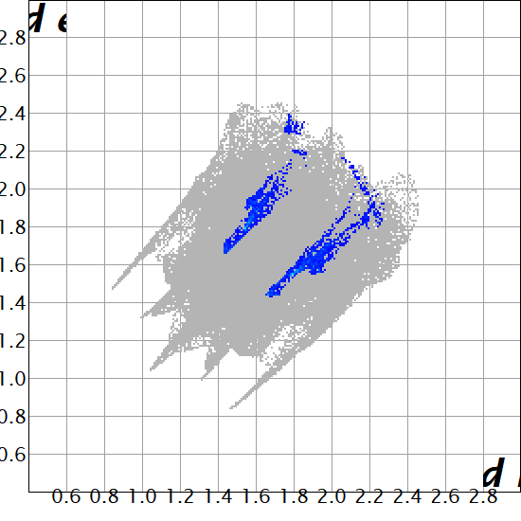
Cl⋯H | 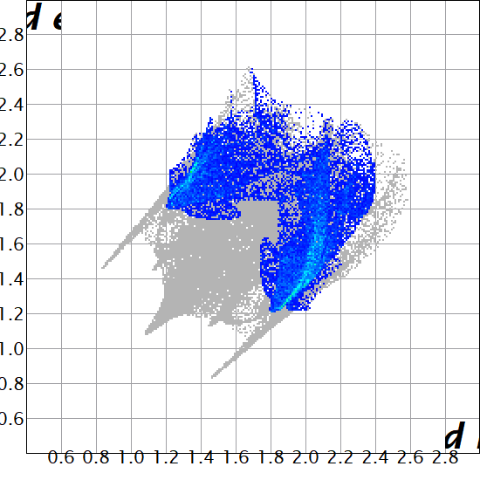 |  |  | S⋯O | 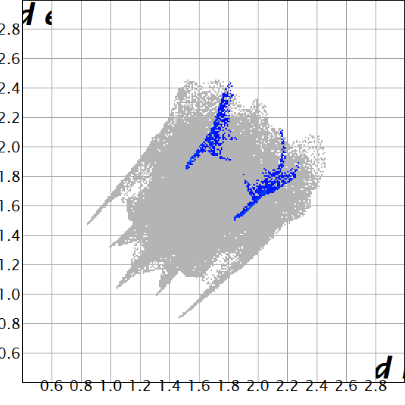
C⋯S | 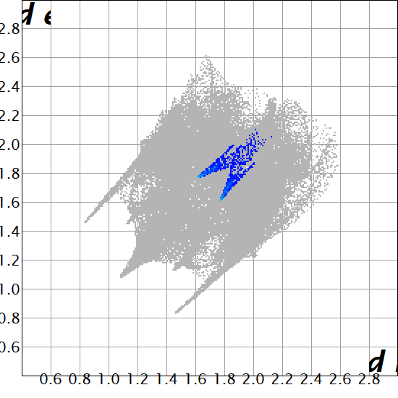 |  |  | O⋯O | 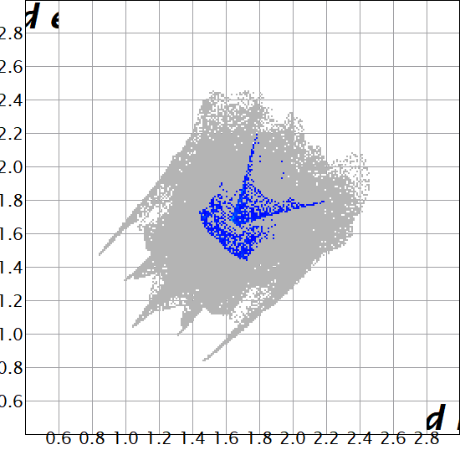
S⋯O | 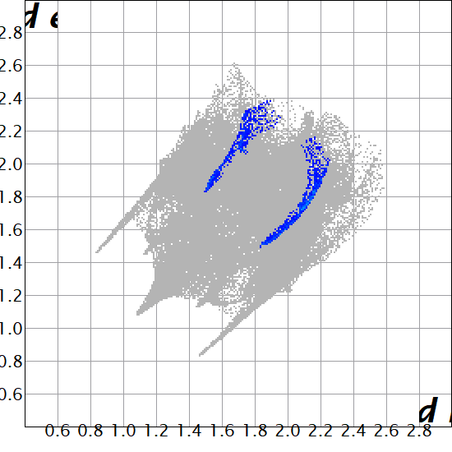

Table S 2: IC₅₀ values (µM) for the compounds 1−5 against seven human cancer cell lines; (cervical 2008 and C13*), (colorectal HT29 and HCT116) and (ovarian carcinoma A2780, A2780/CP and IGROV-1)

Compounds | 2008 | C13* | HT29 | HCT116 | A2780 | A2780/CP | IGROV-1
1 | 24.5±0.4 | 22.7±0.5 | 33.2±1 | 32.6±0.5 | 40.3±0.6 | 38.3±0.2 | 26.7±0.5
2 | 21.5±0.3 | 20.6±0.7 | 29.1±0.5 | 31.5±0.3 | 36.4±0.7 | 34.2±0.4 | 25.4±0.6
3 | 22.4±1 | 23.3±0.5 | 30.6±0.4 | 30.7±0.4 | 37.1±0.2 | 35.3±0.4 | 28.4±0.4
4 | 29.1±0.6 | 25.4±0.3 | 33.6±0.5 | 32.1±0.9 | 30.1±0.8 | 34.5±0.2 | 23.8±0.5
5 | 18.2±5 | 19.2±0.3 | 21.2±0.5 | 25.1±0.4 | 32.5±0.6 | 31.4±0.5 | 24.1±3
5-FU | 4.1±0.3 | 8.5±0.5 | 15.2±2.1 | 13.5±1.8 | 5.5±0.3 | 12.8±0.5 | 5.1±0.2

