[Supplemental Information]

Molecular cloning and characterization of type Ш polyketide synthase from Plumbago zeylanica

Seiichi Sakamoto^{a,†,*}, Yui Morita^{a,†}, Gorawit Yusakul^{a,b}, Waraporn Putalun^{c}, Hiroyuki Tanaka^{a,d}, Satoshi Morimotoª

ª Graduate School of Pharmaceutical Sciences, Kyushu University, 3-1-1 Maidashi, Higashi-ku, Fukuoka 812-8582, Japan
^{b} School of Pharmacy, Walailak University, Thaiburi, Thasala, Nakhon Si Thammarat 80160, Thailand
^{c} Faculty of Pharmaceutical Sciences, Khon Kaen University, Khon Kaen 40002, Thailand
^{d} Faculty of Pharmaceutical Sciences, Sanyo-Onoda City University, 1-1-1 Daigaku-dori, Sanyo-Onoda City 756-0884, Japan

† These authors contributed equally to this work.

Running title: Functional analysis of type III PKSs from P. zeylanica

*Corresponding author: Seiichi Sakamoto
Department of Pharmacognosy, Graduate School of Pharmaceutical Sciences,
Kyushu University; 3-1-1 Maidashi, Higashi-ku, Fukuoka 812-8582, Japan

E-mail: s.sakamoto@phar.kyushu-u.ac.jp Tel. & Fax: +81 92 642 6581

Table S1

Primers used for amplification of PKS1 and PKS2 cDNA fragments.

112K (Forward) | 5'- AAR GCI ITI AAR GAR TGG GGI CA -3'
174A (Forward) | 5'- GCI AAR GAY ITI GCI GAR AAY AA -3'
360T (Reverse) | 5'- CCC CAI TCI ARI CCI TCI CCI GTI GT -3'
3'-GSP1 (Forward) | 5'-ACA AGC CTT ATT CGG AGA CG -3'
3'-GSP2 (Forward) | 5'- CGA TCC TAG ACC AGG TTG AG -3'
Oligo dT-3sites Adaptor Primer | 5'- CTG ATC TAG AGG TAC CGG ATC C -3'
5'RT1 | 5'- GCA CAC AAG CGC TTG -3'
5'RT2 | 5'- CGT GGA GAG GCC AAT -3'
5'-GSP1 (Forward) | 5'- CAT CTC CTC AAG GAC GTT CC -3'
5'-GSP2 (Forward) | 5'- CCA GGT TGA GGA GAA ACT CG -3'
5'-GSP3 (Forward) | 5'- AGA ACA ACA AGG GAG CAC GAG -3'
5'-GSP4 (Forward) | 5'- TTC AGG AGC CGT CAT CAT C -3'
5'-GSP1 (Reverse) | 5'- CTC CTG AAC CGT CTC CGA AT -3'
5'-GSP2 (Reverse) | 5'- ATC TCT GAG CAT ACG ACG AG -3'
5'-GSP3 (Reverse) | 5'- GTC CTT CCG TCA AGC GAT TCA -3'
Full-length PKS2 (Forward) | 5'- CGC GAA TTC ATG GCC CCA TCT GTG GAA GAA-3'
Full-length PKS2 (Reverse) | 5'- TAT GCG GCC GCC TAG TTT ACA ACC GGG ACA CT-3'

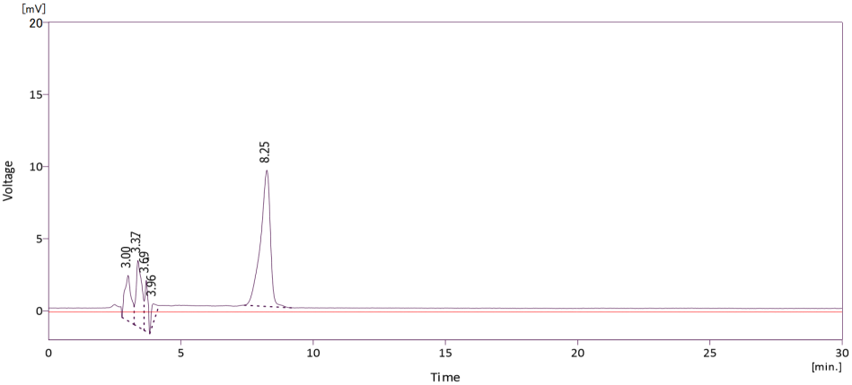
TAL
(A)

(B)
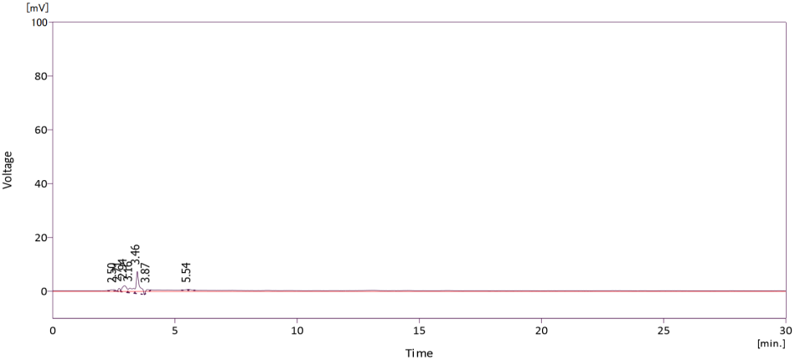

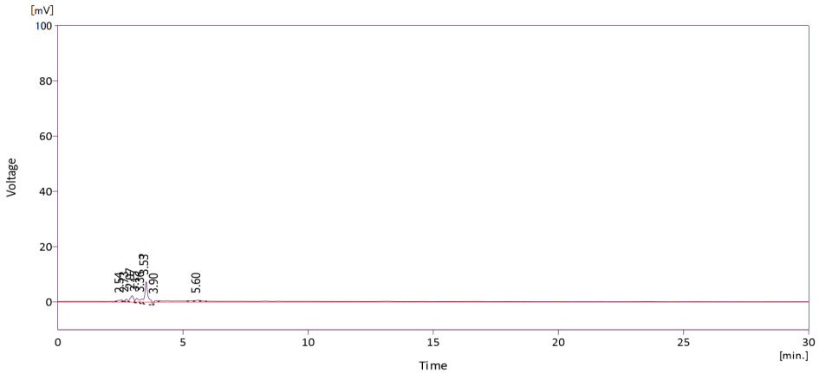
(C)

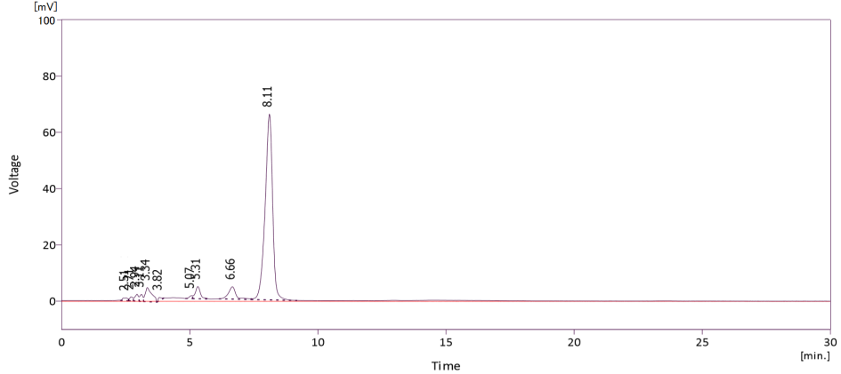
TAL
(D)

Figure S1 HPLC chromatograms of authentic TAL (A), purified PKS1 (B), substrate solution 1 (C), and reaction solution (D). Substrate solution 1 consists of acetyl-CoA and malonyl-CoA, and reaction solution consists of substrate solution 1 with purified PKS1. All solutions were prepared on the basis of 100 mM potassium phosphate buffer (pH 7.0). Solid arrow in (D) indicates the peak of TAL produced by PKS1.

(A)
Naringenin
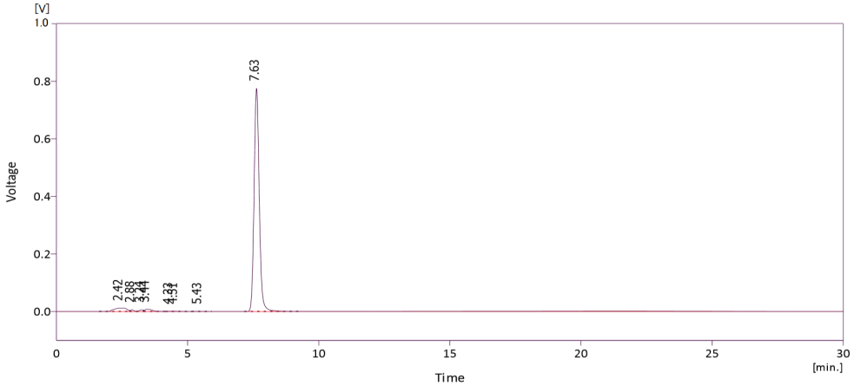

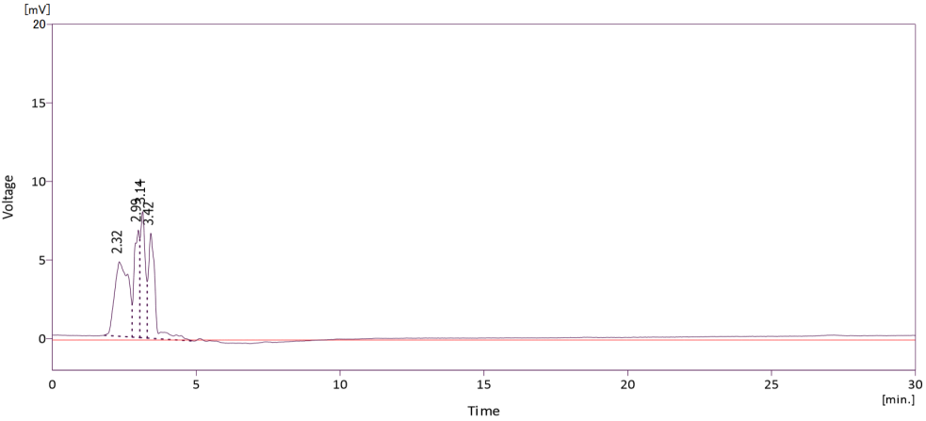
(B)

(C)
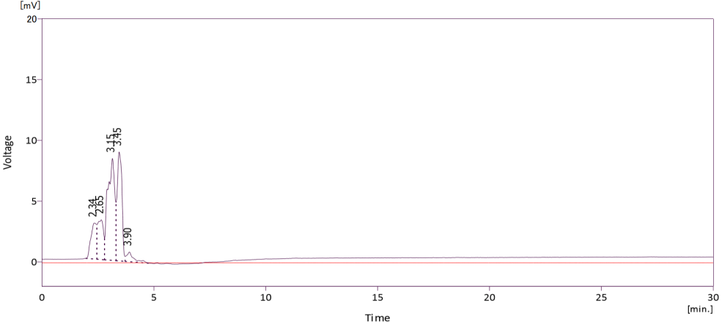

Naringenin
(D)
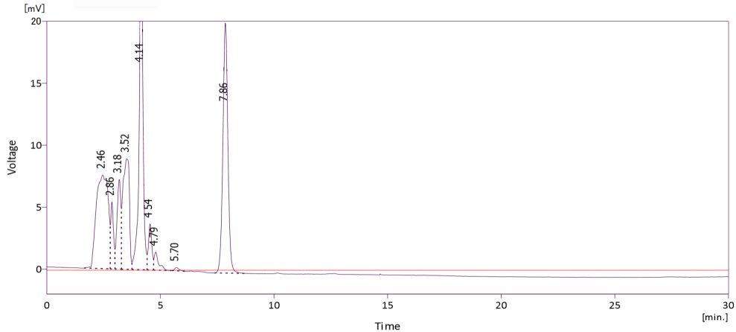

Figure S2 HPLC chromatograms of authentic naringenin (A), purified PKS2 (B), substrate solution 2 (C), and reaction solution (D). Substrate solution 2 consists of consists of p-coumaroyl-CoA and malonyl-CoA, and reaction solution consists of substrate solution 2 with purified PKS2. All solutions were prepared on the basis of 100 mM potassium phosphate buffer (pH 7.0). Solid arrow in (D) indicates the peak of naringenin produced by PKS2.

