Supplementary data

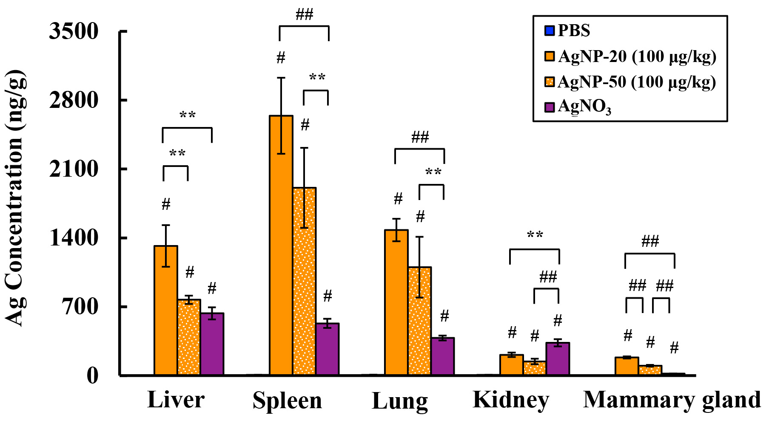
Figure S1. Ag concentration in major organs from mice exposed to AgNP-20 or AgNP-50 at 100 μg/kg body weight, or AgNO₃ at 157 μg/kg body weight (n = 8-10). Liver, spleen, lung, kidney, and the fourth and fifth pairs of mammary glands were collected and digested for the detection of total Ag content by ICP-MS. The symbol # represented P < 0.01 compared to the PBS control. Double asterisks (**) and double pound signs (##) denoted P < 0.05 and P < 0.01 for pairwise comparisons as shown, respectively.

