**Online Supplement**

Table S1. Weblinks to the 16 videos and brief descriptions of the traffic environment.

|  |  |  |  |  |
| --- | --- | --- | --- | --- |
|  | Busy city | Non-busy city | Secondary road | Highway |
| Europe | <https://youtu.be/CPWB9tZhT80?t=298> (04:58–05:58)  Central Amsterdam, The Netherlands. Narrow streets with a high density of cyclists and pedestrians. | <https://youtu.be/SvFIU7ZZDIc?t=96> (01:36–02:36)  Suburbs of The Hague, The Netherlands. One-way road with two lanes, separate bicycle path, and a signalized intersection. | <https://youtu.be/prlUz6V7ZUc?t=7804> (02:10:04–02:11:04)  Goch, Germany, close to the Dutch border. Two-way road. Only cars from the opposite direction are encountered. | <https://youtu.be/K3vTVN7e5zY?t=47> (00:47–01:47)  Dual carriageway A13 from Rotterdam to Delft, The Netherlands, with three lanes per direction, reduced to two for the last 10 s. The ego-vehicle drives at the rightmost lane. |
| India | <https://youtu.be/gjr4k0xJErw?t=58> (00:58–01:58)  Rewari district, Haryana, India. Narrow streets with a high density of cars, tuk-tuks, motorcyclists, and pedestrians. | <https://youtu.be/iss5ULIt13E?t=390> (06:30–07:30)  Bangalore, India. Very narrow street with traffic primarily in the direction of the ego-vehicle, with a few cars, motorcyclists, and pedestrians from the opposite direction. | <https://youtu.be/QXwr8IKp4nk?t=958> (15:58–16:58)  Chandigarh, India. Single carriageway with cars and motorcycles in both directions. | <https://youtu.be/QXwr8IKp4nk?t=26> (00:26–01:26)  Chandigarh, India. Dual carriageway with two lanes per direction. Cars and motorcycles present. |
| United States | <https://youtu.be/7HaJArMDKgI?t=4139> (01:08:59–01:09:59)  Manhattan, New York. One-way four-lane road. Primarily cars and busses, with a few cyclists. Ego-vehicle drives in the middle lane. | <https://youtu.be/bQ7mI-ODxEE?t=2051> (34:11–35:11)  Bronx, New York. One-way two-lane road, plus bicycle lane, and signalized intersections. Only cars, all at the direction of the ego-vehicle. | <https://youtu.be/6Y2hdqK1EnY?t=1281> (21:21–22:21)  Angeles Crest Highway, Los Angeles. One-way two-lane road and signalized intersections. Ego-vehicle drives at the left lane. | <https://youtu.be/Hsr9U8obex0?t=1617> (26:57–27:57)  Pomona Fwy (CA-60), CA. Dual carriageway with four lanes per direction. Ego-vehicle in the second rightmost lane. Traffic consists of cars and heavy vehicles. |
| Venezuela | <https://youtu.be/aMIlfYRhpO8?t=421> (07:01–08:01)  Caracas, Venezuela. Very narrow street at the first half of the video, broader road (single lane & parking lane) for the remainder of the video. Cars and pedestrians present. | <https://youtu.be/HUtLMMim_V0?t=5242> (01:27:22–01:29:22 sped up by 2x to achieve normal speed)  Caracas, Venezuela. One-direction broad road. Cars, buses, and pedestrians present. | <https://youtu.be/bTd6uHxW_Jc?t=507> (08:27–09:27)  Caracas, Venezuela. One-direction road in the first part of the video, two-direction road at the remainder. Cars and motorcyclists present. | <https://youtu.be/h5foQ470048?t=1755> (29:15–31:15 sped up by 2x to achieve normal speed)  Autopista Caracas – La Guaira, Caracas, Venezuela. Double carriageway with two lanes per direction. Ego-vehicle in the leftmost lane. |

Figures S1–S15 show the mean cumulative number of key presses per participant group (United States, Venezuela, India, Western Europe, and other participants) as a function of elapsed time for the Indian highway video. A steep upward slope of the line means that many participants pressed the response key at that point in the video. Furthermore, the top of the figure shows, for each 5-s interval of the video clip, the percentage of participants per participant group who had pressed the response key at least once within those 5 s. Also shown is the result of a chi-squared test, comparing the five participant groups regarding the number of participants who pressed the response key at least once versus the number of participants who pressed the response key zero times. Between parentheses is shown whether the results for participants from that world region differ significantly from participants from the United States (U), Venezuela (V), India (I), Western Europe (W), or other countries (O), as calculated using Fisher’s exact test. For example, “36% (O)” depicted in red between 25 and 30 s means that participants from the USA were more likely to press the response key (36%) than participants from other countries (16%) for that 5-s interval.



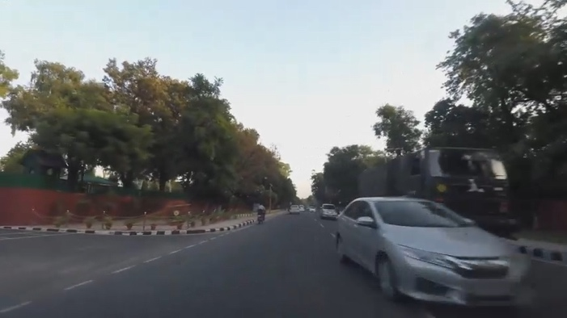 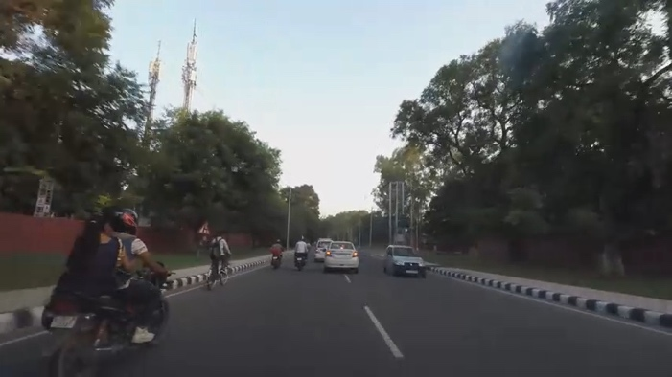

*Figure S1.* India, Secondary road. Screenshots: 19 s and 57 s.



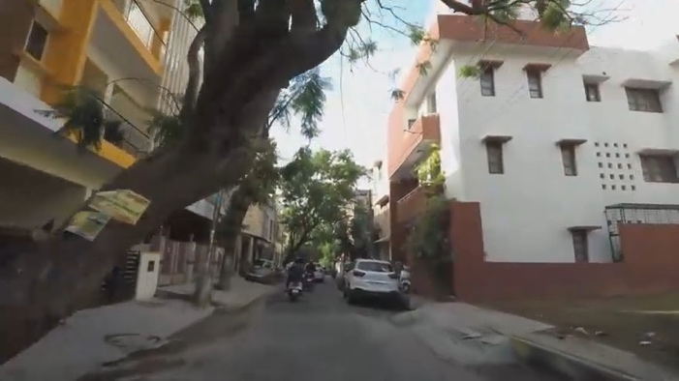 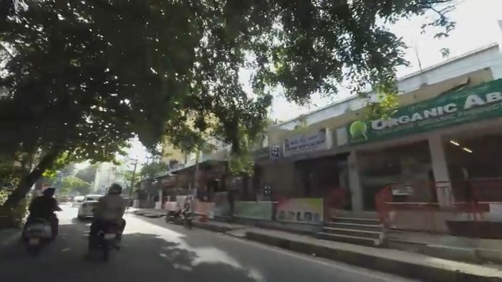

*Figure S2.* India, Non-busy city. Screenshots: 11 s and 56 s.



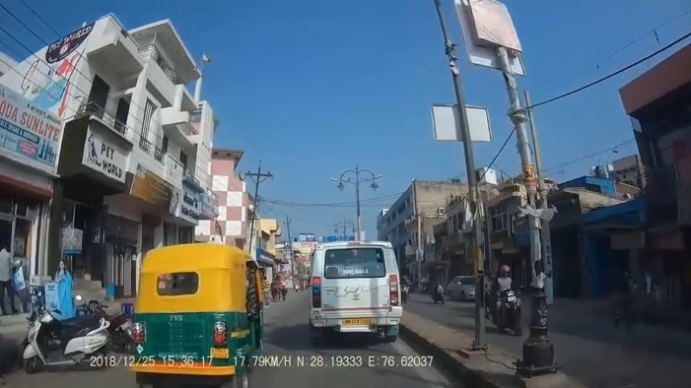 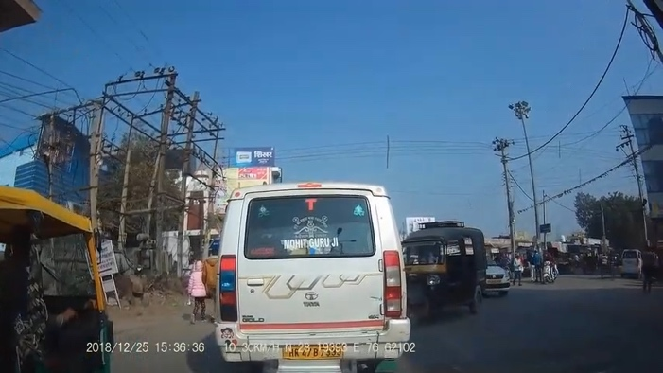

*Figure S3.* India, Busy city. Screenshot: 8 s and 27 s.



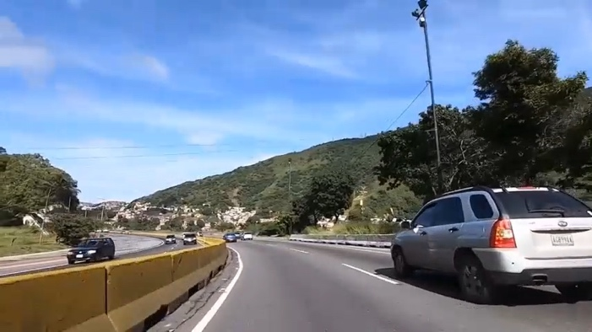 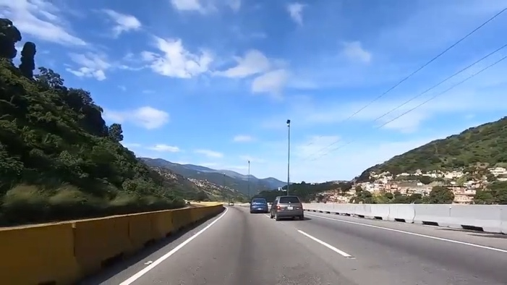

*Figure S4.* Venezuela, Highway. Screenshots: 9 s and 28 s.



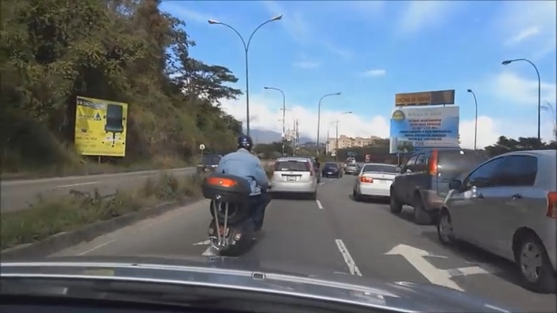 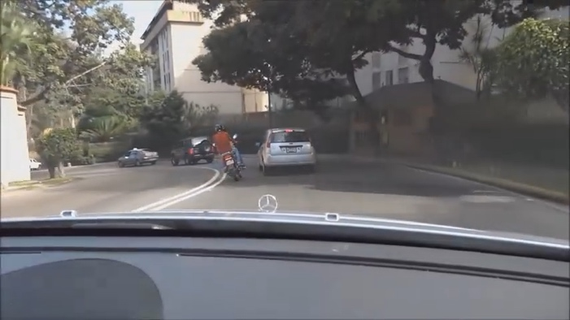

*Figure S5.* Venezuela, Secondary road. Screenshots: 9 s and 47 s.



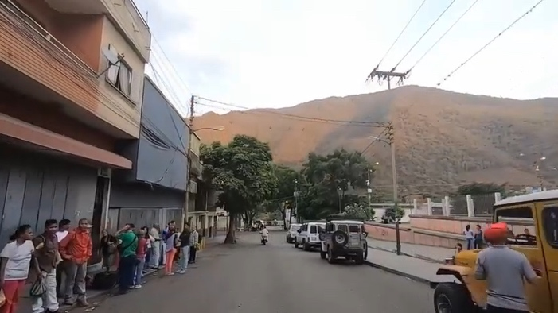 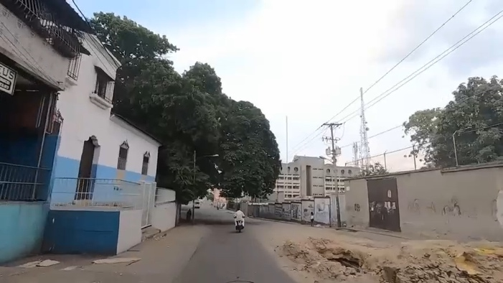

*Figure S6.* Venezuela, Non-busy city. Screenshots: 33 s and 50 s.



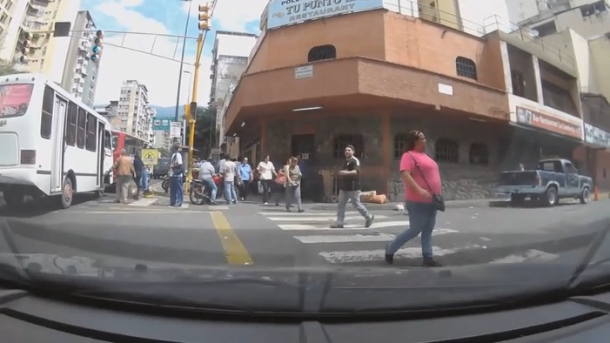 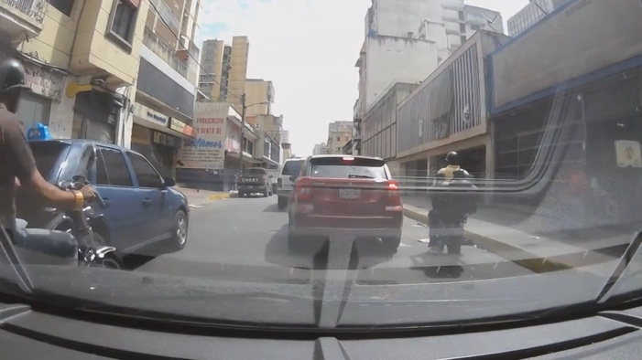

*Figure S7.* Venezuela, Busy city. Screenshots: 28 s and 49 s.



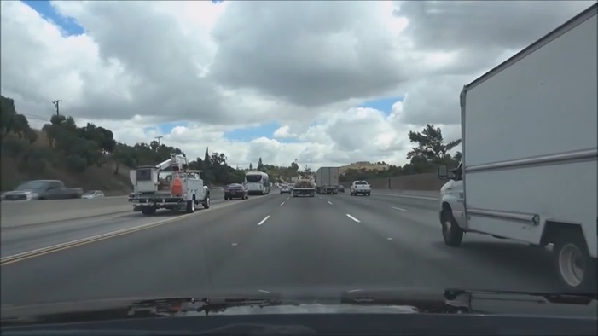 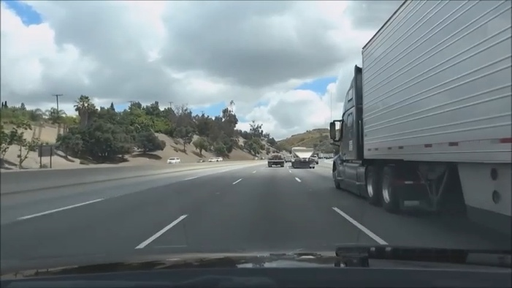

*Figure S8.* United States, Highway. Screenshots: 22 s and 36 s.



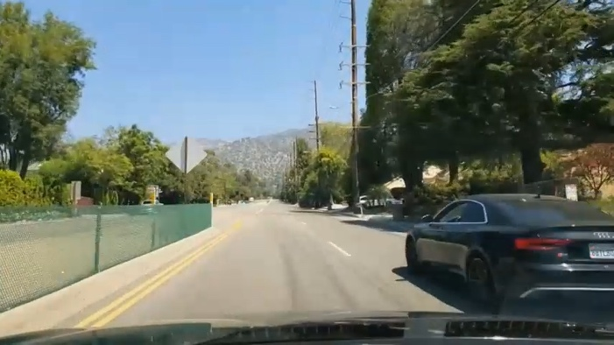 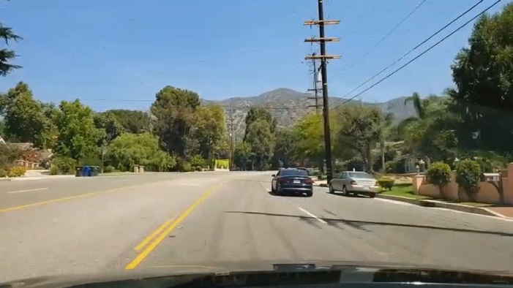

*Figure S9.* United States, Secondary road. Screenshots: 34 s and 59 s.



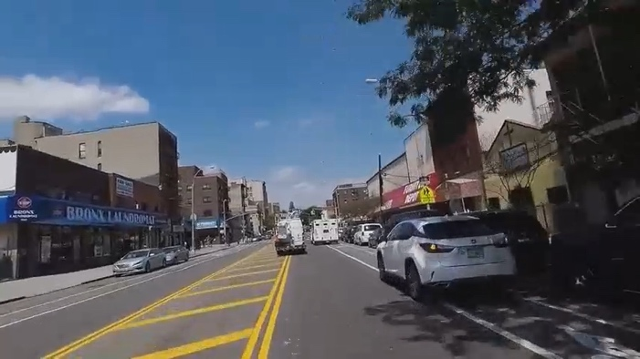 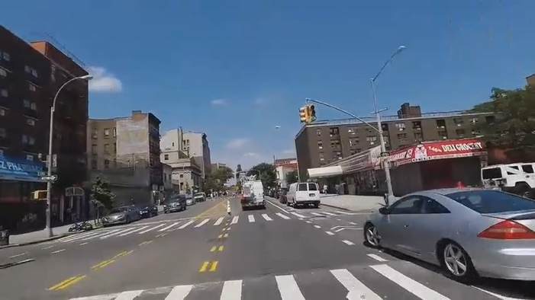

*Figure S10.* United States, Non-busy city. Screenshots: 27 s and 33 s.



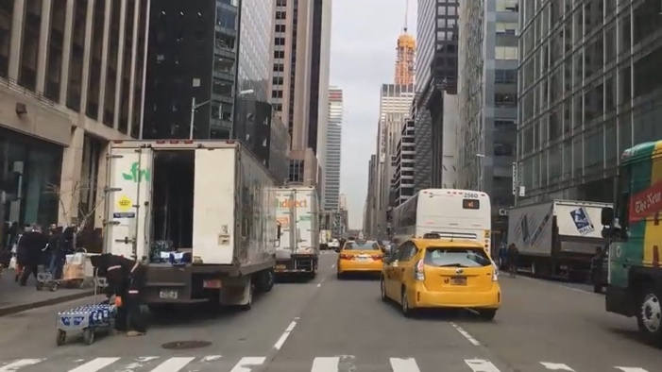 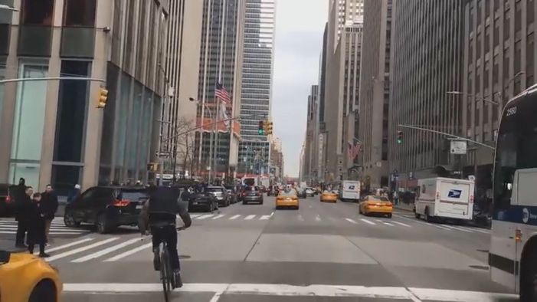

*Figure S11.* United States, Busy city. Screenshots: 8 s and 42 s.



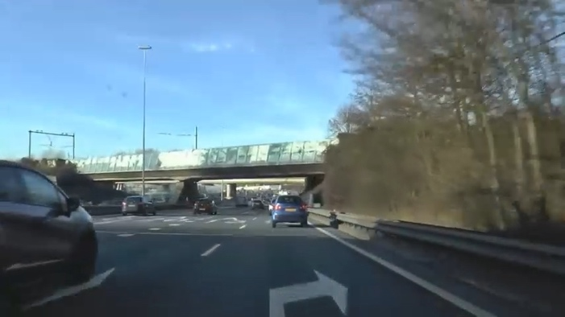 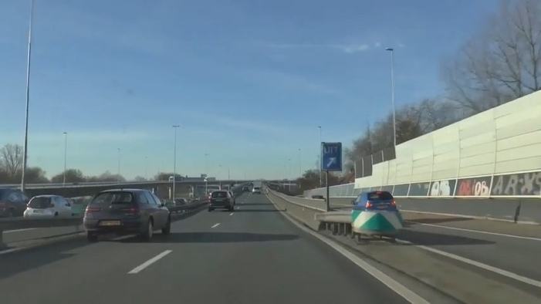

*Figure S12.* Western Europe, Highway. Screenshots: 18 s and 48 s.



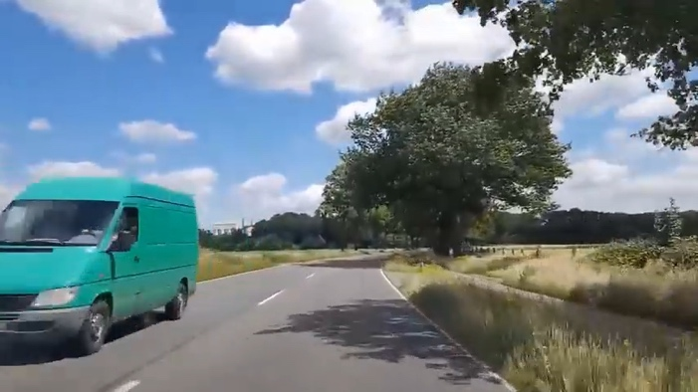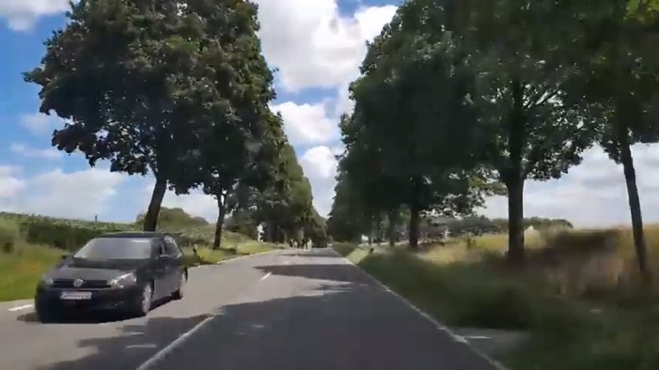

*Figure S13.* Western Europe, Secondary road. Screenshots: 10 s and 42 s.



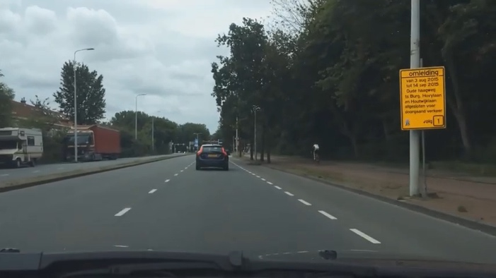 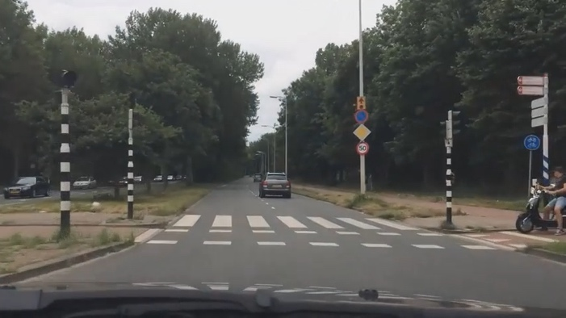

*Figure S14.* Western Europe, Non-busy city. Screenshots: 18 s and 43 s.



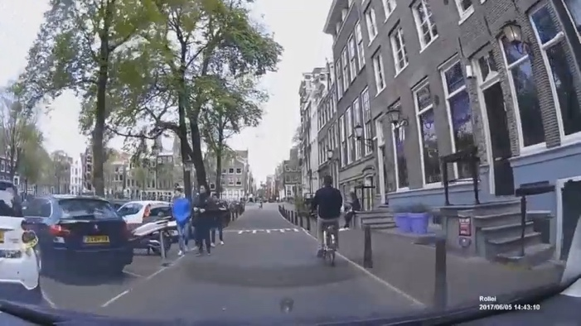 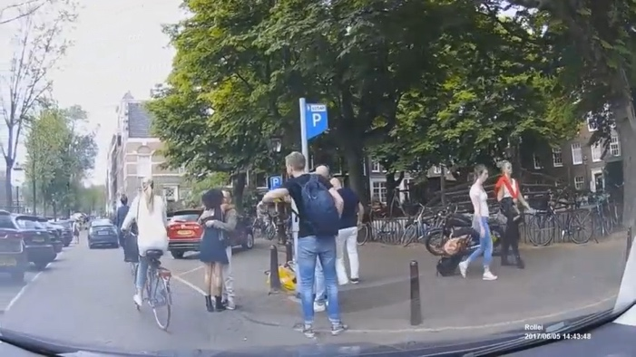

*Figure S15.* Western Europe, Busy city. Screenshots: 20 s and 58 s.