Catching S2- and Cu2+ by a highly sensitive and efficient salamo-like fluorescence-ultraviolet dual channel chemosensor

**Hao-Ran Mua, Meng Yua, Lan Wanga, Yang Zhang a[1]* & Yu-Jie Ding b\***

a School of Chemical and Biological Engineering, Lanzhou Jiaotong University, Lanzhou, Gansu, 730070, PR China

**b** College of Biochemical Engineering, Anhui Polytechnic University, Wuhu, AnHui, 241000, PR China

Email: [zhangy8124@163.com](mailto:zhangy8124@163.com;)

**Supplemental Materials**

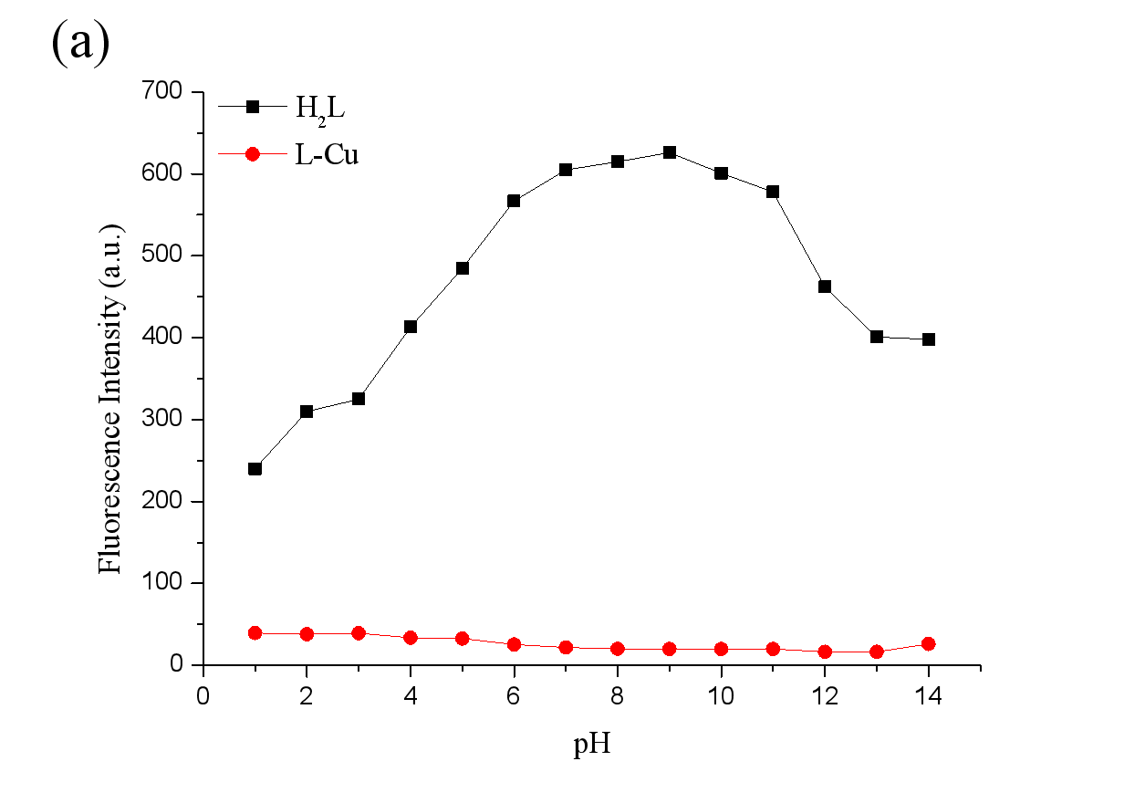

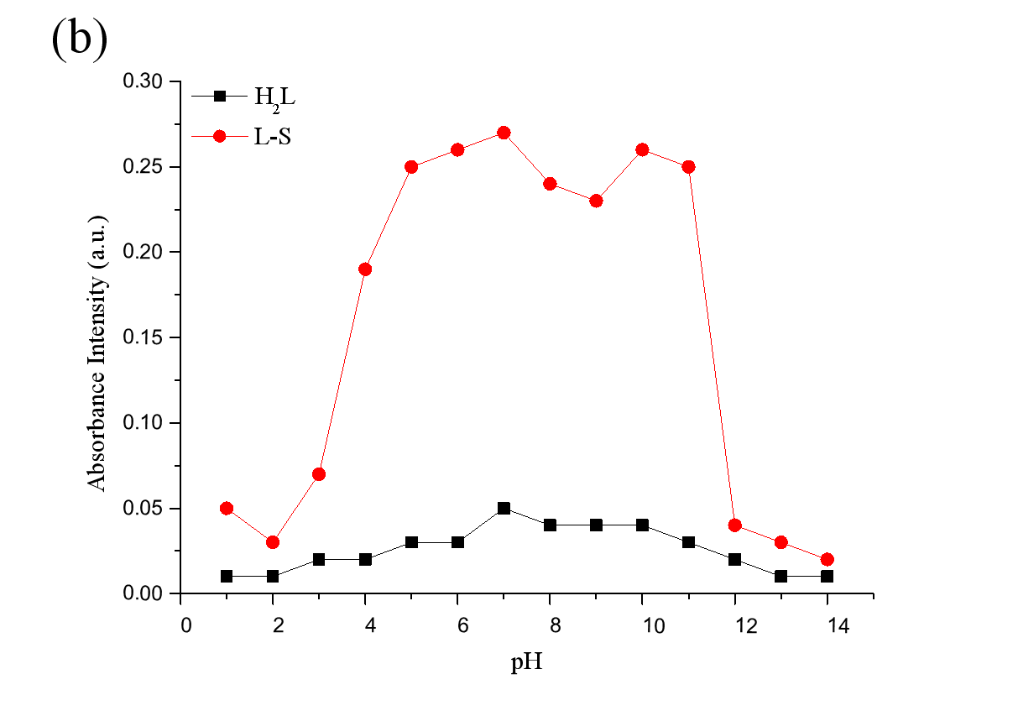

**Figure S 1.** (a) Fluorescence intensities of probe **H2L** and **L-Cu** performed at various pH values at room temperature, λEx = 311 nm. (b) Absorbance spectra at 356 nm of probe **H2L** in the absence and presence of S2−at various pH values at room temperature.



**Figure S 2.** Fluorescence spectra of **H2L** in the presence of different concentration Cu2+ (0.0 to 1.0 equiv.) in triphosphate buffer solution.



**Figure S 3.** Jobʹs plots of the complexion between **L-Cu** complex in triphosphate buffer solution. The total concentration of **H2L** and Cu2+was 20 μM.

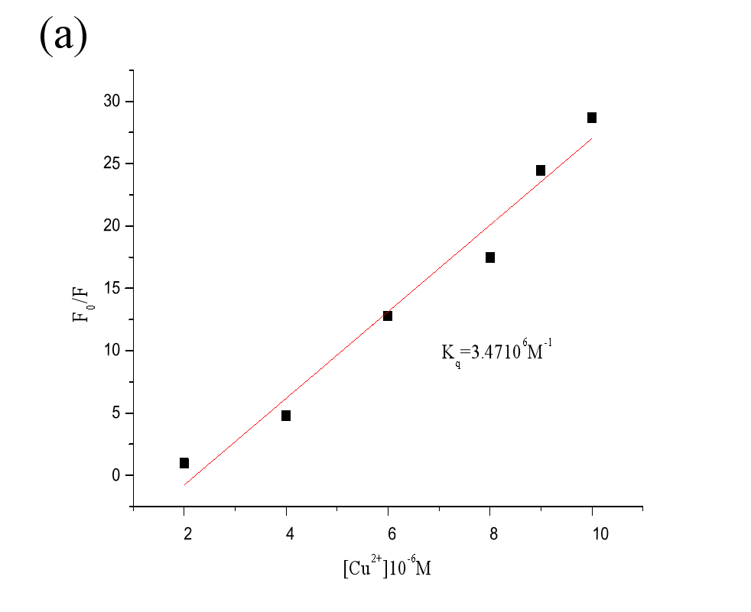

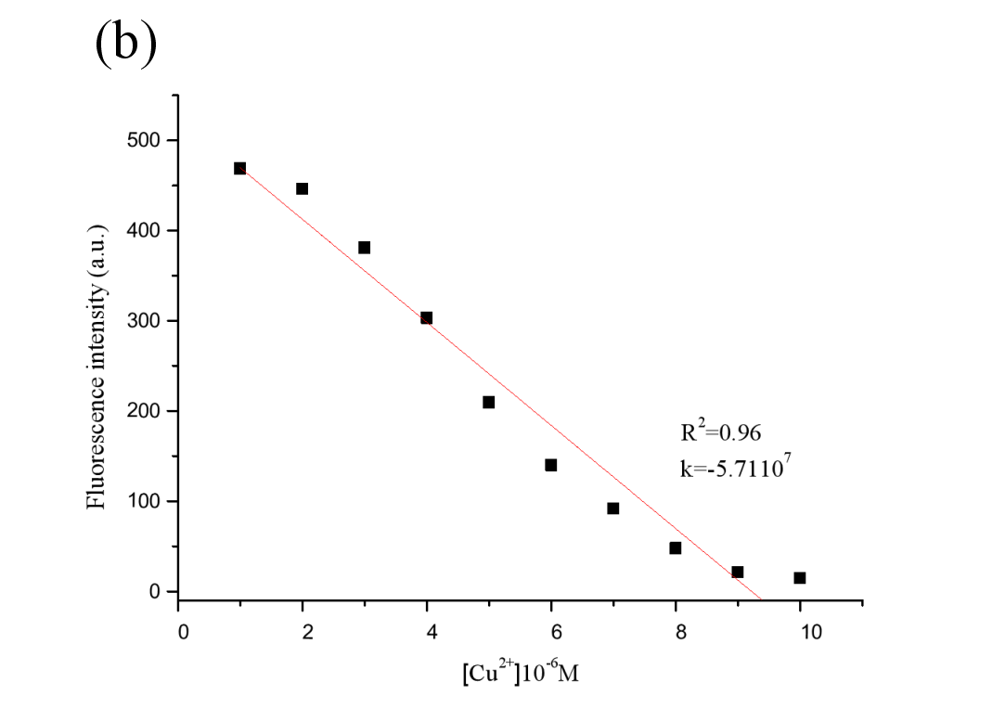

**Figure S 4.** (a) Determination of association constant of **H2L** for Cu2+ in triphosphate buffer solution. (b) Fluorescence detection limit spectra of **H2L** in triphosphate buffer solution upon adding of a concentration of Cu2+.



**Figure S 5.** Changes in UV-Vis absorption spectra of the probe **H2L** solution upon the addition of S2−(0~1.0 equiv).

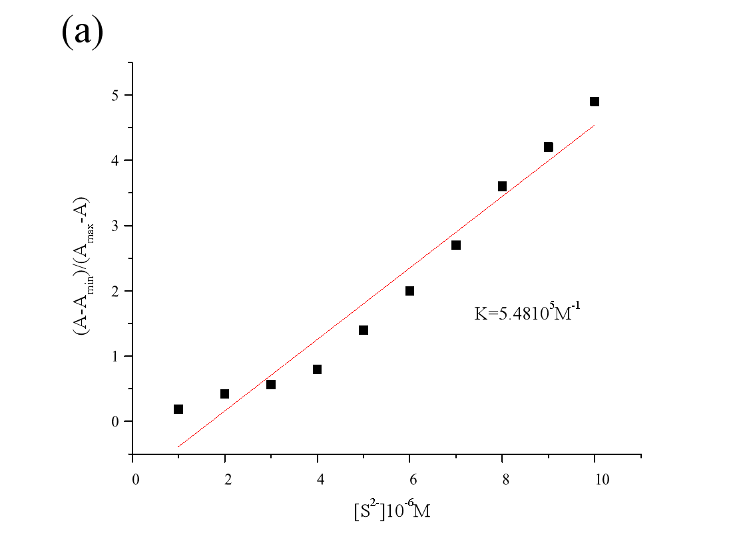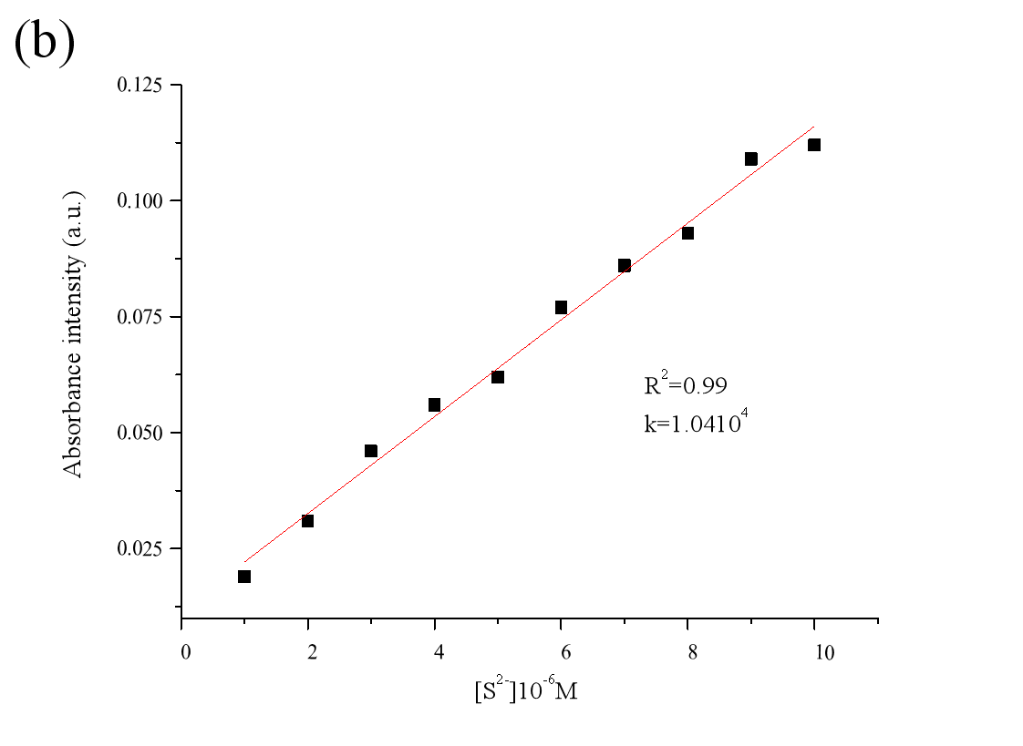

**Figure S 6.** (a) Linear fitting of the probe **H2L** to S2− binding constant. (b) Benesi-Hildebrand plot of the probe **H2L** adding different concentration S2−.

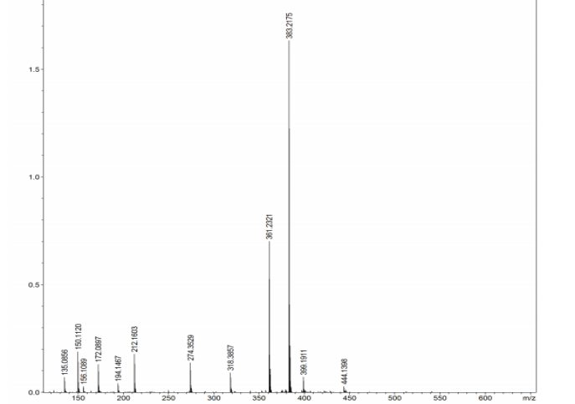

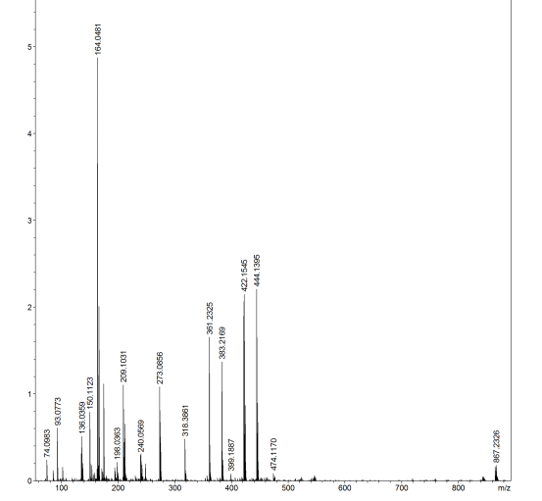

**Figure S 7.** Mass spectrometry analysis on **H2L** and **L-Cu** complex.

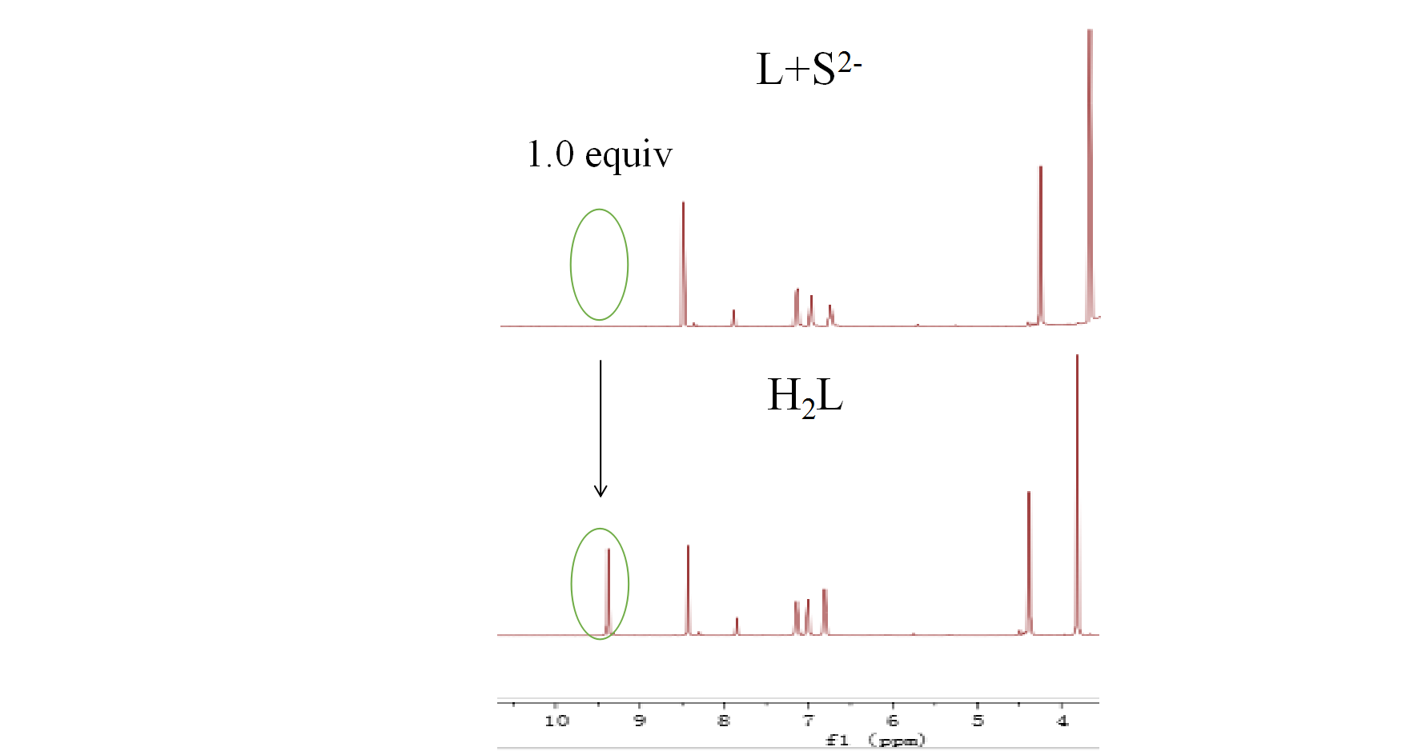

**Figure S 8:** 1H NMR titrations analysis on **H2L** and **L-S** complex.

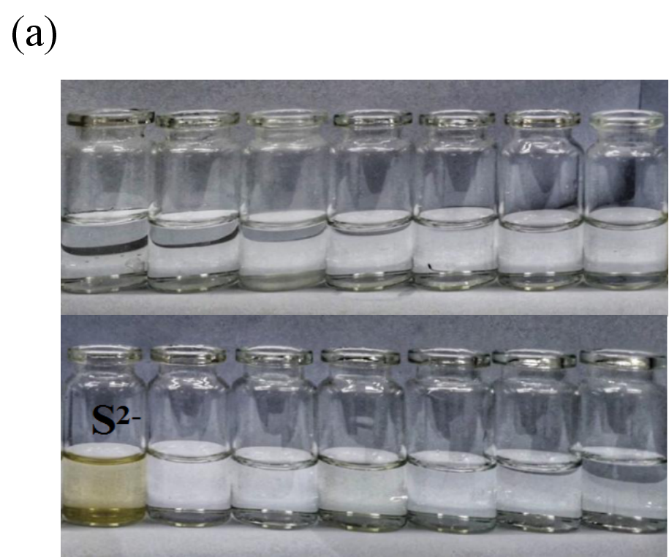

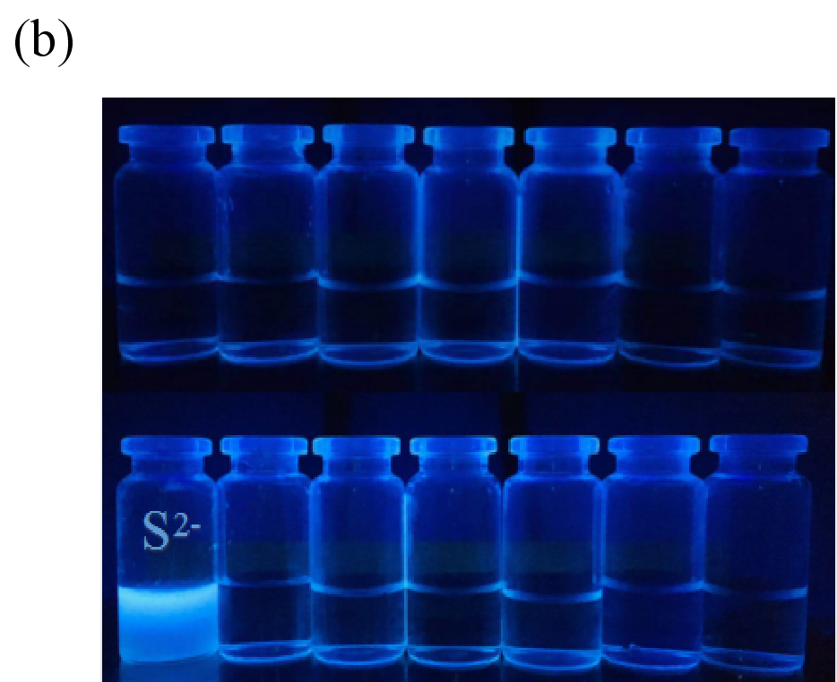

**Figure S 9.** (a) Naked eye recognition S2- under natural light. (b) Naked eye recognition S2- under UV-Vis light at 365 nm

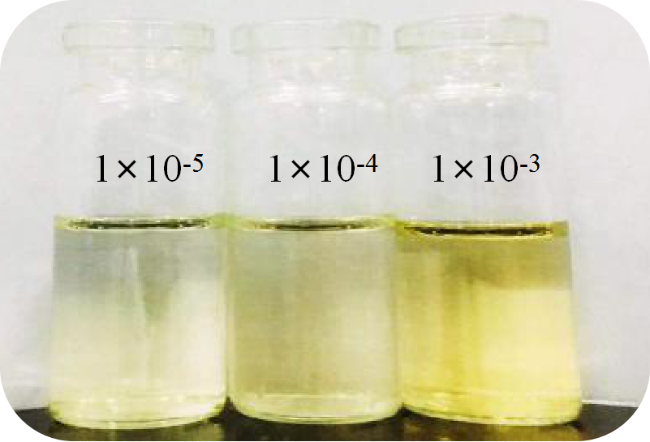

**Figure S 10.** Detection of different concentrations of S2− by probe **H2L** (1 × 10-5 M) under natural light.

1.