**Title:** The Cost Effectiveness of Pembrolizumab versus Chemotherapy or Atezolizumab as Second-Line Therapy for Advanced Urothelial Carcinoma in the United States

**Authors:** Rachael Louise Slater, MSc1; Yizhen Lai, MSc2; YichenZhong, MHS2; Haojie Li, MD, PhD2;Yang Meng, PhD1; Blanca Homet Moreno, MD, PhD2; James Luke Godwin, MD2; Tara Frenkl, MD, MPH2; Guru P Sonpavde, PhD3; Ronac Mamtani, MD, MSCE4.

1BresMed Health Solutions Ltd, Sheffield, UK; 2Merck & Co, Inc., Kenilworth, NJ, US; 3Dana-Farber Cancer Institute, MA, US; 4Abramson Cancer Center, University of Pennsylvania, Philadelphia, PA, US;

## Supplementary appendix

### Base case parameters

Supplementary Table 1: Base case parameters with sensitivity ranges

| Parameters | Mean/ deterministic value | Lower Bound | Upper Bound | Distribution | Source |
| --- | --- | --- | --- | --- | --- |
| ***General information*** | | | | | |
| Model cycle length (weeks) | 1.00 |  |  | Not varied in SA |  |
| Model time horizon (years) | 20.00 |  |  | Not varied in SA |  |
| Discount rate: costs | 3.00% | 0.00% | 5.00% |  | ICER framework[1] |
| Discount rate: health outcomes | 3.00% | 0.00% | 5.00% |  |
| ***Patient information*** | | | | | |
| Patient age | 65.00 | 60.00 | 70.00 | ±5 years | KN-045 |
| Average patient weight (kg) | 73.58 | 70.87 | 76.39 | Log normal |
| Average patient BSA (m2) | 1.85 | 1.49 | 2.21 | Normal |
| ***Utility inputs*** | | | | | |
| ***Utility by time to death (pooled)*** | | | | | |
| ≥360 days | 0.85 | 0.84 | 0.86 | Beta | KN-045 |
| 180-360 days | 0.78 | 0.77 | 0.80 | Beta |
| 90-180 days | 0.70 | 0.68 | 0.72 | Beta |
| 30-90 days | 0.60 | 0.57 | 0.63 | Beta |
| <30 days | 0.51 | 0.43 | 0.58 | Beta |
| ***Utility by progression status (pooled)*** | | | | | |
| Progression-free state | 0.81 | 0.80 | 0.82 | Beta | KN-045 |
| Progressive disease state | 0.73 | 0.71 | 0.75 | Beta |
| ***Regimen related costs*** | | | | | |
| ***Drug costs per dose*** | | | | | |
| Pembrolizumab | $9,299.28 |  |  | Not varied in SA | AnalySource[2] |
| Paclitaxel or docetaxel | $246.34 |  |  | Not varied in SA |
| Atezolizumab | $8,749.30 |  |  | Not varied in SA |
| ***Administration cost for IV*** | | | | | |
| Cost for first hour infusion | $144.72 | $116.36 | $173.08 | Normal | CMS[3] |
| Cost for additional hour infusion (for every hour after first) | $31.68 | $25.47 | $37.89 | Normal |
| ***Subsequent treatment costs*** | | | | | |
| Pembrolizumab | $1,919.92 | $1,543.63 | $2,296.22 | Normal | CMS[4] |
| Chemotherapy | $1,832.37 | $1,473.23 | $2,191.51 | Normal |
| Atezolizumab | $1,919.92 | $1,543.63 | $2,296.22 | Normal |
| ***Disease management costs by progression*** | | | | | |
| PF: Months 0-12 | $2,129.78 | $1,781.51 | $2,478.04 | Normal | SEER study[5] |
| PF: Months 12-24 | $1,082.76 | $325.48 | $1,840.04 | Normal |
| PF: 24+ months | $5,54.80 | $84.13 | $1,025.48 | Normal |
| PP: Months 0-12 | $2,674.55 | $1,714.96 | $3,634.15 | Normal |
| PP: Months 12-24 | $1,971.38 | $1,337.20 | $2,605.56 | Normal |
| PP: 24+ months | $1,327.66 | $709.22 | $1,946.11 | Normal |
| Cost of end of life (last 30 days) | $9,551.62 | $7,994.40 | $11,108.83 | Normal |
| ***Disease management costs by time to death*** | | | | | |
| >= 360 days | $1,801.28 | $1,339.79 | $2,262.78 | Normal | SEER study[5] |
| [180,360) days | $2,384.51 | $1,731.46 | $3,037.55 | Normal |
| [90, 180) days | $2,066.67 | $1,706.04 | $2,427.31 | Normal |
| [30, 90) days | $3,440.62 | $2,697.50 | $4,183.74 | Normal |
| Cost of end of life (last 30 days) | $9,551.62 | $7,994.40 | $11,108.83 | Normal |
| ***Adverse events*** | | | | | |
| ***% AE pembrolizumab*** | | | | | |
| Anemia | 0.75% | 0.16% | 2.39% | Beta | KN-045 |
| Fatigue | 1.13% | 0.32% | 2.98% | Beta |
| Febrile neutropenia | 0.00% | 0.00% | 0.00% | Beta |
| Lymphocyte count decreased | 0.38% | 0.04% | 1.74% | Beta |
| Neutropenia | 0.00% | 0.00% | 0.00% | Beta |
| Neutrophil count decreased | 0.38% | 0.04% | 1.74% | Beta |
| White blood cell count decreased | 0.38% | 0.04% | 1.74% | Beta |
| Asthenia | 0.00% | 0.00% | 0.00% | Beta |
| Peripheral sensory neuropathy | 0.00% | 0.00% | 0.00% | Beta |
| Diarrhea | 2.63% | 1.07% | 4.86% | Beta |
| Leukopenia | 0.00% | 0.00% | 0.00% | Beta |
| ***%AE Control*** | | | | | |
| Anemia | 9.52% | 5.58% | 14.38% | Beta | KN-045 |
| Fatigue | 5.95% | 2.91% | 9.98% | Beta |
| Febrile neutropenia | 4.76% | 2.09% | 8.45% | Beta |
| Lymphocyte count decreased | 2.38% | 0.81% | 5.56% | Beta |
| Neutropenia | 10.71% | 6.51% | 15.80% | Beta |
| Neutrophil count decreased | 14.29% | 9.43% | 19.95% | Beta |
| White blood cell count decreased | 5.95% | 2.91% | 9.98% | Beta |
| Asthenia | 0.00% | 0.00% | 0.00% | Beta |
| Peripheral sensory neuropathy | 2.98% | 1.14% | 6.40% | Beta |
| Diarrhea | 3.57% | 1.33% | 6.85% | Beta |
| Leukopenia | 2.98% | 1.14% | 6.40% | Beta |
| ***%AE atezolizumab*** | | | | | |
| Anemia | 1.96% | 0.90% | 3.41% | Beta | IMvigor211[6] |
| Fatigue | 1.53% | 0.62% | 2.83% | Beta |
| Febrile neutropenia | 0.22% | 0.02% | 1.01% | Beta |
| Lymphocyte count decreased | NR | - | - | Beta |
| Neutropenia | 0.44% | 0.09% | 1.39% | Beta |
| Neutrophil count decreased | 0.00% | 0.00% | 0.00% | Beta |
| White blood cell count decreased | 0.00% | 0.00% | 0.00% | Beta |
| Asthenia | 1.74% | 0.76% | 3.12% | Beta |
| Peripheral sensory neuropathy | 0.00% | 0.00% | 0.00% | Beta |
| Diarrhea | NR | - | - | Beta |
| Leukopenia | NR | - | - | Beta |
| ***AE unit costs*** | | | | | |
| Anemia | $7,530.12 | $6,054.25 | $9,006.00 | Normal | Agency for Health care research and Quality[7] |
| Fatigue | $7,950.87 | $6,392.53 | $9,509.21 | Normal |
| Febrile neutropenia | $13,279.65 | $10,676.89 | $15,882.41 | Normal |
| Lymphocyte count decreased | $7,085.52 | $5,696.78 | $8,474.25 | Normal |
| Neutropenia | $13,308.93 | $10,700.43 | $15,917.43 | Normal |
| Neutrophil count decreased | $13,279.65 | $10,676.89 | $15,882.41 | Normal |
| White blood cell count decreased | $7,085.52 | $5,696.78 | $8,474.25 | Normal |
| Asthenia | $7,950.87 | $6,392.53 | $9,509.21 | Normal |
| Peripheral sensory neuropathy | $8,734.90 | $7,022.89 | $10,446.91 | Normal |
| Diarrhea | $7,563.74 | $6,081.27 | $9,046.20 | Normal |
| Leukopenia | $7,085.52 | $5,696.78 | $8,474.25 | Normal |
| **Survival models – all histology, overall population** | | | | | |
| ***PFS parametric curve fitting*** | | | | | |
| ***Pembrolizumab*** | | | | | |
| Log logistic intercept | 3.87 |  |  | Multivariate normal | KN-045 |
| Log logistic log(scale) | 0.10 |  |  | Multivariate normal |
| Log logistic shape | 0.00 |  |  | Multivariate normal |
| ***Paclitaxel + docetaxel*** | | | | | |
| Exponential rate | 3.27 |  |  | Multivariate normal | KN-045 |
| ***OS parametric curve fitting*** | | | | | |
| ***Pembrolizumab*** | | | | | |
| Log logistic intercept | 4.12 |  |  | Multivariate normal | KN-045 |
| Log logistic log(scale) | 0.05 |  |  | Multivariate normal |
| Log logistic shape | 0.00 |  |  | Multivariate normal |
| ***Paclitaxel + docetaxel*** | | | | | |
| Exponential intercept | 4.01 |  |  | Multivariate normal | KN-045 |
| ***ToT parametric curve fitting*** | | | | | |
| ***Paclitaxel + docetaxel*** | | | | | |
| Generalized gamma intercept | 2.60 |  |  | Multivariate normal | KN-045 |
| Generalized gamma log(scale) | 0.03 |  |  | Multivariate normal |
| Generalized gamma shape | 1.52 |  |  | Multivariate normal |
| **Atezolizumab survival outcomes** | | | | | |
| MAIC constant HR | 0.72 | 0.53 | 0.97 | Lognormal | Gelb et al [8] |
| NMA constant HR | 0.83 | 0.63 | 1.07 | Lognormal |
| **Key:** 2L, second-line; AE, adverse event; BSA, body surface area; HR, hazard ratio; IV, intravenous; MAIC, match-adjusted indirect comparison; NMA, network meta-analysis; OS, overall survival; PF, progression-free; PFS, progression-free survival; PP, post-progression; SA, sensitivity analysis; ToT, time on treatment. | | | | | |

### Curve selection

**Time on treatment**

The parametric fittings for ToT in pembrolizumab did not capture well the time on treatment pattern with a protocol-specified 2 year stopping rule. Therefore, the model used the KM ToT directly for pembrolizumab (see Supplementary Figure 1).

Supplementary Figure : ToT KM data with standard parametric curve fittings - pembrolizumab

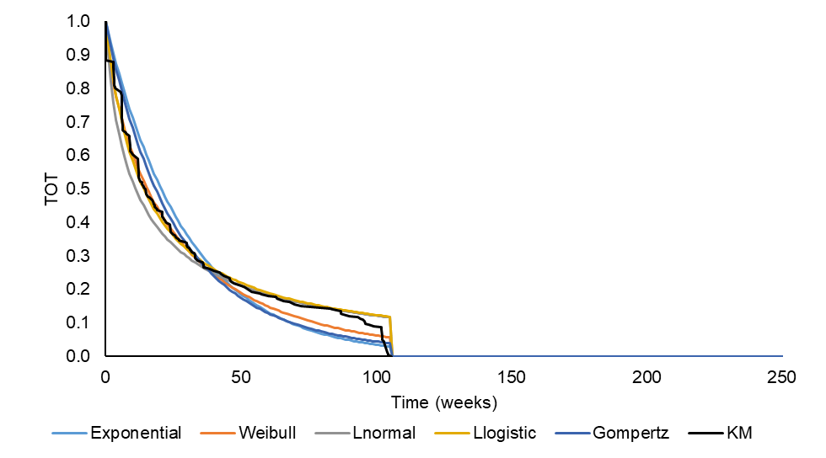

**Key:** KM, Kaplan-Meier; ToT, time on treatment

**Note:** Stopping rule applied to the parametric curves (2-years). Generalised gamma did not converge.

For the chemotherapy arm, the AIC and BIC combined with visual inspection were used to select the generalized gamma distribution (Supplementary Figure 2 and Supplementary Table 2)

Supplementary Table : ToT – AIC and BIC statistics – chemotherapy

| Distribution | AIC | BIC |
| --- | --- | --- |
| Exponential | 1145.4 | 1148.5 |
| Weibull | 1139.8 | 1146 |
| Gompertz | 1147 | 1153.2 |
| Log logistic | 1184 | 1190.2 |
| Log normal | 1193.6 | 1199.8 |
| Generalised Gamma | **1134.2** | **1143.6** |
| **Key:** AIC, Akaike information criterion; BIC, Bayesian information criterion; ToT, time on treatment. | | |

Supplementary Figure : ToT KM data with standard parametric curve fittings – chemotherapy

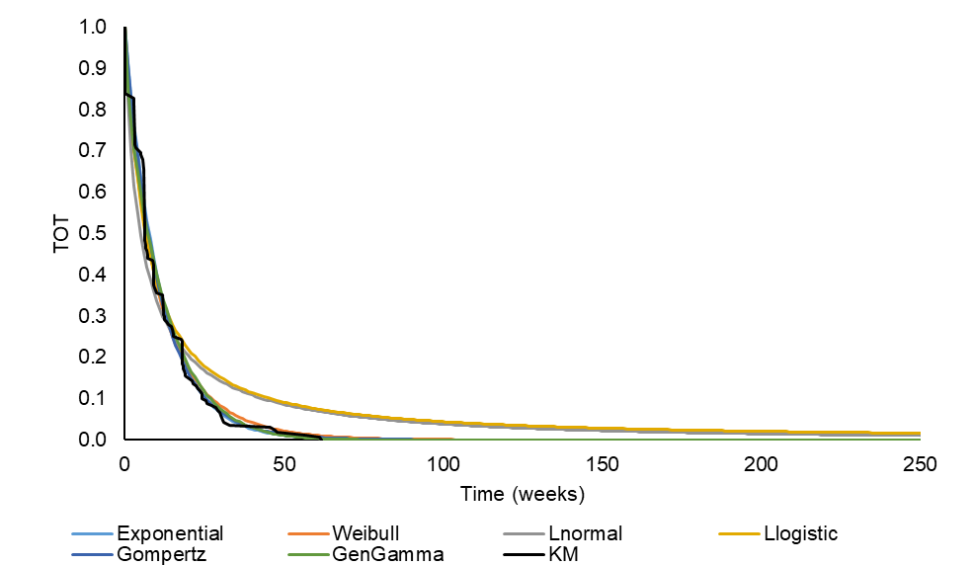

**Key:** KM, Kaplan-Meier; ToT, time on treatment

**Progression-free survival**

The KM of PFS shows a significant drop in PFS up until Week 15. This could be attributed to the first two radiography tests conducted on Week 9 (+/- 1 week) and Week 15 (+/- 1 week); after this the PFS remains relatively steady. As a result, and based on the cumulative hazard plot and the log cumulative hazard plot, Week 15 was used for the base case analysis, where KM data were used directly for the first 15 weeks of model time horizon, and parametric functions were fitted from then onwards.

Based on the AIC and BIC and visual inspection, the log-logistic parametric function was selected as the base case for the pembrolizumab arm. For the chemotherapy arm, the exponential parametric function was applied to extrapolate PFS outcomes (Supplementary Table 3, Supplementary Figure 3 and Supplementary Figure 4).

Supplementary Table 3: PFS – AIC and BIC statistics

| Distribution | Pembrolizumab | | Chemotherapy | |
| --- | --- | --- | --- | --- |
| AIC | BIC | AIC | BIC |
| Exponential | 648.6 | 651.2 | 540.2 | **542.4** |
| Weibull | 640.7 | 645.8 | **538.3** | 542.8 |
| Gompertz | 639.8 | 645 | 539.5 | 544 |
| Log logistic | **639.2** | **644.3** | 542.1 | 546.6 |
| Log normal | 640.3 | 645.4 | 543.9 | 548.4 |
| Generalised Gamma | 641.4 | 649.1 | 540.1 | 546.9 |
| **Key:** AIC, Akaike information criterion; BIC, Bayesian information criterion; PFS, progression-free survival. | | | | |

Supplementary Figure 3: PFS KM data with standard parametric curve fittings – pembrolizumab

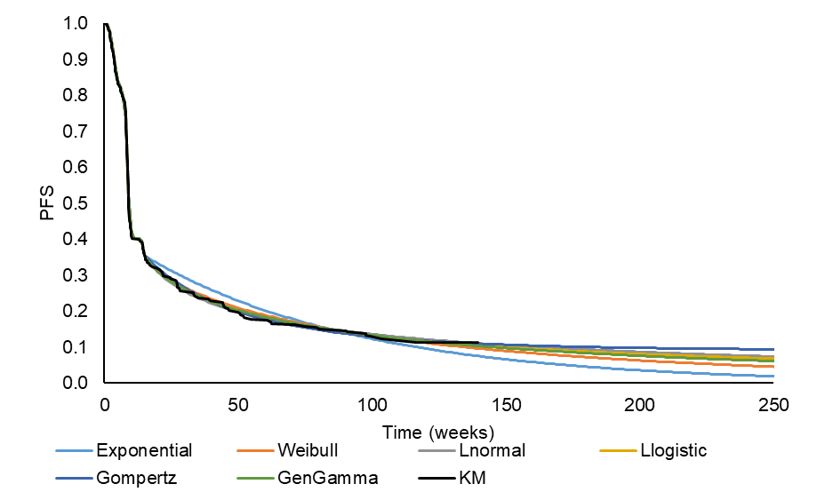

**Key:** KM, Kaplan-Meier; PFS, progression-free survival.

Supplementary Figure 4: PFS KM data with standard parametric curve fittings – chemotherapy

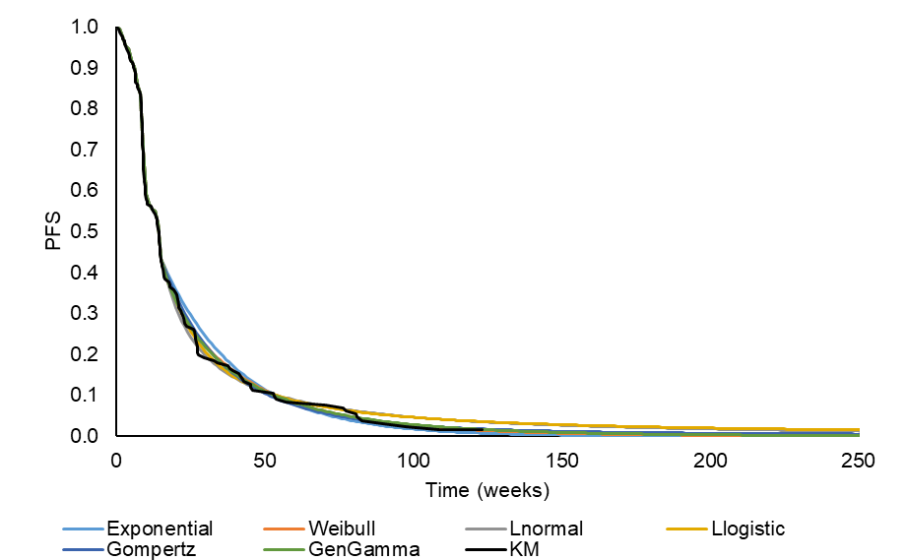

**Key:** KM, Kaplan-Meier; PFS, progression-free survival.

**Overall survival**

In the model base case, the log-logistic parametric function was used after the cut-off point (32-weeks) for the pembrolizumab based on the AIC, the BIC and visual inspection. For the usual care arm, the exponential parametric function was used after the cut-off (32-weeks) based on BIC and visual inspection (Supplementary Table 4, Supplementary Figure 5 and Supplementary Figure 6).

Supplementary Table 4: OS – AIC and BIC statistics

| Distribution | Pembrolizumab | | Chemotherapy | |
| --- | --- | --- | --- | --- |
| AIC | BIC | AIC | BIC |
| Exponential | 1019.3 | 1022.3 | 482.5 | **484.8** |
| Weibull | 1014 | 1020.1 | 482.8 | 487.4 |
| Gompertz | 1013.5 | 1019.6 | **480.9** | 485.5 |
| Log logistic | **1013.4** | **1019.5** | **480.9** | 485.5 |
| Log normal | 1017.8 | 1023.9 | 483 | 487.6 |
| Generalised Gamma | 1015.5 | 1024.7 | 483.5 | 490.3 |
| **Key:** AIC, Akaike information criterion; BIC, Bayesian information criterion; OS, overall survival. | | | | |

Supplementary Figure 5: OS KM data with standard parametric curve fittings – pembrolizumab

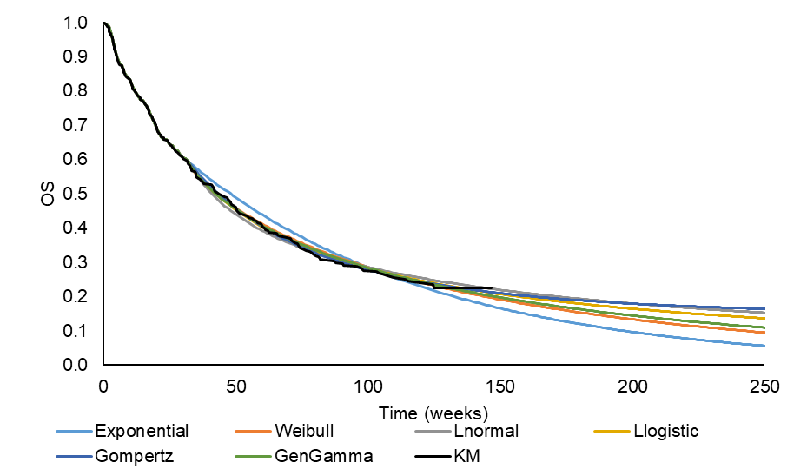

**Key:** KM, Kaplan-Meier; OS, overall survival.

Supplementary Figure 6: OS KM data with standard parametric curve fittings – chemotherapy

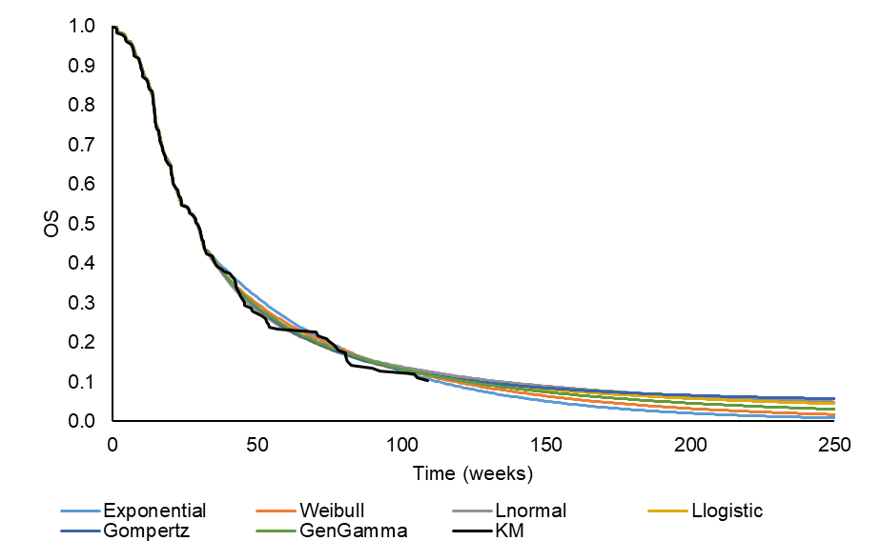

**Key:** KM, Kaplan-Meier; OS, overall survival.

### Validation

Supplementary Figure 7: External validation of the chemotherapy survival arm

**A.**

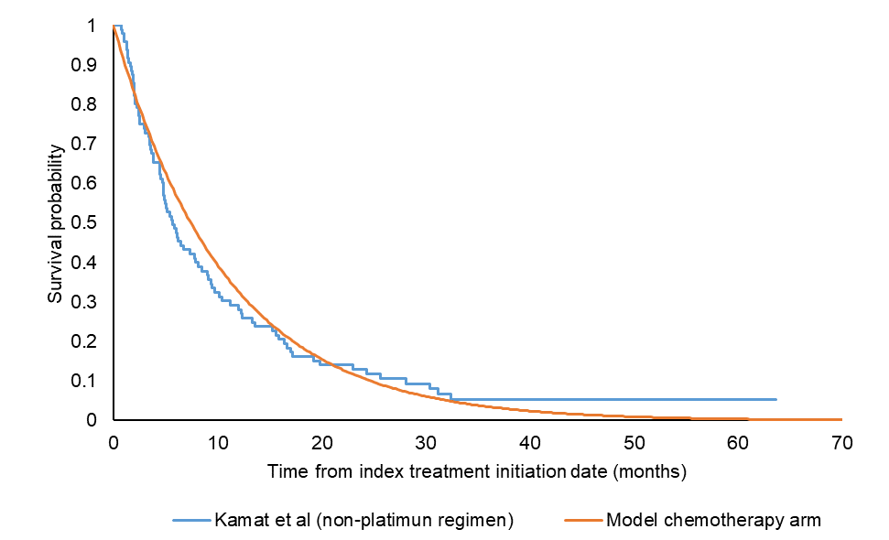

**B**

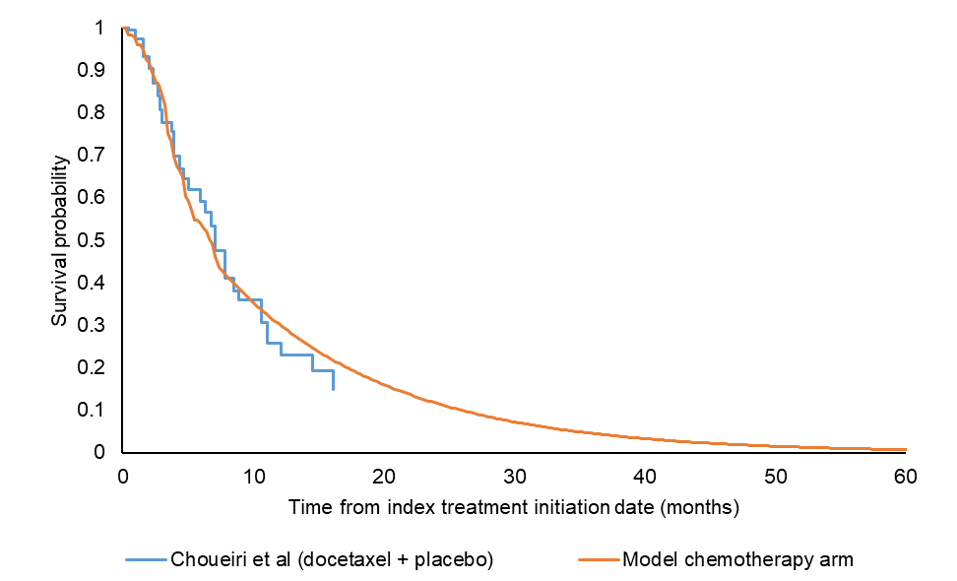

**C**

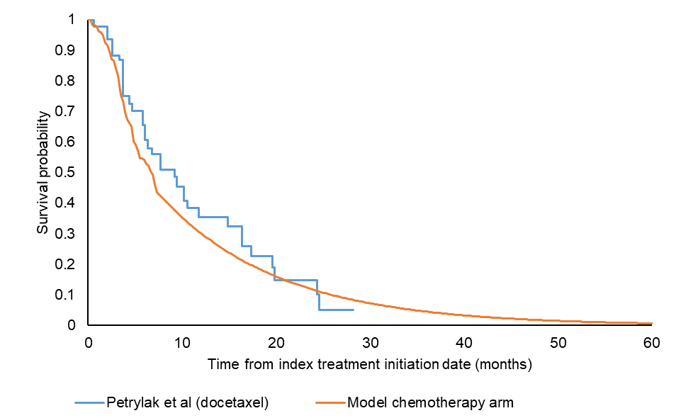

**A**, Retrospective cohort study using the SEER-Medicare data set of first-line and second-line bladder cancer patients receiving non-platinum chemotherapy regimen (Kamat et al.)[9]; **B**, Phase II, double-blind, randomized trial on docetaxel plus vandetanib versus docetaxel plus placebo in metastatic urothelial cancer (Choueiri et al.)[10]; **C**, Open-label, Phase II, three-arm, randomized control trial on docetaxel versus docetaxel plus ramucirumab versus docetaxel plus icrucumab in second-line metastatic urothelial carcinoma (Petrylak et al.)[11]

### Disaggregated costs

Supplementary Table 5: Total discounted disaggregated costs over model time horizon

| **Cost** | **Versus chemotherapy** | | | **Versus atezolizumab** | | |
| --- | --- | --- | --- | --- | --- | --- |
| **Pembrolizumab** | **Chemotherapy** | **Incremental** | **Pembrolizumab** | **Atezolizumab** | **Incremental** |
| Drug acquisition | $96,861 | $1,032 | $95,829 | $96,861 | $137,716 | -$40,855 |
| Drug administration | $754 | $738 | $16 | $754 | $2,278 | -$1,524 |
| Disease management | $38,597 | $22,051 | $16,546 | $52,803 | $36,863 | $15,940 |
| Subsequent treatment | $1,888 | $1,820 | $67 | $1,888 | $1,861 | $27 |
| Terminal care | $2,008 | $2,138 | -$130 | $0 | $0 | $0 |
| Adverse event management | $449 | $6,477 | -$6,029 | $449 | $494 | -$46 |

### Tornado diagram from one-way sensitivity analysis

Figure 8: One-way sensitivity analysis tornado plot – versus chemotherapy



**Key:** 2L, second line; ICER, incremental cost-effectiveness ratio; OS, overall survival; PF, progression free; PFS, progression-free survival; PP, post-progression; QALY, quality-adjusted life-year.

Figure 9: One-way sensitivity analysis tornado plot – versus atezolizumab

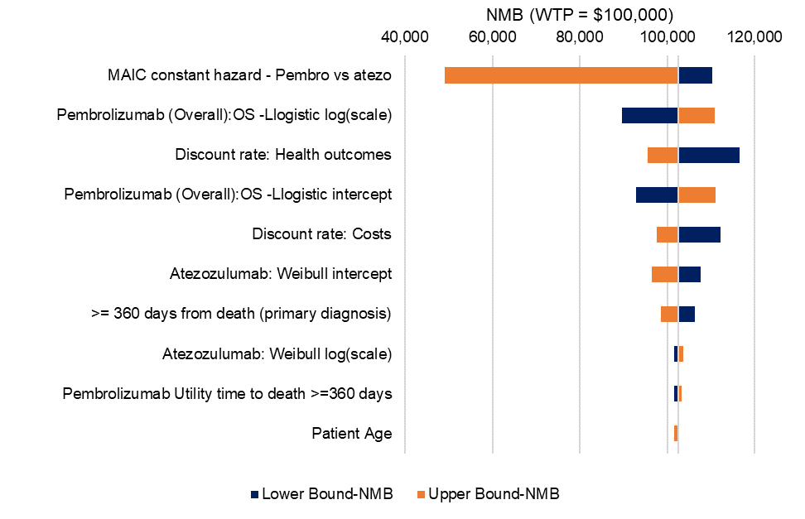

**Key:** 2L, second line; ICER, incremental cost-effectiveness ratio; MAIC, match-adjusted indirect comparison; OS, overall survival; PF, progression free; PFS, progression-free survival; PP, post-progression; QALY, quality-adjusted life-year.

**Note:** Net-monetary benefit (NMB) is a way of placing both costs and effects as a single scale monetary value [12]. This is a useful alternative measure of cost-effectiveness when the ICER falls within another quadrant of the cost-effectiveness plane (i.e. in situations of dominance). The incremental NMB is calculated as: *incremental NMB = incremental QALYs x WTP – incremental costs*. Therefore, if the incremental NMB is positive then the intervention is cost-effective at the specified WTP threshold. In this OWSA, the WTP was set to $100,000, and therefore for each parameter tested pembrolizumab is still considered cost-effective at that threshold versus atezolizumab.

### Scenario analysis

Supplementary Table 6: Scenario analysis

| Parameter | Base case | Scenario | Deterministic ICER vs chemotherapy ($/QALY) | Deterministic ICER vs atezolizumab ($/QALY) |
| --- | --- | --- | --- | --- |
| Base case results | | | 93,481 | Dominant |
| **Utility approach** | Time to death - pooled | Time to death – treatment specific | 91,721 | Dominant |
| Progression status – pooled | 104,355 | NA |
| **Utility source** | KN045 | Criss et al 2018[13]  PFS pembro – 0.80  PFS chemo – 0.69  Progressed – 0.45 | 118,795 | NA |
| Sarfaty et al 2018[14]  Weeks 1-14: 0.60  Weeks 15+:  Pembro – 0.61  Chemo – 0.52 | 125,181 | Dominant |
| **AE disutility** | Not applied | Applied | 93,312 | Dominant |
| **AE rates based on all-cause vs drug-related** | Drug related | All cause | 93,262 | Dominant |
| **Age adjusted utilities\*** | Not applied | Applied | 93,999 | Dominant |
| **Time horizon** | 20 years | 5 years | 184,679 | Dominant |
| 10 years | 120,290 | Dominant |
| 40 years | 87,112 | Dominant |
| **Vial wastage** | No vial wastage | 100% wastage | 93,251 | NA |
| **Disease monitoring** | By progression status (vs chemotherapy) | By time-to-death | 99,110 | NA |
| **Cost sharing** | 0% | 20% | 77,672 | Dominant |
| **Treatment cap for atezolizumab** | No cap | Cap of 2 years | NA | 38,119 |
| **ToT parametric function – paclitaxel or docetaxel** | Gamma | Exponential | 93,484 | NA |
| Weibull | 93,464 | NA |
| Log-normal | 92,650 | NA |
| Log-logistic | 92,405 | NA |
| Gompertz | 93,483 | NA |
| **PFS parametric function – pembrolizumab** | Log logistic (Week 15) | Exponential | 97,603 | NA |
| Log-normal | 93,147 | NA |
| Weibull | 95,889 | NA |
| Gompertz | 90,715 | NA |
| Gamma | 94,539 | NA |
| **PFS parametric function – paclitaxel or docetaxel** | Exponential (Week 15) | Weibull | 93,558 | NA |
| Log-normal | 94,014 | NA |
| Log-logistic | 94,052 | NA |
| Gompertz | 93,664 | NA |
| Gamma | 93,589 | NA |
| **OS parametric function – pembrolizumab** | Log logistic (Week 32) | Exponential | 203,736 | Dominant |
| Log-normal | 86,201 | Dominant |
| Weibull | 150,968 | Dominant |
| Gompertz | 68,516 | Dominant |
| Gamma | 129,677 | Dominant |
| **OS parametric function – paclitaxel or docetaxel** | Exponential (Week 32) | Weibull | 95,591 | NA |
| Log-normal | 112,475 | NA |
| Log-logistic | 111,467 | NA |
| Gompertz | 143,477 | NA |
| Gamma | 100,194 | NA |
| **OS week cut-offs** | Week 32 – pembrolizumab: Log logistic control: exponential | One piece – Pembrolizumab: Log normal. Control: Log logistic | 121,114 | Dominant |
| Week 24 – Pembrolizumab: Gompertz. Control: Log normal | 76,482 | Dominant |
| Week 40 – Pembrolizumab: Log normal. Control: Log normal | 117,399 | Dominant |
| **PFS week cut-offs** | Week 15 – pembrolizumab: Log logistic, control: exponential | Week 9 – Pembrolizumab: Log normal. Control: Weibull | 92,108 | NA |
| Week 21 – Pembrolizumab: Log normal. Control: Weibull | 93,518 | NA |
| Week 27 – Pembrolizumab: Weibull. Control: Gamma | 94,854 | NA |
| **OS adjustment** | Two-stage adjustment | Without adjustment | 98,522 | NA |
| With RPSFT adjustment | 96,869 | NA |
| With IPCW adjustment | 93,997 | NA |
| **ITC HR** | MAIC | NMA | NA | Dominant |
| **Atezolizumab ToT and PFS settings** | ToT based on naïve IMvigor data.  No PFS.  Disease management based on TTD | ToT based on cox HR  No PFS  Disease management based on TTD | NA | 60,089 |
| ToT based on naïve IMvigor data.  PFS based on cox HR (OS vs PFS) 2.28  Disease management based on progression. | NA | Dominant |
| ToT based on cox HR (ToT vs OS) 2.16.  PFS based on cox HR (OS vs PFS) 2.28  Disease management based on progression. | NA | 51,334 |
| **Key:** chemo, chemotherapy; EUR, Euro; HR, hazard ratio; ICER, incremental cost-effectiveness ratio; IPCW, inverse probability of censoring weights; MAIC, match-adjusted indirect comparison; NMA, network meta-analysis; OS, overall survival; PFS, progression-free survival; pembro, pembrolizumab; QALY, quality-adjusted life year; RPSFT, rank preserving structural failure time; ToT, time on treatment; TTD, time to death.  **Notes:** *Adjusts utility values in line with general population natural decline with age. | | | | |

### Comparison of different approaches to OS and PFS from the literature vs model base case

Supplementary Figure 10: Pembrolizumab OS: base case in model vs literature

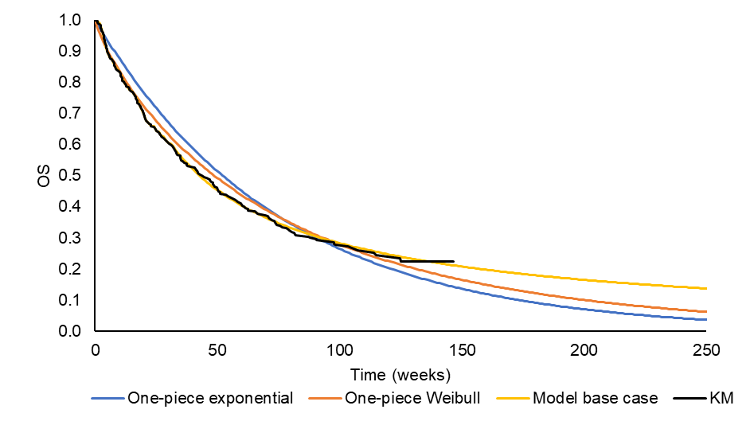

**Key:** KM, Kaplan-Meier; OS, overall survival

**Note:** Criss et al base case (exponential one-piece); Sarfaty et al base case (Weibull one-piece); Model base case (log-logistic piece-wise)

Supplementary Figure 11: Pembrolizumab PFS: base case in model vs literature

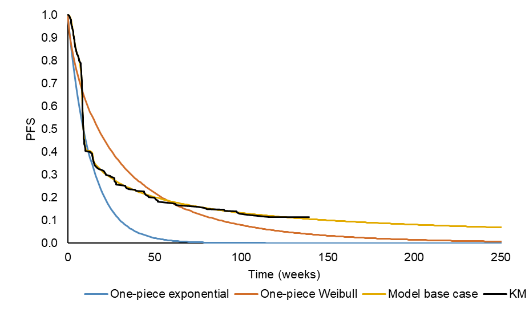

**Key:** KM, Kaplan-Meier; PFS, progression-free survival

**Note**: Criss et al base case (exponential one-piece); Sarfaty et al base case (Weibull one-piece); model base case (log-logistic piece-wise)

## References

1. Institute for Clinical and Economic Review (ICER). ICER's Reference Case for Economic Evaluations: Principles and Rationale 2018 [May 2019]. Available from: <https://icer-review.org/wp-content/uploads/2018/07/ICER_Reference_Case_July-2018.pdf>

2. DMD America. AnalySource Suite of Drug Pricing Services. 2018 [January 2019]. Available from: <https://www.analysource.com/about.html>

3. Centers for Medicare & Medicaid Services. Physician Fee Schedule Search 2018 [10 May 2018]. Available from: <https://www.cms.gov/apps/physician-fee-schedule/search/search-criteria.aspx>

4. Centers for Medicare & Medicaid Services. ASP Drug Pricing Files 2018 [10 May 2018]. Available from: <https://www.cms.gov/Medicare/Medicare-Fee-for-Service-Part-B-Drugs/McrPartBDrugAvgSalesPrice/2018ASPFiles.html>

5. Zhong Y, Li H, He J, et al. C17 Pattern of Disease Management Costs for Advanced Bladder Cancer Patients Receiving Chemotherapy. AMCP Managed Care & Speciality Pharamacy Annual Meeting. San Diego, California US; 2019.

6. Powles T, Duran I, van der Heijden MS, et al. Atezolizumab versus chemotherapy in patients with platinum-treated locally advanced or metastatic urothelial carcinoma (IMvigor211): a multicentre, open-label, phase 3 randomised controlled trial. Lancet (London, England). 2018 Feb 24;391(10122):748-757.

7. Agency for Healthcare Research and Quality. Healthcare Cost and Utilization Project [10 May 2018]. Available from: <https://hcupnet.ahrq.gov/#setup>

8. Gelb D, Zhong Y, Perini R, et al. [P786] Network meta-analysis (NMA) and matching-adjusted indirect comparison (MAIC) of pembrolizumab (pembro) versus atezolizumab (atezo) for second-line (2L) locally advanced/metastatic urothelial carcinoma (mUC). Society of Immunotherapy of Cancer. National Harbour, Maryland: US; 2019.

9. Kamat AM, Cao Z, He J, et al. Costs of Care for Patients Receiving Chemotherapy for Advanced Bladder Cancer. Journal of Clinical Pathways. 2017;3(10):63-70.

10. Choueiri TK, Ross RW, Jacobus S, et al. Double-blind, randomized trial of docetaxel plus vandetanib versus docetaxel plus placebo in platinum-pretreated metastatic urothelial cancer. Journal of clinical oncology : official journal of the American Society of Clinical Oncology. 2012 Feb 10;30(5):507-12.

11. Petrylak DP, Tagawa ST, Kohli M, et al. Docetaxel As Monotherapy or Combined With Ramucirumab or Icrucumab in Second-Line Treatment for Locally Advanced or Metastatic Urothelial Carcinoma: An Open-Label, Three-Arm, Randomized Controlled Phase II Trial. Journal of clinical oncology : official journal of the American Society of Clinical Oncology. 2016 May 1;34(13):1500-9.

12. Drummond MF, Sculpher MJ, Claxton K, Stoddart, G. L.,, et al. Methods for the Economic Evaluation of Health Care Programmes. 4th ed. Oxford: Oxford University Press; 2015.

13. Criss SD, Weaver DT, Sheehan DF, et al. Effect of PD-L1 testing on the cost-effectiveness and budget impact of pembrolizumab for advanced urothelial carcinoma of the bladder in the United States. Urologic oncology. 2019 Mar;37(3):180.e11-180.e18.

14. Sarfaty M, Hall PS, Chan KKW, et al. Cost-effectiveness of Pembrolizumab in Second-line Advanced Bladder Cancer. European urology. 2018 Jul;74(1):57-62.