Supplemental Data

Disclination Network Morphologies in Blue Phase III
Michiko Yamaguchi, Kenji Shimizu, Masanobu Sagisaka and
Atsushi Yoshizawa*
Department of Frontier Materials Chemistry, Graduate School of Science and Technology, Hirosaki University, 3 Bunkyo-cho, Hirosaki, Aomori 036-8561, Japan
E-mail: ayoshiza@hirosaki-u.ac.jp

Figure S1. Electric-field dependence of transmittance for the forward and backward processes in the PS-BPIII of sample B3 at 25 °C. Optical transmittance was observed as a function of the AC field at a frequency of 2 Hz.

Figure S2. Photomicrographs of BPs of samples A1, A3, B1 and B2 on a glass slide with a cover slip before polymerization (scale bar 100 µm). (a) Cubic BP of sample A1 at 66.0 °C. (b) Cubic BP of sample A3 at 63.3 °C. (c) BPIII of sample B1 at 44.0 °C. (d) BPIII of sample B2 at 42.0 °C.

Figure S1. Electric-field dependence of transmittance for the forward and backward processes in the PS-BPIII of sample B3 at 25 °C. Optical transmittance was observed as a function of the AC field at a frequency of 2 Hz.

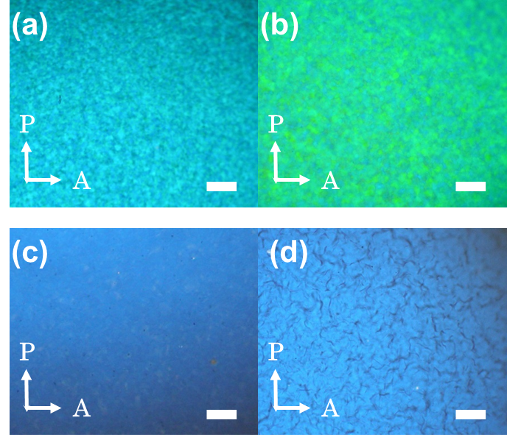

Figure S2. Photomicrographs of BPs of samples A1, A3, B1 and B2 on a glass slide with a cover slip before polymerization (scale bar 100 µm). (a) Cubic BP of sample A1 at 66.0 °C. (b) Cubic BP of sample A3 at 63.3 °C. (c) BPIII of sample B1 at 44.0 °C. (d) BPIII of sample B2 at 42.0 °C.

