Supplementary information

Combined Photodynamic-Chemotherapy investigation of Cancer Cells using Carbon Quantum Dot-Based Drug Carrier System

Xin Liª, Kandasamy Vinothini^{bc}, Mariappan Rajan^{c}*, Andy Ramu^{b}*

ªDepartment of Medical Oncology, Xinxiang Central Hospital,The Fourth Clinical College of Xinxiang Medical College, Xinxiang City,Henan Province, 453000, China
^{b}Department of Inorganic chemistry, School of Chemistry, Madurai Kamaraj University, Madurai 625021, Tamil Nadu, India.
^{c*}Biomaterials in Medicinal Chemistry Laboratory, Department of Natural Products Chemistry, School of Chemistry, Madurai Kamaraj University, Madurai 625021,Tamil Nadu, India.

*Corresponding author
Mariappan Rajan, Biomaterials in Medicinal Chemistry Laboratory, Department of Natural Products Chemistry, School of Chemistry, Madurai Kamaraj University, Madurai - 625021, India. Tel: +91 9488014084; Fax: 0452-2459845; Email: rajanm153@gmail.com.

1. Carbon quantum dots methodology

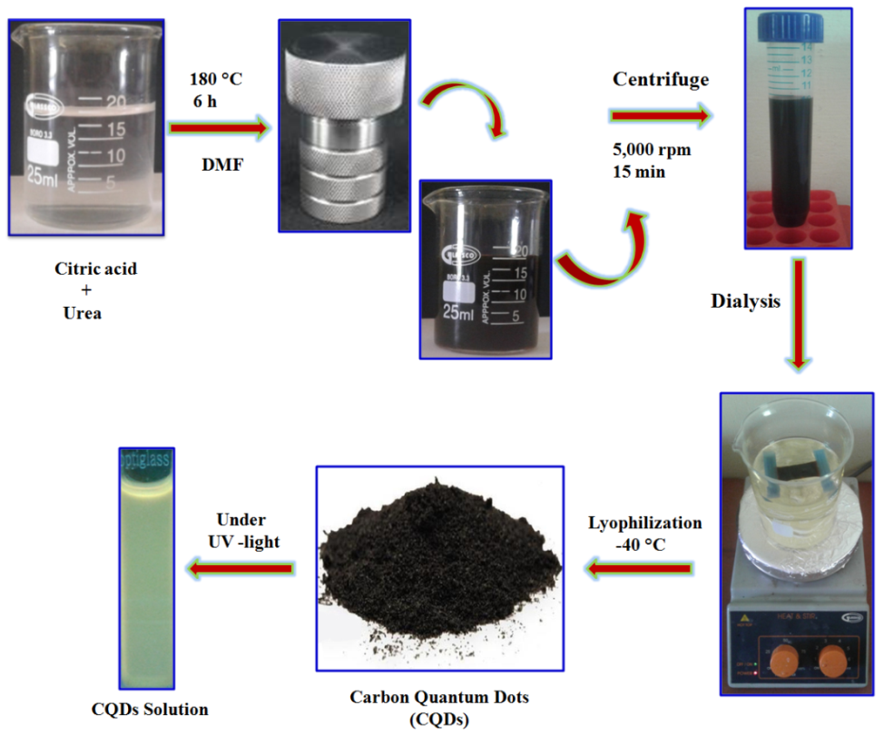
S.Figure 1. Synthetic representation of carbon quantum dot (CQD) preparation

2. UV-Visible, Fluorescence and Raman spectroscopy

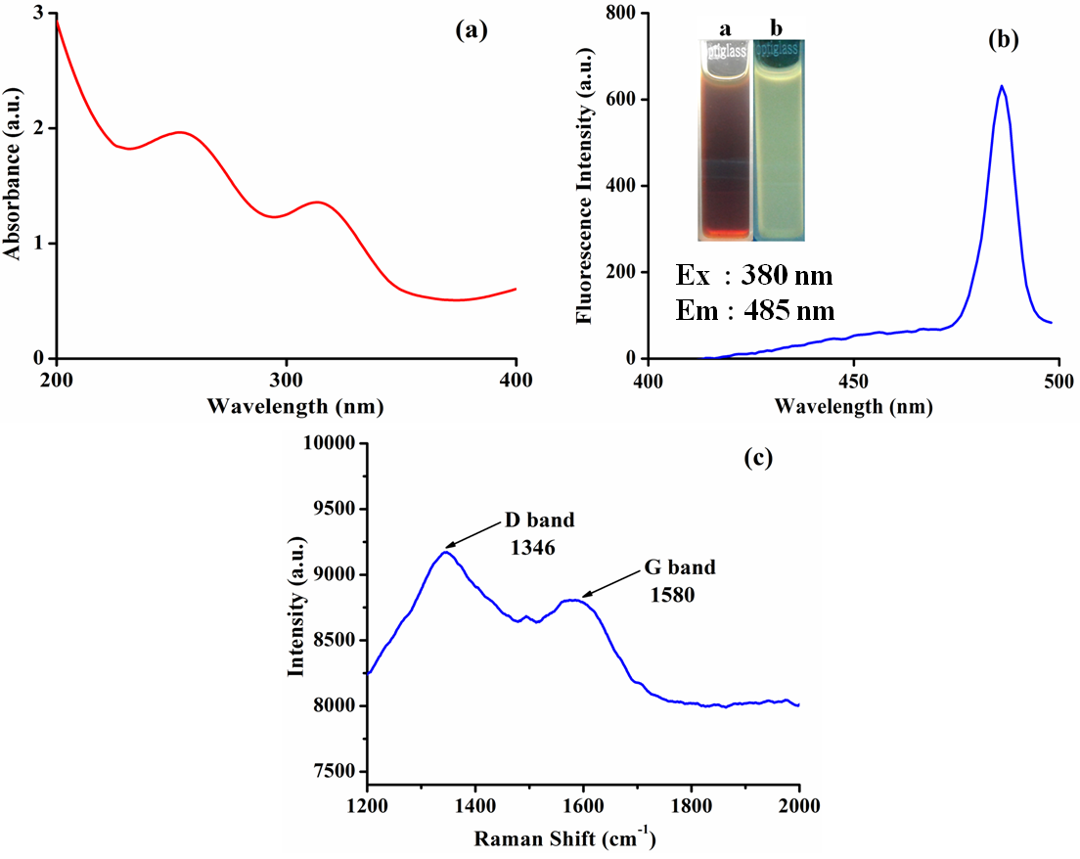
S.Figure 2. Carbon quantum dot spectrum of (a) UV-Visible spectroscopy (b) Fluorescence spectrum and (c) Raman Spectrum

3. In-vitro cell cytotoxicity

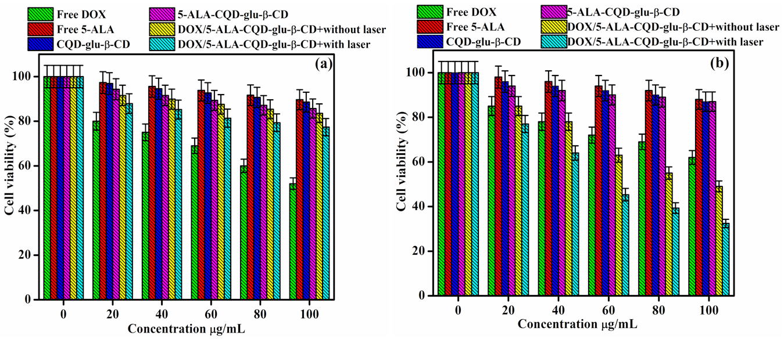
S.Figure 3 (a&b). In-vitro cytotoxic effect of fibroblast (WS-1) cell line and breast cancer (MCF-7) cell line in 24 h incubation with Free DOX, Free 5-ALA, CQD-Glu-β-CD, 5-ALA-CQD-Glu-β-CD and DOX/5-ALA-CQD-Glu-β-CD in without and with laser treatment at different concentration manner such as 0, 20, 40, 60, 80 and 100 μg/mL.

