Supplementary Materials

Supplementary figure 1: Incidence of invasive cervical cancer in Sweden 1960-2017 (Source: the Swedish National Cancer Registry)
Orange: total
Blue: squamous cell cancer
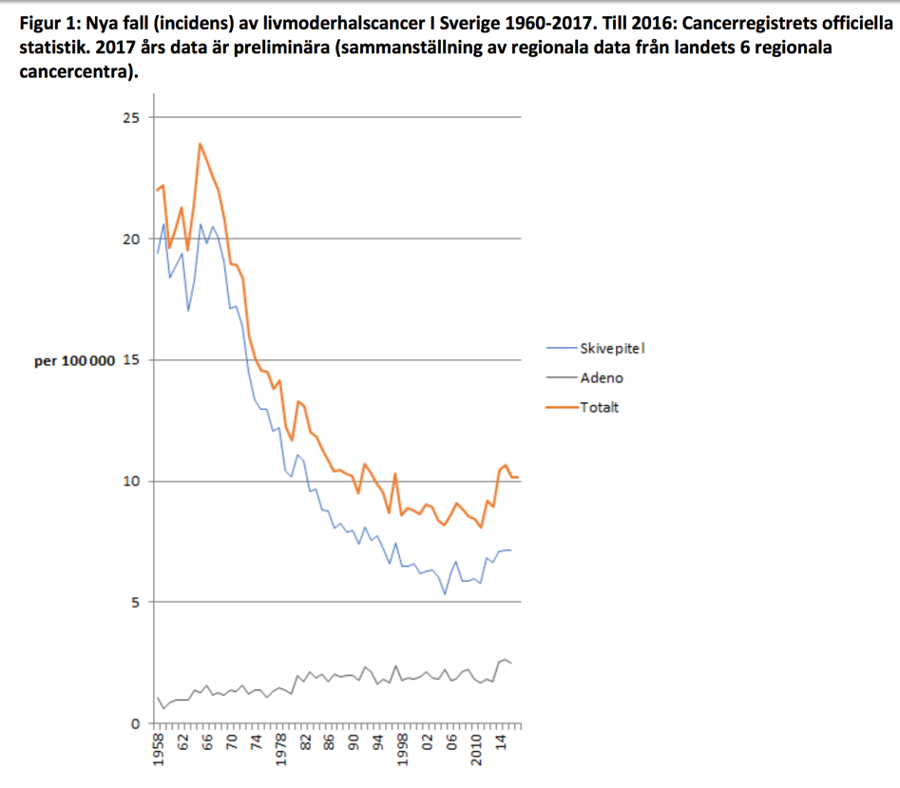
Grey: adenocarcinoma

Supplementary table 1: Number of primary HPV tests and cytology tests in Sweden during 2012-2015
 | Number of primary HPV test | Number of cytology test
2012 | 3085 | 681,936
2013 | 3035 | 683,971
2014 | 22,281 | 697,705
2015 | 51,337 | 687,791

Supplementary table 2: Sensitivity analysis of age-adjusted incidence rate ratio of invasive cervical cancer in 2014-2015 compared to 2002-2013, among women adequately screened with normal results and women unscreened in the preceding two screening intervals, using cervical cancer cases derived from National Cancer Registry during whole study period.
 | Year | Number of cases | IRR (95% CI) | P-value | IRR adjusted for country of birth | P-value adjusted for country of birth
Adequately screened | 2014-2015 | 196 | 1.54 (1.31-1.80) | <0.0001 | 1.53 (1.31-1.79) | <0.0001
 | 2002-2013 | 791 | Ref.
Unscreened | 2014-2015 | 173 | 1.13 (0.96-1.33) | 0.1380 | 1.13 (0.96-1.32) | 0.15
 | 2002-2013 | 950 | Ref.

Supplementary table 3: Incidence rate ration (IRR) and 95% confidence interval (CI) of invasive cervical cancer among women adequately screened with normal results in the preceding two screening intervals comparing 2014-2015 to 2002-2013, by lab/county
Lab/county | Number of cases 2014-2015 | Expected number of cases 2014-2015* | IRR (95%CI) comparing 2014-2015 to 2002-2013 | P-value
S:t Göran | 1 | 2.5 | 0.62(0.08-5.07) | 0.66
Huddinge | 33 | 33.2 | 1.39(0.94-2.05) | 0.10
Uppsala | 11 | 5.6 | 2.49(1.24-5.01) | 0.01
Eskilstuna | 4 | 4.7 | 1.63(0.55-4.83) | 0.37
Linköping | 11 | 8.6 | 2.07(1.03-4.17) | 0.04
Jönköping | 5 | 7.7 | 1.39(0.53-3.67) | 0.50
Växjö | 3 | 3.3 | 2.13(0.58-7.87) | 0.26
Kalmar | 8 | 5.2 | 5.06(2.00-12.8) | <0.01
Karlskrona | 4 | 3.5 | 1.71(0.57-5.15) | 0.34
Kristianstad | 4 | 4.1 | 1.32(0.45-3.84) | 0.61
Skåne | 12 | 22.0 | 1.01(0.54-1.87) | 0.99
Halmstad | 4 | 7.6 | 0.75(0.26-2.19) | 0.60
Sahlgrenska | 21 | 18.5 | 2.14(1.28-3.56) | <0.01
Trollhättan | 6 | 6.5 | 1.95(0.76-4.99) | 0.16
Borås | 6 | 6.9 | 4.33(1.45-12.9) | 0.01
Skövde | 5 | 6.9 | 1.07(0.41-2.81) | 0.89
Karlstad | 8 | 6.3 | 1.70(0.78-3.71) | 0.18
Örebro | 7 | 5.9 | 2.61(1.09-6.24) | 0.03
Västerås | 4 | 5.4 | 1.01(0.35-2.90) | 0.98
Falun | 12 | 7.3 | 2.91(1.46-5.79) | <0.01
Gävleborg | 7 | 6.7 | 1.28(0.57-2.89) | 0.55
Sundsvall | 7 | 5.1 | 2.44(1.03-5.77) | 0.04
Östersund | 2 | 2.8 | 1.19(0.26-5.44) | 0.82
Umeå | 3 | 5.4 | 1.44(0.41-5.12) | 0.57
Luleå | 5 | 5.7 | 1.75(0.65-4.69) | 0.27
Aleris Medilab | 11 | 6.6 | 1.82(0.98-3.38) | 0.06

*Expected number of cases with population size in the county under the national incidence rate in 2014-2015

Supplementary table 4: Test result of the difference in IRRs across labs/counties (model-fitting test in labs/counties with less than 5 expected cases during 2014-2015)
Model | -2Log likelihood | Likelihood-ratio chi2 | Degree of freedom | P-value
With interaction | 1963.36662 | 22.81 | 19 | 0.2457
Without interaction | 1986.17844

