Supplementary Material
Table SM-1: Conditions evaluated in the PCB quantification by HS-SPME method.
Sample | SMPE Fiber | PCB Concentration (mg L⁻¹) | Sample Volume (mL) | NaCl (g) | Extraction Temp. (ºC) | Dessorption Temp. (ºC) | Extraction Time (min) | Internal Standard – Octachloronaphthalene (mg L⁻¹)
PCB + H₂O  PCB + Medium  H₂O | PDMS (100 µm)  PDMS/DVB (65 µm)  Carboxen/PDMS (75 µm) | 0  0.09  1.5  3.0 | 2.0  2.5  3.0 | 0  0.5  1.0 | 22 | 210  250  280 | 5  15  30 | 0  0.5  0.8  1.5  3.0

Figure SM-1: Graphical determination of the linear curves of the SPME technique for PCB in reactors condition. The equation, R², LQ and LD of each congener is presented. Symbols represent data and the line represent calibration curve.

Table SM-2: Intra-day accuracy of the SPME PCB extraction method for each analyte diluted in synthetic medium. M is mean of the chromatographic areas; SD is standard deviation and CV is coefficient of variation of the chromatographic areas.
PCB concnetration
(mg L⁻¹)
 | 0.1¹ |  |  | 0.2² |  |  | 0.3¹ |  |  | 0.5² |  |  | 1.0² |  |  | 2.0¹
 | M³ | SD⁴ | CV⁵ | M³ | SD⁴ | CV⁵ | M³ | SD⁴ | CV⁵ | M³ | SD⁴ | CV⁵ | M³ | SD⁴ | CV⁵ | M³ | SD⁴ | CV⁵
PCB 10 | 4.3 10⁵ | 3.9 10⁴ | 9.1 | 1.4 10⁶ | 1.2 10⁶ | 8.6 | 1.6 10⁶ | 4.5 10⁵ | 27.4 | 5.5 10⁶ | 3.9 10⁵ | 7.2 | 6.4 10⁶ | 1.2 10⁵ | 1.8 | 1.82 10⁷ | 1.5 10⁶ | 8.2
PCB 28 | 6.8 10⁶ | 6.3 10⁴ | 9.2 | 9.8 10⁵ | 7.7 10⁴ | 7.8 | 2.1 10⁶ | 1.8 10⁴ | 7.2 | 2.5 10⁶ | 3.2 10⁵ | 12.6 | 5.6 10⁶ | 4.7 10⁵ | 8.4 | 8.1 10⁶ | 1.7 10⁶ | 21.1
PCB 52 | 6.2 10⁶ | 1.0 10⁶ | 16.3 | 8.5 10⁴ | 4.5 10³ | 5.3 | 3.5 10⁵ | 4.8 10³ | 1.4 | 4.4 10⁵ | 8.3 10⁴ | 19.0 | 4.7 10⁵ | 1.8 10⁴ | 3.9 | 7.8 10⁶ | 7.9 10⁴ | 10.2
PCB 153 | 1.8 10⁵ | 1.1 10⁴ | 6.2 | 2.7 10⁵ | 1.1 10³ | 0.4 | 2.3 10⁵ | 1.9 10⁴ | 8.4 | 2.5 10⁵ | 2.6 10⁴ | 10.6 | 4.1 10⁵ | 8.4 10⁴ | 20.4 | 1.5 10⁶ | 1.5 10⁶ | 10.0
PCB 138 | 9.1 10⁴ | 6.7 10³ | 7.3 | 2.3 10⁵ | 2.7 10⁴ | 11.5 | 3.2 10⁵ | 5.9 10⁴ | 18.8 | 5.6 10⁵ | 2.0 10³ | 3.5 | 6.2 10⁵ | 2.0 10⁴ | 3.3 | 1.7 10⁶ | 2.3 10⁶ | 13.3
PCB 180 | 2.7 10⁴ | 2.7 10¹ | 0.1 | 2.8 10⁵ | 1.7 10⁴ | 5.9 | 4.7 10⁵ | 1.5 10⁴ | 3.2 | 5.0 10⁵ | 2.5 10³ | 0.5 | 6.9 10⁵ | 9.0 10⁴ | 13.1 | 2.1 10⁶ | 2.5 10⁶ | 12.3
¹ n = 5
² n = 3

Figure SM-2: Methane production rates in anaerobic batch reactors (M) spiked with 1.5 mg L⁻¹ of PCB. R² -correlation coefficient-. Line is the Gompertz equation modified fitting, while symbols mark the average measure values.

Table SM-3: Organic acids and COD removal efficiency in control reactor (C).
 | Reactor | Organic Acids (mg L⁻¹) | COD  (mg L⁻¹) |  | COD removal efficiency (%)
Control reactor (C) | 0 day | 1,671.58 | 2,201.48 (±52.98) |  | 0
 | 81 days | 1,961.00 | 2,299.00 (±179.00)
 | 101 days | 1,765.63 | 2,233.00 (±20.50)

Table SM-4: PCB analysis in control reactor along reactor operation time.

 | PCB 10 | PCB 28 | PCB 52 | PCB 153 | PCB 138 | PCB 180
0 day | 0.92 mg L⁻¹ | 0.39 mg L⁻¹ | 0.32 mg L⁻¹ | 0.16 mg L⁻¹ | 0.77 mg L⁻¹ | 0.93 mg L⁻¹
101 days | 0.93 mg L⁻¹ | 0.38 mg L⁻¹ | 0.32 mg L⁻¹ | 0.17 mg L⁻¹ | 0.77 mg L⁻¹ | 0.94 mg L⁻¹
% biossorption | 38.33 | 74.33 | 78.67 | 89.00 | 48.67 | 37.67
Table SM-5: PCB analysis in control reactor along reactor operation time.
 | PCB 10 | PCB 28 | PCB 52 | PCB 153 | PCB 138 | PCB 180 | Total PCBs ²
0 day | 1.01 mg L⁻¹ | 0.42 mg L⁻¹ | 0.24 mg L⁻¹ | 0.11 mg L⁻¹ | 0.55 mg L⁻¹ | 0.59 mg L⁻¹ | 0.49 mg L⁻¹
81 days | 1.05 mg L⁻¹ | 0.30 mg L⁻¹ | 0.26 mg L⁻¹ | 0.08 mg L⁻¹ | 0.02 mg L⁻¹ | 0.12 mg L⁻¹ | 0.30 mg L⁻¹
101 days | 0.09 mg L⁻¹ | 0.23 mg L⁻¹ | 0.06 mg L⁻¹ | 0.04 mg L⁻¹ | 0 mg L⁻¹ | 0.12 mg L⁻¹ | 0.09 mg L⁻¹
Removal | 0.92 mg L⁻¹ | 0.19 mg L⁻¹ | 0.18 mg L⁻¹ | 0.07 mg L⁻¹ | 0.55 mg L⁻¹ | 0.47 mg L⁻¹ | 0.40 mg L⁻¹
% of removal | 91.1 | 45.2 | 75.0 | 63.6 | 100.0 | 79.7 | 81.5

Figure SM- 3: Proportion of each volatile organic acid in the methanogenic reactor M and control reactor C with 0 days (M 0d and C 0d), 81 days (M 81d and C 81d) and 101 days (M 101d and C 101d) of operation.
Similarity (%)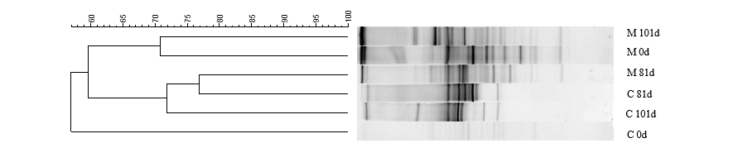
(a)
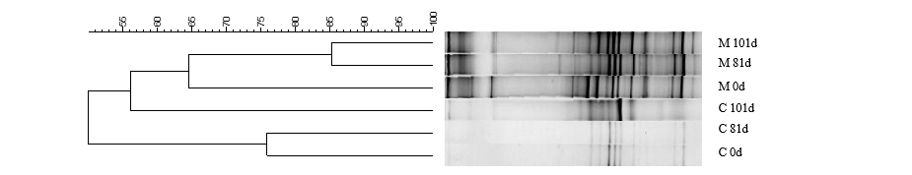
(b)
Figure SM-4: DGGE profiles of bacterial (a) and archaeal (b) communities and dendrogram constructed using Pearson correlations and the UPGMA clustering method on the DGGE banding patterns from samples of the methanogenic reactors (M 0d: at the initial time of operation, M 81d: 81 days of operation and M 101d: 101 days of operation) and control reactors (C 0d: at the initial time of operation, C 81d: 81 days of operation and C 101d: 101 days of operation.

Table SM-6: Diversity analysis indices and estimations for sequences extracted for the Bacteria and Archaea Domain at initial time and 101 days of operation of methanogenic reactor M.
 | M 0d¹ | M 101d²
Sequences | 60,523 | 67,582
OTUs | 2,867 | 2,318
Simpson index (1-D) | 0.960±0.001 | 0.889±0.003
Shannon-Wiener index (H’) | 4.73±0.03 | 3.81±0.03
Pielou index (J’) | 0.595±0.003 | 0.491±0.003
Singletons | 1,576 | 1,311
¹Samples with 0 days (M 0d) of operation in methanogenic reactor M
² Samples with 101 days (M 101d) of operation in methanogenic reactor M.

Figure SM- 5: Rarefaction curve of methanogenic reactor sequences with 0 days (▬M 0d) and with 101 days (▬M 101d) of operation (97% similarity).

Table SM-7: Population of Archaea Domain in the methanogenic reactor by number of OTUs with 0 days (M 0d) and 101 days of operation (M 101d) (97% of similarity).
 | M 0d | M 101d
Methanosaeta | 6,025 | 548
Methanoregulaceae | 1,245 | 801
Methanolinea | 255 | 410
Methanobacterium bryantii | 55 | 100
Methanobacterium | 49 | 124
TOTAL | 7,629 | 1,983

