Supplementary information for
Change detection, risk assessment and mass balance of mobile dune fields near Dunhuang Oasis with optical imagery and global terrain datasets
Chao Dingª, Guangcai Feng^{b}, Mingsheng Liao^{a*}, Lu Zhangª
ªState Key Laboratory of Information Engineering in Surveying, Mapping and Remote Sensing, Wuhan University, Wuhan, China; ^{b}School of Geosciences and Info-Physics, Central South University, Changsha, China
*Correspondence author: Mingsheng Liao, E-mail address: liao@whu.edu.cn
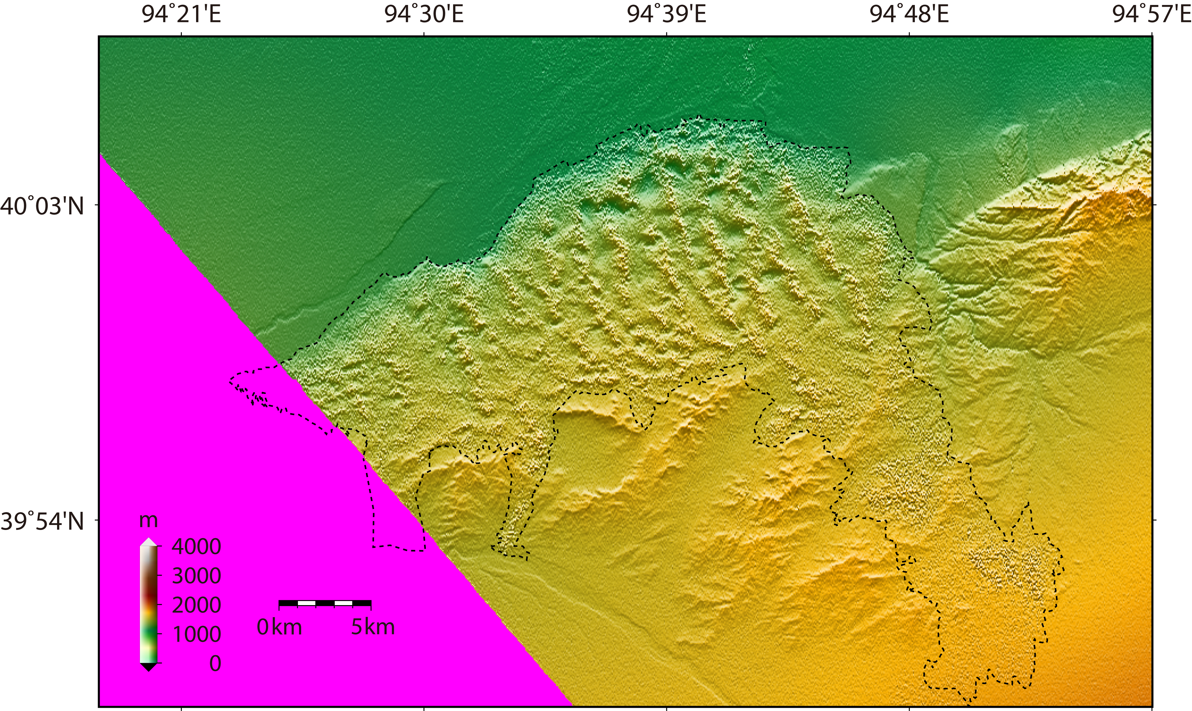
(a)
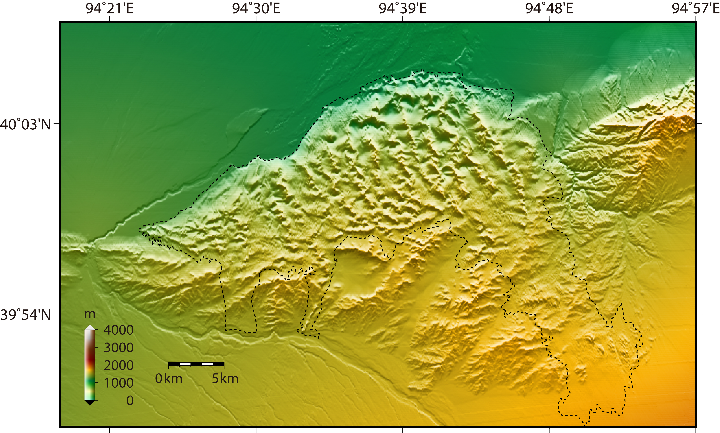
(b)
Figure S1. The coverage of two Digital Elevation Model (DEM) datasets over the study area. The SRTM-X DEM is shown in subplot (a), in which the magenta background denotes the data deficiency due to the specific acquisition mode of a narrow aperture angle. The TanDEM-X DEM is shown in subplot (b). The dotted lines indicate the outline of dune fields in Mingsha mountain.
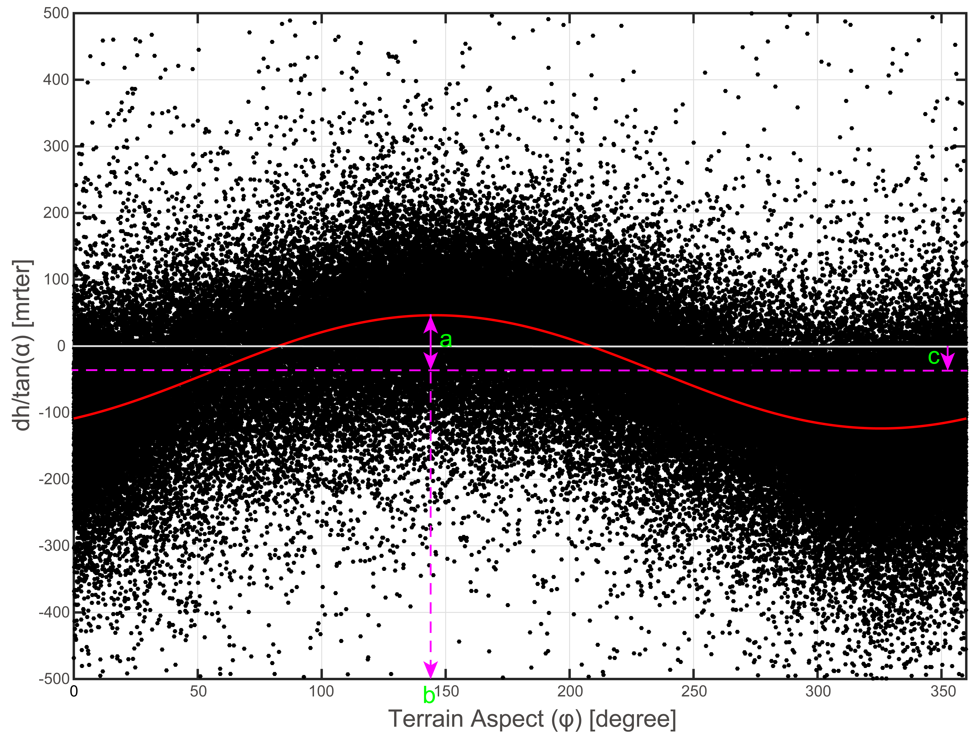
Figure S2. The scatter of elevation differences between TanDEM-X DEM and SRTM-X DEM showing the relationship between the vertical deviations normalized by the slope tangent (y-axis) and terrain aspect (x-axis). The equation (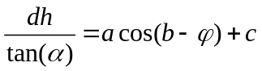) for the solved sinusoidal curve fit is shown as the red curve line along with the three unknown solution parameters, a, b and c. Here, though a robust iteration of the Nonlinear Least Squares method, the a, b, and c were finally determined as 85.03, 145.5, and -38.64, respectively, with the determination of coefficient R² as around 0.59.

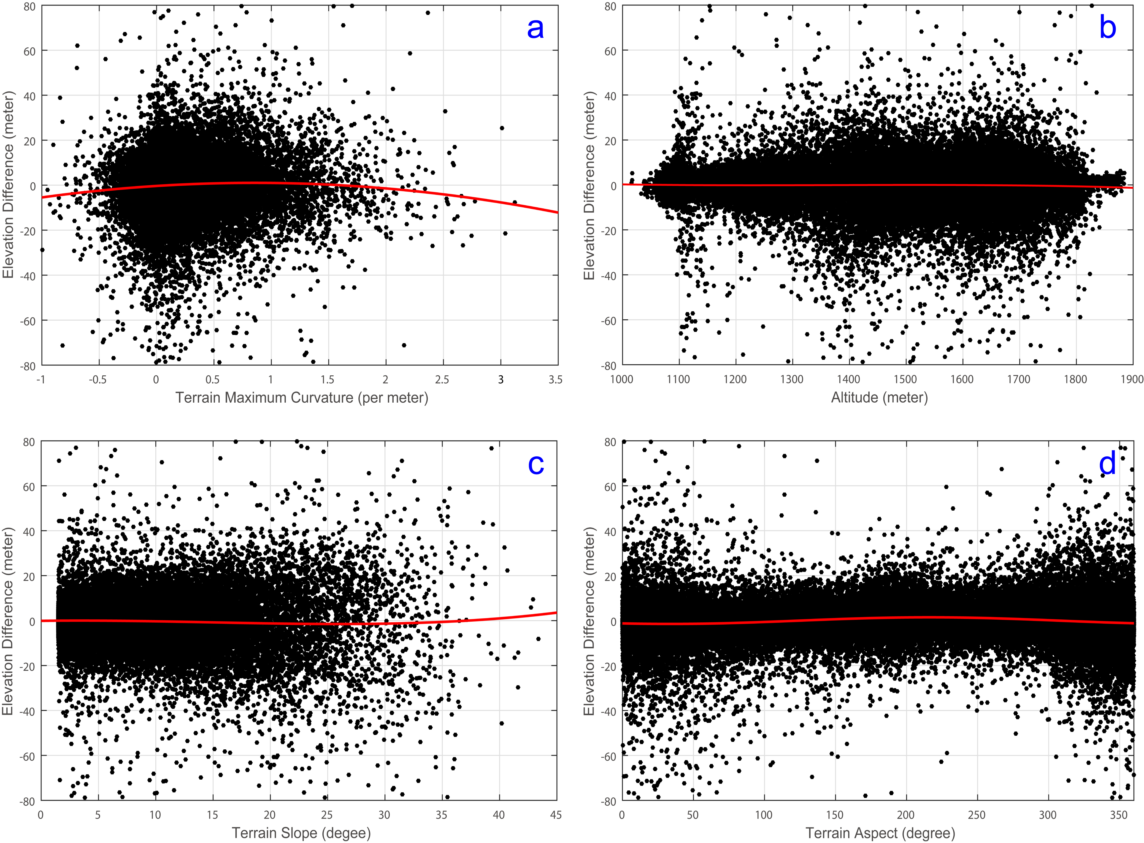
Figure S3. Scatter plots of the elevation difference with various terrain parameters and the fitted terrain parameter dependent bias. (a) Maximum curvature related bias using a second-order polynomial. (b) Elevation related bias using a third-order polynomial. (c) Slope-related bias using a third-order polynomial. (d) Aspect-related bias using a first-order Fourier series.
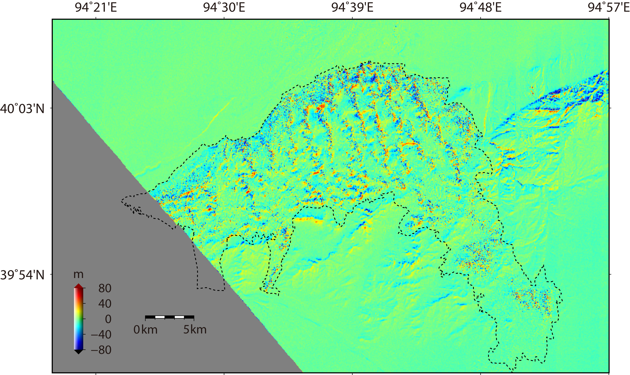
(a)
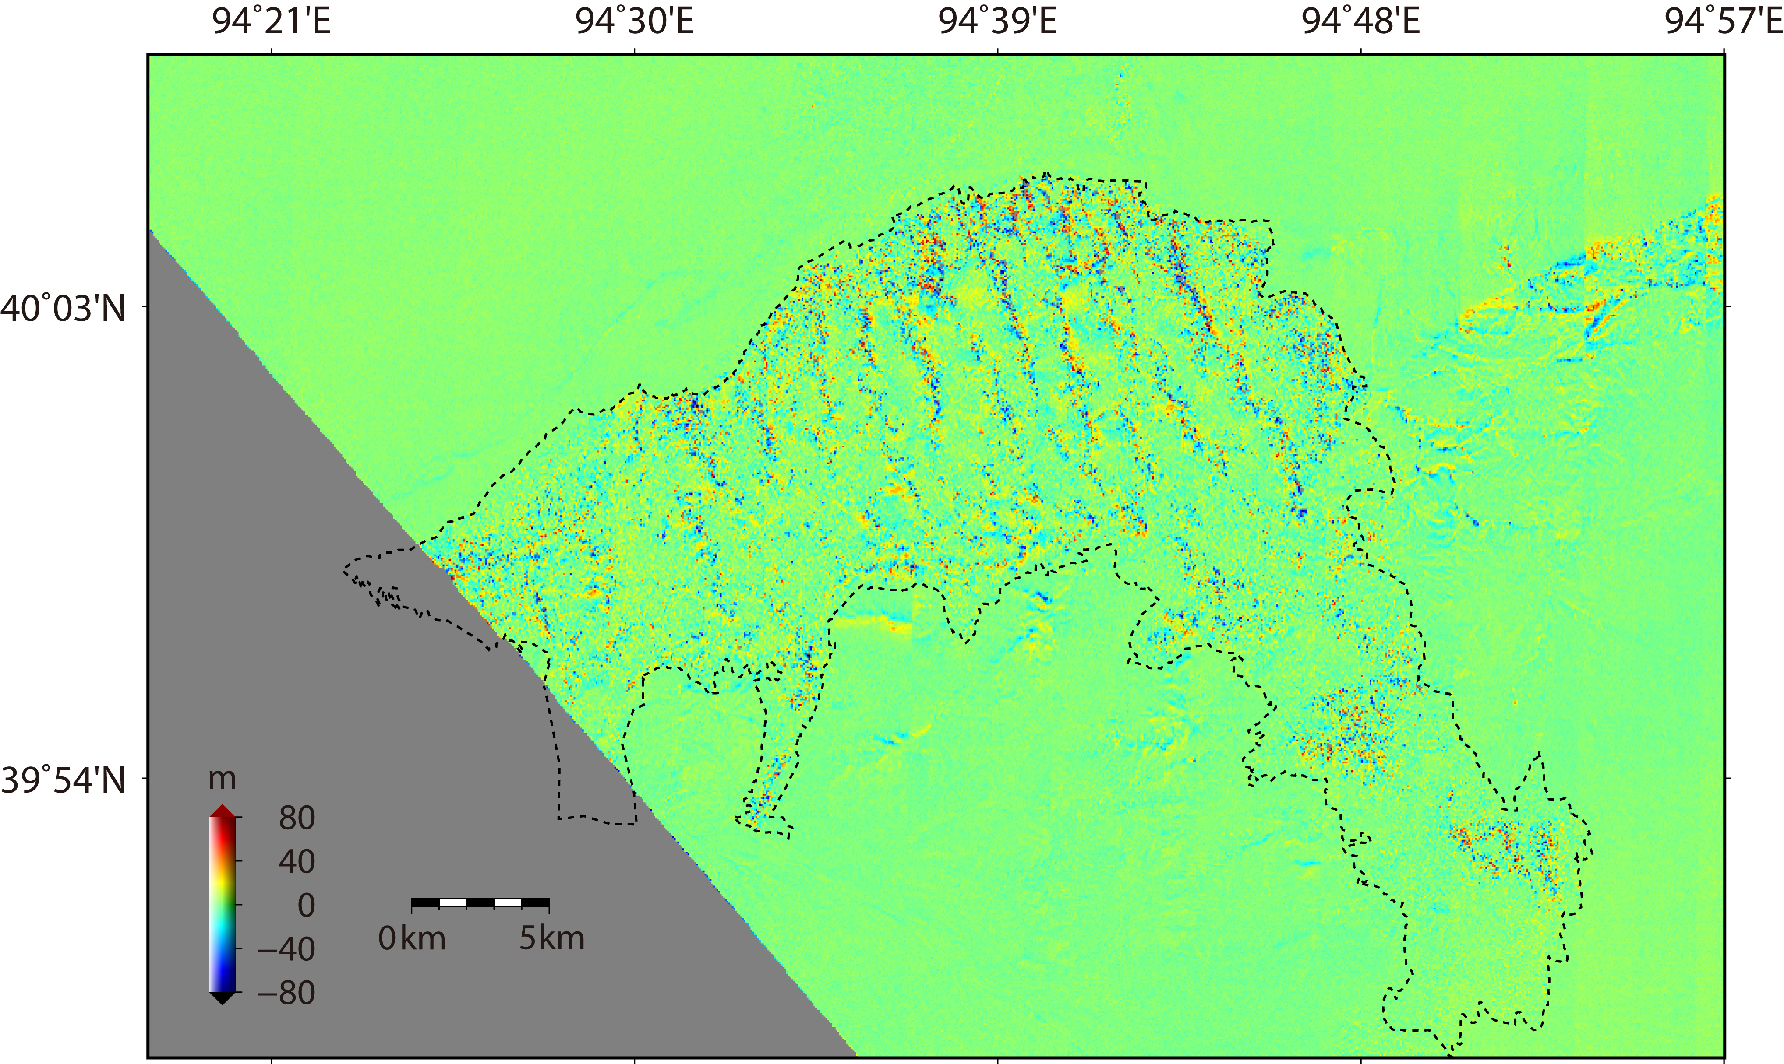
(b)
Figure S4. The DEM differencing map acquired by subtracting the SRTM-X DEM from the TanDEM-X DEM, with the subplot (a) for the original differencing result and subplot (b) for the differencing result after co-registration and terrain-related bias correction. The dotted lines denote the outline of active dune fields in Mingsha mountain. The dark gray regions denote the null values that are caused by the data deficiency of SRTM-X DEM.
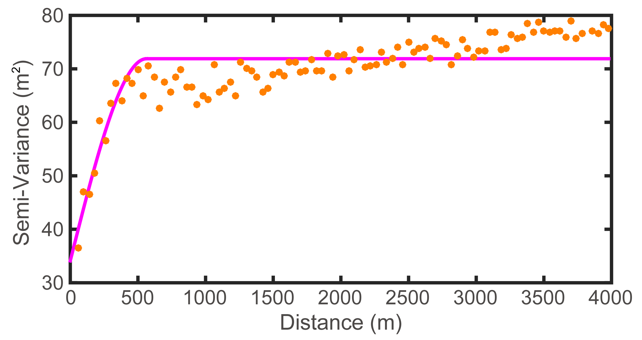
Figure S5. Experimental semi-variogram of the elevation difference in off-dune region. The magenta curve line denotes the best-fit of the semi-variance with the spherical model in the least-square sense.
Table S1
Average migration direction and magnitude of the three test sites derived from L8/S2.
Test sites | F-AAR of L8
Test sites | Direction (°) | Magnitude (m/yr)
A | 105.046 | 1.343
B | 150.349 | 3.053
C | 86.146 | 1.671

