Electronic Supporting Information

**New spectrophotometric protocol using tetra-thiosemicarbazone derivative chelating (TTSC) for the assessment of trace level of cadmium (II) in drinking water**

**Tarek Ahmed Seaf-Elnasr1,2, Ibrahim Hotan Alsohaimi1,*, Wael Abdelgayed Ahmed Arafa1,3, Mutairah Shaker Alshammari1**

1Chemistry Department, College of Science, Jouf University, P.O. Box 2014, Sakaka, Aljouf, Kingdom of Saudi Arabia.

2Chemistry Department, Faculty of Science, Al-Azhar University, Assiut Branch, P.O. Box 71524, Assiut, Egypt.

3Chemistry Department, Faculty of Science, Fayoum University P.O. Box 63514, Fayoum City, Egypt.

**\*Correspondence:**

Dr. Ibrahim Hotan Alsohaimi

Chemistry Department, College of Science, Jouf University, Saudi Arabia

Phone: +966504904183; e-mail: [ehalshaimi@ju.edu.sa](mailto:waarafa@ju.edu.sa); [chem-ihg@hotmail.com](mailto:chem-ihg@hotmail.com)

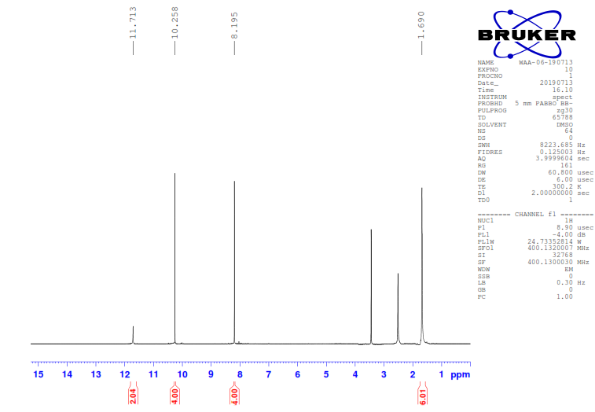

1H NMR (DMSO, *d6*) of **2**

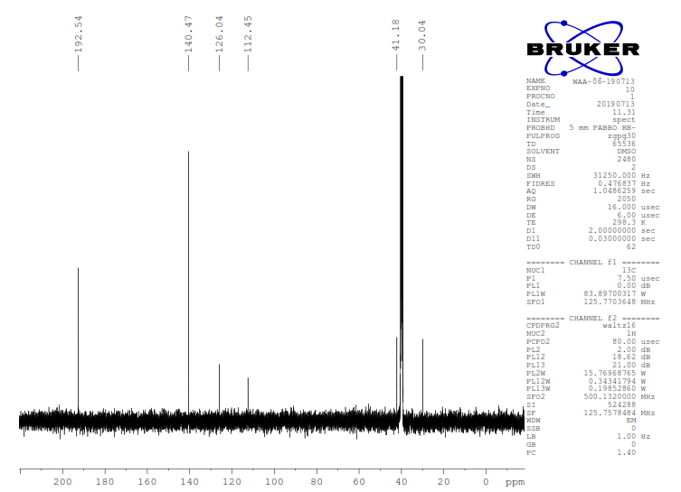

13C NMR (DMSO, *d6*) of **2**

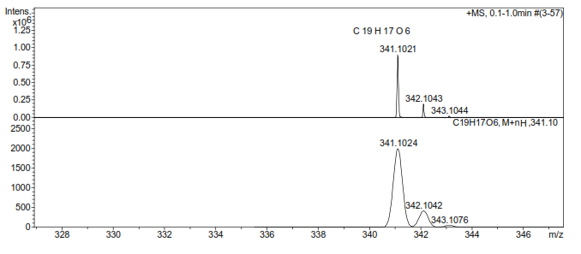

HRMS of **2**



FT-IR of **3**

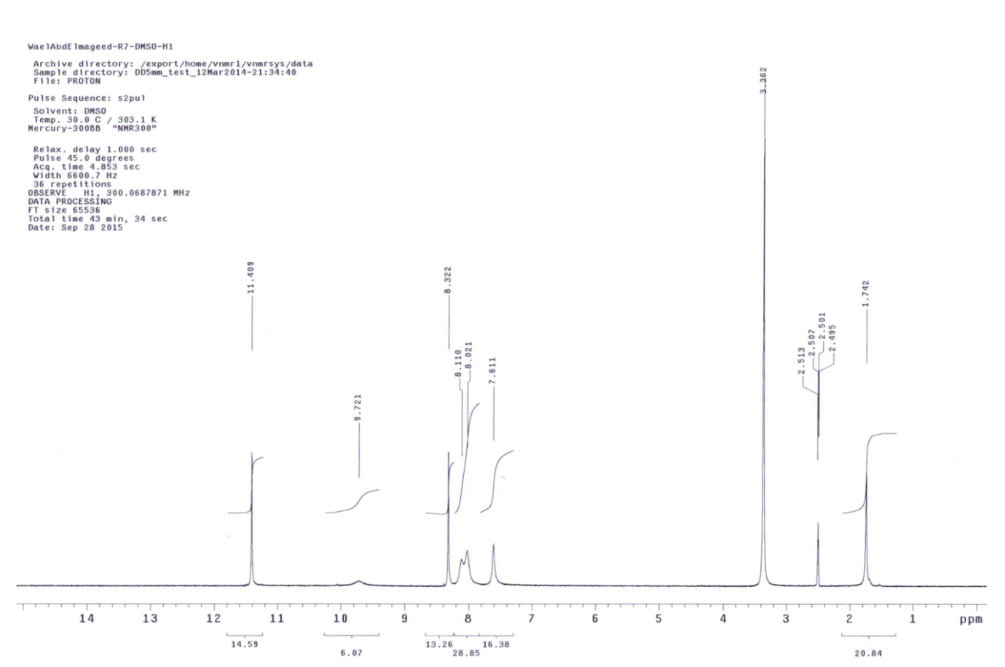

1H NMR (DMSO, *d6*) of **3**

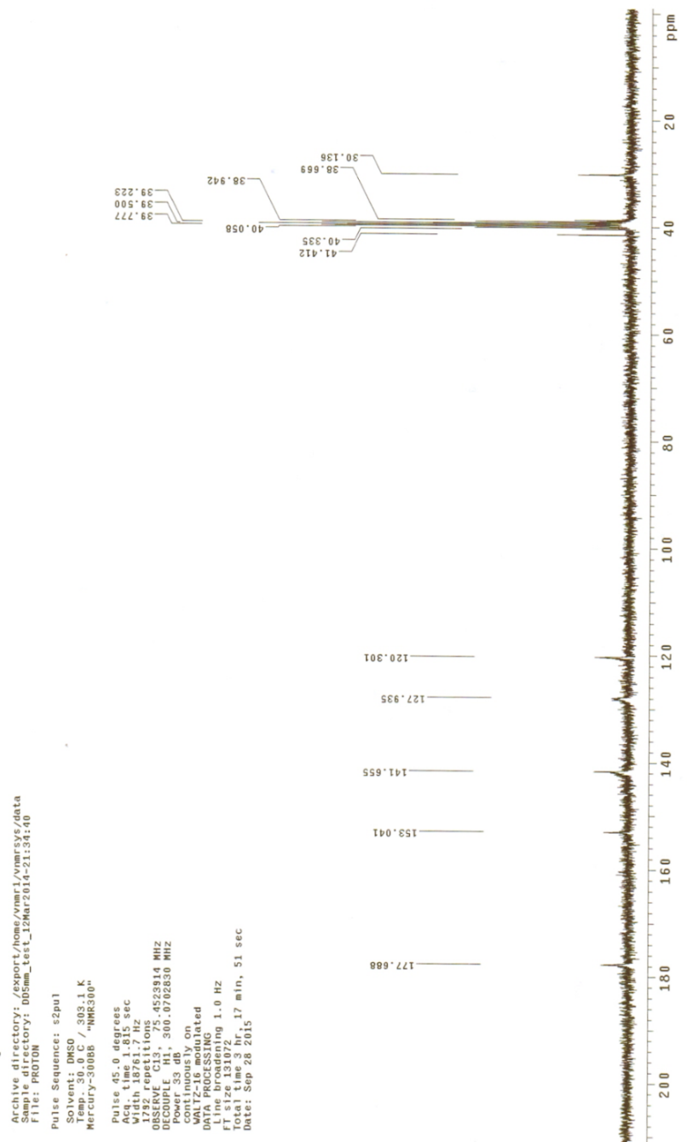

13C NMR (DMSO, *d6*) of **3**



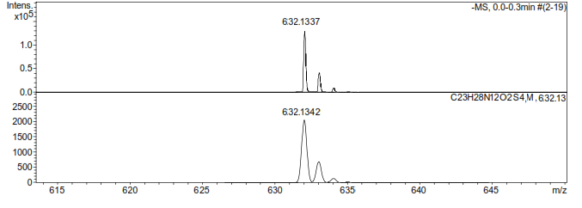

HRMS of **3**