**Supplementary Material**

**C20 fullerene** **and its boron- and nitrogen-doped counterparts as an efficient catalyst for CO oxidation**

Nasim Hassani*[1]

Department of Chemistry, College of Sciences, Shiraz University, Shiraz, Iran

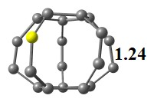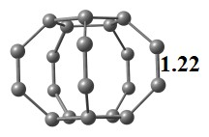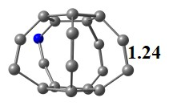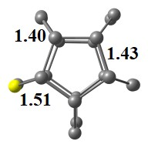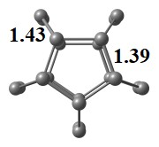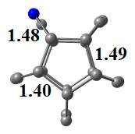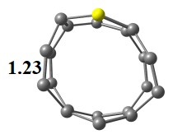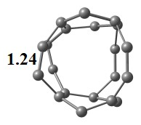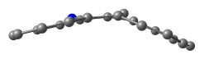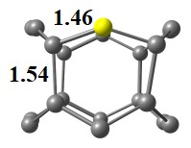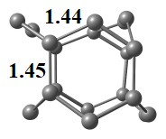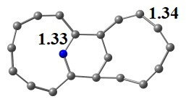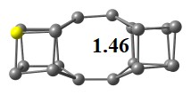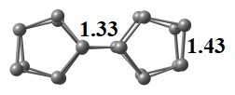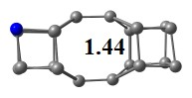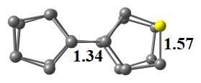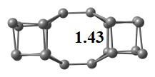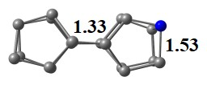

**0.00**

**0.00**

**0.00**

**4.26**

**4.81**

**2.85**

**7.63**

**8.90**

**2.96**

**9.61**

**10.16**

**9.65**

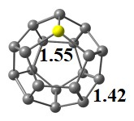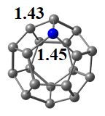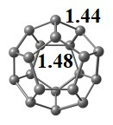

**Fig. S1.** The top and side views of the optimized structures of the cage-like isomers of C20, BC19, and NC19 fullerene-like clusters with the bond distances in Å. The numbers under the structures are relative energy (in eV) with respect to the most stable fullerene-like C20 cluster. Color scheme: M, red; B, yellow; N, dark blue.

1. *1 Corresponding author. E-mail address: [nasim.hassani.chem@gmail.com](mailto:nasim.hassani.chem@gmail.com), Phone: +98-9178255652.

  