Supplemental Materials
Figure S1. Inpatient Infection Distribution
- Baseline
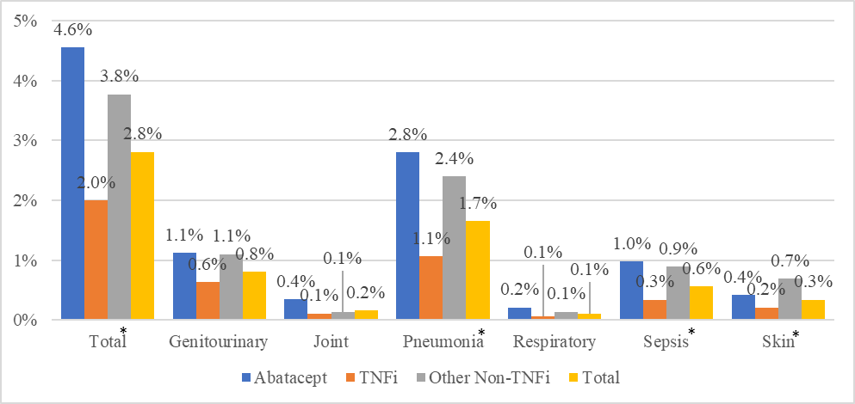
- Follow-up
*P<0.05

