**Supporting Information**

**Nanocrystalline Gold with small size: Inverse Hall–Petch between Mixed Regime and Super-Soft Regime**

Jialin Liua, Xiaofeng Fana,*, Weitao Zhenga,b, David J. Singhc and Yunfeng Shid,†

*a. Key Laboratory of Automobile Materials (Jilin University), Ministry of Education, and College of Materials Science and Engineering, Jilin University, Changchun, 130012, China*

*b. State Key Laboratory of Automotive Simulation and Control, Jilin University, Changchun 130012, China*

*c. Department of Physics and Astronomy, University of Missouri, Columbia, Missouri 65211-7010, USA*

*d. Department of Material Science and Engineering,* Rensselaer Polytechnic Institute*, Troy, New York 12180,* United States

*\*,† Correspondence and requests for materials should be addressed,*

*xffan@jlu.edu.cn (X. Fan); shiy2@rpi.edu (Y. Shi)*

Table S1. Basic properties of gold calculated with the EAM potential, including the lattice constant (a0), bulk modulus (B), elastic constants (C11, C12 and C44), sublimation energy (Esub), and formation energy (EV) of single vacancy.

|  |  |  |  |  |  |  |  |
| --- | --- | --- | --- | --- | --- | --- | --- |
|  | a0  (Å) | B  (Gpa) | C11  (Gpa) | C12  (Gpa) | C44  (Gpa) | Esub  (eV) | EV  (eV) |
| EAM potential | 4.08 | 1.67 | 183 | 159 | 45 | 3.93 | 1.03 |

**Figure S1**

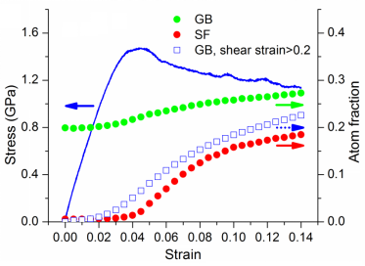

Fig. S1 (a) Stress- strain curves with the atom fraction of grain boundaries (GB), stacking faults (SF), and that in GB with shear strain larger than 0.2 as functions of strain for grain sizes of 10 nm.

**Figure S2**



Fig. S2. The tension process of grain size 4 nm under the applied strain. Snapshots of atomic structures in (a), (b), (c), (d), (e), (f), (g) and (h) is at the strain of 0, 0.02, 0.04, 0.06, 0.08, 0.1, 0.12, and 0.14, respectively. Blue, red and yellow represent inner grain, GB, and SF, respectively.

**Figure S3**



Fig. S3. The tension process of grain size 10 nm under the applied strain. Snapshots of atomic structures in (a), (b), (c), (d), (e), (f), (g) and (h) is at the strain of 0, 0.02, 0.04, 0.06, 0.08, 0.1, 0.12, and 0.14, respectively. Blue, red and yellow represent inner grain, GB, and SF, respectively.

**Figure S4**

F:\origindata\bulk-tension\small-orig\small-orig\Graph7.tifFig. S4. Atom fraction of grain boundaries (GB) with shear strain larger than 0.15, 0.2 and 0.25 as functions of grain size at strain of (a) 4% and (b) 14%.

**Figure S5**

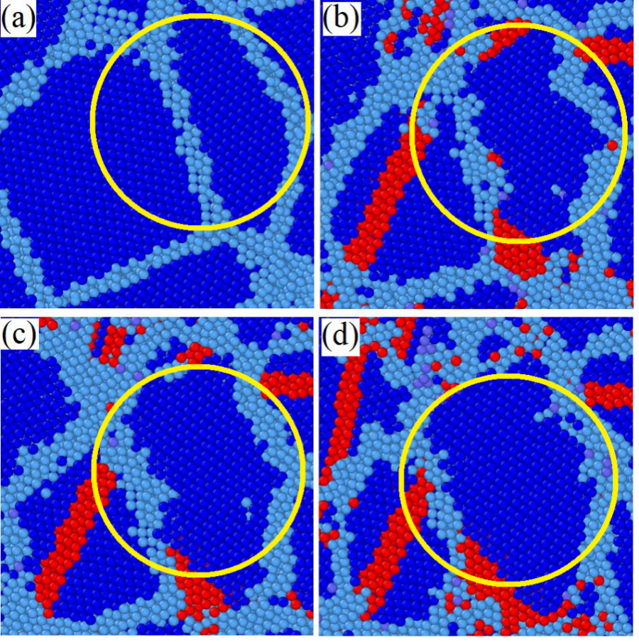

Fig. S5. Snapshots shown grain growth in nanocrystalline gold with average grain size of 3.3 nm under at strains of (a) 0.00, (b) 0.08, (c) 0.11, and (d) 0.14. The circle shows the region of grain growth. Green, gray, and red atoms represent grain boundaries, grain interiors with fcc structure, and stacking faults, respectively.

**Figure S6**

**C:\Users\Administrator\Desktop\7.tif**

Fig. S6. Stress-strain curves of nanocrystalline gold with grain size of 4 nm simulated in supercells with the volume of 10.63 nm3 and 303 nm3.

**Figure S7**

**C:\Users\Administrator\Desktop\8.tif**

Fig. S7. Atom fraction of that in GB with shear strain larger than 0.15, 0.2, 0.25 as functions of strain for grain size of 6 nm.

**Figure S8**

Fig. S8. Atom fraction with rotation more than 2° and 5° along Y and Z axis for strain changes from 10% to 12% as functions of grain size.