Impact of hydroxide ion-chloride ion concentration ratio on crack electrochemistry

A. Turnbull*, Edmund J.F. Dickinson

*National Physical Laboratory, Hampton Road, Teddington, TW11 0LW, United Kingdom*

*\*Corresponding author.* [alan.turnbull@npl.co.uk](mailto:alan.turnbull@npl.co.uk)

Supplementary Material – Model Specification

**Model equations (all notation is specified below):**

*Geometry*

The 1D crack model is solved on a 1D geometry with extent 0 ≤ *x* ≤ *l*c, corresponding to the crack length, with *x* = 0 corresponding to the crack tip, and *x* = *l*c corresponding to the crack mouth. The small-angle approximation is used and the crack shape is assumed to be a Mode I opening crack in the SENT geometry [A1].















*Steel composition*

The Ni content of the steel is about 2.7% by mass but since the hydrolysis constant of Ni2+ is relatively low, a pure Fe-Cr steel is assumed. The previous analysis [A2] incorrectly assumed 12% Cr by atom rather than 12% Cr by mass. Because of the similar of atomic masses of Fe and Cr, the difference is minor (≈ 1% error), but the present analysis is more exact.

*j* = Fe, Cr, representing the solid-phase alloy components







*Bulk chemical composition*













 (M = Fe, Cr)

*Domain equations (crack model)*

*i* = Na, Cl, H, OH, Fe, Fe(OH), Cr, Cr(OH), representing the solution-phase ionic species









*Electrochemical reaction rates (crack model)*

 (*m* = ano, PRR, WRR)



 (M = Fe, Cr)















All other *vim* = 0 if not stated otherwise.

*Precipitation reaction rates (crack model)*

 (M = Fe, Cr)

 (M = Fe, Cr)

 (M = Fe, Cr)

All other *N*pr,*I*= 0 if not stated otherwise.

*Equilibrium reaction rates (crack model)*

 (*q* = H2O, Fe, Cr)



 (M =Fe, Cr)

 (M =Fe, Cr)

The *R*eqm,*q* are determined numerically to satisfy the following constraints, at all locations *x*.



 (M = Fe, Cr)

All other *viq* = 0 if not stated otherwise.

*Boundary conditions (crack model)*

Crack mouth (*x* = *l*c):





Crack tip (*x* = 0):

 (M = Fe, Cr)

 (*i* ≠ Fe, Cr)

*External potential model (Laplace equation)*

The crack mouth potential *E*m (appearing in the crack model through ) is evaluated from the crack mouth current density according to equations specified on the plane 2D quadrant *x*2D ≥ 0, *y*2D ≥ 0. All equations below are solved numerically in a rectangular space (0 ≤ *μ* ≤ *μ*max,0 ≤ *ν* ≤ *π*/2) defined by the following elliptic conformal map:











Symmetry boundary (*x*2D = 0):



Crack mouth (*y*2D = 0, 0 ≤ *x*2D ≤ *hm*):



*φ*m is determined numerically to satisfy the following constraint:





Passive steel surface (*y*2D = 0, *x*2D > *hm*):



Bulk solution (*x*2D, *y*2D 🡪 ∞)



Output:



*Outputs (crack model)*

Reported pH outputs are evaluated from proton concentration without considering activity corrections, based on the low proton concentrations considered.



Crack-tip potential is evaluated as:



Crack-tip chloride content is evaluated as:



*Summary schematics*

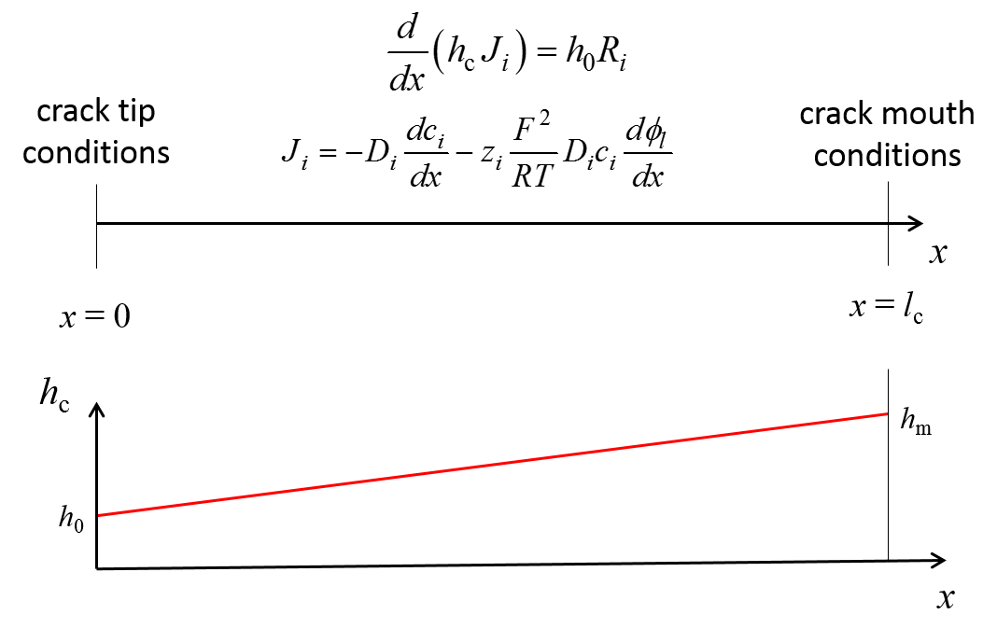

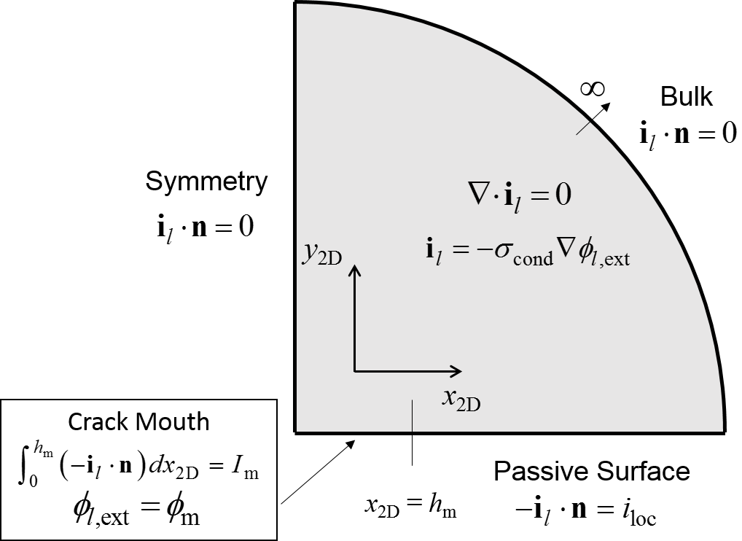

**Solution variables**

|  |  |  |  |
| --- | --- | --- | --- |
| **Variable** | **Unit** | **Definition** | **Corresponding equation** |
| *ci* | mol m-3 | Concentration, species *i* | , |
| *ci*(OH),crit | mol m-3 | Critical precipitation concentration of hydrolysed species *i*(OH) |  |
| *E*act | V | Local electrode potential vs. SCE |  |
| *E*m | V | Crack mouth potential vs. SCE |  |
| *E*tip | V | Crack tip potential vs. SCE |  |
| **i**l | A m-2 | Electrolyte current density, external model |  |
| *I*m | A m-1 | Total outward current at crack mouth, per unit depth out-of-plane |  |
| *im* | A m-2 | Current density, faradaic reaction *m* | , , |
| *Ji* | mol m-2 s-1 | Molar flux along crack, species *i* |  |
| *h*c | m | Half-width, crack |  |
| **n** | 1 | Normal unit vector to surface, outwards from electrolyte | n/a |
| *N*ec,*i* | mol m-2 s-1 | Surface reaction rate from faradaic reactions, species *i* |  |
| *R*eqm,*i* | mol m-3 s-1 | Reaction rate from equilibrium reactions, species *i* |  |
| *R*eqm,*q* | mol m-3 s-1 | Effective volumetric reaction rate of equilibrium reaction *q*, determined numerically | , |
| *Ni* | mol m-2 s-1 | Integrated volumetric reaction rate, species *i* |  |
| *N*pr,*i* | mol m-2 s-1 | Surface reaction rate from precipitation reactions, species *i* | , |
| *x* | m | Coordinate along crack length | n/a |
| *x*2D | m | External coordinate normal to crack | n/a |
| *y*2D | m | External coordinate tangent to crack | n/a |
| *μ* | 1 | Coordinate, elliptic transform space | , |
| *ν* | 1 | Coordinate, elliptic transform space | , |
| *φl* | V | Electrolyte potential |  |
| *φl,*ext | V | Electrolyte potential, external potential model |  |
| *φ*m | V | Electrolyte potential difference between crack mouth and bulk |  |

Global model input variables

|  |  |  |  |
| --- | --- | --- | --- |
| **Variable** | **Unit** | **Definition** | **Corresponding equation** |
| *c*addn,NaOH | mol m-3 | Added NaOH(aq) concentration at reference temperature |  |
| *c*0,*i* | mol m-3 | Bulk concentration, species *i* | - |
| *D*mul | 1 | Multiplier applied to all diffusion coefficients | Defined input |
| pH298 | 1 | pH at *T*0 | Defined input |
| *w*Cl | 1 | Cl- content by mass, bulk | Defined input |
| *σ*cond | S m-1 | Bulk solution conductivity |  |

Model input parameters

* Computed values are quoted to 3 significant figures except where otherwise stated. Values specified at input are quoted to the full specified precision.

|  |  |  |  |
| --- | --- | --- | --- |
| **Parameter** | **Value\*** | **Definition** | **Source** |
| *b*SENT | 3.3 cm | SENT specimen width | [A2] |
| *c*H,ref | 1 M | Reference proton concentration, PRR kinetics | Defined |
| *D*Cl | 7.1 × 10-5 cm2 s-1 | Diffusion coefficient, chloride ion | * |
| *D*Cr | 2 × 10-5 cm2 s-1 | Diffusion coefficient, Cr3+ | * |
| *D*CrOH | 2.5 × 10-5 cm2 s-1 | Diffusion coefficient, Cr(OH)2+ | * |
| *D*Fe | 2.5 × 10-5 cm2 s-1 | Diffusion coefficient, Fe2+ | * |
| *D*FeOH | 2.5 × 10-5 cm2 s-1 | Diffusion coefficient, Fe(OH)+ | * |
| *D*H | 3.2 × 10-4 cm2 s-1 | Diffusion coefficient, protons | * |
| *D*Na | 4.7 × 10-5 cm2 s-1 | Diffusion coefficient, sodium ion | * |
| *D*OH | 1.8 × 10-4 cm2 s-1 | Diffusion coefficient, hydroxide ion | * |
| *E* | 200 GPa | Young’s modulus, steel | [A2] |
| *E'* | 220 GPa | Reduced Young’s modulus, steel |  |
| *E*corr | -0.15 V | Corrosion potential, bulk steel vs. SCE | [A2] |
| *F* | 96485 C mol-1 | Faraday constant | Fixed by SI |
| *F*1 | 1.12 | Tada SENT function |  |
| *F*­10 | 1.122 | Tada SENT function coefficient | [A1] |
| *F*11 | -0.231 | Tada SENT function coefficient | [A1] |
| *F*12 | 10.55 | Tada SENT function coefficient | [A1] |
| *F*13 | -21.71 | Tada SENT function coefficient | [A1] |
| *F*14 | 30.382 | Tada SENT function coefficient | [A1] |
| *hm* | 1.34 μm | Half-width, crack mouth |  |
| *h*0 | 0.649 μm | Half-width, crack tip |  |
| *i*pass | 7.6 × 10-7 A cm-2 | Passive corrosion current density | [A2] |
| *i*0,PRR | 4.2 × 10-8 A cm-2 | Reference current density, proton reduction reaction | [A2] |
| *i*0,WRR | 2.9 × 10-11 A cm-2 | Reference current density, water reduction reaction | [A2] |
| *K* | 20 MPa m1/2 | Stress intensity factor | Defined input |
| *K*a,Cr | 10-2.23 M | Acidity constant, first hydrolysis, Cr | [A3] |
| *K*a,Fe | 10-7.61 M | Acidity constant, first hydrolysis, Fe | [A3] |
| *k*pr,Fe | 1 mol m-2 s-1 | Numerical precipitation rate | Numerical quantity |
| *k*pr,Cr | 0.01 mol m-2 s-1 | Numerical precipitation rate | Numerical quantity |
| *K*sp,Cr(OH)3 | 4.43 × 10-30 M4 | Solubility product, chromium hydroxide | [A3] |
| *K*sp,Fe(OH)2 | 10-13.88 M2 | Solubility product, ferrous hydroxide | [A3] |
| *K*w | (3.1 × 10-7 M)2 | Self-ionisation constant, water (at temperature *T*) | [A2] |
| *l*c | 0.1 mm / 0.3 mm | Crack length | Defined input |
| *M*Cr | 52 g mol-1 | Atomic mass, Cr | Standard value |
| *M*Fe | 55.845 g mol-1 | Atomic mass, Fe | Standard value |
| *M*Cl | 35.5 g mol-1 | Atomic mass, Cl | Standard value |
| *M*steel | 55.4 g mol-1 | Relative molar mass, steel |  |
| *n*Cr | 3 | Number of electrons passed for anodic dissolution, Cr | Standard value |
| *n*Fe | 2 | Number of electrons passed for anodic dissolution, Fe | Standard value |
| *n*steel | 2.13 | Number of electrons passed for anodic dissolution per atom equivalent of steel |  |
| *nm* | various | Number of electrons transferred in faradaic reaction *m*, reductive direction | , |
| p*K*w,298 | 14 | Log scale self-ionisation of water | Standard value |
| *R* | 8.314 J K-1 mol-1 | Gas constant | Fixed by SI |
| *T* | 90 °C | Local temperature | Defined |
| *T*0 | 25 °C | Reference temperature, pH definition | Defined |
| *V*1 | 1.46 | Tada SENT function |  |
| *vim* | various | Stoichiometric coefficient, species *i* in faradaic reaction *m*, reductive direction | , , |
| *viq* | various | Stoichiometric coefficient, species *i* in equilibrium reaction *q* | - |
| *w*Cr | 0.12 | Mass fraction of Cr, steel | Defined for 12Cr steel |
| *w*Fe | 0.18 | Mass fraction of Fe, steel | Defined for 12Cr steel |
| *xj* | various | Mole fraction of species *j*, steel |  |
| *zi* | as species superscript (= ionic charge) | Charge number, species *i* | Standard values |
| *α*ORR | 0.5 | Transfer coefficient, oxygen reduction reaction | *** |
| *α*PRR | 1.5 | Transfer coefficient, proton reduction reaction | [A2] |
| *α*WRR | 0.54 | Transfer coefficient, water reduction reaction | [A2] |
| *θ* | 6.88 × 10-3 rad | Crack angle |  |
| *μ*max | 20 | Maximum extent, elliptic transform space | Numerical value established by convergence study |
| *ν* | 0.3 | Poisson’s ratio, steel | [A2] |
| *ρ*w | 1 kg L-1 | Density, brine | Assumed |
| *σ*0.2 | 841 MPa | 0.2% yield stress, steel | [A2] |

* Diffusion coefficients at *T* = 90 °C follow the values used previously. These were calculated based on known values at *T* = 25 °C with adjustment for temperature and viscosity, *η*, with the assumption that *Dη*/*T* is a constant [A4].

** The *k*pr,M values were chosen for numerical stability while ensuring that the value is still sufficiently large to eliminate observable supersaturation under precipitating conditions, as assessed *a posteriori* from examination of the predicted concentration profiles.

*** For oxygen reduction external to the crack, the transfer coefficient *α*ORR was taken to be 0.5 as in the previous study [A2], in the absence of other reliable data. This is an important parameter in determining the magnitude of the potential drop external to the crack and may vary in real applications.

**Numerical settings**

Equations were implemented in COMSOL Multiphysics 5.5 [A5] using the **Tertiary Current Distribution, Nernst-Planck** and **Coefficient Form PDE** physics, with user-defined modifications as required to represent the mathematical equations. The 1D mesh was defined with a maximum mesh size at *x* = 0, *l*c of *l*c/105, a maximum overall mesh size of *l*c/103, and maximum element growth rate of 1.05. The 2D mesh was defined with a maximum overall mesh size of 0.1 units in the elliptic transform space.

**References For Supplementary Material**

[A1] H. Tada, P. Paris and G. Irwin, The stress analysis of cracks handbook, Del Research Corp., 1973.

[A2] A. Turnbull, L. Wright, Modelling of the electrochemical crack size effect on stress corrosion crack growth rate, Corros. Sci., 126C (2017) 69-77.

[A3] MTDATA, Hampton Thermodynamics Ltd, 2019.

[A4] J. Newman, Mass transport and potential distribution in the geometries of localised corrosion, in: R.W. Staehle, B.F. Brown, J. Kruger, A. Agrawal, eds., Localised Corrosion, NACE Int., Houston, 1974, pp. 45—61.

[A5] COMSOL AB, [www.comsol.com](http://www.comsol.com).