Full title: The Assessment of Impacts and Risks of Climate Change on Agriculture (AIRCCA) model: A tool for a rapid global risk assessment for crop yields at a spatially explicit scale
Running title: Probabilistic estimates of the impacts of climate change on agriculture
Manuscript prepared for the special issue The Spatial Economic Impacts of Climate Change of the journal Spatial Economic Analysis.

Supplemental Material

A. Supplementary tables and figures

Table S1. List of climate models used for projecting maize yields for each of the RCP emissions scenarios.
 | RCP8.5 | RCP6 | RCP4.5 | RCP2.6
1 | ACCESS1-0 | CCSM4 | ACCESS1-0 | BNU-ESM
2 | ACCESS1-3 | CESM1-CAM5 | ACCESS1-3 | CCSM4
3 | BNU-ESM | CSIRO-Mk3-6-0 | BNU-ESM | CESM1-CAM5
4 | CCSM4 | GFDL-ESM2M | CCSM4 | CNRM-CM5
5 | CESM1-BGC | GISS-E2-H (run 1) | CESM1-BGC | CSIRO-Mk3-6-0
6 | CESM1-CAM5 | GISS-E2-H (run 2) | CESM1-CAM5 | CanESM2
7 | CMCC-CMS | GISS-E2-H (run 3) | CMCC-CMS | EC-EARTH
8 | CMCC-CM | GISS-E2-R (run 1) | CMCC-CM | FGOALS-g2
9 | CNRM-CM5 | GISS-E2-R (run 2) | CNRM-CM5 | FIO-ESM
10 | CSIRO-Mk3-6-0 | GISS-E2-R (run 3) | CSIRO-Mk3-6-0 | GFDL-CM3
11 | CanESM2 | HadGEM2-AO | CanESM2 | GFDL-ESM2G
12 | EC-EARTH | HadGEM2-ES | EC-EARTH | GFDL-ESM2M
13 | FGOALS-g2 | IPSL-CM5A-LR | FGOALS-g2 | GISS-E2-H (run 1)
14 | FIO-ESM | IPSL-CM5A-MR | FIO-ESM | GISS-E2-H (run 2)
15 | GFDL-CM3 | MIROC-ESM | GFDL-CM3 | GISS-E2-H (run 3)
16 | GFDL-ESM2G | MIROC5 | GFDL-ESM2G | GISS-E2-R (run 1)
17 | GFDL-ESM2M | MRI-CGCM3 | GFDL-ESM2M | GISS-E2-R (run 2)
18 | GISS-E2-H (run 1) | NorESM1-ME | GISS-E2-H (run 1) | GISS-E2-R (run 3)
19 | GISS-E2-H (run 2) | NorESM1-ME | GISS-E2-H (run 2) | HadGEM2-AO
20 | GISS-E2-H (run 3) | NorESM1-M | GISS-E2-H (run 3) | HadGEM2-ES
21 | GISS-E2-R (run 1) | bcc-csm1-1-m | GISS-E2-R (run 1) | IPSL-CM5A-LR
22 | GISS-E2-R (run 2) | bcc-csm1-1 | GISS-E2-R (run 2) | IPSL-CM5A-MR
23 | GISS-E2-R (run 3) |  | GISS-E2-R (run 3) | MIROC-ESM-CHEM
24 | HadGEM2-AO |  | HadGEM2-AO | MIROC-ESM
25 | HadGEM2-CC |  | HadGEM2-CC | MIROC5
26 | HadGEM2-ES |  | HadGEM2-ES | MPI-ESM-LR
27 | IPSL-CM5A-LR |  | IPSL-CM5A-LR | MPI-ESM-MR
28 | IPSL-CM5A-MR |  | IPSL-CM5A-MR | MRI-CGCM3
29 | IPSL-CM5B-LR |  | IPSL-CM5B-LR | NorESM1-ME
30 | MIROC-ESM-CHEM |  | MIROC-ESM-CHEM | NorESM1-M
31 | MIROC-ESM |  | MIROC-ESM | bcc-csm1-1-m
32 | MIROC5 |  | MIROC5 | bcc-csm1-1
33 | MPI-ESM-LR |  | MPI-ESM-LR
34 | MPI-ESM-MR |  | MPI-ESM-MR
35 | MRI-CGCM3 |  | MRI-CGCM3
36 | NorESM1-ME |  | NorESM1-ME
37 | NorESM1-M |  | NorESM1-M
38 | bcc-csm1-1 |  | bcc-csm1-1
39 | inmcm4 |  | inmcm4

Table S2. Hausman test results for model specifications s1 and s2.
Specification | Test statistic (RCP2.6) | Test statistic (RCP4.5) | Test statistic (RCP6) | Test statistic (RCP8.5)
s1 Maize | 7,115.73  (0.0000) | 38,624.86  (0.0000) | 44,273.74  (0.0000) | 39,236.95  (0.0000)
s2 Maize | 5,431.97  (0.0000) | 51,469.95  (0.0000) | 56,649.66 (0.0000) | 3,374,444.65  (0.0000)
s1 Wheat | 1,839.07  (0.0000) | 9,554.22  (0.0000) | 7,165.34  (0.0000) | 7,790.07  (0.0000)
s2 Wheat | 924.68  (0.0000) | 12,186.75  (0.0000) | 8,236.58  (0.0000) | 9,845.62  (0.0000)
s1 Rice | 16,573.33  (0.0000) | 41,979.73  (0.0000) | 53,112.52  (0.0000) | 22,981.57  (0.0000)
s2 Rice | 12,022.79  (0.0000) | 52,103.05  (0.0000) | 55,579.68  (0.0000) | 335,496.40  (0.0000)

Table S3. Redundant variables tests for cross-section and period fixed effects under specifications s1 and s2 for Maize.
Effects test | Test statistic (s1) | Test statistic (s2)
Cross-section (F-statistic) | 295.24 a  (0.0000)  85.73 b  (0.0000)  58.31 c  (0.0000)  32.56 d  (0.0000) | 257.91 a  (0.0000)  141.66 b  (0.0000)  96.89 c  (0.0000)  48.64 d  (0.0000)
Cross-section Chi-square | 471,258.33 a  (0.0000)  356,280.71 b  (0.0000)  320,970.94 c  (0.0000)  268,489.09 d  (0.0000) | 349,039.75 a  (0.0000)  402,747.06 b  (0.0000)  367,561.87 c  (0.0000)  304,486.56 d  (0.0000)
Period (F-statistic) | 371.25 a  (0.0000)  237.055 b  (0.0000)  162.02 c  (0.0000)  236.00 d  (0.0000) | 583.63 a  (0.0000)  234.72 b  (0.0000)  92.57 c  (0.0000)  85.07 d  (0.0000)
Period (Chi-square) | 1,107.35 a  (0.0000)  708.57 b  (0.0000)  484.87 c  (0.0000)  705.42 d  (0.0000) | 1,156.65 a  (0.0000)  701.60 b  (0.0000)  277.33 c  (0.0000)  254.89 d  (0.0000)
Cross-Section/Period F | 295.37 a  (0.0000)  87.14 b  (0.0000)  60.05 c  (0.0000)  35.55 d  (0.0000) | 258.01 a  (0.0000)  143.69 b  (0.0000)  99.20 c  (0.0000)  52.79 d  (0.0000)
Cross-Section/Period Chi-square | 471,304.20 a  (0.0000)  357,783.65 b  (0.0000)  323,658.36 c  (0.0000)  276,337.99 d  (0.0000) | 349,066.87 a  (0.0000)  404,070.50 b  (0.0000)  369,734.80 c  (0.0000)  311,916.43 d  (0.0000)
Note: a, b c and d denote calculated test values for the panel regressions based on the RCP2.6, RCP45, RCP6 and RCP8.5 datasets.

Table S4. Redundant variables tests for cross-section and period fixed effects under specifications s1 and s2 for Wheat.
Effects test | Test statistic (s1) | Test statistic (s2)
Cross-section (F-statistic) | 189.14 a  (0.0000)  75.37 b  (0.0000)  54.35 c  (0.0000)  30.61 d  (0.0000) | 219.04 a  (0.0000)  86.36 b  (0.0000)  60.89 c  (0.0000)  33.30 d  (0.0000)
Cross-section Chi-square | 429,656.82 a  (0.0000)  344,437.49 b  (0.0000)  314,570.37 c  (0.0000)  263,042.96 d  (0.0000) | 442,490.07 a  (0.0000)  356,945.93 b  (0.0000)  324,906.75 c  (0.0000)  270,488.50 d  (0.0000)
Period (F-statistic) | 823.86 a  (0.0000)  1796.24 b  (0.0000)  867.50 c  (0.0000)  932.39 d  (0.0000) | 1,012.01 a  (0.0000)  1,466.24 b  (0.0000)  342.68 c  (0.0000)  639.20 d  (0.0000)
Period (Chi-square) | 2,439.99 a  (0.0000)  5,240.84 b  (0.0000)  2,567.48 c  (0.0000)  2,756.77 d  (0.0000) | 2,988.32 a  (0.0000)  4,299.40 b  (0.0000)  1,022.52 c  (0.0000)  1,898.46 d  (0.0000)
Cross-Section/Period F | 189.18 a  (0.0000)  75.51 b  (0.0000)  54.40 c  (0.0000)  30.65 d  (0.0000) | 217.07 a  (0.0000)  86.66 b  (0.0000)  61.05 c  (0.0000)  33.45 d  (0.0000)
Cross-Section/Period Chi-square | 429,679.19 a  (0.0000)  344,619.03 b  (0.0000)  314,657.31 c  (0.0000)  263,164.50 d  (0.0000) | 442,508.99 a  (0.0000)  357,276.11 b  (0.0000)  325,147.36 c  (0.0000)  270,889.37 d  (0.0000)
Note: a, b c and d denote calculated test values for the panel regressions based on the RCP2.6, RCP45, RCP6 and RCP8.5 datasets.

Table S5. Redundant variables tests for cross-section and period fixed effects under specifications s1 and s2 for Rice.
Effects test | Test statistic (s1) | Test statistic (s2)
Cross-section (F-statistic) | 243.12 a  (0.0000)  49.62 b  (0.0000)  36.17 c  (0.0000)  22.17 d  (0.0000) | 360.70 a  (0.0000)  86.04 b  (0.0000)  61.38 c  (0.0000)  33.77 d  (0.0000)
Cross-section Chi-square | 453,091.94 a  (0.0000)  306,308.47 b  (0.0000)  277,852.37 c  (0.0000)  234,811.30 d  (0.0000) | 490,006.77 a  (0.0000)  356,608.02 b  (0.0000)  325,641.55 c  (0.0000)  271,752.87 d  (0.0000)
Period (F-statistic) | 415.61 a  (0.0000)  605.45 b  (0.0000)  442.12 c  (0.0000)  994.75 d  (0.0000) | 894.74 a  (0.0000)  517.93 b  (0.0000)  331.93 c  (0.0000)  521.44 d  (0.0000)
Period (Chi-square) | 1,238.78 a  (0.0000)  1,799.25 b  (0.0000)  1,317.27 c  (0.0000)  2,938.27 d  (0.0000) | 2,646.85 a  (0.0000)  1,541.22 b  (0.0000)  990.62 c  (0.0000)  1,551.57 d  (0.0000)
Cross-Section/Period F | 243.34 a  (0.0000)  51.06 b  (0.0000)  38.00 c  (0.0000)  25.34 d  (0.0000) | 360.87 a  (0.0000)  87.92 b  (0.0000)  63.55 c  (0.0000)  37.76 d  (0.0000)
Cross-Section/Period Chi-square | 453,183.55 a  (0.0000)  308,901.11 b  (0.0000)  282,285.78 c  (0.0000)  246,435.06 d  (0.0000) | 490,057.32 a  (0.0000)  358,600.22 b  (0.0000)  328,823.39 c  (0.0000)  281,705.10 d  (0.0000)
Note: a, b c and d denote calculated test values for the panel regressions based on the RCP2.6, RCP45, RCP6 and RCP8.5 datasets.

Table S6. Modified Wald test for groupwise heteroskedasticity for specifications s1 and s2.
Maize |  | Wheat |  | Rice
Test statistic (s1) | Test statistic (s2) | Test statistic (s1) | Test statistic (s2) | Test statistic (s1) | Test statistic (s2)
1.3e+12 a  (0.0000) | 6.5e+09 a  (0.0000) | 8.8e+10 a  (0.0000) | 4.2e+11 a  (0.0000) | 6.1e+10 a  (0.0000) | 6.7e+09 a  (0.0000)
1.5e+11 b  (0.0000) | 1.2e+13 b  (0.0000) | 2.8e+12 b  (0.0000) | 5.5e+11 b  (0.0000) | 1.3e+11 b  (0.0000) | 4.6e+11 b  (0.0000)
6.3e+10 c  (0.0000) | 4.7e+12 c  (0.0000) | 3.4e+11 c  (0.0000) | 1.4e+12 c  (0.0000) | 7.5e+10 c  (0.0000) | 5.6e+10 c  (0.0000)
7.5e+09 d  (0.0000) | 2.5e+12 d  (0.0000) | 3.4e+11 d  (0.0000) | 1.6e+12 d  (0.0000) | 2.4e+13 d  (0.0000) | 2.8e+10 d  (0.0000)
Note: a, b c and d denote calculated test values for the panel regressions based on the RCP2.6, RCP45, RCP6 and RCP8.5 datasets.

Table S7. Wooldridge test for autocorrelation for specifications s1 and s2.
Maize |  | Wheat |  | Rice
Test statistic (s1) | Test statistic (s2) | Test statistic (s1) | Test statistic (s2) | Test statistic (s1) | Test statistic (s2)
2,120.07 a  (0.0000) | 1,754.06 a  (0.0000) | 1,992.69 a  (0.0000) | 2,932.04 a  (0.0000) | 2,541.24 a  (0.0000) | 2,681.09 a  (0.0000)
19,471.23 b  (0.0000) | 12,944.52 b  (0.0000) | 15,425.61 b  (0.0000) | 17,966.56 b  (0.0000) | 12,552.20 b  (0.0000) | 10,540.45 b  (0.0000)
11,884.34 c  (0.0000) | 8,615.59 c  (0.0000) | 15,106.34 c  (0.0000) | 15,597.53 c  (0.0000) | 13,455.75 c  (0.0000) | 10,708.25 c  (0.0000)
13,649.47 d  (0.0000) | 12,360.81 d  (0.0000) | 17,083.22 d  (0.0000) | 20,688.08 d  (0.0000) | 13,634.10 d  (0.0000) | 16,050.88 d  (0.0000)
Note: a, b c and d denote calculated test values for the panel regressions based on the RCP2.6, RCP45, RCP6 and RCP8.5 datasets.

Table S8. Estimation results of the fixed-effects models for maize, wheat and rice under specifications s1 and s2 and different robust standard error estimation methods. Estimations are based on $Y_{it}$, $T_{it}$, $P_{it}$ that correspond to the RCP2.6.
Variable | s1-RCP2.6  Maize | s1-RCP2.6  Wheat | s1-RCP2.6  Rice | s2-RCP2.6  Maize | s2-RCP2.6  Wheat | s2-RCP2.6  Rice
$$T_{it}$$ | 0.2265***  (0.0060)  (0.0069) R  (0.0090) B | -0.0668***  (0.0037)  (0.0045) R  (0.0053) B | 0.1353***  (0.0019)  (0.0024) R  (0.0032) B | 0.1833***  (0.0068)  (0.0079) R  (0.0091) B | -0.0778***  (0.0040)  (0.0047) R  (0.0060) B | 0.1223***  (0.0021)  (0.0027) R  (0.0031) B
$$T_{it}^{2}$$ | -0.0114***  (0.0001)  (0.0002)  (0.0002) | -0.0008***  (0.0001)  (0.0001) R  (0.0001) B | -0.0056***  (0.0000)  (0.0001) R  (0.0001) B | -0.0157***  (0.0001)  (0.0001) R  (0.0002) B | -0.0040***  (0.0001)  (0.0001) R  (0.0001) B | -0.0069***  (0.0000)  (0.0000) R  (0.0001) B
$$P_{it}$$ | 0.0654***  (0.0007)  (0.0010) R  (0.0012) B | 0.0425***  (0.0004)  (0.0006) R  (0.0007) B | 0.0192***  (0.0000)  (0.0000) R  (0.0000) B
$$P_{it}^{2}$$ | -0.0001***  (0.0000)  (0.0000) R  (0.0000) B | -9.86E-06***  (0.0000)  (0.0000) R  (0.0000) B | -1.86E-05***  (0.0000)  (0.0000) R  (0.0000) B
$$P_{it}T_{it}$$ | -0.0008***  (0.0000)  (0.0000) R  (0.0001) B | -0.0014***  (0.0000)  (0.0000) R  (0.0000) B | -0.0003***  (0.0000)  (0.0000) R  (0.0000) B
$$λ_{1}$$ | 0.0386***  (0.0044)  (0.0047) R  (0.0057) B | 0.0228***  (0.0027)  (0.0030) R  (0.0037) B | 0.0036  (0.0014)  (0.0015) R  (0.0019) B | 0.1679***  (0.0048)  (0.0056) R  (0.0067) B | 0.0498***  (0.0028)  (0.0030) R  (0.0038) B | 0.0412***  (0.0015)  (0.0018) R  (0.0020) B
$$λ_{2}$$ | 0.0807***  (0.0043)  (0.0048) R  (0.0059) B | 0.0647  (0.0027)  (0.0029) R  (0.0036) B | 0.0197***  (0.0014)  (0.0016) R  (0.0020) B | 0.2095***  (0.0048)  (0.0056) R  (0.0067) B | 0.0936***  (0.0028)  (0.0030) R  (0.0040) B | 0.0570***  (0.0015)  (0.0018) R  (0.0021) B
Constant | 2.2852***  (0.1100)  (0.1239) R  (0.1556) B | 2.4837***  (0.0683)  (0.0770) R  (0.0914) B | 0.4716***  (0.0351)  (0.0420) R  (0.0530) B | 8.0022***  (0.1130)  (0.1350) R  (0.1572) B | 4.9968***  (0.0666)  (0.0751) R  (0.0970) B | 2.1477***  (0.0354)  (0.0446) R  (0.0499) B
N | 94224 | 94224 | 94224 | 94224 | 94224 | 94224
$$R^{2}$$ | 0.997 | 0.994 | 0.996 | 0.996 | 0.993 | 0.996
$$R_{adj.}^{2}$$ | 0.995 | 0.991 | 0.995 | 0.994 | 0.990 | 0.993
Note: * p<0.05; ** p<0.01; *** p<0.001. N is the total number of observations. R denotes that the standard errors were estimated using the robust Huber/White/sandwich estimator. B indicates that the standard errors were produced using bootstrap estimation. 100 replications were used for the bootstrap estimation of standard errors.

Table S9. Estimation results of the fixed-effects models for maize, wheat and rice under specifications s1 and s2 and different robust standard error estimation methods. Estimations are based on $Y_{it}$, $T_{it}$, $P_{it}$ that correspond to the RCP4.5 scenario.
Variable | s1-RCP4.5  Maize | s1-RCP4.5  Wheat | s1-RCP4.5  Rice | s2-RCP4.5  Maize | s2-RCP4.5  Wheat | s2-RCP4.5  Rice
$$T_{it}$$ | -0.0564***  (0.0057)  (0.0075) R  (0.0093) B | -0.2656***  (0.0032)  (0.0036) R  (0.0045) B | 0.0114***  (0.0021)  (0.0026) R  (0.0035) B | -0.0391***  (0.0059)  (0.0075) R  (0.0095) B | -0.2679***  (0.0034)  (0.0038) R  (0.0050) B | 0.0126***  (0.0022)  (0.0026) R  (0.0031) B
$$T_{it}^{2}$$ | -0.0099***  (0.0001)  (0.0001) R  (0.0001) B | -0.0007***  (0.0001)  (0.0001) R  (0.0001) B | -0.0050***  (0.0000)  (0.0000) R  (0.0001) B | -0.0110***  (0.0001)  (0.0001) R  (0.0001) B | -0.0028***  (0.0001)  (0.0001) R  (0.0001) B | -0.0058***  (0.0000)  (0.0000) R  (0.0000) B
$$P_{it}$$ | 0.0401***  (0.0009)  (0.0018) R  (0.0022) B | 3.82E-02***  (0.0003)  (0.0007) R  (0.0008) B | 1.70E-02***  (0.0003)  (0.0005) R  (0.0006) B
$$P_{it}^{2}$$ | -0.00004193***  (0.0000)  (0.0000) R  (0.0000) B | 5.28E-06***  (0.0000)  (0.0000) R  (0.0000) B | 8.11E-07***  (0.0000)  (0.0000) R  (0.0000) B
$$P_{it}T_{it}$$ | -0.0004***  (0.0000)  (0.0000) R  (0.0000) B | -1.34E-03***  (0.0000)  (0.0000) R  (0.0000) B | -4.81E-04***  (0.0000)  (0.0000) R  (0.0000) B
$$λ_{1}$$ | 0.1928***  (0.0091)  (0.0106) R  (0.0129) B | 0.2381***  (0.0050)  (0.0058) R  (0.0070) B | 0.1070***  (0.0034)  (0.0038) R  (0.0052) B | 0.1914***  (0.0093)  (0.0107) R  (0.0128) B | 0.2024***  (0.0053)  (0.0061) R  (0.0078) B | 0.0962***  (0.0035)  (0.0038) R  (0.0041) B
$$λ_{2}$$ | 0.3384***  (0.0156)  (0.0189) R  (0.0232) B | 0.4915***  (0.0087)  (0.0102) R  (0.0120) B | 0.2021  (0.0058)  (0.0067) R  (0.0089) B | 0.3472***  (0.0160)  (0.0191) R  (0.0231) B | 0.4447***  (0.0092)  (0.0107) R  (0.0140) B | 0.1887***  (0.0060)  (0.0067) R  (0.0072) B
Constant | 7.5396***  (0.1190)  (0.1657) R  (0.2110) B | 5.9573***  (0.0663)  (0.0838) R  (0.1013) B | 2.7176  (0.0445)  (0.0547) R  (0.0734) B | 10.0063***  (0.1129)  (0.1421) R  (0.1785) B | 7.8304***  (0.0650)  (0.0756) R  (0.0981) B | 3.6395***  (0.0422)  (0.0499) R  (0.0559) B
N | 94224 | 94224 | 94224 | 94224 | 94224 | 94224
$$R^{2}$$ | 0.989 | 0.986 | 0.983 | 0.988 | 0.984 | 0.982
$$R_{adj.}^{2}$$ | 0.984 | 0.979 | 0.974 | 0.983 | 0.976 | 0.972
Note: * p<0.05; ** p<0.01; *** p<0.001. N is the total number of observations. R denotes that the standard errors were estimated using the robust Huber/White/sandwich estimator. B indicates that the standard errors were produced using bootstrap estimation. 100 replications were used for the bootstrap estimation of standard errors.
Table S10. Estimation results of the fixed-effects models for maize, wheat and rice under specifications s1 and s2 and different robust standard error estimation methods. Estimations are based on $Y_{it}$, $T_{it}$, $P_{it}$ that correspond to the RCP6 scenario.
Variable | s1-RCP6  Maize | s1-RCP6  Wheat | s1-RCP6  Rice | s2-RCP6  Maize | s2-RCP6  Wheat | s2-RCP6  Rice
$$T_{it}$$ | 0.0799***  (0.0069)  (0.0085) R  (0.0096) B | -0.2318***  (0.0038)  (0.0043) R  (0.0054) B | 0.0141***  (0.0025)  (0.0033) R  (0.0041) B | 0.0438***  (0.0070)  (0.0087) R  (0.0099) B | -0.2046  (0.0040)  (0.0045) R  (0.0057) B | 0.0125**  (0.0026)  (0.0033) R  (0.0044) B
$$T_{it}^{2}$$ | -0.0082***  (0.0001)  (0.0001) R  (0.0001) B | 0.0002**  (0.0000)  (0.0001) R  (0.0001) B | -0.0045***  (0.0000)  (0.0000) R  (0.0000) B | -0.0095***  (0.0001)  (0.0001) R  (0.0001) B | -0.0019  (0.0000)  (0.0001) R  (0.0001) B | -0.0056***  (0.0000)  (0.0000) R  (0.0001) B
$$P_{it}$$ | 0.0521***  (0.0009)  (0.0013) R  (0.0016) B | 3.90E-02***  (0.0005)  (0.0006) R  (0.0007) B | 2.44E-02***  (0.0003)  (0.0005) R  (0.0006) B
$$P_{it}^{2}$$ | -4.1E-05***  (0.0000)  (0.0000) R  (0.0000) B | 8.73E-06***  (0.0000)  (0.0000) R  (0.0000) B | 1.54E-06  (0.0000)  (0.0000) R  (0.0000) B
$$P_{it}T_{it}$$ | -0.0006***  (0.0000)  (0.0000) R  (0.0000) B | -1.50E-03***  (0.0000)  (0.0000) R  (0.0000) B | -0.0007***  (0.0000)  (0.0000) R  (0.0000) B
$$λ_{1}$$ | 0.0088  (0.0086)  (0.0103) R  (0.0109) B | 0.1697***  (0.0047)  (0.0051) R  (0.0064) B | 0.0895***  (0.0031)  (0.0039) R  (0.0050) B | 0.0545***  (0.0087)  (0.0103) R  (0.0122) B | 0.1064  (0.0049)  (0.0053) R  (0.0063) B | 0.0780***  (0.0032)  (0.0039) R  (0.0054) B
$$λ_{2}$$ | -0.1324***  (0.0210)  (0.0268) R  (0.0281) B | 0.4796***  (0.0116)  (0.0132) R  (0.0164) B | 0.2210***  (0.0076)  (0.0102) R  (0.0130) B | 0.0153  (0.0210)  (0.02654) R  (0.0312) B | 0.3081  (0.0120)  (0.0137) R  (0.0164) B | 0.1964***  (0.0077)  (0.0103) R  (0.0143) B
Constant | 4.0262***  (0.1357)  (0.1772) R  (0.1977) B | 5.1882***  (0.0750)  (0.0905) R  (0.1143) B | 2.2523***  (0.0489)  (0.0671) R  (0.0828) B | 8.0382***  (0.1280)  (0.1640) R  (0.1885) B | 6.3808  (0.0729)  (0.0849) R  (0.1026) B | 3.5562***  (0.0468)  (0.0648) R  (0.0919) B
N | 94224 | 94224 | 94224 | 94224 | 94224 | 94224
$$R^{2}$$ | 0.984 | 0.981 | 0.977 | 0.983 | 0.978 | 0.974
$$R_{adj.}^{2}$$ | 0.977 | 0.971 | 0.965 | 0.975 | 0.967 | 0.961
Note: * p<0.05; ** p<0.01; *** p<0.001. N is the total number of observations. R denotes that the standard errors were estimated using the robust Huber/White/sandwich estimator. B indicates that the standard errors were produced using bootstrap estimation. 100 replications were used for the bootstrap estimation of standard errors.
Table S11. Estimation results of the fixed-effects models for maize, wheat and rice under specifications s1 and s2 and different robust standard error estimation methods. Estimations are based on $Y_{it}$, $T_{it}$, $P_{it}$ that correspond to the RCP8.5 scenario.
Variable | s1-RCP8.5  Maize | s1-RCP8.5  Wheat | s1-RCP8.5  Rice | s2-RCP8.5  Maize | s2-RCP8.5  Wheat | s2-RCP8.5  Rice
$$T_{it}$$ | -0.1129***  (0.0054)  (0.0064) R  (0.0078) B | -0.1940***  (0.0032)  (0.0035) R  (0.0038) B | -0.0325***  (0.0018)  (0.0022) R  (0.0029) B | -0.0819***  (0.0058)  (0.0065) R  (0.0079) B | -0.1802***  (0.0034)  (0.0037) R  (0.0045) B | -0.0234***  (0.0020)  (0.0023) R  (0.0025) B
$$T_{it}^{2}$$ | -0.0067***  (0.0001)  (0.0001) R  (0.0001) B | 0.0006***  (0.0000)  (0.0000) R  (0.0001) B | -0.0035***  (0.0000)  (0.0000) R  (0.0000) B | -0.0092***  (0.0001)  (0.0001) R  (0.0001) B | -0.0010***  (0.0000)  (0.0000) R  (0.0000) B | -0.0046***  (0.0000)  (0.0000) R  (0.0000) B
$$P_{it}$$ | 0.0702***  (0.0008)  (0.0023) R  (0.0027) B | 3.74E-02***  (0.0005)  (0.0009) R  (0.0010) B | 2.59E-02***  (0.0003)  (0.0005) R  (0.0006) B
$$P_{it}^{2}$$ | -4.5E-05***  (0.0000)  (0.0000) R  (0.0000) B | -5.59E-06*  (0.0000)  (0.0000) R  (0.0000) B | -3.98E-06**  (0.0000)  (0.0000) R  (0.0000) B
$$P_{it}T_{it}$$ | -0.0012***  (0.0000)  (0.0000) R  (0.0000) B | -0.0012***  (0.0000)  (0.0000) R  (0.0000) B | -0.0007***  (0.0000)  (0.0000) R  (0.0000) B
$$λ_{1}$$ | 0.2540***  (0.0120)  (0.0146) R  (0.0179) B | 0.1614***  (0.0070)  (0.0075) R  (0.0084) B | 0.1668***  (0.0040)  (0.0048) R  (0.0065) B | 0.1643***  (0.0126)  (0.0145) R  (0.0182) B | 0.0648***  (0.0073)  (0.0077) R  (0.0085) B | 0.1184***  (0.0043)  (0.0051) R  (0.0056) B
$$λ_{2}$$ | 0.4912***  (0.0270)  (0.0343) R  (0.0431) B | 0.5577***  (0.0158)  (0.0177) R  (0.0207) B | 0.4067***  (0.0091)  (0.0116) R  (0.0156) B | 0.3381***  (0.0286)  (0.0348) R  (0.0417) B | 0.3575***  (0.0166)  (0.0184) R  (0.0203) B | 0.3123***  (0.0098)  (0.0124) R  (0.0139) B
Constant | 6.2345***  (0.1062)  (0.1473) R  (0.1685) B | 4.1601***  (0.0623)  (0.0760) R  (0.0956) B | 2.5416***  (0.0359)  (0.0473) R  (0.0631) B | 10.1240***  (0.1057)  (0.1280) R  (0.1542) B | 5.6426***  (0.0614)  (0.0677) R  (0.0784) B | 3.8189***  (0.0362)  (0.0462) R  (0.0527) B
N | 94224 | 94224 | 94224 | 94224 | 94224 | 94224
$$R^{2}$$ | 0.972 | 0.964 | 0.962 | 0.968 | 0.960 | 0.955
$$R_{adj.}^{2}$$ | 0.958 | 0.947 | 0.943 | 0.951 | 0.939 | 0.9326
Note: * p<0.05; ** p<0.01; *** p<0.001. N is the total number of observations. R denotes that the standard errors were estimated using the robust Huber/White/sandwich estimator. B indicates that the standard errors were produced using bootstrap estimation. 100 replications were used for the bootstrap estimation of standard errors.

Table S12. Out-of-sample forecast evaluation using a restricted sample within the same RCP emission scenario.
Dataset/  panel model | Forecast evaluation measure | s1  Maize | s2  Maize | s1  Wheat | s2  Wheat | s1  Rice | s2  Rice
RCP2.6 | RMSE  RRMSE | 0.285  0.017 | 0.337  0.020 | 0.182  0.024 | 0.196  0.026 | 0.091  0.016 | 0.105  0.018
 | Theil Inequality Coef. | 0.023 | 0.028 | 0.035 | 0.038 | 0.029 | 0.028
 | Bias Proportion | 0.025 | 0.118 | 0.127 | 0.115 | 0.031 | 0.116
 | Variance Proportion | 0.003 | 0.000 | 0.032 | 0.025 | 0.000 | 0.004
 | Covariance Proportion | 0.975 | 0.886 | 0.840 | 0.861 | 0.975 | 0.886
RCP4.5 | RMSE  RRMSE | 0.843  0.053 | 0.896  0.056 | 0.470  0.060 | 0.469  0.060 | 0.340  0.063 | 0.349  0.064
 | Theil Inequality Coef. | 0.079 | 0.084 | 0.103 | 0.102 | 0.108 | 0.110
 | Bias Proportion | 0.538 | 0.571 | 0.517 | 0.453 | 0.575 | 0.577
 | Variance Proportion | 0.007 | 0.015 | 0.014 | 0.009 | 0.023 | 0.046
 | Covariance Proportion | 0.455 | 0.414 | 0.469 | 0.537 | 0.403 | 0.378
RCP6 | RMSE  RRMSE | 0.839  0.053 | 0.796  0.050 | 0.593  0.082 | 0.634  0.087 | 0.302  0.056 | 0.356  0.066
 | Theil Inequality Coef. | 0.076 | 0.074 | 0.132 | 0.141 | 0.096 | 0.116
 | Bias Proportion | 0.133 | 0.007 | 0.477 | 0.493 | 0.108 | 0.312
 | Variance Proportion | 0.040 | 0.029 | 0.020 | 0.006 | 0.078 | 0.082
 | Covariance Proportion | 0.828 | 0.964 | 0.503 | 0.501 | 0.814 | 0.607
RCP8.5 | RMSE  RRMSE | 0.987  0.068 | 1.053  0.073 | 1.035  0.135 | 0.906  0.118 | 0.394  0.081 | 0.386  0.079
 | Theil Inequality Coef. | 0.105 | 0.111 | 0.254 | 0.215 | 0.156 | 0.148
 | Bias Proportion | 0.044 | 0.030 | 0.656 | 0.512 | 0.274 | 0.150
 | Variance Proportion | 0.072 | 0.140 | 0.012 | 0.007 | 0.051 | 0.191
 | Covariance Proportion | 0.883 | 0.830 | 0.332 | 0.482 | 0.675 | 0.659

Table S13. Forecast evaluation for Maize across different RCP emission scenario for each of the s2 estimated regression models.
s2-RCP2.6 | Horizon | RCP2.6 | RCP4.5 | RCP6 | RCP8.5
 | 2005-2035 | 0.2440 | 0.3087 | 0.3426 | 0.2670
 | 2035-2065 | 0.1834 | 0.4711 | 0.4436 | 0.6780
 | 2069-2099 | 0.2108 | 0.6963 | 0.8381 | 1.2187
s2-RCP4.5 | Horizon | RCP2.6 | RCP4.5 | RCP6 | RCP8.5
 | 2005-2035 | 0.4650 | 0.4270 | 0.4931 | 0.4375
 | 2035-2065 | 0.3798 | 0.1967 | 0.3145 | 0.4167
 | 2069-2099 | 0.4293 | 0.3731 | 0.5577 | 0.9106
s2-RCP6 | Horizon | RCP2.6 | RCP4.5 | RCP6 | RCP8.5
 | 2005-2035 | 0.4778 | 0.4743 | 0.4545 | 0.4302
 | 2035-2065 | 0.4401 | 0.3124 | 0.2274 | 0.4371
 | 2069-2099 | 0.4739 | 0.4422 | 0.5024 | 0.9424
s2-RCP8.5 | Horizon | RCP2.6 | RCP4.5 | RCP6 | RCP8.5
 | 2005-2035 | 0.6779 | 0.7004 | 0.7057 | 0.6394
 | 2035-2065 | 0.6219 | 0.4313 | 0.5067 | 0.2938
 | 2069-2099 | 0.6283 | 0.3812 | 0.3857 | 0.6370
Note: bold figures indicate the lowest RMSE value. s2-RCP2.6, s2-RCP4.5, s2-RCP6 and s2-RCP8.5 denote the projections from the regression equation estimated using the yields and climate data from the EPIC model that correspond to the RCP2.6, RCP4.5, RCP6 and RCP8.5 emissions scenarios, respectively.

Table S14. Forecast evaluation for Wheat across different RCP emission scenario for each of the s2 estimated regression models.
s2-RCP2.6 | Horizon | RCP2.6 | RCP4.5 | RCP6 | RCP8.5
 | 2005-2035 | 0.1476 | 0.1824 | 0.2117 | 0.1682
 | 2035-2065 | 0.1044 | 0.2062 | 0.2133 | 0.2812
 | 2069-2099 | 0.1229 | 0.3704 | 0.4328 | 0.7042
s2-RCP4.5 | Horizon | RCP2.6 | RCP4.5 | RCP6 | RCP8.5
 | 2005-2035 | 0.2567 | 0.2408 | 0.2789 | 0.2376
 | 2035-2065 | 0.1794 | 0.1011 | 0.1750 | 0.2199
 | 2069-2099 | 0.3282 | 0.2256 | 0.3235 | 0.7012
s2-RCP6 | Horizon | RCP2.6 | RCP4.5 | RCP6 | RCP8.5
 | 2005-2035 | 0.2898 | 0.2667 | 0.2653 | 0.2372
 | 2035-2065 | 0.1937 | 0.1657 | 0.1089 | 0.1898
 | 2069-2099 | 0.2723 | 0.2668 | 0.2909 | 0.6048
s2-RCP8.5 | Horizon | RCP2.6 | RCP4.5 | RCP6 | RCP8.5
 | 2005-2035 | 0.4055 | 0.4100 | 0.4247 | 0.3660
 | 2035-2065 | 0.2872 | 0.2330 | 0.2805 | 0.1357
 | 2069-2099 | 0.4169 | 0.3068 | 0.2834 | 0.4073
Note: bold figures indicate the lowest RMSE value. s2-RCP2.6, s2-RCP4.5, s2-RCP6 and s2-RCP8.5 denote the projections from the regression equation estimated using the yields and climate data from the EPIC model that correspond to the RCP2.6, RCP4.5, RCP6 and RCP8.5 emissions scenarios, respectively.

Table S15. Forecast evaluation for Rice across different RCP emission scenario for each of the s2 estimated regression models.
s2-RCP2.6 | Horizon | RCP2.6 | RCP4.5 | RCP6 | RCP8.5
 | 2005-2035 | 0.0776 | 0.1106 | 0.1216 | 0.0897
 | 2035-2065 | 0.0552 | 0.1493 | 0.1354 | 0.2262
 | 2069-2099 | 0.0657 | 0.2542 | 0.2945 | 0.4160
s2-RCP4.5 | Horizon | RCP2.6 | RCP4.5 | RCP6 | RCP8.5
 | 2005-2035 | 0.1532 | 0.1582 | 0.1761 | 0.1497
 | 2035-2065 | 0.1235 | 0.0619 | 0.0953 | 0.1378
 | 2069-2099 | 0.1564 | 0.1445 | 0.1945 | 0.3102
s2-RCP6 | Horizon | RCP2.6 | RCP4.5 | RCP6 | RCP8.5
 | 2005-2035 | 0.1583 | 0.1694 | 0.1673 | 0.1497
 | 2035-2065 | 0.1406 | 0.0944 | 0.0725 | 0.1385
 | 2069-2099 | 0.1708 | 0.1626 | 0.1828 | 0.2948
s2-RCP8.5 | Horizon | RCP2.6 | RCP4.5 | RCP6 | RCP8.5
 | 2005-2035 | 0.2318 | 0.2539 | 0.2572 | 0.2269
 | 2035-2065 | 0.2054 | 0.1465 | 0.1731 | 0.0895
 | 2069-2099 | 0.2961 | 0.1965 | 0.1845 | 0.2078
Note: bold figures indicate the lowest RMSE value. s2-RCP2.6, s2-RCP4.5, s2-RCP6 and s2-RCP8.5 denote the projections from the regression equation estimated using the yields and climate data from the EPIC model that correspond to the RCP2.6, RCP4.5, RCP6 and RCP8.5 emissions scenarios, respectively.

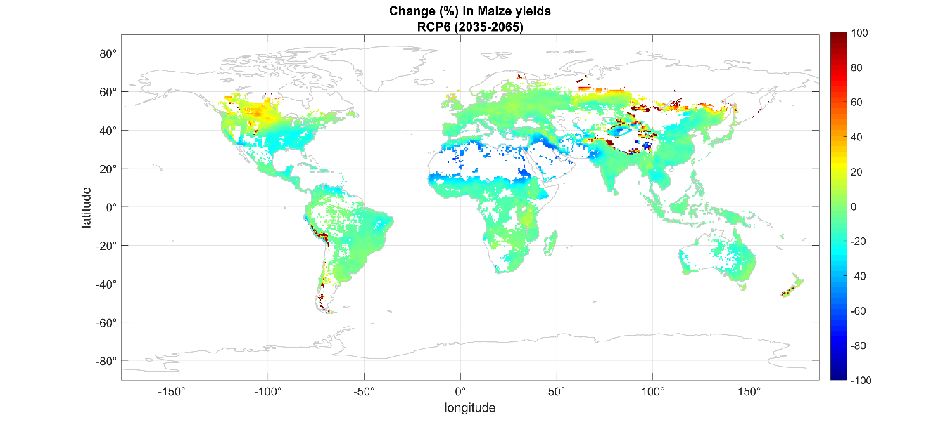
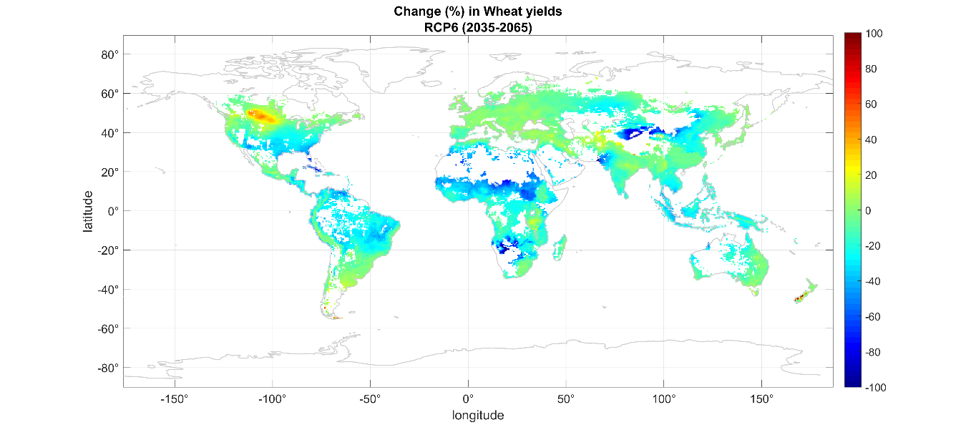
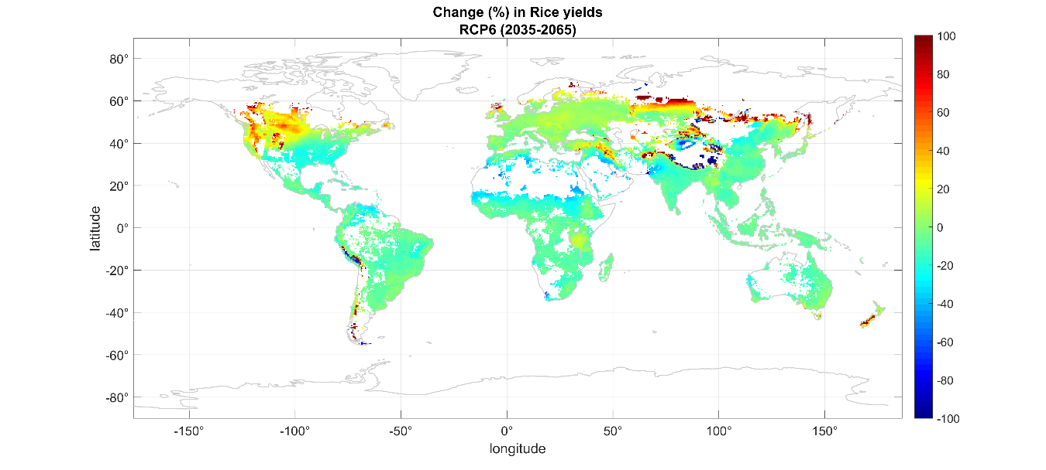
Figure S1. Mean percent change in potential yields under the RCP6 scenario for the medium horizon (2035-2065). The top, middle and bottom panels show the projected changes for rainfed maize, wheat and rice, respectively. White areas represent oceans and places for which the EPIC model does not consider production of these crops possible.
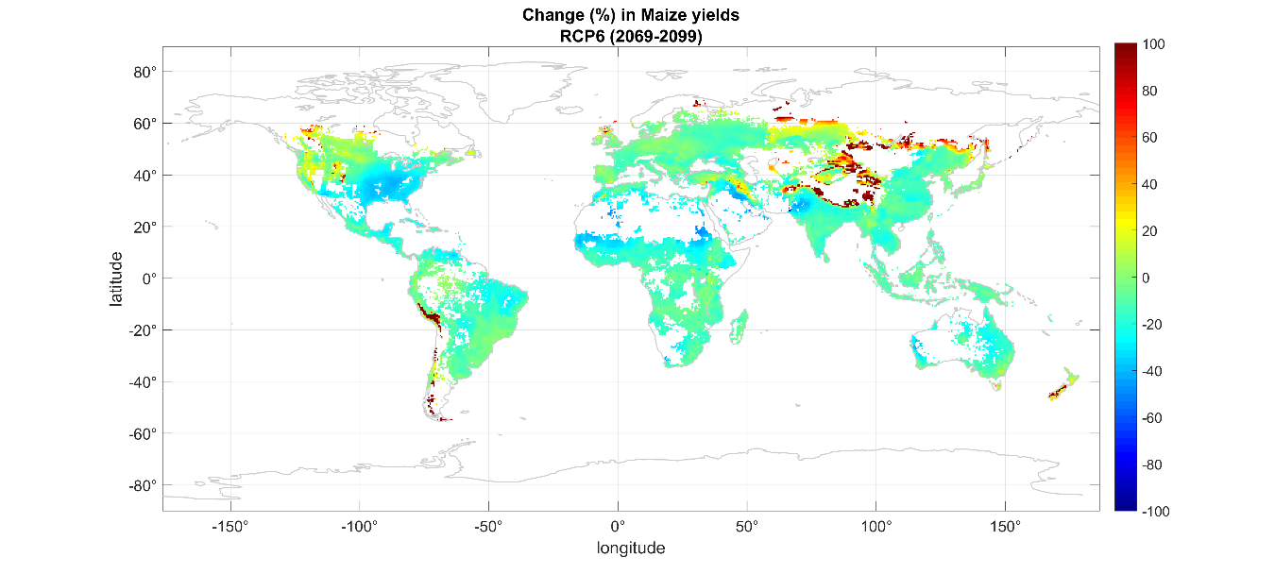
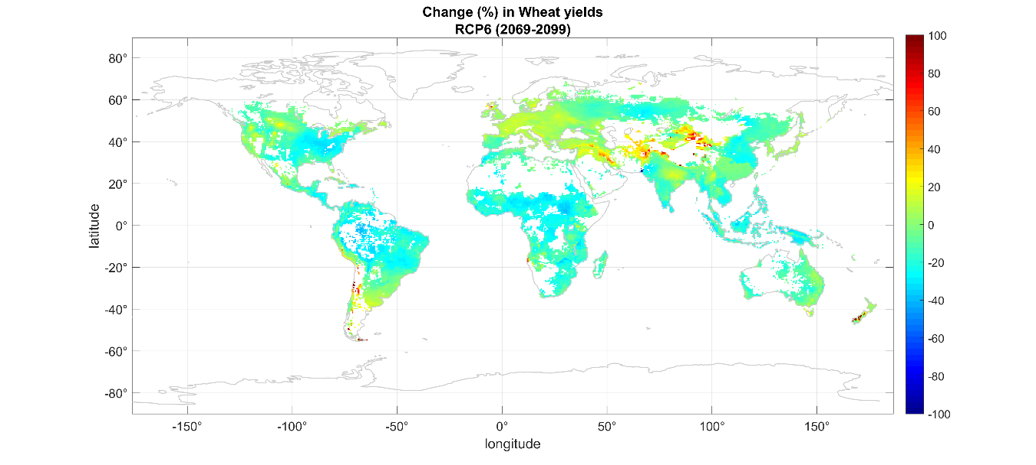
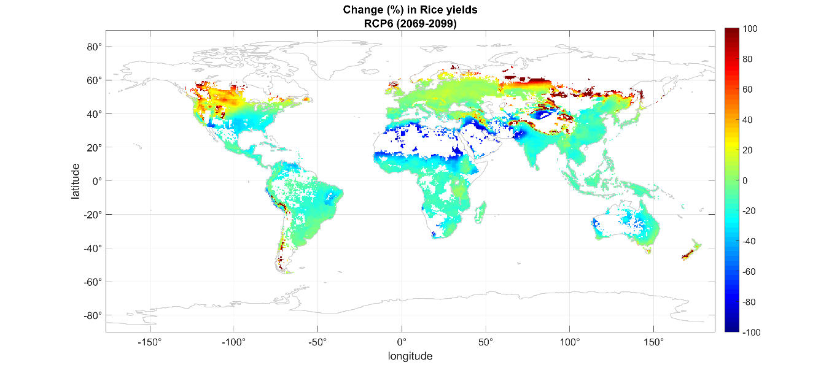
Figure S2. Mean percent change in potential yields under the RCP6 scenario for the long horizon (2069-2099). The top, middle and bottom panels show the projected changes for rainfed maize, wheat and rice, respectively. White areas represent oceans and places for which the EPIC model does not consider production of these crops possible.
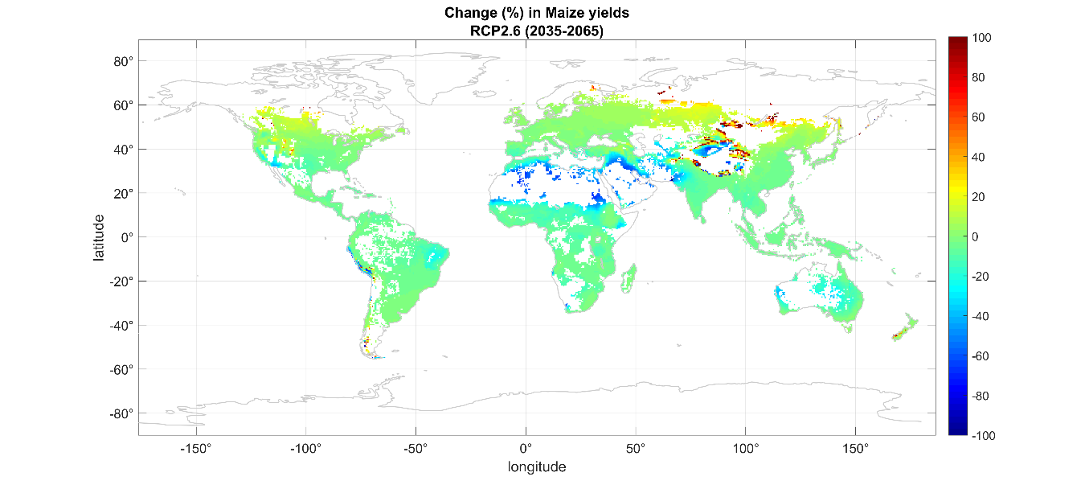
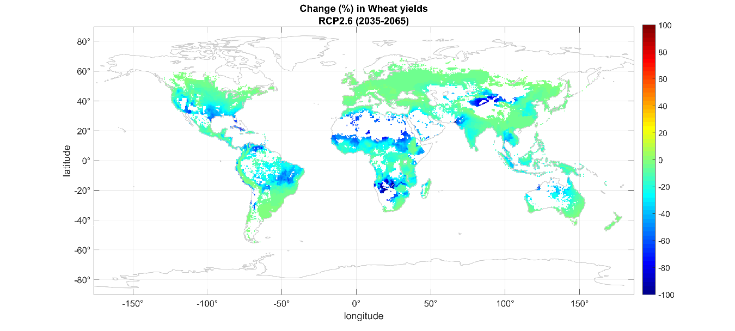
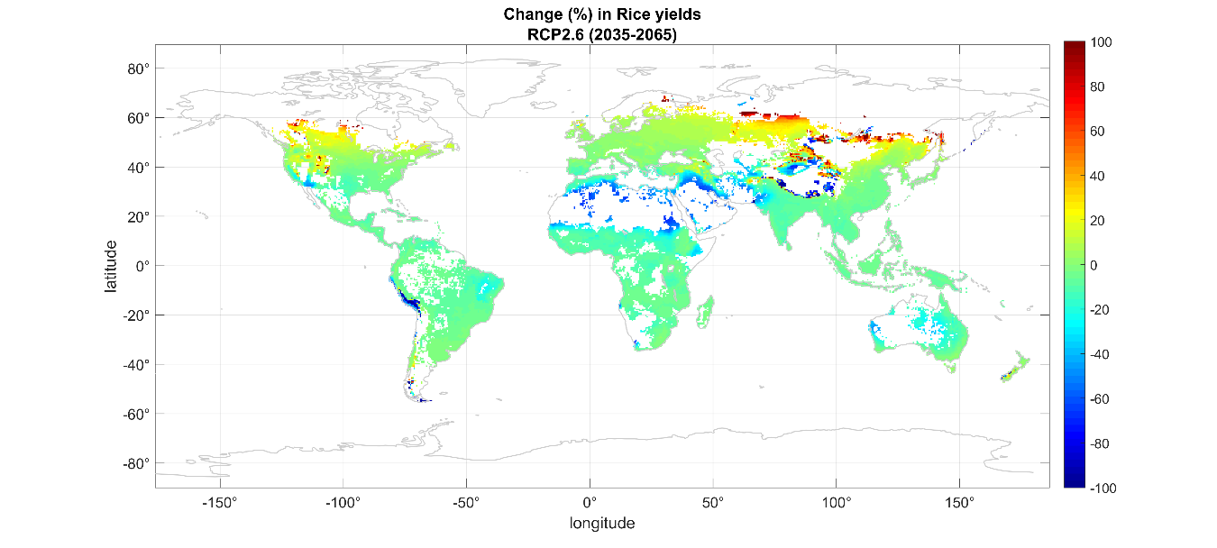
Figure S3. Mean percent change in potential yields under the RCP2.6 scenario for the medium horizon (2035-2065). The top, middle and bottom panels show the projected changes for rainfed maize, wheat and rice, respectively. White areas represent oceans and places for which the EPIC model does not consider production of these crops possible.
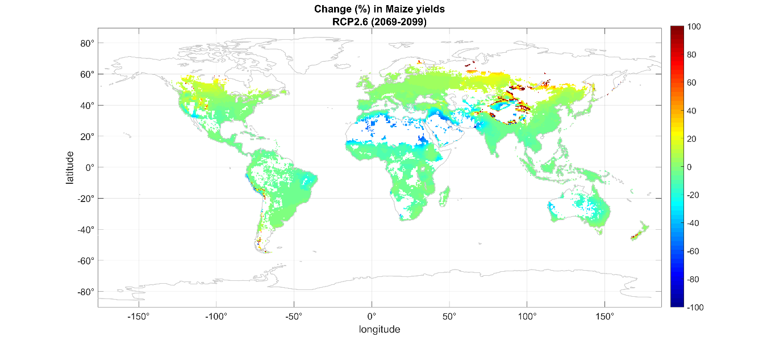
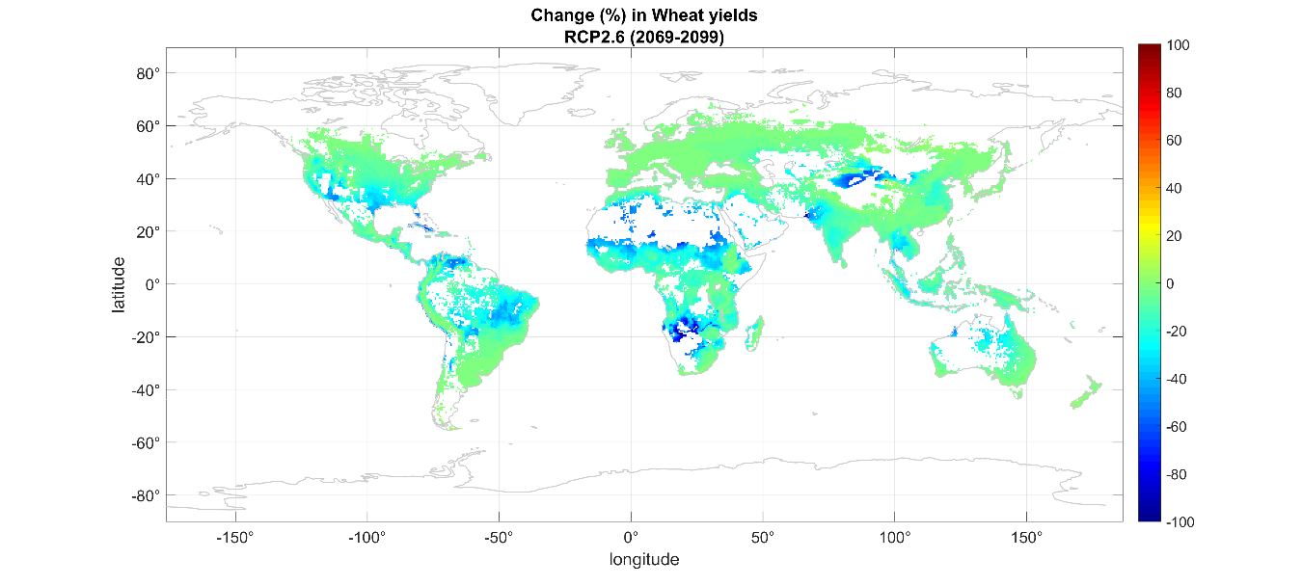
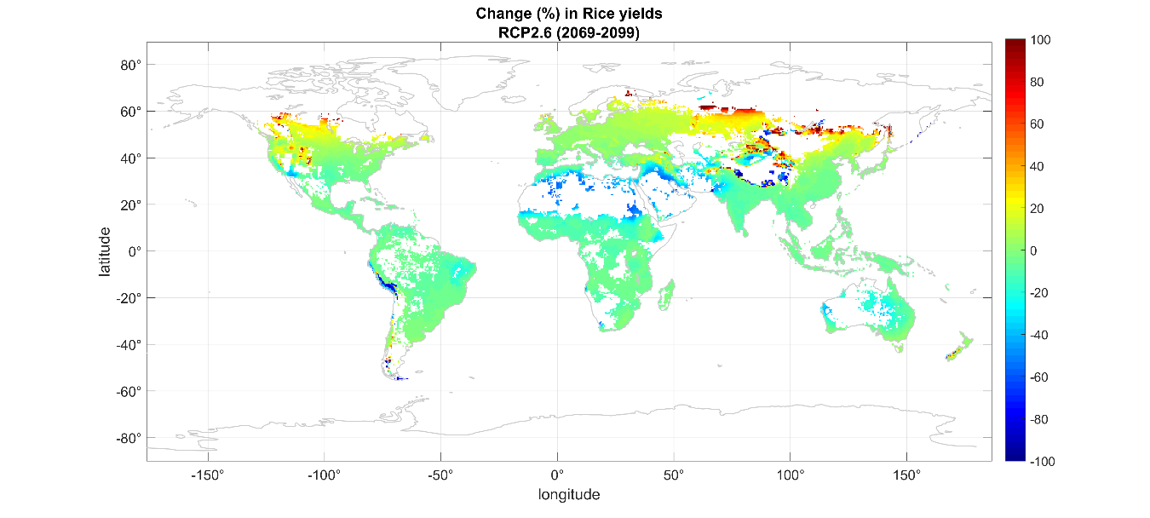
Figure S4. Mean percent change in potential yields under the RCP2.6 scenario for the long horizon (2069-2099). The top, middle and bottom panels show the projected changes for rainfed maize, wheat and rice, respectively. White areas represent oceans and places for which the EPIC model does not consider production of these crops possible.
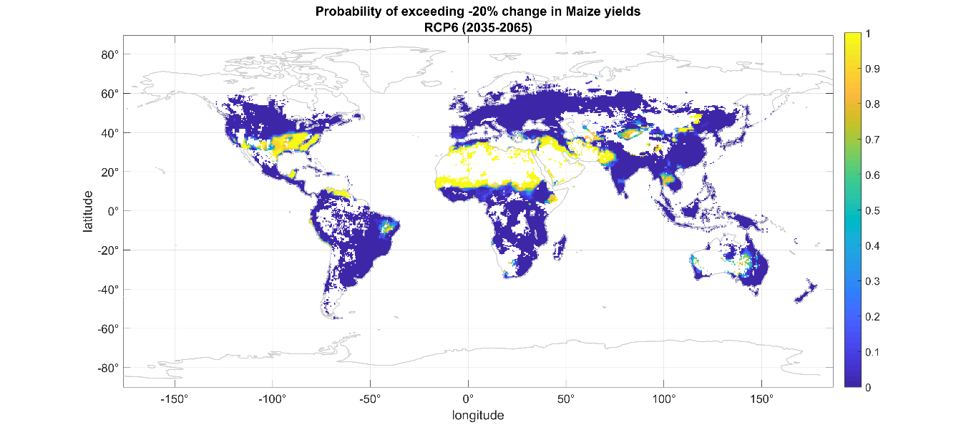
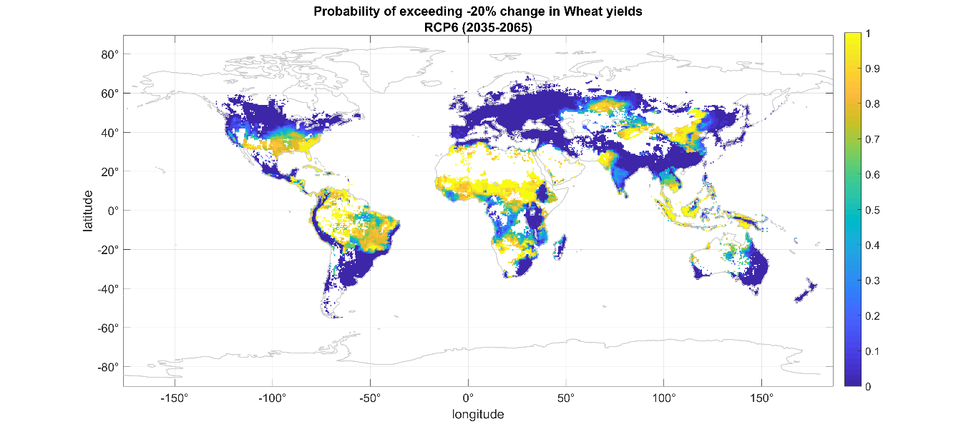
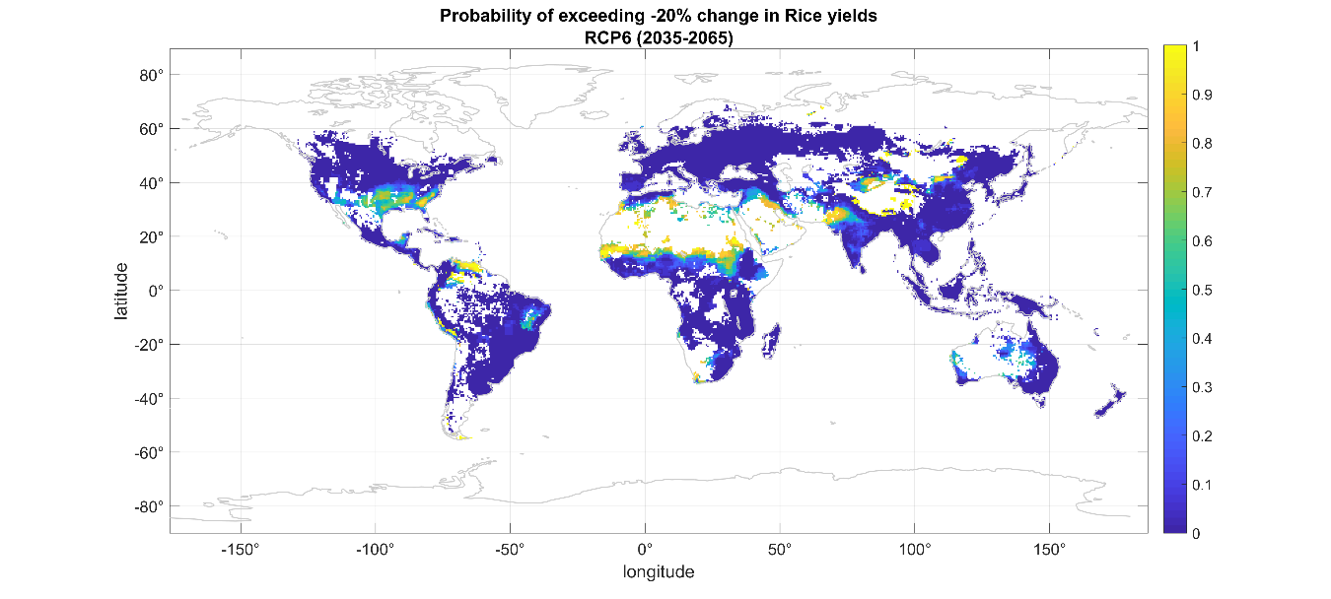
Figure S5. Probabilities of decreases of at least 20% in potential yields under the RCP6 scenario for the medium horizon (2035-2065). The top, middle and bottom panels show the projected changes for rainfed maize, wheat and rice, respectively. White areas represent oceans and places for which the EPIC model does not consider production of these crops possible.
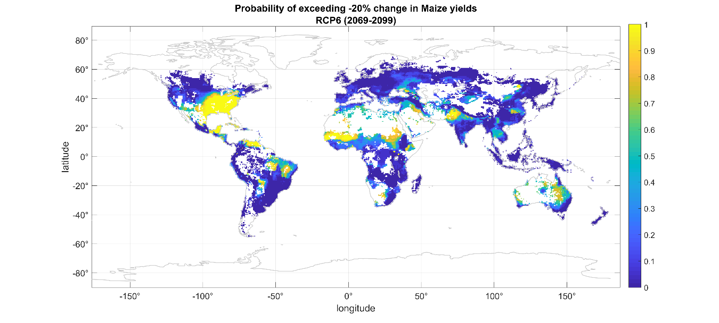
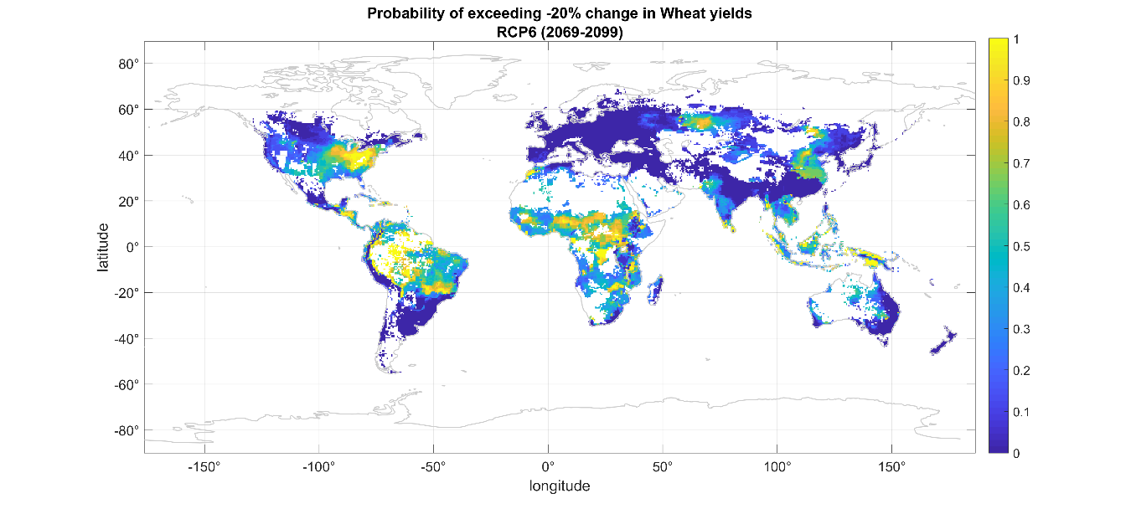
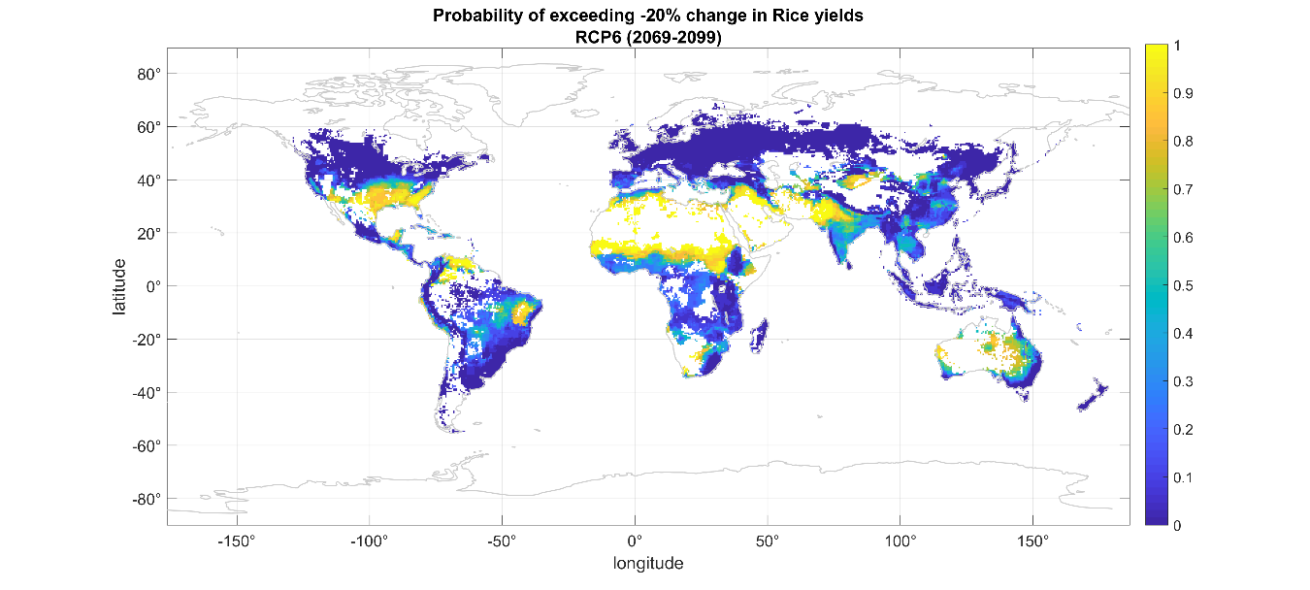
Figure S6. Probabilities of decreases of at least 20% in potential yields under the RCP6 scenario for the long horizon (2069-2099). The top, middle and bottom panels show the projected changes for rainfed maize, wheat and rice, respectively. White areas represent oceans and places for which the EPIC model does not consider production of these crops possible.
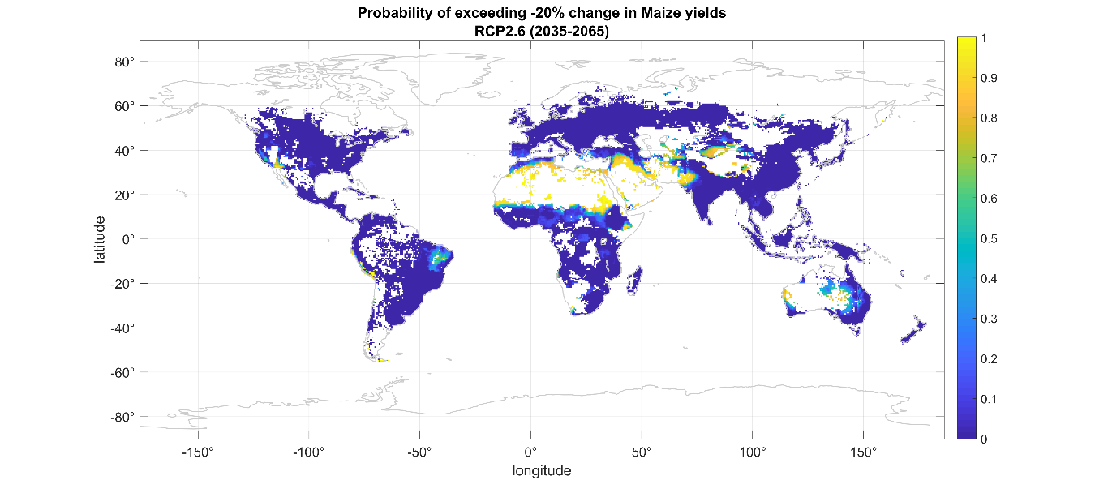
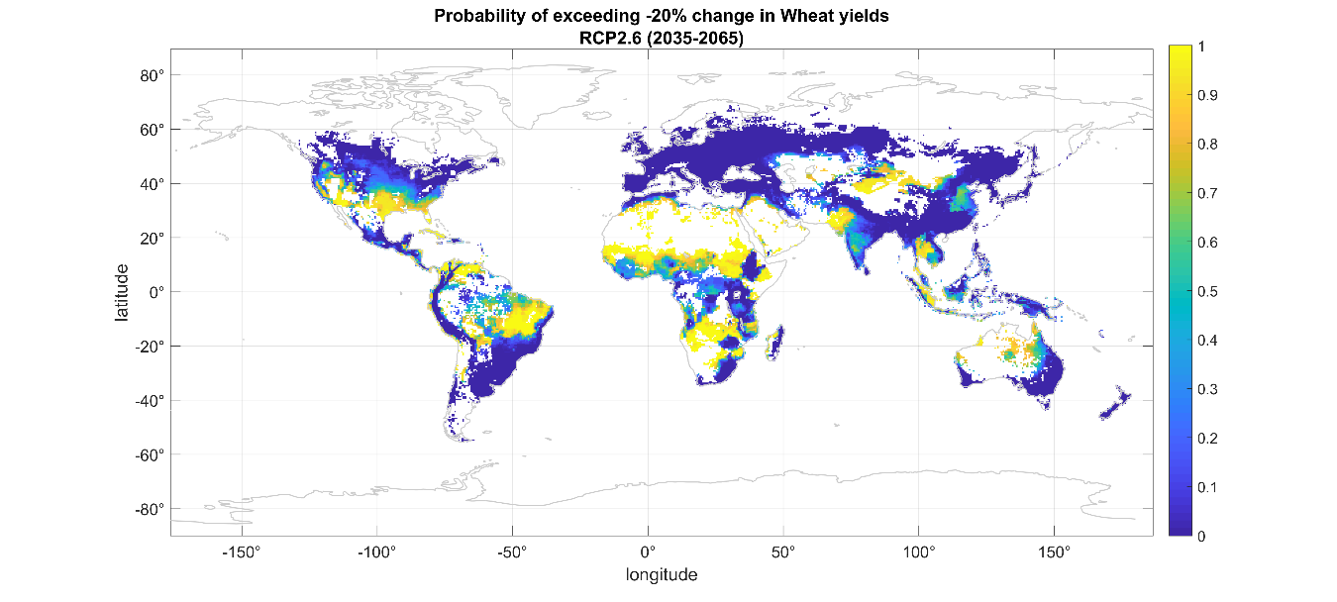
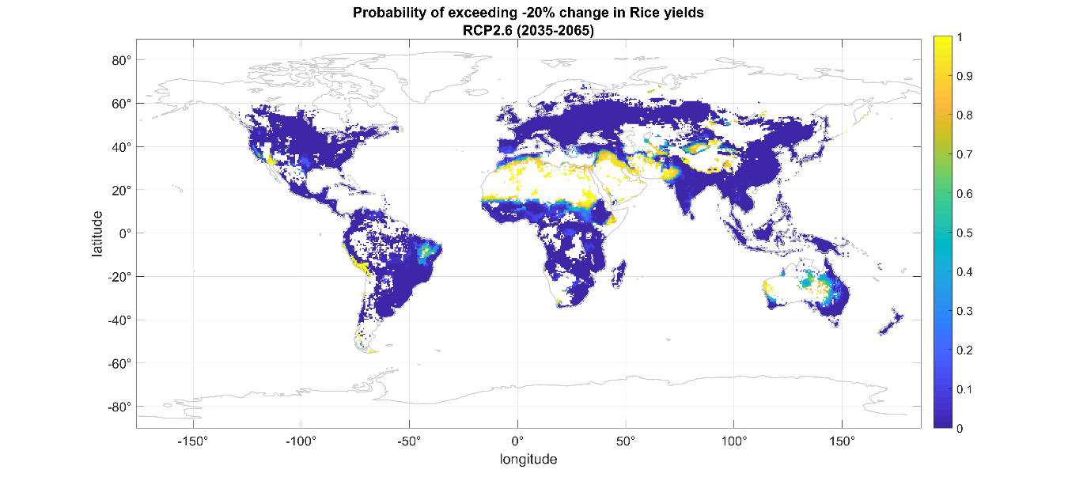
Figure S7. Probabilities of decreases of at least 20% in potential yields under the RCP2.6 scenario for the medium horizon (2035-2065). The top, middle and bottom panels show the projected changes for rainfed maize, wheat and rice, respectively. White areas represent oceans and places for which the EPIC model does not consider production of these crops possible.
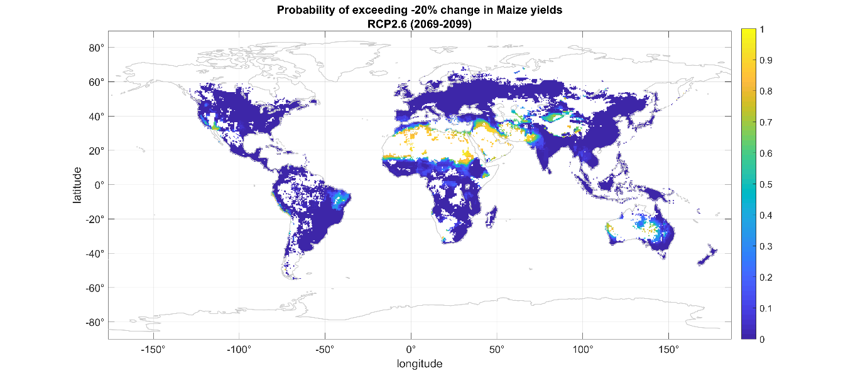
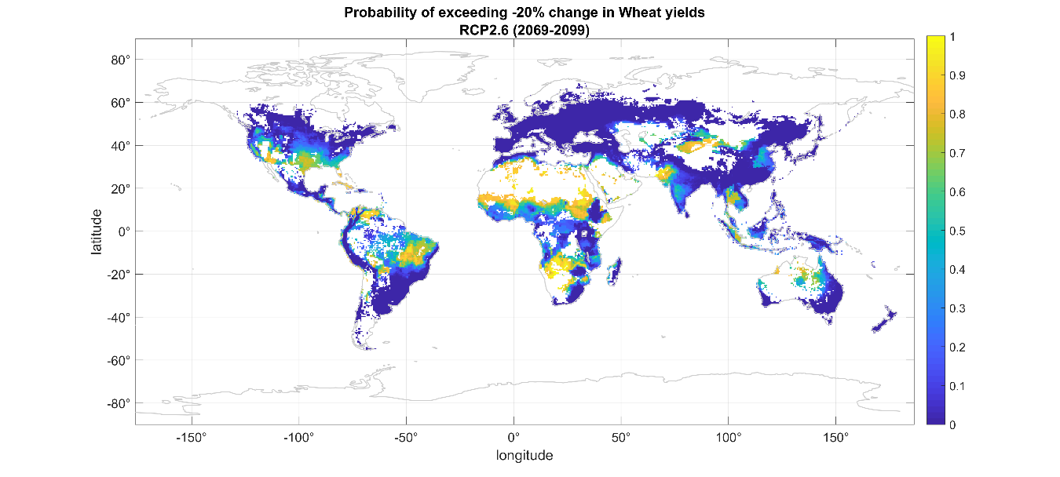
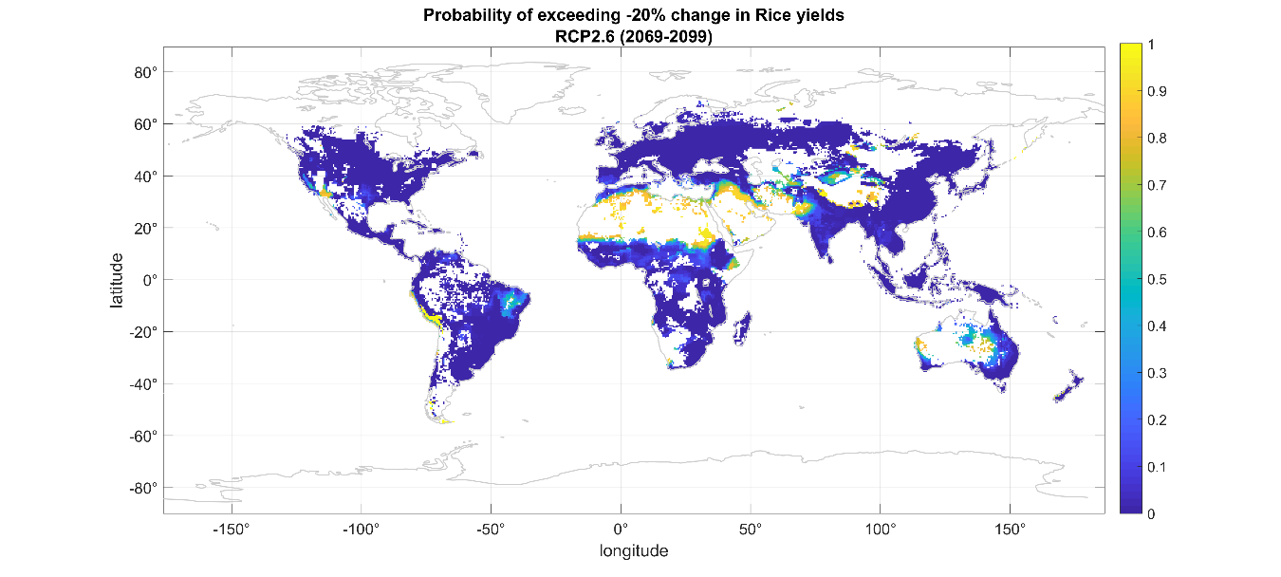
Figure S8. Probabilities of decreases of at least 20% in potential yields under the RCP2.6 scenario for the long horizon (2069-2099). The top, middle and bottom panels show the projected changes for rainfed maize, wheat and rice, respectively. White areas represent oceans and places for which the EPIC model does not consider production of these crops possible.
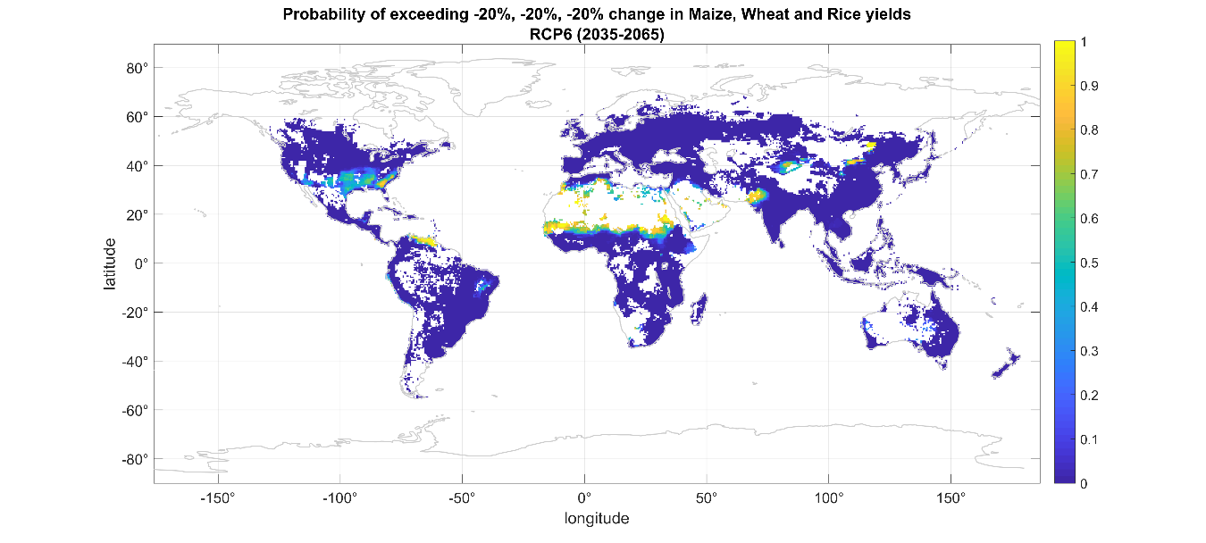
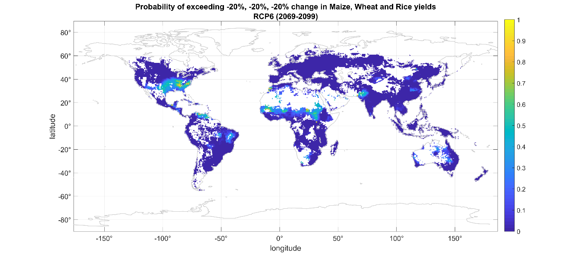
Figure S9. Joint probabilities of decreases of at least 20% in potential yields under the RCP6 scenario. The top and bottom panels show the projected changes for the medium (2035-2065) and long horizons (2069-2099), respectively. White areas represent oceans and places for which the EPIC model does not consider production of these crops possible.

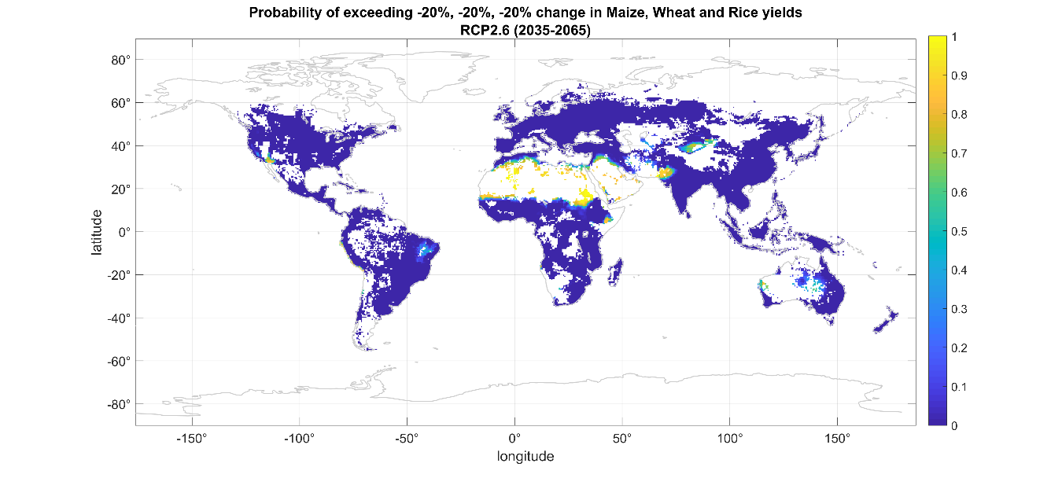
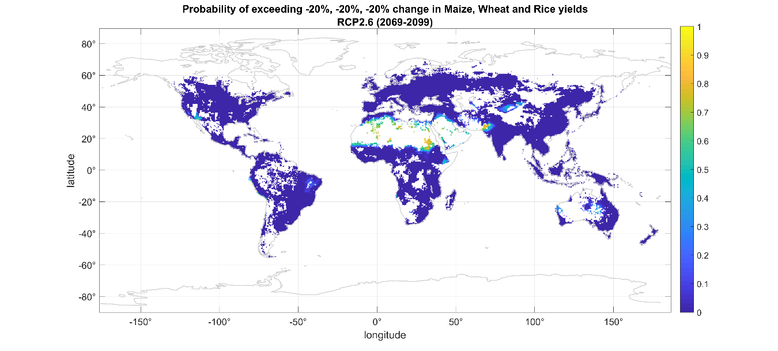
Figure S10. Joint probabilities of decreases of at least 20% in potential yields under the RCP2.6 scenario. The top and bottom panels show the projected changes for the medium (2035-2065) and long horizons (2069-2099), respectively. White areas represent oceans and places for which the EPIC model does not consider production of these crops possible.

B. AIRCCA installation guide and brief user’s guide

1. Installing AIRCCA
The integrated model for the Assessment of Impacts and Risks of Climate Change on Agriculture (AIRCCA) can be downloaded form https://sites.google.com/view/aircc-lab. AIRCCA is distributed as an executable file.
Once downloaded, double click on the file AIRCCAInstaller_web.exe to install. An AIRCCA icon will appear in your screen indicating that the installation process has started (Figure B1).
Figure B1. AIRCCA icon shown at the start of the installation process.
Please make sure that you have a connection to internet as additional files may be downloaded and click next (Figure B2a). Then select the folder where you want AIRCCA to be installed, select the “Add a shortcut to the desktop” option and click next (Figure B2b). AIRCCA requires to download and install the MATLAB Runtime 2018b, which may take a few minutes to complete depending on the speed of the internet connection (Figure B2c). Once this process is finished, please click on install to complete AIRCCA’s installation process.

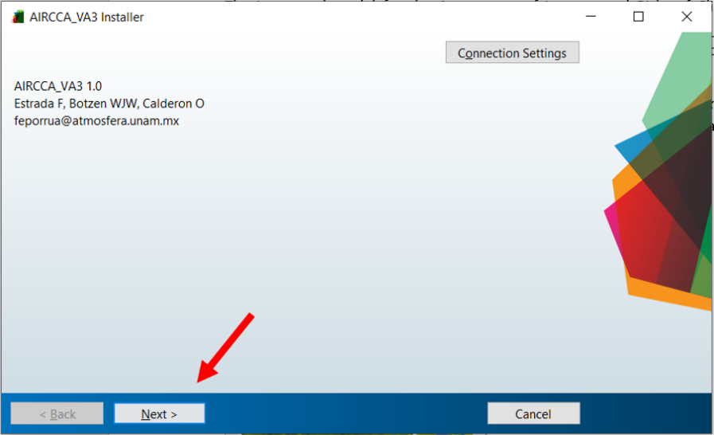
a)
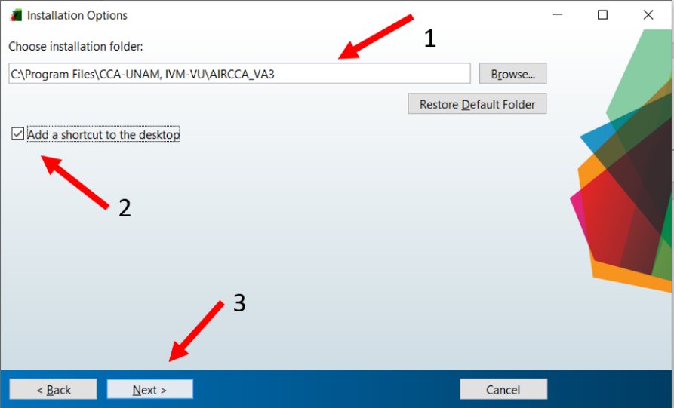
b)
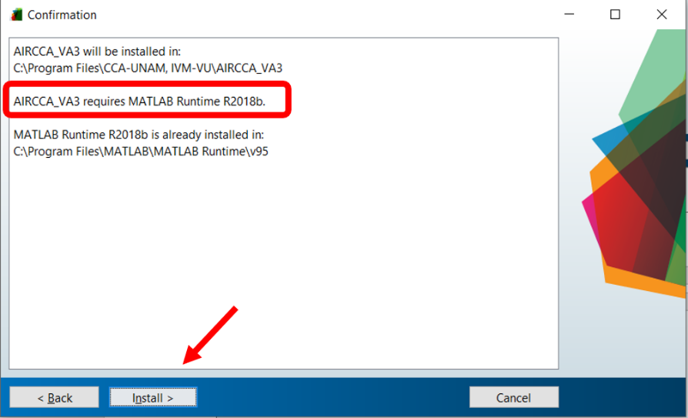
c)

2. Brief user’s guide
Double click on the AIRCCA desktop shortcut to start:
The AIRCCA icon and the start menu with the software information will appear. Click on the start button to begin.
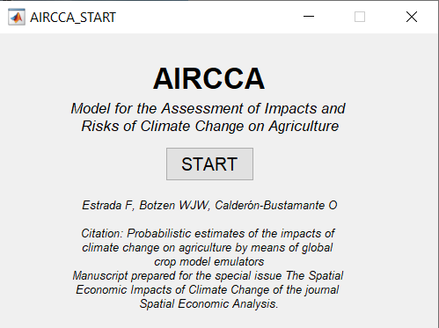
2.1 Simulation specification
This menu allows the user to specify the number of repetitions that will be used for the analysis, the climate scenario and to define thresholds of changes in yields (%) for which the probabilities of being exceeded will be calculated. A dropdown menu allows selecting the emissions scenario for which the changes in yields will be calculated, while the number of repetitions is typed by the user. The user can select different threshold values for the different crops and these thresholds can be positive (increases in yields) or negative decreases in yields). These thresholds are expressed as percentages and can be either positive or negative (e.g., 20%, 1%, -30%). The default values in AIRCCA are 100 repetitions and the thresholds are a reduction of 20% in yields in maize, wheat and rice.

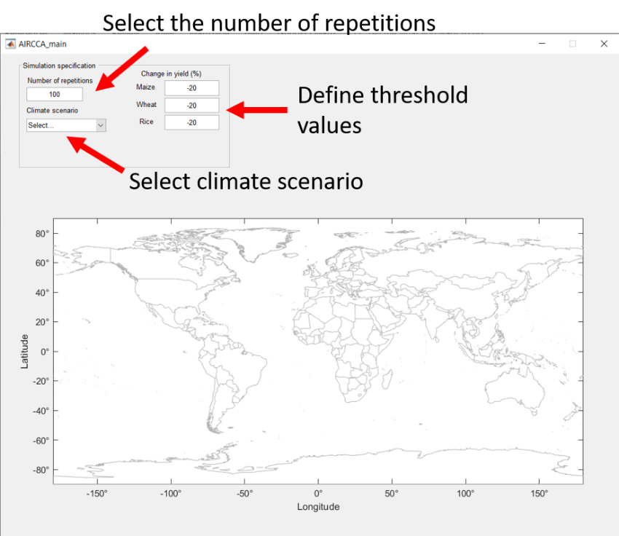

Once the number of repetitions, the climate scenario and the threshold values are defined a RUN button will appear. After clicking on RUN, the visualization and the region menus will be displayed.

2.2 Visualization of impact and risk scenarios
This menu has three components: Horizon, Crop and Analysis. In the Horizon dropdown menu, the user can select either the short-, medium- or long time-horizon for conducting the analysis. The Crop dropdown menu allows the user to select which crop will be analyzed in the case when a univariate impact/risk measure is selected. The Analysis dropdown menu has four options: two that are for analyzing crops separately and two that correspond to multivariate risk measures:

- Yield change (%): shows the mean percent change of potential yields for each grid cell for the selected crop.
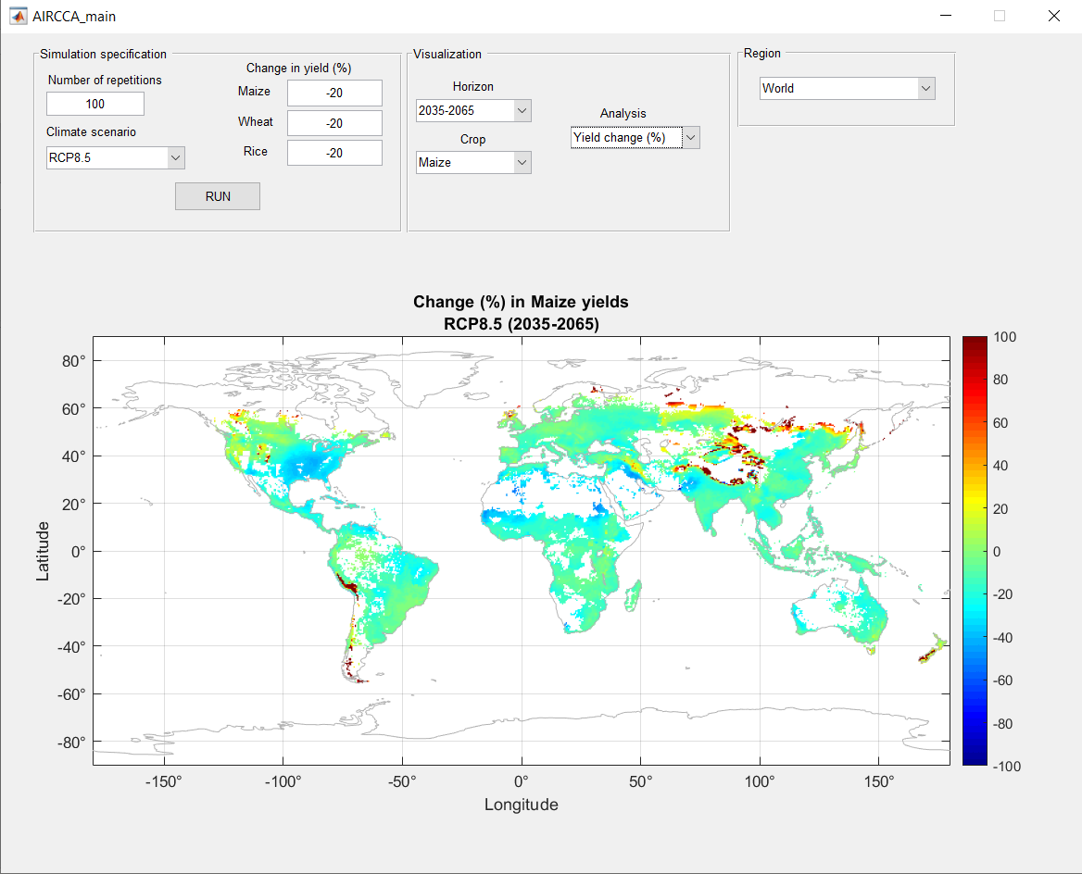
- Probability: shows the probability of exceeding the user-defined threshold in the percent change of potential yields for the selected crop.
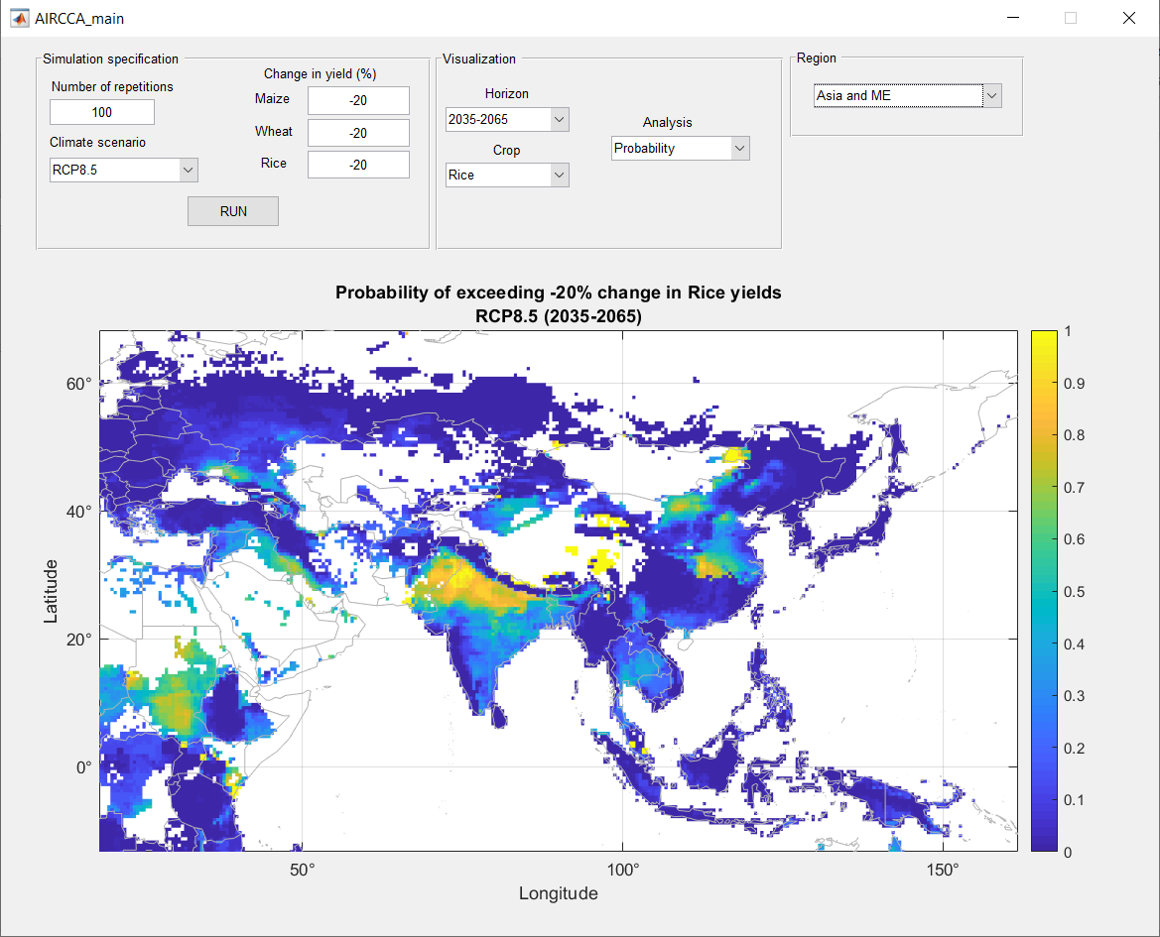

- Risk index (probability): shows the probabilities of jointly exceeding the thresholds selected by the user for maize, wheat and rice.
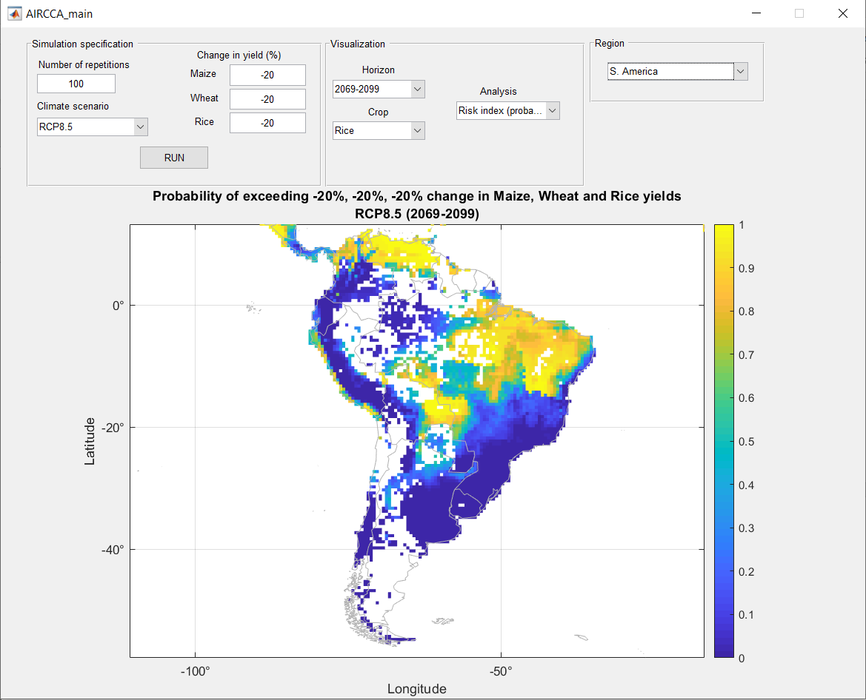
- Risk index (hotspot): shows how many individual thresholds in yield changes have been exceeded. It takes values between zero (no threshold is exceeded) and 3 (the thresholds for maize, wheat and rice have all been exceeded).
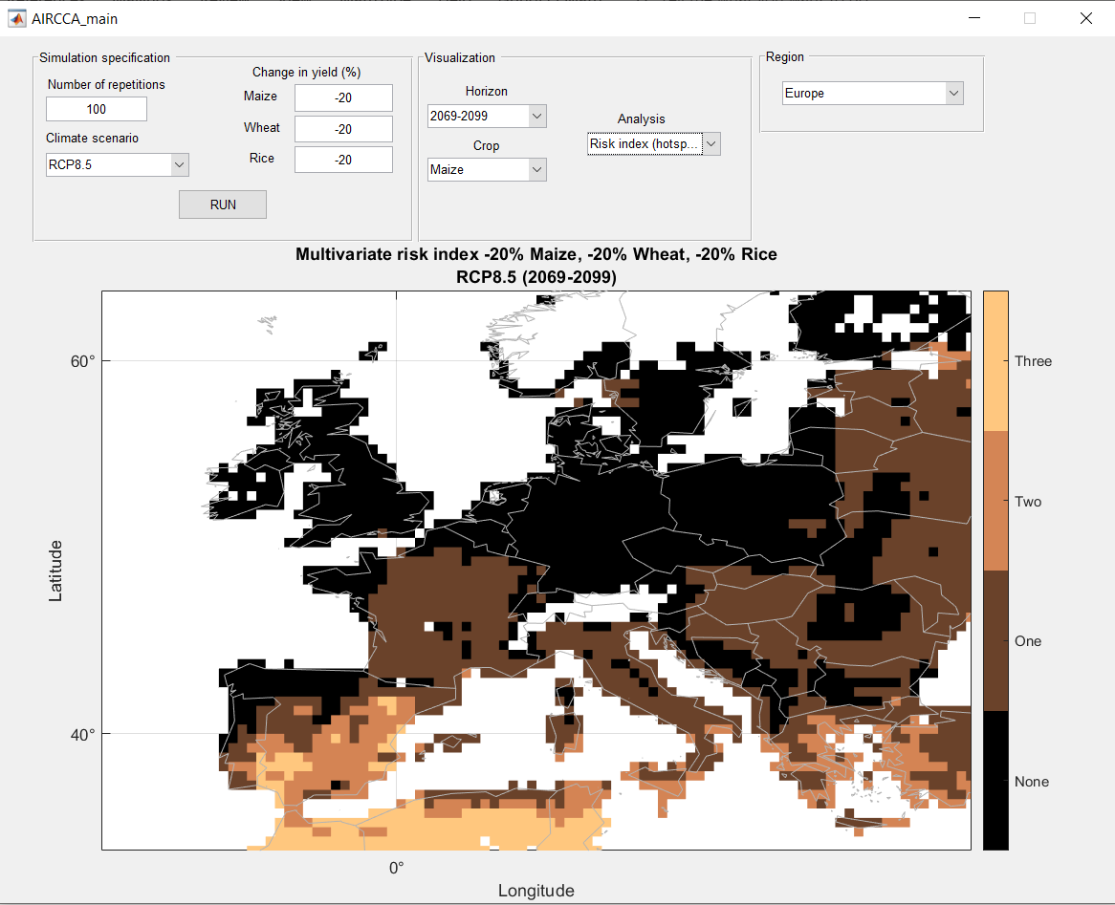
The Region dropdown menu allows to zoom in over the following spatial domains: World, North America, South America, Europe, Asia and the Middle East, Africa and Oceania.

Note: this application is intended for Microsoft Windows operating systems and has been tested on Windows 10. This software is provided free of charge, and, therefore, on an "as is" basis, without warranty of any kind, explicitly or implicitly, including without limitation the warranties that it is free of defects, virus free, able to operate on an uninterrupted basis, fit for a particular purpose or non-interfering.

