Pyrrolizidine alkaloid profiling of four Boraginaceae species from Northern Germany and implications for the analytical scope proposed for monitoring of maximum levels
Inga Mädge^{1,2}, Matthias Gehling¹, Cindy Schöne¹, Peter Winterhalter², Anja These^{1,*}
¹ Department Safety in the Food Chain, German Federal Institute for Risk Assessment, Berlin, Germany
² Institute of Food Chemistry, Technische Universität Braunschweig, Braunschweig, Germany
* Corresponding author. E-mail: anja.these@bfr.bund.de

Appendix A – Supplementary material
Table S1: PA profile of the plant species Echium vulgare is listed with mass spectrometric and structural properties of PAs and PANOs. For tentatively identified PAs and PANOs structural proposals and (trivial) names are listed; (trivial) names were only given if the proposed structure can be associated with alkaloids from literature.
 | PA |  |  |  |  | structure
no. | [M+H]⁺ | sum formula | detected isomers | PA, corresponding PANO¹ and isomer | content² [mg/kg] | necine base³ | necic acid³ at |  | references
 |  |  |  |  |  |  | C7 (R1) | C9 (R2)
1 | 238.1441 | C₁₃H₁₉NO₃ | - | 7-tigloylretronecine^{a,c} or | 0.9 | r | Tigl | H | El-Shazly et al. (1996a)
 |  |  |  | 7-angeloylretronecine^{a,c} |  |  | Ang
2 | 238.1441 | C₁₃H₁₉NO₃ | - | 9-tigloylretronecineª or | 10.3 | r | H | Tigl | El-Shazly et al. (1996a)
 |  |  |  | 9-angeloylretronecineª or |  |  |  | Ang
 |  |  |  | 9-senecionyllretronecineª |  |  |  | Sen
3 | 240.1596 | C₁₃H₂₁NO₃ | - | 7-angeloylplatynecine^{a,b,c} | 0.1 | p | Ang | H | Witte et al. (1993)
4 | 300.1804 | C₁₅H₂₅NO₅ | 1 | intermedine | 9.2 | r | H | (+)-Trach | Skoneczny et al. (2015)
 |  |  |  | lycopsamine |  |  |  | (-)-Vir
5 | 316.1758 | C₁₅H₂₅NO₆ | 1 | echimiplatineª | 256.0 | r | H | Ech | Boppré et al. (2005)
 |  |  |  | leptanthineª |  |  |  | (+)-Trach, 5'-OH
6 | 340.1756 | C₁₇H₂₅NO₆ | 1 | 7-angeloyl-9-(2,3-dihydroxybutyryl)retronecineª or | 3.1 | r | Ang | 2,3-dihydroxybutric acid | El-Shazly et al. (1996a)
 |  |  |  | 7-tigloyl-9-(2, 3-dihydroxybutyryl)retronecineª or |  |  | Tigl | 2,3-dihydroxybutric acid
 |  |  |  | isomerª |  |  | iso
7 | 358.1860 | C₁₇H₂₇NO₇ | - | uplandicineª | 5.6 | r | Ac | Ech | El-Shazly et al. (1996a)
8 | 358.1860 | C₁₇H₂₇NO₇ |  | PA not detected
 |  |  | - | 5'-acetylechimiplatine NO^{a,b} or | 0.2 | r | H | Ech, 5'-OAc
 |  |  |  | 5'-acetylleptanthine NO^{a,b} |  |  |  | (+)-Trach, 5'-OAc
9 | 382.1860 | C₁₉H₂₇NO₇ | - | echiuplatineª | 45.6 | r | Ang | 3-hydroxyl-3-methylglutaric acid | Boppré et al. (2005)
10 | 382.2231 | C₂₀H₃₁NO₆ | 2 | echiumine Aª | 12.0 | r | Ang | (+)-Trach | Skoneczny et al. (2015)
 |  |  |  | echiumine Bª |  |  | iso | (+)-Trach/(-)-Vir
 |  |  |  | unknown isomer^{a,b} |  |  | iso | (+)-Trach/(-)-Vir
11 | 398.2187 | C₂₀H₃₁NO₇ | 1 | echimidine or | 785.6 | r | Ang | Ech | El-Shazly et al. (1996a)
 |  |  |  | echihumilineª or |  |  | Sen | Ech
 |  |  |  | echimidine isomer (tigloyl)ª |  |  | Tigl | Ech
12 | 398.2181 | C₂₀H₃₁NO₇ | - | vulgarineª | 136.8 | r | H | (+)-Trach, 5'-OAng | Boppré et al. (2005)
13 | 400.1968 | C₁₉H₂₉NO₈ | - | 3'-acetyluplandicine^{a,b} or | 0.1 | r | Ac | Ech, 3'-OAc
 |  |  |  | 5'-acetyluplandicine^{a,b} |  |  |  | Ech, 5'-OAc
14 | 400.2342 | C₂₀H₃₃NO₇ | - | 7-(2-methylbutyryl)-9-echimidinylretronecine^{a,b} | 6.1 | r | 2-methyl-butric acid | Ech | El-Shazly et al. (1996b)
15 | 414.2122 | C₂₀H₃₁NO₈ |  | PA not detected
 |  |  | 2 | 7-(4-hydroxy-iso)-9-echimidinylretronecine NO^{a,b} | 0.4 | r | iso + O | Ech
 |  |  |  | unknown isomers NO^{a,b} |  |  |  | Ech/(+)-Trach,5'-OH
16 | 440.2288 | C₂₂H₃₃NO₈ | - | 3'-acetylechimidineª | 2.7 | r | Ang | Ech, 3'-OAc | El-Shazly et al. (1996a)
17 | 440.2272 | C₂₂H₃₃NO₈ | - | 7-acetylvulgarineª | 4.7 | r | Ac | (+)-Trach, 5'-OAng | Boppré et al. (2005)
18 | 480.2585 | C₂₅H₃₇NO₈ | - | echivulgarineª | 50.7 | r | Ang | (+)-Trach, 5'-OH, 3'-OAng | Cairns et al. (2015)
¹ PANO is presented in the form of corresponding PA, exception if no PA was detected. ² sum of PA and PANO ³ The abbreviations of the necine bases and necic acids are described in figure 2a and 2b. ª This is tentatively identified. ^{b} This represents a new PA/PANO for the the species Echium vulgare. ^{c} The PANO was not detected.

Table S2: PA profile of the plant material Symphytum spp. is listed with mass spectrometric and structural properties of PAs and PANOs. For tentatively identified PAs and PANOs structural proposals and (trivial) names are listed; (trivial) names were only given if the proposed structure can be associated with alkaloids from literature.
 | PA |  |  |  |  | structure
no. | [M+H]⁺ | sum formula | detected isomers | PA, corresponding PANO¹ and isomer | content² [mg/kg] | necine base³ | necic acid³ at |  | references
 |  |  |  |  |  |  | C7  (R1) | C9  (R2)
19 | 300.1807 | C₁₅H₂₅NO₅ | 1 | intermedine | 256.9 | r | H | (+)-Trach | El-Shazly and Wink (2014)
 |  |  |  | lycopsamine |  |  |  | (-)-Vir
20 | 316.1755 | C₁₅H₂₅NO₆ |  | PA not detected
 |  |  | 1 | echimiplatine NO^{a,b} | 18.6 | r | H | Ech
 |  |  |  | leptanthine NO^{a,b} |  |  |  | (+)-Trach, 5'-OH
21 | 342.1913 | C₁₇H₂₇NO₆ | - | 7-acetyllycopsamine | 4.0 | r | Ac | (-)-Vir | El-Shazly and Wink (2014)
22 | 382.2264 | C₂₀H₃₁NO₆ | 1 | symlandineª or | 23.8 | r | Ang | (-)-Vir
 |  |  |  | symphytineª or |  |  | Tigl | (-)-Vir
 |  |  |  | symviridineª |  |  | Sen | (-)-Vir
23 | 398.2173 | C₂₀H₃₁NO₇ |  | PA not detected
 |  |  | - | echimidine NO | 53.9 | r | Ang | Ech
¹ PANO is presented in the form of corresponding PA, exception if no PA was detected. ² sum of PA and PANO ³ The abbreviations of the necine base and necic acids are described in figure 2a and 2b. ª This is tentatively identified. ^{b} This represents a new PA/PANO for the genus Symphytum.

Table S3: PA profile of the plant species Cynoglossum officinale is listed with mass spectrometric and structural properties of PAs and PANOs. For tentatively identified PAs and PANOs structural proposals and (trivial) names are listed; (trivial) names were only given if the proposed structure can be associated with alkaloids from literature.
 | PA |  |  |  |  | structure
no. | [M+H]⁺ | sum formula | detected isomers | PA, corresponding PANO¹ and isomer | content² [mg/kg] | necine base³ | necic acid³ at |  | references
 |  |  |  |  |  |  | C7  (R1) | C9  (R2)
24 | 238.1431 | C₁₃H₁₉NO₃ | - | 7-angeloylheliotridineª or | 121.0 | h | Ang | H | van Dam et al. (1995)
 |  |  |  | 7-tigloylheliotridineª |  |  | Tigl |  | El-Shazly et al. (1996c)
25 | 286.2011 | C₁₅H₂₇NO₄ | 1 | trachelanthamine | 2457.3 | t | - | (+)-Trach | van Dam et al. (1995)
 |  |  |  | viridiflorineª |  |  |  | (-)-Vir
26 | 298.1649 | C₁₅H₂₃NO₅ |  | PA not detected
 |  |  | - | unknown PANO^{a,b} | 0.2 | h | H | saturated (+)-Trach/(-)-Vir
27 | 300.1807 | C₁₅H₂₅NO₅ | 1 | rinderine | 15695.2 | h | H | (+)-Trach | van Dam et al. (1995)
 |  |  |  | echinatine |  |  |  | (-)-Vir
28 | 302.1957 | C₁₅H₂₇NO₅ | 1 | floridimine^{a,b} | 15.3 | t | - | (-)-Vir, 5'-OH | Reina et al. (1997)
 |  |  |  | unknown isomer^{a,b} |  |  |  | (+)-Trach, 5'-OH
29 | 302.1962 | C₁₅H₂₇NO₅ |  | PA not detected |  |  |  |  | Reina et al. (1998a)
 |  |  | - | megalanthonine NO^{a,b} | 48.5 | p | H | (-)-Vir
30 | 314.1959 | C₁₆H₂₇NO₅ | 1 | unknown PA^{a,b} | 4.9 | h | H | C₈H₁₆O₄
31 | 316.1758 | C₁₅H₂₅NO₆ | 1 | 5'-hydroxyrinderine^{a,b} | 141.9 | h | H | (+)-Trach, 5'OH | Shimshoni et al. (2015)
 |  |  |  | unknown isomer^{a,b} |  |  |  | Ech
32 | 328.1753 | C₁₆H₂₅NO₆ | - | unknown PA^{a,b} | 7.6 | h | H | C₈H₁₄O₅
33 | 342.1911 | C₁₇H₂₇NO₆ | - | 3'-acetylechinatineª | 28.4 | h | H | (-)-Vir, 3'-OAc | van Dam et al. (1995)
34 | 342.1917 | C₁₇H₂₇NO₆ | - | 7-acetylechinatineª | 5.0 | h | Ac | (-)-Vir | van Dam et al. (1995)
35 | 356.2068 | C₁₈H₂₉NO₆ |  | PA not detected
 |  |  | - | unknown PANO^{a,b} | 0.1 | h | C₃H₆O₂ | (+)-Trach/(-)-Vir
36 | 358.1860 | C₁₇H₂₇NO₇ | - | 3'-acetyl-5-hydroxyrinderine^{a,b} or | 1.2 | h | H | (+)-Trach,5'-OH,3'-OAc
 |  |  |  | unknown isomer^{a,b} |  |  |  | (-)-Vir,5'-OH, 3'-OAc/ Ech, 3'-OAc
37 | 382.2230 | C₂₀H₃₁NO₆ | 1 | 7-angeloylrinderineª | 189.2 | h | Ang | (+)-Trach | El-Shazly et al. (1996c)
 |  |  |  | 7-angeloylechinatineª |  |  |  | (-)-Vir
38 | 384.1970 | C₁₉H₂₉NO₇ | - | 3', 7-diacetylrinderine^{a,b} or | 0.2 | h | Ac | (+)-Trach, 3'-OAc
 |  |  |  | 3', 7-diacetylechinatine^{a,b} |  |  |  | (-)-Vir, 3'-OAc
39 | 386.1809 | C₁₈H₂₇NO₈ |  | PA not detected
 |  |  | - | unknown PANO^{a,b} | 0.8 | h | H | C₁₀H₁₆O₇
40 | 398.2184 | C₂₀H₃₁NO₇ | - | heliosupine | 13464.3 | h | Ang | Ech | Crout (1967)
41 | 414.2122 | C₂₀H₃₁NO₈ |  | PA not detected
 |  |  | 2 | 7-(4-hydroxyl-iso)-9-echimidinyl heliotridine NO^{a,b} | 3.3 | h | iso + O | Ech
 |  |  |  | unknown isomers NO^{a,b} |  |  |  | (+)-Trach/(-)-Vir, 5'-OH
42 | 424.2330 | C₂₂H₃₃NO₇ |  | PA not detected
 |  |  | - | 7-angeloyl-3-acetylrinderine NO^{a,b} or | 2.8 | h | Ang | (+)-Trach, 3'-OAc
 |  |  |  | 7-angeloyl-3-acetylechinatine NO^{a,b} |  |  |  | (-)-Vir, 3'-OAc
43 | 432.2244 | C₂₀H₃₃NO₉ | 1 | unknown PA^{a,b} | 0.4 | h | iso + O₂H₂ | Ech
 |  |  |  | unknown PA^{a,b} |  |  |  | (+)-Trach, 5'-OH
44 | 440.2285 | C₂₂H₃₃NO₈ | - | 3'-acetylheliosupineª | 240.0 | h | Ang | Ech, 3'-OAc | Resch and Meinwald (1982)
45 | 456.2228 | C₂₂H₃₃NO₉ |  | PA not detected
 |  |  | 2 | 7-(4-hydroxyl-iso)-9-3'-acetyl-echimidinyl heliotridine NO^{a,b} | 0.3 | h | iso + O | Ech, 3'-OAc
 |  |  |  | unknown isomers NO^{a,b} |  |  |  | (+)-Trach/(-)-Vir, 5'-OH, 3'-OAc
46 | 468.2592 | C₂₄H₃₇NO₈ |  | PA not detected
 |  |  | - | unknown PANO^{a,b} | 0.2 | h | iso | (+)-Trach/(-)-Vir, 3'-OC₄H₆O₂
47 | 484.2541 | C₂₄H₃₇NO₉ |  | PA not detected
 |  |  | - | unknown PANO^{a,b} | 0.5 | h | iso | Ech, 3'-OC₄H₆O₂
¹ PANO is presented in the form of corresponding PA, exception if no PA was detected. ² sum of PA and PANO. ³ The abbreviations of the necine bases and necic acids are described in figure 2a and 2b. ª This is tentatively identified. ^{b} This represents a new PA/PANO for the species Cynoglossum officinale.

Table S4: PA profile of the plant species Heliotropium europaeum is listed with mass spectrometric and structural properties of PAs and PANOs. For tentatively identified PAs and PANOs structural proposals and (trivial) names are listed; (trivial) names were only given if the proposed structure can be associated with alkaloids from literature.
 | PA |  |  |  |  | structure
no. | [M+H]⁺ | sum formula | detected isomers | PA, corresponding PANO¹ and isomer | content² [mg/kg] | necine base³ | necic acid³ at |  | references
 |  |  |  |  |  |  | C7 (R1) | C9 (R2)
48 | 238.1438 | C₁₃H₁₉NO₃ | - | 7-angeloylheliotridine^{a,b} | 2.2 | h | Ang | - | Crowley and Culvenor (1959)
49 | 284.1857 | C₁₅H₂₅NO₄ | - | supinineª | 1.8 | s | - | (+)-Trach | Culvenor (1954)
50 | 284.1856 | C₁₅H₂₅NO₄ | - | unknown PA^{a,b,c} | 6.7 | t | - | saturated (+)-Trach/ (-)-Vir
51 | 286.2011 | C₁₅H₂₇NO₄ | - | trachelanthamine^{b} or | 4.7 | t | - | (+)-Trach | van Dam et al. (1995)
 |  |  |  | viridiflorine^{a,b} |  |  |  | (-)-Vir
52 | 298.1647 | C₁₅H₂₃NO₅ | - | unknown PA^{a,b} | 0.7 | h | H | saturated (+)-Trach/ (-)-Vir
53 | 298.1645 | C₁₅H₂₃NO₅ | - | unknown PA^{a,b} | 1.9 | h | H | saturated (+)-Trach/ (-)-Vir
54 | 298.2007 | C₁₆H₂₇NO₄ | 1 | heleurine^{a,c} | 12.5 | s | - | Heliot | Culvenor (1954)
 |  |  |  | unknown isomer^{a,b,c}
55 | 300.1801 | C₁₅H₂₅NO₅ | 1 | rinderine | 16.5 | h | H | (+)-Trach | Shimshoni et al. (2015)
 |  |  |  | echinatine |  |  |  | (-)-Vir
56 | 312.1806 | C₁₆H₂₅NO₅ | - | unknown PA^{a,b} | 4.2 | h | H | saturated Heliot | (Culvenor CC and Smith 1969)
57 | 314.1961 | C₁₆H₂₇NO₅ | 1 | heliotrine | 12005.7 | h | H | Heliot | Culvenor et al. (1954)
 |  |  |  | unknown isomer^{a,b}
58 | 316.1749 | C₁₅H₂₅NO₆ | - | 5'-hydroxyrinderineª | 21.8 | h | H | (+)-Trach, 5'-OH | Shimshoni et al. (2015)
59 | 328.2118 | C₁₇H₂₉NO₅ |  | PA not detected
 |  |  | - | unknown PANO^{a,b} | 3.1 | h | H | Heliot + CH₂
60 | 330.1906 | C₁₆H₂₇NO₆ | - | europine | 879.7 | h | H | Las | Culvenor et al. (1954)
61 | 342.1911 | C₁₇H₂₇NO₆ |  | PA not detected |  |  |  |  | Shimshoni et al. (2015)
 |  |  | - | 3'-acetylrinderine NOª | 0.1 | h | H | (+)-Trach, 3'-OAc
62 | 342.1911 | C₁₇H₂₇NO₆ |  | PA not detected
 |  |  | - | unknown PANO^{a,b} | 1.7 | h | CH₂O₂ | Heliot
63 | 356.2068 | C₁₈H₂₉NO₆ |  | PA not detected
 |  |  | - | 2'-acetylheliotrine NO^{a,b} | 0.1 | h | H | Heliot, 2'-OAc
64 | 356.2068 | C₁₈H₂₉NO₆ |  | PA not detected
 |  |  | - | 7-acetylheliotrine NO^{a,b} | 5.5 | h | Ac | Heliot
65 | 358.1853 | C₁₇H₂₇NO₇ | - | 3'-acetyl-5'-hydroxyrinderine^{a,b} or | 1.1 | h | H | (+)-Trach, 5'-OH, 3'-OAc
 |  |  |  | unknown isomer^{a,b} |  |  |  | (-)-Vir,5'-OH, 3'-OAc/ Ech, 3'-OAc
66 | 358.1860 | C₁₇H₂₇NO₇ |  | PA not detected
 |  |  | - | unknown PANO^{a,b} | 0.3 | h | CH₂O₂ | Las
67 | 370.2224 | C₁₉H₃₁NO₆ |  | PA not detected
 |  |  | - | unknown PANO^{a,b} | 0.2 | h | C₃H₆O₂ | Heliot
68 | 372.2035 | C₁₈H₂₉NO₇ | - | 7-acetyleuropine^{a,b} | 1.4 | h | Ac | Las | Reina et al. (1998b)
69 | 372.2017 | C₁₈H₂₉NO₇ | - | 5'-acetyleuropineª | 63.7 | h | H | Las, 5'-OAc | Shimshoni et al. (2015)
70 | 382.2211 | C₂₀H₃₁NO₆ | - | 7-angeloylrinderine^{a,b} or | 2.1 | h | Ang | (+)-Trach | El-Shazly et al. (1996c)
 |  |  |  | 7-angeloylechinatine^{a,b} or |  |  | Ang | (-)-Vir
 |  |  |  | 7-senecioylrinderine^{a,b} |  |  | Sen | (+)-Trach
71 | 396.2337 | C₂₁H₃₃NO₆ | - | 7-angeloylheliotrineª | 94.0 | h | Ang | Heliot | Tosun and Tamer (2004)
72 | 398.2164 | C₂₀H₃₁NO₇ | 1 | heliosupine | 125.0 | h | Ang | Ech | Shimshoni et al. (2015)
 |  |  |  | unknown isomer^{a,b} |  |  | iso | Ech
73 | 412.2316 | C₂₁H₃₃NO₇ | - | lasiocarpine | 2263.4 | h | Ang | Las | Drummond (1951)
74 | 428.2279 | C₂₁H₃₃NO₈ |  | PA not detected
 |  |  | 3 | 7-(4-hydroxyl-iso)-9-lasiocarpic heliotridine NO^{a,b} | 6.5 | h | iso + O | Las
 |  |  |  | unknown isomers NO^{a,b}
75 | 440.2272 | C₂₂H₃₃NO₈ | - | 3'-acetylheliosupineª | 40.6 | h | Ang | Ech, 3'-OAc | Shimshoni et al. (2015)
76 | 454.2435 | C₂₃H₃₅NO₈ | 1 | 5'-acetyllasiocarpineª | 169.4 | h | Ang | Las, 5'-OAc | Culvenor et al. (1975)
 |  |  |  | isomerª |  |  | iso | Las, 5'-OAc | Shimshoni et al. (2015)
¹ PANO is presented in the form of corresponding PA, exception if no PA was detected. ² sum of PA and PANO. ³ The abbreviations of the necine bases and necic acids are described in figure 2a and 2b. ª This is tentatively identified. ^{b} This represents a new PA/ PANO for the species Heliotropium europaeum. ^{c} The PANO was not detected.

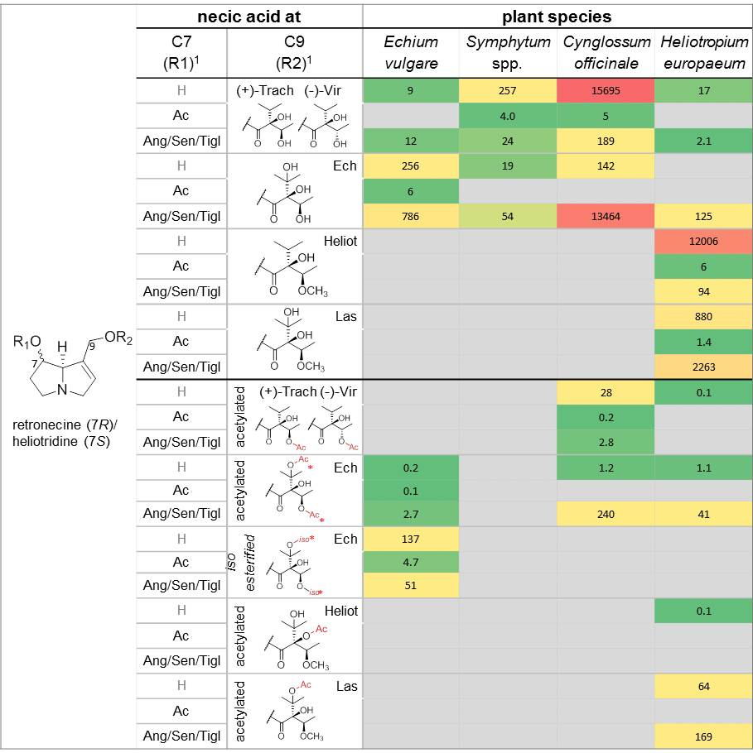
Figure S1. Heatmap of 1,2-unsaturated PA profiles of E. vulgare, Symphytum spp., C. officinale and H. europaeum. The upper part shows PAs esterified with a monocarboxylic acid at C9 and the bottom part shows PAs esterified with a highly branched necic acid at C9. Stereochemistry of necine bases is not considered. ¹ The abbreviations of the necic acids are described in figure 2b. * 3'O- or 5'O- esterification is possible.

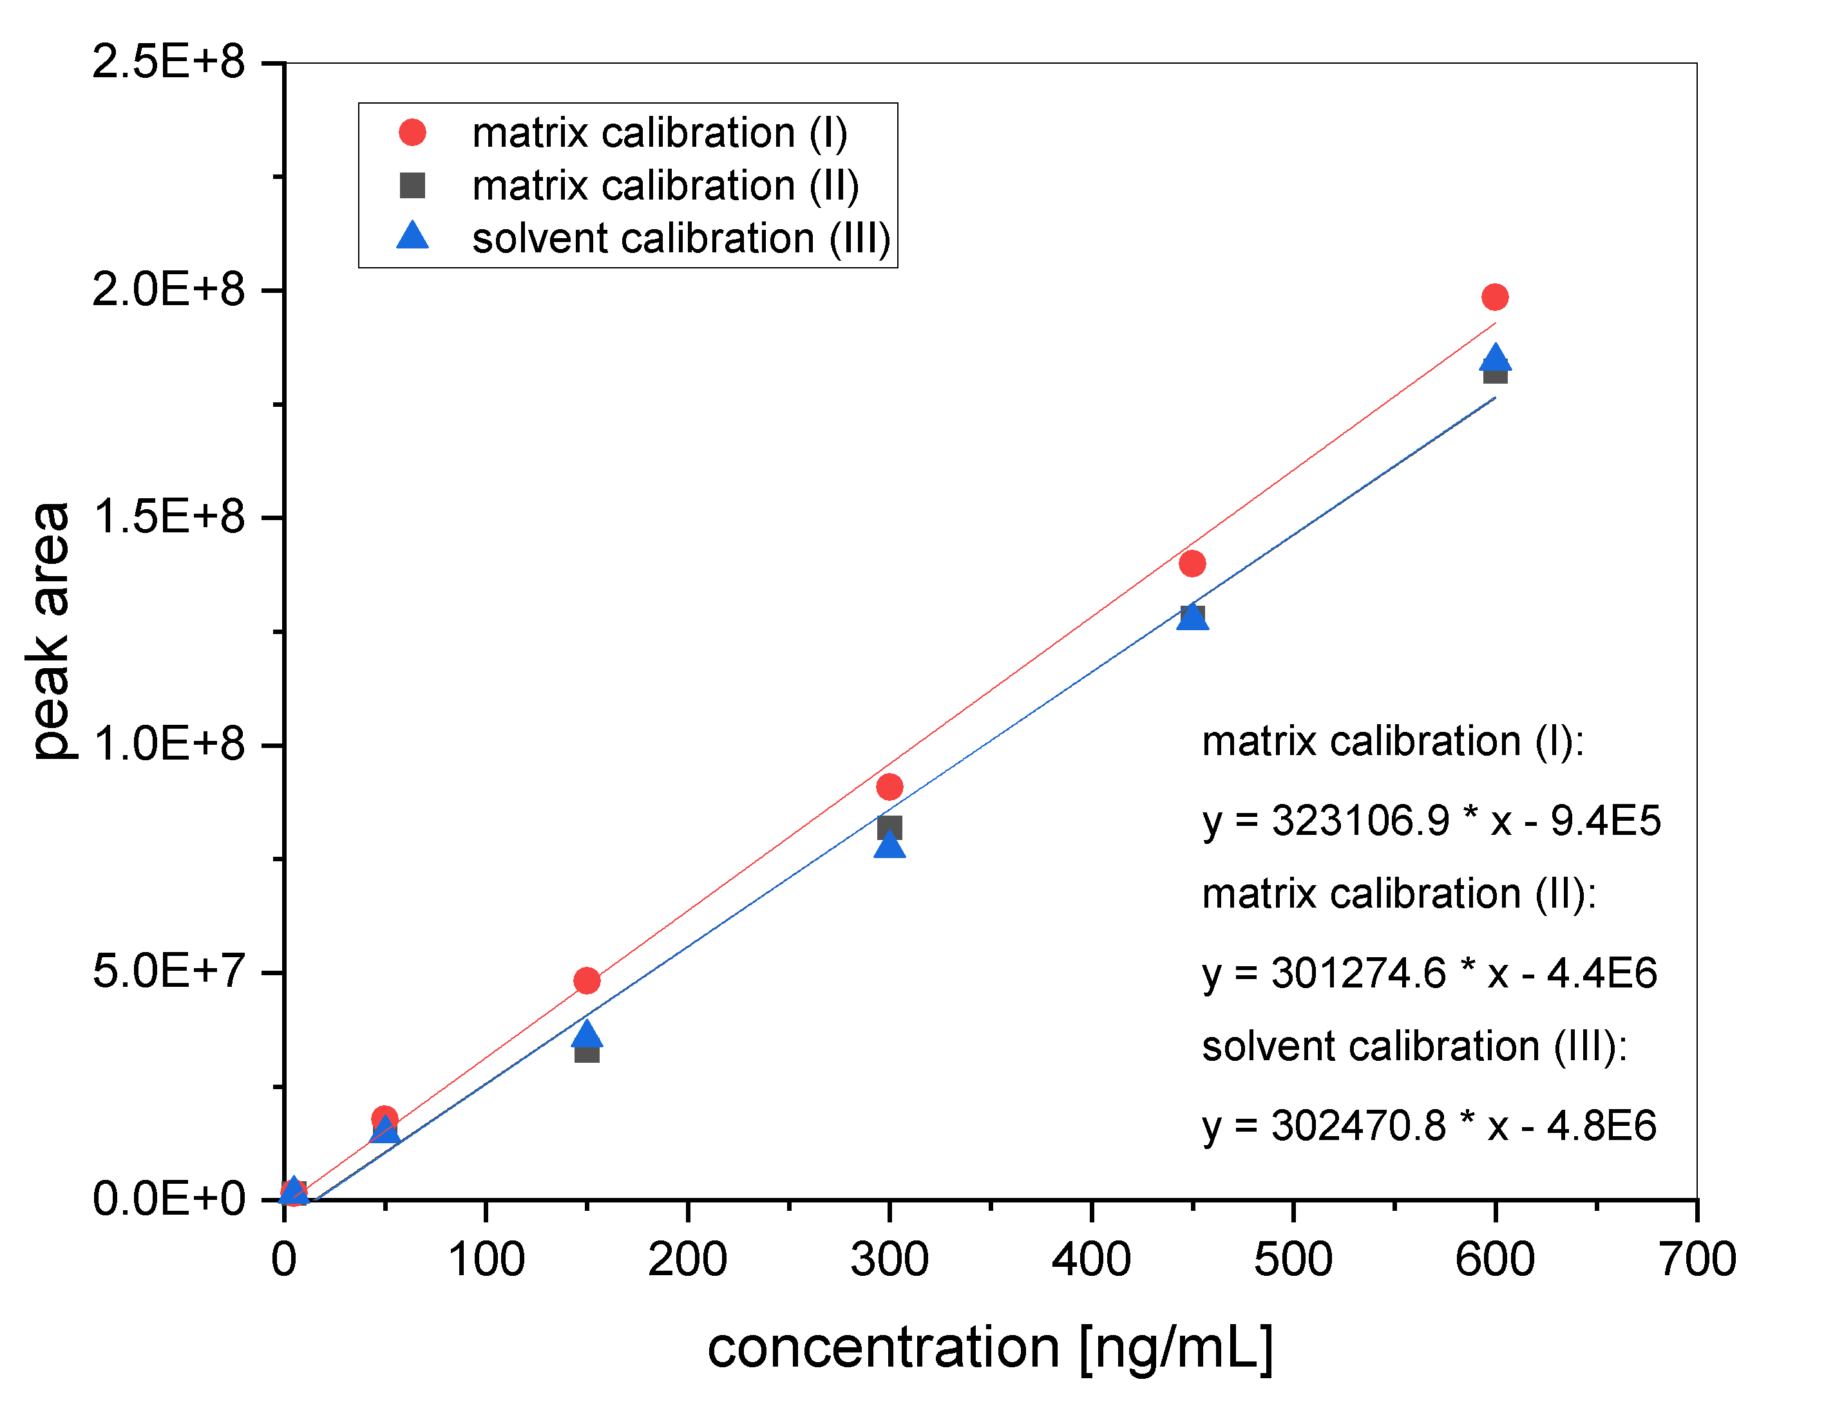
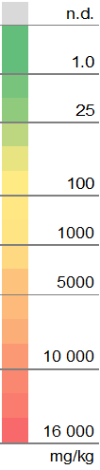
Figure S2. Matrix effect evaluation for the pyrrolizidine alkaloid heliotrine. Plot of curve I (Hypochaeris radicata), II (hay) and III (solvent).

References
Boppré M, Colegate SM, Edgar JA. 2005. Pyrrolizidine alkaloids of Echium vulgare honey found in pure pollen. J Agr Food Chem. 53:594-600.
Cairns E, Hashmi MA, Singh AJ, Eakins G, Lein M, Keyzers R. 2015. Structure of echivulgarine, a pyrrolizidine alkaloid isolated from the pollen of Echium vulgare. J Agr Food Chem. 63(33):7421-7427.
Crout DHG. 1967. Pyrrolizidine alkaloids. Biosynthesis of angelate component of heliosupine. J Chem Soc C.(13):1233-&.
Crowley HC, Culvenor CCJ. 1959. The alkaloids of Heliotropium supinum L, with observations on viridifloric acid. Aust J Chem. 12(4):694-705.
Culvenor CCJ. 1954. The alkaloids of Heliotropium europaeum L.. II. Isolation and structures of the 3rd major alkaloid and 2 minor alkaloids, and isolation of the principal N-oxides. Aust J Chem. 7(3):287-297.
Culvenor CCJ, Drummond LJ, Price JR. 1954. The alkaloids of Heliotropium europaeum L.. I. Heliotrine and lasiocarpine. Aust J Chem. 7(3):277-286.
Culvenor CCJ, Johns SR, Smith LW. 1975. Acetyllasiocarpine, an alkaloid from Heliotropium europaeum. Aust J Chem. 28(10):2319-2322.
Drummond LJ. 1951. Structure of lasiocarpic acid. Nature. 167:41-42.
El-Shazly A, Sarg T, Ateya A, Abdel Aziz E, El-Dahmy S, Witte L, Wink M. 1996a. Pyrrolizidine alkaloids from Echium setosum and Echium vulgare. J Nat Prod. 59:310 - 313.
El-Shazly A, Sarg T, Ateya A, Abdel Aziz E, El-Dahmy S, Witte L, Wink M. 1996b. Pyrrolizidine and tetrahydroisoquinoline alakloids from Echium humile. Phytochemistry. 42(1):225 - 300.
El-Shazly A, Sarg T, Ateya A, Abdel Aziz E, Witte L, Wink M. 1996c. Pyrrolizidine alkaloids of Cynoglossum officinale and Cynoglossum amabile (family Boraginaceae). Biochemical Systematics and Ecology. 24(5):415-421.
El-Shazly A, Wink M. 2014. Diversity of pyrrolizidine alkaloids in the Boraginaceae structures, distribution, and biological properties. Diversity. 6(4):188-282.
Reina M, Gonzalez-Coloma A, Gutierrez C, Cabrera R, Henriquez J, Villarroel L. 1998a. Pyrrolizidine alkaloids from Heliotropium megalanthum. J Nat Prod. 61(11):1418-1420.
Reina M, GonzalezColoma A, Gutierrez C, Cabrera R, Henriquez J, Villarroel L. 1997. Bioactive saturated pyrrolizidine alkaloids from Heliotropium floridum. Phytochemistry. 46(5):845-853.
Reina M, Mericli AH, Gonzalez-Coloma A. 1998b. A minor pyrrolizidine alkaloid from Heliotropium bovei. Nat Prod Lett. 11(4):291-296.
Resch JF, Meinwald J. 1982. A revised structure for acetylheliosupine. Phytochemistry. 21(9):2430-2431.
Shimshoni JA, Mulder PP, Bouznach A, Edery N, Pasval I, Barel S, Abd-El Khaliq M, Perl S. 2015. Heliotropium europaeum poisoning in cattle and analysis of its pyrrolizidine alkaloid profile. J Agric Food Chem. 63(5):1664-1672.
Skoneczny D, Weston PA, Zhu X, Gurr GM, Callaway RM, Weston LA. 2015. Metabolic profiling of pyrrolizidine alkaloids in foliage of two Echium spp. invaders in Australia-A case of novel weapons? Int J Mol Sci. 16(11):26721-26737.
Tosun F, Tamer U. 2004. Determination of pyrrolizidine alkaloids in the seeds of Heliotropium europaeum by GC-MS. Journal of Faculty of Pharmacy of Ankara University. 33(1):7-9.
van Dam NM, Witte L, Theuring C, Hartmann T. 1995. Distribution, biosynthesis and turnover of pyrrolizidine alkaloids in Cynoglossum Officinale. Phytochemistry. 39(2):287-292.
Witte L, Rubiolo P, Bicchi C, Hartmann T. 1993. Comparative analysis of pyrrolizidine alkaloids from natural sources by gas chromatography-mass spectrometry. Phytochemistry. 32(1):187-196.

