6.0 Appendix A
6.1.0 Search Strategy
6.1.1 EMBASE (OVID)
Subject terms were entered as they appear below:
#1 exp cannabis/
#2 exp cannabinoid/
#3 exp dronabinol/ or dronabinol.mp.
#4 exp tetrahydrocannabinol/ or tetrahydrocannabinol.mp.
#5 marijuana.mp.
#6 pot.mp.
#7 hashish.mp.
#8 exp work/ or work*.mp.
#9 job*.mp.
#10 exp employment/ or employ*.mp.
#11 exp labor/ or (labor or labour).mp.
#12 exp career/ or career*.mp.
#13 exp occupation/ or occupation*.mp.
#14 exp injury/ or injur*.mp.
#15 exp wound/ or wound*.mp.
#16 exp accident/ or accident*.mp.
#17 exp mortality or mortalit*.mp.
#18 exp death/ or death*.mp.
#19 incident*.mp.
#20 trauma*.mp.
#21 1 or 2 or 3 or 4 or 5 or 6 or 7
#22 8 or 9 or 10 or 11 or 12 or 13
#23 14 or 15 or 15 or 16 or 17 or 18 or 19 or 20
#25 21 and 22 and 23

6.1.2 MEDLINE
Subject terms were entered as they appear below:
#1 exp cannabis/
#2 exp cannabinoid/
#3 exp dronabinol/ or dronabinol.mp
#4 tetrahydrocannabinol.mp.
#5 marijuana.mp.
#6 pot.mp.
#7 hashish.mp.
#8 exp work/ or work*.mp
#9 job*.mp.
#10 exp employment/ or employ*.mp
#11 (labor or labour).mp.
#12 career*.mp.
#13 exp occupations/ or occupation*.mp
#14 exp”Wounds and injuries”/ or wound*.mp
#15 injur*.mp
#16 exp accidents/ or accident*.mp
#17 exp mortality/ or mortalit*.mp
#18 exp death/ or death*.mp
#19 incident*.mp.
#20 trauma*.mp.
#21 1 or 2 or 3 or 4 or 5 or 6 or 7
#22 8 or 9 or 10 or 11 or 12 or 13
#23 14 or 15 or 15 or 16 or 17 or 18 or 19 or 20
#25 21 and 22 and 23

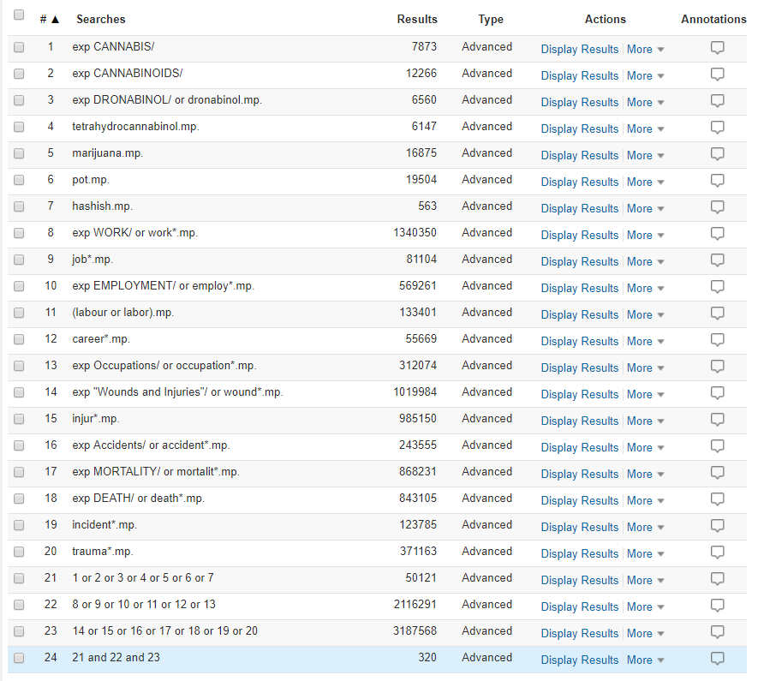
Figure 3. Subject terms and the search results from the MEDLINE (Ovid) database.
*screenshot taken of the Ovid platform hosted by the University of British Columbia

6.1.3 PSYCINFO
Subject terms were entered as they appear below:
Cannabis or cannabinoid or dronabinol or tetrahydrocannabinol or marijuana or thc or pot or hashish
AND
Work* or job* or employment* or occupation* or labor* or career* or employ*
AND
Wound* or injur* or accident* or mortality* or death* or incident* or trauma*

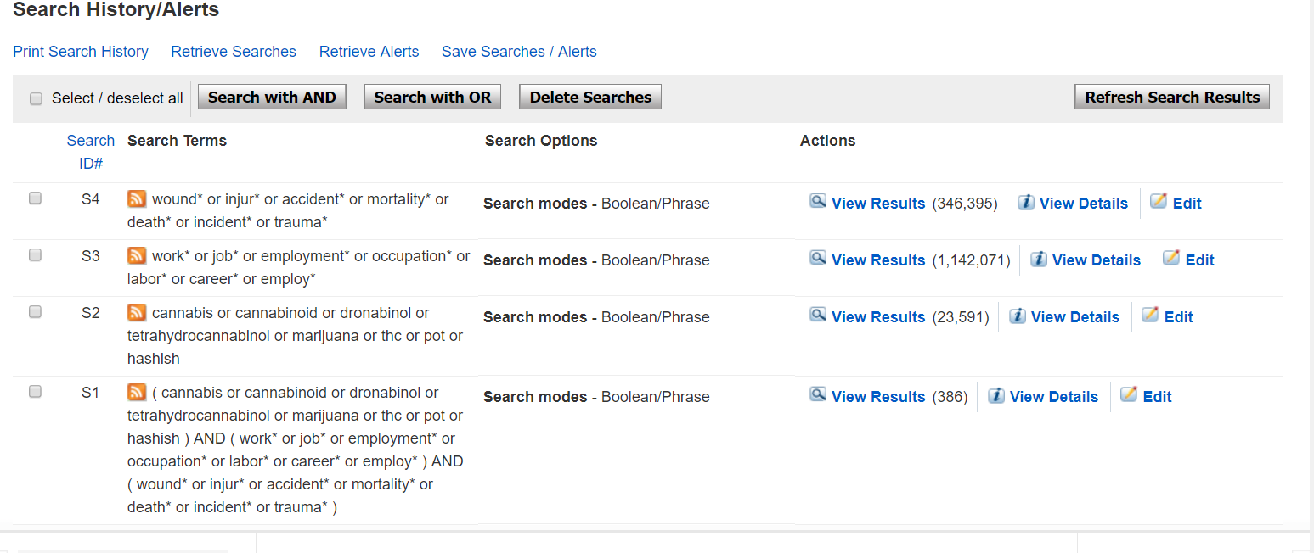
Figure 4. Subject terms and the search results from the PsycInfo (EBSCO) database.
*screenshot taken from the PsychInfo (EBSCO) website.

6.1.4 WEB OF SCIENCE
Subject terms were entered as they appear below:
#1 cannabis or cannabinoid or dronabinol or tetrahydrocannabinol or marijuana or thc or pot or hashish
#2 work* or job* or employment* or occupation* or labor* or career* or employ*
#3 wound* or injur* or accident* or mortality* or death* or incident* or trauma*
#4 1 AND 2 AND 3

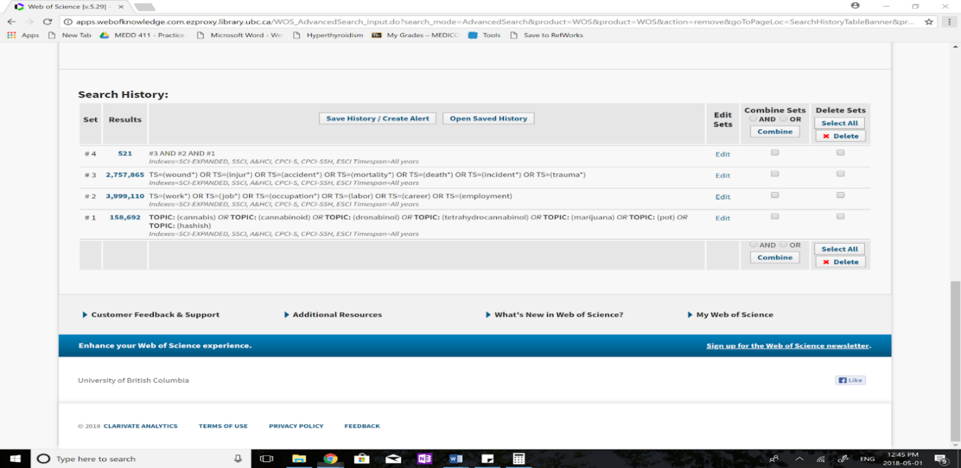
Figure 5. Subject terms and the search results from the Web of Science (Clarivate) database.
*screenshot taken from the Web of Science (Clarivate) platform.
6.1.5 CINAHL
Subject terms were entered as they appear below:
#1 cannabis or cannabinoid or dronabinol or tetrahydrocannabinol or marijuana or thc or pot or hashish
#2 work* or job* or employment* or occupation* or labor* or career* or employ*
#3 wound* or injur* or accident* or mortality* or death* or incident* or trauma*
#4 1 AND 2 AND 3

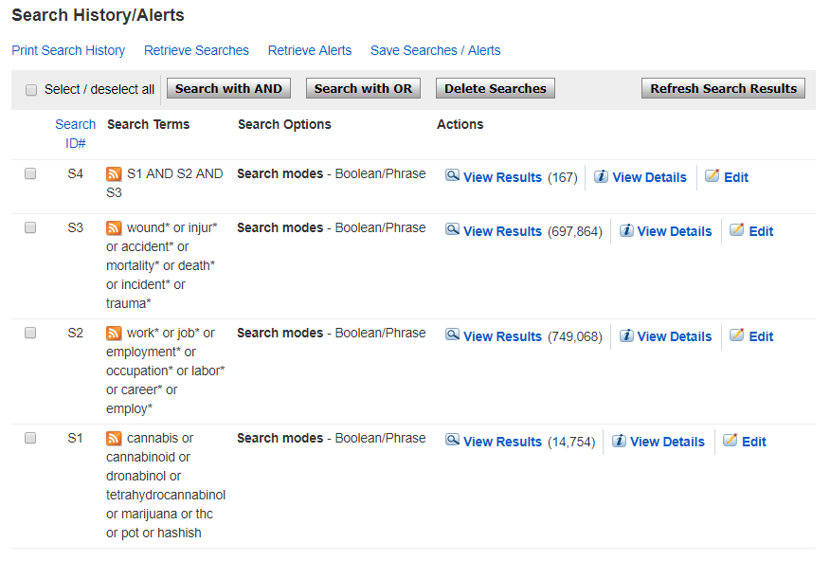
Figure 6. Subject terms and the search results from the CINAHL (EBSCO) database.
*screenshot taken from the CINAHL (EBSCO) website.

6.2.0 Summary of Quality Assessment of Extracted Articles
6.2.1 Summary table of the selection of participants in the included studies
Study | Year | Selection criteria | Notes
Barrio et al. | 2012 | 15-64-year-old residents (Spain) | 2005 Spanish Household Survey on Alcohol and Drugs (SHSAD)  National Survey of 27,934 persons  Response rate: 49.9%
Dong et al. | 2015 | Workers in the labor force only (those who were not in the labor force or those who did not report industry in the survey were excluded) | 1988-2000 Data from the National Longitudinal Survey of Youth, 1979 Cohort (NLSY79)  Sponsored by the US bureau of Labour Statistics  Initial Sample Size: 12,686 men and women aged 14-22 as of January 1979  Work-related injury module was included from 1988-2000  Response rates: 91% (1988) and 83% (2000)
Fransen et al. | 2006 | New Zealand Blood Donors Health Study (NZBDHS) participants who reported being “currently in any paid employment” (15,687 out of 22,389 recruited blood donors) | 22,389 blood donors were recruited for the NZBDHS self-administered questionnaire from April 1998 to October 1999  Response rate: 81% (recruitment); 96% of questionnaires obtained from recruits (overall); 97.9% of questionnaires from recruits who reported being “currently in any paid employment”
Hoffman and Larison | 1999 | Noninstitutionalized population of USA aged 12 and older (specific targeted module for full and part-time workers aged 18 and older) | 1994 National Household Survey on Drug Abuse (NHSDA)  Introduced a workplace module in 1994 to gather data on full and part-time workers aged 18 and older  Response rate: 76.5% (1994-A Survey – sent randomly to 1/5th of participants) and 78.2% (1994-B Survey – sent randomly to 4/5th of participants)  17,809 respondents total; 9,097 (51.1%) reported working full or part-time
Kaestner and Grossman | 1998 | Nationally representative sample of young adults in the United States (must be non-black and must be employed at some time in the year prior to the interview and must have no missing data) | Data from the National Longitudinal Survey of Youth (NLSY)  Years included: 1988 and 1992
Khashaba et al. | 2018 | Cases: 100 acutely injured male construction workers admitted to hospital (Mansoura University Emergency Hospital)  Controls: age-matched, healthy male construction workers
Lasebikan and Ijomanta | 2018 | "Multistage stratified systematic sampling method used to select participants into the study" | Composite International Diagnostic Interview (CIDI) version 7.0  Sample from military population: 224 participants recruited  Response rate: 99.6%
Macdonald | 1995 | Systematic sampling technique used to select cases from telephone directories in Ontario. The number of selected cases was proportional to the population of each region. | Questionnaires delivered to 2,468 households  Response rate: 35.7% (882/2,468); 57 of these were then excluded due to lack of employment
Normand | 1990 | All persons who applied for permanent positions with US postal service and satisfy the following:  1) employment sites with formal preemployment drug-testing program excluded  2) only sites with computerized program databases considered  3) diverse geographic locations to ensure diverse, heterogeneous sample  4) participating sites had a postal service medical officer perform medical examinations in the context of which the urine samples would be collected | All applicants must take drug test prior to being hired  Discuss that participants were noted of drug test prior to hiring well in advance. Urine sample collected at medical examination.  Drug-test results from 5,465 applicants, 4,396 of which were hired (80%)
Price | 2012 | Southern Indiana coal mine employees who work for companies with routine urine drug testing policies.  Random (control) sample (n=215) made up of coal miners presenting for random urine drug testing.  Post-accident (study) sample (n=100) made up of individuals that presented for post-accident urine drug testing. | Data obtained from administrative database maintained by Clinical Reference Laboratory of Lenexa, Kansas.  Urine drug testing occurred between June 11, 2009 and October 5, 2011.
Price | 2014 | Coal mine employees who work for companies in Southern Indiana, Missouri, Kentucky, Ohio, and Pennsylvania with routine urine drug testing policies.  Random (control) sample (n=2834) made up of coal miners presenting for random urine drug testing.  Post-accident (study) sample (n=961) made up of individuals that presented for post-accident urine drug testing. | Data obtained from administrative database maintained by Clinical Reference Laboratory of Lenexa, Kansas.  Urine drug testing occurred between January 2, 2009 and December 30, 2010.  Data may overlap with Price (2012).
Price | 2016 | Participants were employees in various industries in three states (Southern Indiana, Western Kentucky, and Eastern Illinois). The participants all worked for companies with random drug screening.  Random (control) sample (n=3087) made up of coal miners presenting for random urine drug testing.  Post-accident (study) sample (n=1072) made up of individuals that presented for post-accident urine drug testing. | Data obtained from administrative database maintained by Clinical Reference Laboratory of Lenexa, Kansas.  Random sample = 3306 before removal of outliers; Post-accident sample = 1152 before removal of outliers  Data may overlap with Price (2014).
Ryan et al. | 1992 | Study population from 4797 applicants for nonprofessional positions with the US Postal Service in Boston, Massachusetts. 2537 of these applicants were hired and enrolled as subjects in this study.  This follows up on a study conducted by Zwerling et al. 1990 – the same sample population is shared between these studies.  Cohort followed for an average of 2 years. | 7 opiate users excluded, 42 clinical history of nonalcohol substance abuse excluded, 56 excluded due to data tracking errors, 60 Hispanics and 2 Native Americans excluded.
Shipp et al. | 2005 | Students from 23 high schools. Schools chosen by accepting an invite to participate.  7221 high school students from 266 classes were surveyed (18.5% absentee rate, 1% refusal rate)  Analysis limited to students who had ever worked for pay (46% of students (n=3265)). | Data collected in May 1995.  Detailed, self-administered, anonymous survey consisting of 90 items. Administered by teachers.  Survey used items from the CDC Youth Risk Behaviour Survey (YRBS).
Wadsworth et al. | 2006 | Postal questionnaire conducted among 30,000 people selected at random from electoral registers of Cardiff and Merthyr Tydfil (22500 and 7500, respectively).  Two areas chosen due to differing demographics. | Survey based on Bristol Stress and Health Study with additional sections such as demographics, health, injuries, behaviours, and work. Questions regarding drug use taken from the British Crime Survey.  Response rate: 26.6% (7979/30,000)
Zwerling et al. | 1990 | Study population from 4797 applicants for nonprofessional positions with the US Postal Service in Boston, Massachusetts. 2537 of these applicants were hired and enrolled as subjects in this study.  Cohort followed for an average of 1 year. Same Sample population as Ryan et al. 1992. | 7 opiate users excluded, 42 clinical history of nonalcohol substance abuse excluded, 56 excluded due to data tracking errors, 60 Hispanics and 2 Native Americans excluded.

6.2.2 Summary of the assessment of cannabis use in the included studies
Study | Year | Measurement of cannabis use | Notes
Barrio et al. | 2012 | Past-year use (yes or no) and frequency (never, less than weekly, or weekly use) | Survey – see Notes, Section 6.2.1 for details
Dong et al. | 2015 | Lifetime use (11+ occasions, 1-10 occasions, or never) | Survey – see Notes, Section 6.2.1 for details
Fransen et al. | 2006 | Frequency (less than once a month, once a month, once every 2 weeks, once a week, and more than once a week) | Survey – see Notes, Section 6.2.1 for details  Reported statistically as use in general (Yes or No)
Hoffman and Larison | 1999 | Lifetime use and frequency (never used, used 3 or more years ago, used 1-3 years ago, used 1-2 days in past year, 3-51 days in past year, weekly in past year) | Survey – see Notes, Section 6.2.1 for details
Kaestner and Grossman | 1998 | Past-year use (yes or no) | Survey – see Notes, Section 6.2.1 for details
Khashaba et al. | 2018 | Lifetime use (yes or no) | Interview-filled questionnaire  Risk ratio was calculated based on historical data  Urine-blood tests for cannabis metabolites were conducted to determine prevalence estimates in the sample of injured workers.
Lasebikan and Ijomanta | 2018 | Lifetime use (yes or no) and past-year use (yes or no) | Interview-filled questionnaire – see Notes, Section 6.2.1 for details
Macdonald | 1995 | Past-year use (yes or no) | Survey – see Notes, Section 6.2.1 for details
Normand | 1990 | Current use (yes or no, depending on whether urine cannabis metabolites surpass pre-determined cut-off levels) | Cut-off scores selected to comply with those recommended by the U.S. Department of Health and Human Services
Price | 2012 | Presence of cannabis metabolites in urine (yes or no depending on positive or negative urine metabolites) | Analysis of urine testing data from administrative database.  Drug metabolites present in the blood, regardless of being above or below federal drug testing programs’ cut-off levels, indicated a positive result. Samples were screened then positive results were confirmed by gas-chromatography
Price | 2014 | Presence of cannabis metabolites in urine (yes or no depending on positive or negative urine metabolites) | Analysis of urine testing data from administrative database  Drug metabolites present in the blood, regardless of being above or below federal drug testing programs’ cut-off levels, indicated a positive result. Samples were screened then positive results were confirmed by gas-chromatography
Study | Year | Measurement of cannabis use | Notes
Price | 2016 | Presence of cannabis metabolites in urine (yes or no depending on positive or negative urine metabolites) | Analysis of urine testing data from administrative database  Drug metabolites present in the blood, regardless of being above or below federal drug testing programs’ cut-off levels, indicated a positive result. Samples were screened then positive results were confirmed by gas-chromatography
Ryan et al. | 1992 | Presence of cannabis metabolites in urine (yes or no depending on positive or negative urine metabolites) | Drug screening occurred pre-employment, occurring between September 24, 1986 and January 6, 1989.
Shipp et al. | 2005 | Lifetime use (0, 1-9, 10-39, or 40+ times) and past 30-day use (0, 1-9, 10-39, or 40+ times) | Survey – see Notes, Section 6.2.1 for details
Wadsworth et al. | 2006 | Past-year (yes or no) and past month use (yes or no) | Survey – see Notes, Section 6.2.1 for details  Survey included data on cannabis use in the last year and last month, however, only use in general is reported in the statistical analysis.
Zwerling et al. | 1990 | Presence of cannabis metabolites in urine (yes or no depending on positive or negative urine metabolites) | Drug screening occurred pre-employment, occurring between September 24, 1986 and January 6, 1989.

6.2.3 Summary of the assessment of occupational injury in the included studies
Study | Year | Measure of Occupational Injury | Notes
Barrio et al. | 2012 | Injury in past 12 months while working (yes or no) | Survey – see Notes, Section 6.2.1 for details  For place of occurrence (i.e. workplace) only information on the most recent injury could be obtained
Dong et al. | 2015 | Injury while working since last interview (yes or no). | Survey – see Notes, Section 6.2.1 for details  Respondents were asked, "since [date of last interview], have you had an incident at any job that resulted in an injury or illness"
Fransen et al. | 2006 | Past-year work-related accident requiring medical treatment (yes or no). | Survey – see Notes, Section 6.2.1 for details  Participants asked if injury in past 12 months that required treatment from a doctor
Hoffman and Larison | 1999 | Past-year work-related accident (yes or no). | Survey – see Notes, Section 6.2.1 for details  Work-related accident defined as: part of an accident while working and resulting in damage to property, injury to self or another person
Kaestner and Grossman | 1998 | Workers compensation benefits (predicted workplace accident in past year) | Survey – see Notes, Section 6.2.1 for details
Khashaba et al. | 2018 | Injury outcome measures in the form of lost workdays counted from the day of the accident to the day following measured in calendar days, weekdays, work shifts or working days | Interview-filled questionnaire – see Notes, Section 6.2.1 for details
Lasebikan and Ijomanta | 2018 | Injury while working (yes or no) | Interview-filled questionnaire – see Notes, Section 6.2.1 for details
Macdonald | 1995 | Injury while working requiring medical attention (yes or no) | Survey – see Notes, Section 6.2.1 for details  Categorized as injuries or no injuries (more than one injury put in same group as those with only one injury)
Normand et al. | 1990 | Injury while working (yes or no) | Injury recorded on Form CA-1 (US dep. Of Labour, Employee Standard Administration, Office of Worker’s Compensation Program, 1986) were said to have an injury  Minor injuries not recorded were not included
Price | 2012 | Post-accident urine test (infers accident occurred)
Price | 2014 | Post-accident urine test (infers accident occurred)
Price | 2016 | Post-accident urine test (infers accident occurred)
Ryan et al. | 1992 | Injury while working (yes or no) | Injuries were tracked by Workers Comp Form CA-1. Accidents were tracked by postal service form 1769.  Only first injury recorded by postal worker used in analysis. Of 312 injured workers, 41 had 2 injuries, and 8 had 3 injures.
Shipp et al. | 2005 | Injury while working (yes or no) | Survey – see Notes, Section 6.2.1 for details  Defined as at least one injury while working for pay – participants identified their most severe injury.
Wadsworth et al. | 2006 | Minor injury while working (yes or no) or accident while working requiring medical attention (yes or no) during the previous year | Minor injuries include those not requiring medical attention.
Zwerling et al. | 1990 | Injury while working (yes or no) | Injuries were tracked by Workers Comp Form CA-1. Accidents were tracked by postal service form 1769  Only first injury recorded by postal worker used in analysis. Of 312 injured workers, 41 had 2 injuries, and 8 had 3 injures.

6.2.4 Detailed assessment process of all cross-sectional, case-control, and cohort studies included in the present systematic review.

 |  | Selection |  |  |  | Comparability | Outcome
Cross-sectional studies | Year | 1 | 2 | 3 | 4 | 1 | 1 | 2 | Score (/10)
Barrio et al. | 2012 | b | b | c | b | ab | c | b | 5
Dong et al. | 2015 | a | b | c | b | ab | c | a | 6
Fransen et al. | 2006 | c | b | c | b | c | c | a | 3
Hoffman and Larison | 1999 | b | b | c | b | ab | c | b | 5
Kaestner and Grossman | 1998 | a | b | c | b | ab | c | a | 6
Lasebikan and Ijomanta | 2018 | c | a | c | b | b | c | a | 5
Macdonald | 1995 | b | b | c | b | c | c | b | 3
Shipp et al. | 2005 | a | b | c | b | b | c | a | 5
Wadsworth et al. | 2006 | a | b | b | b | b | c | a | 5
 |  | Selection |  |  |  | Comparability | Outcome
Cohort studies | Year | 1 | 2 | 3 | 4 | 1 | 1 | 2 | 3 | Score (/9)
Normand et al. | 1990 | c | a | a | a | ab | c | a | d | 6
Ryan et al. | 1992 | c | a | a | a | ab | c | a | d | 6
Zwerling et al. | 1990 | c | a | a | a | ab | c | a | d | 6
 |  | Selection |  |  |  | Comparability | Exposure
Case-control studies | Year | 1 | 2 | 3 | 4 | 1 | 1 | 2 | 3 | Score (/9)
Khashaba et al. | 2018 | b | b | a | a | c | c | a | a | 4
Price | 2012 | b | b | a | a | c | a | a | a | 5
Price | 2014 | b | b | a | a | c | a | a | a | 5
Price | 2016 | b | b | a | a | c | a | a | a | 5

6.2.5 The Newcastle-Ottawa Scale (NOS) used for quality assessment of the included studies
a) NOS: Case Control Studies
Note: A study can be awarded a maximum of one star for each numbered item within the Selection and Exposure categories. A maximum of two stars can be given for Comparability.
Selection (Maximum 4 stars)
- Is the case definition adequate?
a) yes, with independent validation *
b) yes, eg record linkage or based on self-reports
c) no description
- Representativeness of the cases
a) consecutive or obviously representative series of cases *
b) potential for selection biases or not stated
- Selection of Controls
a) community controls *
b) hospital controls
c) no description
- Definition of Controls
a) no history of injury *
b) no description of source
Comparability (Maximum 2 stars)
1) Comparability of cases and controls on the basis of the design or analysis
a) study controls for Job type *
b) study controls for any additional factor *
Exposure (Maximum 3 stars)
- Ascertainment of exposure
a) secure record (eg surgical records) *
b) structured interview where blind to case/control status *
c) interview not blinded to case/control status
d) written self-report or medical record only
e) no description
- Same method of ascertainment for cases and controls
a) yes *
b) no
- Non-Response rate
a) same rate for both groups *
b) non respondents described
c) rate different and no designation

b) NOS: Cohort Studies
Note: A study can be awarded a maximum of one star for each numbered item within the Selection and Outcome categories. A maximum of two stars can be given for Comparability
Selection (Maximum 4 stars)
- Representativeness of the exposed cohort
a) truly representative of the average worker in the community *
b) somewhat representative of the average worker in the community *
c) selected group of users e.g. nurses, volunteers
d) no description of the derivation of the cohort
- Selection of the non-exposed cohort
a) drawn from the same community as the exposed cohort *
b) drawn from a different source
c) no description of the derivation of the non-exposed cohort
- Ascertainment of exposure
a) secure record (eg surgical records) *
b) structured interview
c) written self-report
d) no description
- Demonstration that outcome of interest was not present at start of study
a) yes *
b) no
Comparability (Maximum 2 stars)
- Comparability of cohorts on the basis of the design or analysis
a) study controls for Job type *
b) study controls for any additional factor *
Outcome
- Assessment of outcome
a) independent blind assessment *
b) record linkage
c) self-report
d) no description
- Was follow-up long enough for outcomes to occur
a) yes *
b) no
- Adequacy of follow up of cohorts
a) complete follow up - all subjects accounted for *
b) subjects lost to follow up unlikely to introduce bias - small number lost or description provided of those lost *
c) follow up rate inadequate and no description of those lost
d) no statement

c) NOS: Cross-sectional studies (Adapted by Herzog et al., 2013)
Selection: (Maximum 5 stars)
- Representativeness of the sample:
a) Truly representative of the average in the target population. * (all subjects or random sampling)
b) Somewhat representative of the average in the target population. * (non-random sampling)
c) Selected group of users.
d) No description of the sampling strategy.
- Sample size:
a) Justified and satisfactory. *
b) Not justified.
- Non-respondents:
a) Comparability between respondents and non-respondents characteristics is established, and the response rate is satisfactory. *
b) The response rate is unsatisfactory, or the comparability between respondents and non-respondents is unsatisfactory.
c) No description of the response rate or the characteristics of the responders and the non-responders.
- Ascertainment of the exposure (risk factor):
a) Validated measurement tool. **
b) Non-validated measurement tool, but the tool is available or described. *
c) No description of the measurement tool.
Comparability: (Maximum 2 stars)
- The subjects in different outcome groups are comparable, based on the study design or analysis. Confounding factors are controlled.
a) The study controls for the most important factor (select one). *
b) The study control for any additional factor. *
Outcome: (Maximum 3 stars)
- Assessment of the outcome:
a) Independent blind assessment. **
b) Record linkage. **
c) Self-report. *
d) No description.
Statistical test:
a) The statistical test used to analyze the data is clearly described and appropriate, and the measurement of the association is presented, including confidence intervals and the probability level (p value). *
b) The statistical test is not appropriate, not described or incomplete.

