Appendix A Supplementary data.

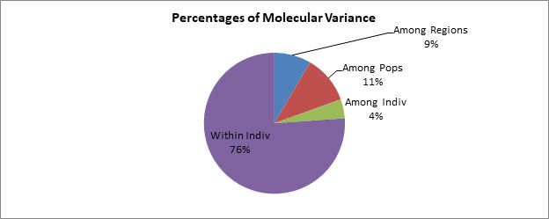
Fig. S1. Graphic representation of the Analysis of molecular variance (AMOVA) based on Fst estimator for the partitioning of SSR variation of C. cardunculs plants among and within populations identified

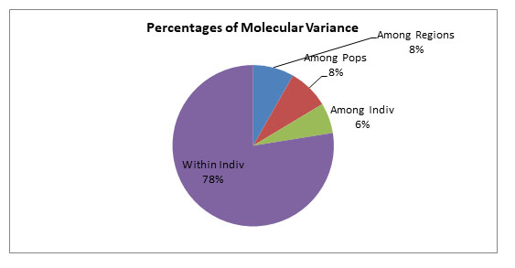
Fig. S2. Graphic representation of the Analysis of molecular variance (AMOVA) based on Fst estimator for the partitioning of SSR variation of wild C. cardunculs plants among and within populations identified.

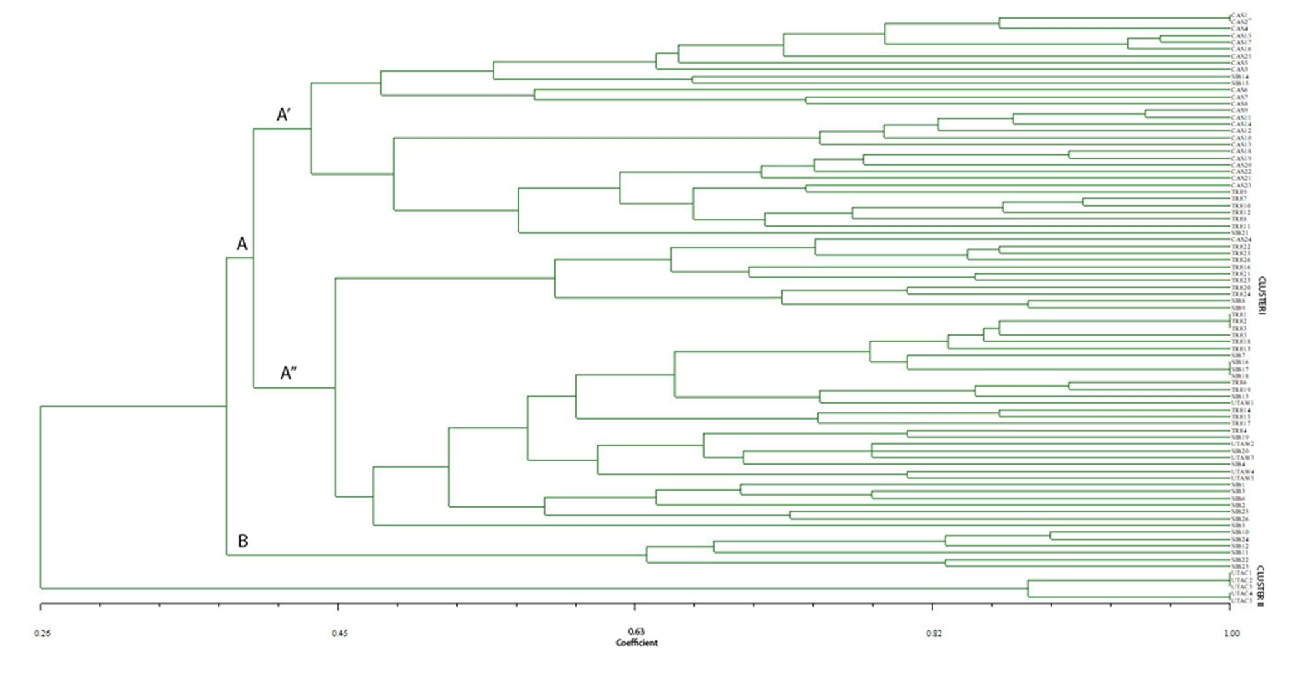
Fig.S3. Dendrogram based on Dice’s Similarity Coefficient and UPGMA clustering for 87 cardoons for the SSRs dataset.

Table S1 Characteristics of microsatellite primers selected for Cynara cardunculus L. Sequences in forward (F) and reverse (R), repeat sequence pattern, individual annealing temperature, original fragment size, and GenBank accession numbers are shown (Acquadro et al., 2003, 2009; Scaglione et al., 2009).

Locus | Repeat motif | Primer pair sequence (5¢-3¢) | T (°C) | Genebank | Allele size range (bp)/  (sequenced allele size)
CELMS 01 | (AG)17 | F:CAACACAGAAGCGAGGTCA | 49 | EU744917 | 356
 |  | R.GAATGAGCCGGATTAGCATT
CELMS 10 | (AG)25 | F:TCAGACTTCAGCACCACCTC | 53 | EU744926 | 315
 |  | R:GTCGTTCTGGATTCCCACAT
CELMS 11 | (TC)21(TTTG)3 | F:GCGAATCAATCCCTTGTCTC | 55 | EU744927 | 258
 |  | R:AAGCCATGGATGAAGCAGAG
CELMS 41 | (ATG)11(GAT)9 | F:CCAAAGCCTTCAGAGCATTC | 53 | EU744957 | 271
 |  | R:GGAATGATGTATGGATCGCC
CELMS 48 | (CTG)5(CTG)7 | F:ATAACAGGACGAGGTGTGGAAG | 49 | EU744964 | 321
 |  | R:CTACAGTTGCTTATTGGTCCCC
CELMS 58 | (AG)18(AGAA)3 | F:GGATTCCATTGGACTTACAGG | 55 | EU744974 | 259
 |  | R:GGTTTGCCTATCTCTGTCTTTCTT

Table S2. Summary of allelic data and statistics for the five SSR loci across five cardoon populations. Na = number of different alleles; Ne = number of effective alleles; I = Shannon's information index; Ho = Observed Heterozygosity; He = Expected Heterozygosity; F = Fixation Index.
 | CAL-CAS-W | CAL-TRE-W | CAL-SIB-W | SAR-UTA-W | SAR-UTA-C | WHOLE
CELMS48
Na | 3 | 3 | 2 | 1 | 2,000 | 2,200
Ne | 2,091 | 2,253 | 1,862 | 1 | 1,923 | 1,826
I | 0,786 | 0,898 | 0,655 | 0 | 0,673 | 0,602
Ho | 0,5 | 0,231 | 0,273 | 0 | 0,000 | 0,201
He | 0,522 | 0,556 | 0,463 | 0,000 | 0,480 | 0,404
F | 0,042 | 0,585 | 0,411 | #N/D | 1,000 | 0,509
CELMS41
N | 22 (44) | 25 (50) | 21 (42) | 5 (10) | 5 (10) | 15,600
Na | 5 | 4 | 7 | 4 | 2,000 | 4,400
Ne | 2,086 | 2,546 | 4,768 | 2,778 | 2,000 | 2,835
I | 1,011 | 1,058 | 1,688 | 1,168 | 0,693 | 1,124
Ho | 0,545 | 0,720 | 0,619 | 0,8 | 1,000 | 0,737
He | 0,521 | 0,607 | 0,790 | 0,640 | 0,500 | 0,612
F | -0,048 | -0,186 | 0,217 | -0,250 | -1,000 | -0,253
CELMS11
N | 25 (50) | 25 (50) | 22 (44) | 5 (10) | 5 (10) | 16,400
Na | 6 | 3 | 4 | 5 | 2,000 | 4,000
Ne | 3,141 | 2,654 | 2,527 | 3,125 | 2,000 | 2,689
I | 1,316 | 1,036 | 1,048 | 1,359 | 0,693 | 1,090
Ho | 1 | 1 | 1 | 0,8 | 1,000 | 0,960
He | 0,682 | 0,623 | 0,604 | 0,680 | 0,500 | 0,618
F | -0,467 | -0,605 | -0,655 | -0,176 | -1,000 | -0,581
CELMS58
N | 23 (46) | 26 (52) | 23 (46) | 5 (10) | 5 (10) | 16,400
Na | 5 | 5 | 8 | 4 | 1,000 | 4,600
Ne | 2,972 | 3,440 | 4,831 | 3,333 | 1,000 | 3,115
I | 1,279 | 1,336 | 1,750 | 1,280 | 0,000 | 1,129
Ho | 0,696 | 0,923 | 0,739 | 0,8 | 0,000 | 0,632
He | 0,664 | 0,709 | 0,793 | 0,700 | 0,000 | 0,573
F | -0,048 | -0,301 | 0,068 | -0,143 | #N/D | -0,106
CELMS01
N | 23 (46) | 26 (52) | 24 (48) | 5 (10) | 5 (10) | 16,600
Na | 5 | 5 | 8 | 4 | 2,000 | 4,800
Ne | 2,997 | 2,998 | 5,878 | 2,941 | 2,000 | 3,363
I | 1,271 | 1,313 | 1,894 | 1,221 | 0,693 | 1,278
Ho | 0,739 | 0,808 | 0,833 | 0,6 | 1,000 | 0,796
He | 0,666 | 0,666 | 0,830 | 0,660 | 0,500 | 0,665
F | -0,109 | -0,212 | -0,004 | 0,091 | -1,000 | -0,247
CELMS10
N | (38) 19 | 25 (50) | 23 (46) | 3 (6) | 5 (10) | 15,000
Na | 6 | 6 | 6 | 1 | 2,000 | 4,200
Ne | 4,719 | 4,771 | 4,266 | 1 | 2,000 | 3,351
I | 1,636 | 1,647 | 1,592 | 0 | 0,693 | 1,114
Ho | 0,842 | 0,960 | 0,826 | 0 | 1,000 | 0,726
He | 0,788 | 0,790 | 0,766 | 0 | 0,500 | 0,569
F | -0,069 | -0,215 | -0,079 | #N/D | -1,000 | -0,341
Overall loci | CAL-CAS-W | CAL-TRE-W | CAL-SIB-W | SAR-UTA-W | SAR-UTA-C | WHOLE
N | 22,33 (45) | 25,50 (51) | 22,50 (51) | 4,67 (9) | 5,0 (10) | 16
Na | 5,000 | 4,333 | 5,833 | 3,167 | 1,833 | 4,033
Ne | 3,001 | 3,110 | 4,022 | 2,363 | 1,821 | 2,863
I | 1,216 | 1,215 | 1,438 | 0,838 | 0,574 | 1,056
Ho | 0,720 | 0,774 | 0,715 | 0,500 | 0,667 | 0,675
He | 0,640 | 0,659 | 0,708 | 0,447 | 0,413 | 0,573
F | -0,117 | -0,156 | -0,007 | -0,120 | -0,600 | -0,191
number of polymorphic loci | 6,000 | 6,000 | 6,000 | 4 | 5,000
percentage of polymorphic loci | 100% | 100% | 100% | 66,67% | 83,330 | 90%

Table S3. Analysis of molecular variance (AMOVA) for 87 individulas of C. cardunculs using SSR: * Significance test after 99 permutations

Source of variance | df | SS | MS | Estimated  Variance | % | F-Statistics |  | Value |  | P-value*
Among Regions | 1 | 14,338 | 14,338 | 0,221 | 9% | Frt |  | 0,085 |  | 0,010
Among Pops | 3 | 39,316 | 13,105 | 0,290 | 11% | Fsr |  | 0,121 |  | 0,010
Among Indiv | 82 | 182,345 | 2,224 | 0,115 | 4% | Fst |  | 0,195 |  | 0,010
Within Indiv | 87 | 173,500 | 1,994 | 1,994 | 76% | Fis |  | 0,054 |  | 0,020
Total | 173 | 409,500 |  | 2,620 | 100% | Fit |  | 0,239 |  | 0,010

Table S4. Analysis of molecular variance (AMOVA) for 87 individulas of C. cardunculs using SSR: * Significance test after 99 permutations

Source of variance | df | SS | MS | Estimated Variance | % | F-Statistics | Value | P-value*
Among Regions | 1 | 8,907 | 8,907 | 0,211 | 8% | Frt | 0,082 | 0,010
Among Pops | 2 | 26,166 | 13,083 | 0,210 | 8% | Fsr | 0,089 | 0,010
Among Indiv | 78 | 179,945 | 2,307 | 0,157 | 6% | Fst | 0,164 | 0,010
Within Indiv | 82 | 163,500 | 1,994 | 1,994 | 78% | Fis | 0,073 | 0,010
Total | 163 | 378,518 |  | 2,572 | 100% | Fit | 0,225 | 0,010

Table S5. Pairwise Matrix of the genetic distance between five populations of C. Cardunculus using Fst and Nei ‘s Index (both identity and distance)
Populations |  | Fst | Nei D | Nei I
CAL-CAS-W | CAL-TRE-W | 0,129 | 0,432 | 0,649
CAL-CAS-W | CAL-SIB-W | 0,091 | 0,393 | 0,675
CAL-TRE-W | CAL-SIB-W | 0,044 | 0,143 | 0,867
CAL-CAS-W | SAR-UTA-W | 0,212 | 0,896 | 0,408
CAL-TRE-W | SAR-UTA-W | 0,165 | 0,547 | 0,579
CAL-SIB-W | SAR-UTA-W | 0,123 | 0,511 | 0,600
CAL-CAS-W | SAR-UTA-C | 0,336 | 1,804 | 0,165
CAL-TRE-W | SAR-UTA-C | 0,347 | 1,704 | 0,182
CAL-SIB-W | SAR-UTA-C | 0,271 | 1,419 | 0,242
SAR-UTA-W | SAR-UTA-C | 0,433 | 1,827 | 0,161

