Supplemental Table 1
Table of Correlations for Men, for Women, and Within Dyads
 | V1 | V2 | V3 | V4 | V5 | V6 | V7 | V8 | V9 | V10 | V11 | V12
V1: Eager. to comm. | -.17 | .04 | .03 | .15 | .16 | .20* | -.00 | .35*** | .40*** | -.31** | .37*** | .50***
V2: Info. seeking (S) | .24* | -.05 | .39*** | .46*** | .23* | .43*** | -.10 | .17 | .28** | -.31** | .33*** | .23*
V3: Info. seeking (O) | -.04 | .31** | -.07 | .12 | .11 | .11 | -.11 | -.10 | .10 | -.06 | .06 | .01
V4: Nonverbal aff. (S) | .28** | .41*** | .19* | .27** | .39*** | .66*** | -.05 | .43*** | .42*** | -.51*** | .63*** | .49***
V5: Nonverbal aff. (O) | .15 | .01 | .22* | .41*** | .41*** | .37*** | .20* | .27** | .23* | -.20* | .42*** | .36***
V6: Disclosure (S) | .15 | .40*** | -.02 | .38*** | .11 | .04 | .00 | .41*** | .44*** | -.50*** | .57*** | .46***
V7: Disclosure (O) | .04 | .05 | -.08 | .28** | .26** | .37*** | -.14 | .15 | .10 | .01 | .16 | .10
V8: Similarity | .37*** | .34*** | -.02 | .35*** | .18 | .33** | .21* | .16 | .49*** | -.57*** | .53*** | .59***
V9: Social attraction | .19* | .10 | -.07 | .39*** | .30** | .27** | .16 | .58*** | -.14 | -.37*** | .72*** | .74***
V10: Uncertainty | -.39*** | -.37*** | .07 | -.53*** | -.12 | -.23* | -.10 | -.53*** | -.41*** | .03 | -.55*** | -.47***
V11: Comm. sat. | .27** | .29** | -.05 | .49*** | .28** | .37*** | .17 | .69*** | .74*** | -.50*** | .19* | .78***
V12: Desire for fut. int. | .32** | .20* | -.08 | .38*** | .23* | .33** | .06 | .63*** | .70*** | -.44*** | .84*** | -.11
Note. Coefficients are above the diagonal for men and below for women. Within-dyad coefficients are underlined on the diagonal. S = self-report and O = observer rating.
* p < .05. ** p < .01. *** p < .001.

Supplemental Figure 1
Significant Actor Effect of Eagerness to Communicate on Communication Satisfaction for Women as a Function of Condition
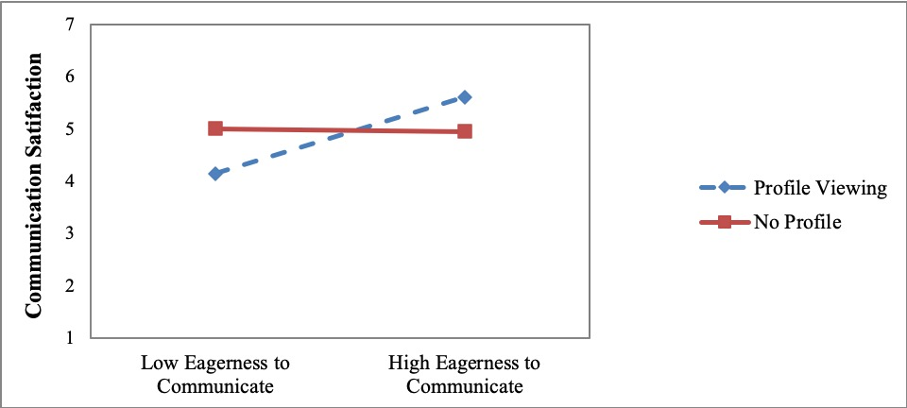

Supplemental Figure 2
Significant Partner Effect of Self-Reported Information Seeking on Communication Satisfaction for Women as a Function of Condition
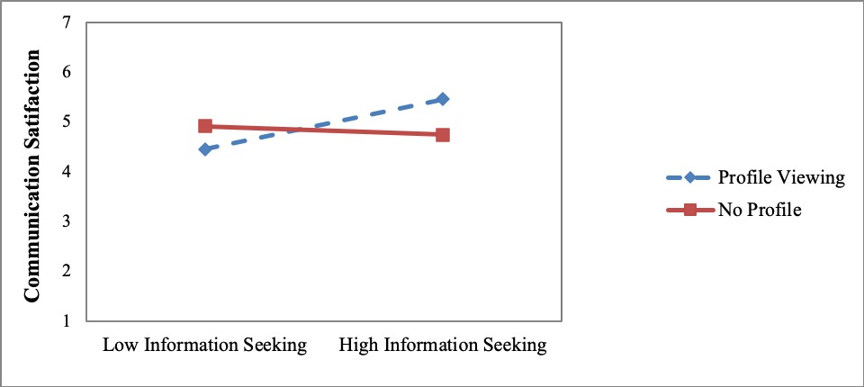

Supplemental Figure 3
Significant Partner Effect of Self-Reported Information Seeking on Communication Satisfaction for Men as a Function of Condition
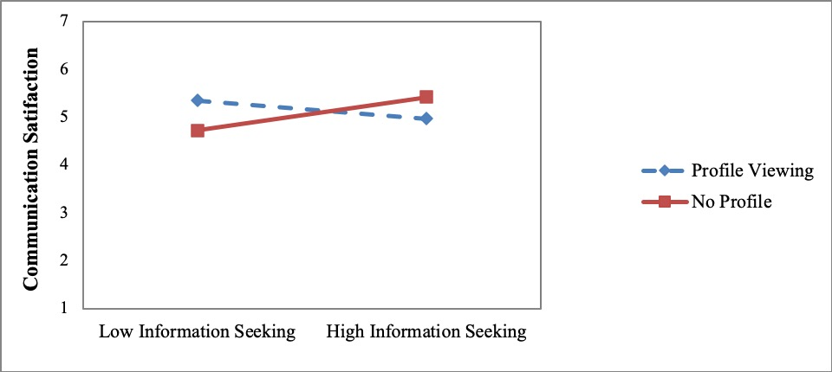

Supplemental Figure 4
Significant Partner Effect of Self-Reported Information Seeking on the Desire for Future Interaction for Men as a Function of Condition
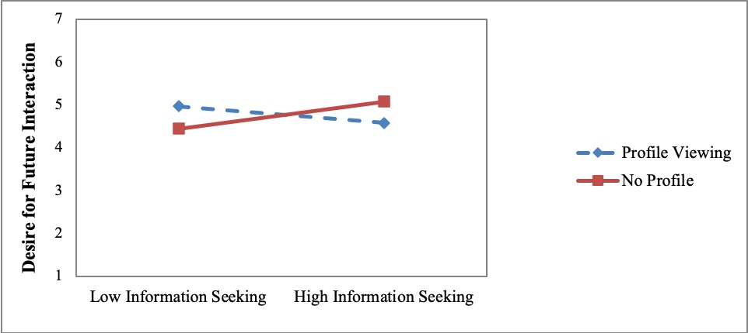

Supplemental Figure 5
Significant Partner Effect of Self-Reported Disclosure on the Desire for Future Interaction for Women as a Function of Condition
