**Electronic Supplementary Information**

**Mechanochemical Approach for the Selective Synthesis of 1,2-Disubstituted Benzimidazoles and their Molecular Docking Studies**

Nusrat Sahibaa, Dinesh Kumar Agarwalb, Anu Manhasc, Ayushi Sethiyaa, Jay Sonia, Prakash Chandra Jhad and Shikha Agarwala\*

*aDepartment of Chemistry, Synthetic Organic Chemistry Laboratory, MLSU, Udaipur, India 313001*

*bDepartment of Pharmacy, B. N. University, Udaipur, India 313001*

*cSchool of chemical sciences, Central University of Gujarat, Gandhinagar, India 382030*

*cSchool of applied materials, Central University of Gujarat, Sec. 30, Gandhinagar, India 382030*

E-mail: [shikhaagarwal@mlsu.ac.in](mailto:shikhaagarwal@mlsu.ac.in), [sahibanusrat786@gmail.com](mailto:sahibanusrat786@gmail.com)

Contents

[1. **Green chemistry matrix calculation** 2](#_Toc35535276)

[1.1 Environmental factor(E-factor) 2](#_Toc35535277)

[1.2 Atom-economy 2](#_Toc35535278)

[1.3 Product mass intensity (PMI) 2](#_Toc35535279)

[1.4 Reaction mass efficiency (RME) 3](#_Toc35535280)

[2. **Eco-score (E-score)** 3](#_Toc35535281)

[3. **Some pictures of reaction process** 4](#_Toc35535282)

[**4.** **Gram-scale synthesis of 1-(4-Chloro-benzyl)-2-(4-chloro-phenyl)-1*H*-benzimidazole** 4](#_Toc35535283)

[5. **Spectral information of Urea nitrate** 5](#_Toc35535284)

[5.1. FT-IR 5](#_Toc35535285)

[5.2. TG-DTA Curve 5](#_Toc35535286)

[6. **1H NMR spectra of selected compounds** 6](#_Toc35535287)

[6.1. 1H NMR spectra of 3a(500 MHz, DMSO-d6) 6](#_Toc35535288)

[6.2. 1H NMR spectra of 3c (500 MHz, CDCl3) 7](#_Toc35535289)

[6.3. 1H NMR spectra of 3e(500 MHz, DMSO-d6) 7](#_Toc35535290)

[6.4. 1H NMR spectra of 3f(500 MHz, CDCl3) 8](#_Toc35535291)

[6.5. 1H NMR spectra of 3g (500 MHz, DMSO-d6) 9](#_Toc35535292)

[6.6. 1H NMR spectra of 3h(500 MHz, DMSO-d6) 9](#_Toc35535293)

[6.7. 1H NMR spectra of 3i(500 MHz, DMSO-d6) 10](#_Toc35535294)

[6.8. 1H NMR spectra of 3j(500 MHz, DMSO-d6) 10](#_Toc35535295)

[6.9. 1H NMR spectra of 3k (500 MHz, DMSO-d6) 11](#_Toc35535296)

[6.10. 1H NMR spectra of 3l(500 MHz, CDCl3) 11](#_Toc35535297)

[7. **In-silico Docking study** 12](#_Toc35535298)

[7.1. 1T5C Protein 12](#_Toc35535299)

[6.2 2XCS Protein 15](#_Toc35535300)

[8. **Reference** 20](#_Toc35535301)

1. Green chemistry matrix calculation

Green chemistry matrix (1) has been calculated for the synthesis on the basis of following parameters

* 1. Environmental factor(E-factor)

E-factor = [mass of waste]/ mass of product

Where mass of waste = total mass of raw materials minus the total mass of product

D:\for green matrx.tif

Mass of product formed = 174.85 mg

E-factor = (54.07+140.57)-174.85 = **0.113** (ideal valve of E-factor is considered zero) 174.85

* 1. Atom-economy

Ideal valve of AE factor is 100% means all starting material converted in product.

AE = MW of product ÷ Σ(MW of stoichiometric reactants) × 100

Atom-economy = 176.62 X 100 = **90.74%**

(54.07+140.57)

* 1. Product mass intensity (PMI)

PMI = Σ(mass of stoichiometic reactants + solvent) / mass of product

PMI = 54.07+140.57 = **1.113**

174.85

Ideal value of PMI = E-factor + 1

PMI = 0.113+1 = 1.113

Both results are resemble to each other.

* 1. Reaction mass efficiency (RME)

RME = mass of product /Σ(mass of stoichiometic reactants) × 100

174.85

RME = X 100 = **89.83%** (Higher value measure the **cleanness** of reaction)

54.07 + 140.57

1. Eco-score (E-score)

An ideal reactions Eco-score value is 100.

Eco-scale from 0 to 100 using the following scores: > 75, excellent; > 50, acceptable; and < 50, inadequate.

E-score(2) has been calculated for the reaction on the basis of following 6 parameters below

|  |  |  |  |
| --- | --- | --- | --- |
| S.No. | Parameter | Values | Penalty points |
| 1 | Yield | 100-99/2 = 0.5 | 0.5 |
| 2 | Price of reaction component | Inexpensive | 0.0 |
| 3 | Safety (Reactant)a | T(Toxic) = 5+5 = 10 | 10.0 |
| 4 | Technical setup | Common setup | 0.0 |
| 5 | Temperature /time | Room temp./ <1h | 0.0 |
| 6 | Workup and purification | Chromatography(in some derivatives) | 10.0 |
|  | Total penalty points | | 20.5 |
| aBased on the hazard warning symbols | | | |

Eco-Score = 100 - sum of individual penalties

= 100 – 20.5 = **78.5** (>75, excellent synthesis)

As per the above results, it was concluded that the reaction has low Environment-factor (E-factor = 0.113), high atom economy (AE = 90.74%),high process mass intensity (PMI = 1.113) and high reaction mass efficiency (RME = 89.83%), with excellent eco-score (78.5%). These values clearly indicated the eco-friendliness of present synthesis.

1. Some pictures of reaction process

|  |  |  |
| --- | --- | --- |
| 1. **3i** (product) synthesis from OPDA and p-cyno benzaldehyde (solid) | | |
| D:\2. Research article\Grind stone\GS cynobenzaldehyde\IMG-20190609-WA0023.jpg  Before reaction | D:\2. Research article\Grind stone\GS cynobenzaldehyde\IMG-20190609-WA0024.jpg  After reaction | D:\2. Research article\2 cyno.jpg  TLC  1.Ophenylenediamine  2.Cynobenzaldehyde  3.product |
|  | | |
| 1. **3k** (Product) synthesis from OPDA and furfural (liquid) | | |
| D:\2. Research article\Grind stone\GS furfural\20190329_103719_Richtone(HDR).jpg  Before reaction | D:\2. Research article\Grind stone\GS furfural\20190329_104300_Richtone(HDR).jpg  After reaction | D:\2. Research article\1 furfural.jpg  TLC  1.Ophenylenediamine  2.fufural  3.product |

# **Gram-scale synthesis of 1-(4-Chloro-benzyl)-2-(4-chloro-phenyl)-1*H*-benzimidazole**

A mixture of *p*-chloro benzaldehyde (2.811 gm, 20mmol), o-phenylenediamine (1.08gm, 10mmol) and urea nitrate (15mol%) were gently grinded using agate mortar-pestle and a noticeable change appeared in colour after few seconds and the mixture turned to thick mass due to the progression of reaction. The formation of product was confirmed by thin layer chromatography. The pasty mass was further treated with cold water for the recovery of urea. Crude product was recrystallized from ethanol to give pure product.

1. Spectral information of Urea nitrate
   1. FT-IR

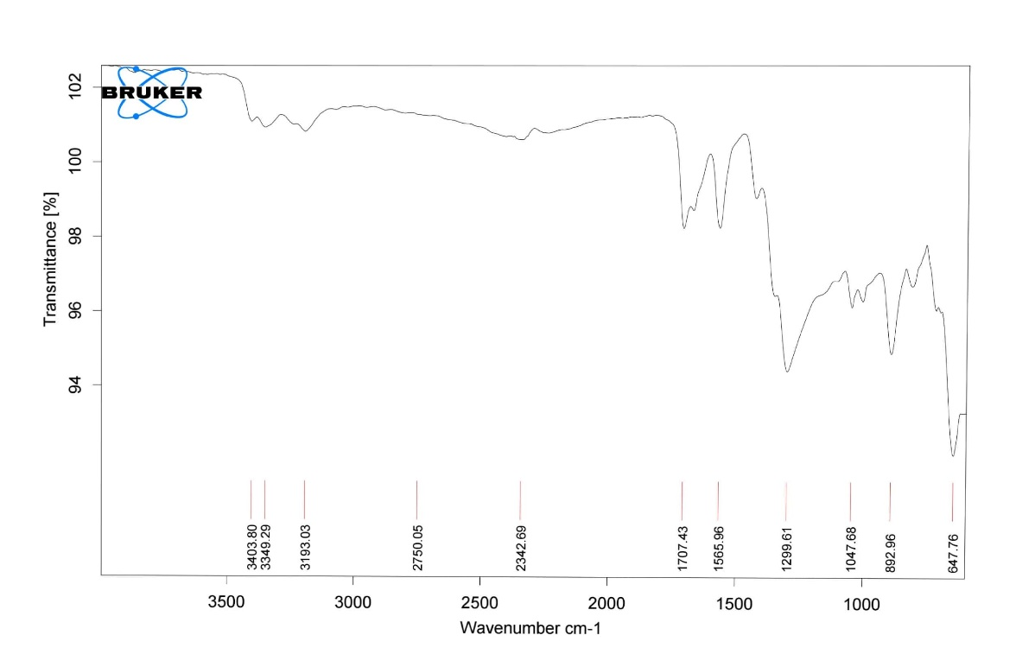

* 1. TG-DTA Curve



1. 1H NMR spectra of selected compounds
   1. 1H NMR spectra of 3a(500 MHz, DMSO-d6)

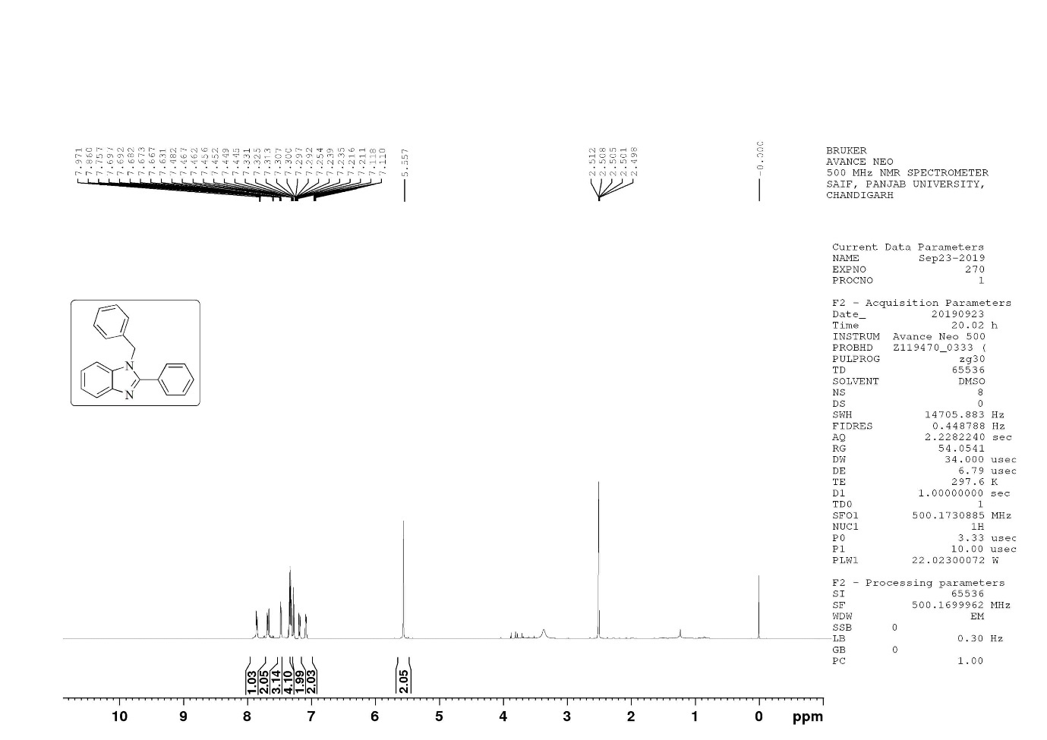

* 1. 1H NMR spectra of 3c (500 MHz, CDCl3)

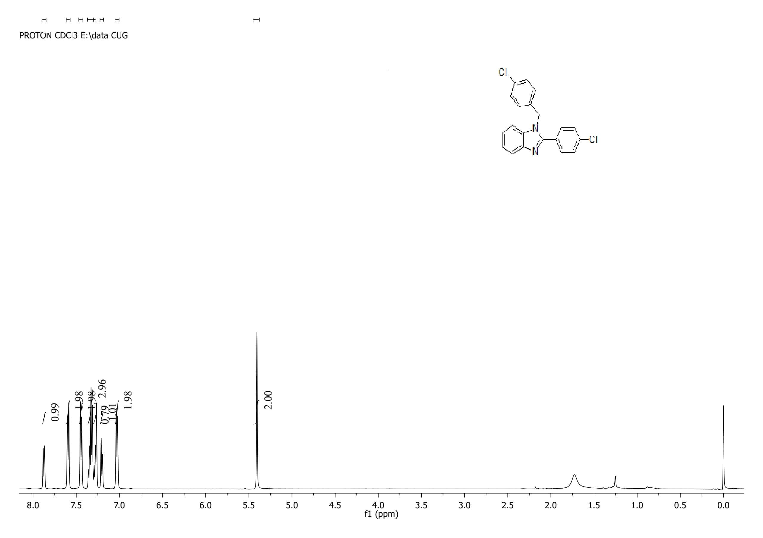

* 1. 1H NMR spectra of 3e(500 MHz, DMSO-d6)

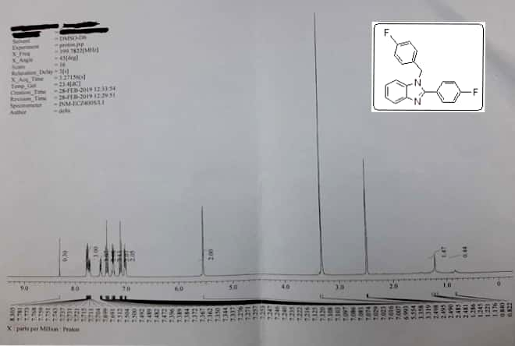

* 1. 1H NMR spectra of 3f(500 MHz, CDCl3)

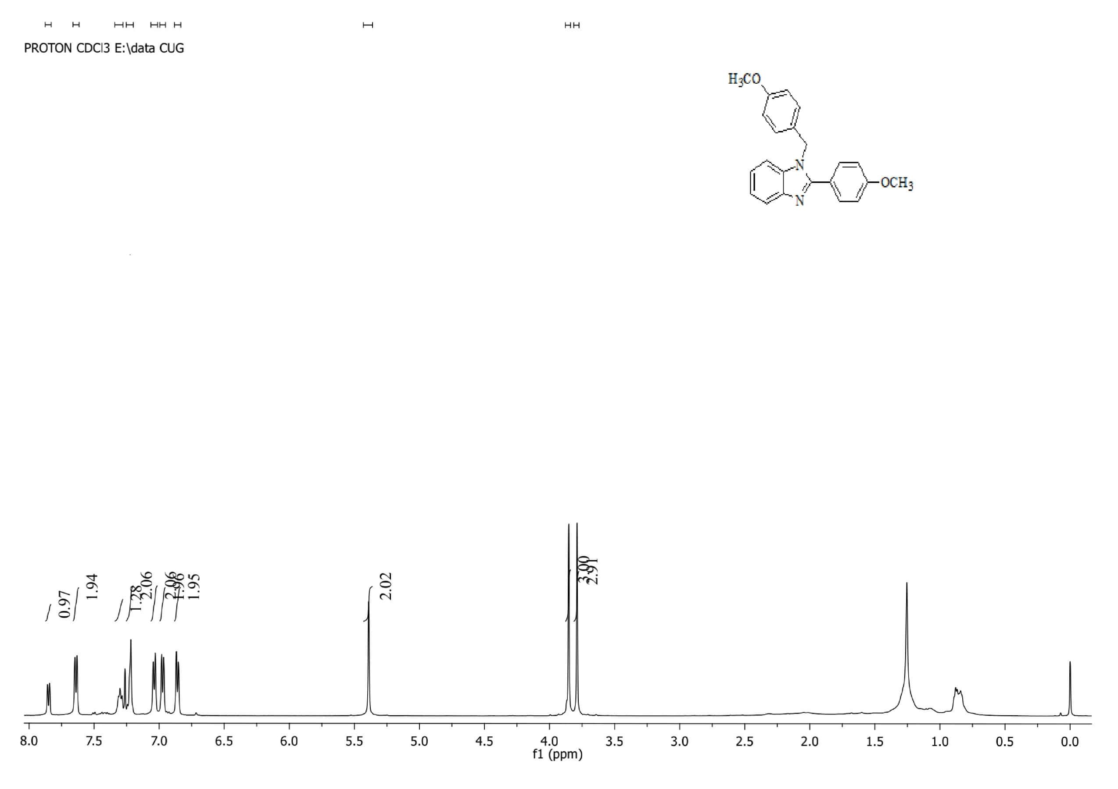

* 1. 1H NMR spectra of 3g (500 MHz, DMSO-d6)

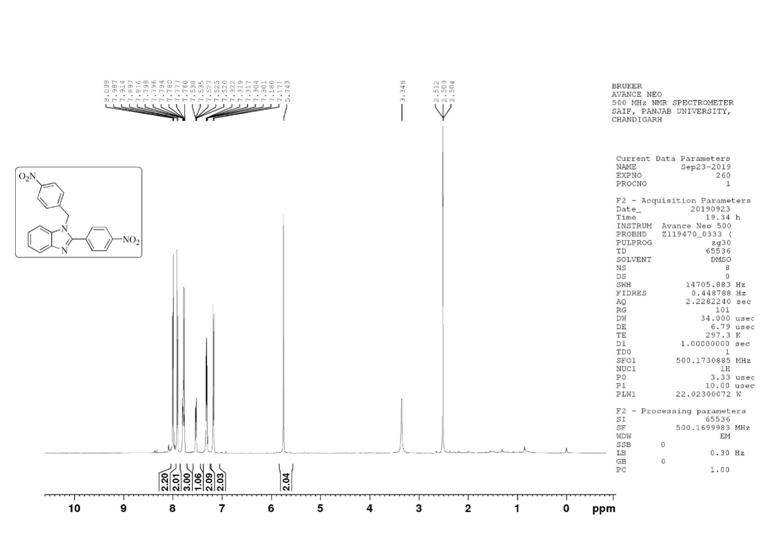

* 1. 1H NMR spectra of 3h(500 MHz, DMSO-d6)

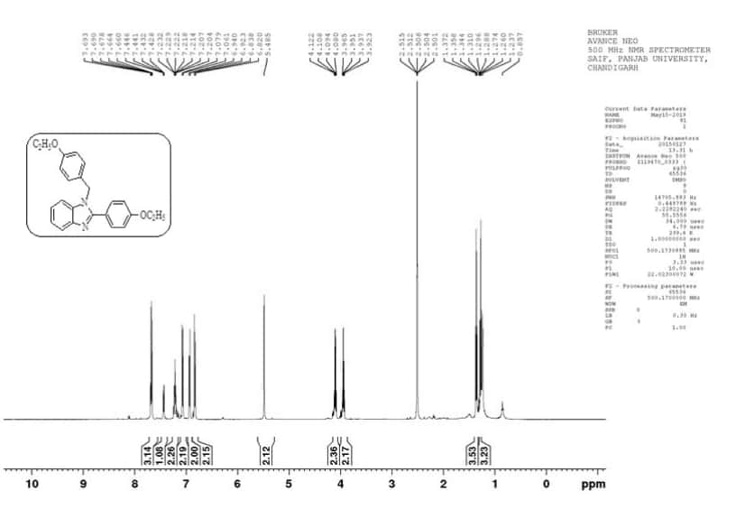

* 1. 1H NMR spectra of 3i(500 MHz, DMSO-d6)

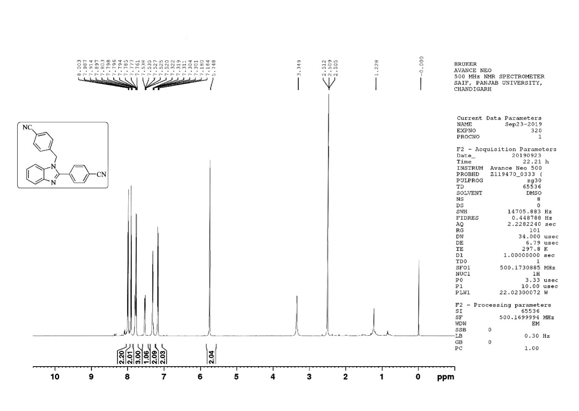

* 1. 1H NMR spectra of 3j(500 MHz, DMSO-d6)

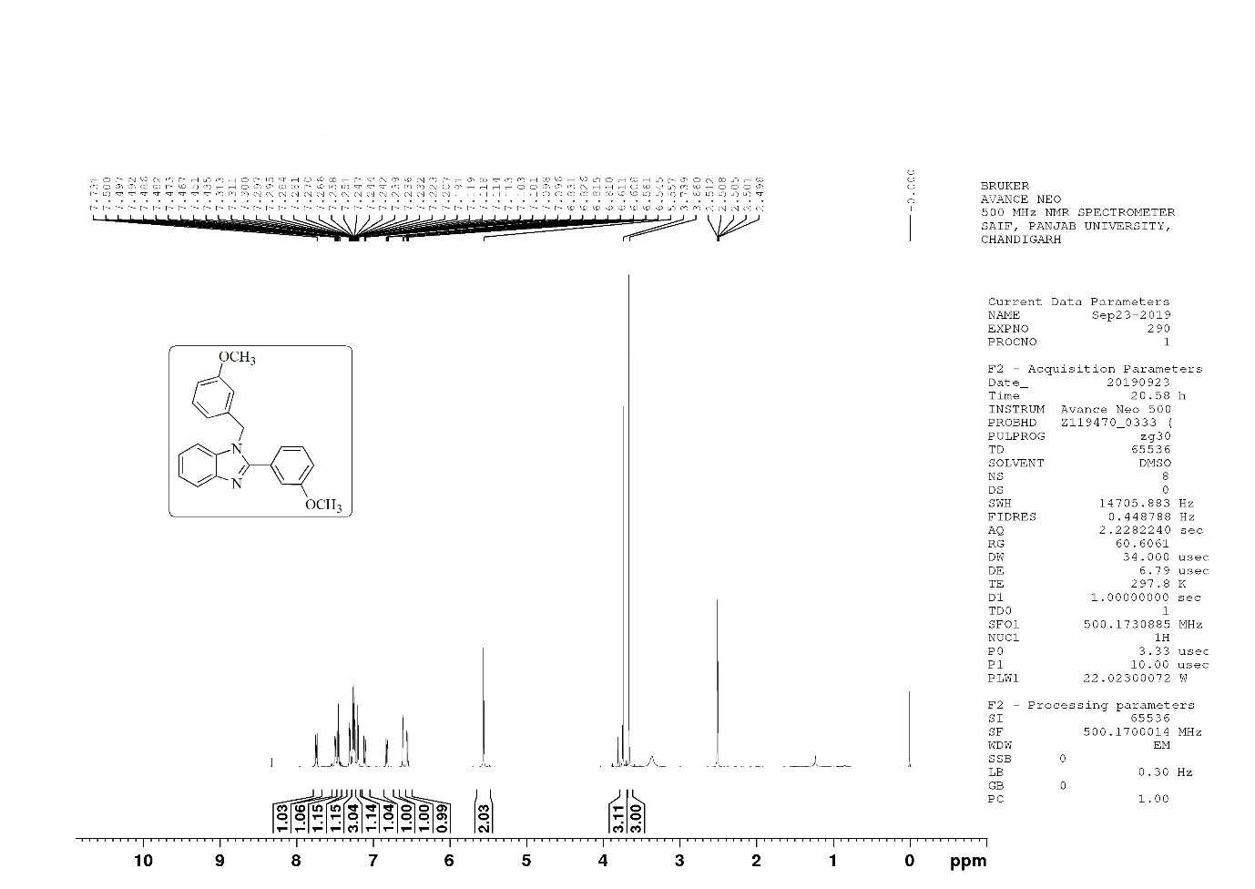

* 1. 1H NMR spectra of 3k (500 MHz, DMSO-d6)

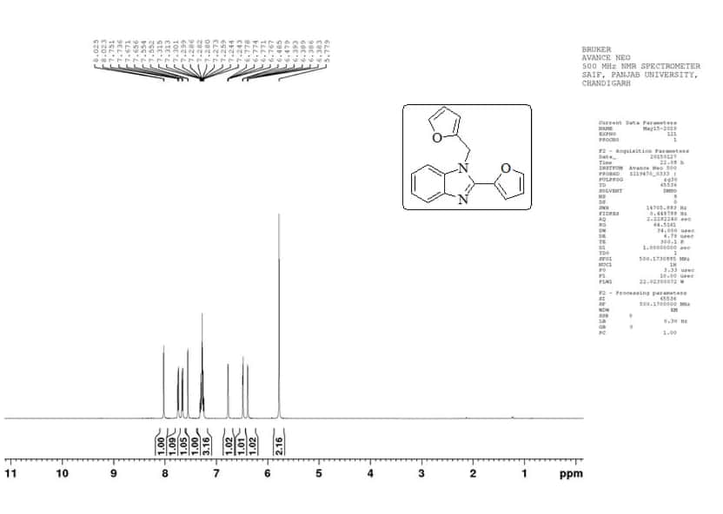

* 1. 1H NMR spectra of 3l(500 MHz, CDCl3)

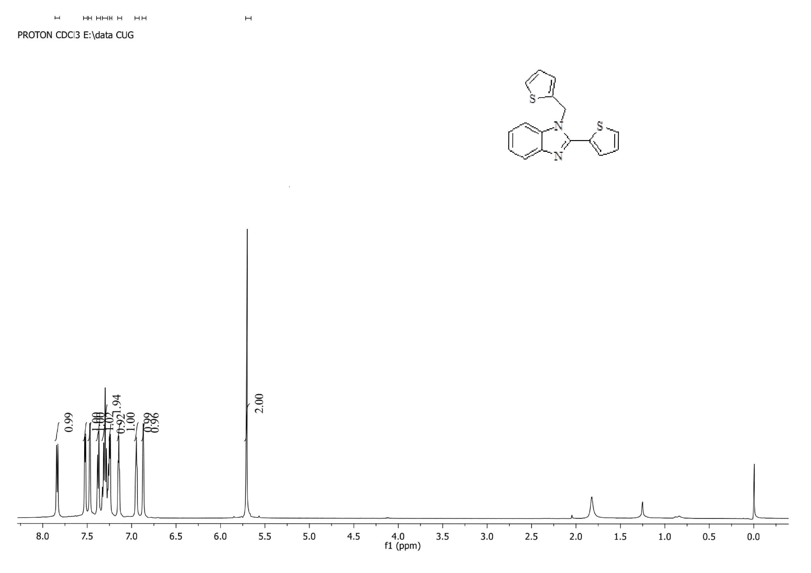

1. In-silico Docking study
   1. 1T5C Protein

After docking, it was observed that out of 12 selected hits, apart from molecule 3i hits were able to be docked within the selected binding pocket. It is obvious from the docking outcome that Molecule **3k** showed the highest docking score (-25.0285), followed by Molecule **3b, 3l, 3g, 3a, 3j, 3e, 3d, 3f, 3c** and **3h**. From the 2D interaction plots (**Table S1**), it was observed that the 11 hits bind well within the active site of the protein. There were number of interactions reported with can be observed in the 2D interaction plot a shown in the Table S1.

**Table S1.** 3D and 2D representation of the docked complexes within 1T5C protein.

|  |  |  |
| --- | --- | --- |
| Molecule 3k | C:\Users\CCLAB\Desktop\Nusrat\second\three\new_1t5c\1_11.tif |  |
| Molecule 3b | C:\Users\CCLAB\Desktop\Nusrat\second\three\new_1t5c\2_10.tif |  |
| Molecule 3l | C:\Users\CCLAB\Desktop\Nusrat\second\three\new_1t5c\2_10.tif |  |
| Molecule 3g | C:\Users\CCLAB\Desktop\Nusrat\second\three\new_1t5c\3_8.tif |  |
| Molecule 3a | C:\Users\CCLAB\Desktop\Nusrat\second\three\new_1t5c\4_6.tif |  |
| Molecule 3j | C:\Users\CCLAB\Desktop\Nusrat\second\three\new_1t5c\5_2.tif |  |
| Molecule 3e | C:\Users\CCLAB\Desktop\Nusrat\second\three\new_1t5c\7_7.tif |  |
| Molecule 3d | C:\Users\CCLAB\Desktop\Nusrat\second\three\new_1t5c\8_1.tif |  |
| Molecule 3f | C:\Users\CCLAB\Desktop\Nusrat\second\three\new_1t5c\9_5.tif |  |
| Molecule 3c | C:\Users\CCLAB\Desktop\Nusrat\second\three\new_1t5c\10_4.tif |  |
| Molecule 3h | C:\Users\CCLAB\Desktop\Nusrat\second\three\new_1t5c\11_3.tif |  |

6.2 2XCS Protein

After docking, it was observed that all hits were docked within the selected binding pocket. It is obvious from the results, that in case of docking with 2XCS, Molecule **3b**, showed the highest docking score (-26.7009), followed by Molecule **3g, 3i, 3k, 3j, 3l, 3e, 3c, 3d, 3f, 3a** and **3h**. From the 2D interaction plots (**Table S2**), it was observed that the 12 hits bind well within the active site of the protein. There were number of interactions reported with can be observed in the 2D interaction plot shown in the **table S2**.

**Table S2.** 3D and 2D representation of the docked complexes within 2XCS protein.

|  |  |  |
| --- | --- | --- |
| Molecule 3b | C:\Users\CCLAB\Desktop\Nusrat\second\three\new_2xcs\1_10.tif |  |
| Molecule 3g | C:\Users\CCLAB\Desktop\Nusrat\second\three\new_2xcs\1_10.tif |  |
| Molecule 3i | C:\Users\CCLAB\Desktop\Nusrat\second\three\new_2xcs\2_7.tif |  |
| Molecule 3k | C:\Users\CCLAB\Desktop\Nusrat\second\three\new_2xcs\3_11.tif |  |
| Molecule 3j | C:\Users\CCLAB\Desktop\Nusrat\second\three\new_2xcs\4_9.tif |  |
| Molecule 3l | C:\Users\CCLAB\Desktop\Nusrat\second\three\new_2xcs\6_8.tif |  |
| Molecule 3e | C:\Users\CCLAB\Desktop\Nusrat\second\three\new_2xcs\5_6.tif |  |
| Molecule 3c | C:\Users\CCLAB\Desktop\Nusrat\second\three\new_2xcs\7_4.tif |  |
| Molecule 3d | C:\Users\CCLAB\Desktop\Nusrat\second\three\new_2xcs\8_2.tif |  |
| Molecule 3f | C:\Users\CCLAB\Desktop\Nusrat\second\three\new_2xcs\9_12.tif |  |
| Molecule 3a | C:\Users\CCLAB\Desktop\Nusrat\second\three\new_2xcs\11_3.tif |  |
| Molecule 3h | C:\Users\CCLAB\Desktop\Nusrat\second\three\new_2xcs\12_1.tif |  |

From the outcome of the docking studies, it can be concluded that in case of 1T5C, molecule **3i** did not fit well in the binding domain of the 1T5C protein. Moreover, among the docked 11 candidates, all can be considered as the potential hits based on the docking score and presence of the important interaction pattern. Where as in case of 2XCS, top nine can be considered as the potential hits based on docking score and interaction patters. Additionally, in this case all the hits were reported to form interaction with the DNA, which is considered crucial for the molecule to be potential against the selected drug target.

1. Reference
2. A. Lapkin, and D.J.C. Constable “*Green Chemistry Metrics. Measuring and Monitoring Sustainable Processes*,” Wiley (2008)
3. Koen Van Aken, Lucjan Strekowski and Luc Patiny, “EcoScale, a semi-quantitative tool to select an organic preparation based on economical and ecological parameters,” *Beilstein J. Org. Chem.* 2 (2006): 2-8.