Supplementary Materials

Vanadium complexes with salicylaldehyde based Schiff base ligands – Structure, properties and biological activity

JANUSZ SZKLARZEWICZ*, ANNA JUROWSKA, MACIEJ HODOROWICZ, RYSZARD GRYBOŚ, KRZYSZTOF KRUCZAŁA, MONIKA GŁUCH-LUTWIN and GRZEGORZ KAZEK

The reflectance spectra of complexes 1-3 and 6-8 are presented in Figures S1-S6. The UV-Vis absorbance spectra of complexes 1, 2 and 8 in organic solvents are presented in Figures S7-S20.
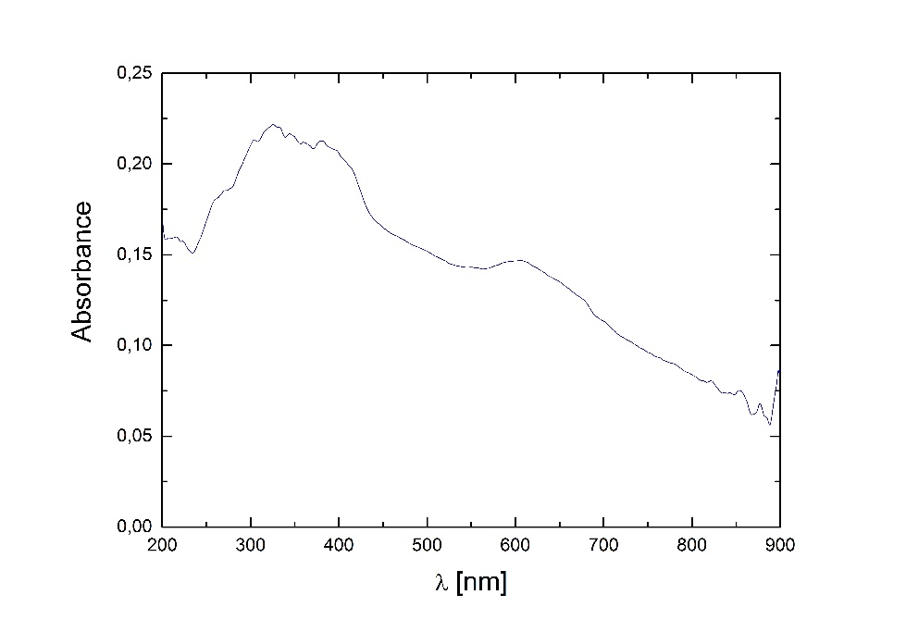
Figure S1. Reflectance spectrum of 1. BaSO₄ as reference.
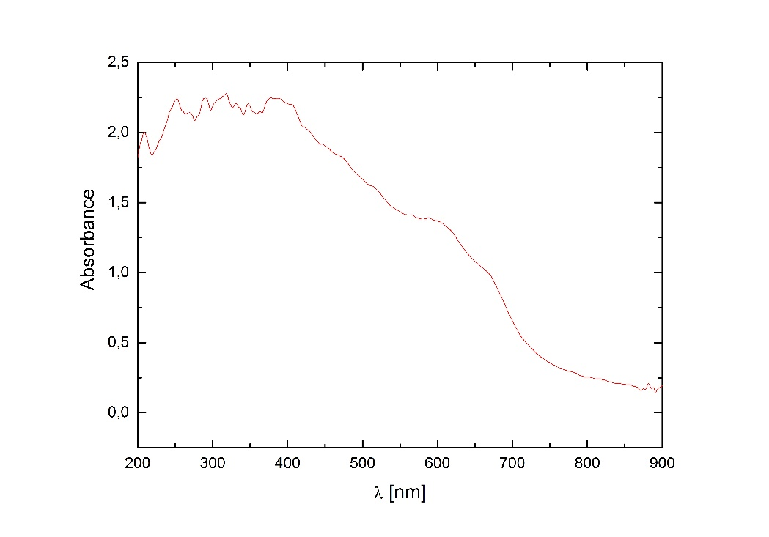
Figure S2. Reflectance spectrum of 2. BaSO₄ as reference.

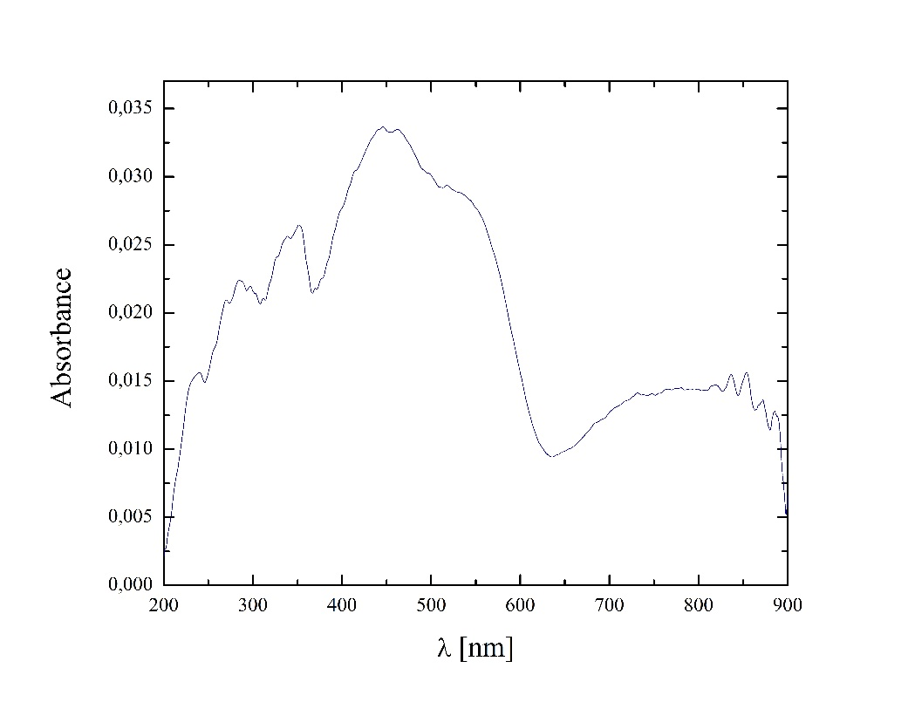
Figure S3. Reflectance spectrum of 3. BaSO₄ as reference.

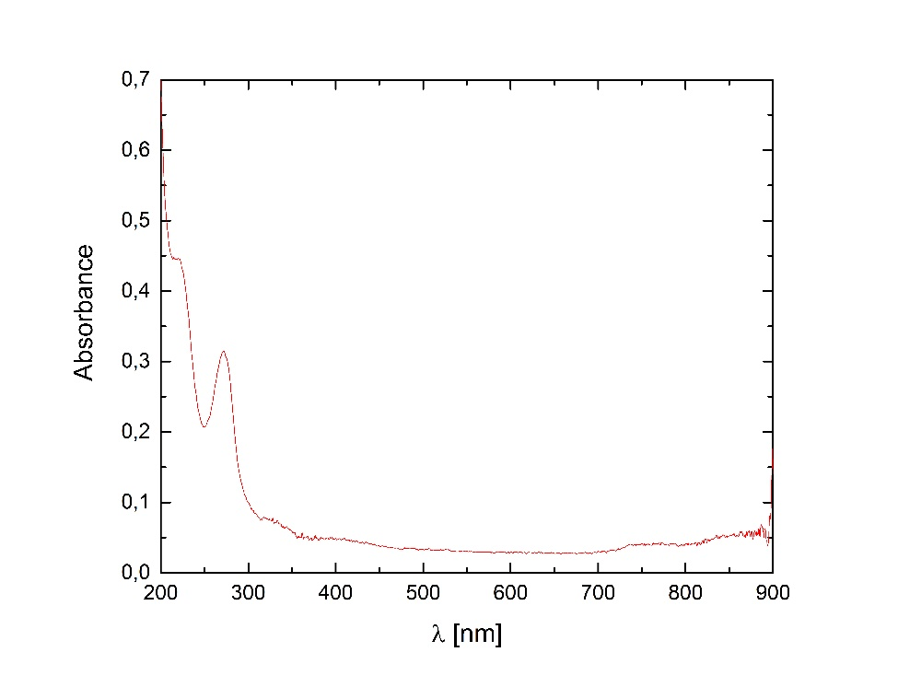
Figure S4. Reflectance spectrum of 6. BaSO₄ as reference.

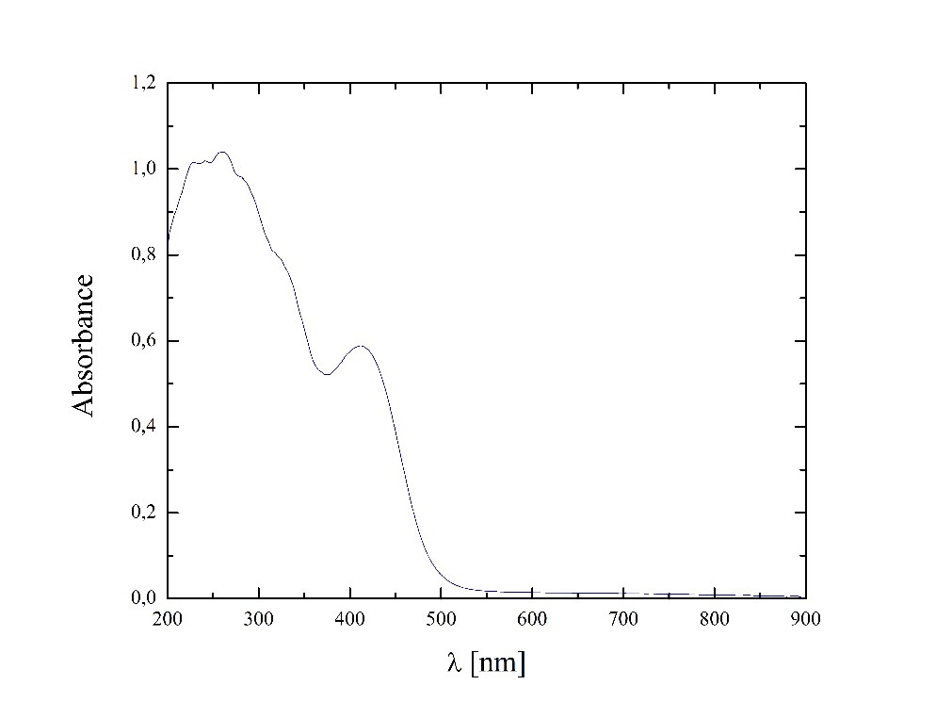
Figure S5. Reflectance spectrum of 7. BaSO₄ as reference.

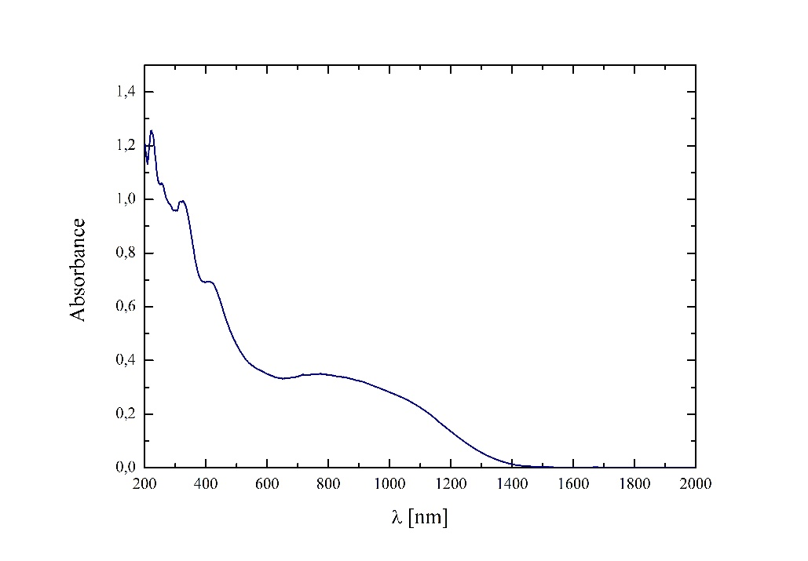
Figure S6. Reflectance spectrum of 8. BaSO₄ as reference.

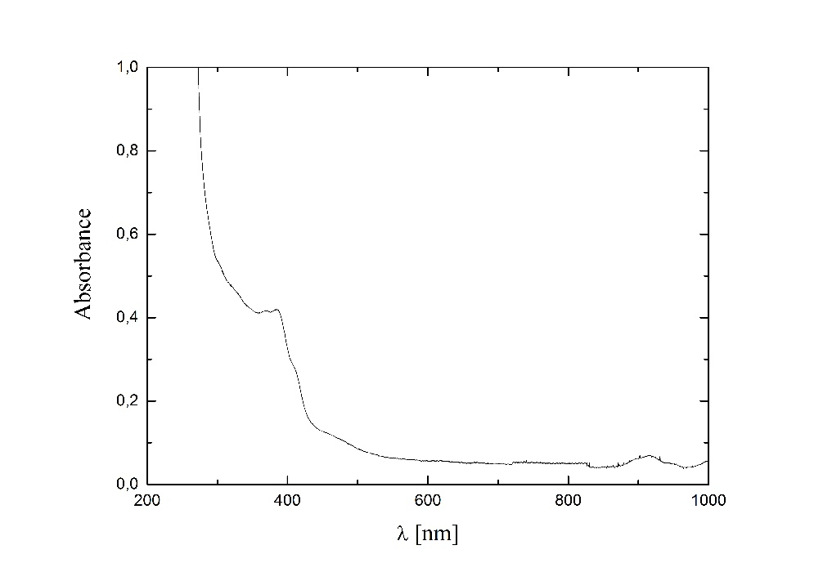
Figure S7. UV-Vis spectrum of 1 in DMF, d = 1 cm.

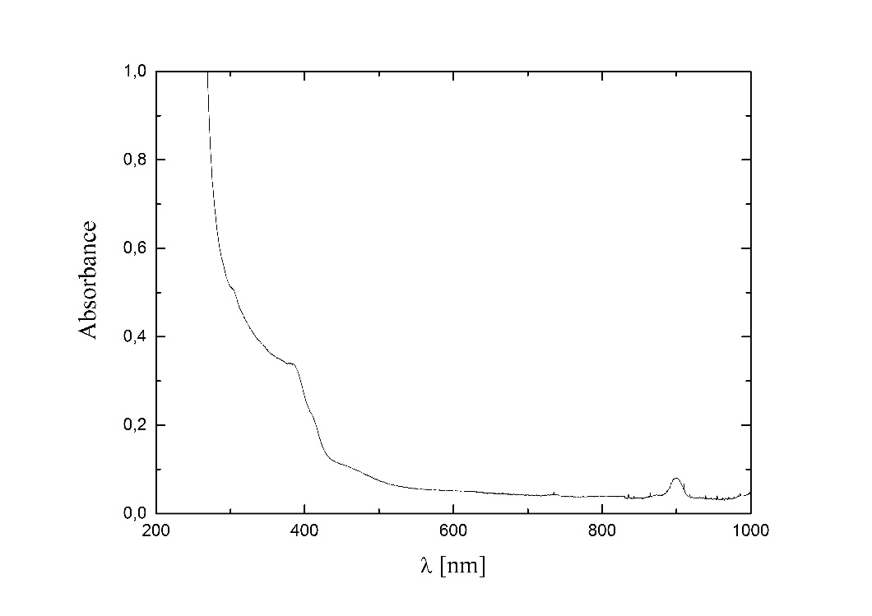
Figure S8. UV-Vis spectrum of 1 in DMSO, d = 1 cm.

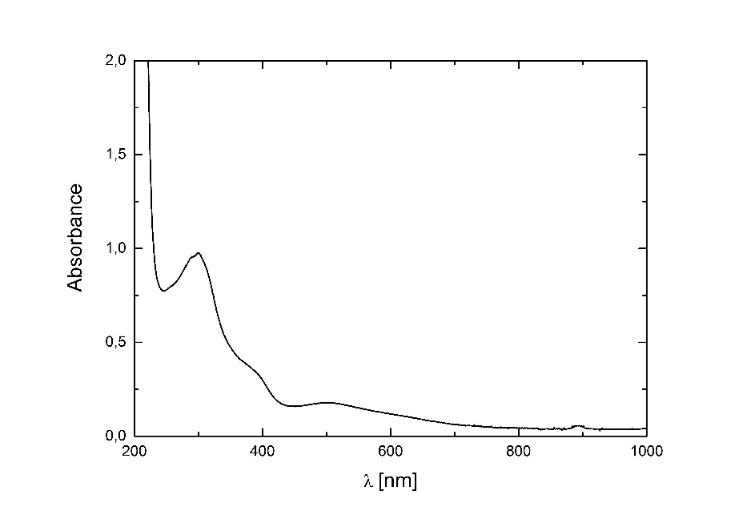
Figure S9. UV-Vis spectrum of 1 in EtCl₂, d = 1 cm.

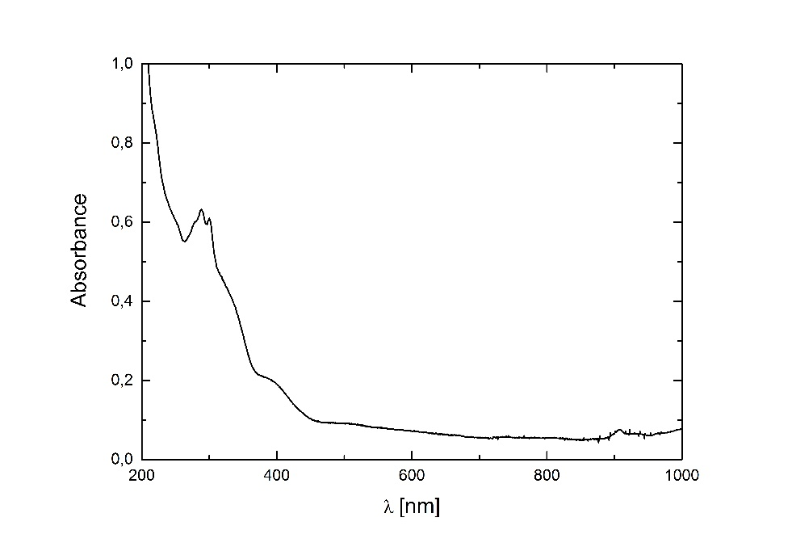
Figure S10. UV-Vis spectrum of 1 in EtOH, d = 1 cm.

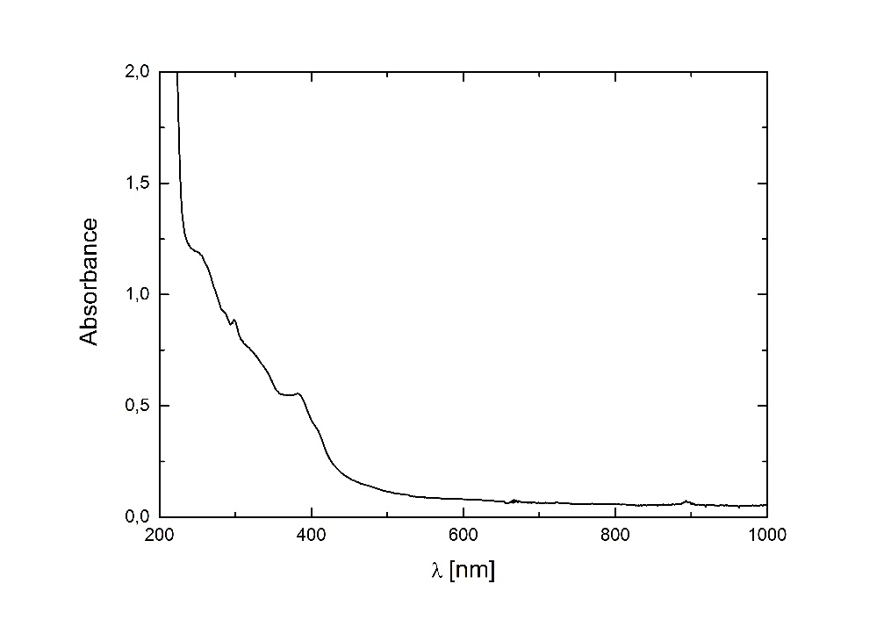
Figure S11. UV-Vis spectrum of 1 in MeCN, d = 1 cm.

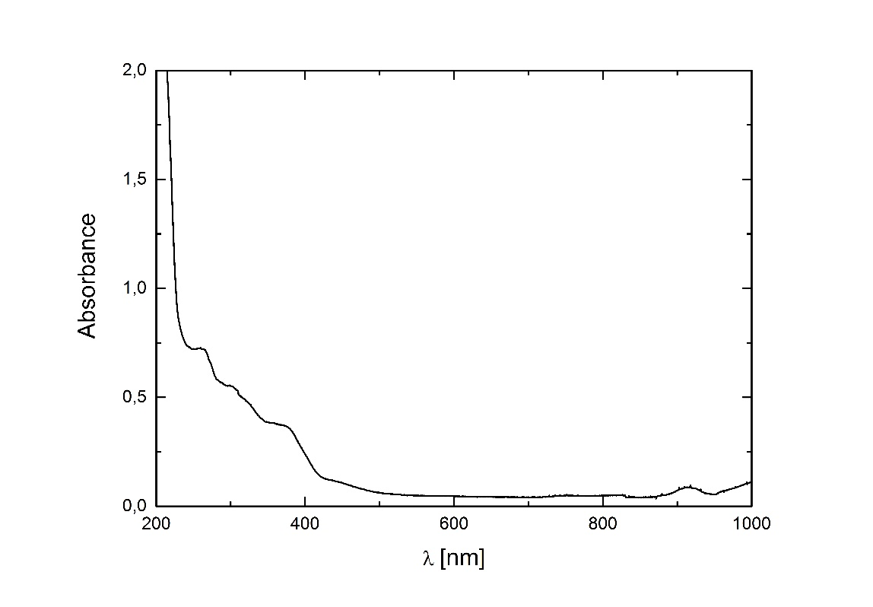
Figure S12. UV-Vis spectrum of 1 in MeOH, d = 1 cm.

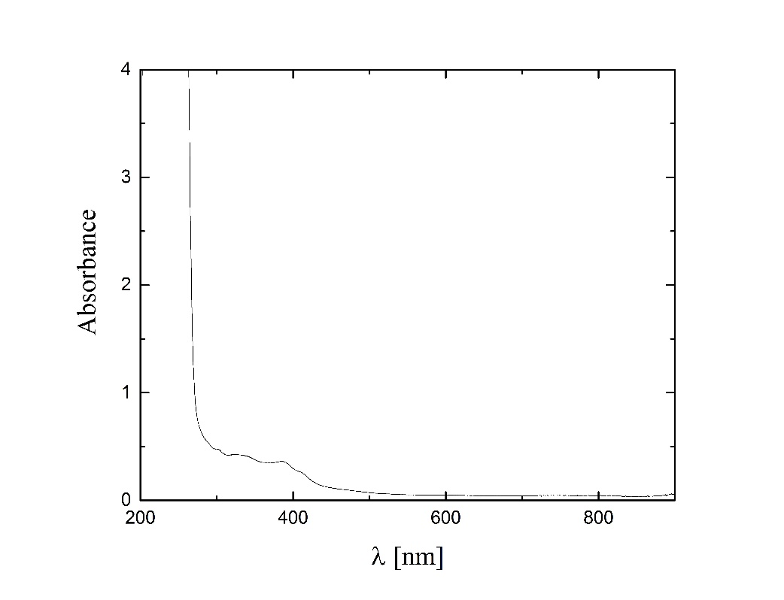
Figure S13. UV-Vis spectrum of 2 in DMF, d = 1 cm.

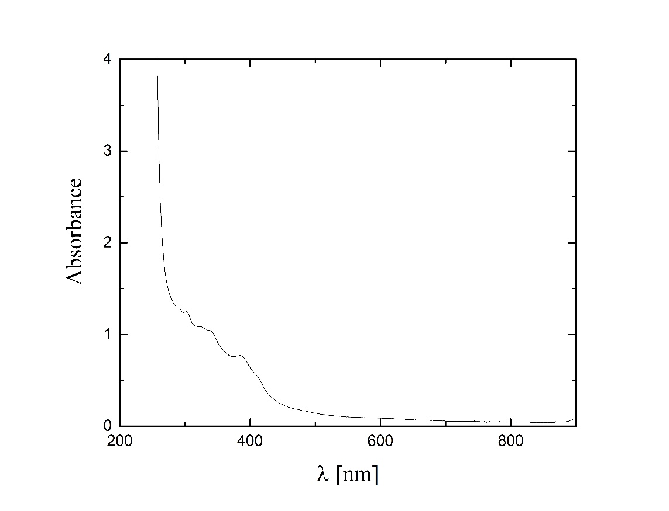
Figure S14. UV-Vis spectrum of 2 in DMSO, d = 1 cm.

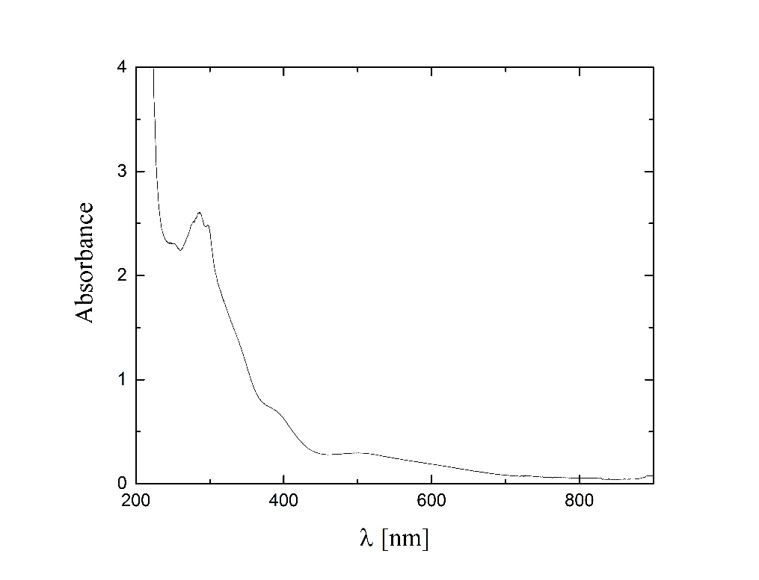
Figure S15. UV-Vis spectrum of 2 in EtCl₂, d = 1 cm.

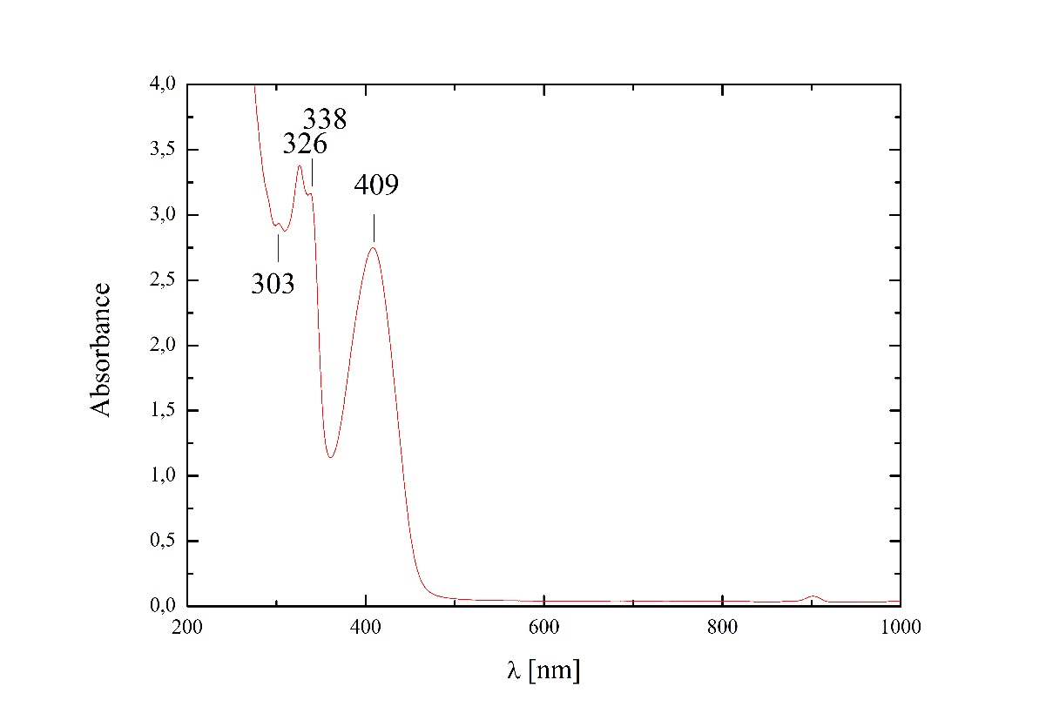
Figure S16. UV-Vis spectrum of 8 in DMSO, d = 1 cm.

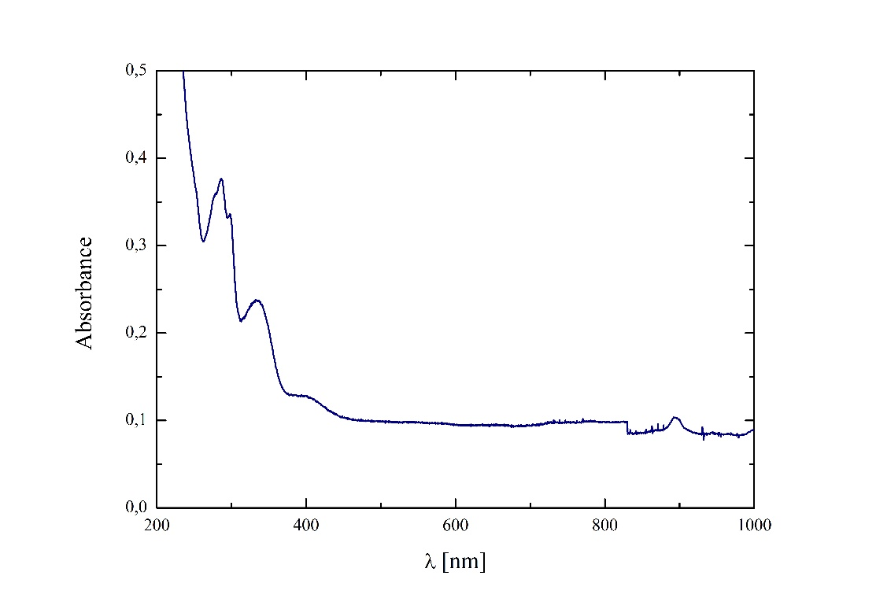
Figure S17. UV-Vis spectrum of 8 in EtCl₂, d = 1 cm.

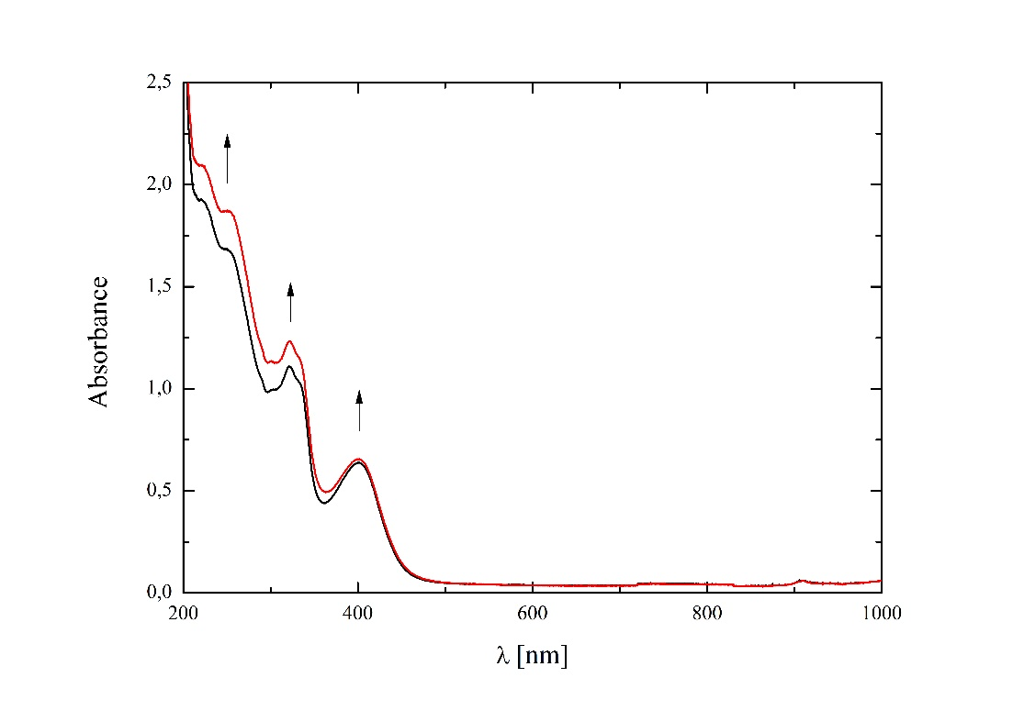
Figure S18. UV-Vis spectrum of 8 in EtOH, d = 1 cm, arrows indicate spectral changes after 20 minutes.

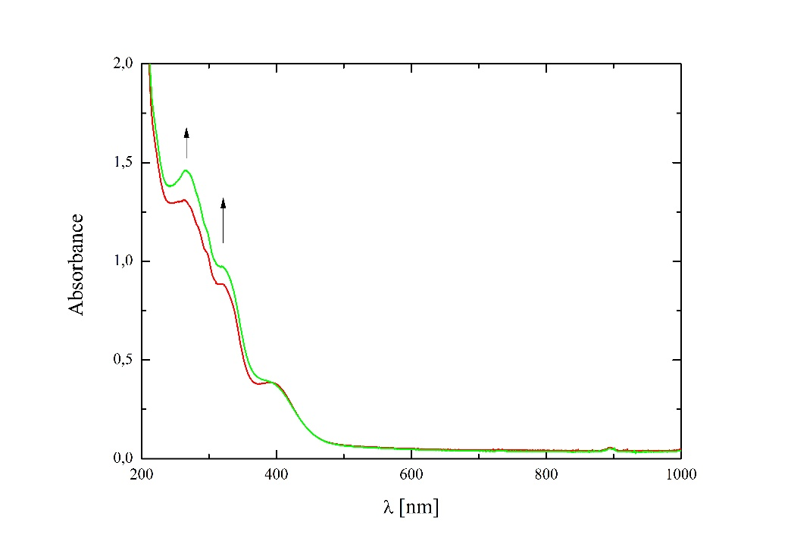
Figure S19. UV-Vis spectrum of 8 in MeCN, d = 1 cm, arrows indicate spectral changes after 20 minutes.

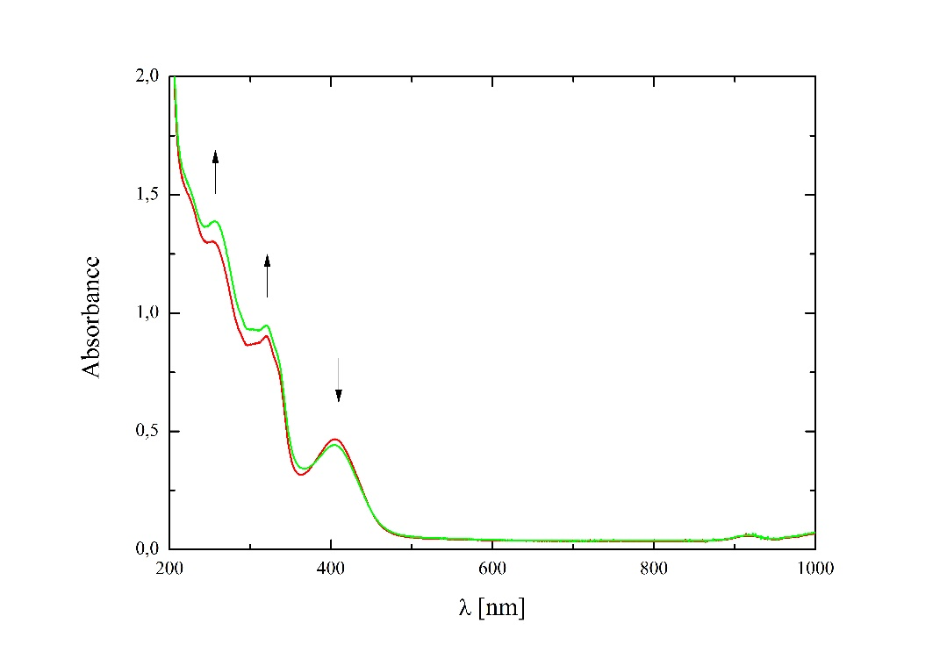
Figure S20. UV-Vis spectrum of 8 in MeOH, d = 1 cm, arrows indicate spectral changes after 20 minutes.

Figure S21. The IR spectrum of ligand L₁. ATR spectrum after ATR correction. IR spectrum was recorded on a Nicolet iS5 FT-IR spectrophotometer.

Figure S22. The IR spectrum of ligand L₂. ATR spectrum after ATR correction. IR spectrum was recorded on a Nicolet iS5 FT-IR spectrophotometer.

