Supplemental Material

Table S1. Background information for students whose think-aloud interviews were selected for further analysis (n = 7).
Interview Number | 1 | 2 | 3 | 4 | 5 | 6 | 7
Number of Semesters Completed | 1 | 4 | 9 | <1 | 15 | 12 | 6
Grade Point Average | 3.00-3.67 | 4.00-4.33 | 2.33-2.67 | 4.00-4.33 | 2.37-3.00 | 3.00-3.33 | 2.67-3.00
English Proficiency (out of 5)¹ | 5 | 5 | 4 | 4 | 5 | 3 | 4
Number of Primary Literature Articles Read² | 7 | 50 | 3 | 15 | >40 | 20 | 10
- 1=low English proficiency; 5=high English proficiency.
- Self-reported.

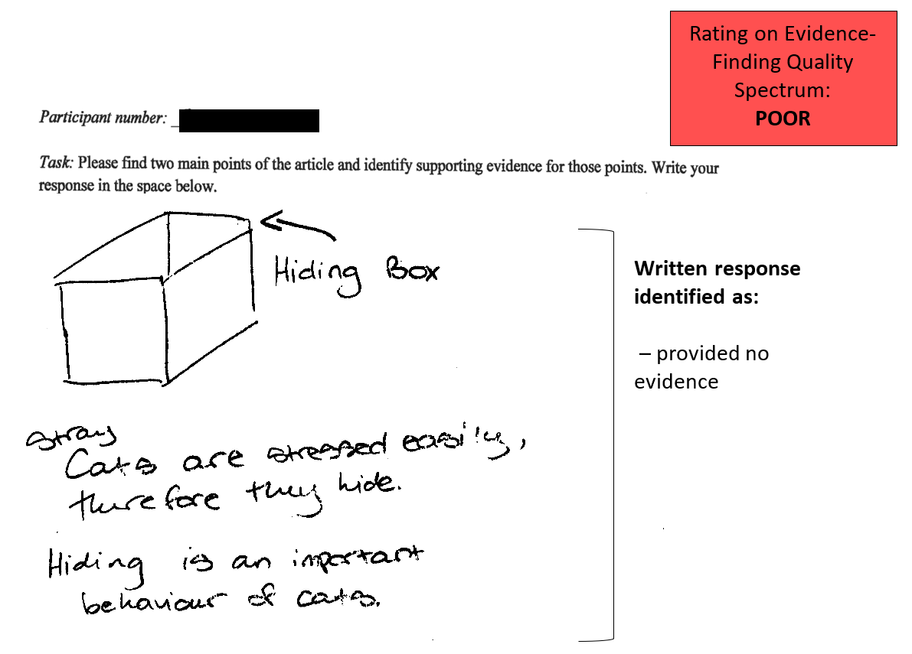

Figure S1A. Exemplar student artefact coded as demonstrative of a ‘poor’ evidence-finding approach.
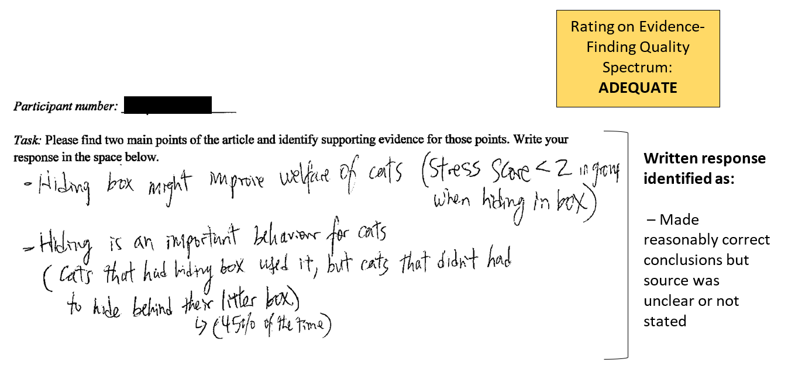
Figure S1B. Exemplar student artefact coded as demonstrative of an ‘adequate’ evidence-finding approach.
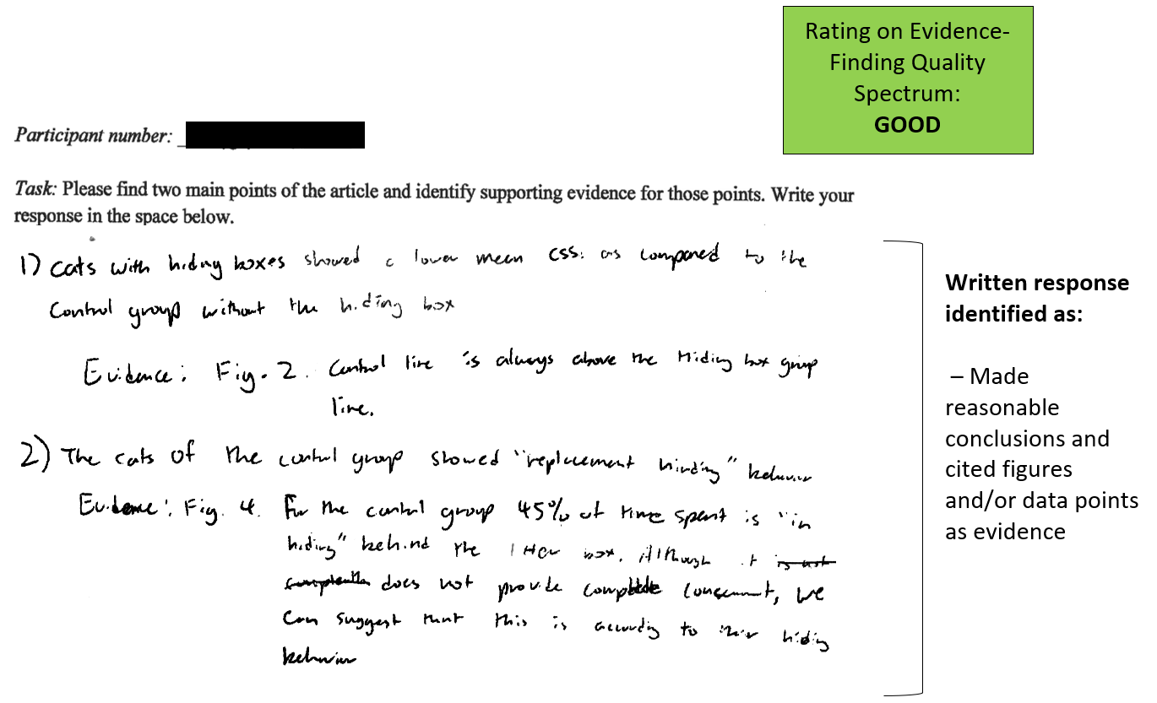

Figure S1C. Exemplar student artefact coded as demonstrative of a ‘good’ evidence-finding approach.
Appendix A: Self-report survey items

- What is your student number?
- Which SFU degree program/faculty are you currently enrolled in?
- If you answered “other” in the previous question about degree program/faculty, please enter your degree program below.
- How many semesters have you been enrolled at SFU full time?
- What is your approximate cumulative GPA currently?
- How would you rate your level of English language proficiency?
- Approximately how many primary literature articles (i.e. peer-reviewed articles that directly report data from research studies) have you previously read the majority of? Please enter a number in the space below.
- In which format did you primarily read the assigned paper? Select the option that applies:
  - Electronic (ex: PDF or web version on a computer or tablet)
  - Paper copy (ex: printed hard copy of the article)
  - Other
- If you selected “other” in the previous question, please explain how you viewed this article. If you did not select “other”, please skip this question.
- Did you annotate the article as you read it? (Ex: highlight, underline, write notes, etc.) Select all that apply:
  - Highlight
  - Underline
  - Make notes
  - Make diagrams
  - None
  - Other
- Describe your annotating practices (ex: highlighting, writing notes, etc.). Why do you annotate articles?
- Approximately how many minutes did you spend reading the paper (not including breaks)?
- Select the response that best represents your attitude towards each statement.
Options: 1 = strongly disagree; 2 = disagree; 3 = neutral; 4 = agree; 5 = strongly agree.
  - I am confident that I can understand the results of this paper.
  - I found this article difficult to read.
  - I have the background knowledge to understand this article in depth.
  - I had enough knowledge of the article’s topic to understand the article.
  - I am confident in my ability to read scientific articles.
  - I enjoyed reading this article.
  - I was able to interpret figures in this article.
  - When I was finished reading the article, I felt I understood all the concepts that were presented.
  - I have the technical skills to understand the results of this article.
  - I have the statistical skills to understand the results of this article.
  - I am confident in identifying limitations in the results of this article based on the research methods that were used.
  - I feel confident interpreting the results of this article from analyzing the scientific data that was presented.
  - I found this paper easy to understand.
- How important was each section below in helping you to understand the paper?
Rank each section on a scale of 1-5, with 1 = very important, 2 = important, 3 = neutral, 4 = not very important, and 5 = not at all important.
  - Abstract
  - Introduction
  - Methods
  - Results
  - Discussion
  - Conclusion
- Which of the following sections do you think is most important for helping you understand the article?
  - Introduction
  - Methods
  - Results
  - Discussion
  - Conclusion
- Why do you think the section you chose in the previous question is the most important for your understanding of the article?
- Which of the following sections do you think is the least important for helping you understand the article?
  - Introduction
  - Methods
  - Results
  - Discussion
  - Conclusion
- Why do you think the section you chose in the previous question is the least important for your understanding of the article?
- On your first reading of the article, in what order did you read the sections below? (Select a number between 1-8 in the space provided next to each section, 1 = section you started reading first, 8 = section you read last; use each number only once.)
  - Title
  - Abstract
  - Introduction
  - Methods
  - Results
  - Discussion
  - Conclusion
  - References
- Why did you read the article in this order?
- Which statement best reflects your approach to reading this article?
  - I read the article from start to finish in sequence.
  - I re-read portions of the article after finishing.
  - I re-read portions of the article while reading the article.
- How much cross-referencing did you conduct between sections? (This refers to switching back and forth between sections, comparing information between sections, re-reading sections to improve your understanding, etc.)
- Between which sections did you spend the most time cross-referencing?
- Which of the following sections did you spend the most time on?
  - Introduction
  - Methods
  - Results
  - Discussion
  - Conclusion
- Why did you spend the most time on this section?
- Which of the following sections did you spend the least amount of time on?
  - Introduction
  - Methods
  - Results
  - Discussion
  - Conclusion
- Why did you spend the least amount of time on this section?
- Select the response that best represents your attitude towards each statement.
  - Figures in the article just repeat information already provided in the text.
  - Figures add new information that was not provided in the text.
  - Figures were important for helping me understand the article.
- How did you respond to new or difficult information presented in the article? (Ex: just kept reading the article, looked up terms you did not understand, asked someone for help, etc.)
- How could you have approached this new or difficult in formation differently to improve your understanding of the article further? Why didn’t you use that approach?

Appendix B: Think-aloud reading interview guide and preamble

Preamble for one-on-one interviews
- “Thank you for participating in our study. This interview will take between 75 and 90 minutes and will be audio recorded. Before we begin, I need to explain a few things. We are interested in the processes students use to read journal articles and complete tasks based on their reading. We are not interested in whether or not you can read or complete the task correctly, but simply in how you do it; as far as we are concerned, there is not one correct way to do these things. Because we are interested in understanding the thought process that goes into reading a journal article, we are asking you to read an article and “think out-loud” for us. Basically, we want you to put your thoughts into words, whatever they may be at those moments. Because this may sound strange, I will demonstrate what we are looking for. Here is a paragraph of text [hands sample paragraph to participant]. I am going to read this paragraph, pausing at the tone to put my thoughts into words [interviewer does so]. Try to avoid thinking quietly during those periods that you are not reading. Because it is a little unnatural to think out-loud consistently, we expect you to fall silent from time to time; when you do, either continue thinking out-loud or reading right away. If you are silent for 30 seconds, we may prompt you with questions such as “what are you thinking?”. Other than this, please feel free to read this article as you would any other journal article, in any order you like and as completely as needed to prepare for the task afterward. Do you have any questions or concerns before you begin?”

- “Before you read the article, please read this paragraph [hands warm-up paragraph to participant] and attempt to think aloud when you hear the tone. This is simply to help you practice a bit with the method before the actual reading task.”

- Feedback will be given only on the participant’s following of instructions; at no point will the interviewer offer feedback on specific thoughts, i.e. word-choice, filler words, etc.

Semi-structured interview questions
- How do you feel about the reading and task you just finished? How does this experience compare with how you typically read journal articles?
- Please describe for us the approach or strategy you used for reading this article.
- Think of a moment while reading this article where you encountered new and difficult information. What was that moment? How did you respond to that information? What other strategies could you use to improve your understanding of the article? Why didn’t you use that/those approach(es) in the moment you chose for us?
- Which section of the article was most important for your understanding: Introduction, Methods, Results, Discussion, or Conclusion? Why? What aspect of that section made it the most important for you?
- Which section of the article was least for your understanding: Introduction, Methods, Results, Discussion, or Conclusion? Why?
- Are there parts of the article that you avoided? Why did you avoid those parts?
- How did you use the figures in the article?
- Did you consider the study design of the article?
- Now think about the task you completed. Describe the evidence that you used to support your answer to the question. Why did you choose this as evidence?
- While you were reading the article, I noticed that you (highlighted, underlined/circled, made notes, and/or another strategy observed by the interviewer, or did not annotate the article at all)? Why did/didn’t you annotate the article (in those ways)? Do you often annotate the journal articles you read? Do you use the same strategies you used here? Why or why not?
- Do you normally read papers in electronic form or in paper form? Why do you choose that format?

Appendix C: Qualitative coding hierarchy and codebook

Coding protocol (a priori coding): Based on an initial read-through of interview transcripts and informed by the deep vs. surface model of learning (Biggs & Tang, 2011; Marton & Säljö, 1976a, 1976b; Ramsden, 2003), a codebook containing code labels, definitions, and exemplar quotes was developed to guide a priori, systematic coding of all 7 interview transcripts. We used NVivo 12, a qualitative data analysis software, to code the transcripts. NVivo 12 facilitated focused, a priori coding in that it recorded user actions; stored labels and definitions for our hierarchical coding structure; and enabled us to keep memos and annotations throughout the process, thus ensuring depth and consistency of analysis, while also providing an audit trail of coding decisions.

Coding hierarchy
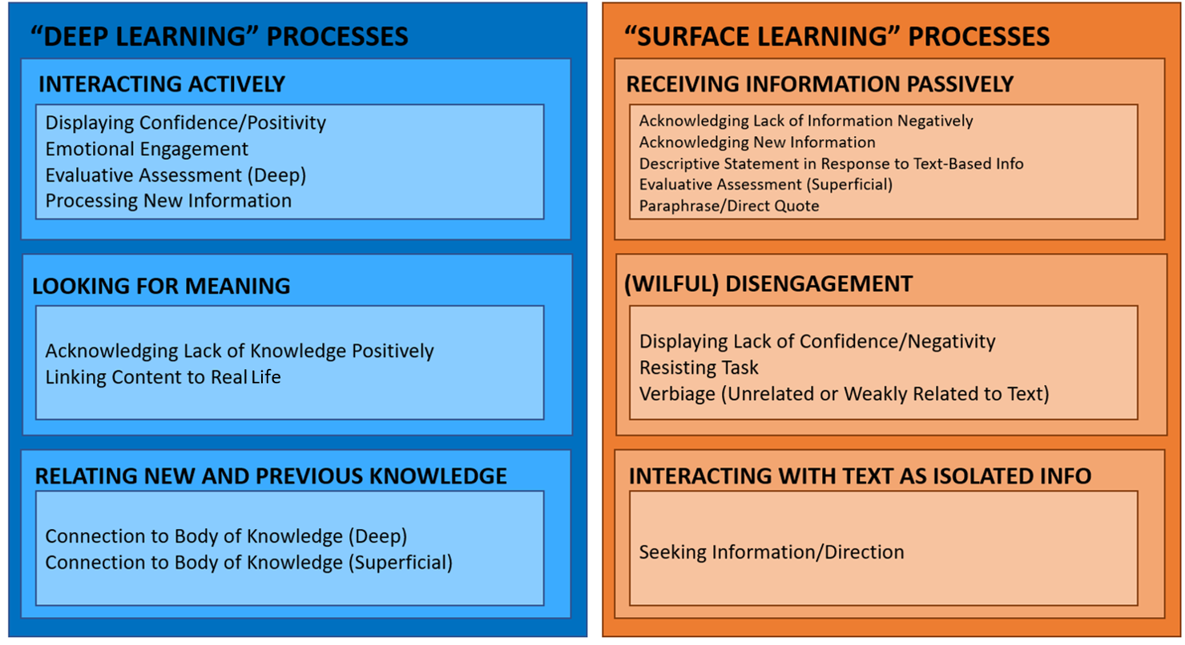

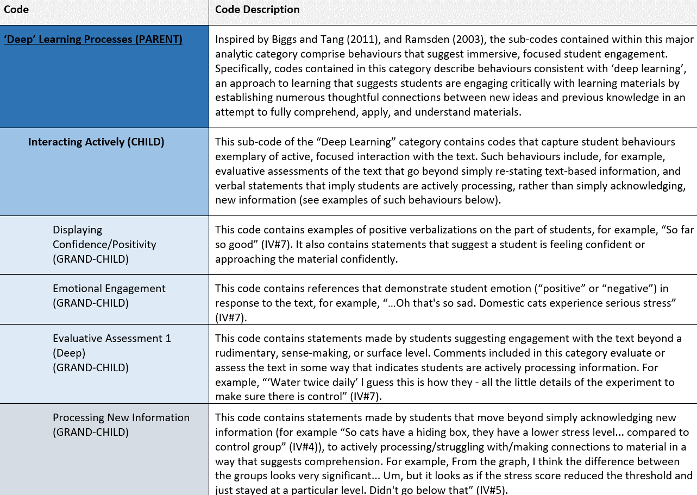
Codebook
