Synthesis, X-ray analysis and computational studies of two novel thiophene derivatives
Abdullatif Bin Muhsinahª, Abdulrhman Asayariª, H. Algarni^{b,c} Saied M. Soliman,^{d,e} Nabila A. Kheder^{f}, Hazem A. Ghabbour^{g}, Yahya I Asiri^{h} , Kumar Venkatesan^{i} and Yahia N. Mabkhot^{i,*}
ªDepartment of Pharmacognosy, College of Pharmacy, King Khalid University, Abha, Saudi Arabia.
^{b}Department of Physics, Faculty of Sciences, King Khalid University, P. O. Box 9004, Abha, Saudi Arabia.
^{c}Research Centre for Advanced Materials Science (RCAMS), King Khalid University, Abha, P. O. Box 9004, Saudi Arabia.
^{d}Department of Chemistry, Faculty of Science, Alexandria University, P.O. Box 426, Ibrahimia 21321, Alexandria, Egypt.
^{e}Department of Chemistry, Rabigh College of Science and Art, King Abdulaziz University, Saudi Arabia
^{f}Department of Chemistry, Faculty of Science, Cairo University, Giza 12613, Egypt.
^{g}Department of Medicinal Chemistry, Faculty of Pharmacy, University of Mansoura, Mansoura 35516, Egypt.
^{h}Department of Pharmacology, College of Pharmacy, King Khalid University, Abha. Saudi Arabia.
^{i}Department of Pharmaceutical Chemistry, College of Pharmacy, King Khalid University, Abha. Saudi Arabia.

Compound 8 | Compound 7

Fig. S1. Optimized structures of compounds 7 and 8.

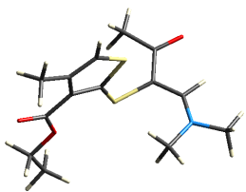 | 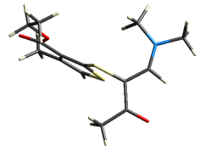 | 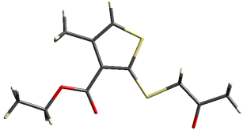 | 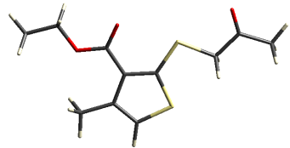
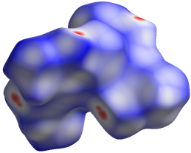 | 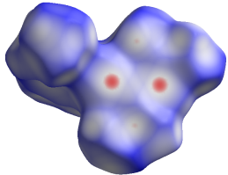 | 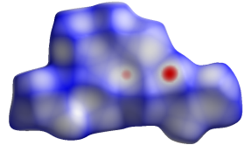 | 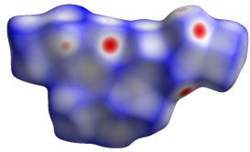 | A
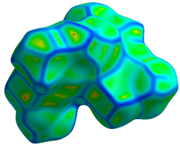 | 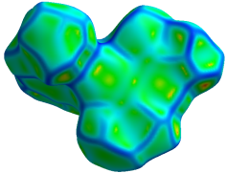 | 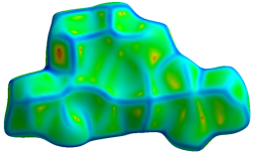 | 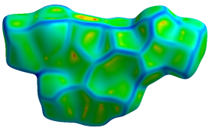 | B
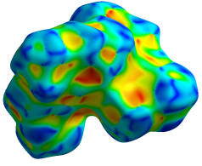 | 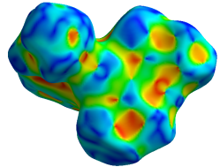 | 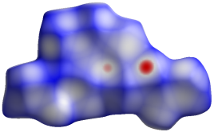 | 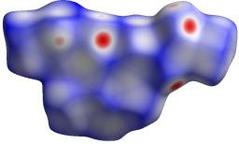 | C
 | 7 |  | 8

Fig. S2. Hirshfeld surfaces of compounds 7 and 8 mapped over A) d_{norm}, B) curvedness and C) shape index.

Table S1. The crystal and experimental data of compounds 7 and 8
Crystal data | 7 | 8
Chemical formula | C₁₁H₁₄O₃S₂ | C₁₄H₁₉NO₃S₂
Mr | 258.34 | 313.42
Crystal system, space group | Monoclinic, P2₁/c | Triclinic, P-1
Temperature (K) | 296 | 296
a, b, c (Å) | 5.6444 (2), 26.9651 (8), 8.0007 (2) | 8.5051 (4), 8.7406 (4), 11.4925 (5)
α, β, γ (°) | 90.0, 104.973 (1), 90.0 | 77.363 (1), 68.514 (1), 73.415 (2)
V (Å³) | 1176.38 (6) | 755.63 (6)
Z | 4 | 2
Radiation type | Mo Kα | Mo Kα
µ (mm⁻¹) | 0.44 | 0.36
Crystal size (mm) | 0.69 × 0.21 × 0.18 | 0.70 × 0.51 × 0.19
Data collection
Diffractometer | Bruker APEX-II D8 venture  diffractometer | Bruker APEX-II D8 venture  diffractometer
Absorption correction | Multi-scan  SADABS Bruker 2014 | Multi-scan  SADABS Bruker 2014
T_{min}, T_{max} | 0.751, 0.923 | 0.788, 0.936
No. of measured, independent and observed [I > 2σ(I)] reflections | 37967, 4491, 4016 | 11701, 2658, 2367
R_{int} | 0.030 | 0.071
Refinement
R[F²> 2σ( F²)], wR( F²), S | 0.028, 0.072, 1.04 | 0.080, 0.223, 1.15
No. of reflections | 4491 | 2658
No. of parameters | 148 | 176
H-atom treatment | H atoms treated by a mixture of independent and constrained refinement | H atoms treated by a mixture of independent and constrained refinement
Δρ_{max}, Δρ_{min} (e Å⁻³) | 0.45, −0.35 | 0.96, −1.33
CCDC number | 1551320 | 1555388

Table S2. Experimental and calculated geometric parameters (Å, º) of compounds 7 and 8.
Compound 8 | Calc | exp | Compound 7 | calc | exp
R(1-17) | 1.783 | 1.765 | R(1-6) | 1.740 | 1.722
R(1-23) | 1.778 | 1.762 | R(1-10) | 1.745 | 1.724
R(2-23) | 1.744 | 1.721 | R(2-10) | 1.763 | 1.747
R(2-26) | 1.740 | 1.724 | R(2-23) | 1.835 | 1.809
R(3-18) | 1.229 | 1.231 | R(3-15) | 1.221 | 1.219
R(4-32) | 1.219 | 1.209 | R(4-15) | 1.354 | 1.341
R(5-32) | 1.356 | 1.349 | R(4-16) | 1.446 | 1.453
R(5-33) | 1.445 | 1.446 | R(5-26) | 1.214 | 1.217
R(6-7) | 1.461 | 1.471 | R(6-8) | 1.363 | 1.362
R(6-11) | 1.460 | 1.464 | R(8-9) | 1.450 | 1.447
R(6-15) | 1.344 | 1.319 | R(8-11) | 1.506 | 1.502
R(15-17) | 1.380 | 1.378 | R(9-10) | 1.393 | 1.392
R(17-18) | 1.491 | 1.470 | R(9-15) | 1.470 | 1.467
R(18-19) | 1.519 | 1.505 | R(16-19) | 1.516 | 1.505
R(23-24) | 1.391 | 1.395 | R(23-26) | 1.526 | 1.510
R(24-25) | 1.452 | 1.445 | R(26-27) | 1.517 | 1.503
R(24-32) | 1.474 | 1.465 | A(6-1-10) | 91.8 | 92.1
R(25-26) | 1.363 | 1.358 | A(1-6-8) | 112.8 | 113.0
R(25-28) | 1.505 | 1.503 | A(1-10-2) | 123.6 | 122.9
R(33-36) | 1.516 | 1.505 | A(1-10-9) | 110.5 | 110.8
R(3-16) | 2.190 | 2.264 | A(10-2-23) | 99.5 | 99.7
A(17-1-23) | 103.1 | 102.3 | A(2-10-9) | 125.9 | 126.3
A(1-17-15) | 125.2 | 124.2 | A(2-23-26) | 109.6 | 110.0
A(1-17-18) | 119.8 | 120.1 | A(3-15-4) | 122.4 | 122.9
A(1-23-2) | 120.1 | 119.8 | A(3-15-9) | 123.7 | 123.6
A(1-23-24) | 128.9 | 129.0 | A(15-4-16) | 115.4 | 115.6
A(23-2-26) | 91.4 | 91.7 | A(4-15-9) | 113.9 | 113.5
A(2-23-24) | 111.0 | 111.2 | A(4-16-19) | 107.6 | 107.0
A(2-26-25) | 113.1 | 113.3 | A(5-26-23) | 121.9 | 121.6
A(3-18-17) | 121.2 | 121.7 | A(5-26-27) | 122.4 | 123.3
A(3-18-19) | 119.8 | 118.8 | A(6-8-9) | 111.7 | 111.3
A(4-32-5) | 122.3 | 122.9 | A(6-8-11) | 122.0 | 122.2
A(4-32-24) | 125.1 | 125.0 | A(9-8-11) | 126.3 | 126.5
A(32-5-33) | 115.8 | 115.0 | A(8-9-10) | 113.2 | 112.8
A(5-32-24) | 112.5 | 112.1 | A(8-9-15) | 127.5 | 127.5
A(5-33-36) | 107.8 | 107.7 | A(10-9-15) | 119.3 | 119.6
A(7-6-11) | 115.2 | 114.6 | A(23-26-27) | 115.8 | 115.1
A(7-6-15) | 125.3 | 125.3
A(11-6-15) | 119.3 | 120.1
A(6-15-17) | 134.3 | 133.9
A(15-17-18) | 114.4 | 115.3
A(17-18-19) | 118.9 | 119.5
A(23-24-25) | 112.9 | 112.4
A(23-24-32) | 125.5 | 124.8
A(25-24-32) | 121.6 | 122.8
A(24-25-26) | 111.6 | 111.3
A(24-25-28) | 125.5 | 125.7
A(26-25-28) | 122.9 | 122.9

XYZ coordinates of the optimized geometry of 7
S 0.888819000 2.240770000 0.000291000
S 1.442959000 -0.799663000 -0.000014000
O -1.106528000 -1.852519000 -0.000201000
O -3.059846000 -0.719537000 -0.000313000
O 3.987499000 -2.122314000 0.000190000
C -0.747498000 2.831682000 0.000216000
H -0.927271000 3.897802000 0.000214000
C -1.671494000 1.830022000 -0.000169000
C -1.043680000 0.522502000 -0.000245000
C 0.348086000 0.582179000 -0.000045000
C -3.150937000 2.109060000 -0.000394000
H -3.329055000 3.187725000 -0.001213000
H -3.639572000 1.676245000 0.876785000
H -3.639591000 1.674785000 -0.876747000
C -1.707322000 -0.789281000 -0.000258000
C -3.746456000 -1.992484000 -0.000239000
H -3.435191000 -2.561791000 0.880981000
H -3.436362000 -2.561248000 -0.882234000
C -5.236271000 -1.709539000 0.000795000
H -5.790883000 -2.652973000 0.000383000
H -5.529018000 -1.139752000 -0.885816000
H -5.528075000 -1.141058000 0.888549000
C 3.050487000 0.086248000 0.000019000
H 3.145877000 0.731478000 -0.882141000
H 3.145949000 0.731326000 0.882298000
C 4.192176000 -0.926009000 -0.000008000
C 5.592048000 -0.340986000 -0.000120000
H 6.322674000 -1.150538000 -0.000964000
H 5.744388000 0.291689000 0.881572000
H 5.743835000 0.293197000 -0.880806000

XYZ coordinates of the optimized geometry of 8
S 0.431191000 0.882713000 0.327294000
S 0.337692000 -2.150637000 0.014733000
O 3.689771000 -0.341203000 2.254218000
O -4.054842000 0.152895000 -0.289250000
O -2.292114000 1.532183000 -0.000865000
N 3.150573000 0.442112000 -1.649215000
C 1.995497000 0.671275000 -2.514160000
H 2.265723000 0.373343000 -3.530658000
H 1.696115000 1.725263000 -2.525396000
H 1.148319000 0.071090000 -2.188277000
C 4.449311000 0.531950000 -2.310379000
H 4.616779000 1.539742000 -2.711326000
H 4.504808000 -0.181323000 -3.140336000
H 5.245343000 0.306569000 -1.599960000
C 3.099995000 0.267111000 -0.317498000
H 4.066434000 0.041883000 0.131095000
C 2.088364000 0.293182000 0.620511000
C 2.529467000 -0.017018000 2.010995000
C 1.519678000 0.080617000 3.141636000
H 1.135014000 1.100748000 3.239288000
H 2.015713000 -0.215342000 4.066488000
H 0.656425000 -0.567642000 2.961689000
C -0.488619000 -0.615557000 0.065239000
C -1.856434000 -0.778483000 -0.128931000
C -2.238072000 -2.167074000 -0.315420000
C -1.158289000 -2.996281000 -0.259932000
H -1.149630000 -4.072999000 -0.360423000
C -3.639235000 -2.665647000 -0.543172000
H -4.297253000 -2.398837000 0.287931000
H -3.636141000 -3.753379000 -0.657208000
H -4.082093000 -2.218085000 -1.436978000
C -2.853676000 0.306964000 -0.150843000
C -3.210376000 2.648015000 0.005562000
H -3.948095000 2.492323000 0.798716000
H -3.752281000 2.663090000 -0.945402000
C -2.401032000 3.912125000 0.220593000
H -3.068404000 4.779626000 0.230715000
H -1.668584000 4.050584000 -0.579611000
H -1.866332000 3.877261000 1.173698000

