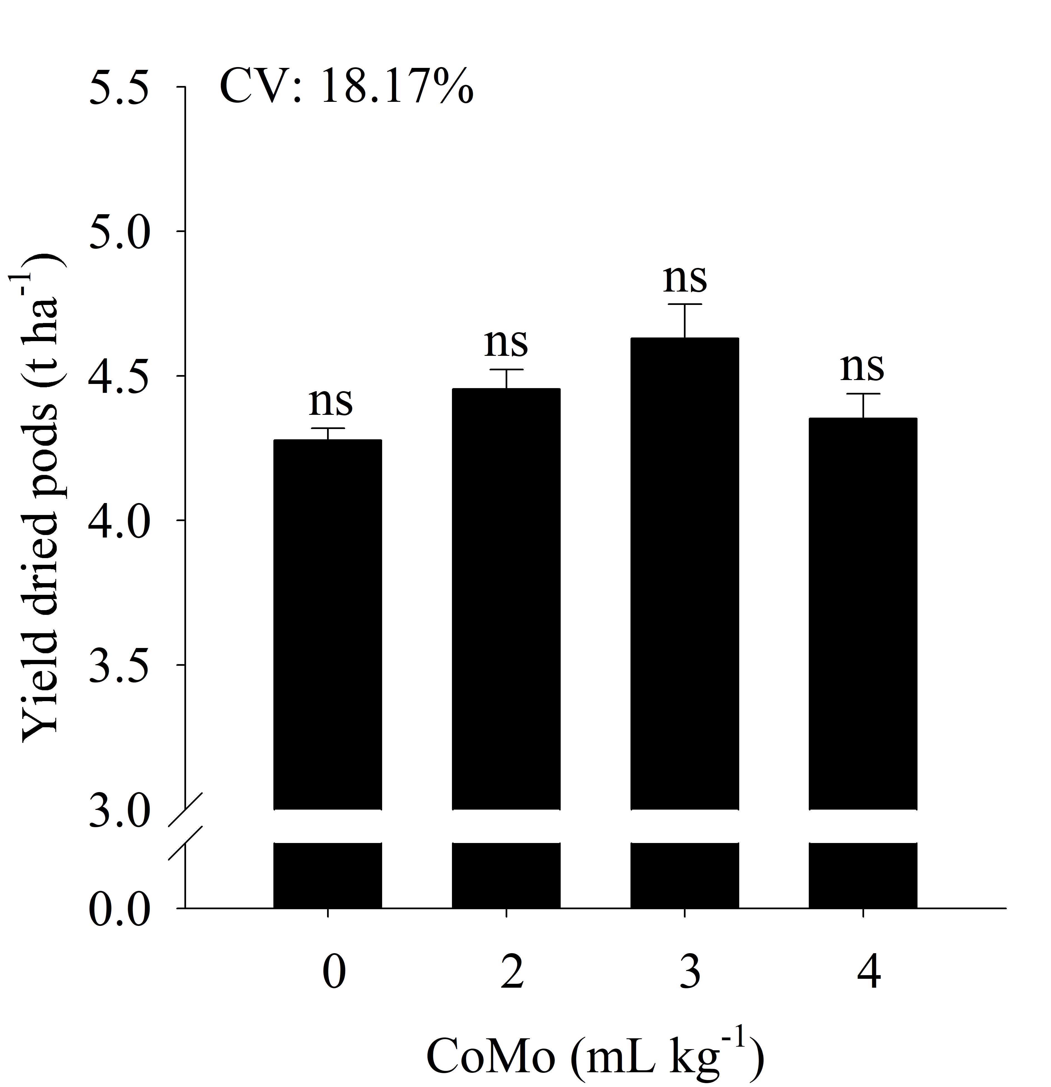
Supplementary material 1. Yield of dried pods in peanut (Arachis hypogaea) plants as a function of cobalt and molybdenum (CoMo) doses in the seed treatment. CV corresponds to the coefficient of variation. Letters classify means according to the Tukey test at 5% probability. The bars represent the standard error of the mean (n = 4).

