Supplementary Information

Metabolomics profiling to investigate nanomaterial toxicity in vitro and in vivo
Anne Bannuscher^{a.b}, Bryan Hellack^{c,d}, Aileen Bahlª, Julie Laloy^{e}, Hildegard Herman^{f}, Miruna S. Stan^{g}, Anca Dinischiotu^{g}, Anna Giustiª, Benjamin-Christoph Krauseª, Jutta Tentschertª, Marcel Roșu^{f}, Cornel Balta^{f}, Anca Hermenean^{f,g}, Martin Wiemann^{h}, Andreas Luchª and Andrea Haaseª
ª German Federal Institute for Risk Assessment (BfR), Department of Chemical and Product Safety, Berlin, Germany
^{b} Adolphe Merkle Institute (AMI), University of Fribourg, Fribourg, Switzerland
^{c} Institute of Energy and Environmental Technology (IUTA) e.V., Duisburg, Germany
^{d} German Environment Agency (UBA), Dessau, Germany
^{e} University of Namur, Department of Pharmacy, Namur Nanosafety Centre, NARILIS, Namur, Belgium
^{f} “Aurel Ardelean” Institute of Life Sciences, “Vasile Goldis” Western University of Arad, Arad, Romania
^{g} Department of Biochemistry and Molecular Biology, University of Bucharest, Bucharest, Romania
^{h g} IBE R&D Institute for Lung Health gGmbH, Münster, Germany

Corresponding author:
Andrea Haase
E-Mail: Andrea.Haase@bfr.bund.de
Telephone: +49-30- 18412 27600

Supplementary Table S1: Overview of NM cytotoxicity in RLE-6TN cells reproduced from (Karkossa et al., 2019)
IC50 and IC25 values in [µg/cm²] for 24h and 48h were given. Abbreviations NR: not reached; NA: not assessed
 | NM | IC50  24h | IC50  48h | IC25  24h | IC25  48h | Overall  Cytotoxicity
RLE-6TN | SiO₂_15_Unmod | NR | NR | NR | NR | None
 | SiO₂_15_Amino | NR | NR | NR | NR | None
 | SiO₂_40 | NR | NR | 37 | NR | Weak
 | SiO₂_7 | NR | NR | 38 | 56 | Weak
 | TiO₂ NM-105 | 7 | 7 | 1 | 1 | Strong

Table S2: Overview of NM cytotoxicity in NR8383 cells (reproduced from (Bannuscher et al., 2019, including additional data for SiO₂_15_Amino from the same experiment series)
NM | Dose | LDH [% of PC]
 | [µg/cm²] | Mean |  | SD
SiO2_15_Unmod | 0 | 21.67 | ± | 2.37
 | 2.5 | 28.36 | ± | 1.12
 | 5 | 44.93 | ± | 8.97*
 | 10 | 93.51 | ± | 19.75*
SiO2_15_Amino | 0 | 21.67 | ± | 2.37
 | 2.5 | 25.34 | ± | 2.90
 | 5 | 26.87 | ± | 1.75
 | 10 | 59.65 | ± | 6.74*
SiO2_7 | 0 | 55 | ± | 1.53
 | 2.5 | 41.25 | ± | 16.35
 | 5 | 91.23 | ± | 16.07*
 | 10 | 95.97 | ± | 15.11*
SiO2_40 | 0 | 55 | ± | 1.53
 | 2.5 | 22.01 | ± | 5.04
 | 5 | 23.91 | ± | 3.56
 | 10 | 71.37 | ± | 19.11*

Supplementary Table S3: Parameters for MPPD calculations.
Parameter | TiO₂ NM-105 |  | SiO₂_7
Aerosol concentration [mg/m³] | Exposure | Recovery | Exposure | Recovery
 | 2.55  4.92  14.98  41.97 | 2.47  3.41  11.57 | 0.74  2.58  5.024 | 0.97  1.41  5.298
MV [m³/min] | 0.0002142
Density [g/cm³] | 3.89 |  | 2.65
GSD | 1.78
t [min] | 1800
Df (TB+Alv) | Exposure | Recovery | Exposure | Recovery
 | 0.1066  0.1109  0.1139  0.0881 | 0.101  0.1242  0.1103 | 0.127  0.098  0.1028 | 0.1216  0.1268  0.1209

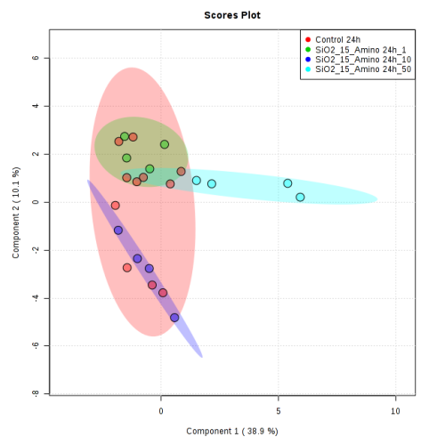
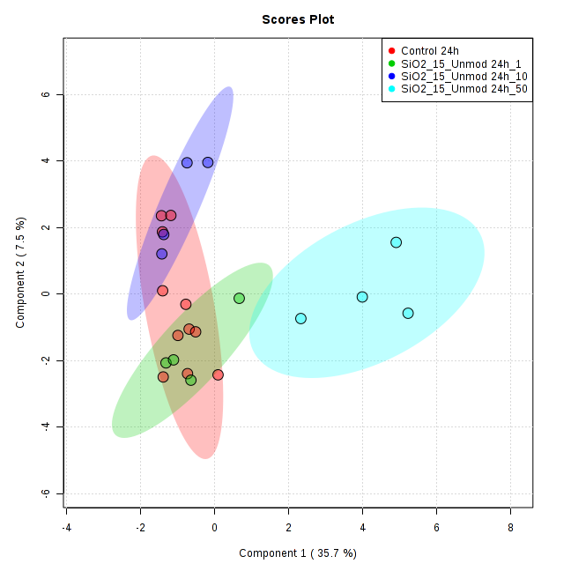

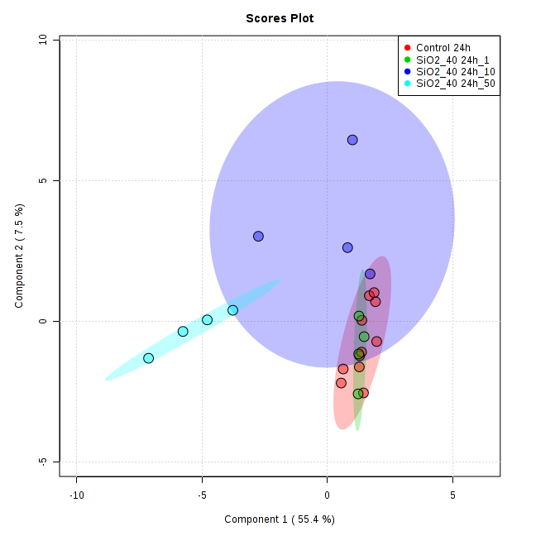
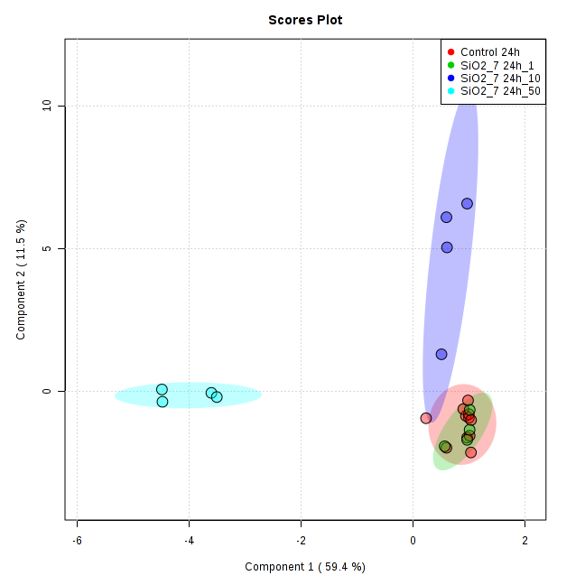

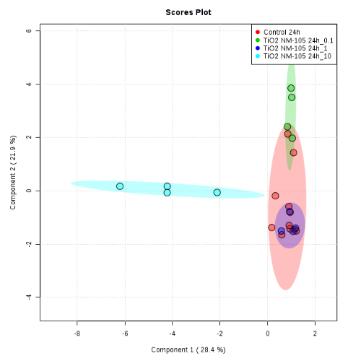

Figure S1 sPLS-DA of metabolomics data in RLE-6TN epithelial cells after 24h of NM exposure.

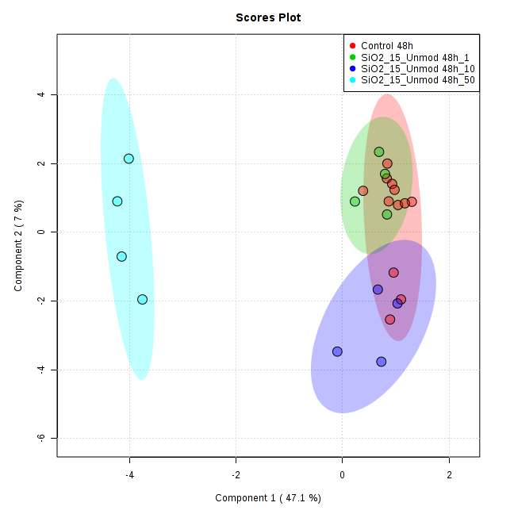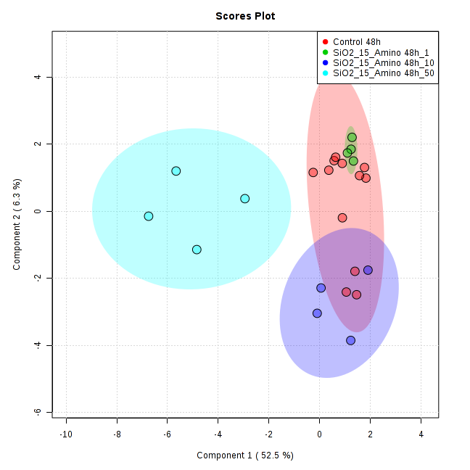
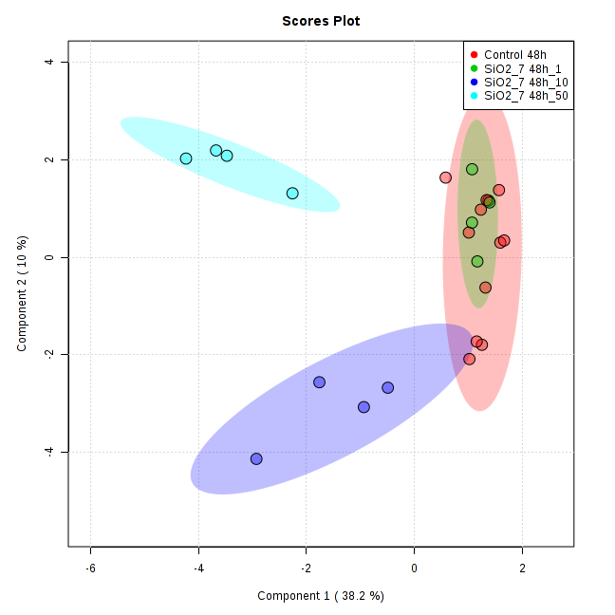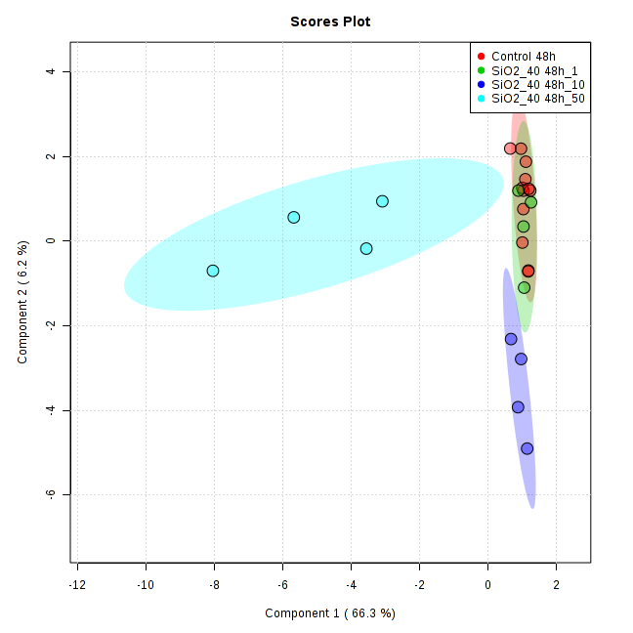
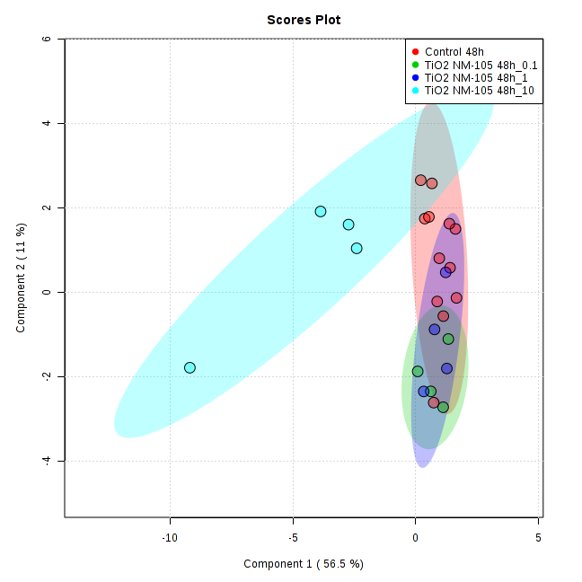

Figure S2 sPLS-DA of metabolomics data in RLE-6TN epithelial cells after 48h of NM exposure.
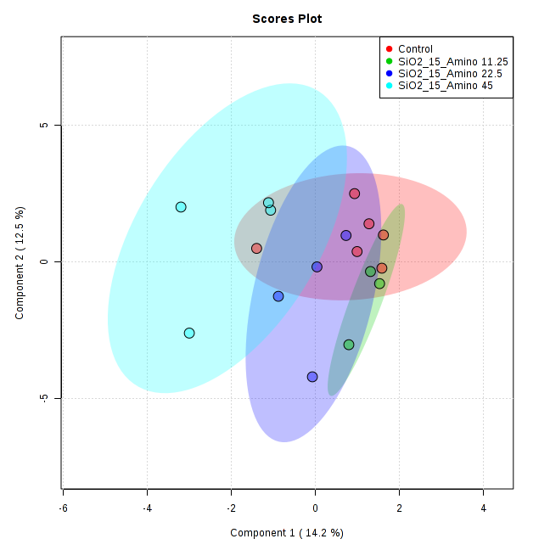
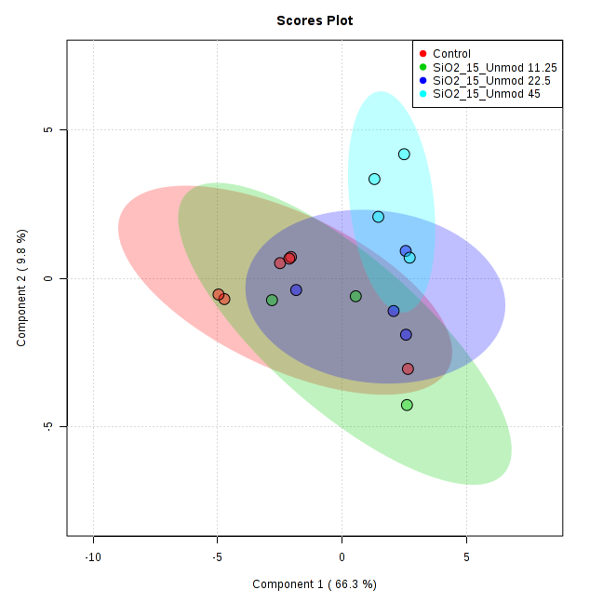

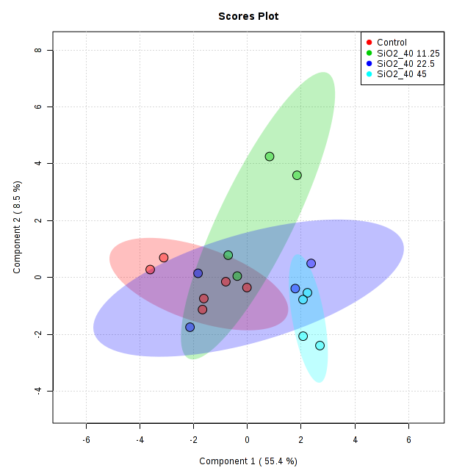
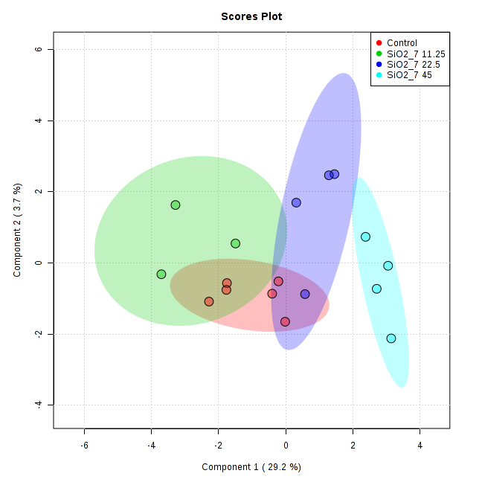

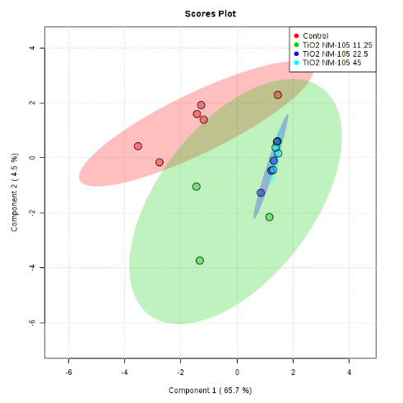

Figure S3 sPLS-DA of metabolomics data in NR8383 Macrophages after 24h of NM exposure.

Figure S4 Number of significantly changed metabolites in vitro in RLE-6TN epithelial cells (A) and NR8383 Macrophages (B). Blue indicates decreased and red increased amount of metabolite compared to untreated controls.

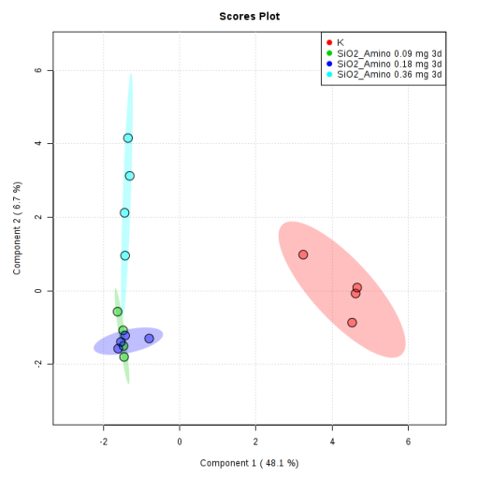
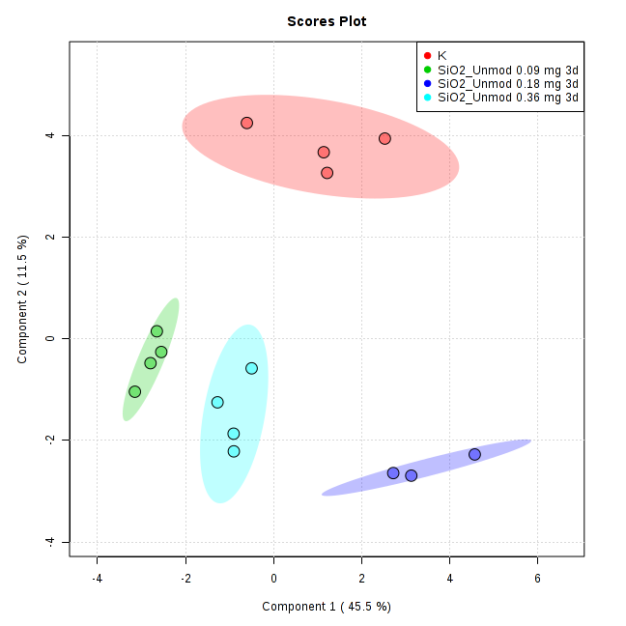

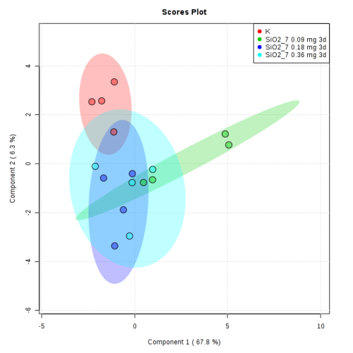
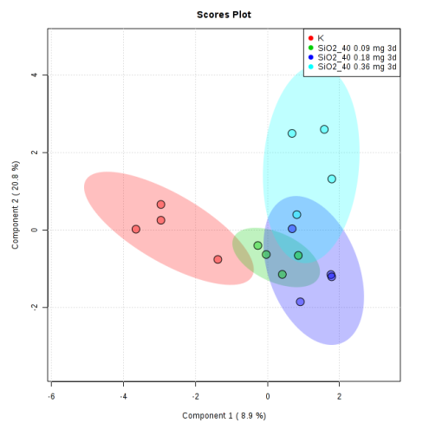

Figure S5 sPLS-DA of metabolomics data of instillation of NMs in exposure group.
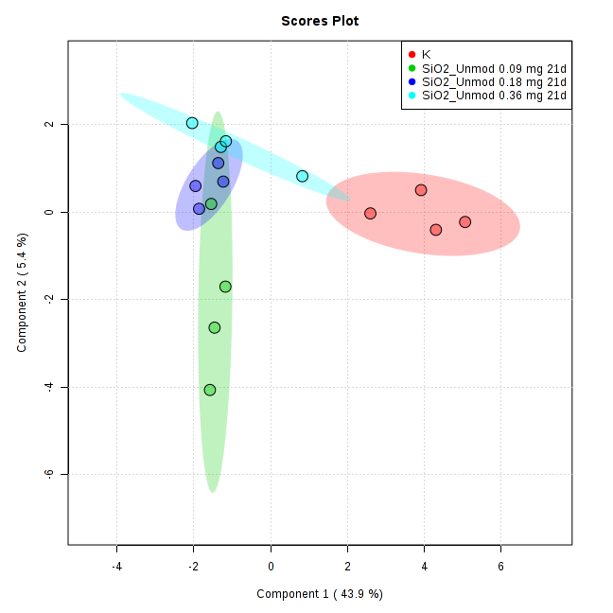
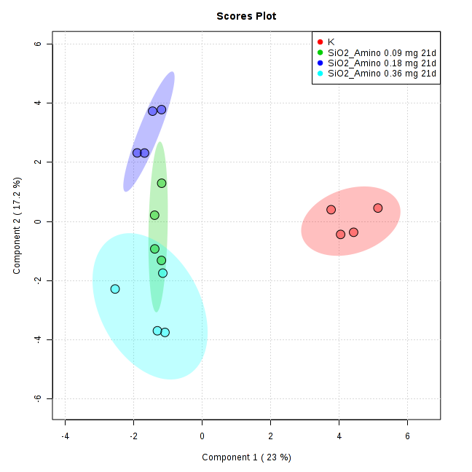

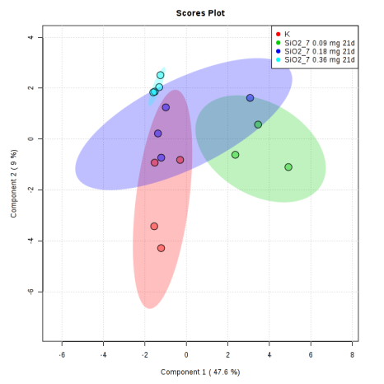
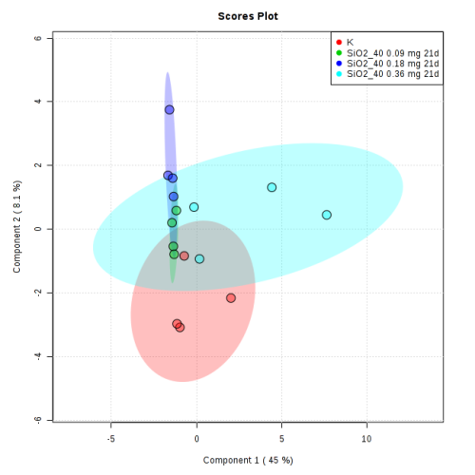

Figure S6 sPLS-DA of metabolomics data of instillation of NMs in recovery group.

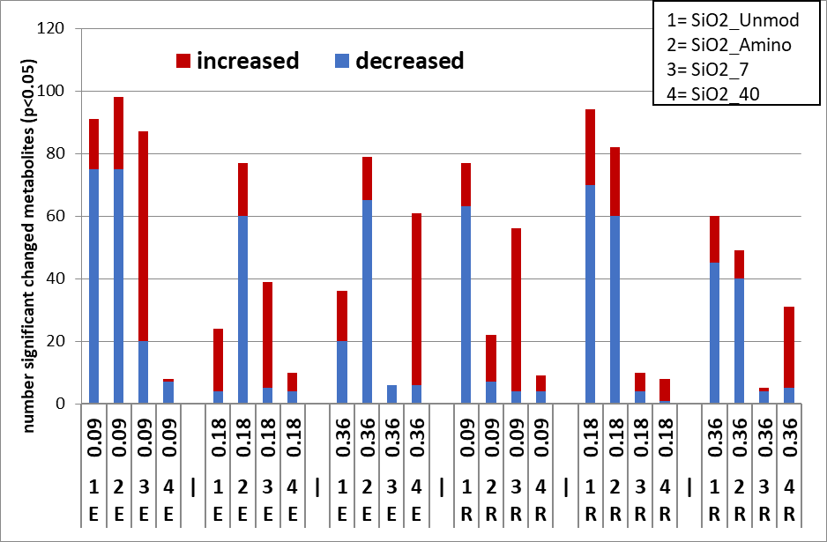
Figure S7 Number of significantly changed metabolites vs. vehicle treated controls secondary to in vivo instillations. Blue indicates decreased and red increased amount of metabolites compared to untreated controls.

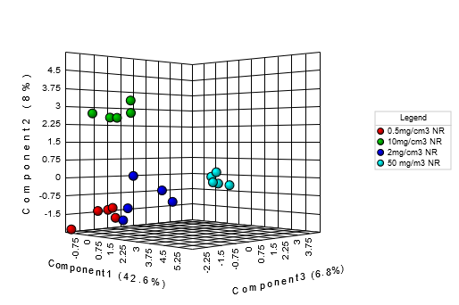
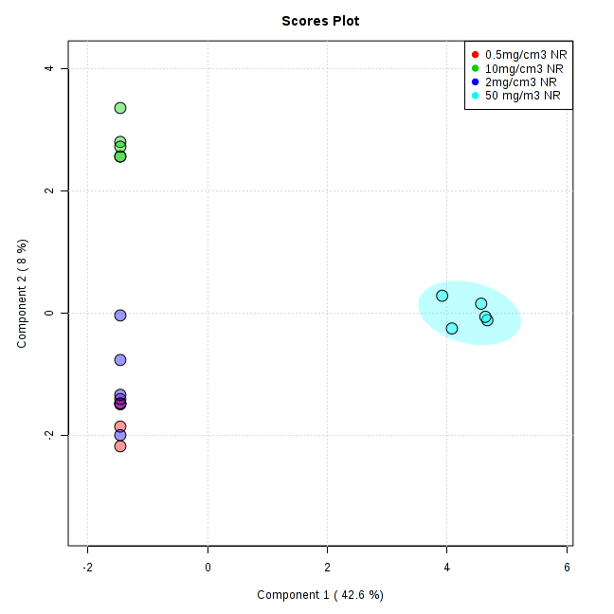
Exposure

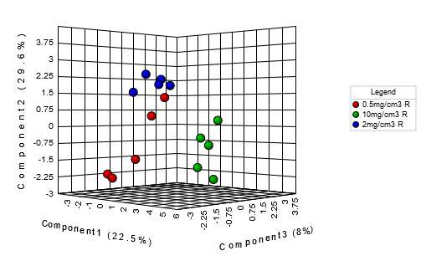
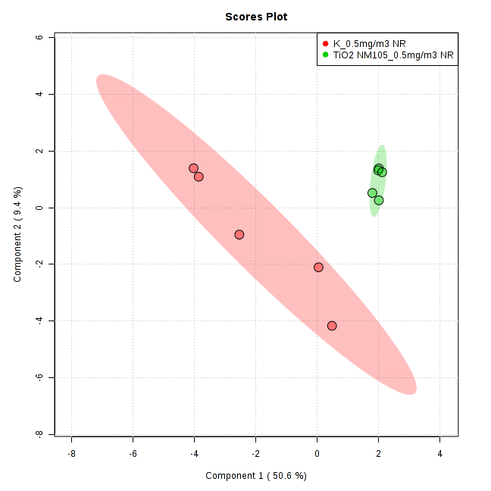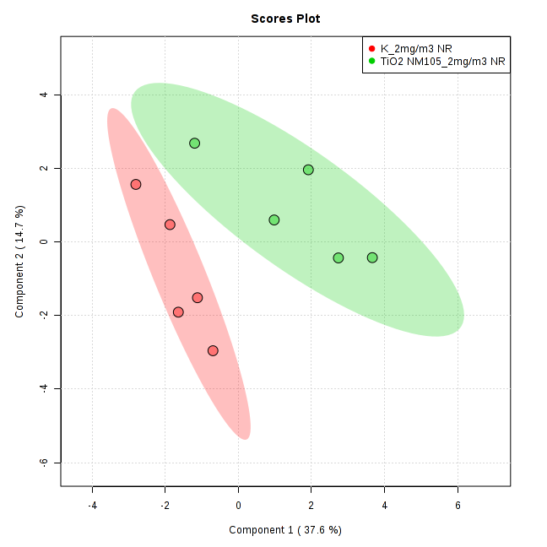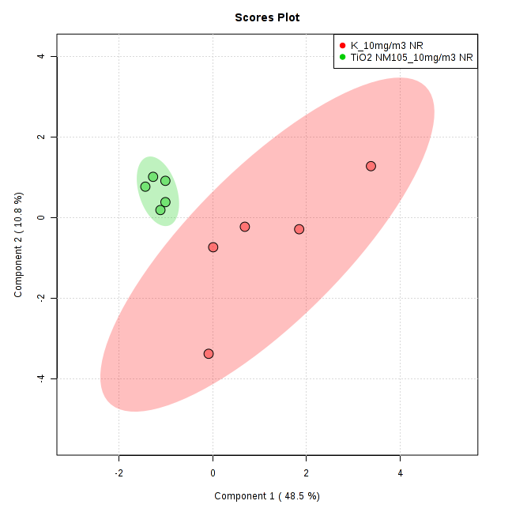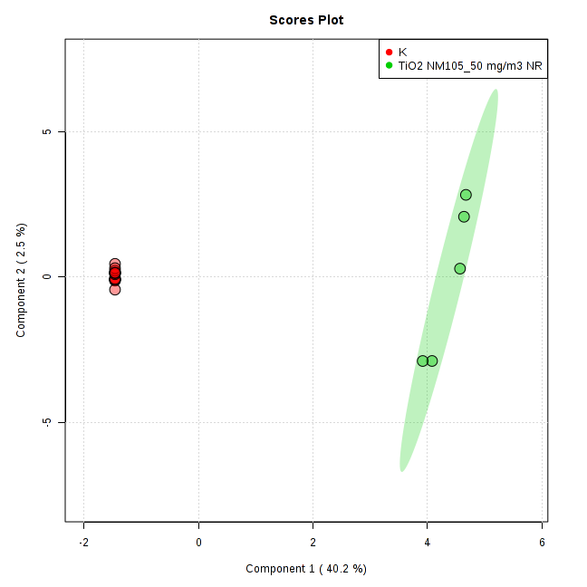
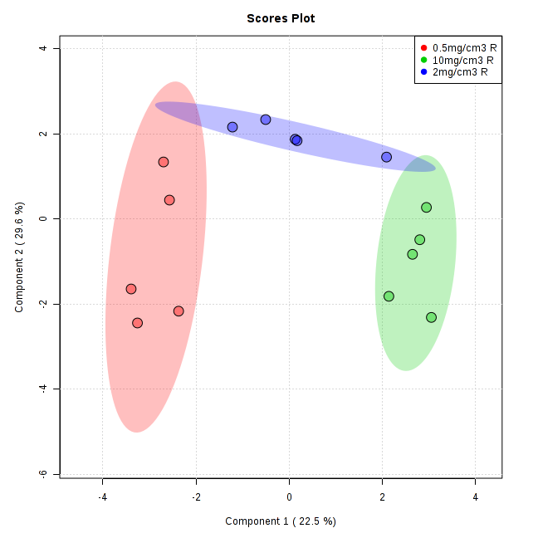
Recovery

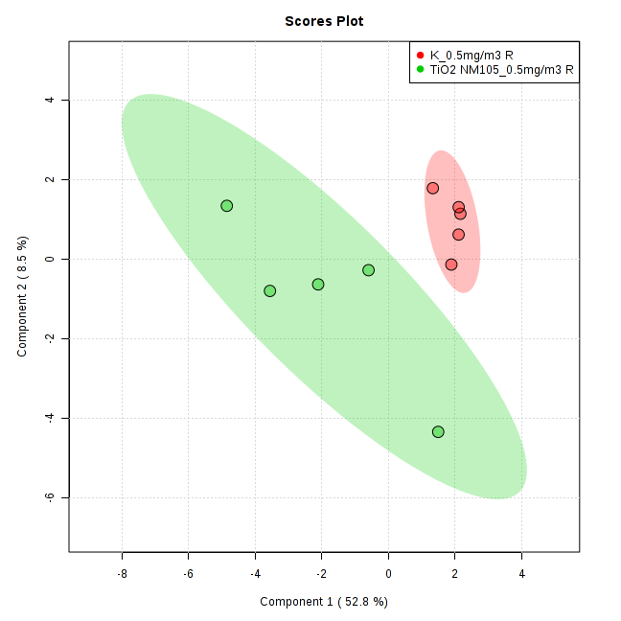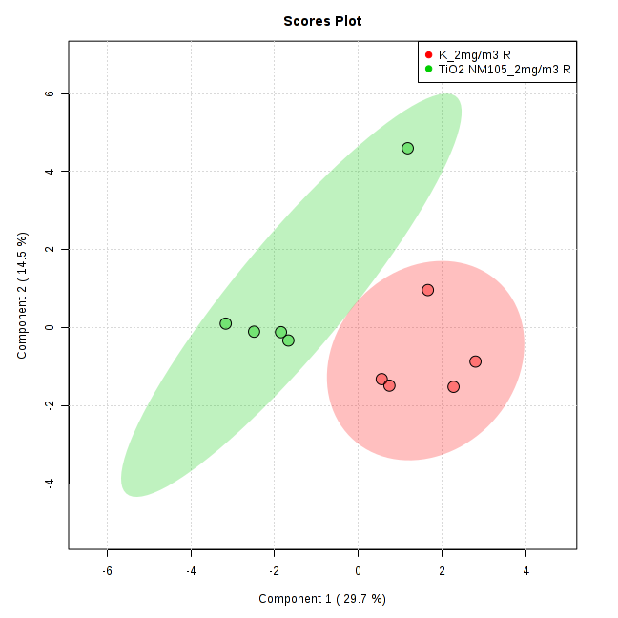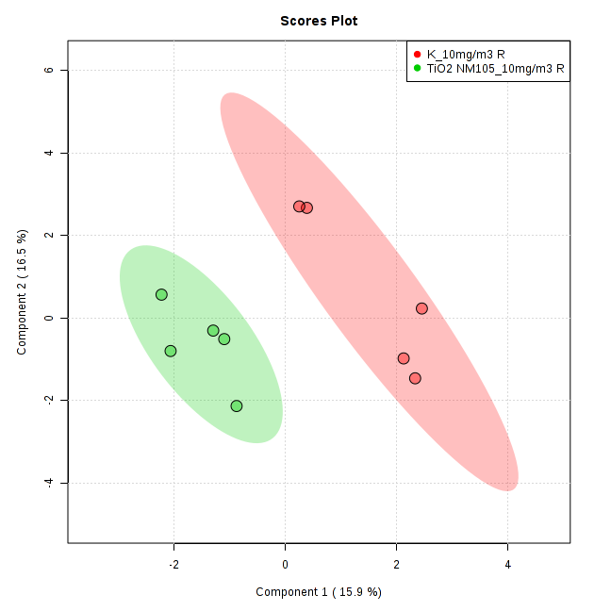
Figure S8 sPLS-DA (3D right, 2D left) of metabolomics data of STIS of TiO₂ NM-105 in exposure and recovery groups.

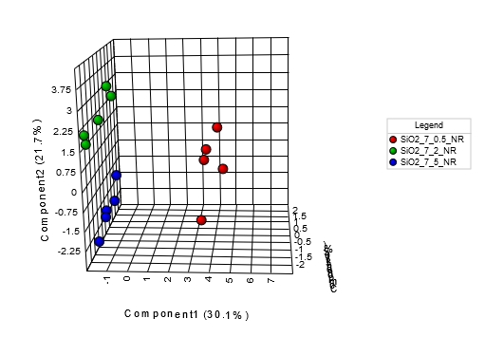
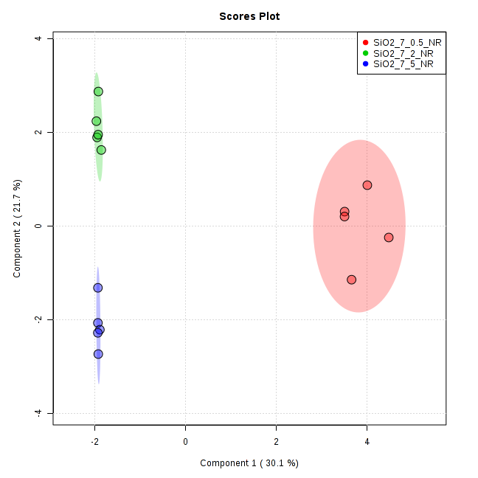
Exposure

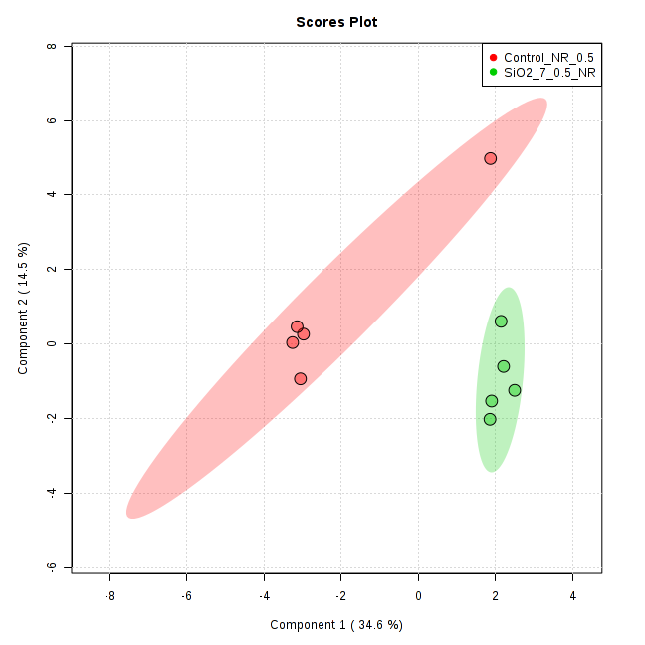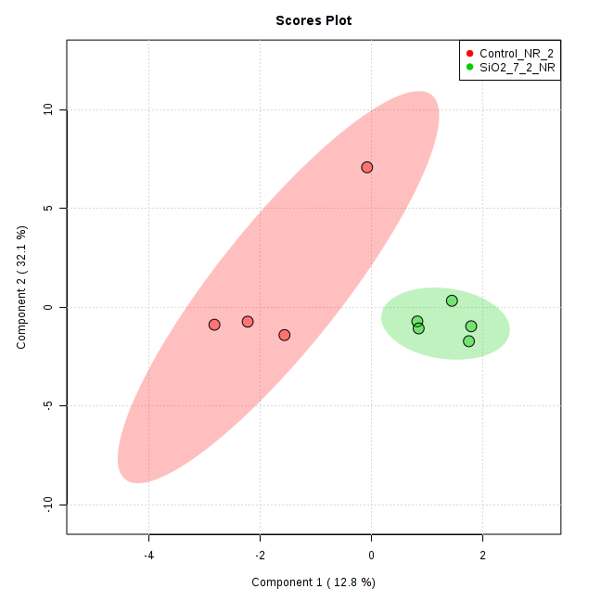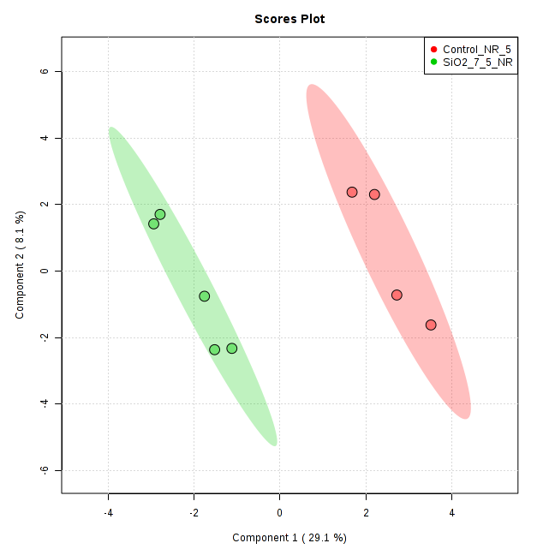
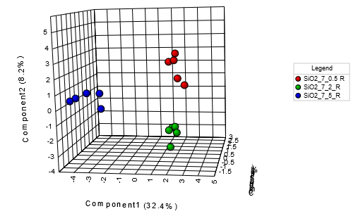
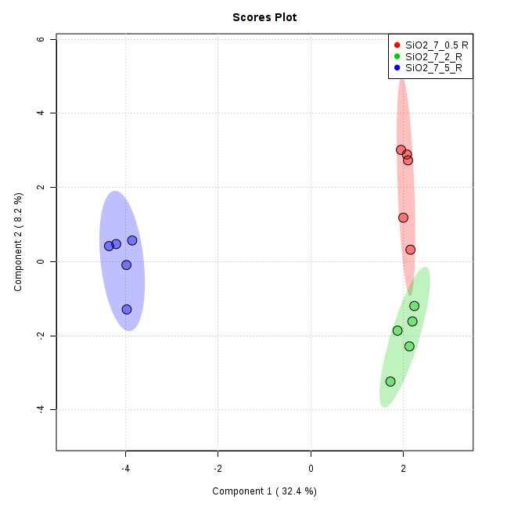
Recovery

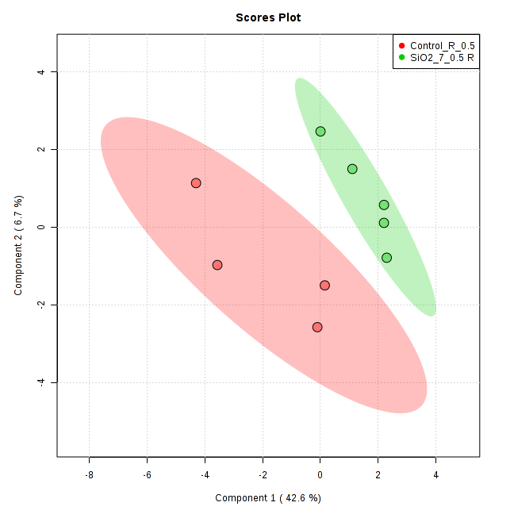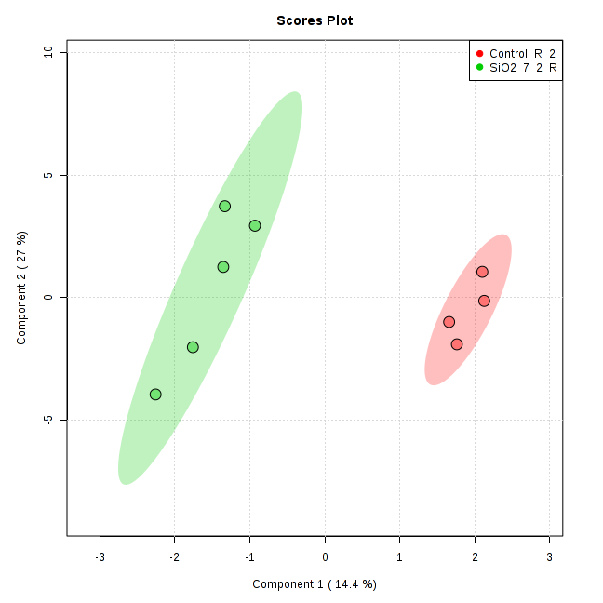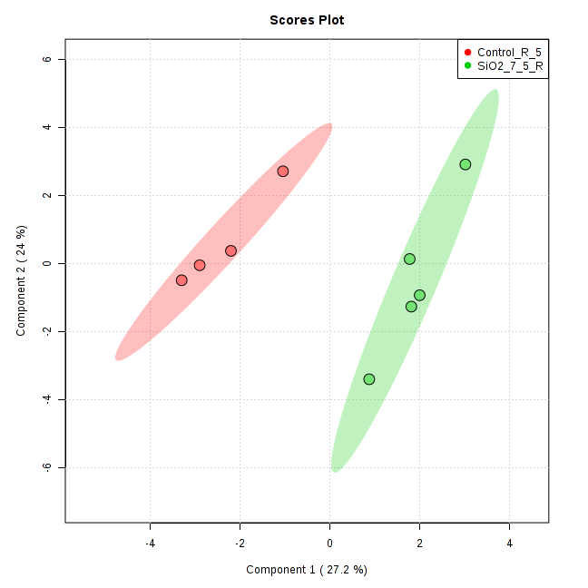
Figure S 9 sPLS-DA (3D left, 2D right) of metabolomics data of STIS of SiO₂_7 in exposure and recovery groups.

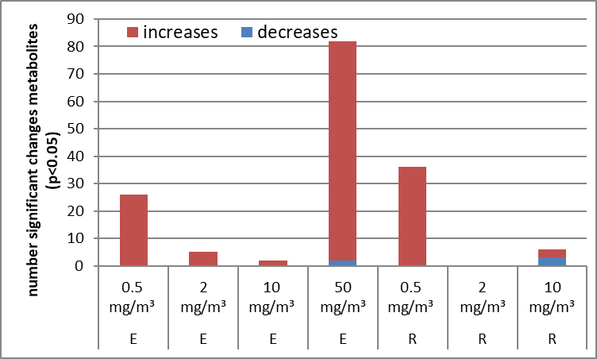
TiO₂ NM-105
Figure S10 Number of significant changed metabolites of in vivo STIS.
Blue indicates decreased and red increased amount of metabolites compared to untreated controls.

Table S4: Overview feature (Metabolite) selection based on sPLS-DA of in vitro data.
NM | 24h |  | 48h
 | RLE-6TN  Epithelial Cells | NR8383 Macrophages | RLE-6TN  Epithelial Cells
SiO₂_15_Unmod | Putrescine  Gly  LysoPCaC18:0  LysoPCaC18:2  LysoPCaC16:0  Creatinine  Spermidine  Spermine  Lys  Phe  SMC26:1 | SMOHC16:1  SMOH14:1  PCaeC44:3  SMC16:0  SMC18:0  PCaeC44:4  Asp  Glu  Spermidine  Putrescine  Thr  Gly  Trp  PCaeC44:5 | PCaeC40:1  Gly  PCaeC38:4  PCaeC38:1  Spermine  Lys  Asp  Spermidine  C12:1  C3  Creatinine
SiO₂_15_Amino | Thr  PCaaC42:4  PCaeC40:1  PCaeC40:5  Spermidine  Spermine  Lys  LysoPCaC16:0  Phe  SMC20:2  Gly | PCaeC44:5  LysoPCaC16:0  PCaaC36:4  LysoPCaC17:0  Orn  Putrescine  Kynurenine  Ser  Thr  Gln  Asp | Thr  SMC18:1  SMC24:1  LysoPCaC16:1  SMC18:0  Gln  LysoPCaC17:0  PCaaC24:0  Spermidine  Spermine
SiO₂_7 | C16,  LysoPCaC18:0  PCaaC40:6  Cit  Pro  Trp  Tyr  Ile  Asn  His  Creatinine  Lys  SM C20:2  SM C24:1  PC ae C30:2 | Gln  Ala  Asp  Glu  Pro  Asn  Trp  SM C22:3  Taurine  LysoPCaC24:0  LysoPCaC26:0  PCaaC24:0  PCaeC44:6  Orn  Spermine  Gly  Cit | Gly  Pro  Putrescine  SMC18:1  Lys  LysoPCaC16:0  Spermine  lysoPCaC26:1  Ala  PCaaC40:2  Glu  SMC26:0  LysoPCaC28:1  LysoPCaC18:0
SiO₂_40 | PCaeC42:2,  LysoPCaC18:0  LysoPCaC17:0  PCaeC40:1  LysoPCaC18:2  Pro  Spermine  Spermidine  Orn  SMC26:1  Lys  C2 | Spermidine  PCaeC44:3  PCaeC44:4  LysoPCaC20:3  ADMA  Ser  Spermine  Lyso PCaC16:0  LysoPCaC17:0  Orn  His  Asp  Kynurenine | PCaeC42:3  PCaaC42:4  LysoPCaC17:0  SMC16:0  Spermidine  Spermine  Orn  Ala  Taurine  SMC22:3  Arg  Thr
TiO₂ NM-105 | Putrescine,  PCaaC42:1,  Cit  PCaeC40:1,  PCaeC30:1,  LysoPCaC28:0  PCaaC24:0  C3  lysoPCaC18:2  lysoPCaC16:0  lysoPCaC18:0  Taurine  SMOHC24:1 | PCaaC36:0,  PCaeC36:5,  PCaeC40:6,  His,  Trp,  Asp,  Val,  Phe,  Lys,  Tyr,  Met  Kynurenine  Glu | Putrescine  Spermine  PCaaC42:1  PCaeC34:2  SMOHC24:1  LysoPCaC20:4  LysoPCaC16:1  LysoPCaC18:0  C16  C3  SMC26:0  Cit

Table S5 Overview feature (Metabolite) selection based on sPLS-DA of in vivo instillation data.
Metabolites were selected of highest components containing highest loadings. Results of exposure and recovery groups were regarded of in vivo instillation studies.
Name | In vivo instillation
 | Exposure | Recovery
SiO₂_15_Unmod | LysoPCaC16:0  LysoPCaC20:4  LysoPCaC18:0  LysoPCaC17:0  C4-OH Pro  Total DMA  Taurine  C5OH  C8  Leu  Phe  PCaeC44:3  C18:2  Thr  Creatinine  C4  PCaaC30:2 | Total DMA  PCaaC34:2  PCaaC36:2  PCaaC38:3  PCaaC34:1  Kynurenine  Trp  PCaeC44:5  PCaeC30:1  Spermidine  Ser  LysoPCaC16:1  LysoPCaC17:0  Glu  C0  Phe
SiO₂_15_Amino | Dopamine  C4-OH Pro  PCaaC42:2  PCaaC34:4  PCaaC40:3  Spermidine  Gly  Ala  Asn  Met  C7-DC  PCaaC42:1  Pro  C6  C16 | C16-OH  TotalDMA  C10  Taurine  C4-OH -Pro  Spermidine  Putrescine  Met-SO  LysoPCaC16:1  LysoPCaC20:4  LysoPCaC18:2  C16  Ser  Spermine  LysoPCaC17:0  Tyr
SiO₂_7 | Asn  Asp  LysoPCaC16:1  C5-OH  Kynurenine  C8  Histamine  C10  C3-DC  C6  Spermidine  Trp  Arg  Putrescine | PCaaC36:3  SMC26:1  PCaaC34:3  PCaaC34:2  His  Creatinine  Ser  C2  t4-OH-Pro  Asp  LysoPCaC18:0  C10  LysoPCaC20:4  C0  Spermine
SiO₂_40 | Alpha-AAA  Spermidine  PCaaC42:1  Asp  LysoPCaC16:1  C10  C6  C0  Thr  Trp  Ser  Pro  C3-DC  Gly  Kynurenine | PCaaC40:3  PCaaC42:1  PCaeC34:0  SMOHC24:1  SMC18:1  C10  C5-OH  Glu  PCaeC44:3  t4-OH-Pro  Spermidine  Val  Histamine  C3-DC  LysoPCaC17:0  Met  Carnosine  lysoPCaC16:1

Table S6 Overview feature (Metabolite) selection based on sPLS-DA of in vivo STIS data.
Metabolites were selected of highest components containing highest loadings. Results of exposure and recovery groups were regarded of in vivo STIS.
Name | In vivo STIS
 | Exposure | Recovery
SiO₂_7 | C12  C16  C14  C5:1-DC  C18  C16:1-OH  C18:2  PCaaC36:3  SMC26:1  PCaaC34:2  PCaaC40:3  t4-OH Pro  Asp  ADMA  lysoPCaC18:0  C10  Ac-Orn  Spermine  lysoPCaC20:4  lysoPCaC18:2 | C16:2-OH  C5:1-DC  C16:1-OH  C18  C16-OH  C14:1  C14:2  Asn  Creatinine  PCaeC38:1  SMOHC24:1  PCaeC36:2  lysoPCaC20:4  lysoPCaC17:0  Spermine  Met  Histamine
TiO₂ NM-105 | C5-OH  C8  C6  C16-OH  SMOHC22:2  C6:1  Ac-Orn  Spermidine  SMC20:2  His  C2  Kynurenine  Histamine  Val  C5  Orn  Gly | C6:1  Gln  Putrescine  Gly  SMOHC22:2  lysoPCaC16:0  lysoPCaC18:2  Spermine  SMC26:0  Glu  Creatinine  C0  Met  Val  Arg  Orn  Ile  Leu  C3  C3-DC

Table S7 Overview feature (Metabolite) selection based on sPLS-DA of in vivo instillation data.
Metabolites were selected of highest components containing high loadings. Results of exposure and recovery groups were regarded of in vivo instillation studies.
Name | In vivo instillation |  | In vivo STIS
 | Exposure | Recovery | Exposure | Recovery
SiO₂_15_Unmod | LysoPCaC16:0  LysoPCaC18:0  C4-OH Pro  Taurine  C5OH  C8  C18:2 | Total DMA  PCaaC34:2  PCaaC36:2  Trp  Spermidine  Ser  LysoPCaC16:1  C0 | NA
SiO₂_15_Amino | C4-OH Pro  PCaaC42:2  PCaaC40:3  Spermidine  Ala  Asn  C7-DC | C16-OH  C4-OH -Pro  Spermidine  Putrescine  Met-SO  LysoPCaC16:1  LysoPCaC18:2  Ser | NA
SiO₂_7 | Asn  Asp  LysoPCaC16:1  C5-OH  Histamine  Spermidine  Arg  Putrescine | PCaaC36:3  His  Ser  C2  t4-OH-Pro  Asp  LysoPCaC18:0  Spermine | C12  C18:2  PCaaC36:3  SMC26:1  t4-OH Pro  Asp  lysoPCaC18:0  Spermine | C18  C16-OH  Asn  SMOHC24:1  PCaeC36:2  lysoPCaC17:0  Spermine  Histamine
SiO₂_40 | Spermidine  PCaaC42:1  Asp  LysoPCaC16:1  C6  C0  Ser  Gly | PCaaC40:3  SMC18:1  C10  C5-OH  t4-OH-Pro  Spermidine  Histamine  lysoPCaC16:1 | NA
TiO₂ NM-105 | NA |  | SMOHC22:2  C6:1  Spermidine  His  C2  Histamine  C5  Gly | C6:1  Gln  Putrescine  Gly  lysoPCaC16:0  lysoPCaC18:2  Spermine  C0

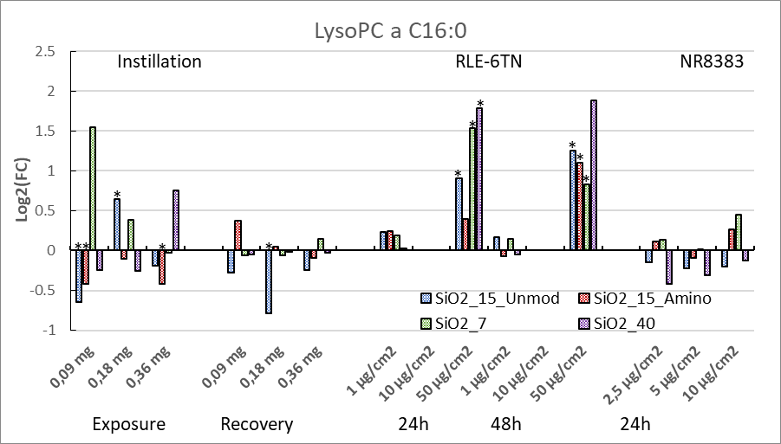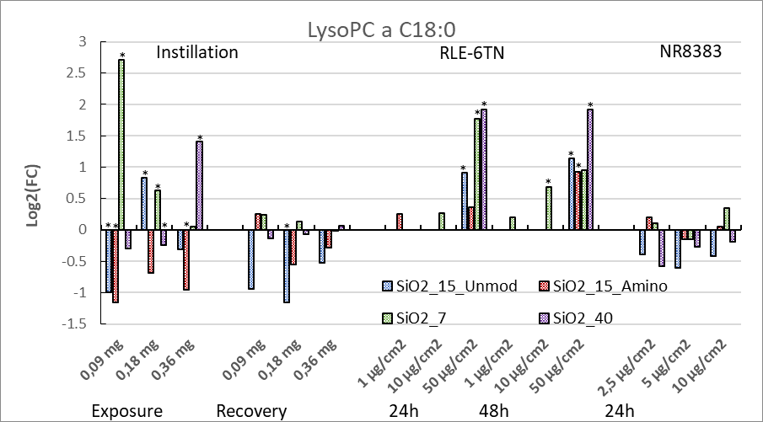
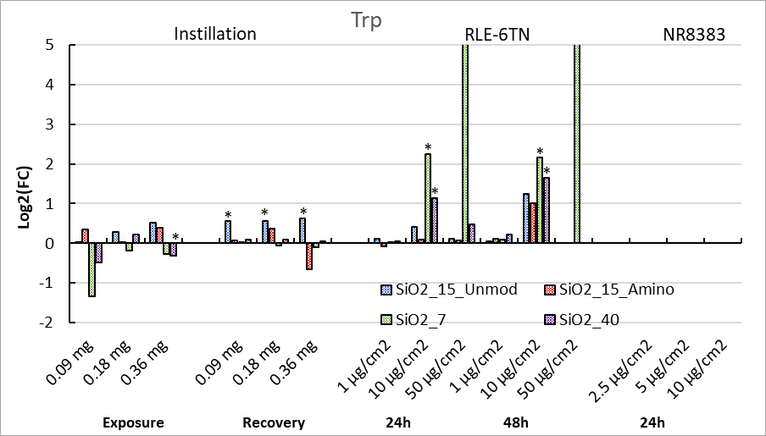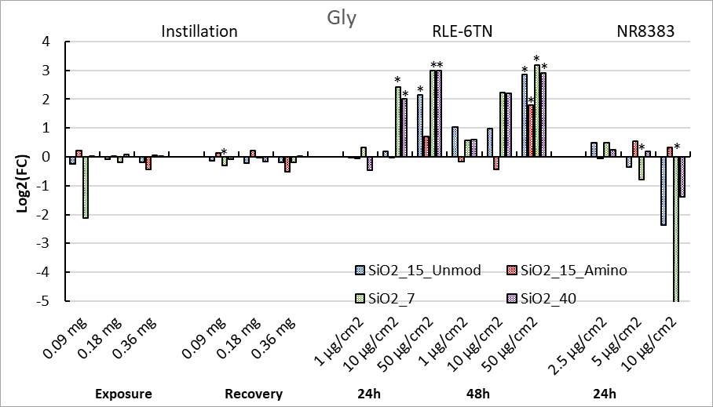
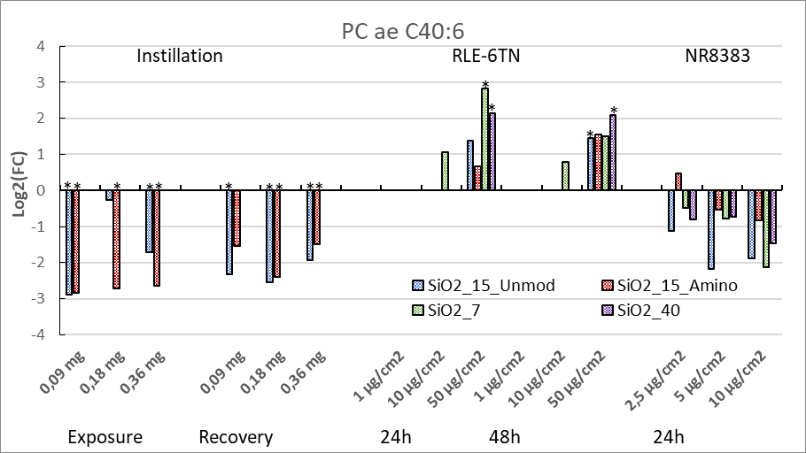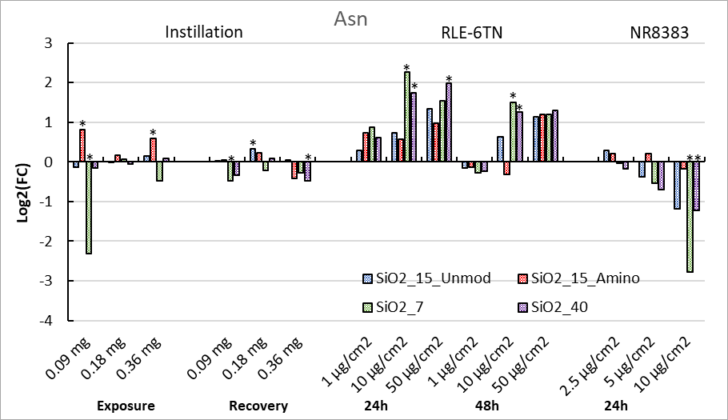
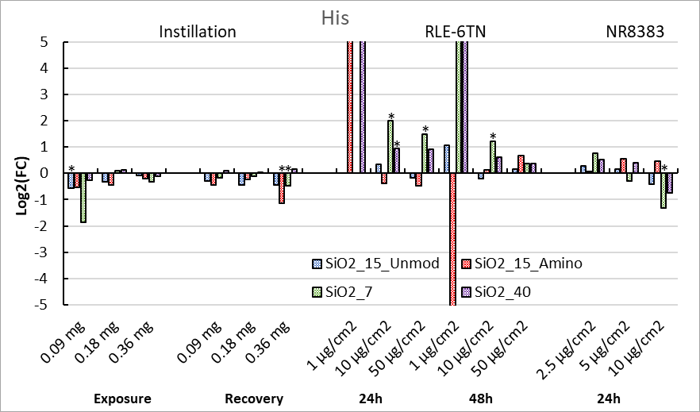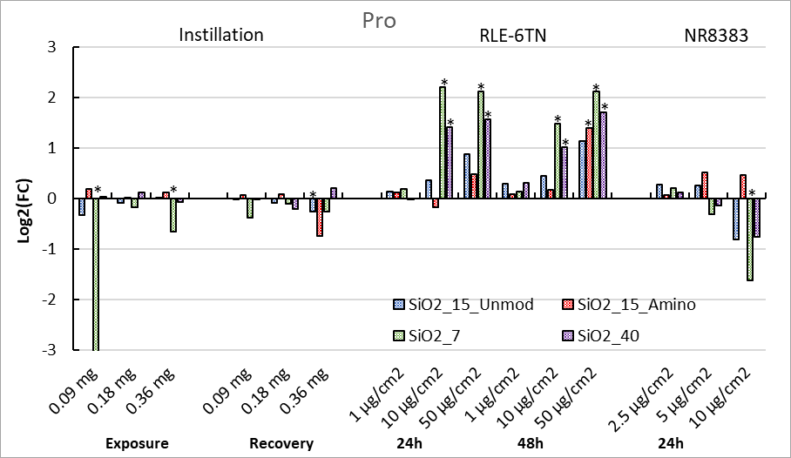
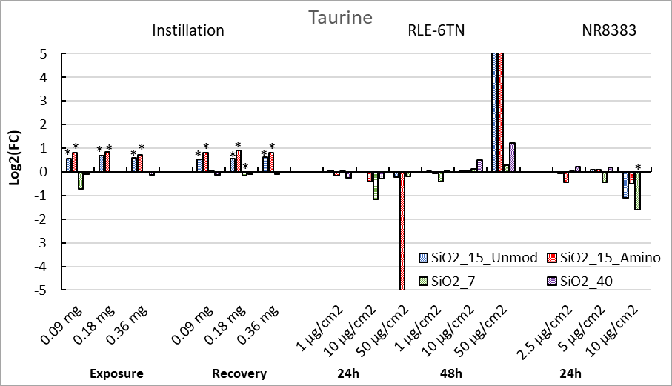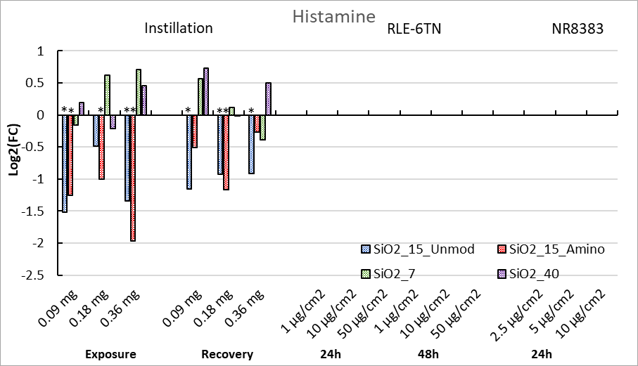
Figure S11. Metabolite changes following in vitro treatments and in vivo instillation exposures of silica NMs. Values are expressed as log2 values of the fold change vs. control (FC).
Supplementary Metabolite Tendencies
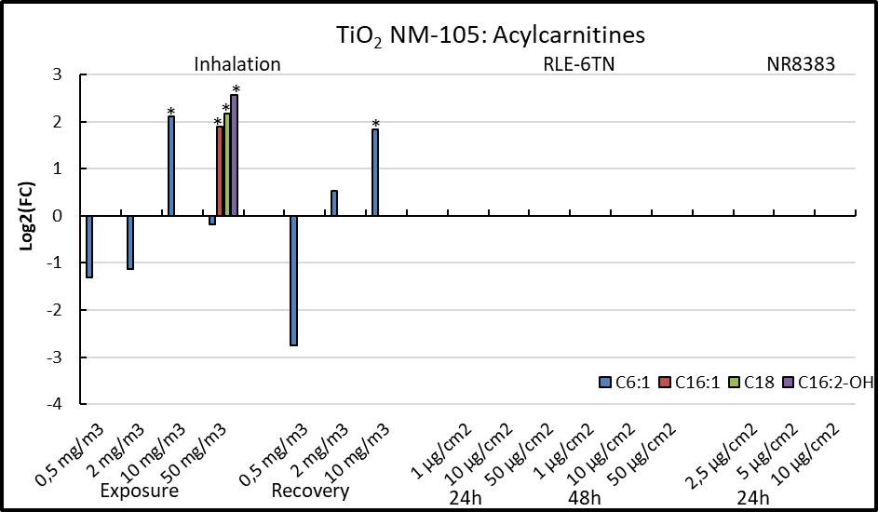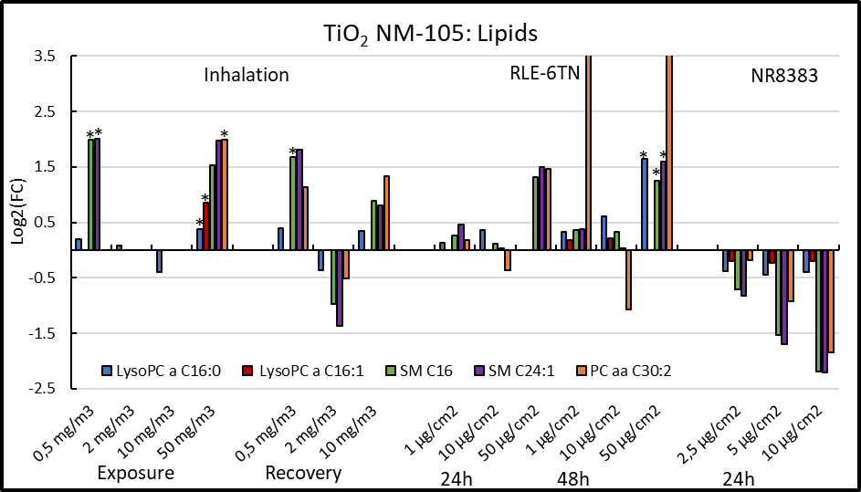
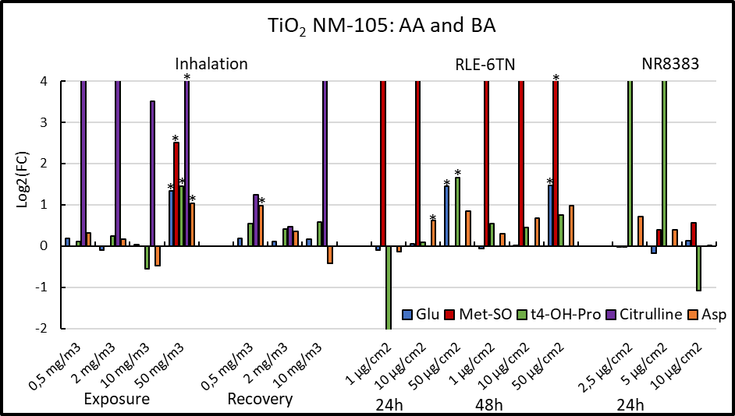
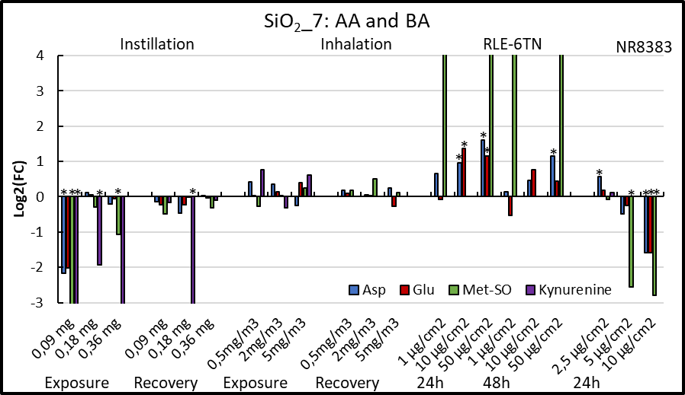
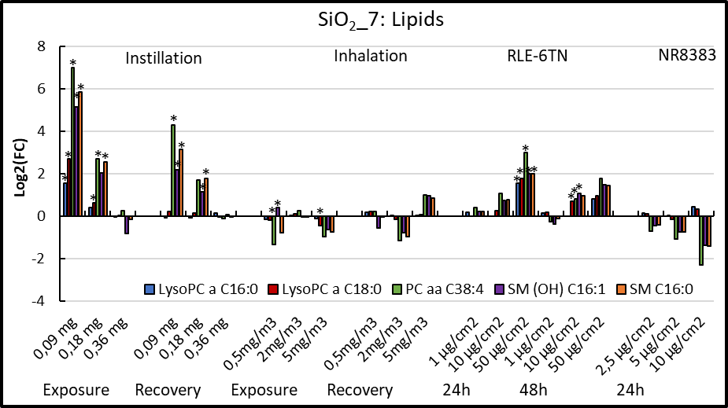
Figure S12. Metabolite tendencies comparing in vitro treatments and in vivo STIS for TiO2 NM-105 and SiO2_7. Values are expressed as log2 values of the fold change vs. control (FC).
References
Bannuscher, A., Karkossa, I., Buhs, S., Nollau, P., Kettler, K., Balas, M., Dinischiotu, A., Hellack, B., Wiemann, M., Luch, A., Von Bergen, M., Haase, A. & Schubert, K., 2019. A multi-omics approach reveals mechanisms of nanomaterial toxicity and structure–activity relationships in alveolar macrophages. Nanotoxicology, 1-15.
Karkossa, I., Bannuscher, A., Hellack, B., Bahl, A., Buhs, S., Nollau, P., Luch, A., Schubert, K., Von Bergen, M. & Haase, A., 2019. An in-depth multi-omics analysis in RLE-6TN rat alveolar epithelial cells allows for nanomaterial categorization. Particle and Fibre Toxicology, 16, 38.

