Lithology

All rocks in the Riverton section have undergone hydrothermal alteration and regional metamorphism, to varying degrees. All plagioclase (which would have been anorthite-rich in an unaltered rock of this composition) is albitised, and some also bears pumpellyite and clay alteration. The abundance of chlorite, some of which pseudomorphs crystal shapes, and absence of olivine suggests that all olivine has been chloritised. Calcite and/or quartz form secondary cement in argillite, lapilli tuff, and the recrystallised inter-pillow matrix. Pillow rims are either not preserved or have lost their glassy texture, and only devitrified glass is discernible in thin section. Some clasts in tuff and lapilli tuff are deformed to form pseudomatrix, and original matrix is not discernible. Throughout the section vesicles are infilled by prehnite, pumpellyite, chlorite, quartz and albite, forming amygdales. Dikes display the most variation in degree of alteration, with some altered to the same extent as the rock around them, while others appear relatively fresh.
Bedding patterns in the lapilli tuff vary across the section. Beds at site 19 are generally reverse graded, with sequences of 2-4 fine to medium beds followed by a bed with very large clasts. At site 22 beds are not graded, but display sequences of 1 coarse sand-grained bed then 2-3 increasingly coarse-grained lapilli tuff beds. At site 10 the beds are graded in both normal and reverse directions. At site 23 the bedding is marked by a band of significantly finer-grained material, with fine sand matrix and few lapilli of 2-20 mm. At site 11 the lapilli tuff has far less matrix; it is framework-supported, with 4-20 cm clasts. Between sites 24 and 27, the bedding is indistinct; in places within this region the lapilli tuff appears massive.

Trace Element Geochemistry

Tables of trace element concentrations from which the diagrams in the paper were constructed are presented here.

Table S1: average trace element concentrations (ppm) from the cores of augites for each sample.
Rock type | Pillow lavas |  | Dikes |  | Lapilli tuffs |  |  | Tuff
Sample | 20 | 21a | 21b | 29a | 17 | 28 | 29b | 5
Li | 2.10 | 1.27 | 1.17 | 1.07 | 0.68 | 0.73 | 0.77 | 0.77
Be | 0.21 | 0.11 | 0.16 | 0.02 | 0.12 | 0.004 | 0.06 | 0.10
K | 266.29 | 81.41 | 89.88 | 4.78 | 10.22 | 5.96 | 20.08 | 2.22
Sc | 146.84 | 159.43 | 129.58 | 106.34 | 105.76 | 83.60 | 113.18 | 107.97
Ti | 5071.81 | 3610.71 | 3249.26 | 2595.70 | 1488.83 | 1264.09 | 2049.57 | 1890.27
V | 469.32 | 430.44 | 376.55 | 312.67 | 224.64 | 162.34 | 303.25 | 227.64
Cr | 265.45 | 1156.20 | 1770.92 | 1573.34 | 3027.26 | 2926.86 | 1278.60 | 2576.45
Mn | 1470.39 | 1297.27 | 1606.57 | 1564.94 | 937.66 | 843.62 | 1251.81 | 954.80
Co | 44.61 | 43.45 | 44.81 | 40.87 | 36.61 | 32.97 | 41.06 | 34.65
Ni | 67.43 | 140.89 | 128.74 | 166.12 | 186.93 | 173.26 | 118.18 | 185.54
Cu | 37.61 | 8.48 | 3.80 | 8.16 | 3.18 | 2.44 | 6.67 | 5.07
Zn | 39.91 | 28.05 | 43.81 | 39.64 | 21.16 | 16.06 | 27.35 | 21.45
Ga | 7.76 | 6.34 | 5.62 | 4.52 | 3.30 | 2.22 | 3.55 | 3.37
Ge | 2.57 | 2.46 | 2.84 | 3.08 | 2.56 | 2.44 | 2.90 | 2.68
As | 0.51 | 0.34 | 0.23 | 0.16 | 0.12 | 0.08 | 0.17 | 0.22
Rb | 1.71 | 0.12 | 0.31 | 0.04 | 0.08 | 0.05 | 0.19 | 0.02
Sr | 27.58 | 17.58 | 18.47 | 28.32 | 13.49 | 13.17 | 14.78 | 16.43
Y | 18.68 | 13.27 | 14.13 | 11.49 | 5.62 | 3.94 | 8.48 | 6.80
Zr | 33.11 | 21.33 | 11.67 | 8.93 | 4.95 | 2.09 | 5.78 | 6.00
Nb | 0.14 | 0.07 | 0.02 | 0.01 | 0.03 | 0.003 | 0.01 | 0.01
Cs | 0.13 | 0.02 | 0.05 | bdl | 0.003 | 0.003 | 0.01 | 0.01
Ba | 2.43 | 0.83 | 0.39 | 0.10 | 0.20 | 0.03 | 0.07 | 0.09
La | 0.56 | 0.37 | 0.36 | 0.32 | 0.16 | 0.09 | 0.19 | 0.20
Ce | 2.71 | 1.67 | 1.84 | 1.86 | 0.73 | 0.43 | 1.03 | 0.87
Pr | 0.63 | 0.43 | 0.46 | 0.46 | 0.18 | 0.12 | 0.27 | 0.23
Nd | 4.46 | 3.14 | 3.46 | 3.00 | 1.36 | 0.86 | 2.02 | 1.67
Sm | 2.11 | 1.47 | 1.60 | 1.30 | 0.68 | 0.43 | 0.95 | 0.78
Eu | 0.77 | 0.57 | 0.58 | 0.51 | 0.25 | 0.17 | 0.35 | 0.28
Gd | 3.01 | 2.11 | 2.37 | 2.02 | 0.95 | 0.66 | 1.41 | 1.10
Tb | 0.54 | 0.38 | 0.41 | 0.33 | 0.16 | 0.11 | 0.25 | 0.20
Dy | 3.61 | 2.60 | 2.88 | 2.33 | 1.14 | 0.82 | 1.71 | 1.34
Ho | 0.76 | 0.53 | 0.58 | 0.47 | 0.23 | 0.16 | 0.34 | 0.27
Er | 2.15 | 1.55 | 1.67 | 1.34 | 0.65 | 0.46 | 0.96 | 0.79
Tm | 0.28 | 0.20 | 0.22 | 0.18 | 0.09 | 0.06 | 0.13 | 0.10
Yb | 1.88 | 1.38 | 1.45 | 1.15 | 0.57 | 0.37 | 0.83 | 0.64
Lu | 0.27 | 0.19 | 0.21 | 0.16 | 0.08 | 0.05 | 0.12 | 0.09
Hf | 1.61 | 1.11 | 0.64 | 0.49 | 0.26 | 0.13 | 0.32 | 0.32
Ta | 0.02 | 0.01 | 0.002 | 0.0005 | 0.002 | 0.0001 | 0.0005 | 0.0003
Pb | 0.45 | 0.12 | 0.10 | 0.59 | 0.35 | 0.03 | 0.05 | 0.26
Th | 0.02 | 0.01 | 0.005 | 0.003 | 0.004 | 0.0002 | 0.001 | 0.001
U | 0.02 | 0.01 | 0.002 | 0.0003 | 0.001 | 0.0003 | 0.001 | 0.001

Table S2: model whole-rock compositions (ppm) calculated from average trace element concentrations from the cores of augites for each sample. Partition coefficients (D) are averages taken from Bédard (2014).
 | D | Pillow lava |  | Dikes |  | Lapilli tuffs |  |  | Tuff
 |  | 20 | 21a | 21b | 29a | 17 | 28 | 29b | 5
Li | 0.275 | 7.63 | 4.61 | 4.49 | 3.87 | 2.49 | 2.65 | 2.79 | 2.82
Be | 0.054 | 3.87 | 1.95 | 3.15 | 0.34 | 2.28 | 0.08 | 1.03 | 1.90
K | 0.0067 | 9744.75 | 12151.10 | 13414.88 | 713.35 | 1524.73 | 889.43 | 2996.87 | 330.63
Sc | 1.675 | 87.68 | 95.19 | 76.72 | 63.49 | 63.15 | 49.91 | 67.58 | 64.46
Ti | 0.317 | 6003.01 | 11383.30 | 10243.79 | 8183.32 | 4693.75 | 3985.24 | 6461.59 | 5959.36
V | 2.098 | 223.74 | 205.21 | 178.29 | 149.06 | 107.09 | 77.40 | 144.57 | 108.52
Cr | 5.15 | 51.54 | 224.51 | 368.74 | 305.50 | 587.82 | 568.32 | 248.27 | 500.28
Co | 1.386 | 32.18 | 31.34 | 32.18 | 29.48 | 26.41 | 23.78 | 29.62 | 24.99
Ni | 4.406 | 15.31 | 31.98 | 29.96 | 37.70 | 42.43 | 39.32 | 26.82 | 42.11
Cu | 1.26 | 29.85 | 6.73 | 3.45 | 6.48 | 2.52 | 1.94 | 5.29 | 4.03
Zn | 21.287 | 1.87 | 1.32 | 2.12 | 1.86 | 0.99 | 0.75 | 1.28 | 1.01
Ga | 0.375 | 20.71 | 16.90 | 15.24 | 12.05 | 8.80 | 5.92 | 9.46 | 8.98
Ge | 1.386 | 1.85 | 1.78 | 2.05 | 2.22 | 1.85 | 1.76 | 2.10 | 1.93
As | 0.019 | 26.65 | 17.77 | 11.83 | 8.59 | 6.28 | 3.95 | 9.18 | 11.42
Rb | 0.012 | 137.12 | 9.93 | 34.04 | 3.29 | 6.12 | 3.83 | 15.61 | 1.26
Sr | 0.090 | 305.14 | 194.56 | 207.93 | 313.39 | 149.23 | 145.71 | 163.54 | 181.80
Y | 0.427 | 43.73 | 31.05 | 32.80 | 26.90 | 13.15 | 9.22 | 19.85 | 15.91
Zr | 0.118 | 280.86 | 180.96 | 98.47 | 75.76 | 41.98 | 17.75 | 49.01 | 50.91
Nb | 0.0046 | 30.05 | 15.86 | 5.74 | 1.31 | 6.41 | 0.79 | 1.41 | 1.65
Cs | 0.0041 | 32.38 | 4.36 | 12.19 | bdl | 0.90 | 0.66 | 2.47 | 3.34
Ba | 0.0052 | 468.26 | 159.94 | 112.87 | 18.58 | 38.58 | 5.80 | 13.69 | 18.29
La | 0.048 | 11.64 | 7.70 | 7.42 | 6.65 | 3.44 | 1.82 | 4.01 | 4.13
Ce | 0.088 | 30.66 | 18.97 | 20.65 | 21.03 | 8.29 | 4.85 | 11.67 | 9.86
Pr | 0.125 | 5.03 | 3.39 | 3.60 | 3.66 | 1.46 | 0.95 | 2.16 | 1.85
Nd | 0.209 | 21.31 | 15.00 | 16.35 | 14.30 | 6.48 | 4.12 | 9.65 | 7.96
Sm | 0.324 | 6.52 | 4.55 | 4.85 | 4.02 | 2.09 | 1.32 | 2.93 | 2.41
Eu | 0.397 | 1.95 | 1.44 | 1.44 | 1.30 | 0.63 | 0.44 | 0.88 | 0.71
Gd | 0.412 | 7.30 | 5.12 | 5.73 | 4.89 | 2.30 | 1.60 | 3.41 | 2.67
Tb | 0.381 | 1.41 | 0.99 | 1.05 | 0.88 | 0.43 | 0.30 | 0.65 | 0.52
Dy | 0.518 | 6.98 | 5.01 | 5.49 | 4.51 | 2.20 | 1.59 | 3.30 | 2.58
Ho | 0.431 | 1.77 | 1.24 | 1.33 | 1.08 | 0.54 | 0.36 | 0.80 | 0.63
Er | 0.574 | 3.75 | 2.71 | 2.88 | 2.33 | 1.14 | 0.80 | 1.68 | 1.37
Tm | 0.427 | 0.66 | 0.47 | 0.51 | 0.42 | 0.20 | 0.14 | 0.30 | 0.24
Yb | 0.470 | 4.00 | 2.93 | 3.06 | 2.45 | 1.20 | 0.78 | 1.77 | 1.37
Lu | 0.459 | 0.59 | 0.41 | 0.45 | 0.36 | 0.18 | 0.12 | 0.26 | 0.20
Hf | 0.223 | 7.19 | 4.98 | 2.83 | 2.21 | 1.19 | 0.58 | 1.43 | 1.43
Ta | 0.013 | 1.30 | 0.64 | 0.16 | 0.04 | 0.16 | 0.01 | 0.04 | 0.02
Pb | 0.108 | 4.19 | 1.14 | 1.14 | 5.49 | 3.20 | 0.24 | 0.46 | 2.44
Th | 0.012 | 1.92 | 0.89 | 0.39 | 0.21 | 0.31 | 0.01 | 0.10 | 0.09
U | 0.015 | 1.60 | 0.38 | 0.12 | 0.02 | 0.09 | 0.02 | 0.08 | 0.07

Some mismatch occurs between our modelled whole-rock data and the published data of Spandler et al. (2005), attributable to a number of factors. Our calculated melt values are based on distribution coefficients which have uncertainties, and the ‘bumps’ in Zr-Hf and Th-U (for example; fig. 8b) may be artefacts of this uncertainty, as might the jagged rare earth element (REE) patterns (fig. 8a). Large ion lithophile element (LILE) concentrations in clinopyroxene are low, and this in combination with uncertainties in distribution coefficients may result in some scatter.

Plots of M/Yb vs Nb/Yb not displayed in the paper are presented here. High field strength elements plot within the mantle array, while light rare earth and large ion lithophile elements are more scattered.
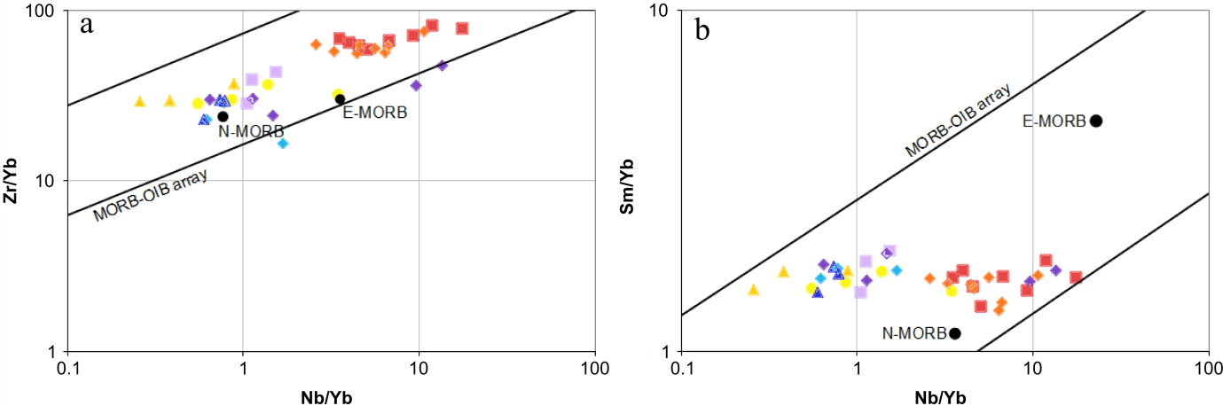
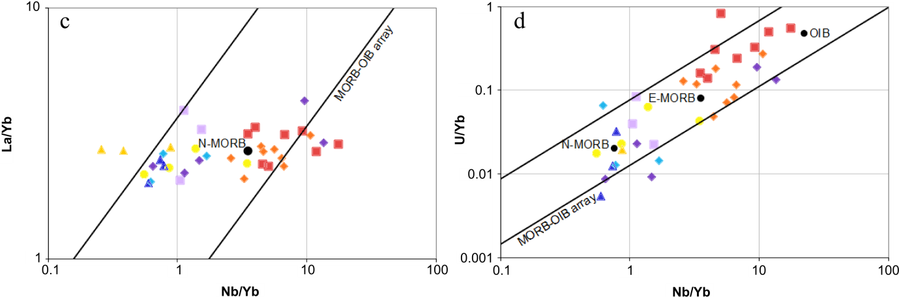
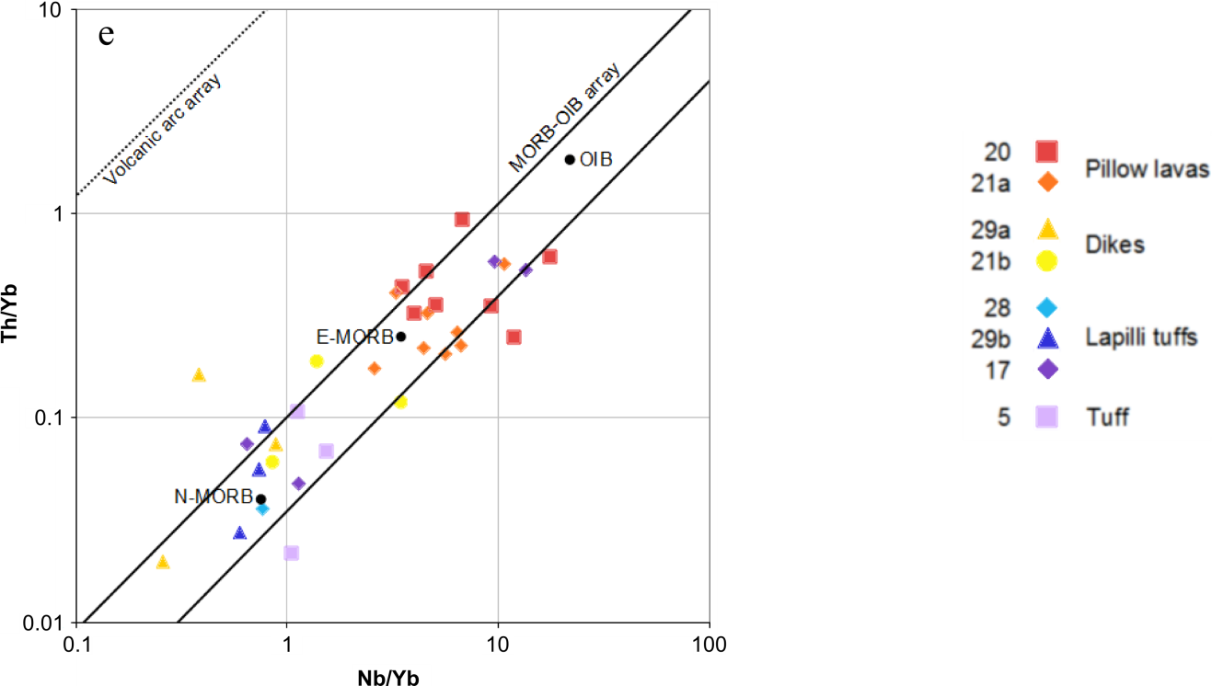
Figure S1: plots of M/Yb vs. Nb/Yb after Maurice et al. (2012). Key beside diagram e applies to all diagrams.

According to Maurice et al. (2012), it is possible to obtain an indication of the mobility of elements during hydrothermal alteration and metamorphism by plotting them against an immobile element such as Zr. Here a good correlation with Zr indicates low mobility. In my samples (fig. 21), Hf correlates very well with Zr; Nb, La, and Th correlate reasonably well; and Rb and Sm correlate poorly (suggesting that Rb and Sm were mobile during alteration).
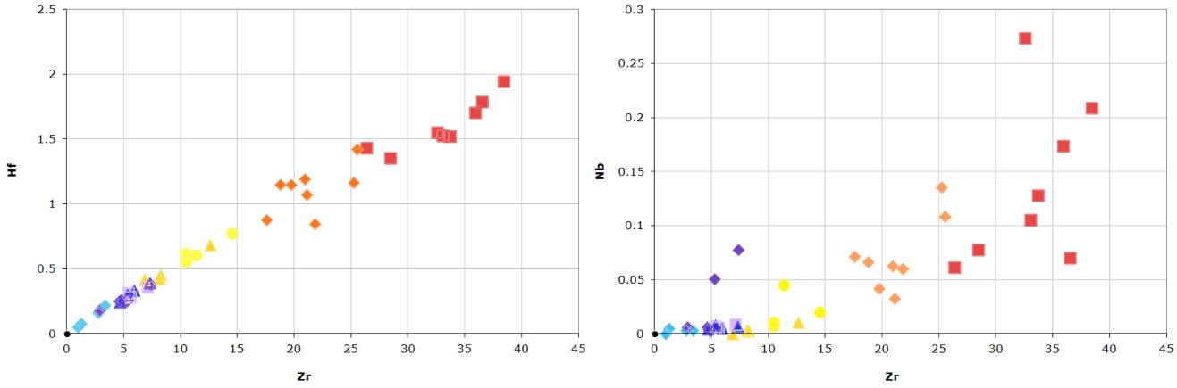
b
a
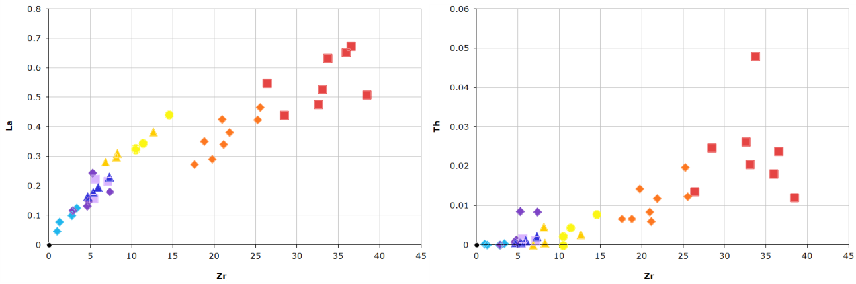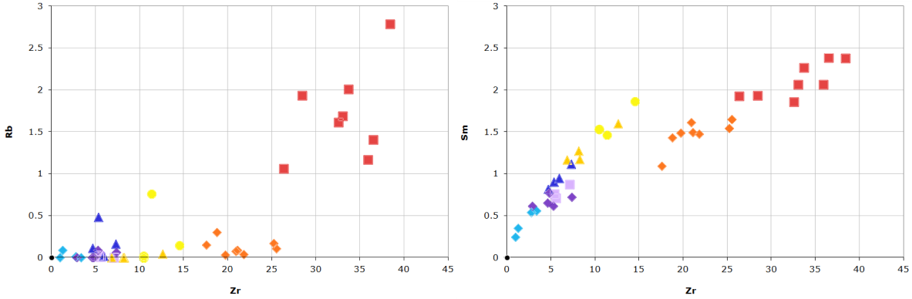
f
e
c
d
Figure S2: plots of major elements against Zr; key in bottom right applies to all graphs.

