Supplemental Information

Effects of propylene glycol, vegetable glycerin, and nicotine on emissions and dynamics of electronic cigarette aerosols

Liqiao Li, Eon S. Lee, Charlene Nguyen, and Yifang Zhu*

Department of Environmental Health Sciences, Jonathan and Karin Fielding School of Public Health, University of California, Los Angeles, CA 90095-1772 USA

* Corresponding author phone: +1-310-825-4324; fax: +1-310-794-2106; e-mail: yifang@ucla.edu

Table S1. Summary of studies on particle size distribution of e-cigarette (e-cig) aerosols
Study | Type | E-cig device | E-liquid |  | Flow Rate (L/min) | Puff duration (s) | Puff interval | PNC (#/cm³) | Dilution ratio or AER | Particle size distribution | Instrument
 |  |  | nicotine | PG/VG
Ingebrethsen et al. 2012 | M | Cigalike | NA | NA | 0.825- 1.65 | 2-4 | NA | ~10⁹ | 1:1 | CMD = 296 - 458 nm | Spectral Transmission
 |  |  |  |  |  |  |  |  | 3400-5500:1 | CMD= 14-18 nm | Electrical mobility particle sizer
McAuley et al. 2012 | M | Cigalike | 2.4% or 2.6 % | NA | 0.75 | 4 | 30 s | ~10³ | Room size 40 m³; AER= 0.3 h⁻¹ | Mode at 40 nm, 100 nm,  300 nm, 1 um, and 2 um | Wide range particle  spectrometer
Zhang et al. 2013 | M | NA | NA | 100/0 | NA | NA | 30 s | ~10⁵ | 50 ml chamber | One puff: single mode at 117 nm; steady state: bimodal at 371 nm | Scanning mobility particle sizer
 |  |  |  | 0/100 |  |  |  |  |  | One puff: single mode at 180 nm; steady state: bimodal at 414 nm
Schripp et al. 2013 | M | Tank-style | 0% or 1.8% | NA | NA | 3 | NA | ~10⁵ | 10L glass chamber; AER = 3 h⁻¹ | Bimodal at 30 and 100 nm; shifts to a single mode with increasing temperature or aging | Fast mobility particle sizer
 | S |  |  |  |  | 3 | 60 s | ~10³ | 8 m³ chamber; AER = 0.3 h⁻¹ | Bimodal at 30 and 100 nm
Fuoco et al. 2014 | M | Tank-style & cigalike | 0%- 1.8% | NA | 1 | 2 | 30 s | ~10⁹ | 880:1 | Bimodal at 10 and 150 nm; single modes at 120-165 nm | Fast mobility particle sizer
Manigrasso et al. 2015 | M | Tank-style | 0%, 1.2%, 1.4% or 1.8% | NA | 1 | 2 | 30 s | ~10⁹ | 880:1 | Single mode range 107-165 nm | Fast mobility particle sizer
Zhao et al. 2016 | M | Cigalike | 0% | NA | 1 | 3 | 30s | ~10⁹ | 6400:1 | Single mode range 18-29 nm | Scanning mobility particle sizer
Mikheev et al. 2016 | M | Tank-style | 0%-2.4% | NA | 0.9 | 5 | NA | 10⁷-10⁸ | 30:1 | Bimodal, CMD=11-15 and 96-175 nm | Differential Mobility Spectrometer
 |  |  |  |  | 0.9 | 5 | NA | 10⁷-10⁸ | 3180:1 | Bimodal, CMD=16 and 75 nm
 |  |  |  |  | 0.9 | 5 | NA | 10⁷-10⁸ | 10600:1 | Bimodal, CMD=16 and 81 nm
 |  |  |  |  | 0.9 | 5 | NA | 10⁷-10⁸ | 26500:1 | Bimodal, CMD=17 and 82 nm
Zhao et al. 2017 | S | E-cig user & cigalike | 0% or 2.4% | NA | NA | 3 | 27 s | ~10⁴ | Room size 80 m³; AER = 4.1 h⁻¹ | Bimodal at 15 and 85 nm | Scanning mobility particle sizer
Baassiri et al. 2017 | M | Tank-style | 1.8% | 100/0, 70/30, 0/100 | 1 | 4 | 10 s | 10⁹-10¹⁰ | 1450:1 | PG/VG=100/0: bimodal, CMD 44 nm; PG/VG=70/30: bimodal, CMD= 81 nm; PG/VG= 0/100: bimodal, CMD=81 nm | Electrical mobility particle sizer
Floyd et al. 2018 | M | Tank-style | 2.4% | 67/33 | 1.2 | 3 | 30 s | ~10⁷ | 4480: 1 or 14933: 1 | Trimodal at 40, 200, and 1000 nm | Scanning mobility particle sizer and aerodynamic particle sizer
Mikheev et al. 2018 | M | A cigalike & two tank-style | 0.6%-0.9% | 50/50 | 0.9-2.7 | 5 | 60 s | 10⁷-10⁸ | 30:1 | Bimodal changed to tri-modal with higher flow rate; 1) CMD 110-117 nm using SCS puff machine; 2) CMD 225-259 nm using HPP2 puff machine | Differential Mobility Spectrometer
Zervas et al. 2018 | M | Tank-style | 0% or 1.2% | 50/50 | NA | 120 | NA | 10⁶-10⁷ | no dilution | Bimodal at ~15 and 200-400 nm | Scanning mobility particle sizer
Scungio et al. 2018 | M | Tank-style | 0% or 1.2% | NA | 1 | 2 | 30 s | ~10⁸ | ~880-1000:1 | Single mode at 34 nm | Fast mobility particle sizer
 | S | E-cig user vaped | NA | NA | NA | NA | 0.7-1.5 puffs/min | ~10³ | Room size 40 m³; AER = 0.2 h⁻¹ | Bimodal at 30 and 90 nm | Fast mobility particle sizer
Nguyen et al. 2019 | S | Vape shop | NA | NA | NA | NA | 0.53 puff/min | 10⁴-10⁵ | Room size 244 m³; AER = 1.7 h⁻¹ | Bimodal of 60 and 250 nm | Scanning mobility particle sizer
Abbreviations: M, mainstream; S, secondhand; e-cig, electronic cigarette; AER, air exchange rate; PNC, particle number concentration; PG, propylene glycol; VG, vegetable glycerin; NA, not applicable.

Table S2. Properties of chemical compounds used in this study at 20 ºC and 1 atm.
Chemical Properties | di-2-ethylhexyl sebacate (DEHS) | Vegetable Glycerin (VG) | Nicotine | Propylene Glycol (PG)
Chemical Formula | C₂₆H₅₀O₄ | C₃H₈O₃ | C₁₀H₁₄N₂ | C₃H₈O₂
CAS Number | 122-62-3 | 56-81-5 | 54-11-5 | 57-55-6
Molecular Weight (g/mol) | 426.67 | 92.09 | 162.23 | 76.09
Density (g/mL) | 1.120 | 1.261 | 1.010 | 1.036
Dynamic Viscosity (Pa∙s) | 0.021 | 1.412 | 0.004 | 0.042
Saturation Vapor Pressure (Pa) | 1.20E-06 | 0.01 | 5.3 | 20
Henry's Law Constant (Pa∙m³/mol) | 8.61 | 9.75E-06 | 8.20E-04 | 1.20E-03

Table S3. A summary of log-linear regression analyses on log-normalized PNC and PM_{2.5}.
Log-linear Regression Data Summary | PNC |  | PM_{2.5}
PG/VG/Nic | Slope | R² | Slope | R²
0/100/0 | 1.92 | 0.93 | 6.76 | 0.96
10/90/0 | 1.90 | 0.95 | 6.85 | 0.96
30/70/0 | 2.09 | 0.96 | 7.08 | 0.96
50/50/0 | 2.08 | 0.97 | 6.51 | 0.96
100/0/0 | 2.20 | 0.96 | 7.16 | 0.90
0/100/2.4 | 1.89 | 0.97 | 6.54 | 0.97
10/90/2.4 | 1.86 | 0.96 | 7.02 | 0.97
30/70/2.4 | 1.85 | 0.98 | 6.91 | 0.97
50/50/2.4 | 1.84 | 0.99 | 5.98 | 0.96
100/0/2.4 | 1.64 | 0.98 | 5.40 | 0.96
DEHS | 1.56 | 0.98 | 1.95 | 0.99

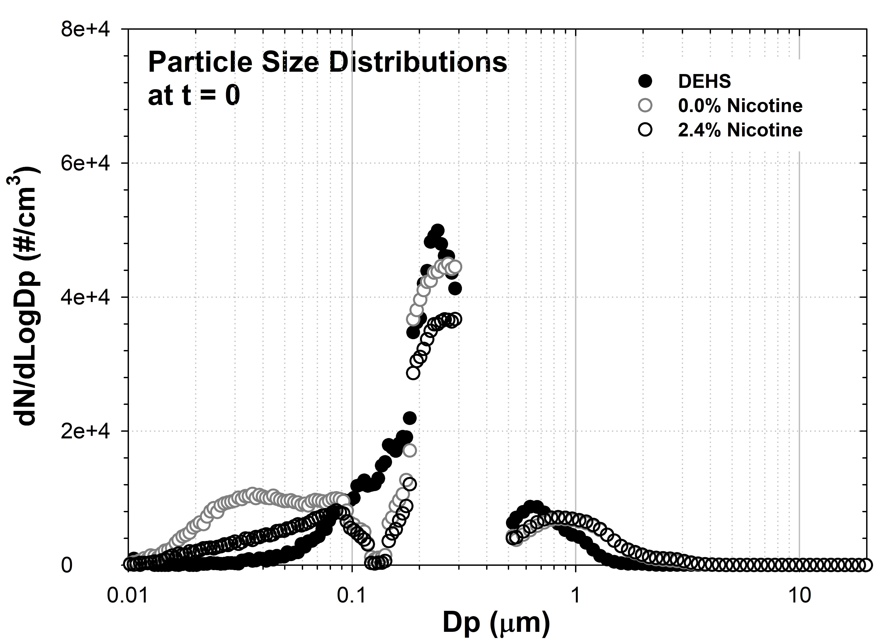
Figure S1. Overall particle size distributions (dN/dLogDp) of DEHS and e-cig aerosols at the start of the decay cycle (t = 0). The plotted data are the means of all measurements conducted with each type of e-liquid mixture evaluated in this study. The plotted data also compare the initial particle size distribution of e-cig aerosols with and without nicotine.

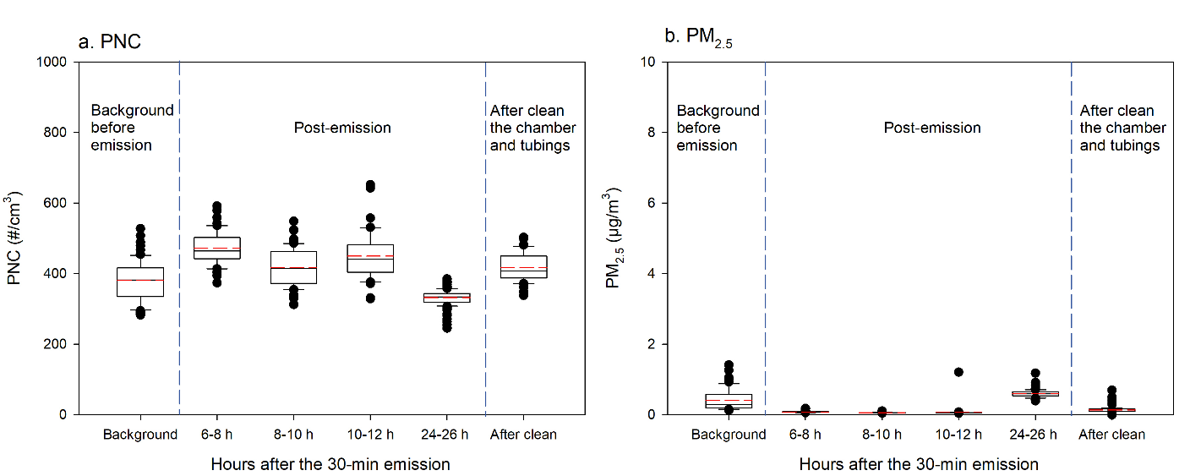
Figure S2. The measured PNC and PM_{2.5} before the 30-min e-cig emission (i.e., background), 6-26 hours after the emission, and after cleaning the chamber walls and tubings.

Coagulation during the decay
Based on the SMPS data, the count median diameter (CMD) and geometric standard deviation (GSD) were used to estimate the average coagulation coefficient (K̅) according to the equation (S1) (Hinds 1999; Lee and Chen 1984):
(S1)
Where λ is mean free path, CMD is count median diameter, σ_{g} is the GSD, k is the Boltzmann’s Constant, η is the gas viscosity, T is the absolute temperature. Because the experiments were conducted under the condition of 297K and 101 kPa, we obtained λ = 0.067 µm and η= 1.82× 10⁻⁵ N.s/m². At the initial concentrations (C_{t=0}) before the decay started, the e-cig aerosols from all tested e-liquid mixtures showed a similar size distribution with a similar CMD (i.e., ~ 175 nm) and GSD (i.e., ~2.35). Thus, the K̅ was determined to be ~ 1.53 × 10⁻⁹ cm³/s. Then, equation (S2) (Hinds 1999) was used to calculate the PNC as a function of time by coagulation, assuming the average coagulation coefficient (K̅) to be a constant:
(S2)
Where C_{t=0} is the initial concentration before decay started, C_{t} is the concentration at time t. The calculated t₅₀ (i.e., time to achieve 50% C_{t=0}) solely due to coagulation was approximately 5-6 hours, which was 14-17 times longer than the overall t₅₀ (i.e., ~ 20 min) for all the e-liquid mixtures summarized in Table 1. Therefore, coagulation during the decay was determined negligible compared to other particle loss mechanisms in this study. Additionally, the concentration changes due to coagulation were similar across all the e-liquid mixtures.

Reference
Hinds, W. C. (1999). Aerosol technology: properties, behavior, and measurement of airborne particles. John Wiley & Sons.
Lee, K. W. and Chen, H. (1984). Coagulation rate of polydisperse particles. Aerosol Science and Technology 3:327-334.

